1:

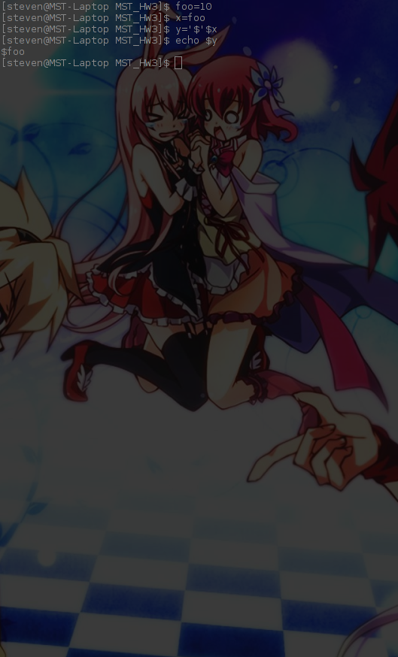

The left program prepends a “$” character to x before assigning it to y, the right program does not prepend the “$” to x.

2: A thread is a set of instructions, often a smaller part of a process, that can run on a single processor. Multiple threads are often run concurrently in a multi-core systems.

3:

A system call is an interface in a higher-level language to access core operating system services. this interface is an Application Program Interface (API), in linux this is the POSIX API. The system calls are more expensive, because as the CPU switches between the processes it is unable to work.

4:

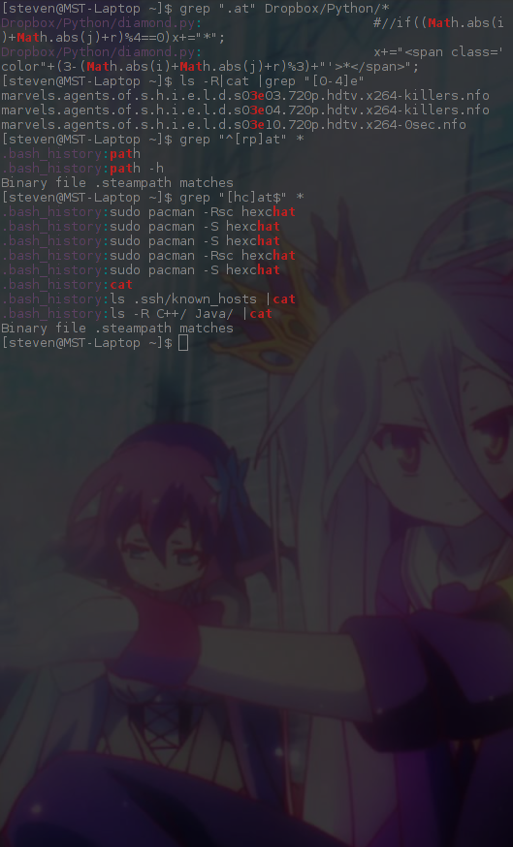

grep “.at” *file*

this command list any lines that contain the string “at” preceded by any single character.

grep “[0-3]at” *file*

this command list any lines that contain a number from 0 to 3 followed by “at”

grep “^[rp]at” *file*

grep “[hc]at$” *file*

this command list any lines that have an h or c, followed by “at” and some form of whitespace

grep ^[rp]at" *file*

this command list any lines that start with either rat or pat

5:



This program attempts print "I am when fork returns 0" and then list the contents of the current working directory. If it fails, it will print “I am when fork returns less than 0.” after that it will print “the last else”