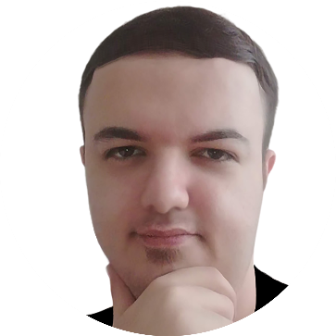

**Sample Projects**

Speech recognition, Music generation

Sound localization, Spell correction

Video action recognition, MRI segmentation

Blockchain-based token creation

AI implementation on Raspberry pi

Chatbot with Deep learning

Recommendation system, Fraud detection

Market value prediction, Sentiment analysis

Sound localization, Speaker recognition

Spiking data analysis, Secure fast compression

Web design of SMalek.ml & Advicify.ml

**Honors**

Holding and presenting in “Baku data webinars”

Finalist of “Global deftech” hackathon

Winner of international “Covidathon” hackathon

Winner of international “Covid19” hackathon

Hackathon committee member and mentor

“Nanotech” conference committee member

Analysis of spiking data certificate

Programming contest winner

Khwarizmi patent festival winner

Anti-impact structures patent

**Work Experience**

Data scientist @ Kontakt home – (Mar2021 (current))

Instructor @ Data school of Khazar University – (Sep2019-Jun2021)

Lecturer @ Khazar University – (Sep2019-Jan2020)

CTO @ Alsatex – 2019-2019 (Apr-Sep)

Chief AI officer @ sabzosalem.com – 2017 (Apr-Sep)

CTO @ Rayan Fartak Azer – 2012 (May-Sep)

**Skills**

Deep machine learning, Blockchain, AI-based IOT, Data visualization, Data scrapping, SQL databases, NoSQL databases, Data Analysis, Web APIs.

Python, MATLAB, C++,…

Graphic design, UI/UX Design, Web development, Financial analysis, Business planning, Business Gamification, Project management, Digital Marketing, Social network analysis, Conference holding, Mentoring.

**Personal information**

I was born in May 1993 in Tabriz. I am single.

I like innovation, research, (Especially in Deep learning), social communities, music, jugging, graphic design, and business planning.

**Contact Info**



**LinkedIn:** SaberMalek



**Google Scholar:** Saber MalekzadeH

**Education**

MSc in Artificial Intelligence, Valiasr University

(2015-2018)

BSc in Computer Science, University of Tabriz

(2010-2015)

**Speaking Languages**

Azerbaijani, English, Turkish, Persian

**Social Networks**



SMalek.ml



Svetlana Memmedova 203C, Baku, Azerbaijan



SMalekzP @ gmail . com



+1 (912) 888 1020

**Saber MalekzadeH**

**Data Scientist**