Final Project

1. Run the two programs

2. Enter ‘ls’ on the server

3. What is the output you are getting from the backdoor? (attach screenshot below):

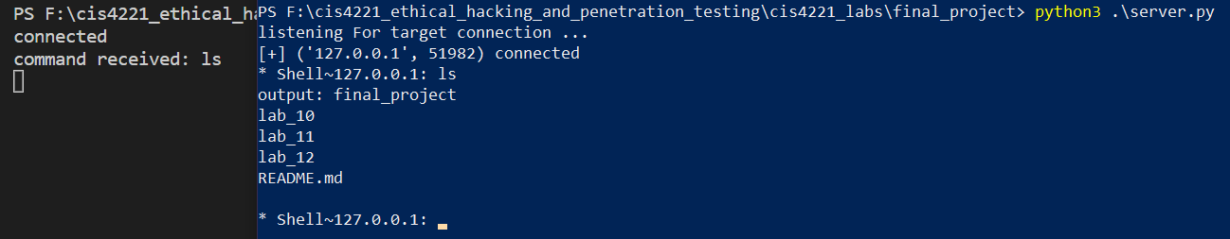

The left panel is our backdoor showing that we received the ls command entered into the server on the right.

4. Enter ‘ifconfig’ on the server

5. What is the output you are getting from the backdoor? (attach screenshot below):

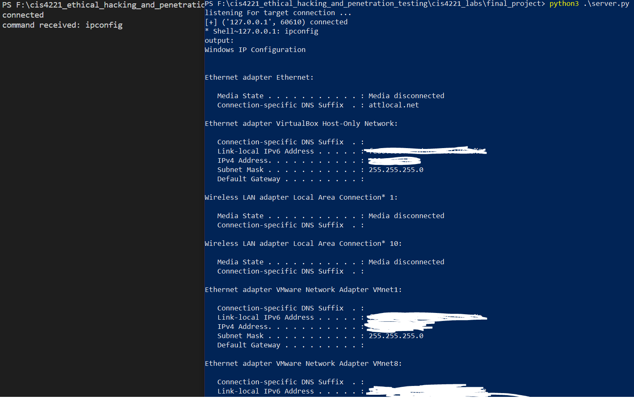

The server on the right shows network data returning from the ipconfig(ifconfig) command.

6. Enter ‘pwd’ on the server

7. What is the output you are getting from the backdoor? (attach screenshot below):

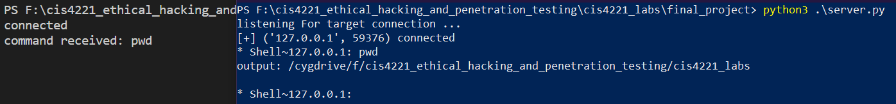

The server on the right shows the path of the folder above the backdoor script.

8. Enter ‘cd ..’ on the server

9. Enter ‘pwd’ on the server again

10. What is the output you are getting from the backdoor? (attach screenshot below):

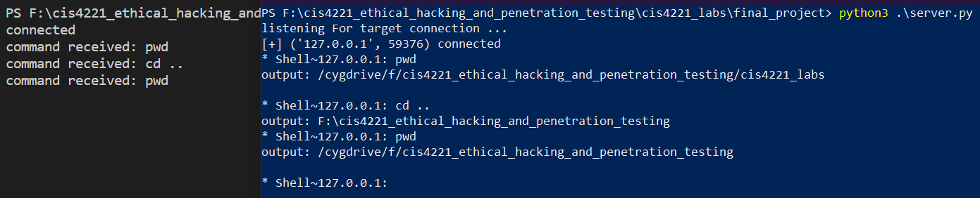

The server on the right shows us the path of the folder containing the folder containing the backdoor script.

11. Start keylogger on the backdoor (run command keylog_start on the server)

12. Dump key logs

13. Stop keylogger on the backdoor

14. Attach screenshots of key dumps below:

