Motion Analysis & Performance Monitoring System for ​Squat Exercise​ by Simple Estimation
Nguyen Phan Kien*¹, Mai Tat Chuyen¹, Trinh Khanh Ly¹, Ong Thi Huyen Trang¹

¹ Hanoi University of Science and Technology, Hanoi, Vietnam
Knguyenp@gmail.com
¹ Hanoi University of Science and Technology, Hanoi, Vietnam
Chuyen.MT213657@sis.hust.edu.vn
¹ Hanoi University of Science and Technology, Hanoi, Vietnam
Ly.TK213676@sis.hust.edu.vn
¹ Hanoi University of Science and Technology, Hanoi, Vietnam
Trang.OTH213683@sis.hust.edu.vn
Abstract. The back squat is recognized as a highly effective exercise for enhancing athletic performance, requiring the coordinated engagement of various muscle groups and strengthening key movers essential for explosive movements like jumping, running, and lifting. Individuals who are new or inexperienced in fitness require precise training regimens to enhance their techniques and reduce the risk of injuries, rather than investing in costly coaching services. Utilizing programs and applications designed for home workouts proves to be a fitting alternative in such cases. This study introduces a markerless approach, measuring the angle between the thigh and the vertical during the squat movement to provide visual insight and assessment for the user. We verify it by collecting actual data and comparing it with the facts estimated by the model. The angle between the thigh and the vertical was calculated through the Machine Learning (ML) pose estimation model “MediaPipe Pose” and Computer Vision (CV) without using markers. To verify accuracy, the obtained values are compared with data on each video frame. 30 data samples from 3 people of different heights were collected, the average absolute value MAE was 4.3 degrees. The study shows that the angle between the thigh and the vertical can be accurately measured using an ML solution to monitor body posture with high accuracy. Professionals involved in the fields of biomechanics, sports medicine, physical therapy as well as other medical fields can use this method as an alternative unsigned approach to measure the angle between thigh and vertical in the squat, and other researchers can integrate this method into their practical application solutions.

Keywords: Biomechanical analysis, Performance monitoring, Back Squat exercise, Mediapipe, Human Pose Estimation.
- Introduction
With the many workout videos accessible on the internet and the availability of dedicated workout programs on popular fitness tracking apps such as Samsung Health, an increasing number of individuals are autonomously engaging in these exercise routines. The prevalence of busy lifestyles and financial constraints has prompted a significant population to opt for independent indoor workouts. While this is convenient, it comes with the risk of potential long-term injuries if the exercises are not executed correctly. For example, if squats are repetitively performed with incorrect postures, stress may accumulate on the knee joints, and eventually injuries can occur, such as patellofemoral pain syndrome [1]. However, for amateurs and beginners, they need accurate training plans to improve technique and minimize injuries instead of spending an expensive cost to hire a coach. Programs and applications that support home training will be suitable options.
The squat movement pattern is required for essential activities of daily living such as sitting, lifting and most sporting activities. It is also a staple exercise in training regimens designed to enhance performance and to build injury resilience. [2,3,4] Despite variations on how squat technique is instructed and executed to address specific performance goals, nearly all squat variations comprise a standard, basic, and fundamental blueprint that underlies the biomechanical technique that will support progressive physical attribute improvements and decrease the risk of training induced injuries.
The back squat is widely regarded as one of the most effective exercises used to enhance athletic performance as it necessitates the coordinated interaction of numerous muscle groups and strengthens the prime movers needed to support explosive athletic movements such as jumping, running, and lifting. Furthermore, back squat proficiency supports derivative squat movements that translate to many everyday tasks such as lifting and carrying heavy objects, which relates this exercise to improve quality of life. The squat has also become more commonly used in clinical settings to strengthen lower-body musculature (especially posterior chain strength and recruitment patterns) with little to no harm on connective tissue after joint-related injury. [5,6]
In the constraints of the problem, instead of employing a resource-intensive 3D pose estima-tion model, which faces difficulties in real-world angle computation given cur-rent technological limitations. A 3D pose estimation model requires 2-3 cameras or even dozens of cameras around with a marker-less system, and it may also neces-sitate marker sensors with a marker-based system. This would be a chal-lenging problem for regular users who typically have only a smartphone and a simple mobile application. Therefore, in our research, we propose an approach to com-pute the estimated angle in real-world 3D space with just a smartphone camera, aiming to be user-friendly and convenient for users, unlike the complexity asso-ciated with multi-camera and marker-based systems commonly used in 3D pose estimation.
In this paper, we focus on developing a Motion Analysis and Performance Monitoring System for Squat Exercise without utilizing any hardware sensors. Instead, our emphasis lies in applying advanced motion analysis methods and measurement algorithms to assess and provide feedback on the performance of individuals during the squat exercise. This approach not only helps us reduce costs and simplify the system but also opens up the possibility of seamless integration into existing training environments without the need for expensive auxiliary devices. Moreover, our system represents a significant advancement in incorporating fundamental technology to enhance understanding and execution of one of the most foundational exercises in strength training.
There-fore, our study attempts
(i). Proposing a simple method to compute the estimated angle in real-world 3D space and shows that measuring the angle between the thigh and the vertical during a squat can be measured with ML solution with high accuracy.
(ii). Providing users with practical methods to accurately measure squat depth, evaluate the symmetry of move-ments., enhancing their overall workout experience.
- Related work
Our work involves the convergence of several subfields in computer vision, By intertwining these elements, our approach aims to create a comprehensive understanding of human movement and provide us-ers with a seamless and ac-cessible means of self-evaluation
Tianyi Wang et al [7] has introduced a online fitness system: Biosignal Art, which is an open access, includes self-monitoring and coaching, as well as music, and is an interactive online fitness system. Body weight squat was utilized for fitness exercise and evaluated based on three indices: knee width, hip depth, and rhythm. Visitors could observe their movement and download the data and video after they finished the exercise. The exercise score was given by each squat exer-cise.
2D musculoskeletal models have traditionally operated under the assumption that there are no bilateral differences in the forces and moments gov-erning squat motions. However, studies have reported significant bilateral varia-tions in ground reaction forces and joint torques depending on loading conditions [8,9]. Flanagan et al. [8] observed that the average vertical ground reaction force on the left side is slightly (~6%) larger than on the right side. Moreover, there were average net joint moment differences between the left and right hip, knee, and ankle joints during barbell squats, measuring approximately ~16%, ~14%, and ~20%, respectively. Asymmetrical movement patterns like these theo-retically pose an increased risk of injury due to uneven force distribution. There-fore, comprehensive evaluations should be conducted on both sides of the trunk to assess movements lacking symmetry.
Gregory D. Myer et al [10] also confirmed in their study about deficits and technical factors which limit performance the back squat that Attaining an ap-propriate depth during squats is a crucial aspect for maximizing the benefits of the exercise. Failing to squat to the proper depth may result in insufficient chal-lenge to the hamstrings and gluteus muscular complex. The desired technique involves achieving full depth, ensuring that the tops of the thighs are at least parallel to the ground, and maintaining a seamless alignment at the knee, ankle, and hips without any disjointed deviations.
- Materials And Methods
3.1 Pose Estimation Model for Back- Squat Assessment
Human pose estimation, as defined in literature [11], is the process of determining or estimating human body poses from digital images, involving the precise detection and identification of human joints. Pose estimation algorithms are generally classified into two main types: the top-down approach [12] and the bottom-up approach [13]. The top-down approach initially identifies potential human regions in the image, extracts joints from these regions, and then deduces poses based on the extracted joints. While effective, this approach can be computationally expensive as each region is processed individually. On the other hand, the bottom-up approach processes the entire image to extract potential joints, which are then connected to form a pose. Although computationally less expensive than the top-down approach, it comes with the drawback of potentially generating faulty pose models in multi-person scenarios due to erroneous joint connections.
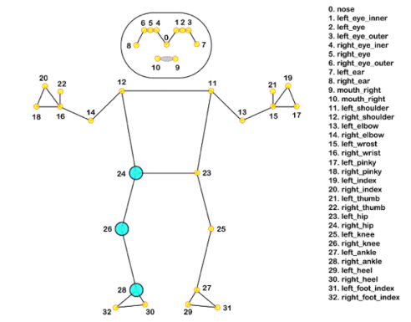

Figure 1. 33 Pose landmarks in MediaPipe Pose Landmark Model

MediaPipe serves as a framework or platform designed for the construction of Google-developed machine learning pipelines dedicated to handling and processing time-series data, such as audio and video. Within the MediaPipe framework, various machine-learning solutions are available, encompassing functions like face detection, object detection, and pose estimation. Specifically, MediaPipe Pose stands out as a machine learning solution within this framework, employing a bottom-up multi-person pose estimation model capable of detecting 33 anatomical landmarks. In the context of gait analysis, landmarks such as 24 (Right Hip), 26 (Right Knee), and 28 (Right Ankle), as depicted in Figure 1, are utilized to measure the knee-hip angle of the left leg during a squat cycle. Futhermore, it is known for its low computation cost [14,15], which allows for real-time pose tracking, and its cross-platform compatibility. This makes it suitable for deployment on various devices, such as mobile phones, desktops/laptops, and even on the web, and in programming languages such as Python.

3.2 The proposed method to calculate the angle between the thigh and the vertical
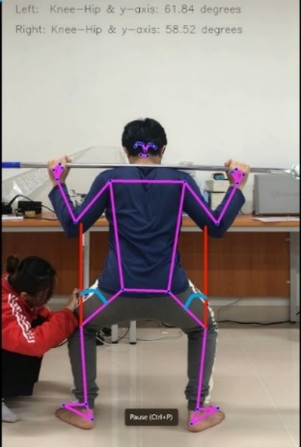
Figure 2. The angle be-tween the thighs and the vertical axis.
From the perspective of setting up the camera in the scenario from behind, instead of choosing the angle between the upper limbs, we opted for the angle between the thighs and the vertical axis in three-dimensional space, with the origin located at the knee (indicated by the blue curve in Figure 2). This angle will simultaneously determine factors related to the depth of the squat and the width of each thigh during execution. The modified model we have will calculate the angle in real-world conditions rather than on a 2D video screen.
By computing the angle in real-world conditions, we have integrated additional features into the system. The system will generate alerts when the x-angle exceeds 90 degrees (meaning the thighs are no longer parallel to the horizontal plane, as referenced in [4x]). Subsequently, the angle between the two thighs will be recorded, triggering an alert when the deviation between the two thighs exceeds 10 degrees. The system will also store the execution process, allowing users to review and enhance their skills.
- Calculating the angle:
Through practical experiments, we confirm that within the constraints of the problem, to optimize conditions, we verify the real-world angle between the thighs and the vertical axis, as mentioned. During the squat execution, we choose the starting point (Start-point) corresponding to when the person is standing upright, and the final point (final-point) corresponding to when the person squats with the hip-thigh parallel to the ground.
In this case, let α₁ be the angle between the thigh and the vertical axis, taken at the knee of the Start-point, and α₂ corresponding to the final-point. β₁ and β₂ are the angles corresponding to the Start-point and final-point, directly readable from the 2D video camera (which we do not display).
We will divide the calculation into two stages to compute α₁ and α₂:
a. α₁
In the upright position, the angle α₁ in this case approximates the angle that the camera sees head-on. We decide to choose this as the angle that mediapipe reads in the 2D video, so β₁ ≈ α₁.
b. α₂
In the squatting position, the actual angle α₂ is 90 degrees. We recorded this with a setup distance of 2.6m, at a height of 65% of the user's height, obtaining β₂ angles ranging from 110 to 130 degrees.
According to observations, even though the movement during half of the squat motion (meaning from standing to sitting or from sitting to standing) causes the positions of the keypoints to move along certain curves. What we need to do is find the representation of these curves between the angles.
While β₁ ≈ α₁, and the difference between α₂ and β₂ is 90 degrees and ~120 degrees, a context applied to both new and amateur exercisers, we accept taking a negligible deviation value through linear conversion from beta to alpha. I can represent this in the figure below for better visualization. This ensures that we avoid complex formulas and computational resources, as well as infrastructure for users, accepting a small error that causes negligible harm for higher efficiency.
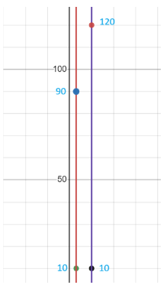
Figure 3. Illustrates conversion between 90 degrees and 120 degrees.
From there, the calculation of angle alpha will be as follows:
α= β. $\frac{90}{x}$
Where x is determined by the person's lowest movement at the first attempt
β will be calculated based on the 2D video program from the media pipe, is the angle between 3 points, with one being the reference point, is shown below.
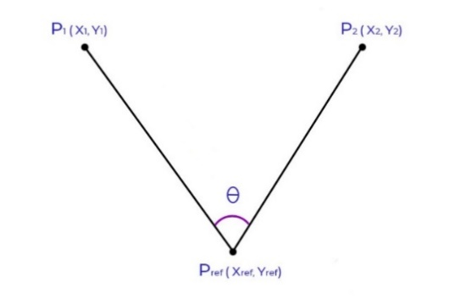

Figure 4. The angle between three points
The equation is given by:
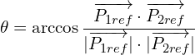
3.3 Video Data Collection for calibration
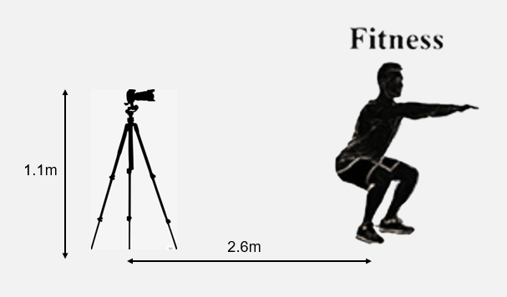
Figure 5. Camera setup for motion capture video collection
In this experiment, video recordings of a subject doing squat with markers on the hip, knee, and ankle of the right leg were captured. Squat cycles were captured using a mobile phone camera mounted on a tripod stand. The phone resolution was 1920 x 1080 pixels at an average rate of 30 frames per second. Three healthy subjects aged 20 - 21 years old have different heights participated in the experiment. Thirty (30) videos consisting of single squat cycles of the subject were recorded for the experiment. With different user heights, the camera viewing angle is different. Through actual testing, we found that with a set distance of 2.6m, placing the camera at a height of 65% of the with the user's height to cover the viewing angle and be most effective in minimizing errors, in the case of our data collection, the height is 1.1m and the distance between the camera and the subject was 2.6m
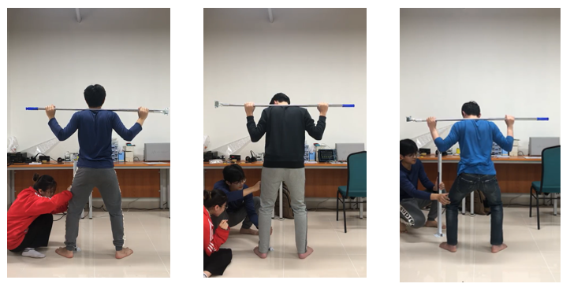

- (b) (c)
Figure 6. Three healthy subjects (a), (b), (c) have different heights
3.4 Evaluation methods
Then the videos were analyzed by MediaPipe Pose. For each frame during the squat cycle for each trial, the angle between hip and knee were calculated using two methods. Hip, knee, and ankle coordinates were obtained from the pose estimation MediaPipe Pose model using a Python program to calculate the knee-hip angles. Likewise, we measure the actual angle between the hip and knee using a mechanical protractor for comparison with the theoretical values were calculated for the obtained knee-hip angles by Python model. Then values of both these methods were used to calculate Mean Absolute Error (MAE). The Mean Absolute Error (MAE) serves as a crucial metric in assessing the accuracy of knee and hip angle predictions derived from a Python model compared to ac-tual angles measured with a mechanical protractor. In this comparison, the theo-retical angles generated by the Python model are evaluated against the ground truth angles obtained through direct mechanical measurements. The MAE quanti-fies the average absolute difference between the predicted and actual angles, providing a clear indication of the model's precision in estimating knee and hip joint positions. A lower MAE suggests a closer alignment between the Python model's predictions and the real-world measurements, highlighting the efficacy of the model in capturing the complex dynamics of knee and hip movements. This evaluation using MAE contributes valuable insights into the reliability and per-formance of the Python model for angle prediction in biomechanical analyses.

3.5 The Appication for Motion Analysis and Performance Feedback
From the perspective of setting up the camera in the scenario from behind, in-stead of choosing the angle between the upper limbs, we opted for the angle be-tween the thighs and the vertical axis in three-dimensional space, with the origin located at the knee (indicated by the blue curve in the image). This angle will simultaneously determine factors related to the depth of the squat and the width of each thigh during execution. The modified model we have will calculate the angle in real-world conditions rather than on a 2D video screen.
By computing the angle in real-world conditions, we have integrated addition-al features into the system. The system will generate alerts when the x-angle ex-ceeds 90 degrees (meaning the thighs are no longer parallel to the horizontal plane, as referenced in [10]). Subsequently, the angle between the two thighs will be recorded, triggering an alert when the deviation between the two thighs ex-ceeds a suitable degree. The system will also store the execution process, allowing us-ers to review and enhance their skills.

- Results and Discussion
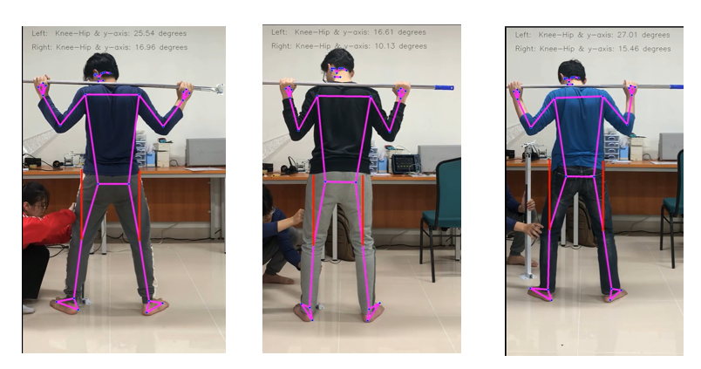
(a) (b) (c)
s

In the range from 0 to 90 degrees of the angle between the thigh and the vertical line, with the origin at the knee, we recorded the angle of both thighs and averaged the value at points 5 degrees apart in the Table 1(with the first column denoted P for Person). The smallest MAE values at Person 1 at 90 degrees are 2.77 and the maximum values are at Person 2 at 10 degrees. Observing the values in the table, we can see that the MAE value tends to be larger at small angles and gradually decreases when measuring at large angles and Graph 1 is a graph of the distribution of estimated and actual points that also shows the difference at small value angles. High Corelation (0.998) and Low P-value( 7.37e-21) in Table 3 also demonstrates that there is a strong and reliable relationship between the analyzed variables.This deviation may be due to external causes such as inaccurate measurement techniques and loose clothing or may may have some minor limitations related to lighting and environment that also affects the model's pose estimation performance.

P | 10º | 15º | 20º | 25º | 30º | 35º | 40º | 45º | 50º | 55º | 60º | 65º | 70º | 75º | 80º | 85º | 90º
1 | 9.85 | 9.01 | 8.68 | 6.61 | 4.82 | 3.68 | 2.78 | 2.79 | 2.54 | 3.79 | 3.68 | 3.27 | 3.05 | 4.39 | 4.72 | 3.71 | 2.77
2 | 10.67 | 8.43 | 6.50 | 5.23 | 4.58 | 3.26 | 2.01 | 2.13 | 3.11 | 4.16 | 4.97 | 3.34 | 3.49 | 4.17 | 4.92 | 5.79 | 4.53
3 | 10.26 | 8.87 | 8.08 | 6.71 | 5.23 | 3.60 | 3.64 | 2.84 | 2.92 | 3.70 | 4.26 | 2.93 | 3.40 | 3.14 | 3.76 | 5.11 | 4.32
Table 1. Mean Absolute Error for each 17 Trials.

The average mean absolute error for each person in the experiment was calculated. The MAE for 3 people and the average MAE are shown in table 2 along with height and weight values, respectively. It can be seen that the MAE values are very small, only 4.0 degrees, showing that our model has performed effectively in the context of the constraints of this squat movement.
Person | Heigh(m) | Weight(kg) | MAE
1 | 1,70 | 64 | 4.56 º
2 | 1,77 | 66 | 4.46 º
3 | 1,64 | 60 | 3.62 º
Average |  |  | 4.30 º

Table 2. Mean Absolute Error average for each person.

Metrics | Person 1 | Person 2 | Person 3
Correlation  Coefficient(r) | 0.998 | 0.989 | 0.989
P-values | 7.37e-21 | 5.85e-14 | 5.85e-14

Table 3. Pearson Correlation Coefficient and P-values

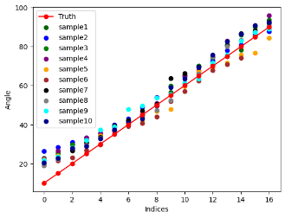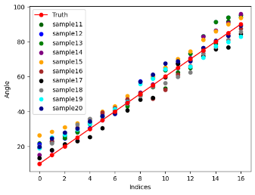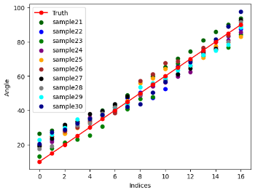
Figure 8. The distribution of estimated and actual points
- Conclusion
A strong correlation (r = 0.992) and a low mean absolute error (4.3 degrees) observed between the two methodologies indicate the accurate measurement of angle parameters between the thigh and the vertical axis anchored at the knee using pose estimation techniques like MediaPipe. This implies that the thigh angle with the vertical can be precisely determined without the need for a markerbase, showcasing the effectiveness of the Pose Estimation Method. The study affirms the feasibility of utilizing a simple smartphone camera for real-time recording and analysis of movements, offering users a practical tool to enhance technique and reduce the risk of injuries during squat exercises. The integration of MediaPipe Pose with actual measurements demonstrates accurate results. Despite potential minor environmental limitations in pose estimation, this research introduces a marker-free and cost-effective approach for measuring angular parameters, contributing to improved back squat practice. Furthermore, our findings suggest that other parameters, such as the angle between the shin and thigh or angles involving the arm and shoulder, can also be reliably measured.

References
- Gooyers, C.E.; Beach, T.A.; Frost, D.M.; Callaghan, J.P. The influence of re-sistance bands on frontal plane knee mechanics during body-weight squat and verti-cal jump movements. Sports Biomech. 2012, 11, 391–401.
- McLaughlin TM, Lardner TJ, Dillman CJ. Kinetics of the parallel squat. Re-search Quarterly American Alliance for Health, Physical Education and Recreation. 1978;49:175–189
- Miletello WM, Beam JR, Cooper ZC. A biomechanical analysis of the squat between competitive collegiate, competitive high school, and novice powerlifters. J Strength Cond Res. 2009;23:1611–1617
- Myer GD, Brent JL, Ford KR, Hewett TE. Real-time assessment and neuromus-cular training feedback techniques to prevent ACL injury in female athletes. Strength Cond J. 2011;33:21–35
- Escamilla RF. Knee biomechanics of the dynamic squat exercise. Med Sci Sports Exerc. 2001;33:127–141.
- Escamilla RF, Fleisig GS, Lowry TM, Barrentine SW, Andrews JR. A three-dimensional biomechanical analysis of the squat during varying stance widths. Med Sci Sports Exerc. 2001;33:984–998
- Seno R. Development and verification of vital data art system for sports promo-tion. (master's thesis. Ritsumeikan University, Kyoto, Japan (2020)
- Flanagan S.P., Salem G.J. Bilateral differences in the net joint torques during the squat exercise. J. Strength Cond. Res. 2007;21:1220–1226. doi: 10.1519/R-21156.1.
- Kobayashi Y., Kubo J., Matsuo A., Matsubayashi T., Kobayashi K., Ishii N. Bi-lateral symmetry in joint torque during squat exercise performed by long jumpers. J. Strength Cond. Res. 2010;24:2826–2830
- Myer GD, Kushner AM, Brent JL, Schoenfeld BJ, Hugentobler J, Lloyd RS, Vermeil A, Chu DA, Harbin J, McGill SM. The back squat: A proposed assessment of functional deficits and technical factors that limit performance. Strength Cond J. 2014 Dec 1;36(6):4-27.
- R. Josyula and S. Ostadabbas, “A Review on Human Pose Estimation,” Oct. 2021, [Online]. Available: http://arxiv.org/abs/2110.06877
- G. Ning, P. Liu, X. Fan, and C. Zhang, “A top-down approach to articulated human pose estimation and tracking,” in Proceedings of the European Conference on Computer Vision (ECCV) Workshops, 2018, p. 0.
- M. Li, Z. Zhou, J. Li, and X. Liu, “Bottom-up pose estimation of multiple person with bounding box constraint,” in 2018 24th International Conference on Pattern Recognition (ICPR), 2018, pp. 115–120.
- Bazarevsky, V.; Grishchenko, I.; Raveendran, K.; Zhu, T.; Zhang, F.; Grundmann, M. BlazePose: On-device Real-time Body Pose tracking. arXiv 2020, arXiv:2006.10204.
- Tony Hii, C.S.; Gan, K.B.; Zainal, N.; Ibrahim, N.M.; Md Rani, S.A.; Shattar, N.A. Marker Free Gait Analysis using Pose Estimation Model. In Proceedings of the 2022 IEEE 20th Student Conference on Research and Development (SCOReD), Bangi, Malaysia, 8–9 November 2022; IEEE: Piscataway, NJ, USA, 2022; pp. 109–113.

