COMMANDS:

Linux Commands:

**1. pwd Command**

The [pwd](https://www.javatpoint.com/linux-pwd) command is used to display the location of the current working directory.

**Syntax:**

1. pwd

**Output:**

Linux Commands with Examples

**2. mkdir Command**

The [mkdir](https://www.javatpoint.com/linux-mkdir) command is used to create a new directory under any directory.

**Syntax:**

1. mkdir **<directory** name**>**

**Output:**

Linux Commands with Examples

**3. rmdir Command**

The [rmdir](https://www.javatpoint.com/linux-rmdir) command is used to delete a directory.

**Syntax:**

1. rmdir **<directory** name**>**

**Output:**

Linux Commands with Examples

**4. ls Command**

The [ls](https://www.javatpoint.com/linux-ls) command is used to display a list of content of a directory.

**Syntax:**

1. ls

**Output:**

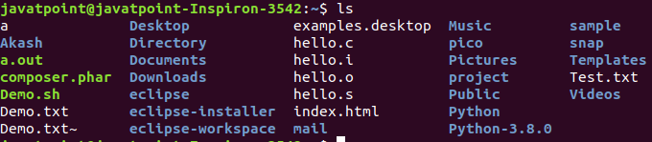

**5. cd Command**

The [cd](https://www.javatpoint.com/linux-cd) command is used to change the current directory.

**Syntax:**

1. cd **<directory** name**>**

**Output:**

Linux Commands with Examples

Linux File commands

**6. touch Command**

The [touch](https://www.javatpoint.com/linux-touch) command is used to create empty files. We can create multiple empty files by executing it once.

**Syntax:**

1. touch **<file** name**>**
2. touch **<file1>**  **<file2>** ....

**Output:**

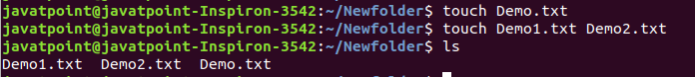

**7. cat Command**

The [cat](https://www.javatpoint.com/linux-cat) command is a multi-purpose utility in the Linux system. It can be used to create a file, display content of the file, copy the content of one file to another file, and more.

**Syntax:**

1. cat [OPTION]... [FILE]..

To create a file, execute it as follows:

1. cat **>** **<file** name**>**
2. // Enter file content

Press "**CTRL+ D**" keys to save the file. To display the content of the file, execute it as follows:

1. cat **<file** name**>**

**Output:**

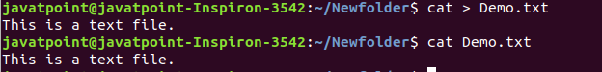

**8. rm Command**

The [rm](https://www.javatpoint.com/linux-rm) command is used to remove a file.

**Syntax:**

rm <file name>

**Output:**

Linux Commands with Examples

**9. cp Command**

The [cp](https://www.javatpoint.com/linux-cp) command is used to copy a file or directory.

**Syntax:**

To copy in the same directory:

1. cp **<existing** file name**>** **<new** file name**>**

To copy in a different directory:

**Output:**

Linux Commands with Examples

**10. mv Command**

The [mv](https://www.javatpoint.com/linux-mv) command is used to move a file or a directory form one location to another location.

**Syntax:**

1. mv **<file** name**>** **<directory** path**>**

**Output:**

Linux Commands with Examples

**11. rename Command**

The [rename](https://www.javatpoint.com/linux-rename) command is used to rename files. It is useful for renaming a large group of files.

**Syntax:**

1. rename 's/old-name/new-name/' files

For example, to convert all the text files into pdf files, execute the below command:

1. rename 's/\.txt$/\.pdf/' *.txt

**Output:**

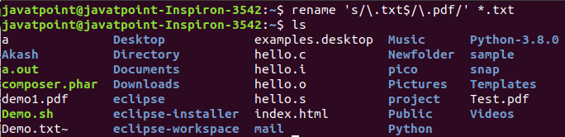

Linux File Content Commands

**12. head Command**

The [head](https://www.javatpoint.com/linux-head) command is used to display the content of a file. It displays the first 10 lines of a file.

**Syntax:**

1. head **<file** name**>**

**Output:**

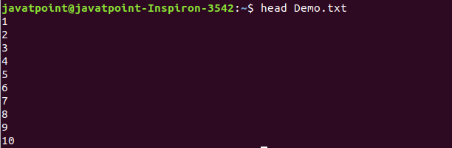

**13. tail Command**

The [tail](https://www.javatpoint.com/linux-tail) command is similar to the head command. The difference between both commands is that it displays the last ten lines of the file content. It is useful for reading the error message.

**Syntax:**

1. tail **<file** name**>**

**Output:**

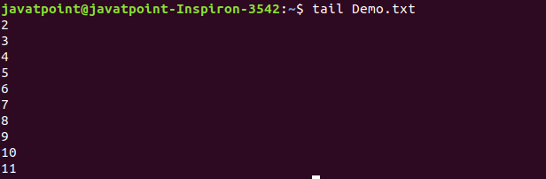

**14. tac Command**

The [tac](https://www.javatpoint.com/linux-tac) command is the reverse of cat command, as its name specified. It displays the file content in reverse order (from the last line).

**Syntax:**

1. tac **<file** name**>**

**Output:**

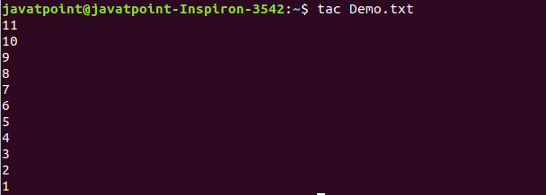

**15. more command**

The [more](https://www.javatpoint.com/linux-more) command is quite similar to the cat command, as it is used to display the file content in the same way that the cat command does. The only difference between both commands is that, in case of larger files, the more command displays screenful output at a time.

In more command, the following keys are used to scroll the page:

**ENTER key:** To scroll down page by line.

**Space bar:** To move to the next page.

**b key:** To move to the previous page.

**/ key:** To search the string.

**Syntax:**

1. more **<file** name**>**

**Output:**

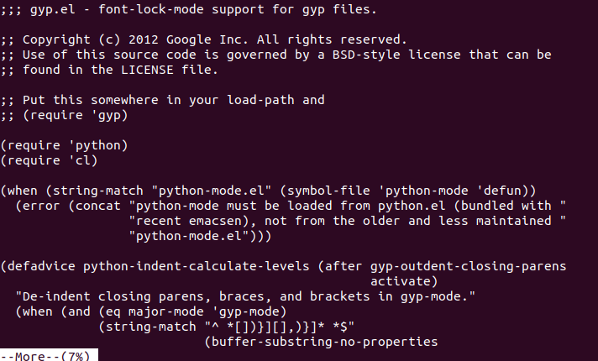

**16. less Command**

The [less](https://www.javatpoint.com/linux-less) command is similar to the more command. It also includes some extra features such as 'adjustment in width and height of the terminal.' Comparatively, the more command cuts the output in the width of the terminal.

**Syntax:**

1. less **<file** name**>**

**Output:**

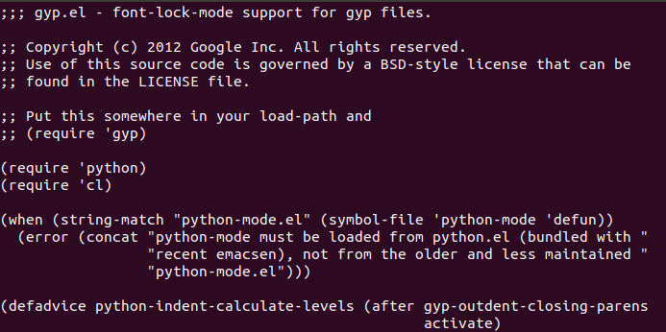

Linux User Commands

**17. su Command**

The [su](https://www.javatpoint.com/linux-su-commands) command provides administrative access to another user. In other words, it allows access of the Linux shell to another user.

**Syntax:**

1. su **<user** name**>**

**Output:**

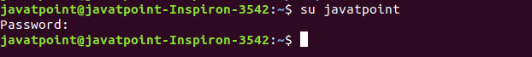

**18. id Command**

The [id](https://www.javatpoint.com/linux-id-command) command is used to display the user ID (UID) and group ID (GID).

**Syntax:**

1. id

**Output:**

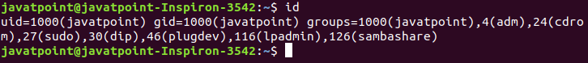

**19. useradd Command**

The [useradd](https://www.javatpoint.com/linux-create-user) command is used to add or remove a user on a Linux server.

**Syntax:**

1. useradd  username

**Output:**

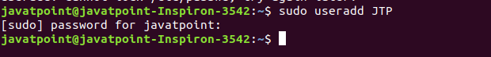

**20. passwd Command**

The [passwd](https://www.javatpoint.com/linux-user-password) command is used to create and change the password for a user.

**Syntax:**

1. passwd **<username>**

**Output:**

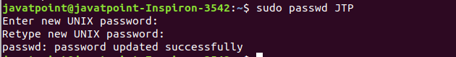

**21. groupadd Command**

The [groupadd](https://www.javatpoint.com/linux-add-user-to-group) command is used to create a user group.

**Syntax:**

1. groupadd **<group** name**>**

**Output:**

Linux Commands with Examples

Linux Filter Commands

**22. cat Command**

The [cat](https://www.javatpoint.com/linux-cat-filters) command is also used as a filter. To filter a file, it is used inside pipes.

**Syntax:**

1. cat **<fileName>** | cat or tac | cat or tac |. . .

**Output:**

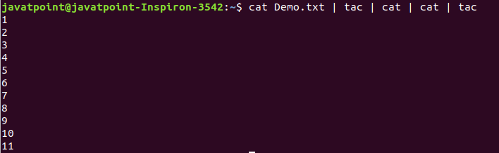

**23. cut Command**

The [cut](https://www.javatpoint.com/linux-cut) command is used to select a specific column of a file. The '-d' option is used as a delimiter, and it can be a space (' '), a slash (/), a hyphen (-), or anything else. And, the '-f' option is used to specify a column number.

**Syntax:**

1. cut -d(delimiter) -f(columnNumber) **<fileName>**

**Output:**

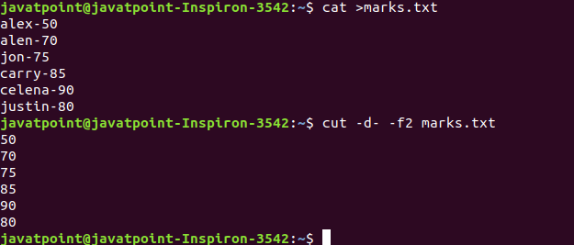

**24. grep Command**

The [grep](https://www.javatpoint.com/linux-grep) is the most powerful and used filter in a Linux system. The 'grep' stands for "**global regular expression print**." It is useful for searching the content from a file. Generally, it is used with the pipe.

**Syntax:**

1. command | grep **<searchWord>**

**Output:**

Linux Commands with Examples

**25. comm Command**

The ['comm'](https://www.javatpoint.com/linux-comm) command is used to compare two files or streams. By default, it displays three columns, first displays non-matching items of the first file, second indicates the non-matching item of the second file, and the third column displays the matching items of both files.

**Syntax:**

1. comm **<file1>** **<file2>**

**Output:**

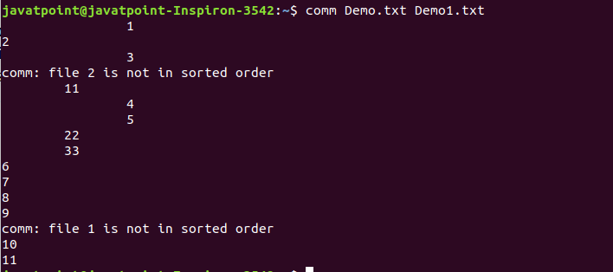

**26. sed command**

The [sed](https://www.javatpoint.com/linux-sed) command is also known as **stream editor**. It is used to edit files using a regular expression. It does not permanently edit files; instead, the edited content remains only on display. It does not affect the actual file.

**Syntax:**

1. command | sed 's/**<oldWord>**/**<newWord>**/'

**Output:**

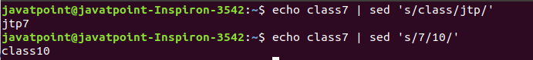

**27. tee command**

The [tee](https://www.javatpoint.com/linux-tee) command is quite similar to the cat command. The only difference between both filters is that it puts standard input on standard output and also write them into a file.

**Syntax:**

1. cat **<fileName>** | tee **<newFile>** |  cat or tac |.....

**Output:**

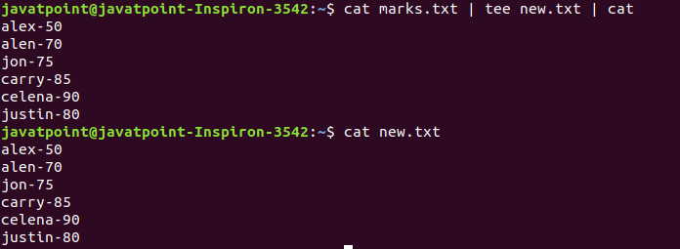

**28. tr Command**

The [tr](https://www.javatpoint.com/linux-tr) command is used to translate the file content like from lower case to upper case.

**Syntax:**

1. command | tr **<**'old'**>** **<**'new'**>**

**Output:**

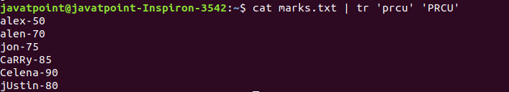

**29. uniq Command** :The [uniq](https://www.javatpoint.com/linux-uniq) command is used to form a sorted list in which every word will occur only once.

**Syntax:** command **<fileName>** | uniq

**Output:**

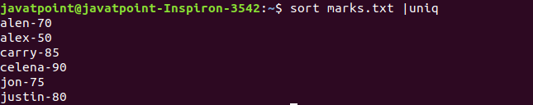

**30. wc Command** :The [wc](https://www.javatpoint.com/linux-wc) command is used to count the lines, words, and characters in a file.

**Syntax:** wc **<file** name**>**

**Output:**

Linux Commands with Examples

**31. od Command** :The [od](https://www.javatpoint.com/linux-od) command is used to display the content of a file in different s, such as hexadecimal, octal, and ASCII characters.

**Syntax:**

1. od -b **<fileName>**      // Octal format
2. od -t x1 **<fileName>**   // Hexa decimal format
3. od -c **<fileName>**     // ASCII character format

**Output:**

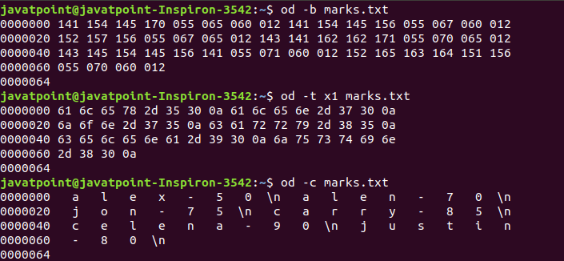

**32. sort Command** :The [sort](https://www.javatpoint.com/linux-sort) command is used to sort files in alphabetical order.

**Syntax:** sort **<file** name**>**

**Output:**

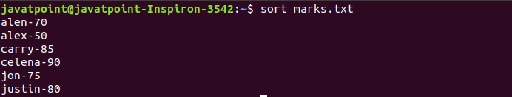

**33. gzip Command** : The [gzip](https://www.javatpoint.com/linux-gzip) command is used to truncate the file size. It is a compressing tool. It replaces the original file by the compressed file having '.gz' extension.

**Syntax :** gzip **<file1>** **<file2>** **<file3>**...

**Output:**

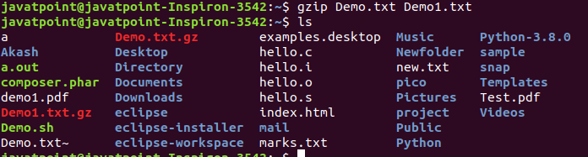

**34. gunzip Command** :The [gunzip](https://www.javatpoint.com/linux-gzip) command is used to decompress a file. It is a reverse operation of gzip command.

**Syntax:** gunzip **<file1>** **<file2>** **<file3>**. .

**Output:**

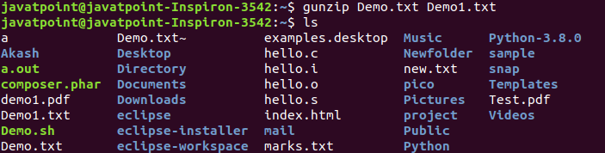

Linux Utility Commands

**35. find Command** : The [find](https://www.javatpoint.com/linux-find) command is used to find a particular file within a directory. It also supports various options to find a file such as byname, by type, by date, and more.

The following symbols are used after the find command:

(.) : For current directory name

(/) : For root

**Syntax:** find . -name "*.pdf"

**Output:**

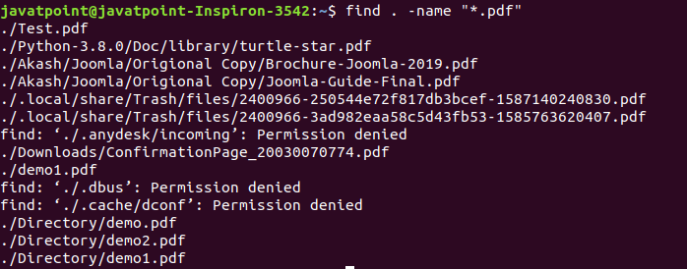

**36. locate Command** :The [locate](https://www.javatpoint.com/linux-locate) command is used to search a file by file name. It is quite similar to find command; the difference is that it is a background process. It searches the file in the database, whereas the find command searches in the file system. It is faster than the find command. To find the file with the locates command, keep your database updated.

**Syntax:** locate **<file** name**>**

**Output:**

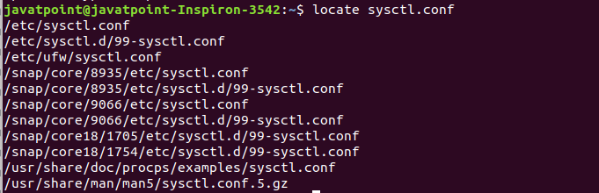

**37. date Command** :The [date](https://www.javatpoint.com/linux-date) command is used to display date, time, time zone, and more.

**Syntax:** date

**Output:**

Linux Commands with Examples

**38. cal Command** :The [cal](https://www.javatpoint.com/linux-cal) command is used to display the current month's calendar with the current date highlighted.

**Syntax:** cal**<**

**Output:**

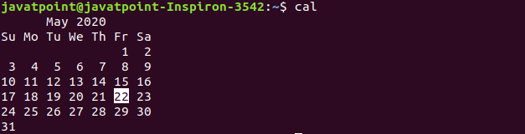

**39. sleep Command** : The [sleep](https://www.javatpoint.com/linux-sleep) command is used to hold the terminal by the specified amount of time. By default, it takes time in seconds.

**Syntax:** sleep **<time>**

**Output:**

Linux Commands with Examples

**40. time Command** : The [time](https://www.javatpoint.com/linux-time) command is used to display the time to execute a command.

**Syntax:** time

**Output:**

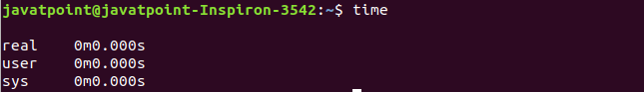

**41. zcat Command** : The zcat command is used to display the compressed files.

**Syntax:** zcat **<file** name**>**

**Output:**

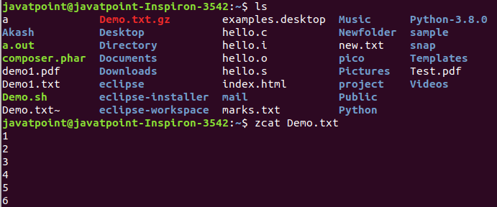

**42. df Command** : The [df](https://www.javatpoint.com/linux-df) command is used to display the disk space used in the file system. It displays the output as in the number of used blocks, available blocks, and the mounted directory.

**Syntax:** df

**Output:**

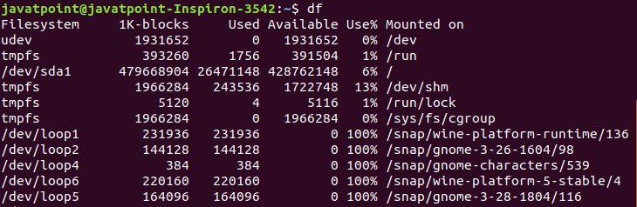

**43. mount Command** : The [mount](https://www.javatpoint.com/linux-mount) command is used to connect an external device file system to the system's file system.

**Syntax:** mount -t type **<device>** **<directory>**

**Output:**

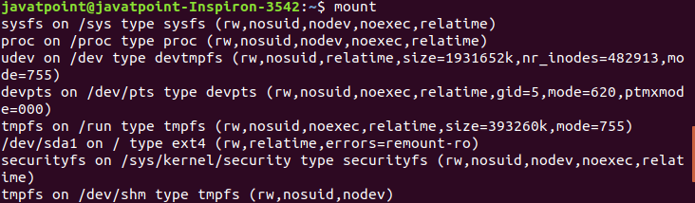

**44. exit Command** : Linux [exit](http://javatpoint.com/linux-exit-command) command is used to exit from the current shell. It takes a parameter as a number and exits the shell with a return of status number.

**Syntax:** exit

**Output:**

Linux Commands with Examples

After pressing the ENTER key, it will exit the terminal.

**45. clear Command** : Linux **clear** command is used to clear the terminal screen.

**Syntax:** clear

**Output:**

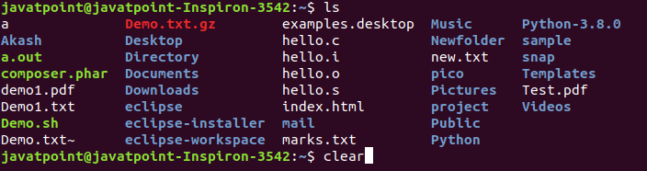

After pressing the ENTER key, it will clear the terminal screen.

Linux Networking Commands

**46. ip Command** : Linux [ip](https://www.javatpoint.com/linux-ip) command is an updated version of the ipconfig command. It is used to assign an IP address, initialize an interface, disable an interface.

**Syntax:** ip a or ip addr

**Output:**

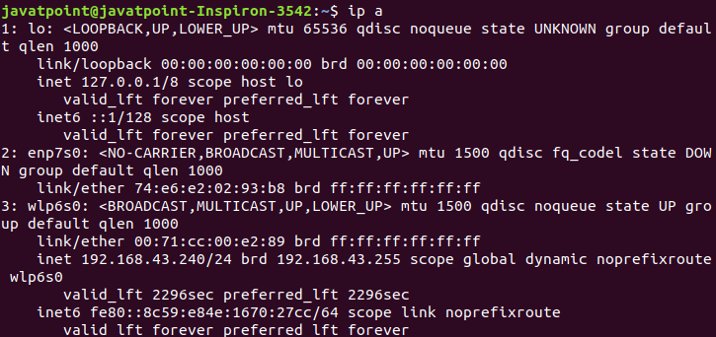

**47. ssh Command** : Linux [ssh](https://www.javatpoint.com/ssh-linux) command is used to create a remote connection through the ssh protocol.

**Syntax:** ssh user_name@host(IP/Domain_name)**</p>**

**48. mail Command** : The [mail](https://www.javatpoint.com/linux-mail-command) command is used to send emails from the command line.

**Syntax:** mail -s "Subject" **<recipient** address**>**

**Output:**



**49. ping Command** : The [ping](https://www.javatpoint.com/linux-ping) command is used to check the connectivity between two nodes, that is whether the server is connected. It is a short form of "Packet Internet Groper."

**Syntax:** ping **<destination>**

**Output:**

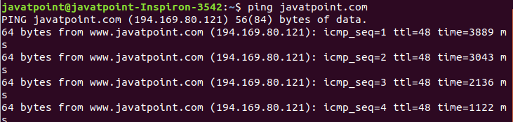

**50. host Command**

The [host](https://www.javatpoint.com/linux-host) command is used to display the IP address for a given domain name and vice versa. It performs the DNS lookups for the DNS Query.

**Syntax:** host **<domain** name**>** or **<ip** address**>**

**Output:**

Linux Commands with Examples

### MAVEN:

* **mvn compile:** This command is used to compile the project’s source code.
* **mvn clean:** Here, the project is cleaned to remove all previous-build files generated.
* **mvn test:** With this command, one can run project testing steps.
* **mvn test-compile:** This command is used to compile the code from the test source.
* **mvn install:** This command helps deploys the packaged WAR/JAR files storing them as classes in the local repository.
* **mvn package:** With this Maven lifecycle command, one packages or creates a project WAR or JAR file to be able to use a distributable format.
* **mvn deploy:** The deploy command occurs after compilation, running project tests and project building. Here the packaged WAR/JAR files are copied to the remote repository for use by other developers
* **mvn compiler:compile :** This command compiles the java source classes of the maven project.
* **mvn compiler:testCompile :** This command compiles the test classes of the maven project.
* **mvn validate :** This command validates the maven project that everything is correct and all the necessary information is available.
* **mvn dependency:tree** : This command generates the dependency tree of the maven project.
* **mvn dependency:analyse** : This command analyzes the maven project to identify the unused declared and used undeclared dependencies. It’s useful in reducing the build size by identifying the unused dependencies and then remove it from the pom.xml file.
* **mvn archetype:generate :** Maven archetypes is a maven project templating toolkit. We can use this command to generate a skeleton maven project of different types, such as JAR, web application, maven site, etc.
* **mvn site:site :** This command generates a site for the project. You will notice a “site” directory in the target after executing this command. There will be multiple HTML files inside the site directory that provides information related to the project.
* **mvn verify :** This command build the project, runs all the test cases and run any checks on the results of the integration tests to ensure quality criteria are met.
* **mvn -f maven-example-jar/pom.xml package :** This command is used to build a project from a different location. We are providing the pom.xml file location to build the project. It’s useful when you have to run a maven build from a script.
* **mvn -o package :** This command is used to run the maven build in the offline mode. It’s useful when we have all the required JARs download in the local repository and we don’t want Maven to look for any JARs in the remote repository.
* **mvn -q package :** Runs the maven build in the quiet mode, only the test cases results and errors are displayed
* **mvn -X package** : Prints the maven version and runs the build in the debug mode. It’s opposite of the quiet mode and you will see a lot of debug messages in the console.
* **mvn –v :** Used to display the maven version information.
* **mvn -V package :** This command prints the maven version and then continue with the build. It’s equivalent to the commands mvn -v;mvn package
* **mvn -DskipTests package :** The skipTests system property is used to skip the unit test cases from the build cycle. We can also use -Dmaven.test.skip=true to skip the test cases execution.
* mvn -T 4 package : This command tells maven to run parallel builds using the specified thread count. It’s useful in multiple module projects where modules can be built in parallel. It can reduce the build time of the project.

### Docker CMD’s:

**$ sudo docker info                        —  shows docker status and configuration  
$ sudo docker ps                              — show docker containers  
$ sudo docker ps -l                                — show “latest” docker container -l = lower case L  
$ sudo docker ps -a                               — show “all” docker container; even those not running  
$ sudo docker images                            — show docker images (and tags)  
$ sudo docker run -it <container> <app> — connect / login to work interactively on container  
$ systemctl status docker                     — show status and log for docker  <CTRL-C> to exit  
# sudo systemctl enable docker          — enable docker <not usually needed> using system control  
# sudo systemctl start docker             —  start docker <if it was stopped>  
$ sudo service docker stop                  — Stop docker service  
$ sudo service docker start                 — Start docker service  
$ sudo service docker restart              — restart docker service  
$ sudo usermod -aG docker <AdminUser> — Add the <AdminUser> to Linux Authorized users for docker replace <AdminUser> with your username must log out and log back in for it to take affect**