# **SCM (Source Configuration Management) or VCS(Version Control System)**

## GIT

[Git Tutorial | Why do we need Git? | Applications of GIT (educba.com)](https://www.educba.com/software-development/software-development-tutorials/git-tutorial/)

[Github Tutorial | A Quick glance of Self Guide to Learn Github (educba.com)](https://www.educba.com/software-development/software-development-tutorials/github-tutorial/)

[Git Tutorial (tutorialspoint.com)](https://www.tutorialspoint.com/git/index.htm)

GIT:

Git is a distributed version control system (DVCS) tool that supports distributed non-linear workflows by providing data assurance for developing quality software.

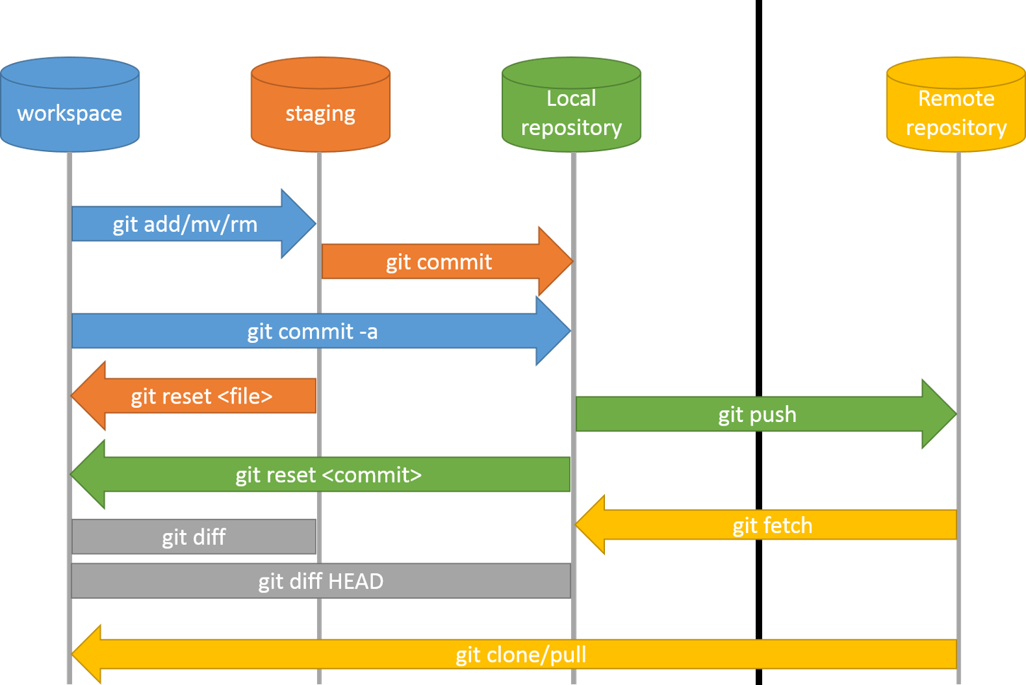

Git – version control system

Git 🡪 software, Github 🡪 Server

git hash-object –stdin –w 🡪 Creates a new dir 🡪 hash =folder + file name

Hash 🡪 hexadecimal value (40 char)

Git object structure 🡪 content + obj type + length =hash

.git -🡪 Objects 🡪 blog, tree, commit, annotate tier

4 type of objects

blog, tree, commit, annotate tier

blog:

git cat file –p <Hashvalue>

-s 🡪 size

-t 🡪 type

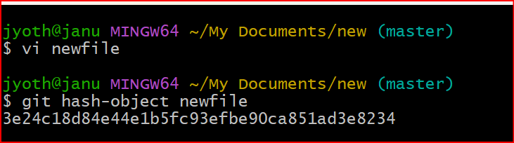

To check any files in staging use

Git ls-files –s

To move tree to staging area

Git read-tree <SHA>

To move tree to Working dir

Git checkout-index –a (index=staging)

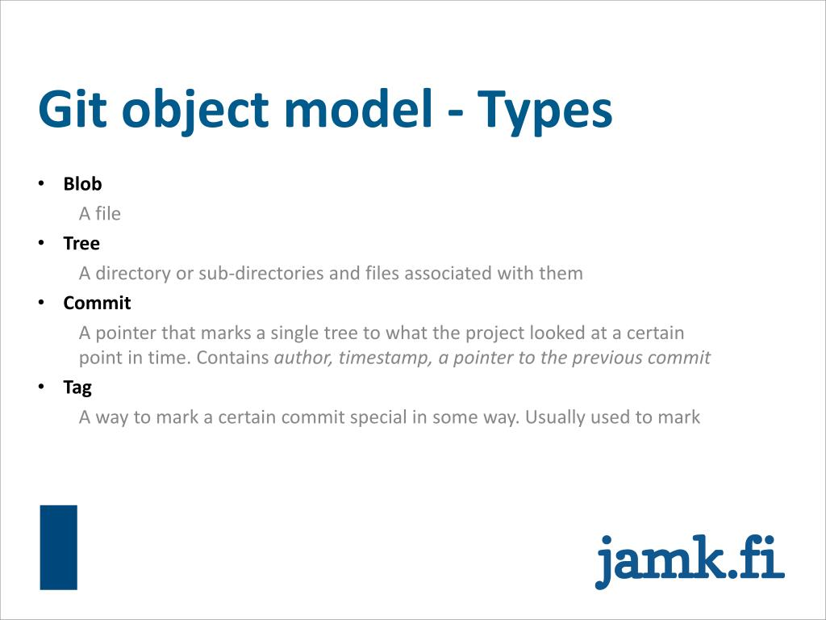

SCM 🡪 Source code management (or) Software configuration management

SCM or VCS is divided into 2 types. There are

1. CVCS 🡪 Centralized version control system 🡪 SVN
2. DVCS 🡪 Distributed version control system 🡪 Git, GIthub, BitBucket etc

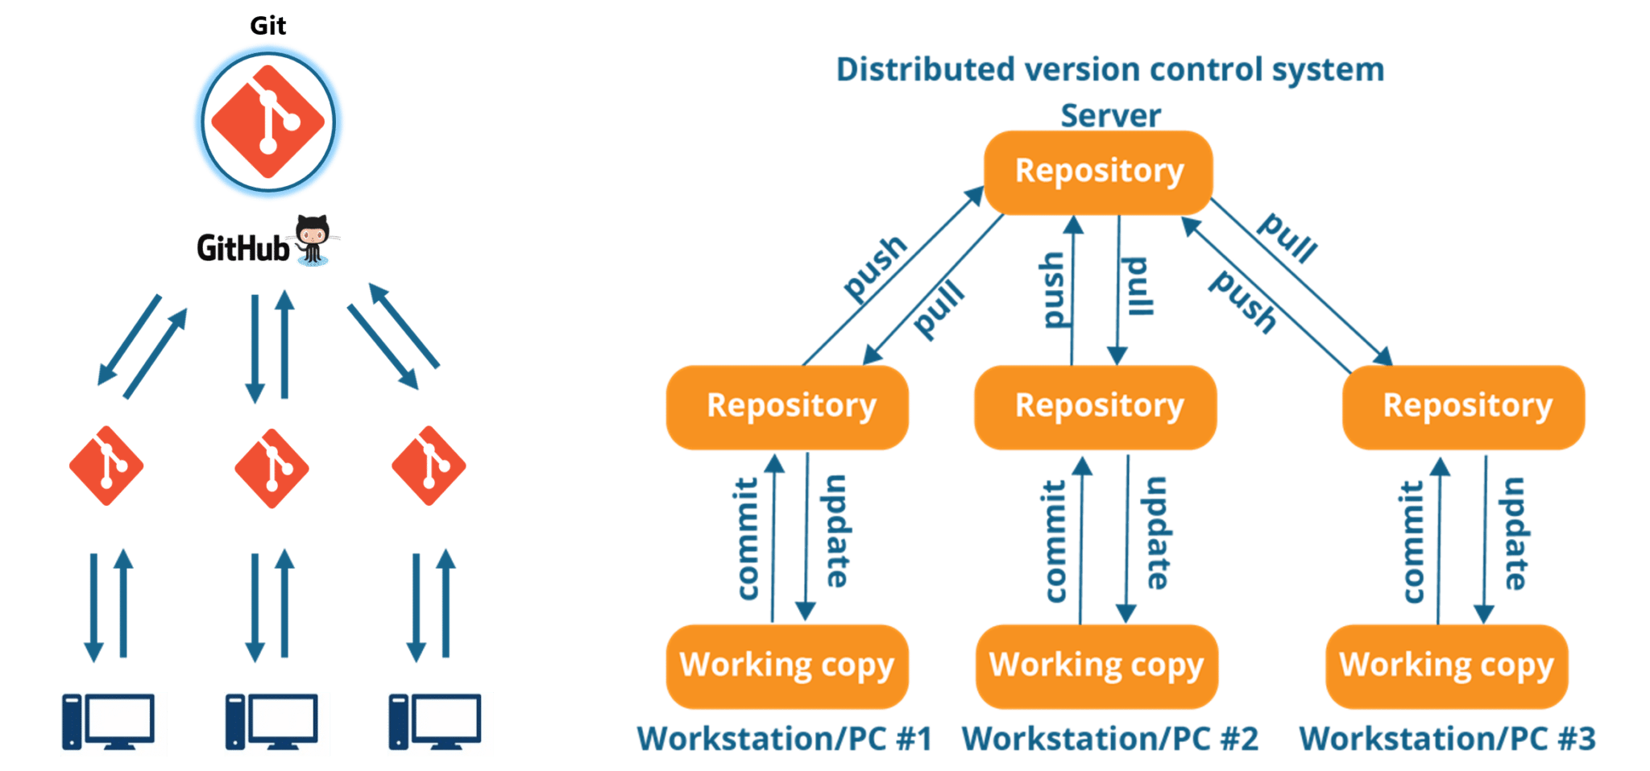

Life cycle or workflow of Git:

**Step 1** − You modify a file from the working directory.

**Step 2** − You add these files to the staging area.

Git add filename (or) git add . [. Will add all files in the dir]

**Step 3** − You perform commit operation that moves the files from the staging area. After push operation, it stores the changes permanently to the Git repository.

Git commit –m “message or comment”

Multiline commit message:

Git commit –m

Above command open in editior so we can add multi-line commit message

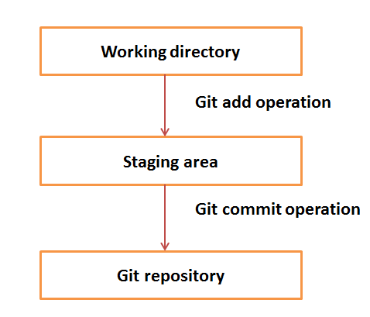

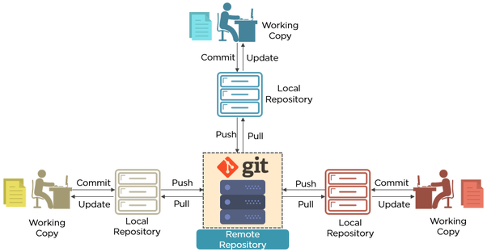

GIT commands:

### **1. Git configuration**

* **Git config**

Get and set configuration variables that control all facets of how Git looks and operates.

**Set the name:**

$ git config --global user.name "User name"

**Set the email:**

$ git config --global user.email "your github e-mail"

**Set the default editor:**

$ git config --global core.editor Vim

**Check the setting:**

$ git config –list

* **Git alias**

**Set up an alias** for each command:

$ git config --global alias.co checkout

$ git config --global alias.br branch

$ git config --global alias.ci commit

$ git config --global alias.st status

### **2. Starting a project**

* **Git init**

**Create a local repository:**

$ git init

* **Git clone**

**Make a local copy** of the server repository.  
$ git clone

### **3. Local changes**

* **Git add**  
  **Add a file** to staging (Index) area:  
  $ git add Filename
* **Add all files** of a repo to staging (Index) area:  
  $ git add*
* **Gitcommit**  
  **Record** or snapshots the file permanently in the version history **with a message**.  
  $ git commit -m " Commit Message"

### **4. Track changes**

* **Git diff**

Track the changes that have not been staged: $ git diff

Track the changes that have staged but not committed:

$ git diff –staged

Track the changes after committing a file:

$ git diff HEAD

Track the changes between two commits:

$ git diff Git Diff Branches:

$ git diff < branch 2>

* **Git status**

Display the state of the working directory and the staging area.  
$ git status

* **Git show Shows objects:**

$ git show

### **5. Commit History**

* **Git log**

Display the most recent commits and the status of the head:

$ git log

Display the output as one commit per line:

$ git log –oneline

Displays the files that have been modified:

$ git log –stat

Display the modified files with location:

$ git log –p

To check only specific logs

$git log -3

Shows the full details of logs

$git reflog

* **Git blame**

Display the modification on each line of a file:

$ git blame <file name>

### **6. Ignoring files**

* **.gitignore**

Specify intentionally untracked files that Git should ignore. Create .gitignore:

$ touch .gitignore List the ignored files:

$ git ls-files -i --exclude-standard

### **7. Branching**

* **Git branch Create branch:**

To know on which branch you are working

$ git branch

List Branch:

$ git branch --list

Delete a Branch:

$ git branch -d <branch name>

Delete a remote Branch:

$ git push origin -delete

Rename Branch:

$ git branch -m

* **Git checkout**

Switch between branches in a repository.  
Switch to a particular branch:

$ git checkout

Create a new branch and switch to it:

$ git checkout –b

Checkout a Remote branch:

$ git checkout

* **Git stash**

Switch branches without committing the current branch. Stash current work:

$ git stash

Saving stashes with a message:

$ git stash save ""

Check the stored stashes:

$ git stash list

Re-apply the changes that you just stashed:

$ git stash apply

Track the stashes and their changes:

$ git stash show

Re-apply the previous commits:

$ git stash pop

Delete a most recent stash from the queue:

$ git stash drop

Delete all the available stashes at once:

$ git stash clear

Stash work on a separate branch:

$ git stash branch

* **Git cherry pic**

Apply the changes introduced by some existing commit:

$ git cherry-pick

### **8. Merging**

* **Git merge**

Merge the branches:

$ git merge

Merge the specified commit to currently active branch:

$ git merge

* **Git rebase**

Apply a sequence of commits from distinct branches into a final commit.

$ git rebase

Continue the rebasing process:

$ git rebase -continue Abort the rebasing process:

$ git rebase –skip

* **Git interactive rebase**

Allow various operations like edit, rewrite, reorder, and more on existing commits.

$ git rebase –i

### **9. Remote**

* **Git remote**  
  Check the configuration of the remote server:

$ git remote –v

Add a remote for the repository:

$ git remote add

Fetch the data from the remote server:

$ git fetch

Remove a remote connection from the repository:

$ git remote rm

Rename remote server:

$ git remote rename

Show additional information about a particular remote:

$ git remote show

Change remote:

$ git remote set-url

* **Git origin master**

Push data to the remote server:  
$ git push origin master

Pull data from remote server:  
$ git pull origin master

### **10. Pushing Updates**

* **Git push**

Transfer the commits from your local repository to a remote server. Push data to the remote server:  
$ git push origin master

Force push data:  
$ git push –f

Delete a remote branch by push command:  
$ git push origin -delete edited

### **11. Pulling updates**

* **Git pull**

Pull the data from the server:

$ git pull origin master

Pull a remote branch:

$ git pull

* **Git fetch**

Download branches and tags from one or more repositories. Fetch the remote repository:

$ git fetch< repository Url>

Fetch a specific branch:  
$ git fetch

Fetch all the branches simultaneously:  
$ git fetch –all

Synchronize the local repository:  
$ git fetch origin

### **12. Undo changes**

* **Git revert**

Undo the changes:  
$ git revert

Revert a particular commit:  
$ git revert

* **Git reset**

Reset the changes:  
$ git reset -hard  
$ git reset -soft:  
$ git reset –mixed

### **13. Removing files**

* **Git rm**

Remove the files from the working tree and from the index:  
$ git rm <file Name>

Remove files from the Git But keep the files in your local repository:  
$ git rm --cached