SCM (Source Configuration Management) or VCS(Version Control System)

GIT

Git Tutorial | Why do we need Git? | Applications of GIT (educba.com)
Github Tutorial | A Quick glance of Self Guide to Learn Github (educba.com)
Git Tutorial (tutorialspoint.com)

GIT:
Git is a distributed version control system (DVCS) tool that supports distributed non-linear workflows by providing data assurance for developing quality software.
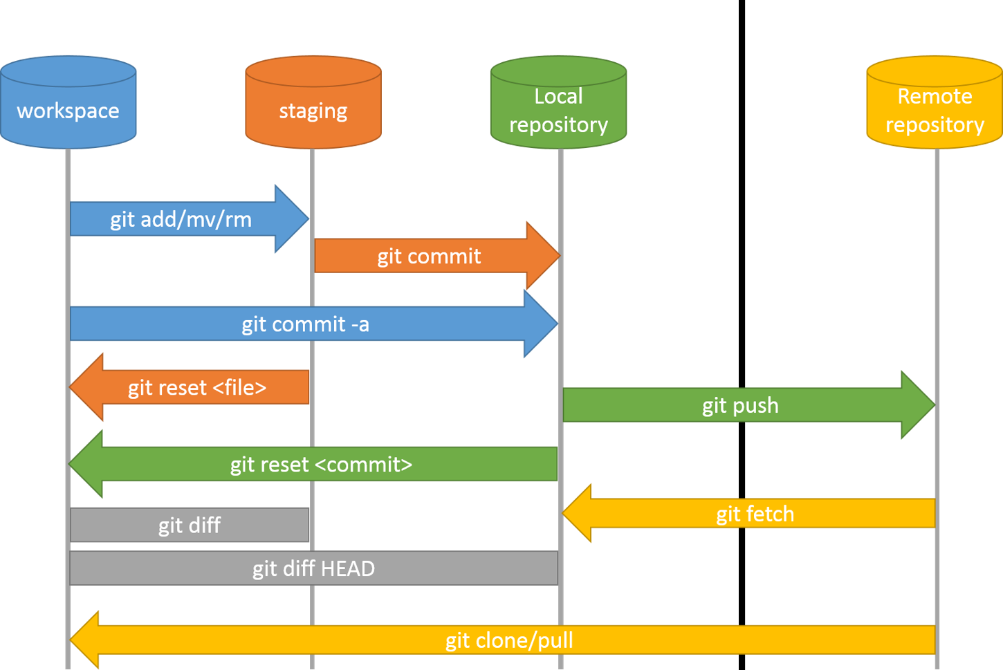

Git – version control system
Git software, Github Server
git hash-object –stdin –w Creates a new dir hash =folder + file name
Hash hexadecimal value (40 char)
Git object structure content + obj type + length =hash
.git - Objects blog, tree, commit, annotate tier
4 type of objects
blog, tree, commit, annotate tier
blog:
git cat file –p <Hashvalue>
-s size
-t type

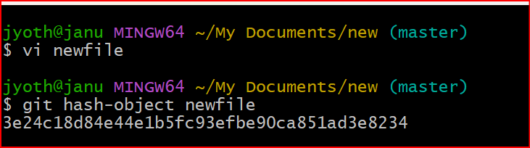
To check any files in staging use
Git ls-files –s
To move tree to staging area
Git read-tree <SHA>
To move tree to Working dir
Git checkout-index –a (index=staging)

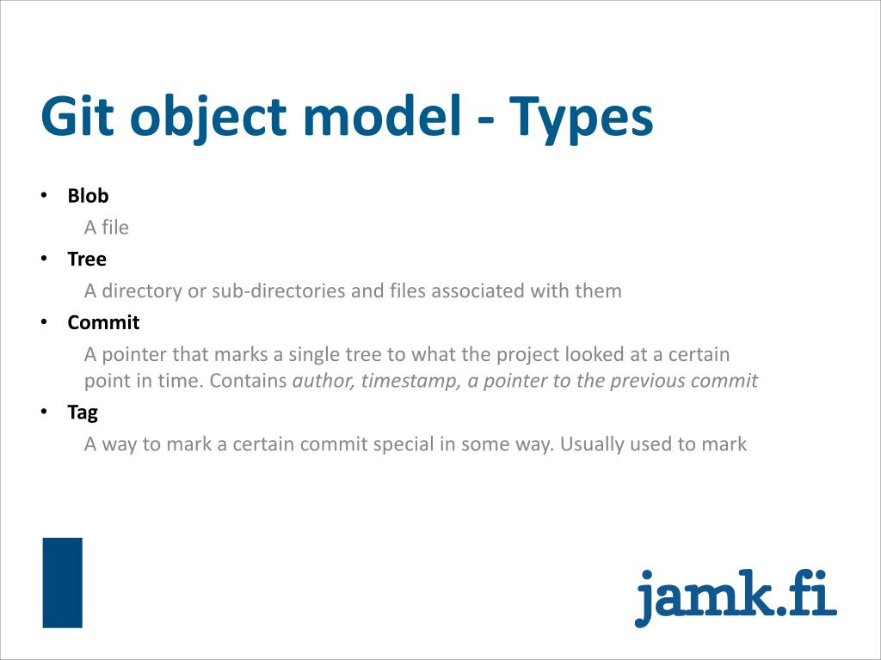

SCM Source code management (or) Software configuration management
SCM or VCS is divided into 2 types. There are
- CVCS Centralized version control system SVN
- DVCS Distributed version control system Git, GIthub, BitBucket etc
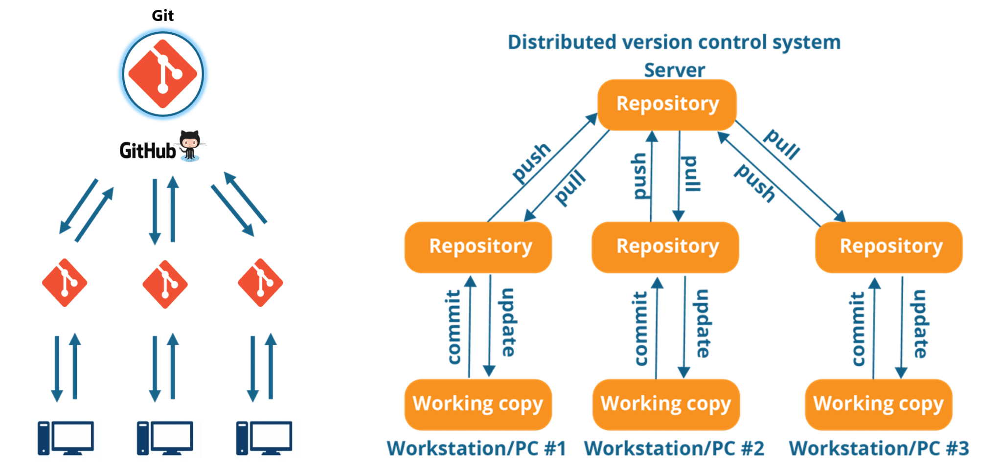

Life cycle or workflow of Git:
Step 1 − You modify a file from the working directory.
Step 2 − You add these files to the staging area.
Git add filename (or) git add . [. Will add all files in the dir]
Step 3 − You perform commit operation that moves the files from the staging area. After push operation, it stores the changes permanently to the Git repository.
Git commit –m “message or comment”
Multiline commit message:
Git commit –m
Above command open in editior so we can add multi-line commit message
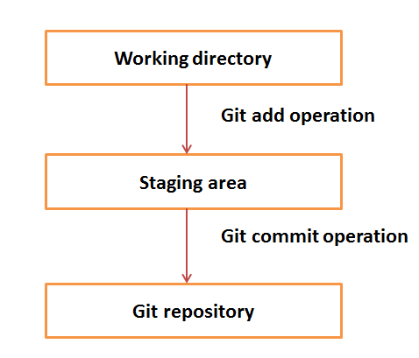

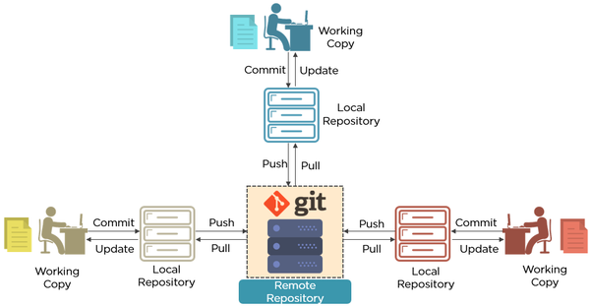

GIT commands:

1. Git configuration

- Git config
Get and set configuration variables that control all facets of how Git looks and operates.
Set the name:
$ git config --global user.name "User name"
Set the email:
$ git config --global user.email "your github e-mail"
Set the default editor:
$ git config --global core.editor Vim
Check the setting:
$ git config –list

- Git alias
Set up an alias for each command:
$ git config --global alias.co checkout
$ git config --global alias.br branch
$ git config --global alias.ci commit
$ git config --global alias.st status

2. Starting a project

- Git init
Create a local repository:
$ git init

- Git clone
Make a local copy of the server repository.
$ git clone

3. Local changes
- Git add
Add a file to staging (Index) area:
$ git add Filename
- Add all files of a repo to staging (Index) area:
$ git add*
- Gitcommit
Record or snapshots the file permanently in the version history with a message.
$ git commit -m " Commit Message"

4. Track changes
- Git diff
Track the changes that have not been staged: $ git diff
Track the changes that have staged but not committed:
$ git diff –staged
Track the changes after committing a file:
$ git diff HEAD
Track the changes between two commits:
$ git diff Git Diff Branches:
$ git diff < branch 2>

- Git status
Display the state of the working directory and the staging area.
$ git status

- Git show Shows objects:
$ git show

5. Commit History
- Git log
Display the most recent commits and the status of the head:
$ git log
Display the output as one commit per line:
$ git log –oneline
Displays the files that have been modified:
$ git log –stat
Display the modified files with location:
$ git log –p
To check only specific logs
$git log -3
Shows the full details of logs
$git reflog

- Git blame
Display the modification on each line of a file:
$ git blame <file name>

6. Ignoring files

- .gitignore
Specify intentionally untracked files that Git should ignore. Create .gitignore:
$ touch .gitignore List the ignored files:
$ git ls-files -i --exclude-standard

7. Branching
- Git branch Create branch:
To know on which branch you are working
$ git branch
List Branch:
$ git branch --list
Delete a Branch:
$ git branch -d <branch name>
Delete a remote Branch:
$ git push origin -delete
Rename Branch:
$ git branch -m

- Git checkout
Switch between branches in a repository.
Switch to a particular branch:
$ git checkout
Create a new branch and switch to it:
$ git checkout –b
Checkout a Remote branch:
$ git checkout

- Git stash
Switch branches without committing the current branch. Stash current work:
$ git stash
Saving stashes with a message:
$ git stash save ""
Check the stored stashes:
$ git stash list
Re-apply the changes that you just stashed:
$ git stash apply
Track the stashes and their changes:
$ git stash show
Re-apply the previous commits:
$ git stash pop
Delete a most recent stash from the queue:
$ git stash drop
Delete all the available stashes at once:
$ git stash clear
Stash work on a separate branch:
$ git stash branch

- Git cherry pic
Apply the changes introduced by some existing commit:
$ git cherry-pick

8. Merging
- Git merge
Merge the branches:
$ git merge
Merge the specified commit to currently active branch:
$ git merge
- Git rebase
Apply a sequence of commits from distinct branches into a final commit.
$ git rebase
Continue the rebasing process:
$ git rebase -continue Abort the rebasing process:
$ git rebase –skip
- Git interactive rebase
Allow various operations like edit, rewrite, reorder, and more on existing commits.
$ git rebase –i

9. Remote

- Git remote
Check the configuration of the remote server:
$ git remote –v
Add a remote for the repository:
$ git remote add
Fetch the data from the remote server:
$ git fetch
Remove a remote connection from the repository:
$ git remote rm
Rename remote server:
$ git remote rename
Show additional information about a particular remote:
$ git remote show
Change remote:
$ git remote set-url
- Git origin master
Push data to the remote server:
$ git push origin master
Pull data from remote server:
$ git pull origin master

10. Pushing Updates

- Git push
Transfer the commits from your local repository to a remote server. Push data to the remote server:
$ git push origin master
Force push data:
$ git push –f
Delete a remote branch by push command:
$ git push origin -delete edited

11. Pulling updates

- Git pull
Pull the data from the server:
$ git pull origin master
Pull a remote branch:
$ git pull
- Git fetch
Download branches and tags from one or more repositories. Fetch the remote repository:
$ git fetch< repository Url>
Fetch a specific branch:
$ git fetch
Fetch all the branches simultaneously:
$ git fetch –all
Synchronize the local repository:
$ git fetch origin

12. Undo changes

- Git revert
Undo the changes:
$ git revert
Revert a particular commit:
$ git revert
- Git reset
Reset the changes:
$ git reset -hard
$ git reset -soft:
$ git reset –mixed

13. Removing files

- Git rm
Remove the files from the working tree and from the index:
$ git rm <file Name>
Remove files from the Git But keep the files in your local repository:
$ git rm --cached

