WAALAF PROPERTY LOGO
FIRST VERSION FRENCH AND ENGLISH. THIS WEBSITE WILL WORK IN SENEGAL IS FRENCH LANGUAGE SPOKEN
About -Apartments – Houses – Offices – Shops –Land – Industrial – Contact us
- PLEASE PUT MAPS OF SENEGAL 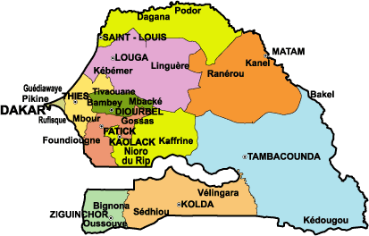
- OPTION TO GET MORE FILTRE LIKE www.24property.com
- SENEGAL HAVE 14 PROVINCES WILL SHOW THE IN THE MAPS . THE CAPITAL IS (DAKAR)
- OPTION TO SEARCH BY PROVINCE AND ZONE OR CITIES EXAPMLE UNDER THE CAPITAL CITY OF DAKAR WE HAVE LIST OF THE ZONE LIKE
- LOCATION FOR NOW WILL PUT THIS
DAKAR PROVINCES
- Dakar CENTRE
- Almadies
- North foire
- West foire
- EAST FOIRE
- Mermoz
- Mamelles
- Ngor
- Guediawaye
- Rufisque
- Pikine
- Medina
- Sicap
- Parcelles
- Virage
- Patte doie
- Thiaroye
- Hann
- Hlm
- Clobane
- POSSIBLITY TO ADD MORE

- ON THE HOME PAGE PUT WEBMAIL LINK PEOLE CAN LOGIN GO
WEBMAIL LINK
TRUE TO WAALAF WEBMAIL
- MORE ESPACES FOR ADVERTISES
- APPLICATION FORM FOR SOMEONE NEED ASSISTANT TO HELP HIM LOOKING PARTNERS WHO DEVELOP HIS LAN OR SALES HIS LAND OR HOUSE OR APPARTMENT OR COMMERCIAL PROPERTY HE WILL FEEL THE FORM AND SEND US ALL DETAILS.

address: LOT NO: 380 C NGOR ALMADIES
POSTAL CODE 12500
DAKAR SENEGAL
EMAIL: info@waalafproperty.com / tel :L +221 77 479 81 60 / +221 78 428 0507

- About Us

- Contact Us

- Feedback

- Join Our Team

- Terms & Conditions

- Sitemap

- Agent Zone
HELP
OUR PARNERS PAGES
A PAGE FOR LOST AND FOUND

