KS2 Maths: Test Practice Questions
Topic: Measures
Subtopic: Mass

Q1
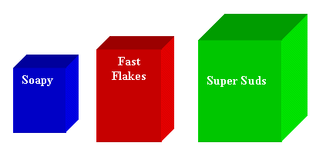
This table shows the weights of some boxes of soap powder.
Complete the table.

 | Grams | Kilograms
Soapy | 500
Fast Flakes | 1500 | 1.5
Super Suds |  | 2

............................................................................................................................................
............................................................................................................................................
(2)
Q2 Sue buys 20 packets of biscuits. Each packet weighs 150g.

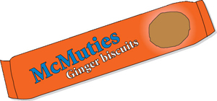

How many kilograms of biscuits does Sue buy?

............................................................................................................................................
............................................................................................................................................
(2)

Q 3 a) Fill in the table for the weights of the elephants.

Elephant | Tonnes | Kilograms
Tom | 2.3
Suzy |  | 3000
Sam |  | 500
Amy | 2.6

............................................................................................................................................
............................................................................................................................................
............................................................................................................................................
............................................................................................................................................
(4)

b) Place the elephants in order of size with the largest first.

............................................................................................................................................
(1)
KS2 Maths: Test Practice Questions & Answers
Topic: Measures
Subtopic: Mass

Q1
This table shows the weights of some boxes of soap powder.
Complete the table.

 | Grams | Kilograms
Soapy | 500 | 0.5 (= 1 mark)
Fast Flakes | 1500 | 1.5
Super Suds | 2000 (= 1 mark) | 2


Q2 Sue buys 20 packets of biscuits. Each packet weighs 150g.

How many kilograms of biscuits does Sue buy?
1 packet of biscuits weighs 150g
20 packets = 150g x 20 = 3000g (= 1 mark)
= 3kg (= 1 mark)
Q 3 a) Fill in the table for the weights of the elephants.

Elephant | Tonnes | Kilograms
Tom | 2.3 | 2300 (= 1 mark)
Suzy | 3 (= 1 mark) | 3000
Sam | 0.5 (= 1 mark) | 500
Amy | 2.6 | 2600 (= 1 mark)

b) Place the elephants in order of size with the largest first.
1. Suzy
2. Amy
3. Tom
4. Sam
All correct (= 1 mark)

