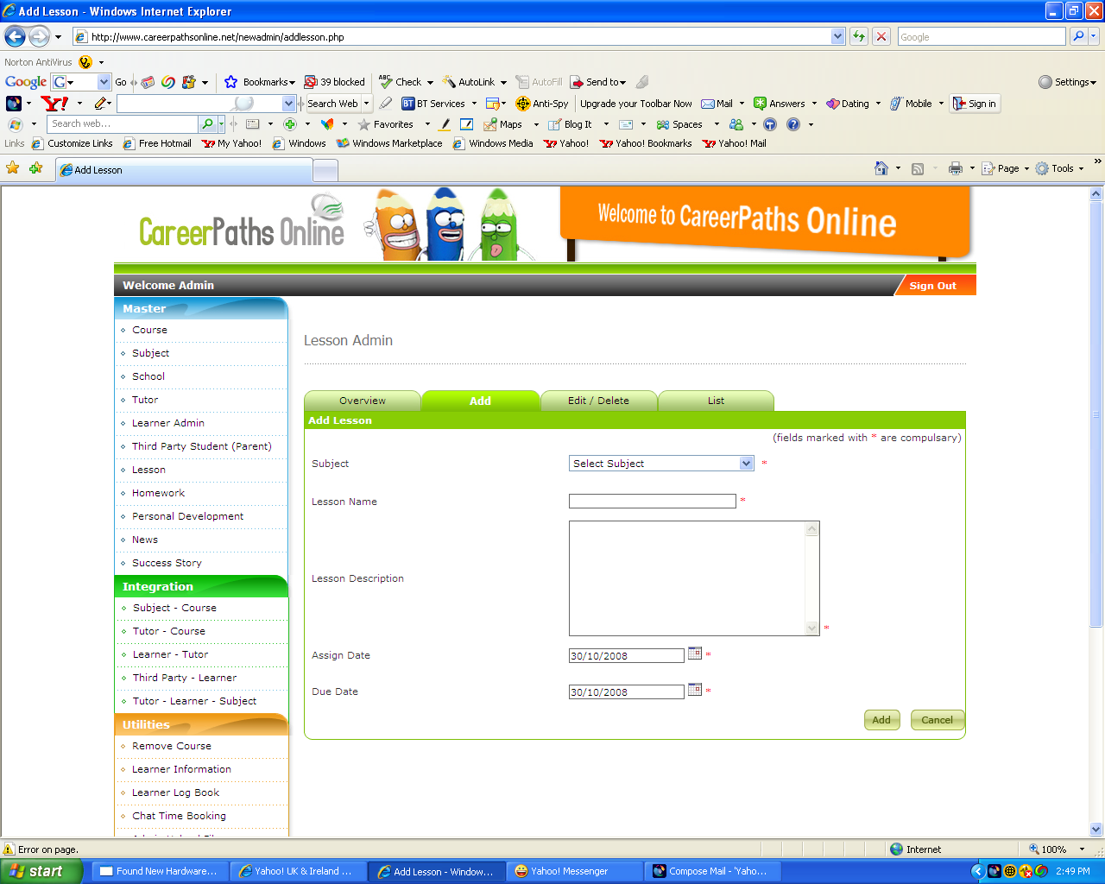

The assign and date due calendar is not working.

Please fix as soon as possible,

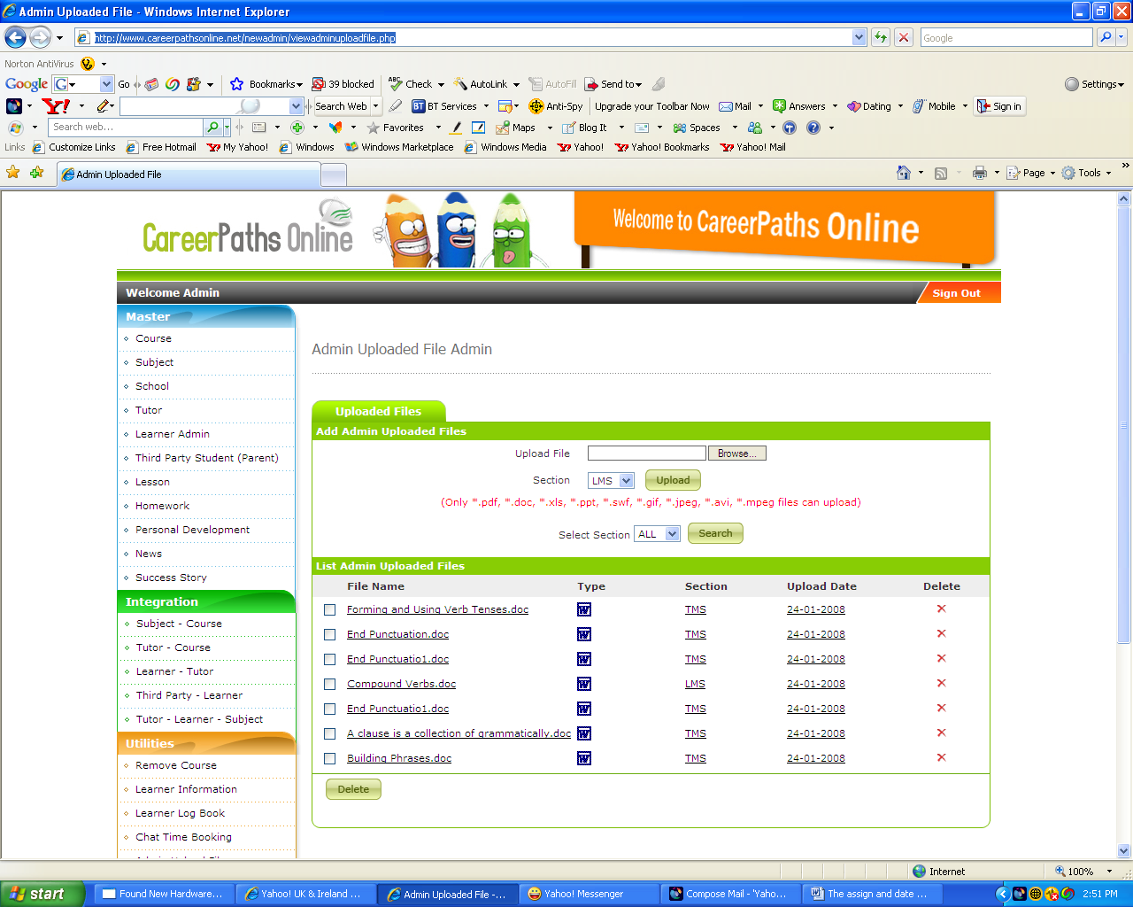

I am unable to UP Load Documents

