Interest Overlap Report Tool

Documented by: Mike MacRae – April 10, 2014

Updated: Robert Ehlert - May 16, 2017

**Intended use:** This tool will run an overlap report to determine if different land use types (layers) overlap an area of interest as determined by the user.

**System Requirements**

* Access to government Desktop Terminal Services (DTS GIS access)
* ArcInfo license
* Read access to: Database Connections\MEMPRD.sde

Database Connections\BCGW.sde (Check for access on Warehouse Archaeology data. A separate request may be required to view the data)

* Read/Write access to: \\spatialfiles.bcgov\Work\em\vic\mtb
* Access to the following python modules: win32com.client, ntpath, arcpy, time

**Location of Files**

* Tool location:

\\spatialfiles.bcgov\Work\em\vic\mtb\Local\ArcGIS_Tools\MTB_Tools\Reporting_Tools\Interest_Overlap_Report\Script\Interest_Overlap_Report_v3-1-0

* Master Layer File Excel Spreadsheet:   
  \\spatialfiles.bcgov\Work\em\vic\mtb\Local\ArcGIS_Tools\MTB_Tools\Reporting_Tools\Interest_Overlap_Report\Excel_Spreadsheets\InterestReport_Layer_List_MASTER.xls
* \\spatialfiles.bcgov\Work\em\vic\mtb\Local\ArcGIS_Tools\MTB_Tools\Reporting_Tools\Interest_Overlap_Report\ScratchGDB

**Known Limitations**

* Input:
  + Area of Interest Input must be a polygon file (it does not support line or point features at this time). If using a line or point file, create buffer of the feature and use the buffer polygon as the input.
  + Report will on run on one feature in the Area of Interest input polygon file. If it contains multiple features, you must query to one individual feature using the SQL Query dialogue
  + For any files used as input, review the projection. KMZ files will need to be re-projected after being converted to feature class in order to get area.
  + It is recommended to use feature classes as opposed to shapefiles for input file. If an error occurs while running a shapefile, export to a geodatabase and try re-running.
* Printing:
  + Printing will need to be on 8.5X11 landscape orientation. You may have to adjust some columns widths to fit to the printable area. Make use of text wrapping in cells
  + Printing in black and white makes the legend colors to appear the same shade of grey.
* Running:
* Errors:

1. Report may error out if your ArcCatalogue/Map session has timed out. restart your Arc product and rerun.
2. If any error is encountered, try:
3. Closing all ArcGIS products and ensure all ArcGIS processes have been killed via Task manager. Restarter ArcMap and rerun. If error still exists;
4. Close DTA session and restart. Try running tool again.

Please report bugs including screen grabs to: [Michael.MacRae@gov.bc.ca](mailto:Michael.MacRae@gov.bc.ca)

**Procedures**

*Updating the Layer Spreadsheet*

The Layer Spreadsheet is a configuration file used to add/remove/update layers used in the tool.

1. Navigate to the spreadsheet location: \\spatialfiles.bcgov\Work\em\vic\mtb\Local\ArcGIS_Tools\MTB_Tools\Reporting_Tools\Interest_Overlap_Report\Excel_Spreadsheets
2. You will find 2 spreadsheet you will have to update. One is for layers sourced to MEMPRD (IOR default) and one that sources layers to BCGW. They are identical except the workspace_path for MTB layers will point to MEMPRD in one spreadsheet and BCGW in the other.
3. Before you open either spreadsheet, right click on the .xls🡪properties🡪General tab and uncheck ‘Read Only’.
   * **Note:** remember to set each spreadsheet to ‘Read Only’ after you have made your edits.
4. Open each spreadsheet:
   * InterestReport_Layer_List_MASTER.xls
   * InterestReport_Layer_List_MASTER_BCGW_Data.xls
5. Activate sheet name 'MineralTitles Dataset selection$'
6. Update the list by adding a layer, removing a layer or edit existing layers.
   1. Remove layers by removing the whole row in the spreadsheet
   2. Adding/editing layers in the spreadsheet:

|  |  |
| --- | --- |
| **Category** | Find an existing category to fit a new layer into and update this field |
| **Featureclass_Name** | The name as it appears in the report. Please be descriptive. Do not use underscores in place of spaces |
| **workspace_path** | Workspace path to the underlying feature class or shapefile as seen in ArcCatalogue* |
| **Layer_File** | A layer file used to symbolize the dataset if used in a map |
| **dataSource** | The featureclass or shapefile name as seen in the geodatabase or folder location* |
| **shapeType** | Optional: Enter Point, Line or Polygon |
| **Join_Table** | If a join table is required, provide the **datasource** name* |
| **dataSource_Join_Field** | Provide the field from the **dataSource** feature class or shapefile*** |
| **Join_Table_Field** | Provide the associated join field from the **Join_Table**\*\*\* |
| **Definition_Query** | Build a definition query and test it to make sure it works. Copy and Paste the query into this field** |
| **Buffer_Distance** | Optional: Provide a buffer distance |
| **Fields_to_Summarize** | Provide a field to summarize*** |
| **Fields_to_Summarize2** | Provide an additional field to summarize*** |
| **Fields_to_Summarize3** | Provide an additional field to summarize*** |
| **Fields_to_Summarize4** | Provide an additional field to summarize*** |
| **Fields_to_Summarize5** | Provide an additional field to summarize*** |
| **Fields_to_Summarize6** | Provide an additional field to summarize*** |
| **map_label_field** | Optional: Provide a field to label in a map. Note: This came with the original spreadsheet. The IOR does not produce a map, so this is here for future development opportunities. |

***IMPORTANT***

* indicates that the path or name must be **IDENTICAL**, accounting for capitalization, spelling and special characters (underscores, periods, etc) as seen in ArcCatalogue. Best practice is to copy and paste path names and files names directly from the ‘Location’ toolbar and into the spreadsheet

** Definition Query must be INDENTICAL as it appears in the layers property dialogue box in ArcMap. Please build Definition Query in ArcMap layers property, validate and copy and paste directly from ArcMap into the spreadsheet

***Field names must be **IDENTICAL**, accounting for capitalization, spelling and special characters (underscores, periods, etc) as seen in ArcCatalogue. Best practice is to copy and paste field names from the feature class properties Fields tab, by right clicking on the feature class in ArcCatalogue

*Adding the tool to ArcMap/Catalogue*

1. Open ArcToolbox with ArcMap/Catalogue
2. Right click on the ‘ArcToolBox’ heading and ‘Add Toolbox...’
3. Navigate to the following location and add the ‘MTB_Tools’ toolbox: \\spatialfiles.bcgov\Work\em\vic\mtb\Local\MTB_Scripts\MTB_Tools.tbx

*Running the tool*

1. Open MTB_Tools.tbx 🡪 Reporting_Tools toolset 🡪 Interest Overlap Report tool
2. Two Database Connection dialogue box may prompt you to enter your username and password. One each for BCGW.sde and MEMPRD.sde
3. Enter the parameters for the tool (See below)
4. Run the tool

The following is a screengrab of the tools dialogue box:

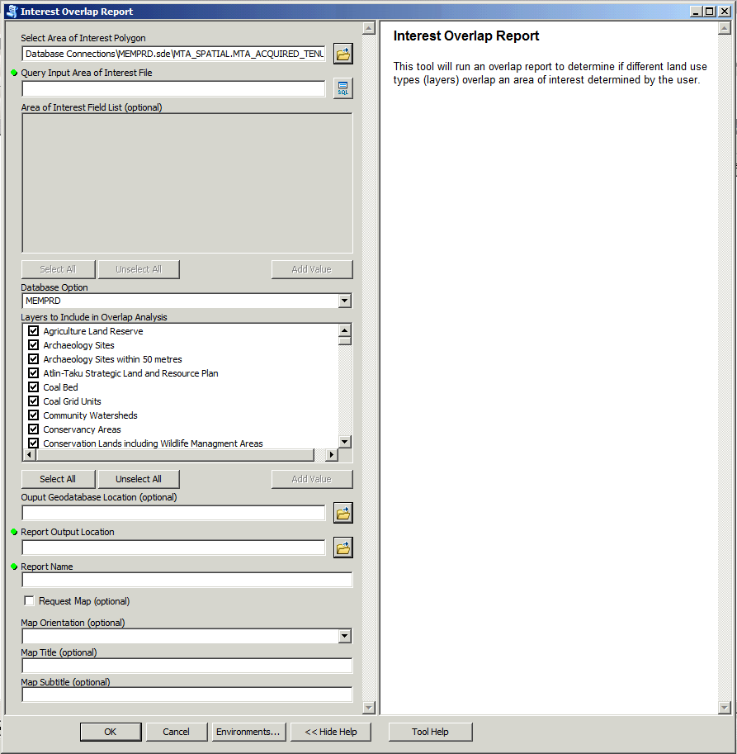

*Tool Parameters:*

* **Select Area of Interest Polygon (Required)**
  + Input must be a spatial file (feature class or shapefile) and must be a polygon
  + *Default* is the Mineral/Placer/Coal tenure feature class (**MTA_SPATIAL.MTA_ACQUIRED_TENURE_SVW**)
* **Query Input Extent File (Required)**
  + Used to query a specific record of the “Area of Interest”. Please Query to one feature in the Area of Interest Input file
* if using tenures (**MTA_SPATIAL.MTA_ACQUIRED_TENURE_SVW**) as the area of interest, query on the **TENURE_NUMBER_ID** field
* if using reserves (**MTA_SPATIAL.MTA_SITE_SVW**) as the area of interest, query on the **SITE_NUMBER_ID** field.
* If using any other spatial file, create a query on any field and make sure it only returns a single record
* **Area of Interest Field List (Optional)**
  + Choose fields from the Area of Interest input to be summarized in the report header.
* This is only required and enabled if the Area of Interest is not **MTA_SPATIAL.MTA_ACQUIRED_TENURE_SVW** or **MTA_SPATIAL.MTA_SITE_SVW**
* **Layers to be Included in Overlap Analysis (Required)**
  + Choose the layers to be included in the overlap analysis
  + *Default* is all layers
  + The list is built dynamically from the MASTER spreadsheet. If a layer is added or removed, the tool will update the list automatically each time it initializes on startup
* **Database Option**
  + Choose the database to which the mineral titles datasets will be drawn from
* **Output Geodatabase (Optional)**
* The folder location of the output geodatabase which will contain the clipped, overlapping feature classes
* This is optional. If you do not need to retain the clipped feature classes, then they will be sent to a scratch workspace location, so leave this parameter blank
* **Report Output Location (Required)**
  + Choose a folder to output the excel report
* **Report Name**
  + Type a name to be used in the file path for the output spreadsheet. Keep in mind that the file name convention will look like this:

**Interest_report_*Report_Name*_18Jun14.xlsx**

* **Request Map (Optional)**
  + A boolean parameter that provides the option to create a map
  + This will create a .mxd, .pdf and will embed the pdf into the second sheet in the report workbook.
* **Map Orientation (Optional)**
  + Choose a page orientation for the map (Landscape or Portrait)
* **Map Title (Optional)**
  + Enter a title to be used in the map. Please keep it fairly short as it does not have a lot of room in the map layout area
* **Map Subtitle (Optional)**
  + Enter a subtitle to be used in the map (if applicable). if no subtitle is needed, leave this parameter blank.

Location of Edit Requests and Status File:

\\spatialfiles.bcgov\Work\em\vic\mtb\Local\ArcGIS_Tools\MTB_Tools\Reporting_Tools\Interest_Overlap_Report\Excel_Spreadsheets\Edit_Requests.xlsx