**MATLAB SIGN-IN AND SET UP WALKTHROUGH**

**STEP 1**: Open a web browser and navigate to the MATLAB Online sign-in page (usually found at [MATLAB Online Sign-In](https://www.mathworks.com/login). Click the "Sign In" button.

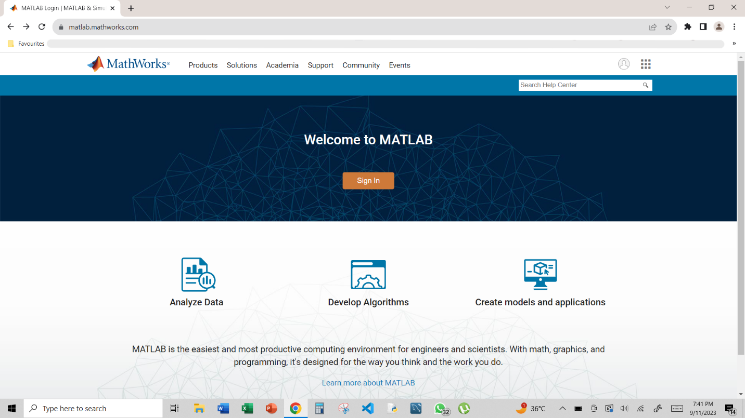

**STEP 2**: If you don't already have an account, you'll need to create one. Click the "Create Account" option.

If you have already created an account, please skip to step 8.

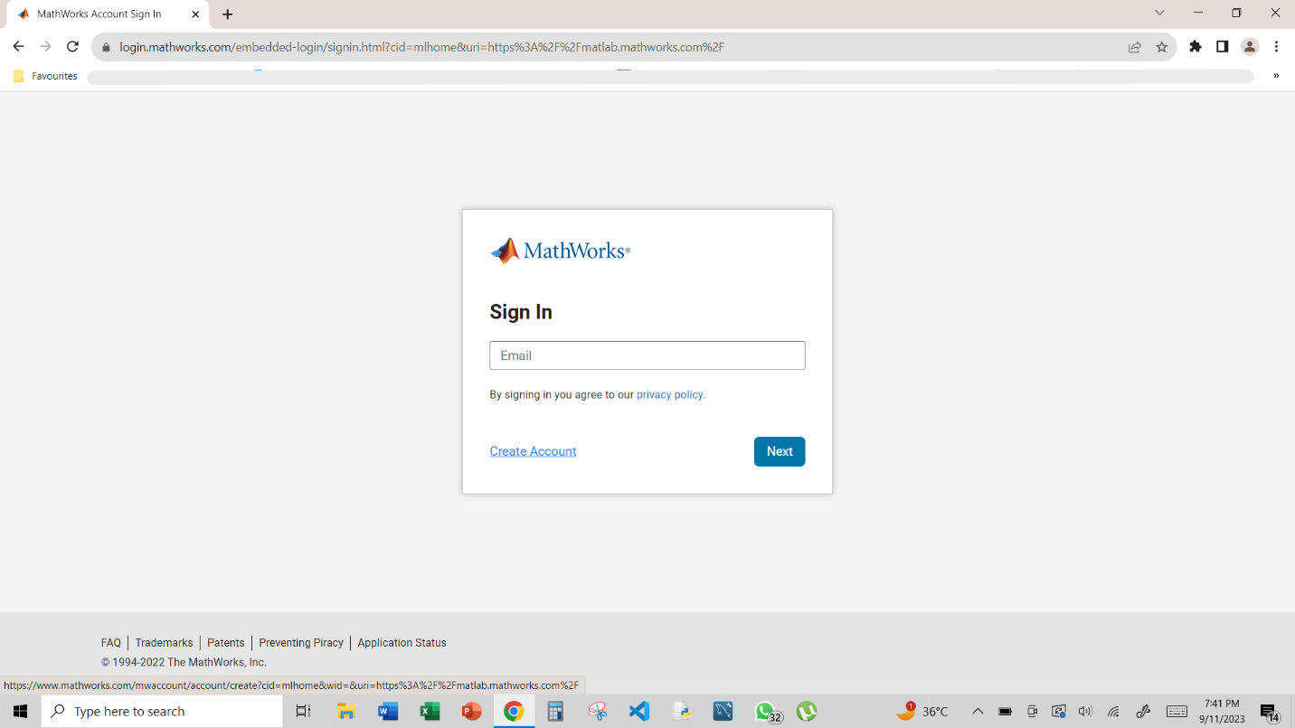

**STEP 3**: Make sure to register using your BITS email ID, which is typically provided by your institution. Ensure that you are using your institutional email address and not a personal one.

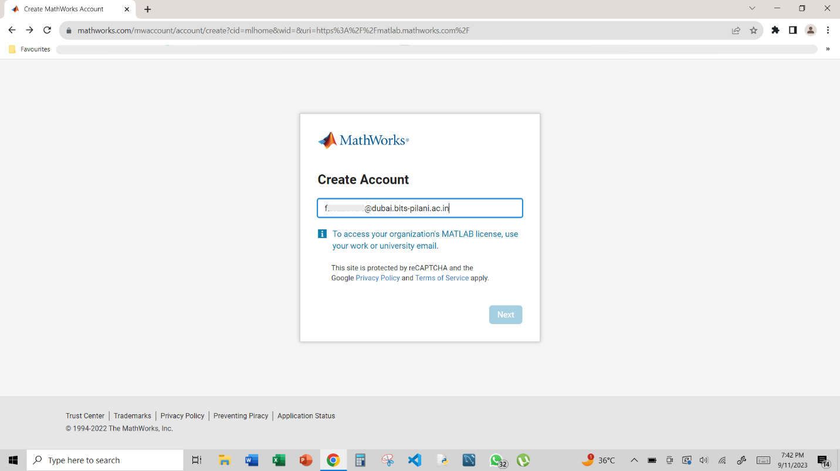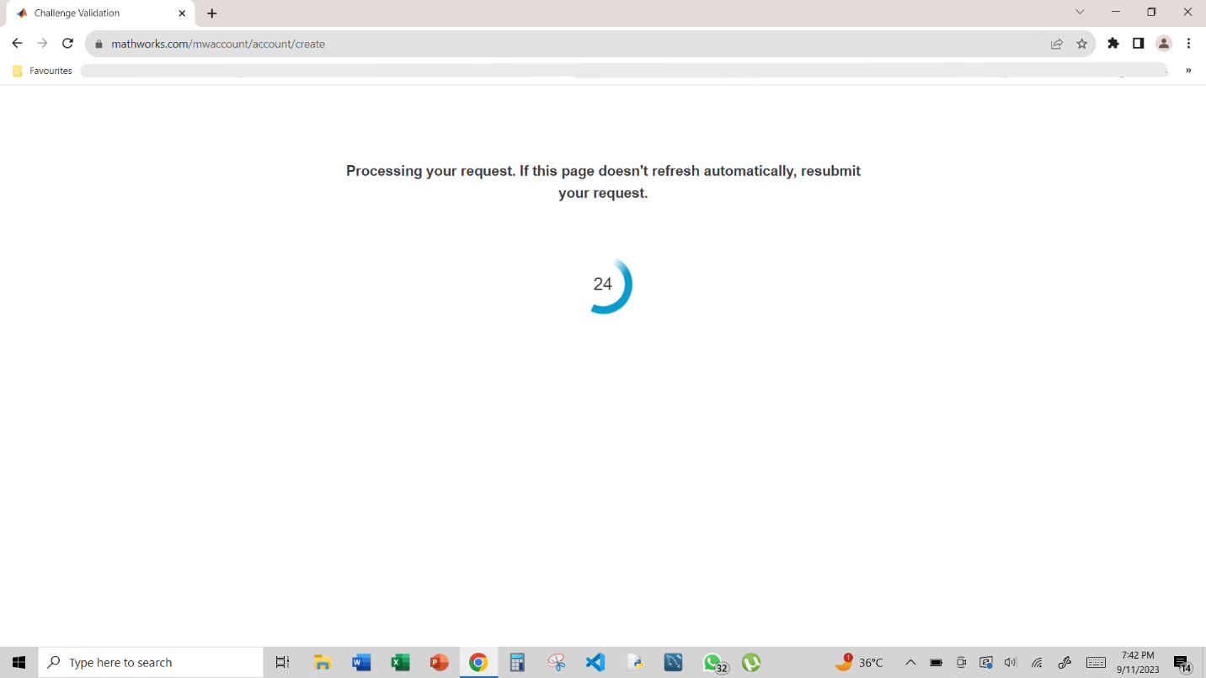

**STEP 4:** After entering your BITS email ID, you'll be prompted to create a password. Follow the password requirements provided and click "Next."

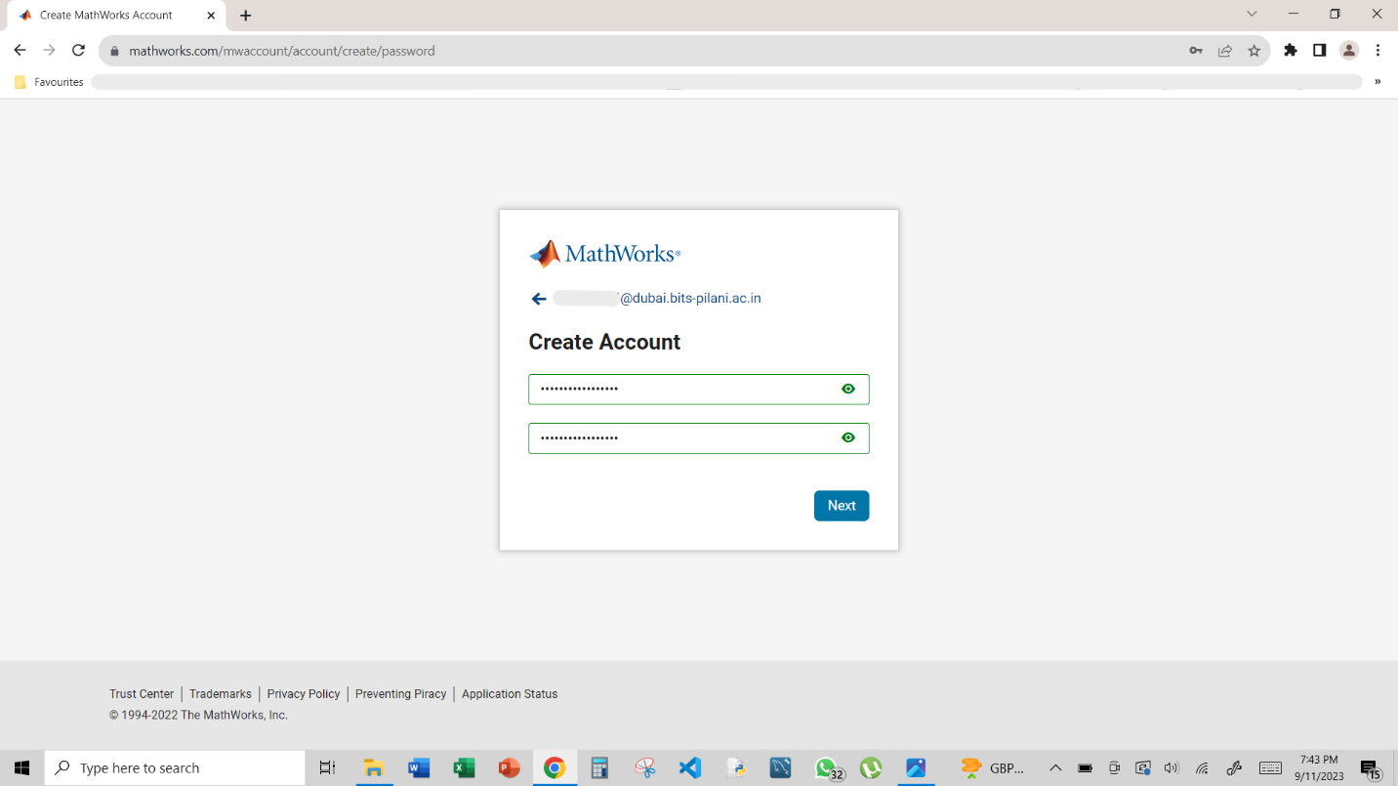

**STEP 5**: You'll receive a One-Time Password (OTP) on your BITS email ID. Check your inbox for the OTP and enter it on the MATLAB Online registration page. This step is for verification.

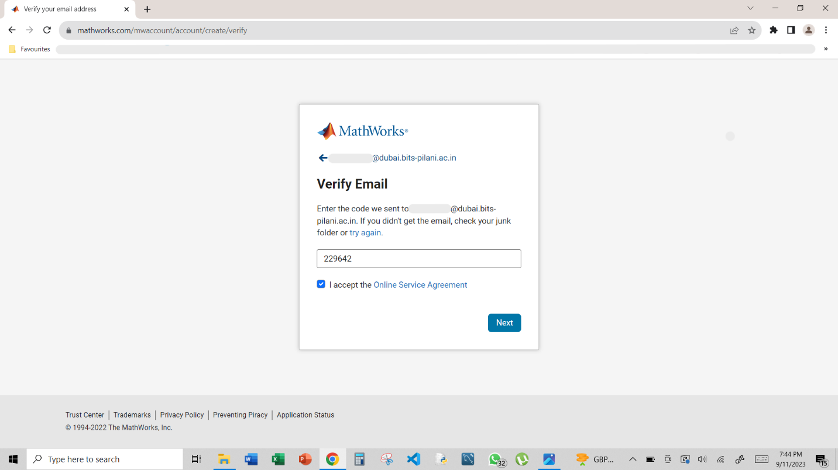

**STEP 6**: Fill in your personal details, including your name and any other required information. These details are usually used for account identification and communication.

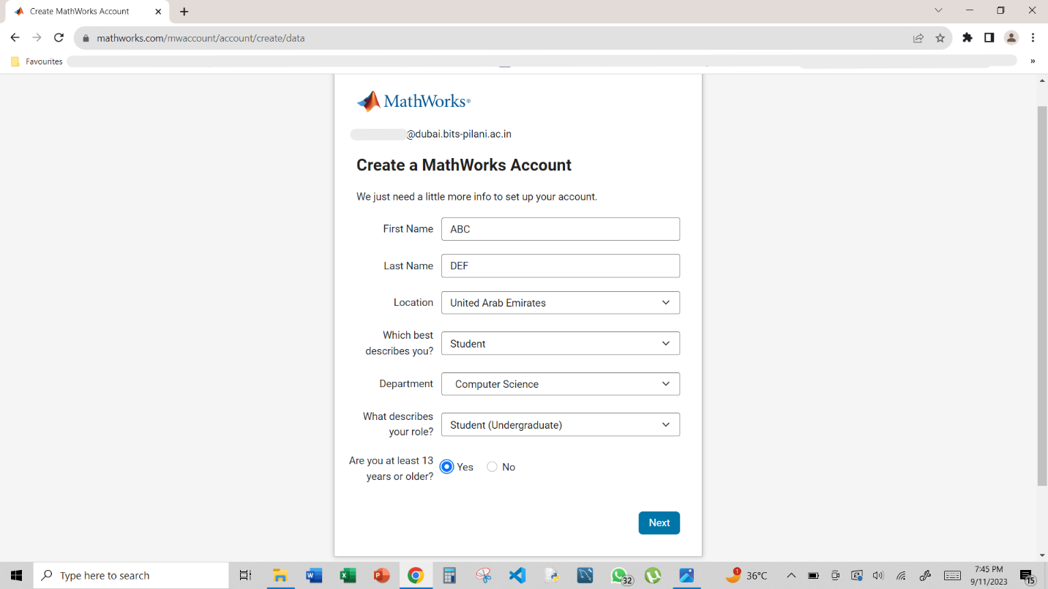

**STEP 7:** After providing your information, review it for accuracy, and then complete the registration process.

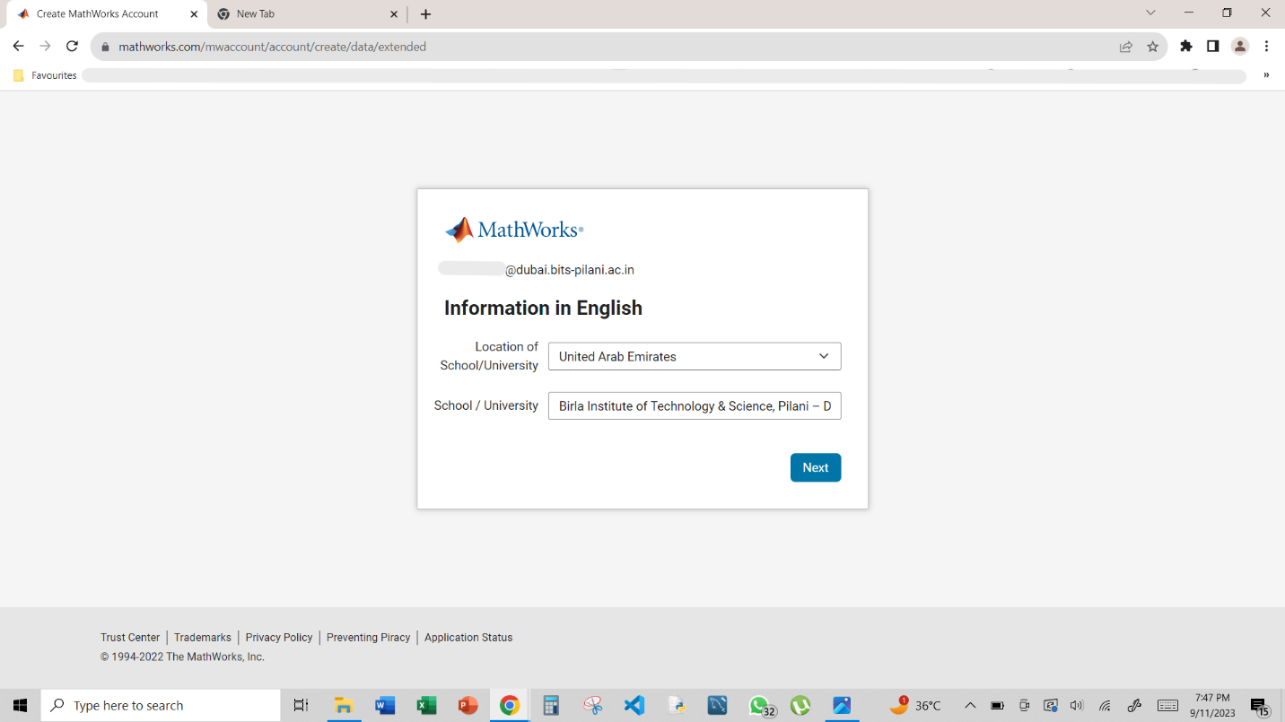

**STEP 8:** Once you have successfully registered and logged in, you'll typically be directed to your MATLAB Online dashboard. Look for an option like "Use MATLAB Online (Basic)" or "Start using MATLAB Online for free." Click on this option to access the basic version of MATLAB Online.

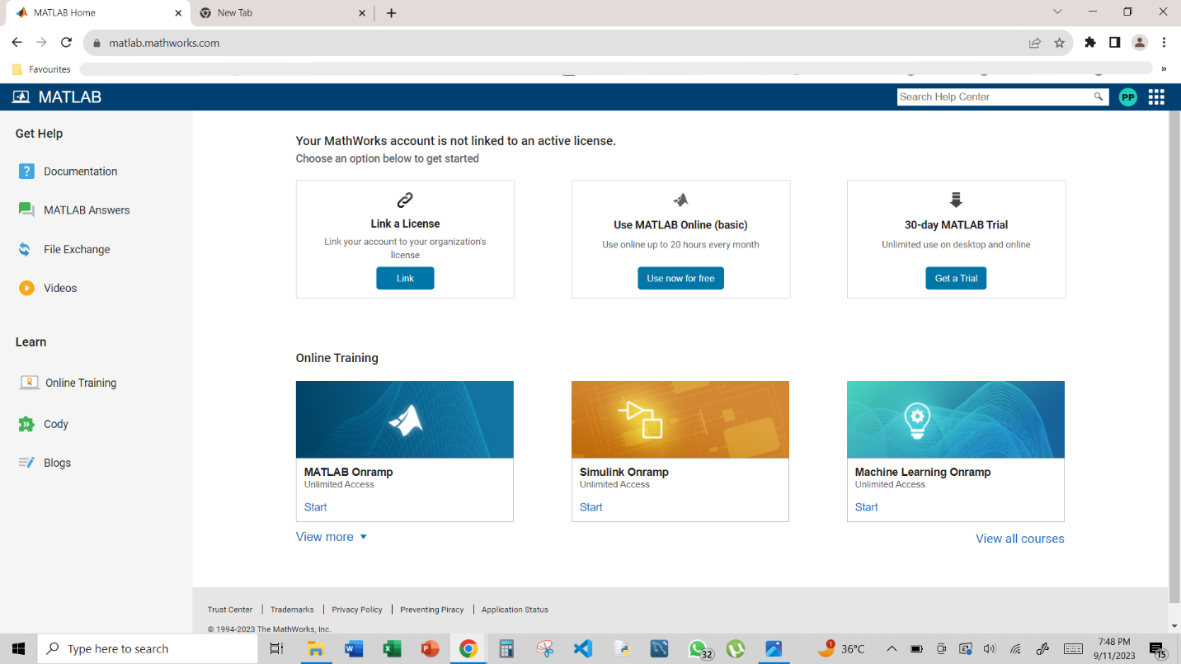

Congratulations! You should now be logged in to MATLAB Online and ready to start coding.

