**期末复习总结:**

1、特别重要内容：counting、关系、图、树；

图、树涉及到各种概念以及它们的计算，如Euler graph, Hamilton graph, directed graph等

图树的内容有可能会和实际问题关联；

图树章节，涉及到一些计数问题，如顶点、边、区域的关系；树中叶节点、内节点数量的计算等。

有些常见图，Qn, Kn, K(n,m)等，要知道他们的具体表示；

Hoffmann coding, 树的遍历是重要内容；

传递关系，是关系章的难点也是重点；涉及到基础概念，以及闭包计算等。

2、counting各种计算问题都可能出现，比重也很大，要清晰把握；

求解线性递归关系，以及容斥定理，是advanced counting章的重要内容；注意一般形式的求解。

鸽笼原理用来证明问题是难点；

对于球放在盒子里的问题，盒子不一样，计算方法是明确的；盒子一样，多枚举。

3、1,2,3,5；内容相对基础，小问题、小概念会比较多；

normal form虽然课本上没有，但考试会涉及到；

**典型题目：**

( ) Let *R* be a relation on the nonempty set *A*. if then *R* is transitive.

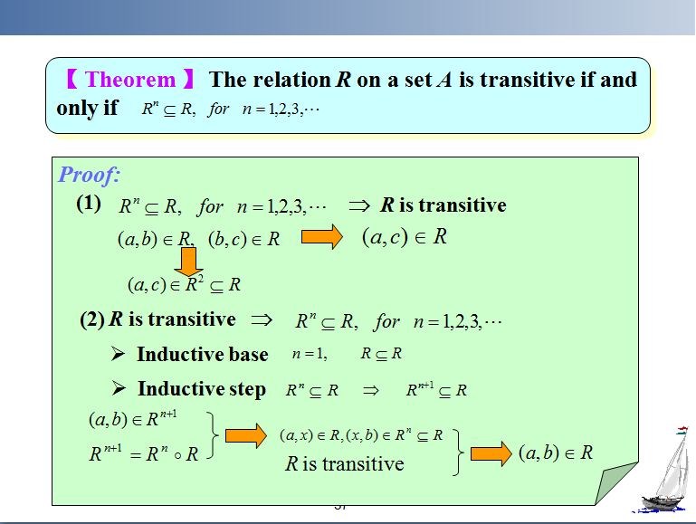

(**  * ***) Let R and S be relations on nonempty set A，if R and S are symmetric, then so is.

(**  * ***)Let R and S be relations on nonempty set A，if R and S are transitive, then so is .

There are ___ equivalence relations on the set with 3 elements.

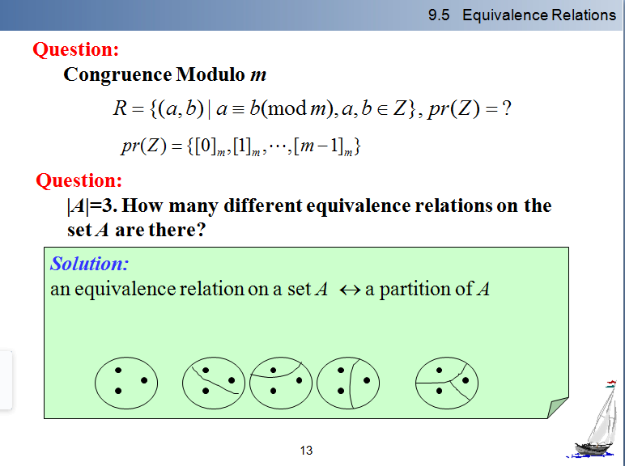

let A={a，b，c，d}, and R={<a , b > ,< b , a > ,< b, c > , < c , d >}is a relation on A. Find the smallest relation S containing R that is an equivalence relation.

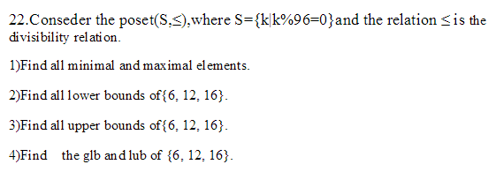

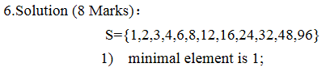

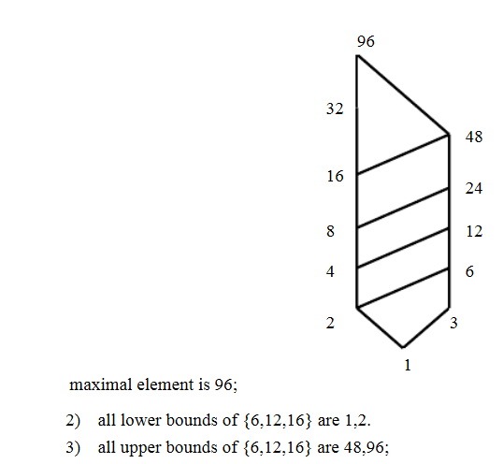



**-----------------------------------------------------------------------------------**

( ) The Hasse diagram for the partial ordering ({1,2,3,4,5,6,7,8,9},|) is a tree.

( ) There is at least one vertex with degree no more than 5 in a simple connected planar graph.

( ) There is a tree with degree 3,2,2,2,1,1,1,1,1.

( ) A bipartite graph with an odd number of vertices does not have a Hamilton circuit.

() A connected undirected graph which has *n* vertices and *n*-1 edges is a tree.

(*** *** ) if G = (V,E) is a simple connected non-planar undirected graph, then |V|+|E| ≥ 15.

***     ***)The chromatic number of a simple connected non-bipartite undirected graph is no less than 3.

(  ) If both planar graphs *G*1 and planar graphs *G*2 each have *v* vertices, *e* edges, and *r* regions, these two graphs are isomorphic.

1. ( T ) There is at least a maximal in any nonempty poset .

( F** **) Let *R* be a relation on the nonempty set *A*. if then *R* is transitive.

( F***  *** )The graph Q3 is a Euler graph.

( T ) Simple graphs G1 and G2 are isomorphic if and only if and are isomorphic.

Suppose that a full 5-ary tree has 100 internal vertices. it has________ leaves

The maximum number of edges in a simple, disconnected graph with n vertices is __________

How many edges cube Qn has?

1. If *G* is a planar connected graph with 20 vertices, each of degree 4, then *G* has _____________ regions.

1）Let *G* be a planar graph with *k* connected components, *v* vertices and *e* edges, then Euler’s Formula for this graph is *v − e* + *r* = 1+*k* .

If G is simple undirected planar graph, VE = |V(G)|+ |E(G)|, where |V(G)| is number of vertex of G, |E(G)| is number of edges of G, then the maximum number of VE is _14__

1. Use Huffman coding to encode these symbols with given frequencies: a: 0.10, B:0.25, C: 0.05, D: 0.15, E: 0.30, F: 0.07, G: 0.08. Give the average number of bits required to encode a symbol._____.
2. How many spanning trees has K2,n? _____________
3. There are _____________ non-isomorphic rooted trees with 5 vertices.
4. In the k × n grid (graph), the length of every edge is 1, counting the number of shortest paths from the bottom left corner to the top right corner. (Note that the distance between these two points is k+n−2.)._____________
5. There is a binary tree. Its preorder traversal is ABDECF，and its inorder traversal is DBEACF. Its post order traversal is _____________

W

Given symbols with frequencies: E: 0.5, F:0.3, G: 0.2.

1. Construct a Huffman code for these three symbols;
2. Form a new set of symbols by grouping together blocks of two symbols, EE,EF,EG,FE,FF,FG,GE,GF,GG. Construct a Huffman code for these nine symbols, assuming that the occurrences of the symbols in the original text are independent;
3. Compare the average number of bits required to encode the text using the Huffman code for the three symbols in part (1) and the Huffman code for the nine blocks of two symbols constructed in part (2). Which is more efficient?

*G* is a directed graph(See Fig. 3).

1. Find the number of different paths of length 4.
2. Find the strongly connected components of the graph G.
3. Determine if *G* has Euler circuit/path or Hamilton circuit/path. If yes, give a path or circuit; otherwise, give the reason.
4. Find the chromatic number of the underlying undirected graph of the directed graph *G*.
5. Find the spanning tree for the underlying undirected graph of the directed graph *G*. Choose *V*4 as the root of the spanning tree.

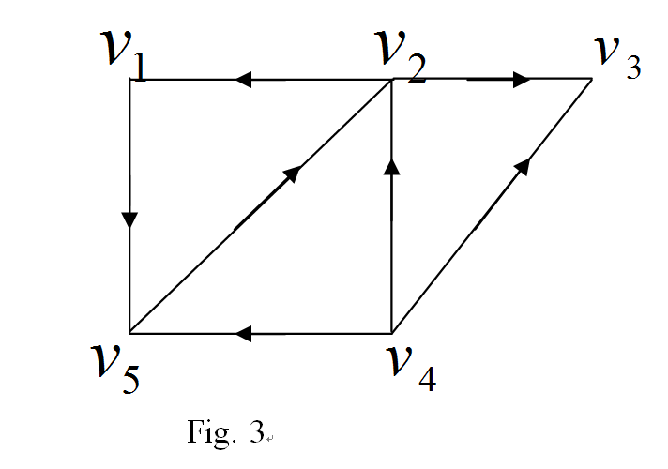

T2: Draw a graph respectively satisfying:

_ Both have a Euler circuit and a Hamilton circuit;

_ Has a Euler circuit but not Hamilton circuit;

_ Has no Euler circuit but a Hamilton circuit;

_ Has neither Euler circuit or Hamilton circuit;

_ Mark the Euler circuit or Hamilton circuit if it exists.

1. Both have a Euler circuit and a Hamilton circuit

a b

c d

Euler circuit: a→b→c→d→a

Hamilton circuit: a→b→c→d→a

(b)Has a Euler circuit but not Hamilton circuit

a b

c

d e

Euler circuit: c→a→d→c→e→b→c

(c)Has no Euler circuit but a Hamilton circuit

a b

c d

Hamilton circuit: a→b→d→c→a

(d)Has neither Euler circuit or Hamilton circuit

a b c d

-----------------

The diagram below represents a floor plan with the doors between the rooms and the outside indicated. The real estate agent would like to be able to tour the house, starting and ending outside, by going through each door exactly once. What is the fewest number of doors that should be added, and where should they be placed in order to make this tour possible? Give reasons for your answer.

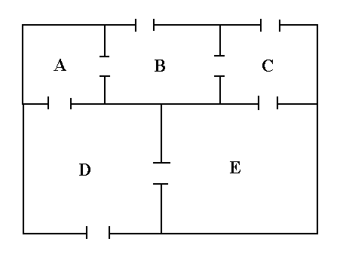

Solution: Letting the rooms be vertices (with the outside as a vertex also) and the doors be edges between these vertices, the tour corresponds to an Eulerian circuit in this graph. This is possible if and only if every vertex has even degree. Since rooms B, C, D and the outside have odd degree, the tour is not possible. We would have to add at least two edges between these vertices (i.e., at least 2 new doors) to make it possible. Since we can not join C to D (there is no common wall to put a door in), we could join C to B and D to the outside. Thus, it is possible to take the tour with the addition of two doors, a first one between rooms C and B and a second door from D to the outside.

6) The full disjunctive normal form of is _.



