## Ban 502 Project

### Part 1 - Data Exploration, Preparation, and Visualization

library(tidyverse)

## -- Attaching packages -------------------------------------------------------------------------------- tidyverse 1.2.1 --

## v ggplot2 3.1.0 v purrr 0.3.0   
## v tibble 2.0.1 v dplyr 0.8.0.1  
## v tidyr 0.8.2 v stringr 1.4.0   
## v readr 1.3.1 v forcats 0.4.0

## -- Conflicts ----------------------------------------------------------------------------------- tidyverse_conflicts() --  
## x dplyr::filter() masks stats::filter()  
## x dplyr::lag() masks stats::lag()

library(mice)

## Loading required package: lattice

##   
## Attaching package: 'mice'

## The following object is masked from 'package:tidyr':  
##   
## complete

## The following objects are masked from 'package:base':  
##   
## cbind, rbind

library(VIM)

## Loading required package: colorspace

## Loading required package: grid

## Loading required package: data.table

##   
## Attaching package: 'data.table'

## The following objects are masked from 'package:dplyr':  
##   
## between, first, last

## The following object is masked from 'package:purrr':  
##   
## transpose

## VIM is ready to use.   
## Since version 4.0.0 the GUI is in its own package VIMGUI.  
##   
## Please use the package to use the new (and old) GUI.

## Suggestions and bug-reports can be submitted at: https://github.com/alexkowa/VIM/issues

##   
## Attaching package: 'VIM'

## The following object is masked from 'package:datasets':  
##   
## sleep

library(GGally)

##   
## Attaching package: 'GGally'

## The following object is masked from 'package:dplyr':  
##   
## nasa

library(ggcorrplot)

library(readr)  
rain <- read_csv("rain.csv")

## Parsed with column specification:  
## cols(  
## .default = col_double(),  
## Date = col_character(),  
## WindGustDir = col_character(),  
## WindDir9am = col_character(),  
## WindDir3pm = col_character(),  
## RainToday = col_character(),  
## RainTomorrow = col_character()  
## )

## See spec(...) for full column specifications.

summary(rain)

## Date MinTemp MaxTemp Rainfall   
## Length:28003 Min. :-8.50 Min. :-3.00 Min. : 0.000   
## Class :character 1st Qu.: 7.60 1st Qu.:17.90 1st Qu.: 0.000   
## Mode :character Median :12.00 Median :22.60 Median : 0.000   
## Mean :12.16 Mean :23.18 Mean : 2.265   
## 3rd Qu.:16.80 3rd Qu.:28.20 3rd Qu.: 0.650   
## Max. :30.50 Max. :47.00 Max. :268.600   
## NA's :132 NA's :64 NA's :295   
## WindGustDir WindGustSpeed WindDir9am WindDir3pm   
## Length:28003 Min. : 7.00 Length:28003 Length:28003   
## Class :character 1st Qu.: 31.00 Class :character Class :character   
## Mode :character Median : 39.00 Mode :character Mode :character   
## Mean : 40.02   
## 3rd Qu.: 48.00   
## Max. :135.00   
## NA's :1840   
## WindSpeed9am WindSpeed3pm Humidity9am Humidity3pm   
## Min. : 0.00 Min. : 0.00 Min. : 1.00 Min. : 0.00   
## 1st Qu.: 7.00 1st Qu.:13.00 1st Qu.: 57.00 1st Qu.: 36.00   
## Median :13.00 Median :19.00 Median : 70.00 Median : 52.00   
## Mean :13.97 Mean :18.59 Mean : 68.86 Mean : 51.54   
## 3rd Qu.:19.00 3rd Qu.:24.00 3rd Qu.: 83.00 3rd Qu.: 66.00   
## Max. :87.00 Max. :83.00 Max. :100.00 Max. :100.00   
## NA's :308 NA's :526 NA's :366 NA's :694   
## Pressure9am Pressure3pm Cloud9am Cloud3pm   
## Min. : 980.5 Min. : 978.2 Min. :0.000 Min. :0.000   
## 1st Qu.:1013.0 1st Qu.:1010.5 1st Qu.:1.000 1st Qu.:2.000   
## Median :1017.7 Median :1015.3 Median :5.000 Median :5.000   
## Mean :1017.7 Mean :1015.3 Mean :4.459 Mean :4.513   
## 3rd Qu.:1022.4 3rd Qu.:1020.0 3rd Qu.:7.000 3rd Qu.:7.000   
## Max. :1041.0 Max. :1037.0 Max. :8.000 Max. :8.000   
## NA's :2837 NA's :2817 NA's :10673 NA's :11341   
## Temp9am Temp3pm RainToday RainTomorrow   
## Min. :-5.60 Min. :-4.20 Length:28003 Length:28003   
## 1st Qu.:12.30 1st Qu.:16.60 Class :character Class :character   
## Median :16.70 Median :21.10 Mode :character Mode :character   
## Mean :16.96 Mean :21.63   
## 3rd Qu.:21.50 3rd Qu.:26.40   
## Max. :38.60 Max. :45.20   
## NA's :196 NA's :532

COnvert characters into factors

rain <- rain %>%  
 mutate(RainToday = as_factor(as.character(RainToday))) %>%  
 mutate(RainTomorrow = as_factor(as.character(RainTomorrow))) %>%  
 mutate(WindGustDir = as_factor(as.character(WindGustDir))) %>%  
 mutate(WindDir9am = as_factor(as.character(WindDir9am))) %>%  
 mutate(WindDir3pm = as_factor(as.character(WindDir3pm)))  
glimpse(rain)

## Observations: 28,003  
## Variables: 20  
## $ Date <chr> "12/5/2008", "12/6/2008", "12/16/2008", "12/17/2...  
## $ MinTemp <dbl> 17.5, 14.6, 9.8, 14.1, 20.5, 20.1, 9.6, 14.0, 12...  
## $ MaxTemp <dbl> 32.3, 29.7, 27.7, 20.9, 31.8, 32.7, 23.9, 28.3, ...  
## $ Rainfall <dbl> 1.0, 0.2, NA, 0.0, 0.0, 0.0, 0.0, 0.0, 0.0, 0.0,...  
## $ WindGustDir <fct> W, WNW, WNW, ENE, WNW, WNW, W, W, NE, NW, WNW, W...  
## $ WindGustSpeed <dbl> 41, 56, 50, 22, 41, 48, 41, 48, 37, 39, 44, 28, ...  
## $ WindDir9am <fct> ENE, W, NA, SSW, W, N, WSW, W, SSE, SSE, W, ENE,...  
## $ WindDir3pm <fct> NW, W, WNW, E, W, WNW, SSW, WSW, S, SSW, W, SSW,...  
## $ WindSpeed9am <dbl> 7, 19, NA, 11, 19, 13, 19, 17, 20, 7, 20, 17, 9,...  
## $ WindSpeed3pm <dbl> 20, 24, 22, 9, 20, 30, 11, 24, 9, 17, 28, 15, 11...  
## $ Humidity9am <dbl> 82, 55, 50, 69, 54, 56, 44, 43, 38, 40, 34, 34, ...  
## $ Humidity3pm <dbl> 33, 23, 28, 82, 24, 15, 22, 15, 16, 8, 28, 17, 1...  
## $ Pressure9am <dbl> 1010.8, 1009.2, 1013.4, 1012.2, 1007.8, 1005.2, ...  
## $ Pressure3pm <dbl> 1006.0, 1005.4, 1010.3, 1010.4, 1005.7, 1001.7, ...  
## $ Cloud9am <dbl> 7, NA, 0, 8, NA, NA, NA, NA, NA, NA, NA, NA, NA,...  
## $ Cloud3pm <dbl> 8, NA, NA, 1, NA, NA, NA, NA, NA, NA, NA, NA, NA...  
## $ Temp9am <dbl> 17.8, 20.6, 17.3, 17.2, 23.8, 24.6, 14.9, 17.9, ...  
## $ Temp3pm <dbl> 29.7, 28.9, 26.2, 18.1, 30.8, 32.1, 22.1, 27.6, ...  
## $ RainToday <fct> No, No, NA, No, No, No, No, No, No, No, No, No, ...  
## $ RainTomorrow <fct> No, No, No, Yes, No, No, No, No, No, No, No, No,...

View Missingness

vim_plot = aggr(rain, numbers = TRUE, prop = c(TRUE, FALSE),cex.axis=.7)

## Warning in plot.aggr(res, ...): not enough vertical space to display  
## frequencies (too many combinations)

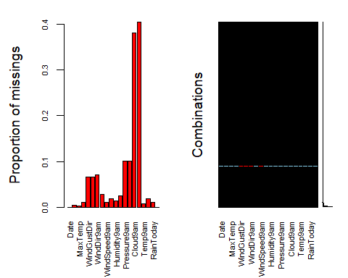

imputation of missing data

rain2 = rain %>% select(c("Date","MinTemp", "MaxTemp", "Rainfall", "WindGustDir", "WindGustSpeed", "WindDir9am", "WindDir3pm", "WindSpeed9am", "WindSpeed3pm", "Humidity9am", "Humidity3pm","Pressure9am", "Pressure3pm", "Cloud9am", "Cloud3pm", "Temp9am", "Temp3pm", "RainToday", "RainTomorrow"))  
  
imp_rain = mice(rain2, m=1, method='pmm', printFlag=FALSE)

## Warning: Number of logged events: 1

summary(imp_rain)

## Class: mids  
## Number of multiple imputations: 1   
## Imputation methods:  
## Date MinTemp MaxTemp Rainfall WindGustDir   
## "" "pmm" "pmm" "pmm" "pmm"   
## WindGustSpeed WindDir9am WindDir3pm WindSpeed9am WindSpeed3pm   
## "pmm" "pmm" "pmm" "pmm" "pmm"   
## Humidity9am Humidity3pm Pressure9am Pressure3pm Cloud9am   
## "pmm" "pmm" "pmm" "pmm" "pmm"   
## Cloud3pm Temp9am Temp3pm RainToday RainTomorrow   
## "pmm" "pmm" "pmm" "pmm" ""   
## PredictorMatrix:  
## Date MinTemp MaxTemp Rainfall WindGustDir WindGustSpeed  
## Date 0 1 1 1 1 1  
## MinTemp 0 0 1 1 1 1  
## MaxTemp 0 1 0 1 1 1  
## Rainfall 0 1 1 0 1 1  
## WindGustDir 0 1 1 1 0 1  
## WindGustSpeed 0 1 1 1 1 0  
## WindDir9am WindDir3pm WindSpeed9am WindSpeed3pm Humidity9am  
## Date 1 1 1 1 1  
## MinTemp 1 1 1 1 1  
## MaxTemp 1 1 1 1 1  
## Rainfall 1 1 1 1 1  
## WindGustDir 1 1 1 1 1  
## WindGustSpeed 1 1 1 1 1  
## Humidity3pm Pressure9am Pressure3pm Cloud9am Cloud3pm  
## Date 1 1 1 1 1  
## MinTemp 1 1 1 1 1  
## MaxTemp 1 1 1 1 1  
## Rainfall 1 1 1 1 1  
## WindGustDir 1 1 1 1 1  
## WindGustSpeed 1 1 1 1 1  
## Temp9am Temp3pm RainToday RainTomorrow  
## Date 1 1 1 1  
## MinTemp 1 1 1 1  
## MaxTemp 1 1 1 1  
## Rainfall 1 1 1 1  
## WindGustDir 1 1 1 1  
## WindGustSpeed 1 1 1 1  
## Number of logged events: 1   
## it im dep meth out  
## 1 0 0 constant Date

Compare original to new imputed data.

densityplot(imp_rain, ~MinTemp) #red imputed, blue original

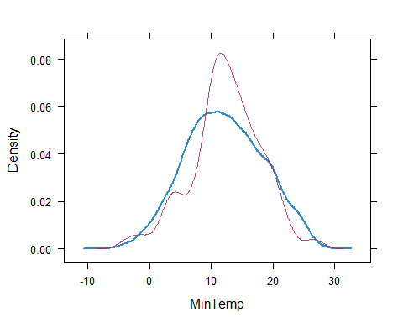

densityplot(imp_rain, ~MaxTemp)

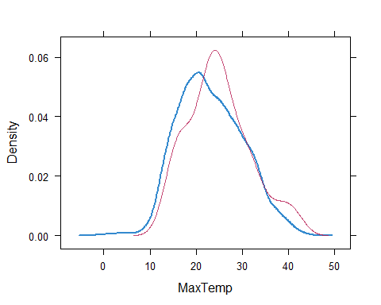

densityplot(imp_rain, ~Rainfall)

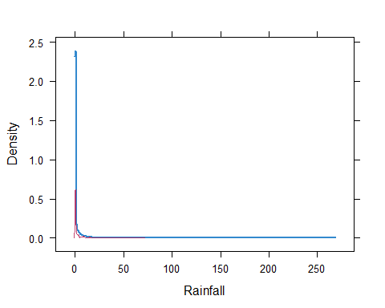

densityplot(imp_rain, ~WindGustDir)

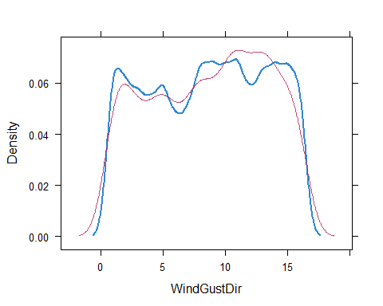

densityplot(imp_rain, ~WindGustSpeed)

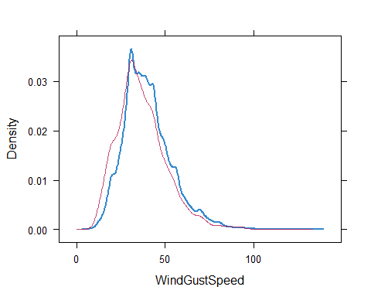

densityplot(imp_rain, ~WindDir9am)

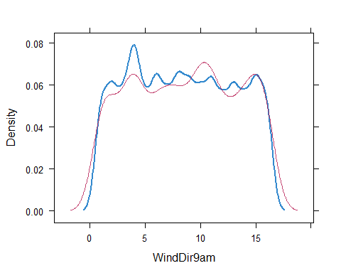

densityplot(imp_rain, ~WindDir3pm)

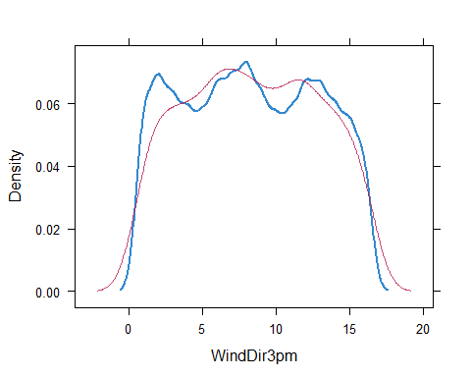

densityplot(imp_rain, ~WindSpeed9am)

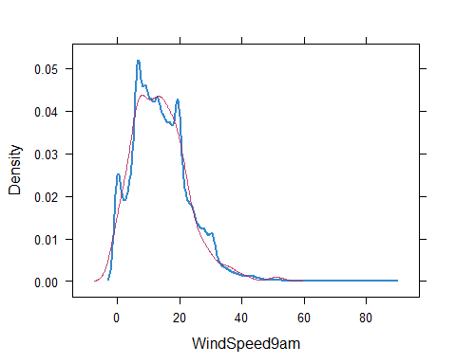

densityplot(imp_rain, ~WindSpeed3pm)

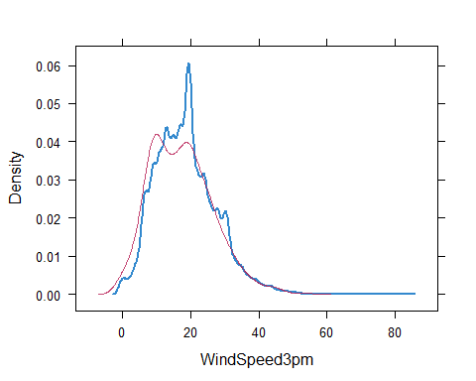

densityplot(imp_rain, ~Humidity9am)

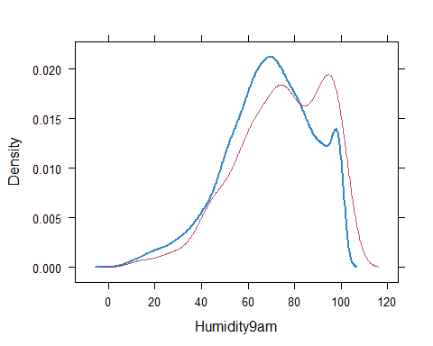

densityplot(imp_rain, ~Humidity3pm)

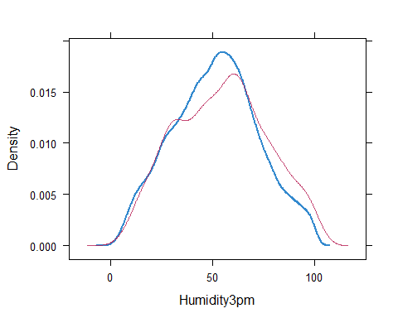

densityplot(imp_rain, ~Pressure9am)

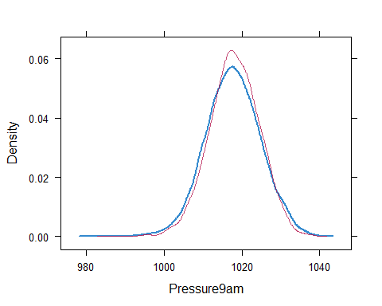

densityplot(imp_rain, ~Pressure3pm)

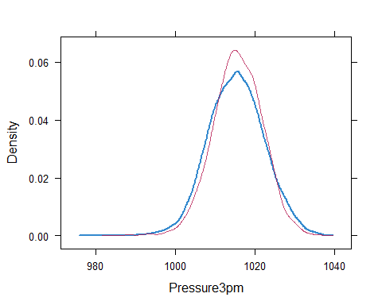

densityplot(imp_rain, ~Cloud9am)

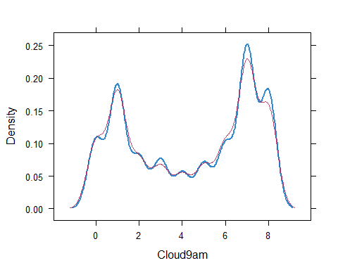

densityplot(imp_rain, ~Cloud3pm)

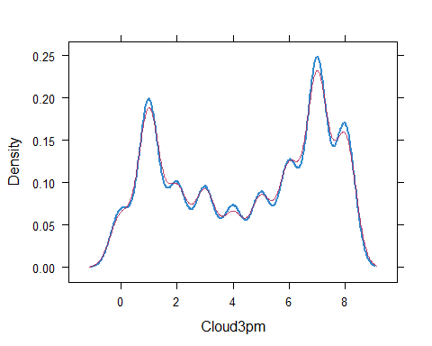

densityplot(imp_rain, ~Temp9am)

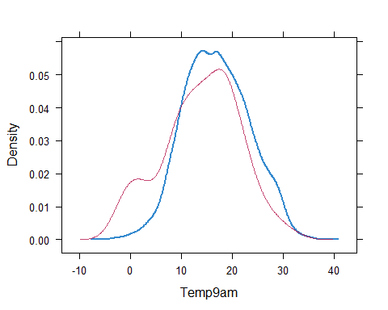

densityplot(imp_rain, ~Temp3pm)

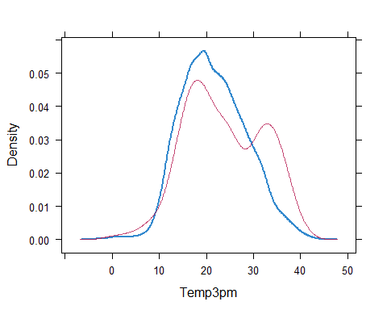

densityplot(imp_rain, ~RainToday)

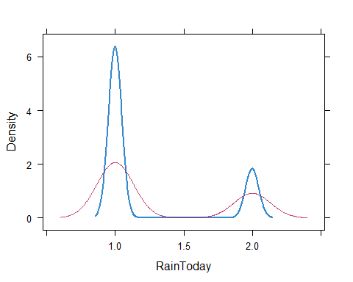

merge imputed values

rain3 <- complete(imp_rain)   
summary(rain3)

## Date MinTemp MaxTemp Rainfall   
## Length:28003 Min. :-8.50 Min. :-3.00 Min. : 0.000   
## Class :character 1st Qu.: 7.60 1st Qu.:17.90 1st Qu.: 0.000   
## Mode :character Median :12.00 Median :22.60 Median : 0.000   
## Mean :12.16 Mean :23.18 Mean : 2.275   
## 3rd Qu.:16.80 3rd Qu.:28.20 3rd Qu.: 0.800   
## Max. :30.50 Max. :47.00 Max. :268.600   
##   
## WindGustDir WindGustSpeed WindDir9am WindDir3pm   
## W : 2052 Min. : 7.00 N : 2456 SE : 2095   
## SE : 2014 1st Qu.: 30.00 SSE : 1904 W : 1971   
## E : 1943 Median : 39.00 SE : 1889 S : 1929   
## S : 1896 Mean : 39.81 E : 1880 SSE : 1924   
## SW : 1886 3rd Qu.: 48.00 NW : 1856 WSW : 1914   
## WSW : 1877 Max. :135.00 S : 1754 SW : 1874   
## (Other):16335 (Other):16264 (Other):16296   
## WindSpeed9am WindSpeed3pm Humidity9am Humidity3pm   
## Min. : 0.00 Min. : 0.00 Min. : 1.00 Min. : 0.00   
## 1st Qu.: 7.00 1st Qu.:13.00 1st Qu.: 57.00 1st Qu.: 36.00   
## Median :13.00 Median :19.00 Median : 70.00 Median : 52.00   
## Mean :13.97 Mean :18.56 Mean : 68.93 Mean : 51.61   
## 3rd Qu.:19.00 3rd Qu.:24.00 3rd Qu.: 83.00 3rd Qu.: 66.00   
## Max. :87.00 Max. :83.00 Max. :100.00 Max. :100.00   
##   
## Pressure9am Pressure3pm Cloud9am Cloud3pm   
## Min. : 980.5 Min. : 978.2 Min. :0.000 Min. :0.000   
## 1st Qu.:1013.1 1st Qu.:1010.6 1st Qu.:1.000 1st Qu.:2.000   
## Median :1017.7 Median :1015.4 Median :5.000 Median :5.000   
## Mean :1017.7 Mean :1015.3 Mean :4.431 Mean :4.509   
## 3rd Qu.:1022.4 3rd Qu.:1020.0 3rd Qu.:7.000 3rd Qu.:7.000   
## Max. :1041.0 Max. :1037.0 Max. :8.000 Max. :8.000   
##   
## Temp9am Temp3pm RainToday RainTomorrow  
## Min. :-5.60 Min. :-4.20 No :21729 No :21713   
## 1st Qu.:12.30 1st Qu.:16.60 Yes: 6274 Yes: 6290   
## Median :16.70 Median :21.10   
## Mean :16.93 Mean :21.67   
## 3rd Qu.:21.50 3rd Qu.:26.40   
## Max. :38.60 Max. :45.20   
##

use ggplot to get some visuals

ggplot(rain3, aes(x=RainTomorrow, y=MinTemp)) + geom_boxplot()

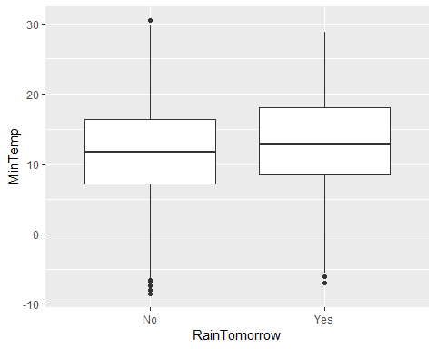

ggplot(rain3, aes(x=RainTomorrow, y=MaxTemp)) + geom_boxplot()

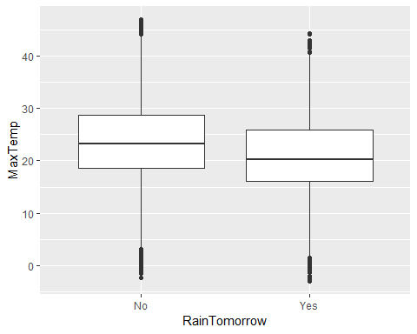

ggplot(rain3, aes(x=RainTomorrow,y=Rainfall)) + geom_boxplot()

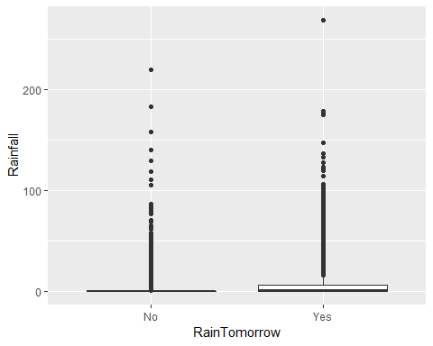

ggplot(rain3, aes(x=RainTomorrow,y=WindGustSpeed)) + geom_boxplot()

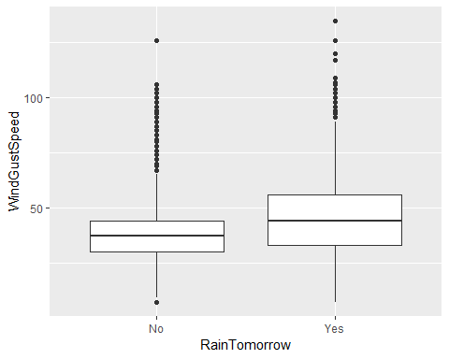

ggplot(rain3, aes(x=RainTomorrow,y=WindSpeed9am)) + geom_boxplot()

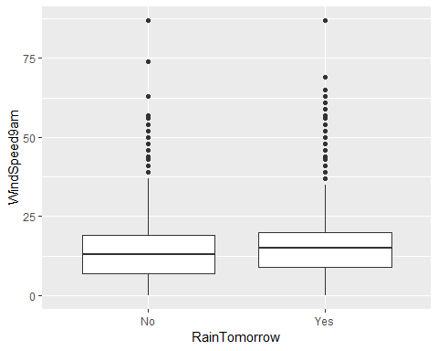

ggplot(rain3, aes(x=RainTomorrow,y=WindSpeed3pm)) + geom_boxplot()

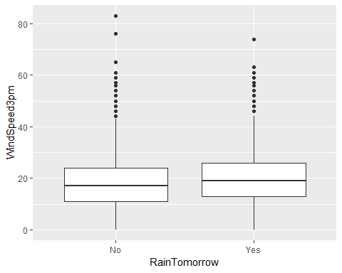

ggplot(rain3, aes(x=RainTomorrow,y=Humidity9am)) + geom_boxplot()

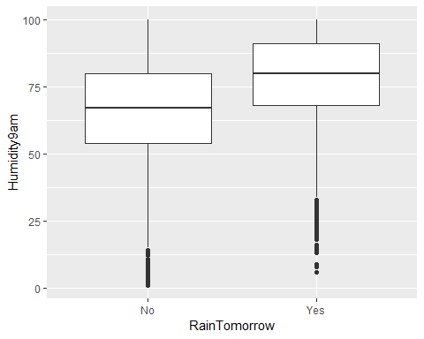

ggplot(rain3, aes(x=RainTomorrow,y=Humidity3pm)) + geom_boxplot()

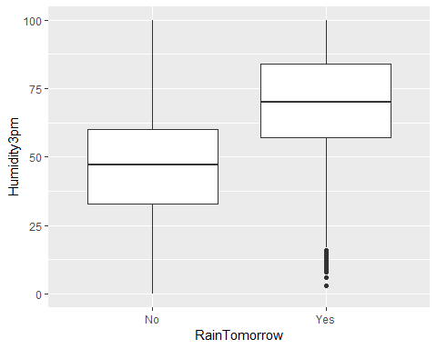

ggplot(rain3, aes(x=RainTomorrow,y=Pressure9am)) + geom_boxplot()

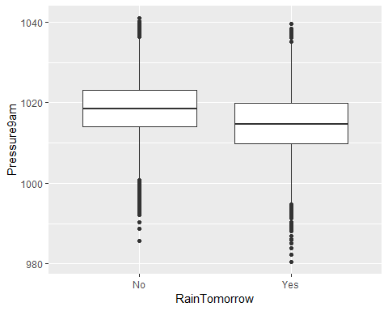

ggplot(rain3, aes(x=RainTomorrow,y=Pressure3pm)) + geom_boxplot()

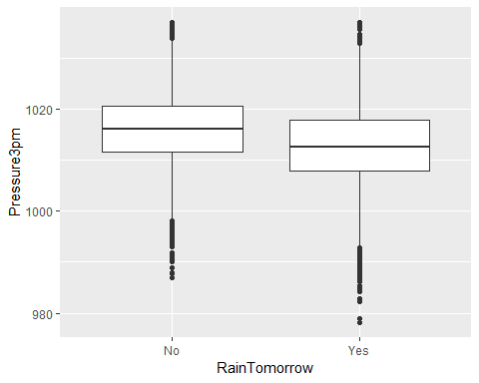

ggplot(rain3, aes(x=RainTomorrow,y=Cloud9am)) + geom_boxplot()

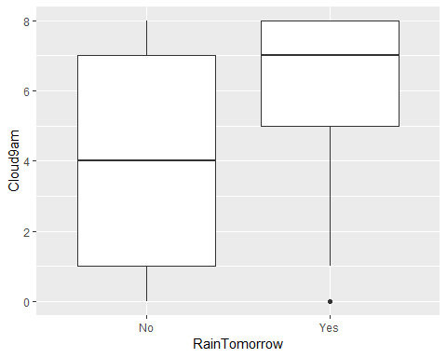

ggplot(rain3, aes(x=RainTomorrow,y=Cloud3pm)) + geom_boxplot()

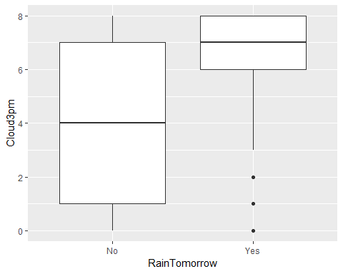

ggplot(rain3, aes(x=RainTomorrow,y=Temp9am)) + geom_boxplot()

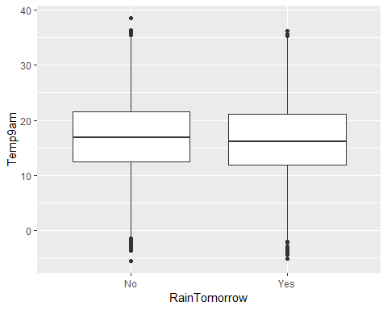

ggplot(rain3, aes(x=RainTomorrow,y=Temp3pm)) + geom_boxplot()

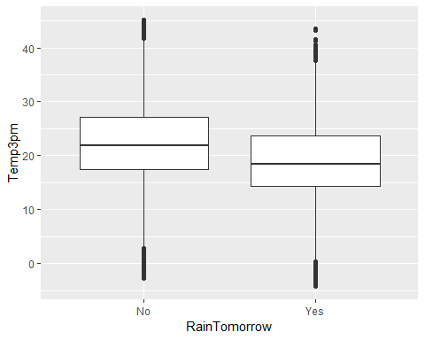

ggplot(rain3, aes(x=MinTemp)) + geom_histogram() + theme_bw()

## `stat_bin()` using `bins = 30`. Pick better value with `binwidth`.

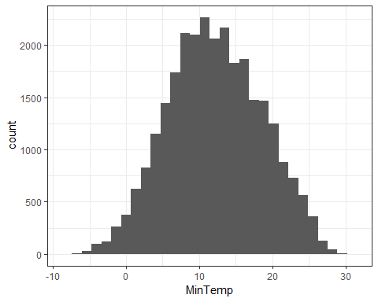

ggplot(rain3, aes(x=MaxTemp)) + geom_histogram() + theme_bw()

## `stat_bin()` using `bins = 30`. Pick better value with `binwidth`.

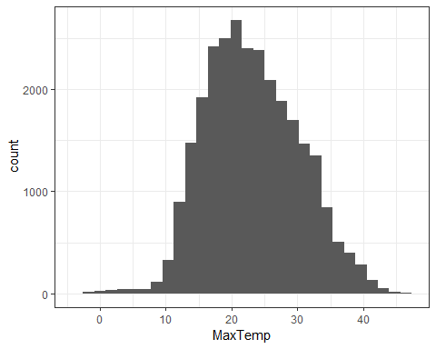

ggplot(rain3, aes(x=Rainfall)) + geom_histogram() + theme_bw()

## `stat_bin()` using `bins = 30`. Pick better value with `binwidth`.

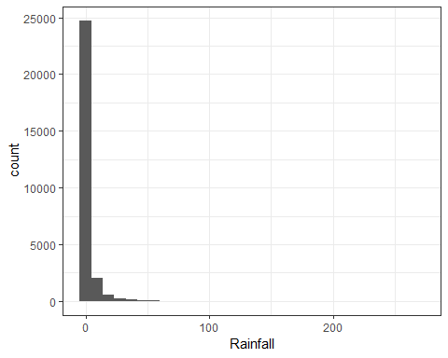

ggplot(rain3, aes(x=WindGustSpeed)) + geom_histogram() + theme_bw()

## `stat_bin()` using `bins = 30`. Pick better value with `binwidth`.

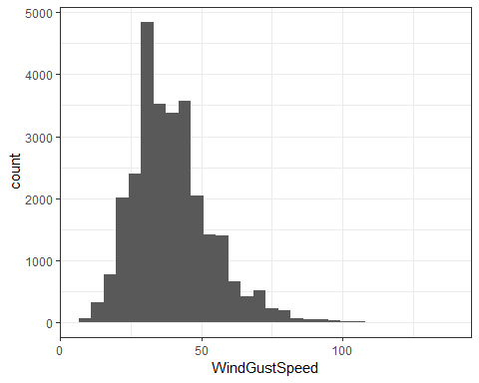

ggplot(rain3, aes(x=WindSpeed9am)) + geom_histogram() + theme_bw()

## `stat_bin()` using `bins = 30`. Pick better value with `binwidth`.

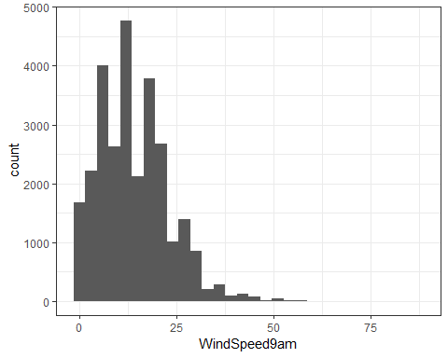

ggplot(rain3, aes(x=WindSpeed3pm)) + geom_histogram() + theme_bw()

## `stat_bin()` using `bins = 30`. Pick better value with `binwidth`.

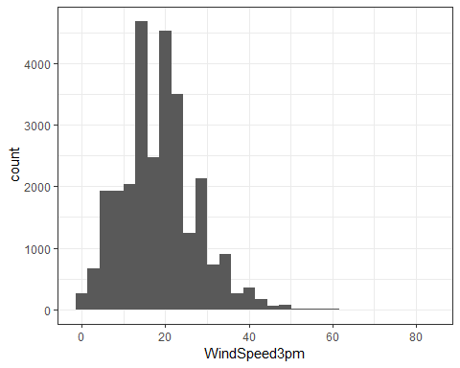

ggplot(rain3, aes(x=Humidity9am)) + geom_histogram() + theme_bw()

## `stat_bin()` using `bins = 30`. Pick better value with `binwidth`.

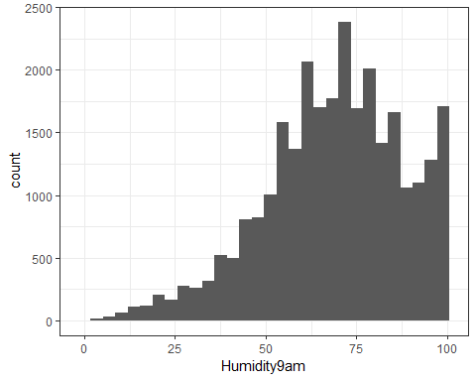

ggplot(rain3, aes(x=Humidity3pm)) + geom_histogram() + theme_bw()

## `stat_bin()` using `bins = 30`. Pick better value with `binwidth`.

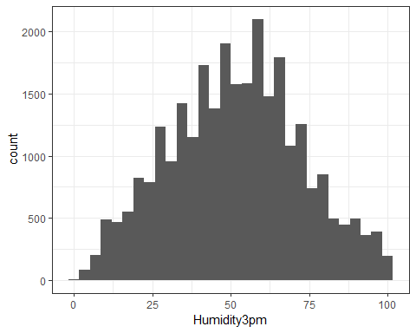

ggplot(rain3, aes(x=Pressure9am)) + geom_histogram() + theme_bw()

## `stat_bin()` using `bins = 30`. Pick better value with `binwidth`.

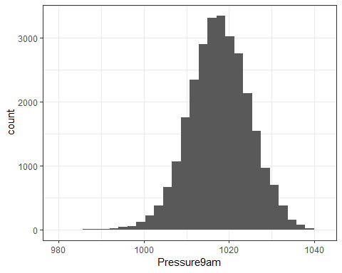

ggplot(rain3, aes(x=Pressure3pm)) + geom_histogram() + theme_bw()

## `stat_bin()` using `bins = 30`. Pick better value with `binwidth`.

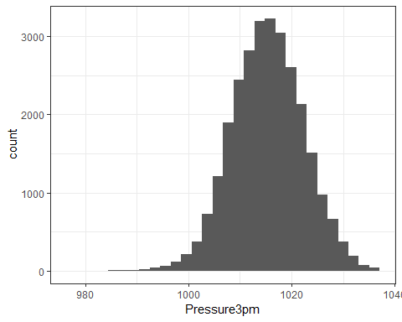

ggplot(rain3, aes(x=Cloud9am)) + geom_histogram() + theme_bw()

## `stat_bin()` using `bins = 30`. Pick better value with `binwidth`.

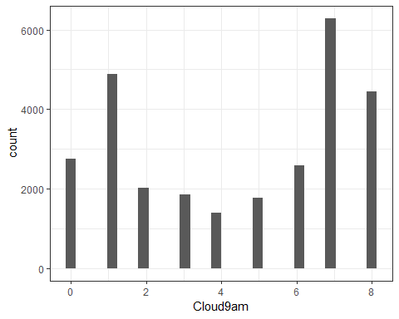

ggplot(rain3, aes(x=Cloud3pm)) + geom_histogram() + theme_bw()

## `stat_bin()` using `bins = 30`. Pick better value with `binwidth`.

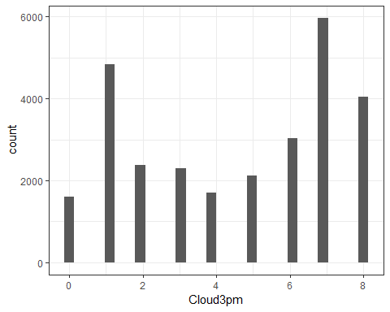

ggplot(rain3, aes(x=Temp9am)) + geom_histogram() + theme_bw()

## `stat_bin()` using `bins = 30`. Pick better value with `binwidth`.

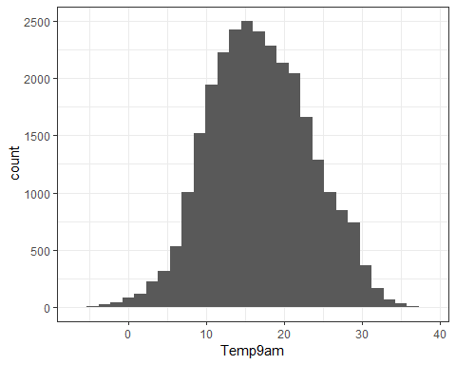

ggplot(rain3, aes(x=Temp3pm)) + geom_histogram() + theme_bw()

## `stat_bin()` using `bins = 30`. Pick better value with `binwidth`.

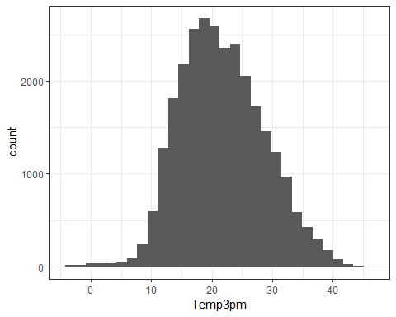

t1 = table(rain3$RainTomorrow,rain3$MinTemp)  
prop.table(t1, margin = 2)

##   
## -8.5 -8 -7.3 -7 -6.7 -6.6  
## No 1.00000000 1.00000000 1.00000000 0.00000000 1.00000000 1.00000000  
## Yes 0.00000000 0.00000000 0.00000000 1.00000000 0.00000000 0.00000000  
##   
## -6.5 -6.1 -6 -5.9 -5.8 -5.6  
## No 1.00000000 1.00000000 0.66666667 1.00000000 1.00000000 1.00000000  
## Yes 0.00000000 0.00000000 0.33333333 0.00000000 0.00000000 0.00000000  
##   
## -5.5 -5.4 -5.3 -5.2 -5.1 -5  
## No 0.66666667 1.00000000 1.00000000 0.66666667 1.00000000 1.00000000  
## Yes 0.33333333 0.00000000 0.00000000 0.33333333 0.00000000 0.00000000  
##   
## -4.8 -4.7 -4.6 -4.5 -4.4 -4.3  
## No 0.66666667 0.50000000 1.00000000 0.87500000 0.75000000 0.85714286  
## Yes 0.33333333 0.50000000 0.00000000 0.12500000 0.25000000 0.14285714  
##   
## -4.2 -4.1 -4 -3.9 -3.8 -3.7  
## No 1.00000000 0.80000000 0.80000000 1.00000000 0.77777778 0.71428571  
## Yes 0.00000000 0.20000000 0.20000000 0.00000000 0.22222222 0.28571429  
##   
## -3.6 -3.5 -3.4 -3.3 -3.2 -3.1  
## No 0.87500000 0.88888889 0.78571429 0.87500000 1.00000000 1.00000000  
## Yes 0.12500000 0.11111111 0.21428571 0.12500000 0.00000000 0.00000000  
##   
## -3 -2.9 -2.8 -2.7 -2.6 -2.5  
## No 1.00000000 0.50000000 1.00000000 0.88888889 0.83333333 0.71428571  
## Yes 0.00000000 0.50000000 0.00000000 0.11111111 0.16666667 0.28571429  
##   
## -2.4 -2.3 -2.2 -2.1 -2 -1.9  
## No 0.81818182 1.00000000 0.69230769 0.88235294 1.00000000 0.75000000  
## Yes 0.18181818 0.00000000 0.30769231 0.11764706 0.00000000 0.25000000  
##   
## -1.8 -1.7 -1.6 -1.5 -1.4 -1.3  
## No 0.80000000 0.76923077 0.78947368 0.97142857 1.00000000 0.92857143  
## Yes 0.20000000 0.23076923 0.21052632 0.02857143 0.00000000 0.07142857  
##   
## -1.2 -1.1 -1 -0.9 -0.8 -0.7  
## No 1.00000000 0.85714286 0.93750000 0.81481481 0.95833333 1.00000000  
## Yes 0.00000000 0.14285714 0.06250000 0.18518519 0.04166667 0.00000000  
##   
## -0.6 -0.5 -0.4 -0.3 -0.2 -0.1  
## No 0.90476190 0.80555556 0.87500000 0.87500000 0.84848485 0.87500000  
## Yes 0.09523810 0.19444444 0.12500000 0.12500000 0.15151515 0.12500000  
##   
## 0 0.1 0.2 0.3 0.4 0.5  
## No 0.87096774 0.94444444 0.87096774 0.89285714 0.90476190 0.86363636  
## Yes 0.12903226 0.05555556 0.12903226 0.10714286 0.09523810 0.13636364  
##   
## 0.6 0.7 0.8 0.9 1 1.1  
## No 0.90000000 0.91891892 0.88372093 0.91489362 0.86111111 0.85416667  
## Yes 0.10000000 0.08108108 0.11627907 0.08510638 0.13888889 0.14583333  
##   
## 1.2 1.3 1.4 1.5 1.6 1.7  
## No 0.93617021 0.88636364 0.95121951 0.73529412 0.80000000 0.91071429  
## Yes 0.06382979 0.11363636 0.04878049 0.26470588 0.20000000 0.08928571  
##   
## 1.8 1.9 2 2.1 2.2 2.3  
## No 0.92592593 0.87755102 0.89130435 0.88524590 0.88888889 0.89285714  
## Yes 0.07407407 0.12244898 0.10869565 0.11475410 0.11111111 0.10714286  
##   
## 2.4 2.5 2.6 2.7 2.8 2.9  
## No 0.87755102 0.79452055 0.89062500 0.87209302 0.77777778 0.87878788  
## Yes 0.12244898 0.20547945 0.10937500 0.12790698 0.22222222 0.12121212  
##   
## 3 3.1 3.2 3.3 3.4 3.5  
## No 0.89830508 0.86764706 0.82432432 0.87301587 0.91304348 0.83561644  
## Yes 0.10169492 0.13235294 0.17567568 0.12698413 0.08695652 0.16438356  
##   
## 3.6 3.7 3.8 3.9 4 4.1  
## No 0.84722222 0.83783784 0.83823529 0.90666667 0.80000000 0.83333333  
## Yes 0.15277778 0.16216216 0.16176471 0.09333333 0.20000000 0.16666667  
##   
## 4.2 4.3 4.4 4.5 4.6 4.7  
## No 0.73404255 0.86419753 0.82000000 0.77528090 0.80219780 0.84782609  
## Yes 0.26595745 0.13580247 0.18000000 0.22471910 0.19780220 0.15217391  
##   
## 4.8 4.9 5 5.1 5.2 5.3  
## No 0.78021978 0.81000000 0.79130435 0.80952381 0.81720430 0.86021505  
## Yes 0.21978022 0.19000000 0.20869565 0.19047619 0.18279570 0.13978495  
##   
## 5.4 5.5 5.6 5.7 5.8 5.9  
## No 0.81196581 0.83333333 0.85585586 0.81451613 0.73809524 0.80645161  
## Yes 0.18803419 0.16666667 0.14414414 0.18548387 0.26190476 0.19354839  
##   
## 6 6.1 6.2 6.3 6.4 6.5  
## No 0.83673469 0.84210526 0.78358209 0.78260870 0.76315789 0.80357143  
## Yes 0.16326531 0.15789474 0.21641791 0.21739130 0.23684211 0.19642857  
##   
## 6.6 6.7 6.8 6.9 7 7.1  
## No 0.83125000 0.79545455 0.80597015 0.80740741 0.79856115 0.76821192  
## Yes 0.16875000 0.20454545 0.19402985 0.19259259 0.20143885 0.23178808  
##   
## 7.2 7.3 7.4 7.5 7.6 7.7  
## No 0.76712329 0.79470199 0.75833333 0.75974026 0.76100629 0.74482759  
## Yes 0.23287671 0.20529801 0.24166667 0.24025974 0.23899371 0.25517241  
##   
## 7.8 7.9 8 8.1 8.2 8.3  
## No 0.76433121 0.78620690 0.74647887 0.76470588 0.78289474 0.75609756  
## Yes 0.23566879 0.21379310 0.25352113 0.23529412 0.21710526 0.24390244  
##   
## 8.4 8.5 8.6 8.7 8.8 8.9  
## No 0.78709677 0.76300578 0.80666667 0.73825503 0.80000000 0.80571429  
## Yes 0.21290323 0.23699422 0.19333333 0.26174497 0.20000000 0.19428571  
##   
## 9 9.1 9.2 9.3 9.4 9.5  
## No 0.79881657 0.77222222 0.82119205 0.74691358 0.72592593 0.75449102  
## Yes 0.20118343 0.22777778 0.17880795 0.25308642 0.27407407 0.24550898  
##   
## 9.6 9.7 9.8 9.9 10 10.1  
## No 0.78235294 0.79591837 0.79503106 0.80000000 0.80116959 0.77987421  
## Yes 0.21764706 0.20408163 0.20496894 0.20000000 0.19883041 0.22012579  
##   
## 10.2 10.3 10.4 10.5 10.6 10.7  
## No 0.74342105 0.73437500 0.69186047 0.77777778 0.79054054 0.71111111  
## Yes 0.25657895 0.26562500 0.30813953 0.22222222 0.20945946 0.28888889  
##   
## 10.8 10.9 11 11.1 11.2 11.3  
## No 0.72891566 0.79581152 0.74456522 0.76623377 0.72955975 0.73684211  
## Yes 0.27108434 0.20418848 0.25543478 0.23376623 0.27044025 0.26315789  
##   
## 11.4 11.5 11.6 11.7 11.8 11.9  
## No 0.73584906 0.73913043 0.75000000 0.76331361 0.73410405 0.72784810  
## Yes 0.26415094 0.26086957 0.25000000 0.23668639 0.26589595 0.27215190  
##   
## 12 12.1 12.2 12.3 12.4 12.5  
## No 0.76000000 0.76433121 0.77777778 0.80281690 0.77272727 0.82758621  
## Yes 0.24000000 0.23566879 0.22222222 0.19718310 0.22727273 0.17241379  
##   
## 12.6 12.7 12.8 12.9 13 13.1  
## No 0.73026316 0.74050633 0.77070064 0.77272727 0.76100629 0.79113924  
## Yes 0.26973684 0.25949367 0.22929936 0.22727273 0.23899371 0.20886076  
##   
## 13.2 13.3 13.4 13.5 13.6 13.7  
## No 0.83439490 0.75362319 0.79289941 0.77173913 0.73780488 0.77333333  
## Yes 0.16560510 0.24637681 0.20710059 0.22826087 0.26219512 0.22666667  
##   
## 13.8 13.9 14 14.1 14.2 14.3  
## No 0.77777778 0.74683544 0.78911565 0.80158730 0.76027397 0.75182482  
## Yes 0.22222222 0.25316456 0.21088435 0.19841270 0.23972603 0.24817518  
##   
## 14.4 14.5 14.6 14.7 14.8 14.9  
## No 0.82733813 0.73417722 0.82666667 0.75886525 0.74452555 0.77777778  
## Yes 0.17266187 0.26582278 0.17333333 0.24113475 0.25547445 0.22222222  
##   
## 15 15.1 15.2 15.3 15.4 15.5  
## No 0.80000000 0.76612903 0.79850746 0.85365854 0.79720280 0.77922078  
## Yes 0.20000000 0.23387097 0.20149254 0.14634146 0.20279720 0.22077922  
##   
## 15.6 15.7 15.8 15.9 16 16.1  
## No 0.80434783 0.81632653 0.76923077 0.79389313 0.82031250 0.79508197  
## Yes 0.19565217 0.18367347 0.23076923 0.20610687 0.17968750 0.20491803  
##   
## 16.2 16.3 16.4 16.5 16.6 16.7  
## No 0.79020979 0.76335878 0.74814815 0.78400000 0.79687500 0.78225806  
## Yes 0.20979021 0.23664122 0.25185185 0.21600000 0.20312500 0.21774194  
##   
## 16.8 16.9 17 17.1 17.2 17.3  
## No 0.81355932 0.76842105 0.82644628 0.72000000 0.81300813 0.77586207  
## Yes 0.18644068 0.23157895 0.17355372 0.28000000 0.18699187 0.22413793  
##   
## 17.4 17.5 17.6 17.7 17.8 17.9  
## No 0.78378378 0.76422764 0.70689655 0.75229358 0.80833333 0.78787879  
## Yes 0.21621622 0.23577236 0.29310345 0.24770642 0.19166667 0.21212121  
##   
## 18 18.1 18.2 18.3 18.4 18.5  
## No 0.77118644 0.81188119 0.78151261 0.67592593 0.73275862 0.68421053  
## Yes 0.22881356 0.18811881 0.21848739 0.32407407 0.26724138 0.31578947  
##   
## 18.6 18.7 18.8 18.9 19 19.1  
## No 0.66990291 0.78301887 0.73737374 0.75652174 0.70422535 0.80000000  
## Yes 0.33009709 0.21698113 0.26262626 0.24347826 0.29577465 0.20000000  
##   
## 19.2 19.3 19.4 19.5 19.6 19.7  
## No 0.79268293 0.77108434 0.66990291 0.71428571 0.79611650 0.71428571  
## Yes 0.20731707 0.22891566 0.33009709 0.28571429 0.20388350 0.28571429  
##   
## 19.8 19.9 20 20.1 20.2 20.3  
## No 0.76576577 0.77000000 0.72463768 0.66279070 0.76344086 0.70212766  
## Yes 0.23423423 0.23000000 0.27536232 0.33720930 0.23655914 0.29787234  
##   
## 20.4 20.5 20.6 20.7 20.8 20.9  
## No 0.73255814 0.77894737 0.75824176 0.71641791 0.73333333 0.77922078  
## Yes 0.26744186 0.22105263 0.24175824 0.28358209 0.26666667 0.22077922  
##   
## 21 21.1 21.2 21.3 21.4 21.5  
## No 0.81159420 0.68604651 0.80519481 0.73846154 0.71428571 0.72368421  
## Yes 0.18840580 0.31395349 0.19480519 0.26153846 0.28571429 0.27631579  
##   
## 21.6 21.7 21.8 21.9 22 22.1  
## No 0.79710145 0.81967213 0.76056338 0.77358491 0.67605634 0.71153846  
## Yes 0.20289855 0.18032787 0.23943662 0.22641509 0.32394366 0.28846154  
##   
## 22.2 22.3 22.4 22.5 22.6 22.7  
## No 0.75000000 0.66000000 0.78125000 0.77777778 0.75000000 0.73913043  
## Yes 0.25000000 0.34000000 0.21875000 0.22222222 0.25000000 0.26086957  
##   
## 22.8 22.9 23 23.1 23.2 23.3  
## No 0.68627451 0.67346939 0.69387755 0.71153846 0.80434783 0.68292683  
## Yes 0.31372549 0.32653061 0.30612245 0.28846154 0.19565217 0.31707317  
##   
## 23.4 23.5 23.6 23.7 23.8 23.9  
## No 0.64444444 0.59259259 0.67441860 0.68627451 0.53846154 0.64000000  
## Yes 0.35555556 0.40740741 0.32558140 0.31372549 0.46153846 0.36000000  
##   
## 24 24.1 24.2 24.3 24.4 24.5  
## No 0.63636364 0.63265306 0.60000000 0.66666667 0.67500000 0.60000000  
## Yes 0.36363636 0.36734694 0.40000000 0.33333333 0.32500000 0.40000000  
##   
## 24.6 24.7 24.8 24.9 25 25.1  
## No 0.43750000 0.52500000 0.55102041 0.60714286 0.75675676 0.58064516  
## Yes 0.56250000 0.47500000 0.44897959 0.39285714 0.24324324 0.41935484  
##   
## 25.2 25.3 25.4 25.5 25.6 25.7  
## No 0.69696970 0.56666667 0.69230769 0.60606061 0.70588235 0.76923077  
## Yes 0.30303030 0.43333333 0.30769231 0.39393939 0.29411765 0.23076923  
##   
## 25.8 25.9 26 26.1 26.2 26.3  
## No 0.46666667 0.57142857 0.60000000 0.68421053 0.66666667 0.61538462  
## Yes 0.53333333 0.42857143 0.40000000 0.31578947 0.33333333 0.38461538  
##   
## 26.4 26.5 26.6 26.7 26.8 26.9  
## No 0.80000000 0.66666667 0.62500000 0.66666667 0.33333333 0.83333333  
## Yes 0.20000000 0.33333333 0.37500000 0.33333333 0.66666667 0.16666667  
##   
## 27 27.1 27.2 27.3 27.4 27.5  
## No 0.57142857 0.75000000 0.57142857 0.60000000 0.60000000 0.75000000  
## Yes 0.42857143 0.25000000 0.42857143 0.40000000 0.40000000 0.25000000  
##   
## 27.6 27.7 27.8 27.9 28 28.1  
## No 1.00000000 0.85714286 1.00000000 0.66666667 0.33333333 1.00000000  
## Yes 0.00000000 0.14285714 0.00000000 0.33333333 0.66666667 0.00000000  
##   
## 28.2 28.3 28.4 28.5 28.6 28.7  
## No 0.75000000 0.50000000 0.50000000 1.00000000 0.50000000 1.00000000  
## Yes 0.25000000 0.50000000 0.50000000 0.00000000 0.50000000 0.00000000  
##   
## 28.8 28.9 29 29.4 29.6 29.7  
## No 0.66666667 1.00000000 1.00000000 1.00000000 1.00000000 1.00000000  
## Yes 0.33333333 0.00000000 0.00000000 0.00000000 0.00000000 0.00000000  
##   
## 30.5  
## No 1.00000000  
## Yes 0.00000000

t2 = table(rain3$RainTomorrow,rain3$MaxTemp)  
prop.table(t2, margin = 2)

##   
## -3 -2.9 -2.5 -2.3 -2.2 -2.1  
## No 0.00000000 0.00000000 0.00000000 1.00000000 0.00000000 0.00000000  
## Yes 1.00000000 1.00000000 1.00000000 0.00000000 1.00000000 1.00000000  
##   
## -1.5 -1.4 -1.3 -1.2 -1.1 -1  
## No 1.00000000 0.50000000 0.00000000 0.00000000 0.00000000 0.00000000  
## Yes 0.00000000 0.50000000 1.00000000 1.00000000 1.00000000 1.00000000  
##   
## -0.9 -0.8 -0.7 -0.5 -0.4 -0.3  
## No 0.00000000 0.50000000 0.00000000 0.00000000 1.00000000 0.50000000  
## Yes 1.00000000 0.50000000 1.00000000 1.00000000 0.00000000 0.50000000  
##   
## -0.2 -0.1 0 0.1 0.2 0.3  
## No 0.00000000 0.00000000 0.33333333 0.00000000 1.00000000 0.50000000  
## Yes 1.00000000 1.00000000 0.66666667 1.00000000 0.00000000 0.50000000  
##   
## 0.4 0.6 0.8 0.9 1 1.1  
## No 0.50000000 0.66666667 0.50000000 0.00000000 1.00000000 0.50000000  
## Yes 0.50000000 0.33333333 0.50000000 1.00000000 0.00000000 0.50000000  
##   
## 1.2 1.3 1.4 1.6 1.7 1.9  
## No 1.00000000 0.50000000 0.50000000 0.00000000 0.00000000 0.50000000  
## Yes 0.00000000 0.50000000 0.50000000 1.00000000 1.00000000 0.50000000  
##   
## 2 2.1 2.2 2.3 2.4 2.5  
## No 1.00000000 1.00000000 0.50000000 1.00000000 1.00000000 0.75000000  
## Yes 0.00000000 0.00000000 0.50000000 0.00000000 0.00000000 0.25000000  
##   
## 2.6 2.7 2.9 3 3.1 3.2  
## No 0.66666667 0.66666667 1.00000000 0.50000000 0.50000000 1.00000000  
## Yes 0.33333333 0.33333333 0.00000000 0.50000000 0.50000000 0.00000000  
##   
## 3.3 3.4 3.5 3.6 3.7 3.8  
## No 1.00000000 1.00000000 0.33333333 0.66666667 1.00000000 0.57142857  
## Yes 0.00000000 0.00000000 0.66666667 0.33333333 0.00000000 0.42857143  
##   
## 3.9 4 4.1 4.2 4.3 4.4  
## No 0.66666667 0.66666667 1.00000000 0.00000000 1.00000000 1.00000000  
## Yes 0.33333333 0.33333333 0.00000000 1.00000000 0.00000000 0.00000000  
##   
## 4.5 4.7 4.8 4.9 5 5.1  
## No 1.00000000 0.50000000 0.50000000 1.00000000 0.00000000 0.75000000  
## Yes 0.00000000 0.50000000 0.50000000 0.00000000 1.00000000 0.25000000  
##   
## 5.2 5.3 5.4 5.6 5.7 5.8  
## No 0.71428571 0.66666667 1.00000000 0.50000000 1.00000000 1.00000000  
## Yes 0.28571429 0.33333333 0.00000000 0.50000000 0.00000000 0.00000000  
##   
## 5.9 6 6.1 6.3 6.4 6.5  
## No 1.00000000 0.50000000 1.00000000 0.66666667 1.00000000 1.00000000  
## Yes 0.00000000 0.50000000 0.00000000 0.33333333 0.00000000 0.00000000  
##   
## 6.6 6.8 6.9 7 7.1 7.2  
## No 0.60000000 0.33333333 1.00000000 0.00000000 0.25000000 0.50000000  
## Yes 0.40000000 0.66666667 0.00000000 1.00000000 0.75000000 0.50000000  
##   
## 7.3 7.4 7.5 7.6 7.7 7.8  
## No 0.80000000 1.00000000 0.75000000 0.50000000 0.50000000 0.42857143  
## Yes 0.20000000 0.00000000 0.25000000 0.50000000 0.50000000 0.57142857  
##   
## 7.9 8 8.1 8.2 8.3 8.4  
## No 0.11111111 1.00000000 0.50000000 0.75000000 0.71428571 0.50000000  
## Yes 0.88888889 0.00000000 0.50000000 0.25000000 0.28571429 0.50000000  
##   
## 8.5 8.6 8.7 8.8 8.9 9  
## No 0.60000000 0.33333333 0.50000000 0.54545455 0.71428571 0.83333333  
## Yes 0.40000000 0.66666667 0.50000000 0.45454545 0.28571429 0.16666667  
##   
## 9.1 9.2 9.3 9.4 9.5 9.6  
## No 0.70000000 0.60000000 0.41666667 0.50000000 0.16666667 0.42857143  
## Yes 0.30000000 0.40000000 0.58333333 0.50000000 0.83333333 0.57142857  
##   
## 9.7 9.8 9.9 10 10.1 10.2  
## No 0.38461538 0.54545455 0.61538462 0.72222222 0.57894737 0.60000000  
## Yes 0.61538462 0.45454545 0.38461538 0.27777778 0.42105263 0.40000000  
##   
## 10.3 10.4 10.5 10.6 10.7 10.8  
## No 0.53333333 0.58333333 0.72727273 0.61111111 0.84210526 0.56521739  
## Yes 0.46666667 0.41666667 0.27272727 0.38888889 0.15789474 0.43478261  
##   
## 10.9 11 11.1 11.2 11.3 11.4  
## No 0.50000000 0.61904762 0.65625000 0.65517241 0.70588235 0.52941176  
## Yes 0.50000000 0.38095238 0.34375000 0.34482759 0.29411765 0.47058824  
##   
## 11.5 11.6 11.7 11.8 11.9 12  
## No 0.68292683 0.45000000 0.57142857 0.67441860 0.62264151 0.65853659  
## Yes 0.31707317 0.55000000 0.42857143 0.32558140 0.37735849 0.34146341  
##   
## 12.1 12.2 12.3 12.4 12.5 12.6  
## No 0.63793103 0.66666667 0.56410256 0.61643836 0.46774194 0.68493151  
## Yes 0.36206897 0.33333333 0.43589744 0.38356164 0.53225806 0.31506849  
##   
## 12.7 12.8 12.9 13 13.1 13.2  
## No 0.67741935 0.60759494 0.62500000 0.73076923 0.67142857 0.57971014  
## Yes 0.32258065 0.39240506 0.37500000 0.26923077 0.32857143 0.42028986  
##   
## 13.3 13.4 13.5 13.6 13.7 13.8  
## No 0.57894737 0.65671642 0.75714286 0.72340426 0.68131868 0.58823529  
## Yes 0.42105263 0.34328358 0.24285714 0.27659574 0.31868132 0.41176471  
##   
## 13.9 14 14.1 14.2 14.3 14.4  
## No 0.71604938 0.70786517 0.70833333 0.56842105 0.64000000 0.63000000  
## Yes 0.28395062 0.29213483 0.29166667 0.43157895 0.36000000 0.37000000  
##   
## 14.5 14.6 14.7 14.8 14.9 15  
## No 0.63541667 0.68141593 0.65217391 0.74107143 0.67032967 0.69298246  
## Yes 0.36458333 0.31858407 0.34782609 0.25892857 0.32967033 0.30701754  
##   
## 15.1 15.2 15.3 15.4 15.5 15.6  
## No 0.67961165 0.73437500 0.69696970 0.68041237 0.75454545 0.70093458  
## Yes 0.32038835 0.26562500 0.30303030 0.31958763 0.24545455 0.29906542  
##   
## 15.7 15.8 15.9 16 16.1 16.2  
## No 0.64912281 0.74336283 0.71311475 0.75000000 0.72727273 0.69047619  
## Yes 0.35087719 0.25663717 0.28688525 0.25000000 0.27272727 0.30952381  
##   
## 16.3 16.4 16.5 16.6 16.7 16.8  
## No 0.65765766 0.72033898 0.73170732 0.76800000 0.68333333 0.73451327  
## Yes 0.34234234 0.27966102 0.26829268 0.23200000 0.31666667 0.26548673  
##   
## 16.9 17 17.1 17.2 17.3 17.4  
## No 0.77952756 0.69277108 0.75423729 0.70198675 0.70731707 0.66187050  
## Yes 0.22047244 0.30722892 0.24576271 0.29801325 0.29268293 0.33812950  
##   
## 17.5 17.6 17.7 17.8 17.9 18  
## No 0.68840580 0.74000000 0.75757576 0.67832168 0.72058824 0.72500000  
## Yes 0.31159420 0.26000000 0.24242424 0.32167832 0.27941176 0.27500000  
##   
## 18.1 18.2 18.3 18.4 18.5 18.6  
## No 0.73684211 0.75657895 0.62666667 0.74305556 0.77018634 0.70921986  
## Yes 0.26315789 0.24342105 0.37333333 0.25694444 0.22981366 0.29078014  
##   
## 18.7 18.8 18.9 19 19.1 19.2  
## No 0.74468085 0.75510204 0.68181818 0.77848101 0.68702290 0.72180451  
## Yes 0.25531915 0.24489796 0.31818182 0.22151899 0.31297710 0.27819549  
##   
## 19.3 19.4 19.5 19.6 19.7 19.8  
## No 0.75159236 0.75172414 0.73026316 0.73248408 0.69918699 0.81632653  
## Yes 0.24840764 0.24827586 0.26973684 0.26751592 0.30081301 0.18367347  
##   
## 19.9 20 20.1 20.2 20.3 20.4  
## No 0.81707317 0.77005348 0.74691358 0.70760234 0.80821918 0.71232877  
## Yes 0.18292683 0.22994652 0.25308642 0.29239766 0.19178082 0.28767123  
##   
## 20.5 20.6 20.7 20.8 20.9 21  
## No 0.77333333 0.82000000 0.77852349 0.75757576 0.75862069 0.79518072  
## Yes 0.22666667 0.18000000 0.22147651 0.24242424 0.24137931 0.20481928  
##   
## 21.1 21.2 21.3 21.4 21.5 21.6  
## No 0.79245283 0.79220779 0.73381295 0.75625000 0.79629630 0.81617647  
## Yes 0.20754717 0.20779221 0.26618705 0.24375000 0.20370370 0.18382353  
##   
## 21.7 21.8 21.9 22 22.1 22.2  
## No 0.82634731 0.83766234 0.77165354 0.72666667 0.75912409 0.78947368  
## Yes 0.17365269 0.16233766 0.22834646 0.27333333 0.24087591 0.21052632  
##   
## 22.3 22.4 22.5 22.6 22.7 22.8  
## No 0.79411765 0.83333333 0.77777778 0.81045752 0.78688525 0.83846154  
## Yes 0.20588235 0.16666667 0.22222222 0.18954248 0.21311475 0.16153846  
##   
## 22.9 23 23.1 23.2 23.3 23.4  
## No 0.82580645 0.76027397 0.78906250 0.75630252 0.78400000 0.77397260  
## Yes 0.17419355 0.23972603 0.21093750 0.24369748 0.21600000 0.22602740  
##   
## 23.5 23.6 23.7 23.8 23.9 24  
## No 0.82575758 0.82442748 0.79090909 0.75590551 0.81595092 0.84397163  
## Yes 0.17424242 0.17557252 0.20909091 0.24409449 0.18404908 0.15602837  
##   
## 24.1 24.2 24.3 24.4 24.5 24.6  
## No 0.88617886 0.87804878 0.84800000 0.80327869 0.87301587 0.81060606  
## Yes 0.11382114 0.12195122 0.15200000 0.19672131 0.12698413 0.18939394  
##   
## 24.7 24.8 24.9 25 25.1 25.2  
## No 0.82170543 0.81818182 0.88617886 0.79113924 0.83593750 0.79661017  
## Yes 0.17829457 0.18181818 0.11382114 0.20886076 0.16406250 0.20338983  
##   
## 25.3 25.4 25.5 25.6 25.7 25.8  
## No 0.80357143 0.82170543 0.84496124 0.84328358 0.76785714 0.81818182  
## Yes 0.19642857 0.17829457 0.15503876 0.15671642 0.23214286 0.18181818  
##   
## 25.9 26 26.1 26.2 26.3 26.4  
## No 0.88333333 0.81118881 0.76388889 0.85714286 0.85294118 0.82727273  
## Yes 0.11666667 0.18881119 0.23611111 0.14285714 0.14705882 0.17272727  
##   
## 26.5 26.6 26.7 26.8 26.9 27  
## No 0.81746032 0.83809524 0.84892086 0.84259259 0.79816514 0.75555556  
## Yes 0.18253968 0.16190476 0.15107914 0.15740741 0.20183486 0.24444444  
##   
## 27.1 27.2 27.3 27.4 27.5 27.6  
## No 0.84615385 0.86466165 0.79090909 0.78861789 0.81372549 0.80769231  
## Yes 0.15384615 0.13533835 0.20909091 0.21138211 0.18627451 0.19230769  
##   
## 27.7 27.8 27.9 28 28.1 28.2  
## No 0.78846154 0.83516484 0.87301587 0.72972973 0.82352941 0.83620690  
## Yes 0.21153846 0.16483516 0.12698413 0.27027027 0.17647059 0.16379310  
##   
## 28.3 28.4 28.5 28.6 28.7 28.8  
## No 0.87628866 0.82692308 0.88596491 0.84848485 0.85585586 0.88596491  
## Yes 0.12371134 0.17307692 0.11403509 0.15151515 0.14414414 0.11403509  
##   
## 28.9 29 29.1 29.2 29.3 29.4  
## No 0.86315789 0.83962264 0.82352941 0.85263158 0.83505155 0.85567010  
## Yes 0.13684211 0.16037736 0.17647059 0.14736842 0.16494845 0.14432990  
##   
## 29.5 29.6 29.7 29.8 29.9 30  
## No 0.81481481 0.87951807 0.84337349 0.86315789 0.77419355 0.85344828  
## Yes 0.18518519 0.12048193 0.15662651 0.13684211 0.22580645 0.14655172  
##   
## 30.1 30.2 30.3 30.4 30.5 30.6  
## No 0.83561644 0.83333333 0.87368421 0.82417582 0.81904762 0.85882353  
## Yes 0.16438356 0.16666667 0.12631579 0.17582418 0.18095238 0.14117647  
##   
## 30.7 30.8 30.9 31 31.1 31.2  
## No 0.75324675 0.81632653 0.79761905 0.72222222 0.86046512 0.81521739  
## Yes 0.24675325 0.18367347 0.20238095 0.27777778 0.13953488 0.18478261  
##   
## 31.3 31.4 31.5 31.6 31.7 31.8  
## No 0.79220779 0.82857143 0.81521739 0.75903614 0.81159420 0.83950617  
## Yes 0.20779221 0.17142857 0.18478261 0.24096386 0.18840580 0.16049383  
##   
## 31.9 32 32.1 32.2 32.3 32.4  
## No 0.75581395 0.82222222 0.80246914 0.90476190 0.67123288 0.78947368  
## Yes 0.24418605 0.17777778 0.19753086 0.09523810 0.32876712 0.21052632  
##   
## 32.5 32.6 32.7 32.8 32.9 33  
## No 0.84946237 0.84615385 0.84285714 0.83561644 0.90140845 0.88235294  
## Yes 0.15053763 0.15384615 0.15714286 0.16438356 0.09859155 0.11764706  
##   
## 33.1 33.2 33.3 33.4 33.5 33.6  
## No 0.76923077 0.84210526 0.82857143 0.70967742 0.82539683 0.82608696  
## Yes 0.23076923 0.15789474 0.17142857 0.29032258 0.17460317 0.17391304  
##   
## 33.7 33.8 33.9 34 34.1 34.2  
## No 0.83870968 0.79245283 0.89230769 0.80000000 0.79310345 0.82456140  
## Yes 0.16129032 0.20754717 0.10769231 0.20000000 0.20689655 0.17543860  
##   
## 34.3 34.4 34.5 34.6 34.7 34.8  
## No 0.75000000 0.90909091 0.82352941 0.86666667 0.87179487 0.91666667  
## Yes 0.25000000 0.09090909 0.17647059 0.13333333 0.12820513 0.08333333  
##   
## 34.9 35 35.1 35.2 35.3 35.4  
## No 0.82352941 0.90476190 0.88095238 0.90243902 0.81818182 0.93181818  
## Yes 0.17647059 0.09523810 0.11904762 0.09756098 0.18181818 0.06818182  
##   
## 35.5 35.6 35.7 35.8 35.9 36  
## No 0.90243902 0.89189189 0.90000000 0.92592593 0.88000000 0.82758621  
## Yes 0.09756098 0.10810811 0.10000000 0.07407407 0.12000000 0.17241379  
##   
## 36.1 36.2 36.3 36.4 36.5 36.6  
## No 0.88888889 0.96428571 0.91176471 0.86956522 0.82352941 0.95454545  
## Yes 0.11111111 0.03571429 0.08823529 0.13043478 0.17647059 0.04545455  
##   
## 36.7 36.8 36.9 37 37.1 37.2  
## No 0.91304348 0.91304348 0.85714286 0.89189189 0.97058824 0.91428571  
## Yes 0.08695652 0.08695652 0.14285714 0.10810811 0.02941176 0.08571429  
##   
## 37.3 37.4 37.5 37.6 37.7 37.8  
## No 0.95833333 0.85714286 0.83333333 0.75000000 0.88461538 1.00000000  
## Yes 0.04166667 0.14285714 0.16666667 0.25000000 0.11538462 0.00000000  
##   
## 37.9 38 38.1 38.2 38.3 38.4  
## No 1.00000000 0.86363636 0.94444444 0.86956522 1.00000000 0.78947368  
## Yes 0.00000000 0.13636364 0.05555556 0.13043478 0.00000000 0.21052632  
##   
## 38.5 38.6 38.7 38.8 38.9 39  
## No 0.85714286 0.94736842 0.91666667 0.95652174 0.83333333 0.90476190  
## Yes 0.14285714 0.05263158 0.08333333 0.04347826 0.16666667 0.09523810  
##   
## 39.1 39.2 39.3 39.4 39.5 39.6  
## No 0.91304348 1.00000000 0.95000000 1.00000000 0.83333333 0.92307692  
## Yes 0.08695652 0.00000000 0.05000000 0.00000000 0.16666667 0.07692308  
##   
## 39.7 39.8 39.9 40 40.1 40.2  
## No 0.85714286 0.92000000 0.92000000 0.75000000 0.75000000 0.85714286  
## Yes 0.14285714 0.08000000 0.08000000 0.25000000 0.25000000 0.14285714  
##   
## 40.3 40.4 40.5 40.6 40.7 40.8  
## No 0.82352941 0.83333333 0.93333333 0.88888889 0.90000000 1.00000000  
## Yes 0.17647059 0.16666667 0.06666667 0.11111111 0.10000000 0.00000000  
##   
## 40.9 41 41.1 41.2 41.3 41.4  
## No 0.78571429 1.00000000 1.00000000 1.00000000 1.00000000 1.00000000  
## Yes 0.21428571 0.00000000 0.00000000 0.00000000 0.00000000 0.00000000  
##   
## 41.5 41.6 41.7 41.8 41.9 42  
## No 0.87500000 1.00000000 1.00000000 1.00000000 0.83333333 1.00000000  
## Yes 0.12500000 0.00000000 0.00000000 0.00000000 0.16666667 0.00000000  
##   
## 42.1 42.2 42.3 42.4 42.5 42.6  
## No 0.87500000 1.00000000 1.00000000 0.83333333 0.42857143 1.00000000  
## Yes 0.12500000 0.00000000 0.00000000 0.16666667 0.57142857 0.00000000  
##   
## 42.7 42.8 42.9 43 43.1 43.2  
## No 1.00000000 1.00000000 1.00000000 0.75000000 1.00000000 1.00000000  
## Yes 0.00000000 0.00000000 0.00000000 0.25000000 0.00000000 0.00000000  
##   
## 43.3 43.4 43.5 43.6 43.7 43.8  
## No 1.00000000 1.00000000 1.00000000 1.00000000 1.00000000 1.00000000  
## Yes 0.00000000 0.00000000 0.00000000 0.00000000 0.00000000 0.00000000  
##   
## 43.9 44 44.1 44.2 44.3 44.4  
## No 1.00000000 1.00000000 0.75000000 1.00000000 1.00000000 0.00000000  
## Yes 0.00000000 0.00000000 0.25000000 0.00000000 0.00000000 1.00000000  
##   
## 44.5 44.8 45.1 45.2 45.3 45.5  
## No 1.00000000 1.00000000 1.00000000 1.00000000 1.00000000 1.00000000  
## Yes 0.00000000 0.00000000 0.00000000 0.00000000 0.00000000 0.00000000  
##   
## 46 46.3 46.6 47  
## No 1.00000000 1.00000000 1.00000000 1.00000000  
## Yes 0.00000000 0.00000000 0.00000000 0.00000000

t3 = table(rain3$RainTomorrow,rain3$Rainfall)  
prop.table(t3, margin = 2)

##   
## 0 0.1 0.2 0.3 0.4 0.5  
## No 0.8695797 0.8684211 0.7841044 0.8333333 0.7083333 0.5000000  
## Yes 0.1304203 0.1315789 0.2158956 0.1666667 0.2916667 0.5000000  
##   
## 0.6 0.8 0.9 1 1.2 1.4  
## No 0.7053232 0.6800948 0.7500000 0.6993865 0.6289308 0.6254826  
## Yes 0.2946768 0.3199052 0.2500000 0.3006135 0.3710692 0.3745174  
##   
## 1.6 1.7 1.8 1.9 2 2.1  
## No 0.6718147 0.0000000 0.6985646 0.5000000 0.6666667 1.0000000  
## Yes 0.3281853 1.0000000 0.3014354 0.5000000 0.3333333 0.0000000  
##   
## 2.2 2.3 2.4 2.5 2.6 2.8  
## No 0.6598985 0.0000000 0.6022727 0.5000000 0.6145251 0.6122449  
## Yes 0.3401015 1.0000000 0.3977273 0.5000000 0.3854749 0.3877551  
##   
## 2.9 3 3.1 3.2 3.3 3.4  
## No 1.0000000 0.6258993 1.0000000 0.5769231 1.0000000 0.4923077  
## Yes 0.0000000 0.3741007 0.0000000 0.4230769 0.0000000 0.5076923  
##   
## 3.6 3.8 3.9 4 4.1 4.2  
## No 0.6111111 0.5968992 1.0000000 0.5603448 1.0000000 0.5137615  
## Yes 0.3888889 0.4031008 0.0000000 0.4396552 0.0000000 0.4862385  
##   
## 4.4 4.5 4.6 4.7 4.8 4.9  
## No 0.5161290 1.0000000 0.6382979 1.0000000 0.5441176 1.0000000  
## Yes 0.4838710 0.0000000 0.3617021 0.0000000 0.4558824 0.0000000  
##   
## 5 5.2 5.4 5.6 5.8 6  
## No 0.5102041 0.5000000 0.6000000 0.5000000 0.5285714 0.4933333  
## Yes 0.4897959 0.5000000 0.4000000 0.5000000 0.4714286 0.5066667  
##   
## 6.2 6.4 6.5 6.6 6.8 7  
## No 0.5128205 0.5272727 0.5000000 0.5517241 0.4385965 0.4464286  
## Yes 0.4871795 0.4727273 0.5000000 0.4482759 0.5614035 0.5535714  
##   
## 7.2 7.4 7.5 7.6 7.8 8  
## No 0.5081967 0.5576923 1.0000000 0.5000000 0.4222222 0.4666667  
## Yes 0.4918033 0.4423077 0.0000000 0.5000000 0.5777778 0.5333333  
##   
## 8.2 8.4 8.5 8.6 8.7 8.8  
## No 0.5272727 0.5757576 0.5000000 0.5614035 1.0000000 0.4615385  
## Yes 0.4727273 0.4242424 0.5000000 0.4385965 0.0000000 0.5384615  
##   
## 9 9.2 9.4 9.6 9.8 9.9  
## No 0.4871795 0.5925926 0.4250000 0.6750000 0.3500000 0.0000000  
## Yes 0.5128205 0.4074074 0.5750000 0.3250000 0.6500000 1.0000000  
##   
## 10 10.2 10.4 10.6 10.8 10.9  
## No 0.4166667 0.2592593 0.4000000 0.4838710 0.4482759 0.0000000  
## Yes 0.5833333 0.7407407 0.6000000 0.5161290 0.5517241 1.0000000  
##   
## 11 11.2 11.4 11.5 11.6 11.8  
## No 0.4054054 0.5714286 0.3529412 0.0000000 0.3636364 0.2962963  
## Yes 0.5945946 0.4285714 0.6470588 1.0000000 0.6363636 0.7037037  
##   
## 12 12.2 12.4 12.5 12.6 12.8  
## No 0.5945946 0.5416667 0.4545455 0.0000000 0.2777778 0.5200000  
## Yes 0.4054054 0.4583333 0.5454545 1.0000000 0.7222222 0.4800000  
##   
## 13 13.2 13.3 13.4 13.6 13.8  
## No 0.3571429 0.3500000 0.0000000 0.2333333 0.2962963 0.4117647  
## Yes 0.6428571 0.6500000 1.0000000 0.7666667 0.7037037 0.5882353  
##   
## 14 14.2 14.4 14.6 14.8 15  
## No 0.4166667 0.2916667 0.4117647 0.3181818 0.3181818 0.4285714  
## Yes 0.5833333 0.7083333 0.5882353 0.6818182 0.6818182 0.5714286  
##   
## 15.2 15.4 15.5 15.6 15.8 16  
## No 0.3125000 0.3125000 0.0000000 0.4210526 0.5000000 0.2307692  
## Yes 0.6875000 0.6875000 1.0000000 0.5789474 0.5000000 0.7692308  
##   
## 16.2 16.4 16.6 16.8 17 17.2  
## No 0.4000000 0.4000000 0.5000000 0.5294118 0.3636364 0.2307692  
## Yes 0.6000000 0.6000000 0.5000000 0.4705882 0.6363636 0.7692308  
##   
## 17.4 17.5 17.6 17.8 18 18.1  
## No 0.3000000 1.0000000 0.4285714 0.3500000 0.4000000 1.0000000  
## Yes 0.7000000 0.0000000 0.5714286 0.6500000 0.6000000 0.0000000  
##   
## 18.2 18.4 18.6 18.8 19 19.2  
## No 0.6666667 0.4375000 0.6250000 0.4000000 0.6428571 0.6666667  
## Yes 0.3333333 0.5625000 0.3750000 0.6000000 0.3571429 0.3333333  
##   
## 19.4 19.6 19.8 20 20.2 20.4  
## No 0.4444444 0.3750000 0.4545455 0.5000000 0.2857143 0.6666667  
## Yes 0.5555556 0.6250000 0.5454545 0.5000000 0.7142857 0.3333333  
##   
## 20.6 20.7 20.8 21 21.2 21.4  
## No 0.5000000 0.0000000 0.5714286 0.5714286 0.8750000 0.7000000  
## Yes 0.5000000 1.0000000 0.4285714 0.4285714 0.1250000 0.3000000  
##   
## 21.6 21.8 22 22.2 22.4 22.6  
## No 0.8750000 0.2000000 0.1666667 0.0000000 0.5833333 0.4000000  
## Yes 0.1250000 0.8000000 0.8333333 1.0000000 0.4166667 0.6000000  
##   
## 22.8 23 23.2 23.4 23.6 23.8  
## No 0.4000000 1.0000000 0.2500000 0.0000000 0.7000000 0.5000000  
## Yes 0.6000000 0.0000000 0.7500000 1.0000000 0.3000000 0.5000000  
##   
## 24 24.2 24.4 24.6 24.8 25  
## No 0.2857143 0.2500000 0.1666667 0.1250000 0.5000000 0.2000000  
## Yes 0.7142857 0.7500000 0.8333333 0.8750000 0.5000000 0.8000000  
##   
## 25.2 25.4 25.6 25.8 26 26.2  
## No 0.1666667 0.3333333 0.5000000 0.6666667 0.3333333 0.7777778  
## Yes 0.8333333 0.6666667 0.5000000 0.3333333 0.6666667 0.2222222  
##   
## 26.4 26.5 26.6 26.8 27 27.2  
## No 0.5000000 0.0000000 0.2500000 0.2500000 0.6666667 0.1818182  
## Yes 0.5000000 1.0000000 0.7500000 0.7500000 0.3333333 0.8181818  
##   
## 27.4 27.6 27.8 28 28.2 28.4  
## No 0.5714286 0.3333333 0.5000000 0.3333333 0.0000000 1.0000000  
## Yes 0.4285714 0.6666667 0.5000000 0.6666667 1.0000000 0.0000000  
##   
## 28.6 28.8 29 29.1 29.2 29.3  
## No 0.1428571 0.0000000 0.3333333 1.0000000 1.0000000 1.0000000  
## Yes 0.8571429 1.0000000 0.6666667 0.0000000 0.0000000 0.0000000  
##   
## 29.4 29.6 29.8 30 30.2 30.4  
## No 0.5000000 0.8333333 0.2500000 0.0000000 0.0000000 0.0000000  
## Yes 0.5000000 0.1666667 0.7500000 1.0000000 1.0000000 1.0000000  
##   
## 30.6 30.8 31 31.2 31.4 31.6  
## No 0.6000000 0.2500000 0.2000000 0.0000000 0.0000000 0.0000000  
## Yes 0.4000000 0.7500000 0.8000000 1.0000000 1.0000000 1.0000000  
##   
## 31.8 32 32.2 32.4 32.6 32.8  
## No 0.2857143 0.1250000 0.5000000 1.0000000 0.2500000 0.6666667  
## Yes 0.7142857 0.8750000 0.5000000 0.0000000 0.7500000 0.3333333  
##   
## 33 33.2 33.4 33.6 33.8 34  
## No 0.4285714 0.0000000 0.0000000 0.2500000 0.0000000 0.8000000  
## Yes 0.5714286 1.0000000 1.0000000 0.7500000 1.0000000 0.2000000  
##   
## 34.2 34.4 34.6 34.8 35 35.2  
## No 0.2500000 0.8000000 0.0000000 0.5714286 0.3333333 0.0000000  
## Yes 0.7500000 0.2000000 1.0000000 0.4285714 0.6666667 1.0000000  
##   
## 35.4 35.6 36 36.2 36.4 36.6  
## No 0.6666667 0.3333333 0.2500000 0.5000000 0.5000000 0.2000000  
## Yes 0.3333333 0.6666667 0.7500000 0.5000000 0.5000000 0.8000000  
##   
## 36.8 37 37.2 37.4 37.6 37.8  
## No 0.5000000 0.0000000 1.0000000 0.3333333 0.0000000 0.0000000  
## Yes 0.5000000 1.0000000 0.0000000 0.6666667 1.0000000 1.0000000  
##   
## 37.9 38 38.2 38.4 38.6 38.8  
## No 0.0000000 0.1250000 0.0000000 0.5000000 0.3333333 0.0000000  
## Yes 1.0000000 0.8750000 1.0000000 0.5000000 0.6666667 1.0000000  
##   
## 39 39.2 39.4 39.6 39.8 39.9  
## No 0.0000000 0.0000000 0.0000000 0.0000000 0.5000000 0.0000000  
## Yes 1.0000000 1.0000000 1.0000000 1.0000000 0.5000000 1.0000000  
##   
## 40 40.2 40.6 40.8 41 41.4  
## No 1.0000000 1.0000000 0.0000000 0.0000000 0.0000000 0.0000000  
## Yes 0.0000000 0.0000000 1.0000000 1.0000000 1.0000000 1.0000000  
##   
## 41.6 41.8 42 42.2 42.4 42.6  
## No 0.0000000 0.5000000 1.0000000 1.0000000 0.2500000 0.4000000  
## Yes 1.0000000 0.5000000 0.0000000 0.0000000 0.7500000 0.6000000  
##   
## 43 43.2 43.4 43.6 43.8 44  
## No 1.0000000 0.0000000 0.2500000 0.5000000 0.2500000 0.0000000  
## Yes 0.0000000 1.0000000 0.7500000 0.5000000 0.7500000 1.0000000  
##   
## 44.2 44.4 44.6 44.8 45 45.2  
## No 0.0000000 0.0000000 0.0000000 0.5000000 0.5000000 0.0000000  
## Yes 1.0000000 1.0000000 1.0000000 0.5000000 0.5000000 1.0000000  
##   
## 45.4 45.6 46.4 46.8 47 47.4  
## No 0.5000000 0.0000000 0.0000000 0.5000000 0.1666667 1.0000000  
## Yes 0.5000000 1.0000000 1.0000000 0.5000000 0.8333333 0.0000000  
##   
## 47.6 47.8 48 48.2 48.4 48.6  
## No 0.0000000 0.0000000 0.0000000 0.3333333 1.0000000 0.0000000  
## Yes 1.0000000 1.0000000 1.0000000 0.6666667 0.0000000 1.0000000  
##   
## 48.8 49 49.4 49.6 50.4 50.6  
## No 0.5000000 0.0000000 0.0000000 0.0000000 0.0000000 0.0000000  
## Yes 0.5000000 1.0000000 1.0000000 1.0000000 1.0000000 1.0000000  
##   
## 50.8 51 51.6 51.8 52.8 53  
## No 1.0000000 0.2500000 0.0000000 0.0000000 0.5000000 1.0000000  
## Yes 0.0000000 0.7500000 1.0000000 1.0000000 0.5000000 0.0000000  
##   
## 53.4 54 54.2 54.4 54.6 55  
## No 0.0000000 0.0000000 1.0000000 0.0000000 0.0000000 0.0000000  
## Yes 1.0000000 1.0000000 0.0000000 1.0000000 1.0000000 1.0000000  
##   
## 55.2 55.4 55.6 56 56.8 57.4  
## No 1.0000000 1.0000000 0.0000000 0.0000000 0.0000000 0.0000000  
## Yes 0.0000000 0.0000000 1.0000000 1.0000000 1.0000000 1.0000000  
##   
## 57.8 58.4 58.6 59 59.2 59.6  
## No 0.5000000 0.0000000 0.0000000 0.0000000 0.0000000 0.0000000  
## Yes 0.5000000 1.0000000 1.0000000 1.0000000 1.0000000 1.0000000  
##   
## 59.8 60.4 60.6 61 61.2 61.4  
## No 0.0000000 0.0000000 0.0000000 0.0000000 0.3333333 0.0000000  
## Yes 1.0000000 1.0000000 1.0000000 1.0000000 0.6666667 1.0000000  
##   
## 62.8 63 63.4 64.2 64.8 65.2  
## No 1.0000000 0.0000000 0.0000000 0.0000000 0.0000000 1.0000000  
## Yes 0.0000000 1.0000000 1.0000000 1.0000000 1.0000000 0.0000000  
##   
## 65.6 65.8 66.2 67 68.2 68.4  
## No 0.0000000 0.0000000 0.0000000 0.0000000 0.0000000 0.5000000  
## Yes 1.0000000 1.0000000 1.0000000 1.0000000 1.0000000 0.5000000  
##   
## 68.8 69.2 69.6 69.8 70.4 71  
## No 1.0000000 0.0000000 0.0000000 0.0000000 0.5000000 0.0000000  
## Yes 0.0000000 1.0000000 1.0000000 1.0000000 0.5000000 1.0000000  
##   
## 71.4 72.2 73.8 74.4 74.8 76  
## No 0.0000000 0.0000000 0.0000000 0.0000000 0.0000000 0.0000000  
## Yes 1.0000000 1.0000000 1.0000000 1.0000000 1.0000000 1.0000000  
##   
## 76.6 77.8 78.4 78.8 79 79.2  
## No 1.0000000 1.0000000 1.0000000 0.0000000 1.0000000 0.0000000  
## Yes 0.0000000 0.0000000 0.0000000 1.0000000 0.0000000 1.0000000  
##   
## 79.4 79.8 80.4 80.6 81.8 82.6  
## No 0.0000000 1.0000000 0.0000000 1.0000000 1.0000000 0.0000000  
## Yes 1.0000000 0.0000000 1.0000000 0.0000000 0.0000000 1.0000000  
##   
## 83 83.2 83.6 84.8 86.8 87.6  
## No 1.0000000 0.0000000 0.5000000 0.0000000 1.0000000 0.0000000  
## Yes 0.0000000 1.0000000 0.5000000 1.0000000 0.0000000 1.0000000  
##   
## 87.8 88.6 89.8 92.2 93.6 93.8  
## No 0.0000000 0.0000000 0.0000000 0.0000000 0.0000000 0.0000000  
## Yes 1.0000000 1.0000000 1.0000000 1.0000000 1.0000000 1.0000000  
##   
## 95.6 96 96.4 99.4 102 104.2  
## No 0.0000000 0.0000000 0.0000000 0.0000000 0.0000000 0.0000000  
## Yes 1.0000000 1.0000000 1.0000000 1.0000000 1.0000000 1.0000000  
##   
## 104.8 105.4 106.2 106.4 110.8 114.4  
## No 1.0000000 0.0000000 0.0000000 0.0000000 1.0000000 0.0000000  
## Yes 0.0000000 1.0000000 1.0000000 1.0000000 0.0000000 1.0000000  
##   
## 118.6 119.4 120.8 122.8 127.6 129  
## No 1.0000000 0.0000000 0.0000000 0.0000000 0.0000000 1.0000000  
## Yes 0.0000000 1.0000000 1.0000000 1.0000000 1.0000000 0.0000000  
##   
## 132.5 132.6 136.4 140.2 147.2 157.8  
## No 0.0000000 0.0000000 0.0000000 1.0000000 0.0000000 1.0000000  
## Yes 1.0000000 1.0000000 1.0000000 0.0000000 1.0000000 0.0000000  
##   
## 174.6 177.6 178.2 182.6 219.6 268.6  
## No 0.0000000 0.0000000 0.0000000 1.0000000 1.0000000 0.0000000  
## Yes 1.0000000 1.0000000 1.0000000 0.0000000 0.0000000 1.0000000

t4 = table(rain3$RainTomorrow,rain3$WindGustDir)  
prop.table(t4, margin = 2)

##   
## W WNW ENE NE NW NNE  
## No 0.7353801 0.7185664 0.8336460 0.8051075 0.7213303 0.7647975  
## Yes 0.2646199 0.2814336 0.1663540 0.1948925 0.2786697 0.2352025  
##   
## NNW E N WSW SE ESE  
## No 0.7123386 0.8373649 0.7273212 0.7639851 0.8093347 0.8216113  
## Yes 0.2876614 0.1626351 0.2726788 0.2360149 0.1906653 0.1783887  
##   
## SW S SSE SSW  
## No 0.7910923 0.7832278 0.7958422 0.7779006  
## Yes 0.2089077 0.2167722 0.2041578 0.2220994

t5 = table(rain3$RainTomorrow,rain3$WindGustSpeed)  
prop.table(t5, margin = 2)

##   
## 7 9 11 13 15 17  
## No 0.8571429 0.8888889 0.7297297 0.8013699 0.8313953 0.8623596  
## Yes 0.1428571 0.1111111 0.2702703 0.1986301 0.1686047 0.1376404  
##   
## 19 20 22 24 26 28  
## No 0.8864734 0.8808290 0.8411054 0.8674419 0.8465251 0.8426471  
## Yes 0.1135266 0.1191710 0.1588946 0.1325581 0.1534749 0.1573529  
##   
## 30 31 33 35 37 39  
## No 0.8499661 0.8426082 0.8204645 0.8308746 0.8220859 0.8154270  
## Yes 0.1500339 0.1573918 0.1795355 0.1691254 0.1779141 0.1845730  
##   
## 41 43 44 46 48 50  
## No 0.8090967 0.7827403 0.7660142 0.7720848 0.7416503 0.7207031  
## Yes 0.1909033 0.2172597 0.2339858 0.2279152 0.2583497 0.2792969  
##   
## 52 54 56 57 59 61  
## No 0.6872370 0.6492221 0.6588022 0.6324786 0.5937500 0.5117493  
## Yes 0.3127630 0.3507779 0.3411978 0.3675214 0.4062500 0.4882507  
##   
## 63 65 67 69 70 72  
## No 0.6094891 0.5685484 0.5000000 0.5291005 0.5312500 0.5000000  
## Yes 0.3905109 0.4314516 0.5000000 0.4708995 0.4687500 0.5000000  
##   
## 74 76 78 80 81 83  
## No 0.4824561 0.4528302 0.4923077 0.4657534 0.4745763 0.3953488  
## Yes 0.5175439 0.5471698 0.5076923 0.5342466 0.5254237 0.6046512  
##   
## 85 87 89 91 93 94  
## No 0.3846154 0.4285714 0.3636364 0.3333333 0.5000000 0.5000000  
## Yes 0.6153846 0.5714286 0.6363636 0.6666667 0.5000000 0.5000000  
##   
## 96 98 100 102 104 106  
## No 0.3125000 0.2857143 0.6250000 0.5000000 0.5000000 0.2000000  
## Yes 0.6875000 0.7142857 0.3750000 0.5000000 0.5000000 0.8000000  
##   
## 107 109 117 120 126 135  
## No 0.0000000 0.0000000 0.0000000 0.0000000 0.5000000 0.0000000  
## Yes 1.0000000 1.0000000 1.0000000 1.0000000 0.5000000 1.0000000

t6 = table(rain3$RainTomorrow,rain3$WindDir9am)  
prop.table(t6, margin = 2)

##   
## ENE W SSW N WSW SSE  
## No 0.8328446 0.7394080 0.7763496 0.6999186 0.7408431 0.8256303  
## Yes 0.1671554 0.2605920 0.2236504 0.3000814 0.2591569 0.1743697  
##   
## ESE SE S NNE NW WNW  
## No 0.8503444 0.8321863 0.8095781 0.7257310 0.7316810 0.7420844  
## Yes 0.1496556 0.1678137 0.1904219 0.2742690 0.2683190 0.2579156  
##   
## SW NE E NNW  
## No 0.7676016 0.7969052 0.8462766 0.7044393  
## Yes 0.2323984 0.2030948 0.1537234 0.2955607

t7 = table(rain3$RainTomorrow,rain3$WindDir3pm)  
prop.table(t7, margin = 2)

##   
## NW W WNW E SSW WSW  
## No 0.7274788 0.7382040 0.7332196 0.8339372 0.7799496 0.7648903  
## Yes 0.2725212 0.2617960 0.2667804 0.1660628 0.2200504 0.2351097  
##   
## S SE ESE ENE NE SSE  
## No 0.7760498 0.7990453 0.8246900 0.8062065 0.8067692 0.8154886  
## Yes 0.2239502 0.2009547 0.1753100 0.1937935 0.1932308 0.1845114  
##   
## SW N NNW NNE  
## No 0.7902882 0.7385621 0.7089504 0.7524677  
## Yes 0.2097118 0.2614379 0.2910496 0.2475323

t8 = table(rain3$RainTomorrow,rain3$WindSpeed9am)  
prop.table(t8, margin = 2)

##   
## 0 2 4 6 7 9  
## No 0.8104887 0.8250265 0.8059701 0.8071038 0.8043179 0.7852784  
## Yes 0.1895113 0.1749735 0.1940299 0.1928962 0.1956821 0.2147216  
##   
## 11 13 15 17 19 20  
## No 0.7979185 0.7824675 0.7810288 0.7890961 0.7751619 0.7601246  
## Yes 0.2020815 0.2175325 0.2189712 0.2109039 0.2248381 0.2398754  
##   
## 22 24 26 28 30 31  
## No 0.7169460 0.7100298 0.7326590 0.7500000 0.7027027 0.6756098  
## Yes 0.2830540 0.2899702 0.2673410 0.2500000 0.2972973 0.3243902  
##   
## 33 35 37 39 41 43  
## No 0.7163462 0.6416185 0.6666667 0.5862069 0.4603175 0.5789474  
## Yes 0.2836538 0.3583815 0.3333333 0.4137931 0.5396825 0.4210526  
##   
## 44 46 48 50 52 54  
## No 0.6764706 0.6052632 0.6666667 0.5714286 0.4666667 0.2500000  
## Yes 0.3235294 0.3947368 0.3333333 0.4285714 0.5333333 0.7500000  
##   
## 56 57 59 61 63 65  
## No 0.5714286 0.7142857 0.0000000 0.0000000 0.5000000 0.0000000  
## Yes 0.4285714 0.2857143 1.0000000 1.0000000 0.5000000 1.0000000  
##   
## 69 74 87  
## No 0.0000000 1.0000000 0.5000000  
## Yes 1.0000000 0.0000000 0.5000000

t9 = table(rain3$RainTomorrow,rain3$WindSpeed3pm)  
prop.table(t9, margin = 2)

##   
## 0 2 4 6 7 9  
## No 0.6821705 0.7880184 0.7500000 0.7902375 0.8287905 0.8055843  
## Yes 0.3178295 0.2119816 0.2500000 0.2097625 0.1712095 0.1944157  
##   
## 11 13 15 17 19 20  
## No 0.8137592 0.8045696 0.7942627 0.7909903 0.8025732 0.7834142  
## Yes 0.1862408 0.1954304 0.2057373 0.2090097 0.1974268 0.2165858  
##   
## 22 24 26 28 30 31  
## No 0.7782329 0.7774679 0.7540323 0.7195893 0.7275862 0.7156593  
## Yes 0.2217671 0.2225321 0.2459677 0.2804107 0.2724138 0.2843407  
##   
## 33 35 37 39 41 43  
## No 0.6955645 0.7087379 0.6093750 0.6562500 0.7266187 0.5729167  
## Yes 0.3044355 0.2912621 0.3906250 0.3437500 0.2733813 0.4270833  
##   
## 44 46 48 50 52 54  
## No 0.6081081 0.5081967 0.5111111 0.3947368 0.5714286 0.4166667  
## Yes 0.3918919 0.4918033 0.4888889 0.6052632 0.4285714 0.5833333  
##   
## 56 57 59 61 63 65  
## No 0.3636364 0.6000000 0.6000000 0.2857143 0.0000000 1.0000000  
## Yes 0.6363636 0.4000000 0.4000000 0.7142857 1.0000000 0.0000000  
##   
## 74 76 83  
## No 0.0000000 1.0000000 1.0000000  
## Yes 1.0000000 0.0000000 0.0000000

t10 = table(rain3$RainTomorrow,rain3$Humidity9am)  
prop.table(t10, margin = 2)

##   
## 1 2 3 4 5 6  
## No 1.00000000 1.00000000 1.00000000 1.00000000 1.00000000 0.87500000  
## Yes 0.00000000 0.00000000 0.00000000 0.00000000 0.00000000 0.12500000  
##   
## 7 8 9 10 11 12  
## No 1.00000000 0.92857143 0.92307692 1.00000000 1.00000000 1.00000000  
## Yes 0.00000000 0.07142857 0.07692308 0.00000000 0.00000000 0.00000000  
##   
## 13 14 15 16 17 18  
## No 0.82608696 0.95454545 0.91111111 0.94285714 1.00000000 0.95238095  
## Yes 0.17391304 0.04545455 0.08888889 0.05714286 0.00000000 0.04761905  
##   
## 19 20 21 22 23 24  
## No 0.97368421 0.92000000 0.96551724 0.94642857 0.94000000 0.94545455  
## Yes 0.02631579 0.08000000 0.03448276 0.05357143 0.06000000 0.05454545  
##   
## 25 26 27 28 29 30  
## No 0.93650794 0.91228070 0.94202899 0.94871795 0.94285714 0.96385542  
## Yes 0.06349206 0.08771930 0.05797101 0.05128205 0.05714286 0.03614458  
##   
## 31 32 33 34 35 36  
## No 0.92473118 0.98795181 0.95744681 0.93636364 0.91666667 0.93103448  
## Yes 0.07526882 0.01204819 0.04255319 0.06363636 0.08333333 0.06896552  
##   
## 37 38 39 40 41 42  
## No 0.88524590 0.92424242 0.88590604 0.92546584 0.96078431 0.91847826  
## Yes 0.11475410 0.07575758 0.11409396 0.07453416 0.03921569 0.08152174  
##   
## 43 44 45 46 47 48  
## No 0.92090395 0.91428571 0.91878173 0.90625000 0.89600000 0.92222222  
## Yes 0.07909605 0.08571429 0.08121827 0.09375000 0.10400000 0.07777778  
##   
## 49 50 51 52 53 54  
## No 0.90365449 0.89968652 0.86206897 0.89315068 0.91489362 0.89920424  
## Yes 0.09634551 0.10031348 0.13793103 0.10684932 0.08510638 0.10079576  
##   
## 55 56 57 58 59 60  
## No 0.86821705 0.88838269 0.88705882 0.86238532 0.88408644 0.84000000  
## Yes 0.13178295 0.11161731 0.11294118 0.13761468 0.11591356 0.16000000  
##   
## 61 62 63 64 65 66  
## No 0.83527132 0.85178571 0.83457249 0.83928571 0.85665529 0.80900901  
## Yes 0.16472868 0.14821429 0.16542751 0.16071429 0.14334471 0.19099099  
##   
## 67 68 69 70 71 72  
## No 0.80710660 0.82372323 0.82608696 0.79545455 0.79193548 0.78546713  
## Yes 0.19289340 0.17627677 0.17391304 0.20454545 0.20806452 0.21453287  
##   
## 73 74 75 76 77 78  
## No 0.77855888 0.75359712 0.75746924 0.74912281 0.73069680 0.71092077  
## Yes 0.22144112 0.24640288 0.24253076 0.25087719 0.26930320 0.28907923  
##   
## 79 80 81 82 83 84  
## No 0.72475248 0.74161736 0.68902439 0.70464135 0.65555556 0.68181818  
## Yes 0.27524752 0.25838264 0.31097561 0.29535865 0.34444444 0.31818182  
##   
## 85 86 87 88 89 90  
## No 0.68765133 0.67500000 0.62990196 0.64364641 0.58404558 0.55587393  
## Yes 0.31234867 0.32500000 0.37009804 0.35635359 0.41595442 0.44412607  
##   
## 91 92 93 94 95 96  
## No 0.53225806 0.54727794 0.52631579 0.57565789 0.56270096 0.47896440  
## Yes 0.46774194 0.45272206 0.47368421 0.42434211 0.43729904 0.52103560  
##   
## 97 98 99 100  
## No 0.59154930 0.63425926 0.64880952 0.63531353  
## Yes 0.40845070 0.36574074 0.35119048 0.36468647

t11 = table(rain3$RainTomorrow,rain3$Humidity3pm)  
prop.table(t11, margin = 2)

##   
## 0 1 2 3 4 5  
## No 1.00000000 1.00000000 1.00000000 0.94444444 1.00000000 1.00000000  
## Yes 0.00000000 0.00000000 0.00000000 0.05555556 0.00000000 0.00000000  
##   
## 6 7 8 9 10 11  
## No 0.94230769 1.00000000 0.96470588 0.97647059 0.98425197 0.98425197  
## Yes 0.05769231 0.00000000 0.03529412 0.02352941 0.01574803 0.01574803  
##   
## 12 13 14 15 16 17  
## No 0.98675497 0.98101266 0.93243243 0.96855346 0.96739130 0.97340426  
## Yes 0.01324503 0.01898734 0.06756757 0.03144654 0.03260870 0.02659574  
##   
## 18 19 20 21 22 23  
## No 0.96666667 0.94845361 0.96022727 0.95726496 0.95370370 0.96707819  
## Yes 0.03333333 0.05154639 0.03977273 0.04273504 0.04629630 0.03292181  
##   
## 24 25 26 27 28 29  
## No 0.95780591 0.96732026 0.93288591 0.92203390 0.95161290 0.92097264  
## Yes 0.04219409 0.03267974 0.06711409 0.07796610 0.04838710 0.07902736  
##   
## 30 31 32 33 34 35  
## No 0.93558282 0.91746032 0.92063492 0.91712707 0.93142857 0.89221557  
## Yes 0.06441718 0.08253968 0.07936508 0.08287293 0.06857143 0.10778443  
##   
## 36 37 38 39 40 41  
## No 0.92780749 0.91223404 0.91232877 0.92628993 0.90487805 0.94799054  
## Yes 0.07219251 0.08776596 0.08767123 0.07371007 0.09512195 0.05200946  
##   
## 42 43 44 45 46 47  
## No 0.91422122 0.90909091 0.92122538 0.87288136 0.87389381 0.90233546  
## Yes 0.08577878 0.09090909 0.07877462 0.12711864 0.12610619 0.09766454  
##   
## 48 49 50 51 52 53  
## No 0.90732759 0.86859688 0.86847195 0.88888889 0.86456401 0.83101392  
## Yes 0.09267241 0.13140312 0.13152805 0.11111111 0.13543599 0.16898608  
##   
## 54 55 56 57 58 59  
## No 0.84456929 0.78378378 0.81300813 0.81902985 0.81695568 0.78531073  
## Yes 0.15543071 0.21621622 0.18699187 0.18097015 0.18304432 0.21468927  
##   
## 60 61 62 63 64 65  
## No 0.77237354 0.73921569 0.72520661 0.74279835 0.73885350 0.73245614  
## Yes 0.22762646 0.26078431 0.27479339 0.25720165 0.26114650 0.26754386  
##   
## 66 67 68 69 70 71  
## No 0.73165138 0.68925234 0.65415550 0.68169761 0.61027190 0.63333333  
## Yes 0.26834862 0.31074766 0.34584450 0.31830239 0.38972810 0.36666667  
##   
## 72 73 74 75 76 77  
## No 0.59666667 0.57770270 0.66329966 0.56692913 0.53937008 0.51502146  
## Yes 0.40333333 0.42229730 0.33670034 0.43307087 0.46062992 0.48497854  
##   
## 78 79 80 81 82 83  
## No 0.55506608 0.48523207 0.44594595 0.45121951 0.39130435 0.39354839  
## Yes 0.44493392 0.51476793 0.55405405 0.54878049 0.60869565 0.60645161  
##   
## 84 85 86 87 88 89  
## No 0.36708861 0.26950355 0.24000000 0.25641026 0.26573427 0.18461538  
## Yes 0.63291139 0.73049645 0.76000000 0.74358974 0.73426573 0.81538462  
##   
## 90 91 92 93 94 95  
## No 0.11538462 0.14285714 0.12500000 0.12931034 0.18181818 0.15151515  
## Yes 0.88461538 0.85714286 0.87500000 0.87068966 0.81818182 0.84848485  
##   
## 96 97 98 99 100  
## No 0.10227273 0.20689655 0.18965517 0.13592233 0.17391304  
## Yes 0.89772727 0.79310345 0.81034483 0.86407767 0.82608696

t12 = table(rain3$RainTomorrow,rain3$Pressure9am)  
prop.table(t12, margin = 2)

##   
## 980.5 982.2 982.3 983.9 985.1 985.8  
## No 0.00000000 0.00000000 0.00000000 0.00000000 0.00000000 1.00000000  
## Yes 1.00000000 1.00000000 1.00000000 1.00000000 1.00000000 0.00000000  
##   
## 985.9 986.2 987 988.1 988.3 988.5  
## No 0.00000000 0.00000000 0.00000000 0.00000000 0.00000000 0.00000000  
## Yes 1.00000000 1.00000000 1.00000000 1.00000000 1.00000000 1.00000000  
##   
## 988.8 988.9 989.5 989.7 989.8 990.2  
## No 1.00000000 0.00000000 0.00000000 0.00000000 0.00000000 0.00000000  
## Yes 0.00000000 1.00000000 1.00000000 1.00000000 1.00000000 1.00000000  
##   
## 990.3 990.4 991.4 991.5 991.7 991.8  
## No 0.00000000 1.00000000 0.00000000 0.00000000 0.00000000 0.00000000  
## Yes 1.00000000 0.00000000 1.00000000 1.00000000 1.00000000 1.00000000  
##   
## 992 992.2 992.4 992.5 992.7 992.9  
## No 0.00000000 1.00000000 0.00000000 1.00000000 0.00000000 0.00000000  
## Yes 1.00000000 0.00000000 1.00000000 0.00000000 1.00000000 1.00000000  
##   
## 993 993.1 993.2 993.5 993.6 993.7  
## No 0.00000000 1.00000000 0.00000000 0.50000000 0.00000000 0.50000000  
## Yes 1.00000000 0.00000000 1.00000000 0.50000000 1.00000000 0.50000000  
##   
## 993.8 993.9 994 994.1 994.4 994.5  
## No 0.00000000 1.00000000 1.00000000 1.00000000 0.20000000 0.50000000  
## Yes 1.00000000 0.00000000 0.00000000 0.00000000 0.80000000 0.50000000  
##   
## 994.6 994.7 994.8 994.9 995 995.1  
## No 0.00000000 0.00000000 0.00000000 0.00000000 0.00000000 0.00000000  
## Yes 1.00000000 1.00000000 1.00000000 1.00000000 1.00000000 1.00000000  
##   
## 995.2 995.3 995.4 995.5 995.6 995.7  
## No 0.50000000 0.33333333 0.00000000 0.00000000 1.00000000 0.00000000  
## Yes 0.50000000 0.66666667 1.00000000 1.00000000 0.00000000 1.00000000  
##   
## 995.8 995.9 996 996.1 996.2 996.3  
## No 0.00000000 0.33333333 1.00000000 0.00000000 0.50000000 0.33333333  
## Yes 1.00000000 0.66666667 0.00000000 1.00000000 0.50000000 0.66666667  
##   
## 996.4 996.5 996.6 996.7 996.8 996.9  
## No 0.33333333 0.16666667 1.00000000 0.60000000 1.00000000 0.50000000  
## Yes 0.66666667 0.83333333 0.00000000 0.40000000 0.00000000 0.50000000  
##   
## 997 997.1 997.2 997.3 997.5 997.6  
## No 0.40000000 0.50000000 0.00000000 0.00000000 0.00000000 0.00000000  
## Yes 0.60000000 0.50000000 1.00000000 1.00000000 1.00000000 1.00000000  
##   
## 997.7 997.8 997.9 998 998.1 998.2  
## No 0.50000000 0.25000000 0.00000000 0.00000000 0.40000000 0.00000000  
## Yes 0.50000000 0.75000000 1.00000000 1.00000000 0.60000000 1.00000000  
##   
## 998.3 998.4 998.5 998.6 998.7 998.8  
## No 0.50000000 0.00000000 0.33333333 0.20000000 0.33333333 0.25000000  
## Yes 0.50000000 1.00000000 0.66666667 0.80000000 0.66666667 0.75000000  
##   
## 998.9 999 999.1 999.2 999.3 999.4  
## No 0.50000000 0.40000000 0.50000000 0.62500000 0.33333333 0.50000000  
## Yes 0.50000000 0.60000000 0.50000000 0.37500000 0.66666667 0.50000000  
##   
## 999.5 999.6 999.7 999.8 999.9 1000  
## No 0.57142857 0.33333333 0.30000000 0.37500000 0.00000000 1.00000000  
## Yes 0.42857143 0.66666667 0.70000000 0.62500000 1.00000000 0.00000000  
##   
## 1000.1 1000.2 1000.3 1000.4 1000.5 1000.6  
## No 0.36363636 0.20000000 0.66666667 0.50000000 0.54545455 0.33333333  
## Yes 0.63636364 0.80000000 0.33333333 0.50000000 0.45454545 0.66666667  
##   
## 1000.7 1000.8 1000.9 1001 1001.1 1001.2  
## No 0.50000000 0.58823529 0.42857143 0.42857143 0.50000000 0.50000000  
## Yes 0.50000000 0.41176471 0.57142857 0.57142857 0.50000000 0.50000000  
##   
## 1001.3 1001.4 1001.5 1001.6 1001.7 1001.8  
## No 0.50000000 0.37500000 0.40000000 0.71428571 0.46153846 1.00000000  
## Yes 0.50000000 0.62500000 0.60000000 0.28571429 0.53846154 0.00000000  
##   
## 1001.9 1002 1002.1 1002.2 1002.3 1002.4  
## No 0.38095238 0.40000000 0.80000000 0.47058824 0.41176471 0.23529412  
## Yes 0.61904762 0.60000000 0.20000000 0.52941176 0.58823529 0.76470588  
##   
## 1002.5 1002.6 1002.7 1002.8 1002.9 1003  
## No 0.58333333 0.40000000 0.52941176 0.33333333 0.35714286 0.83333333  
## Yes 0.41666667 0.60000000 0.47058824 0.66666667 0.64285714 0.16666667  
##   
## 1003.1 1003.2 1003.3 1003.4 1003.5 1003.6  
## No 0.50000000 0.60000000 0.52380952 0.52000000 0.58333333 0.44444444  
## Yes 0.50000000 0.40000000 0.47619048 0.48000000 0.41666667 0.55555556  
##   
## 1003.7 1003.8 1003.9 1004 1004.1 1004.2  
## No 0.55555556 0.61764706 0.57142857 0.44444444 0.33333333 0.71428571  
## Yes 0.44444444 0.38235294 0.42857143 0.55555556 0.66666667 0.28571429  
##   
## 1004.3 1004.4 1004.5 1004.6 1004.7 1004.8  
## No 0.59090909 0.46666667 0.50000000 0.43750000 0.59090909 0.40000000  
## Yes 0.40909091 0.53333333 0.50000000 0.56250000 0.40909091 0.60000000  
##   
## 1004.9 1005 1005.1 1005.2 1005.3 1005.4  
## No 0.35000000 0.53846154 0.50000000 0.42857143 0.39285714 0.66666667  
## Yes 0.65000000 0.46153846 0.50000000 0.57142857 0.60714286 0.33333333  
##   
## 1005.5 1005.6 1005.7 1005.8 1005.9 1006  
## No 0.63888889 0.48571429 0.48484848 0.58695652 0.72413793 0.44186047  
## Yes 0.36111111 0.51428571 0.51515152 0.41304348 0.27586207 0.55813953  
##   
## 1006.1 1006.2 1006.3 1006.4 1006.5 1006.6  
## No 0.50847458 0.45833333 0.69230769 0.69767442 0.58974359 0.66666667  
## Yes 0.49152542 0.54166667 0.30769231 0.30232558 0.41025641 0.33333333  
##   
## 1006.7 1006.8 1006.9 1007 1007.1 1007.2  
## No 0.57777778 0.64102564 0.61904762 0.62222222 0.71052632 0.61764706  
## Yes 0.42222222 0.35897436 0.38095238 0.37777778 0.28947368 0.38235294  
##   
## 1007.3 1007.4 1007.5 1007.6 1007.7 1007.8  
## No 0.51219512 0.48648649 0.58208955 0.57692308 0.73469388 0.61538462  
## Yes 0.48780488 0.51351351 0.41791045 0.42307692 0.26530612 0.38461538  
##   
## 1007.9 1008 1008.1 1008.2 1008.3 1008.4  
## No 0.70212766 0.55384615 0.61666667 0.65000000 0.60000000 0.53061224  
## Yes 0.29787234 0.44615385 0.38333333 0.35000000 0.40000000 0.46938776  
##   
## 1008.5 1008.6 1008.7 1008.8 1008.9 1009  
## No 0.62500000 0.69863014 0.58208955 0.55000000 0.68421053 0.57142857  
## Yes 0.37500000 0.30136986 0.41791045 0.45000000 0.31578947 0.42857143  
##   
## 1009.1 1009.2 1009.3 1009.4 1009.5 1009.6  
## No 0.55844156 0.62500000 0.62500000 0.67469880 0.60256410 0.61363636  
## Yes 0.44155844 0.37500000 0.37500000 0.32530120 0.39743590 0.38636364  
##   
## 1009.7 1009.8 1009.9 1010 1010.1 1010.2  
## No 0.62686567 0.71232877 0.65853659 0.67619048 0.59813084 0.75000000  
## Yes 0.37313433 0.28767123 0.34146341 0.32380952 0.40186916 0.25000000  
##   
## 1010.3 1010.4 1010.5 1010.6 1010.7 1010.8  
## No 0.63000000 0.67567568 0.62195122 0.65591398 0.70967742 0.65517241  
## Yes 0.37000000 0.32432432 0.37804878 0.34408602 0.29032258 0.34482759  
##   
## 1010.9 1011 1011.1 1011.2 1011.3 1011.4  
## No 0.68518519 0.65853659 0.61739130 0.69306931 0.70707071 0.66071429  
## Yes 0.31481481 0.34146341 0.38260870 0.30693069 0.29292929 0.33928571  
##   
## 1011.5 1011.6 1011.7 1011.8 1011.9 1012  
## No 0.69387755 0.72527473 0.68695652 0.76190476 0.66666667 0.72222222  
## Yes 0.30612245 0.27472527 0.31304348 0.23809524 0.33333333 0.27777778  
##   
## 1012.1 1012.2 1012.3 1012.4 1012.5 1012.6  
## No 0.74400000 0.76027397 0.75000000 0.70072993 0.72656250 0.76315789  
## Yes 0.25600000 0.23972603 0.25000000 0.29927007 0.27343750 0.23684211  
##   
## 1012.7 1012.8 1012.9 1013 1013.1 1013.2  
## No 0.71551724 0.80851064 0.70634921 0.65648855 0.68992248 0.70422535  
## Yes 0.28448276 0.19148936 0.29365079 0.34351145 0.31007752 0.29577465  
##   
## 1013.3 1013.4 1013.5 1013.6 1013.7 1013.8  
## No 0.72268908 0.74149660 0.75781250 0.76642336 0.76666667 0.68852459  
## Yes 0.27731092 0.25850340 0.24218750 0.23357664 0.23333333 0.31147541  
##   
## 1013.9 1014 1014.1 1014.2 1014.3 1014.4  
## No 0.74509804 0.74218750 0.82068966 0.72972973 0.77419355 0.75833333  
## Yes 0.25490196 0.25781250 0.17931034 0.27027027 0.22580645 0.24166667  
##   
## 1014.5 1014.6 1014.7 1014.8 1014.9 1015  
## No 0.74666667 0.80128205 0.76774194 0.78947368 0.80434783 0.72972973  
## Yes 0.25333333 0.19871795 0.23225806 0.21052632 0.19565217 0.27027027  
##   
## 1015.1 1015.2 1015.3 1015.4 1015.5 1015.6  
## No 0.85925926 0.72185430 0.80000000 0.79746835 0.77358491 0.84000000  
## Yes 0.14074074 0.27814570 0.20000000 0.20253165 0.22641509 0.16000000  
##   
## 1015.7 1015.8 1015.9 1016 1016.1 1016.2  
## No 0.82758621 0.86060606 0.75641026 0.80625000 0.83766234 0.78612717  
## Yes 0.17241379 0.13939394 0.24358974 0.19375000 0.16233766 0.21387283  
##   
## 1016.3 1016.4 1016.5 1016.6 1016.7 1016.8  
## No 0.78321678 0.83908046 0.82424242 0.80147059 0.79870130 0.73480663  
## Yes 0.21678322 0.16091954 0.17575758 0.19852941 0.20129870 0.26519337  
##   
## 1016.9 1017 1017.1 1017.2 1017.3 1017.4  
## No 0.76502732 0.80000000 0.77622378 0.78205128 0.79558011 0.81699346  
## Yes 0.23497268 0.20000000 0.22377622 0.21794872 0.20441989 0.18300654  
##   
## 1017.5 1017.6 1017.7 1017.8 1017.9 1018  
## No 0.79354839 0.80346821 0.85207101 0.85227273 0.83734940 0.81609195  
## Yes 0.20645161 0.19653179 0.14792899 0.14772727 0.16265060 0.18390805  
##   
## 1018.1 1018.2 1018.3 1018.4 1018.5 1018.6  
## No 0.84868421 0.80120482 0.80000000 0.78260870 0.81690141 0.79411765  
## Yes 0.15131579 0.19879518 0.20000000 0.21739130 0.18309859 0.20588235  
##   
## 1018.7 1018.8 1018.9 1019 1019.1 1019.2  
## No 0.84571429 0.79452055 0.86184211 0.84732824 0.84172662 0.80666667  
## Yes 0.15428571 0.20547945 0.13815789 0.15267176 0.15827338 0.19333333  
##   
## 1019.3 1019.4 1019.5 1019.6 1019.7 1019.8  
## No 0.80503145 0.83908046 0.82000000 0.82666667 0.86013986 0.80722892  
## Yes 0.19496855 0.16091954 0.18000000 0.17333333 0.13986014 0.19277108  
##   
## 1019.9 1020 1020.1 1020.2 1020.3 1020.4  
## No 0.81460674 0.80519481 0.78787879 0.81645570 0.79720280 0.81756757  
## Yes 0.18539326 0.19480519 0.21212121 0.18354430 0.20279720 0.18243243  
##   
## 1020.5 1020.6 1020.7 1020.8 1020.9 1021  
## No 0.87417219 0.84105960 0.83088235 0.82905983 0.84444444 0.82014388  
## Yes 0.12582781 0.15894040 0.16911765 0.17094017 0.15555556 0.17985612  
##   
## 1021.1 1021.2 1021.3 1021.4 1021.5 1021.6  
## No 0.84000000 0.76811594 0.84210526 0.78688525 0.84246575 0.80851064  
## Yes 0.16000000 0.23188406 0.15789474 0.21311475 0.15753425 0.19148936  
##   
## 1021.7 1021.8 1021.9 1022 1022.1 1022.2  
## No 0.81481481 0.83552632 0.84251969 0.81944444 0.85294118 0.87786260  
## Yes 0.18518519 0.16447368 0.15748031 0.18055556 0.14705882 0.12213740  
##   
## 1022.3 1022.4 1022.5 1022.6 1022.7 1022.8  
## No 0.82300885 0.80141844 0.87735849 0.80392157 0.87200000 0.88392857  
## Yes 0.17699115 0.19858156 0.12264151 0.19607843 0.12800000 0.11607143  
##   
## 1022.9 1023 1023.1 1023.2 1023.3 1023.4  
## No 0.83333333 0.79674797 0.83448276 0.91379310 0.72566372 0.84158416  
## Yes 0.16666667 0.20325203 0.16551724 0.08620690 0.27433628 0.15841584  
##   
## 1023.5 1023.6 1023.7 1023.8 1023.9 1024  
## No 0.83333333 0.89411765 0.88000000 0.81679389 0.85585586 0.86607143  
## Yes 0.16666667 0.10588235 0.12000000 0.18320611 0.14414414 0.13392857  
##   
## 1024.1 1024.2 1024.3 1024.4 1024.5 1024.6  
## No 0.82474227 0.89285714 0.80898876 0.81250000 0.84375000 0.81000000  
## Yes 0.17525773 0.10714286 0.19101124 0.18750000 0.15625000 0.19000000  
##   
## 1024.7 1024.8 1024.9 1025 1025.1 1025.2  
## No 0.86046512 0.90654206 0.84684685 0.88888889 0.85106383 0.81707317  
## Yes 0.13953488 0.09345794 0.15315315 0.11111111 0.14893617 0.18292683  
##   
## 1025.3 1025.4 1025.5 1025.6 1025.7 1025.8  
## No 0.86170213 0.80851064 0.90000000 0.85365854 0.86666667 0.85714286  
## Yes 0.13829787 0.19148936 0.10000000 0.14634146 0.13333333 0.14285714  
##   
## 1025.9 1026 1026.1 1026.2 1026.3 1026.4  
## No 0.84615385 0.85526316 0.85294118 0.90123457 0.88172043 0.89743590  
## Yes 0.15384615 0.14473684 0.14705882 0.09876543 0.11827957 0.10256410  
##   
## 1026.5 1026.6 1026.7 1026.8 1026.9 1027  
## No 0.83783784 0.91803279 0.81012658 0.84057971 0.87096774 0.84848485  
## Yes 0.16216216 0.08196721 0.18987342 0.15942029 0.12903226 0.15151515  
##   
## 1027.1 1027.2 1027.3 1027.4 1027.5 1027.6  
## No 0.85714286 0.89473684 0.96000000 0.90769231 0.84210526 0.95081967  
## Yes 0.14285714 0.10526316 0.04000000 0.09230769 0.15789474 0.04918033  
##   
## 1027.7 1027.8 1027.9 1028 1028.1 1028.2  
## No 0.92424242 0.87500000 0.90000000 0.88235294 0.90740741 0.84615385  
## Yes 0.07575758 0.12500000 0.10000000 0.11764706 0.09259259 0.15384615  
##   
## 1028.3 1028.4 1028.5 1028.6 1028.7 1028.8  
## No 0.85714286 0.91525424 0.97777778 0.87500000 0.86666667 0.84210526  
## Yes 0.14285714 0.08474576 0.02222222 0.12500000 0.13333333 0.15789474  
##   
## 1028.9 1029 1029.1 1029.2 1029.3 1029.4  
## No 0.85000000 0.86666667 0.84444444 0.86486486 0.97435897 0.89285714  
## Yes 0.15000000 0.13333333 0.15555556 0.13513514 0.02564103 0.10714286  
##   
## 1029.5 1029.6 1029.7 1029.8 1029.9 1030  
## No 0.89189189 0.93750000 0.90476190 0.92307692 0.83333333 0.87096774  
## Yes 0.10810811 0.06250000 0.09523810 0.07692308 0.16666667 0.12903226  
##   
## 1030.1 1030.2 1030.3 1030.4 1030.5 1030.6  
## No 0.90384615 0.83783784 0.89743590 0.88888889 0.90243902 0.88888889  
## Yes 0.09615385 0.16216216 0.10256410 0.11111111 0.09756098 0.11111111  
##   
## 1030.7 1030.8 1030.9 1031 1031.1 1031.2  
## No 0.90322581 0.88888889 0.82142857 0.71428571 0.92500000 0.88888889  
## Yes 0.09677419 0.11111111 0.17857143 0.28571429 0.07500000 0.11111111  
##   
## 1031.3 1031.4 1031.5 1031.6 1031.7 1031.8  
## No 0.84210526 0.85714286 0.87500000 1.00000000 0.85185185 0.96428571  
## Yes 0.15789474 0.14285714 0.12500000 0.00000000 0.14814815 0.03571429  
##   
## 1031.9 1032 1032.1 1032.2 1032.3 1032.4  
## No 0.83333333 0.78571429 0.80000000 0.92307692 0.80000000 0.92000000  
## Yes 0.16666667 0.21428571 0.20000000 0.07692308 0.20000000 0.08000000  
##   
## 1032.5 1032.6 1032.7 1032.8 1032.9 1033  
## No 1.00000000 0.88000000 0.90000000 0.90000000 0.91304348 1.00000000  
## Yes 0.00000000 0.12000000 0.10000000 0.10000000 0.08695652 0.00000000  
##   
## 1033.1 1033.2 1033.3 1033.4 1033.5 1033.6  
## No 0.86666667 1.00000000 1.00000000 1.00000000 0.77777778 0.90909091  
## Yes 0.13333333 0.00000000 0.00000000 0.00000000 0.22222222 0.09090909  
##   
## 1033.7 1033.8 1033.9 1034 1034.1 1034.2  
## No 0.91666667 1.00000000 0.83333333 0.87500000 0.85714286 0.80000000  
## Yes 0.08333333 0.00000000 0.16666667 0.12500000 0.14285714 0.20000000  
##   
## 1034.3 1034.4 1034.5 1034.6 1034.7 1034.8  
## No 1.00000000 1.00000000 1.00000000 1.00000000 0.92307692 1.00000000  
## Yes 0.00000000 0.00000000 0.00000000 0.00000000 0.07692308 0.00000000  
##   
## 1034.9 1035 1035.1 1035.2 1035.3 1035.4  
## No 0.87500000 1.00000000 0.50000000 1.00000000 1.00000000 1.00000000  
## Yes 0.12500000 0.00000000 0.50000000 0.00000000 0.00000000 0.00000000  
##   
## 1035.5 1035.6 1035.7 1035.8 1035.9 1036  
## No 1.00000000 1.00000000 1.00000000 1.00000000 1.00000000 1.00000000  
## Yes 0.00000000 0.00000000 0.00000000 0.00000000 0.00000000 0.00000000  
##   
## 1036.1 1036.2 1036.3 1036.4 1036.5 1036.6  
## No 0.85714286 1.00000000 0.66666667 1.00000000 0.83333333 1.00000000  
## Yes 0.14285714 0.00000000 0.33333333 0.00000000 0.16666667 0.00000000  
##   
## 1036.7 1036.8 1036.9 1037 1037.1 1037.2  
## No 1.00000000 1.00000000 1.00000000 0.75000000 1.00000000 1.00000000  
## Yes 0.00000000 0.00000000 0.00000000 0.25000000 0.00000000 0.00000000  
##   
## 1037.3 1037.4 1037.5 1037.6 1037.7 1037.8  
## No 1.00000000 1.00000000 1.00000000 0.66666667 1.00000000 0.66666667  
## Yes 0.00000000 0.00000000 0.00000000 0.33333333 0.00000000 0.33333333  
##   
## 1038 1038.1 1038.2 1038.3 1038.4 1038.5  
## No 1.00000000 1.00000000 0.75000000 0.75000000 1.00000000 1.00000000  
## Yes 0.00000000 0.00000000 0.25000000 0.25000000 0.00000000 0.00000000  
##   
## 1038.6 1038.8 1039.2 1039.3 1039.5 1039.6  
## No 1.00000000 1.00000000 1.00000000 1.00000000 0.50000000 1.00000000  
## Yes 0.00000000 0.00000000 0.00000000 0.00000000 0.50000000 0.00000000  
##   
## 1039.9 1040.1 1041  
## No 1.00000000 1.00000000 1.00000000  
## Yes 0.00000000 0.00000000 0.00000000

t13 = table(rain3$RainTomorrow,rain3$Pressure3pm)  
prop.table(t13, margin = 2)

##   
## 978.2 979 982.2 982.9 984.2 984.9  
## No 0.00000000 0.00000000 0.00000000 0.00000000 0.00000000 0.00000000  
## Yes 1.00000000 1.00000000 1.00000000 1.00000000 1.00000000 1.00000000  
##   
## 985.2 985.4 985.5 986.1 986.2 986.4  
## No 0.00000000 0.00000000 0.00000000 0.00000000 0.00000000 0.00000000  
## Yes 1.00000000 1.00000000 1.00000000 1.00000000 1.00000000 1.00000000  
##   
## 987 987.6 987.8 988 988.2 988.6  
## No 0.50000000 0.00000000 0.50000000 0.50000000 0.00000000 0.00000000  
## Yes 0.50000000 1.00000000 0.50000000 0.50000000 1.00000000 1.00000000  
##   
## 988.8 988.9 989 989.4 989.8 989.9  
## No 0.00000000 0.00000000 1.00000000 0.00000000 0.00000000 0.00000000  
## Yes 1.00000000 1.00000000 0.00000000 1.00000000 1.00000000 1.00000000  
##   
## 990 990.1 990.4 990.6 990.7 990.9  
## No 1.00000000 0.00000000 0.00000000 0.00000000 1.00000000 0.50000000  
## Yes 0.00000000 1.00000000 1.00000000 1.00000000 0.00000000 0.50000000  
##   
## 991.1 991.3 991.4 991.5 991.6 991.9  
## No 0.50000000 0.00000000 0.00000000 0.50000000 0.00000000 0.50000000  
## Yes 0.50000000 1.00000000 1.00000000 0.50000000 1.00000000 0.50000000  
##   
## 992 992.2 992.3 992.4 992.8 992.9  
## No 0.00000000 0.00000000 0.00000000 0.00000000 0.00000000 0.00000000  
## Yes 1.00000000 1.00000000 1.00000000 1.00000000 1.00000000 1.00000000  
##   
## 993 993.1 993.2 993.3 993.4 993.5  
## No 0.50000000 0.00000000 0.50000000 0.00000000 0.00000000 0.00000000  
## Yes 0.50000000 1.00000000 0.50000000 1.00000000 1.00000000 1.00000000  
##   
## 993.6 993.7 993.8 993.9 994 994.1  
## No 0.66666667 0.50000000 0.33333333 0.00000000 0.50000000 0.33333333  
## Yes 0.33333333 0.50000000 0.66666667 1.00000000 0.50000000 0.66666667  
##   
## 994.2 994.3 994.4 994.6 994.7 994.8  
## No 0.33333333 0.00000000 0.50000000 0.00000000 0.00000000 0.00000000  
## Yes 0.66666667 1.00000000 0.50000000 1.00000000 1.00000000 1.00000000  
##   
## 994.9 995 995.1 995.2 995.3 995.4  
## No 0.50000000 0.20000000 0.66666667 0.00000000 0.60000000 0.40000000  
## Yes 0.50000000 0.80000000 0.33333333 1.00000000 0.40000000 0.60000000  
##   
## 995.5 995.6 995.7 995.8 995.9 996  
## No 0.00000000 0.50000000 1.00000000 1.00000000 0.28571429 0.25000000  
## Yes 1.00000000 0.50000000 0.00000000 0.00000000 0.71428571 0.75000000  
##   
## 996.1 996.2 996.3 996.4 996.5 996.6  
## No 0.00000000 0.37500000 0.25000000 0.66666667 1.00000000 0.60000000  
## Yes 1.00000000 0.62500000 0.75000000 0.33333333 0.00000000 0.40000000  
##   
## 996.7 996.8 996.9 997 997.1 997.3  
## No 0.33333333 0.50000000 0.71428571 0.50000000 0.40000000 0.00000000  
## Yes 0.66666667 0.50000000 0.28571429 0.50000000 0.60000000 1.00000000  
##   
## 997.4 997.5 997.6 997.7 997.8 997.9  
## No 0.40000000 0.25000000 0.55555556 0.25000000 0.55555556 0.57142857  
## Yes 0.60000000 0.75000000 0.44444444 0.75000000 0.44444444 0.42857143  
##   
## 998 998.1 998.2 998.3 998.4 998.5  
## No 0.40000000 0.00000000 0.25000000 0.50000000 0.45454545 0.62500000  
## Yes 0.60000000 1.00000000 0.75000000 0.50000000 0.54545455 0.37500000  
##   
## 998.6 998.7 998.8 998.9 999 999.1  
## No 0.50000000 0.42857143 0.50000000 0.50000000 0.53333333 0.37500000  
## Yes 0.50000000 0.57142857 0.50000000 0.50000000 0.46666667 0.62500000  
##   
## 999.2 999.3 999.4 999.5 999.6 999.7  
## No 0.53846154 0.31250000 0.33333333 0.28571429 0.57142857 0.87500000  
## Yes 0.46153846 0.68750000 0.66666667 0.71428571 0.42857143 0.12500000  
##   
## 999.8 999.9 1000 1000.1 1000.2 1000.3  
## No 0.40000000 0.75000000 0.50000000 0.60000000 0.27272727 0.63636364  
## Yes 0.60000000 0.25000000 0.50000000 0.40000000 0.72727273 0.36363636  
##   
## 1000.4 1000.5 1000.6 1000.7 1000.8 1000.9  
## No 0.50000000 0.50000000 0.50000000 0.90909091 0.62500000 0.62500000  
## Yes 0.50000000 0.50000000 0.50000000 0.09090909 0.37500000 0.37500000  
##   
## 1001 1001.1 1001.2 1001.3 1001.4 1001.5  
## No 0.44444444 0.52941176 0.50000000 0.50000000 0.50000000 0.31578947  
## Yes 0.55555556 0.47058824 0.50000000 0.50000000 0.50000000 0.68421053  
##   
## 1001.6 1001.7 1001.8 1001.9 1002 1002.1  
## No 0.46153846 0.65217391 0.35294118 0.47058824 0.47368421 0.31578947  
## Yes 0.53846154 0.34782609 0.64705882 0.52941176 0.52631579 0.68421053  
##   
## 1002.2 1002.3 1002.4 1002.5 1002.6 1002.7  
## No 0.43478261 0.70000000 0.64000000 0.55172414 0.44000000 0.50000000  
## Yes 0.56521739 0.30000000 0.36000000 0.44827586 0.56000000 0.50000000  
##   
## 1002.8 1002.9 1003 1003.1 1003.2 1003.3  
## No 0.45714286 0.62790698 0.63636364 0.60869565 0.55000000 0.70967742  
## Yes 0.54285714 0.37209302 0.36363636 0.39130435 0.45000000 0.29032258  
##   
## 1003.4 1003.5 1003.6 1003.7 1003.8 1003.9  
## No 0.63888889 0.68750000 0.53333333 0.59459459 0.51111111 0.60000000  
## Yes 0.36111111 0.31250000 0.46666667 0.40540541 0.48888889 0.40000000  
##   
## 1004 1004.1 1004.2 1004.3 1004.4 1004.5  
## No 0.47368421 0.60416667 0.77419355 0.51724138 0.54716981 0.63414634  
## Yes 0.52631579 0.39583333 0.22580645 0.48275862 0.45283019 0.36585366  
##   
## 1004.6 1004.7 1004.8 1004.9 1005 1005.1  
## No 0.55555556 0.39622642 0.44444444 0.67567568 0.52542373 0.57142857  
## Yes 0.44444444 0.60377358 0.55555556 0.32432432 0.47457627 0.42857143  
##   
## 1005.2 1005.3 1005.4 1005.5 1005.6 1005.7  
## No 0.60606061 0.68965517 0.61194030 0.61538462 0.68627451 0.60294118  
## Yes 0.39393939 0.31034483 0.38805970 0.38461538 0.31372549 0.39705882  
##   
## 1005.8 1005.9 1006 1006.1 1006.2 1006.3  
## No 0.62711864 0.56451613 0.71951220 0.67213115 0.59756098 0.64179104  
## Yes 0.37288136 0.43548387 0.28048780 0.32786885 0.40243902 0.35820896  
##   
## 1006.4 1006.5 1006.6 1006.7 1006.8 1006.9  
## No 0.61842105 0.61333333 0.61111111 0.64383562 0.72826087 0.67469880  
## Yes 0.38157895 0.38666667 0.38888889 0.35616438 0.27173913 0.32530120  
##   
## 1007 1007.1 1007.2 1007.3 1007.4 1007.5  
## No 0.65060241 0.63218391 0.53750000 0.67469880 0.65432099 0.75308642  
## Yes 0.34939759 0.36781609 0.46250000 0.32530120 0.34567901 0.24691358  
##   
## 1007.6 1007.7 1007.8 1007.9 1008 1008.1  
## No 0.69014085 0.71276596 0.58139535 0.67256637 0.70526316 0.66666667  
## Yes 0.30985915 0.28723404 0.41860465 0.32743363 0.29473684 0.33333333  
##   
## 1008.2 1008.3 1008.4 1008.5 1008.6 1008.7  
## No 0.60919540 0.63736264 0.61607143 0.70833333 0.61682243 0.75757576  
## Yes 0.39080460 0.36263736 0.38392857 0.29166667 0.38317757 0.24242424  
##   
## 1008.8 1008.9 1009 1009.1 1009.2 1009.3  
## No 0.74576271 0.76068376 0.71551724 0.75510204 0.74380165 0.69747899  
## Yes 0.25423729 0.23931624 0.28448276 0.24489796 0.25619835 0.30252101  
##   
## 1009.4 1009.5 1009.6 1009.7 1009.8 1009.9  
## No 0.62204724 0.73770492 0.73529412 0.72307692 0.73387097 0.77685950  
## Yes 0.37795276 0.26229508 0.26470588 0.27692308 0.26612903 0.22314050  
##   
## 1010 1010.1 1010.2 1010.3 1010.4 1010.5  
## No 0.73504274 0.74809160 0.64843750 0.69696970 0.66233766 0.74436090  
## Yes 0.26495726 0.25190840 0.35156250 0.30303030 0.33766234 0.25563910  
##   
## 1010.6 1010.7 1010.8 1010.9 1011 1011.1  
## No 0.73809524 0.81981982 0.79699248 0.71428571 0.74468085 0.77685950  
## Yes 0.26190476 0.18018018 0.20300752 0.28571429 0.25531915 0.22314050  
##   
## 1011.2 1011.3 1011.4 1011.5 1011.6 1011.7  
## No 0.76859504 0.78906250 0.79194631 0.77083333 0.77027027 0.80291971  
## Yes 0.23140496 0.21093750 0.20805369 0.22916667 0.22972973 0.19708029  
##   
## 1011.8 1011.9 1012 1012.1 1012.2 1012.3  
## No 0.78620690 0.77622378 0.75694444 0.70253165 0.73333333 0.79761905  
## Yes 0.21379310 0.22377622 0.24305556 0.29746835 0.26666667 0.20238095  
##   
## 1012.4 1012.5 1012.6 1012.7 1012.8 1012.9  
## No 0.79856115 0.81081081 0.77397260 0.82857143 0.85416667 0.80405405  
## Yes 0.20143885 0.18918919 0.22602740 0.17142857 0.14583333 0.19594595  
##   
## 1013 1013.1 1013.2 1013.3 1013.4 1013.5  
## No 0.72992701 0.81528662 0.80625000 0.75572519 0.79729730 0.74468085  
## Yes 0.27007299 0.18471338 0.19375000 0.24427481 0.20270270 0.25531915  
##   
## 1013.6 1013.7 1013.8 1013.9 1014 1014.1  
## No 0.75471698 0.78750000 0.80555556 0.78362573 0.76623377 0.83870968  
## Yes 0.24528302 0.21250000 0.19444444 0.21637427 0.23376623 0.16129032  
##   
## 1014.2 1014.3 1014.4 1014.5 1014.6 1014.7  
## No 0.73134328 0.82089552 0.83333333 0.77108434 0.77852349 0.83132530  
## Yes 0.26865672 0.17910448 0.16666667 0.22891566 0.22147651 0.16867470  
##   
## 1014.8 1014.9 1015 1015.1 1015.2 1015.3  
## No 0.83647799 0.81818182 0.77777778 0.76136364 0.81927711 0.82876712  
## Yes 0.16352201 0.18181818 0.22222222 0.23863636 0.18072289 0.17123288  
##   
## 1015.4 1015.5 1015.6 1015.7 1015.8 1015.9  
## No 0.80503145 0.82812500 0.81564246 0.84408602 0.80701754 0.82911392  
## Yes 0.19496855 0.17187500 0.18435754 0.15591398 0.19298246 0.17088608  
##   
## 1016 1016.1 1016.2 1016.3 1016.4 1016.5  
## No 0.77142857 0.86184211 0.88636364 0.85185185 0.81756757 0.77358491  
## Yes 0.22857143 0.13815789 0.11363636 0.14814815 0.18243243 0.22641509  
##   
## 1016.6 1016.7 1016.8 1016.9 1017 1017.1  
## No 0.75886525 0.78378378 0.81456954 0.82119205 0.79141104 0.86549708  
## Yes 0.24113475 0.21621622 0.18543046 0.17880795 0.20858896 0.13450292  
##   
## 1017.2 1017.3 1017.4 1017.5 1017.6 1017.7  
## No 0.84810127 0.79577465 0.76582278 0.84027778 0.80666667 0.80740741  
## Yes 0.15189873 0.20422535 0.23417722 0.15972222 0.19333333 0.19259259  
##   
## 1017.8 1017.9 1018 1018.1 1018.2 1018.3  
## No 0.81690141 0.76331361 0.80714286 0.81208054 0.83225806 0.89542484  
## Yes 0.18309859 0.23668639 0.19285714 0.18791946 0.16774194 0.10457516  
##   
## 1018.4 1018.5 1018.6 1018.7 1018.8 1018.9  
## No 0.86577181 0.85815603 0.79605263 0.81935484 0.87037037 0.86554622  
## Yes 0.13422819 0.14184397 0.20394737 0.18064516 0.12962963 0.13445378  
##   
## 1019 1019.1 1019.2 1019.3 1019.4 1019.5  
## No 0.82014388 0.79487179 0.79245283 0.86718750 0.83571429 0.83898305  
## Yes 0.17985612 0.20512821 0.20754717 0.13281250 0.16428571 0.16101695  
##   
## 1019.6 1019.7 1019.8 1019.9 1020 1020.1  
## No 0.83571429 0.83200000 0.85333333 0.81751825 0.88372093 0.85714286  
## Yes 0.16428571 0.16800000 0.14666667 0.18248175 0.11627907 0.14285714  
##   
## 1020.2 1020.3 1020.4 1020.5 1020.6 1020.7  
## No 0.80991736 0.86991870 0.80714286 0.80620155 0.81967213 0.80508475  
## Yes 0.19008264 0.13008130 0.19285714 0.19379845 0.18032787 0.19491525  
##   
## 1020.8 1020.9 1021 1021.1 1021.2 1021.3  
## No 0.87068966 0.82352941 0.83653846 0.77777778 0.77500000 0.86915888  
## Yes 0.12931034 0.17647059 0.16346154 0.22222222 0.22500000 0.13084112  
##   
## 1021.4 1021.5 1021.6 1021.7 1021.8 1021.9  
## No 0.82352941 0.85858586 0.84705882 0.84375000 0.85555556 0.84466019  
## Yes 0.17647059 0.14141414 0.15294118 0.15625000 0.14444444 0.15533981  
##   
## 1022 1022.1 1022.2 1022.3 1022.4 1022.5  
## No 0.85882353 0.83653846 0.82105263 0.80555556 0.86666667 0.86956522  
## Yes 0.14117647 0.16346154 0.17894737 0.19444444 0.13333333 0.13043478  
##   
## 1022.6 1022.7 1022.8 1022.9 1023 1023.1  
## No 0.86868687 0.82608696 0.85393258 0.81176471 0.84466019 0.83146067  
## Yes 0.13131313 0.17391304 0.14606742 0.18823529 0.15533981 0.16853933  
##   
## 1023.2 1023.3 1023.4 1023.5 1023.6 1023.7  
## No 0.85135135 0.88888889 0.80246914 0.86956522 0.89247312 0.88372093  
## Yes 0.14864865 0.11111111 0.19753086 0.13043478 0.10752688 0.11627907  
##   
## 1023.8 1023.9 1024 1024.1 1024.2 1024.3  
## No 0.88888889 0.91250000 0.85245902 0.86111111 0.91228070 0.85915493  
## Yes 0.11111111 0.08750000 0.14754098 0.13888889 0.08771930 0.14084507  
##   
## 1024.4 1024.5 1024.6 1024.7 1024.8 1024.9  
## No 0.81250000 0.85333333 0.90277778 0.87719298 0.81250000 0.82758621  
## Yes 0.18750000 0.14666667 0.09722222 0.12280702 0.18750000 0.17241379  
##   
## 1025 1025.1 1025.2 1025.3 1025.4 1025.5  
## No 0.78723404 0.83928571 0.80645161 0.85714286 0.95121951 0.82142857  
## Yes 0.21276596 0.16071429 0.19354839 0.14285714 0.04878049 0.17857143  
##   
## 1025.6 1025.7 1025.8 1025.9 1026 1026.1  
## No 0.92452830 0.85483871 0.87500000 0.87755102 0.95348837 0.86666667  
## Yes 0.07547170 0.14516129 0.12500000 0.12244898 0.04651163 0.13333333  
##   
## 1026.2 1026.3 1026.4 1026.5 1026.6 1026.7  
## No 0.91111111 0.91489362 0.93023256 0.94285714 0.89189189 0.86206897  
## Yes 0.08888889 0.08510638 0.06976744 0.05714286 0.10810811 0.13793103  
##   
## 1026.8 1026.9 1027 1027.1 1027.2 1027.3  
## No 0.85365854 0.86046512 0.87096774 0.88000000 0.86486486 0.83333333  
## Yes 0.14634146 0.13953488 0.12903226 0.12000000 0.13513514 0.16666667  
##   
## 1027.4 1027.5 1027.6 1027.7 1027.8 1027.9  
## No 0.85294118 0.83333333 0.97142857 0.82857143 0.80000000 0.85714286  
## Yes 0.14705882 0.16666667 0.02857143 0.17142857 0.20000000 0.14285714  
##   
## 1028 1028.1 1028.2 1028.3 1028.4 1028.5  
## No 0.90322581 0.91304348 0.75675676 0.85714286 0.74285714 0.80000000  
## Yes 0.09677419 0.08695652 0.24324324 0.14285714 0.25714286 0.20000000  
##   
## 1028.6 1028.7 1028.8 1028.9 1029 1029.1  
## No 0.96969697 0.90000000 0.90476190 0.80000000 0.85185185 0.81818182  
## Yes 0.03030303 0.10000000 0.09523810 0.20000000 0.14814815 0.18181818  
##   
## 1029.2 1029.3 1029.4 1029.5 1029.6 1029.7  
## No 1.00000000 0.75000000 0.88235294 0.88235294 0.83333333 0.88461538  
## Yes 0.00000000 0.25000000 0.11764706 0.11764706 0.16666667 0.11538462  
##   
## 1029.8 1029.9 1030 1030.1 1030.2 1030.3  
## No 0.80000000 1.00000000 0.75000000 0.82608696 0.70588235 0.94736842  
## Yes 0.20000000 0.00000000 0.25000000 0.17391304 0.29411765 0.05263158  
##   
## 1030.4 1030.5 1030.6 1030.7 1030.8 1030.9  
## No 0.63157895 0.86666667 0.93750000 0.89473684 1.00000000 0.92307692  
## Yes 0.36842105 0.13333333 0.06250000 0.10526316 0.00000000 0.07692308  
##   
## 1031 1031.1 1031.2 1031.3 1031.4 1031.5  
## No 0.92857143 0.81818182 1.00000000 1.00000000 1.00000000 0.83333333  
## Yes 0.07142857 0.18181818 0.00000000 0.00000000 0.00000000 0.16666667  
##   
## 1031.6 1031.7 1031.8 1031.9 1032 1032.1  
## No 1.00000000 0.91666667 0.92857143 0.90909091 0.81818182 0.81818182  
## Yes 0.00000000 0.08333333 0.07142857 0.09090909 0.18181818 0.18181818  
##   
## 1032.2 1032.3 1032.4 1032.5 1032.6 1032.7  
## No 0.90000000 0.83333333 0.80000000 1.00000000 1.00000000 0.80000000  
## Yes 0.10000000 0.16666667 0.20000000 0.00000000 0.00000000 0.20000000  
##   
## 1032.8 1032.9 1033 1033.1 1033.2 1033.3  
## No 1.00000000 0.90909091 1.00000000 1.00000000 0.75000000 1.00000000  
## Yes 0.00000000 0.09090909 0.00000000 0.00000000 0.25000000 0.00000000  
##   
## 1033.4 1033.5 1033.6 1033.7 1033.8 1033.9  
## No 1.00000000 1.00000000 0.85714286 1.00000000 1.00000000 0.88888889  
## Yes 0.00000000 0.00000000 0.14285714 0.00000000 0.00000000 0.11111111  
##   
## 1034 1034.1 1034.2 1034.3 1034.4 1034.5  
## No 0.85714286 1.00000000 1.00000000 1.00000000 1.00000000 1.00000000  
## Yes 0.14285714 0.00000000 0.00000000 0.00000000 0.00000000 0.00000000  
##   
## 1034.6 1034.7 1034.8 1034.9 1035 1035.1  
## No 1.00000000 0.66666667 1.00000000 1.00000000 1.00000000 1.00000000  
## Yes 0.00000000 0.33333333 0.00000000 0.00000000 0.00000000 0.00000000  
##   
## 1035.2 1035.3 1035.4 1035.5 1035.6 1035.7  
## No 1.00000000 1.00000000 1.00000000 1.00000000 1.00000000 0.60000000  
## Yes 0.00000000 0.00000000 0.00000000 0.00000000 0.00000000 0.40000000  
##   
## 1035.8 1035.9 1036 1036.1 1036.2 1036.3  
## No 0.50000000 1.00000000 1.00000000 1.00000000 1.00000000 0.75000000  
## Yes 0.50000000 0.00000000 0.00000000 0.00000000 0.00000000 0.25000000  
##   
## 1036.4 1036.5 1036.6 1036.8 1036.9 1037  
## No 0.00000000 1.00000000 1.00000000 1.00000000 0.00000000 1.00000000  
## Yes 1.00000000 0.00000000 0.00000000 0.00000000 1.00000000 0.00000000

t14 = table(rain3$RainTomorrow,rain3$Cloud9am)  
prop.table(t14, margin = 2)

##   
## 0 1 2 3 4 5  
## No 0.96803487 0.91511175 0.86302730 0.84884346 0.81565836 0.80427447  
## Yes 0.03196513 0.08488825 0.13697270 0.15115654 0.18434164 0.19572553  
##   
## 6 7 8  
## No 0.76065066 0.67928731 0.55260791  
## Yes 0.23934934 0.32071269 0.44739209

t15 = table(rain3$RainTomorrow,rain3$Cloud3pm)  
prop.table(t15, margin = 2)

##   
## 0 1 2 3 4 5  
## No 0.99378496 0.94360669 0.90638119 0.88903338 0.82831858 0.83317625  
## Yes 0.00621504 0.05639331 0.09361881 0.11096662 0.17168142 0.16682375  
##   
## 6 7 8  
## No 0.77950413 0.66716918 0.44990128  
## Yes 0.22049587 0.33283082 0.55009872

t16 = table(rain3$RainTomorrow,rain3$Temp9am)  
prop.table(t16, margin = 2)

##   
## -5.6 -5.2 -4.5 -4.3 -4.1 -3.7  
## No 1.00000000 0.00000000 0.00000000 0.00000000 0.00000000 0.50000000  
## Yes 0.00000000 1.00000000 1.00000000 1.00000000 1.00000000 0.50000000  
##   
## -3.6 -3.4 -3.3 -3.2 -3.1 -3  
## No 0.00000000 0.50000000 1.00000000 1.00000000 1.00000000 0.33333333  
## Yes 1.00000000 0.50000000 0.00000000 0.00000000 0.00000000 0.66666667  
##   
## -2.9 -2.8 -2.7 -2.6 -2.4 -2.3  
## No 0.25000000 1.00000000 1.00000000 1.00000000 1.00000000 1.00000000  
## Yes 0.75000000 0.00000000 0.00000000 0.00000000 0.00000000 0.00000000  
##   
## -2.2 -2.1 -2 -1.9 -1.8 -1.7  
## No 0.50000000 0.33333333 1.00000000 1.00000000 0.00000000 0.50000000  
## Yes 0.50000000 0.66666667 0.00000000 0.00000000 1.00000000 0.50000000  
##   
## -1.6 -1.5 -1.4 -1.3 -1.2 -1.1  
## No 1.00000000 0.66666667 1.00000000 1.00000000 1.00000000 0.50000000  
## Yes 0.00000000 0.33333333 0.00000000 0.00000000 0.00000000 0.50000000  
##   
## -1 -0.9 -0.8 -0.7 -0.6 -0.5  
## No 1.00000000 0.66666667 0.50000000 0.33333333 1.00000000 1.00000000  
## Yes 0.00000000 0.33333333 0.50000000 0.66666667 0.00000000 0.00000000  
##   
## -0.4 -0.3 -0.2 -0.1 0 0.1  
## No 0.60000000 1.00000000 1.00000000 0.75000000 1.00000000 0.63636364  
## Yes 0.40000000 0.00000000 0.00000000 0.25000000 0.00000000 0.36363636  
##   
## 0.2 0.3 0.4 0.5 0.6 0.7  
## No 0.83333333 1.00000000 1.00000000 0.83333333 0.33333333 0.53846154  
## Yes 0.16666667 0.00000000 0.00000000 0.16666667 0.66666667 0.46153846  
##   
## 0.8 0.9 1 1.1 1.2 1.3  
## No 0.75000000 1.00000000 0.70000000 1.00000000 1.00000000 0.62500000  
## Yes 0.25000000 0.00000000 0.30000000 0.00000000 0.00000000 0.37500000  
##   
## 1.4 1.5 1.6 1.7 1.8 1.9  
## No 0.75000000 1.00000000 0.87500000 0.69230769 0.85714286 0.85714286  
## Yes 0.25000000 0.00000000 0.12500000 0.30769231 0.14285714 0.14285714  
##   
## 2 2.1 2.2 2.3 2.4 2.5  
## No 0.85714286 0.92307692 0.87500000 1.00000000 0.58333333 0.81818182  
## Yes 0.14285714 0.07692308 0.12500000 0.00000000 0.41666667 0.18181818  
##   
## 2.6 2.7 2.8 2.9 3 3.1  
## No 1.00000000 0.83333333 0.66666667 0.80000000 0.91666667 1.00000000  
## Yes 0.00000000 0.16666667 0.33333333 0.20000000 0.08333333 0.00000000  
##   
## 3.2 3.3 3.4 3.5 3.6 3.7  
## No 0.90000000 0.81818182 0.86666667 0.88235294 0.92857143 0.90909091  
## Yes 0.10000000 0.18181818 0.13333333 0.11764706 0.07142857 0.09090909  
##   
## 3.8 3.9 4 4.1 4.2 4.3  
## No 0.81250000 1.00000000 0.93750000 0.80000000 0.73684211 0.76000000  
## Yes 0.18750000 0.00000000 0.06250000 0.20000000 0.26315789 0.24000000  
##   
## 4.4 4.5 4.6 4.7 4.8 4.9  
## No 0.86666667 0.75862069 0.88888889 0.76470588 0.70370370 0.89473684  
## Yes 0.13333333 0.24137931 0.11111111 0.23529412 0.29629630 0.10526316  
##   
## 5 5.1 5.2 5.3 5.4 5.5  
## No 0.73333333 0.72000000 0.83333333 1.00000000 0.88461538 0.79411765  
## Yes 0.26666667 0.28000000 0.16666667 0.00000000 0.11538462 0.20588235  
##   
## 5.6 5.7 5.8 5.9 6 6.1  
## No 0.75000000 0.73913043 0.80000000 0.70000000 0.75555556 0.81818182  
## Yes 0.25000000 0.26086957 0.20000000 0.30000000 0.24444444 0.18181818  
##   
## 6.2 6.3 6.4 6.5 6.6 6.7  
## No 0.86486486 0.79310345 0.84090909 0.71428571 0.83333333 0.73809524  
## Yes 0.13513514 0.20689655 0.15909091 0.28571429 0.16666667 0.26190476  
##   
## 6.8 6.9 7 7.1 7.2 7.3  
## No 0.76923077 0.73333333 0.75862069 0.81428571 0.70312500 0.78431373  
## Yes 0.23076923 0.26666667 0.24137931 0.18571429 0.29687500 0.21568627  
##   
## 7.4 7.5 7.6 7.7 7.8 7.9  
## No 0.81081081 0.74545455 0.85074627 0.73611111 0.67532468 0.79729730  
## Yes 0.18918919 0.25454545 0.14925373 0.26388889 0.32467532 0.20270270  
##   
## 8 8.1 8.2 8.3 8.4 8.5  
## No 0.73972603 0.82954545 0.76666667 0.68918919 0.77272727 0.74390244  
## Yes 0.26027397 0.17045455 0.23333333 0.31081081 0.22727273 0.25609756  
##   
## 8.6 8.7 8.8 8.9 9 9.1  
## No 0.77272727 0.79032258 0.74285714 0.76543210 0.73000000 0.79710145  
## Yes 0.22727273 0.20967742 0.25714286 0.23456790 0.27000000 0.20289855  
##   
## 9.2 9.3 9.4 9.5 9.6 9.7  
## No 0.73000000 0.78947368 0.74509804 0.74561404 0.75471698 0.64356436  
## Yes 0.27000000 0.21052632 0.25490196 0.25438596 0.24528302 0.35643564  
##   
## 9.8 9.9 10 10.1 10.2 10.3  
## No 0.80000000 0.72972973 0.76821192 0.80952381 0.72807018 0.78378378  
## Yes 0.20000000 0.27027027 0.23178808 0.19047619 0.27192982 0.21621622  
##   
## 10.4 10.5 10.6 10.7 10.8 10.9  
## No 0.75384615 0.78358209 0.75454545 0.73846154 0.70833333 0.70247934  
## Yes 0.24615385 0.21641791 0.24545455 0.26153846 0.29166667 0.29752066  
##   
## 11 11.1 11.2 11.3 11.4 11.5  
## No 0.72592593 0.79365079 0.76666667 0.70895522 0.79865772 0.70967742  
## Yes 0.27407407 0.20634921 0.23333333 0.29104478 0.20134228 0.29032258  
##   
## 11.6 11.7 11.8 11.9 12 12.1  
## No 0.72297297 0.67175573 0.69014085 0.71250000 0.79054054 0.75000000  
## Yes 0.27702703 0.32824427 0.30985915 0.28750000 0.20945946 0.25000000  
##   
## 12.2 12.3 12.4 12.5 12.6 12.7  
## No 0.72955975 0.84375000 0.76623377 0.75949367 0.78260870 0.70072993  
## Yes 0.27044025 0.15625000 0.23376623 0.24050633 0.21739130 0.29927007  
##   
## 12.8 12.9 13 13.1 13.2 13.3  
## No 0.76729560 0.78145695 0.76373626 0.73571429 0.77070064 0.75418994  
## Yes 0.23270440 0.21854305 0.23626374 0.26428571 0.22929936 0.24581006  
##   
## 13.4 13.5 13.6 13.7 13.8 13.9  
## No 0.72435897 0.72903226 0.77697842 0.79487179 0.75742574 0.84076433  
## Yes 0.27564103 0.27096774 0.22302158 0.20512821 0.24257426 0.15923567  
##   
## 14 14.1 14.2 14.3 14.4 14.5  
## No 0.75308642 0.74509804 0.76582278 0.73125000 0.72727273 0.76219512  
## Yes 0.24691358 0.25490196 0.23417722 0.26875000 0.27272727 0.23780488  
##   
## 14.6 14.7 14.8 14.9 15 15.1  
## No 0.71917808 0.76821192 0.76162791 0.74390244 0.74431818 0.77300613  
## Yes 0.28082192 0.23178808 0.23837209 0.25609756 0.25568182 0.22699387  
##   
## 15.2 15.3 15.4 15.5 15.6 15.7  
## No 0.72625698 0.77692308 0.80571429 0.79710145 0.78260870 0.75163399  
## Yes 0.27374302 0.22307692 0.19428571 0.20289855 0.21739130 0.24836601  
##   
## 15.8 15.9 16 16.1 16.2 16.3  
## No 0.73571429 0.72972973 0.75609756 0.77931034 0.78571429 0.79470199  
## Yes 0.26428571 0.27027027 0.24390244 0.22068966 0.21428571 0.20529801  
##   
## 16.4 16.5 16.6 16.7 16.8 16.9  
## No 0.80246914 0.79213483 0.82722513 0.79865772 0.84146341 0.75316456  
## Yes 0.19753086 0.20786517 0.17277487 0.20134228 0.15853659 0.24683544  
##   
## 17 17.1 17.2 17.3 17.4 17.5  
## No 0.74585635 0.76433121 0.81176471 0.88387097 0.76712329 0.75838926  
## Yes 0.25414365 0.23566879 0.18823529 0.11612903 0.23287671 0.24161074  
##   
## 17.6 17.7 17.8 17.9 18 18.1  
## No 0.75595238 0.82098765 0.77707006 0.72307692 0.80392157 0.79333333  
## Yes 0.24404762 0.17901235 0.22292994 0.27692308 0.19607843 0.20666667  
##   
## 18.2 18.3 18.4 18.5 18.6 18.7  
## No 0.76219512 0.76470588 0.80838323 0.83006536 0.78125000 0.77083333  
## Yes 0.23780488 0.23529412 0.19161677 0.16993464 0.21875000 0.22916667  
##   
## 18.8 18.9 19 19.1 19.2 19.3  
## No 0.83216783 0.80000000 0.73758865 0.79856115 0.82608696 0.75342466  
## Yes 0.16783217 0.20000000 0.26241135 0.20143885 0.17391304 0.24657534  
##   
## 19.4 19.5 19.6 19.7 19.8 19.9  
## No 0.75000000 0.77514793 0.77443609 0.81294964 0.81739130 0.76612903  
## Yes 0.25000000 0.22485207 0.22556391 0.18705036 0.18260870 0.23387097  
##   
## 20 20.1 20.2 20.3 20.4 20.5  
## No 0.77070064 0.80272109 0.80833333 0.73809524 0.76875000 0.78767123  
## Yes 0.22929936 0.19727891 0.19166667 0.26190476 0.23125000 0.21232877  
##   
## 20.6 20.7 20.8 20.9 21 21.1  
## No 0.82000000 0.78358209 0.75396825 0.78225806 0.81428571 0.78417266  
## Yes 0.18000000 0.21641791 0.24603175 0.21774194 0.18571429 0.21582734  
##   
## 21.2 21.3 21.4 21.5 21.6 21.7  
## No 0.71559633 0.78571429 0.77192982 0.79687500 0.77464789 0.82400000  
## Yes 0.28440367 0.21428571 0.22807018 0.20312500 0.22535211 0.17600000  
##   
## 21.8 21.9 22 22.1 22.2 22.3  
## No 0.81395349 0.76146789 0.86428571 0.74285714 0.78260870 0.82352941  
## Yes 0.18604651 0.23853211 0.13571429 0.25714286 0.21739130 0.17647059  
##   
## 22.4 22.5 22.6 22.7 22.8 22.9  
## No 0.83050847 0.82113821 0.82945736 0.82407407 0.84482759 0.76785714  
## Yes 0.16949153 0.17886179 0.17054264 0.17592593 0.15517241 0.23214286  
##   
## 23 23.1 23.2 23.3 23.4 23.5  
## No 0.84166667 0.78095238 0.79310345 0.75308642 0.76136364 0.82500000  
## Yes 0.15833333 0.21904762 0.20689655 0.24691358 0.23863636 0.17500000  
##   
## 23.6 23.7 23.8 23.9 24 24.1  
## No 0.73033708 0.79569892 0.84210526 0.74712644 0.82644628 0.83333333  
## Yes 0.26966292 0.20430108 0.15789474 0.25287356 0.17355372 0.16666667  
##   
## 24.2 24.3 24.4 24.5 24.6 24.7  
## No 0.82222222 0.80882353 0.75000000 0.84761905 0.77108434 0.71951220  
## Yes 0.17777778 0.19117647 0.25000000 0.15238095 0.22891566 0.28048780  
##   
## 24.8 24.9 25 25.1 25.2 25.3  
## No 0.83516484 0.85483871 0.82857143 0.80681818 0.84090909 0.83908046  
## Yes 0.16483516 0.14516129 0.17142857 0.19318182 0.15909091 0.16091954  
##   
## 25.4 25.5 25.6 25.7 25.8 25.9  
## No 0.82539683 0.80327869 0.78750000 0.81666667 0.82608696 0.73770492  
## Yes 0.17460317 0.19672131 0.21250000 0.18333333 0.17391304 0.26229508  
##   
## 26 26.1 26.2 26.3 26.4 26.5  
## No 0.78666667 0.74137931 0.75384615 0.74545455 0.81666667 0.73437500  
## Yes 0.21333333 0.25862069 0.24615385 0.25454545 0.18333333 0.26562500  
##   
## 26.6 26.7 26.8 26.9 27 27.1  
## No 0.77419355 0.80000000 0.73770492 0.77966102 0.77777778 0.80357143  
## Yes 0.22580645 0.20000000 0.26229508 0.22033898 0.22222222 0.19642857  
##   
## 27.2 27.3 27.4 27.5 27.6 27.7  
## No 0.76785714 0.84615385 0.82758621 0.77192982 0.74468085 0.77192982  
## Yes 0.23214286 0.15384615 0.17241379 0.22807018 0.25531915 0.22807018  
##   
## 27.8 27.9 28 28.1 28.2 28.3  
## No 0.75471698 0.84782609 0.81481481 0.58490566 0.67924528 0.75000000  
## Yes 0.24528302 0.15217391 0.18518519 0.41509434 0.32075472 0.25000000  
##   
## 28.4 28.5 28.6 28.7 28.8 28.9  
## No 0.79591837 0.71428571 0.86956522 0.84444444 0.68627451 0.67272727  
## Yes 0.20408163 0.28571429 0.13043478 0.15555556 0.31372549 0.32727273  
##   
## 29 29.1 29.2 29.3 29.4 29.5  
## No 0.76470588 0.73684211 0.75555556 0.73076923 0.68750000 0.76315789  
## Yes 0.23529412 0.26315789 0.24444444 0.26923077 0.31250000 0.23684211  
##   
## 29.6 29.7 29.8 29.9 30 30.1  
## No 0.85294118 0.73529412 0.79310345 0.73170732 0.77142857 0.79411765  
## Yes 0.14705882 0.26470588 0.20689655 0.26829268 0.22857143 0.20588235  
##   
## 30.2 30.3 30.4 30.5 30.6 30.7  
## No 0.74193548 0.55000000 0.74074074 0.72413793 0.80000000 0.78947368  
## Yes 0.25806452 0.45000000 0.25925926 0.27586207 0.20000000 0.21052632  
##   
## 30.8 30.9 31 31.1 31.2 31.3  
## No 0.81250000 0.68750000 0.73684211 0.83333333 0.80000000 0.77777778  
## Yes 0.18750000 0.31250000 0.26315789 0.16666667 0.20000000 0.22222222  
##   
## 31.4 31.5 31.6 31.7 31.8 31.9  
## No 0.72727273 0.83333333 1.00000000 0.70000000 0.66666667 1.00000000  
## Yes 0.27272727 0.16666667 0.00000000 0.30000000 0.33333333 0.00000000  
##   
## 32 32.1 32.2 32.3 32.4 32.5  
## No 0.75000000 0.93333333 0.83333333 0.82352941 0.00000000 1.00000000  
## Yes 0.25000000 0.06666667 0.16666667 0.17647059 1.00000000 0.00000000  
##   
## 32.6 32.7 32.8 32.9 33 33.1  
## No 0.90000000 1.00000000 1.00000000 1.00000000 1.00000000 1.00000000  
## Yes 0.10000000 0.00000000 0.00000000 0.00000000 0.00000000 0.00000000  
##   
## 33.2 33.3 33.4 33.5 33.6 33.7  
## No 0.77777778 1.00000000 1.00000000 0.75000000 0.66666667 1.00000000  
## Yes 0.22222222 0.00000000 0.00000000 0.25000000 0.33333333 0.00000000  
##   
## 33.8 33.9 34 34.1 34.2 34.3  
## No 1.00000000 1.00000000 0.75000000 1.00000000 0.80000000 0.66666667  
## Yes 0.00000000 0.00000000 0.25000000 0.00000000 0.20000000 0.33333333  
##   
## 34.4 34.5 34.6 34.7 34.8 34.9  
## No 0.50000000 1.00000000 1.00000000 1.00000000 0.83333333 0.00000000  
## Yes 0.50000000 0.00000000 0.00000000 0.00000000 0.16666667 1.00000000  
##   
## 35 35.1 35.2 35.3 35.4 35.5  
## No 1.00000000 1.00000000 1.00000000 0.75000000 1.00000000 1.00000000  
## Yes 0.00000000 0.00000000 0.00000000 0.25000000 0.00000000 0.00000000  
##   
## 35.6 35.7 35.8 35.9 36 36.1  
## No 0.00000000 1.00000000 1.00000000 1.00000000 1.00000000 1.00000000  
## Yes 1.00000000 0.00000000 0.00000000 0.00000000 0.00000000 0.00000000  
##   
## 36.3 36.4 38.6  
## No 0.50000000 1.00000000 1.00000000  
## Yes 0.50000000 0.00000000 0.00000000

t17 = table(rain3$RainTomorrow,rain3$Temp3pm)  
prop.table(t17, margin = 2)

##   
## -4.2 -3.8 -3.7 -3.5 -3.2 -3.1  
## No 0.00000000 0.00000000 0.00000000 0.00000000 0.00000000 0.00000000  
## Yes 1.00000000 1.00000000 1.00000000 1.00000000 1.00000000 1.00000000  
##   
## -3 -2.9 -2.8 -2.7 -2.6 -2.5  
## No 0.00000000 0.00000000 1.00000000 0.00000000 0.50000000 0.00000000  
## Yes 1.00000000 1.00000000 0.00000000 1.00000000 0.50000000 1.00000000  
##   
## -2.4 -2.3 -2.2 -2 -1.9 -1.8  
## No 1.00000000 0.00000000 1.00000000 0.00000000 0.50000000 0.00000000  
## Yes 0.00000000 1.00000000 0.00000000 1.00000000 0.50000000 1.00000000  
##   
## -1.5 -1.4 -1.1 -1 -0.9 -0.7  
## No 0.00000000 0.50000000 0.00000000 0.00000000 1.00000000 0.00000000  
## Yes 1.00000000 0.50000000 1.00000000 1.00000000 0.00000000 1.00000000  
##   
## -0.5 -0.4 -0.3 -0.2 -0.1 0  
## No 0.66666667 1.00000000 0.50000000 1.00000000 0.50000000 0.66666667  
## Yes 0.33333333 0.00000000 0.50000000 0.00000000 0.50000000 0.33333333  
##   
## 0.1 0.2 0.3 0.4 0.7 0.8  
## No 0.00000000 0.33333333 0.00000000 0.80000000 0.66666667 1.00000000  
## Yes 1.00000000 0.66666667 1.00000000 0.20000000 0.33333333 0.00000000  
##   
## 0.9 1.1 1.2 1.3 1.4 1.5  
## No 0.66666667 0.66666667 1.00000000 0.50000000 0.00000000 0.00000000  
## Yes 0.33333333 0.33333333 0.00000000 0.50000000 1.00000000 1.00000000  
##   
## 1.6 1.7 1.8 2 2.1 2.2  
## No 0.50000000 0.50000000 0.50000000 0.75000000 1.00000000 0.80000000  
## Yes 0.50000000 0.50000000 0.50000000 0.25000000 0.00000000 0.20000000  
##   
## 2.3 2.4 2.6 2.7 2.8 2.9  
## No 0.66666667 1.00000000 0.50000000 1.00000000 0.60000000 1.00000000  
## Yes 0.33333333 0.00000000 0.50000000 0.00000000 0.40000000 0.00000000  
##   
## 3 3.1 3.2 3.3 3.4 3.5  
## No 1.00000000 1.00000000 1.00000000 0.00000000 1.00000000 1.00000000  
## Yes 0.00000000 0.00000000 0.00000000 1.00000000 0.00000000 0.00000000  
##   
## 3.6 3.7 3.8 3.9 4 4.1  
## No 0.66666667 1.00000000 1.00000000 1.00000000 0.33333333 0.50000000  
## Yes 0.33333333 0.00000000 0.00000000 0.00000000 0.66666667 0.50000000  
##   
## 4.2 4.3 4.4 4.6 4.7 4.8  
## No 0.75000000 1.00000000 0.75000000 0.50000000 0.50000000 1.00000000  
## Yes 0.25000000 0.00000000 0.25000000 0.50000000 0.50000000 0.00000000  
##   
## 4.9 5 5.1 5.2 5.3 5.4  
## No 0.66666667 0.50000000 0.66666667 1.00000000 0.33333333 0.50000000  
## Yes 0.33333333 0.50000000 0.33333333 0.00000000 0.66666667 0.50000000  
##   
## 5.5 5.6 5.7 5.8 5.9 6  
## No 1.00000000 0.50000000 0.25000000 0.57142857 0.60000000 0.66666667  
## Yes 0.00000000 0.50000000 0.75000000 0.42857143 0.40000000 0.33333333  
##   
## 6.1 6.2 6.3 6.4 6.5 6.6  
## No 0.50000000 0.37500000 0.50000000 1.00000000 0.50000000 0.50000000  
## Yes 0.50000000 0.62500000 0.50000000 0.00000000 0.50000000 0.50000000  
##   
## 6.7 6.8 6.9 7 7.1 7.2  
## No 0.42857143 0.16666667 0.33333333 0.66666667 0.00000000 0.27272727  
## Yes 0.57142857 0.83333333 0.66666667 0.33333333 1.00000000 0.72727273  
##   
## 7.3 7.4 7.5 7.6 7.7 7.8  
## No 0.50000000 0.60000000 0.50000000 0.20000000 0.36363636 0.60000000  
## Yes 0.50000000 0.40000000 0.50000000 0.80000000 0.63636364 0.40000000  
##   
## 7.9 8 8.1 8.2 8.3 8.4  
## No 0.66666667 0.46666667 0.66666667 0.60000000 0.33333333 0.66666667  
## Yes 0.33333333 0.53333333 0.33333333 0.40000000 0.66666667 0.33333333  
##   
## 8.5 8.6 8.7 8.8 8.9 9  
## No 0.56250000 0.46153846 0.52941176 0.35294118 0.37500000 0.50000000  
## Yes 0.43750000 0.53846154 0.47058824 0.64705882 0.62500000 0.50000000  
##   
## 9.1 9.2 9.3 9.4 9.5 9.6  
## No 0.50000000 0.68000000 0.48148148 0.43478261 0.83333333 0.53125000  
## Yes 0.50000000 0.32000000 0.51851852 0.56521739 0.16666667 0.46875000  
##   
## 9.7 9.8 9.9 10 10.1 10.2  
## No 0.58333333 0.58620690 0.44827586 0.58333333 0.50000000 0.58139535  
## Yes 0.41666667 0.41379310 0.55172414 0.41666667 0.50000000 0.41860465  
##   
## 10.3 10.4 10.5 10.6 10.7 10.8  
## No 0.44444444 0.60526316 0.50000000 0.68888889 0.72727273 0.46428571  
## Yes 0.55555556 0.39473684 0.50000000 0.31111111 0.27272727 0.53571429  
##   
## 10.9 11 11.1 11.2 11.3 11.4  
## No 0.72727273 0.52542373 0.60000000 0.49206349 0.46938776 0.65384615  
## Yes 0.27272727 0.47457627 0.40000000 0.50793651 0.53061224 0.34615385  
##   
## 11.5 11.6 11.7 11.8 11.9 12  
## No 0.61016949 0.59701493 0.56410256 0.62650602 0.75000000 0.64102564  
## Yes 0.38983051 0.40298507 0.43589744 0.37349398 0.25000000 0.35897436  
##   
## 12.1 12.2 12.3 12.4 12.5 12.6  
## No 0.61538462 0.59793814 0.51612903 0.58241758 0.57647059 0.69892473  
## Yes 0.38461538 0.40206186 0.48387097 0.41758242 0.42352941 0.30107527  
##   
## 12.7 12.8 12.9 13 13.1 13.2  
## No 0.66250000 0.56179775 0.70707071 0.60194175 0.57500000 0.64485981  
## Yes 0.33750000 0.43820225 0.29292929 0.39805825 0.42500000 0.35514019  
##   
## 13.3 13.4 13.5 13.6 13.7 13.8  
## No 0.71962617 0.59259259 0.69298246 0.68181818 0.62376238 0.65686275  
## Yes 0.28037383 0.40740741 0.30701754 0.31818182 0.37623762 0.34313725  
##   
## 13.9 14 14.1 14.2 14.3 14.4  
## No 0.63247863 0.69354839 0.78448276 0.70992366 0.64150943 0.69421488  
## Yes 0.36752137 0.30645161 0.21551724 0.29007634 0.35849057 0.30578512  
##   
## 14.5 14.6 14.7 14.8 14.9 15  
## No 0.68939394 0.67226891 0.73394495 0.61111111 0.68067227 0.71428571  
## Yes 0.31060606 0.32773109 0.26605505 0.38888889 0.31932773 0.28571429  
##   
## 15.1 15.2 15.3 15.4 15.5 15.6  
## No 0.61607143 0.69918699 0.64814815 0.75177305 0.69718310 0.73426573  
## Yes 0.38392857 0.30081301 0.35185185 0.24822695 0.30281690 0.26573427  
##   
## 15.7 15.8 15.9 16 16.1 16.2  
## No 0.77235772 0.64788732 0.78400000 0.73333333 0.73376623 0.80000000  
## Yes 0.22764228 0.35211268 0.21600000 0.26666667 0.26623377 0.20000000  
##   
## 16.3 16.4 16.5 16.6 16.7 16.8  
## No 0.72656250 0.76760563 0.63829787 0.74666667 0.69064748 0.70629371  
## Yes 0.27343750 0.23239437 0.36170213 0.25333333 0.30935252 0.29370629  
##   
## 16.9 17 17.1 17.2 17.3 17.4  
## No 0.73333333 0.67721519 0.73714286 0.72727273 0.71621622 0.80571429  
## Yes 0.26666667 0.32278481 0.26285714 0.27272727 0.28378378 0.19428571  
##   
## 17.5 17.6 17.7 17.8 17.9 18  
## No 0.70700637 0.73015873 0.74172185 0.77514793 0.68354430 0.77272727  
## Yes 0.29299363 0.26984127 0.25827815 0.22485207 0.31645570 0.22727273  
##   
## 18.1 18.2 18.3 18.4 18.5 18.6  
## No 0.85906040 0.75182482 0.75155280 0.74149660 0.79393939 0.72535211  
## Yes 0.14093960 0.24817518 0.24844720 0.25850340 0.20606061 0.27464789  
##   
## 18.7 18.8 18.9 19 19.1 19.2  
## No 0.83703704 0.74820144 0.77124183 0.79679144 0.77844311 0.75000000  
## Yes 0.16296296 0.25179856 0.22875817 0.20320856 0.22155689 0.25000000  
##   
## 19.3 19.4 19.5 19.6 19.7 19.8  
## No 0.77439024 0.73157895 0.79166667 0.75471698 0.77707006 0.80000000  
## Yes 0.22560976 0.26842105 0.20833333 0.24528302 0.22292994 0.20000000  
##   
## 19.9 20 20.1 20.2 20.3 20.4  
## No 0.80405405 0.78285714 0.77906977 0.81632653 0.78980892 0.77108434  
## Yes 0.19594595 0.21714286 0.22093023 0.18367347 0.21019108 0.22891566  
##   
## 20.5 20.6 20.7 20.8 20.9 21  
## No 0.77027027 0.79310345 0.77852349 0.81203008 0.80246914 0.79720280  
## Yes 0.22972973 0.20689655 0.22147651 0.18796992 0.19753086 0.20279720  
##   
## 21.1 21.2 21.3 21.4 21.5 21.6  
## No 0.77611940 0.82394366 0.79527559 0.83916084 0.83823529 0.82876712  
## Yes 0.22388060 0.17605634 0.20472441 0.16083916 0.16176471 0.17123288  
##   
## 21.7 21.8 21.9 22 22.1 22.2  
## No 0.78417266 0.78832117 0.86259542 0.79354839 0.84057971 0.78030303  
## Yes 0.21582734 0.21167883 0.13740458 0.20645161 0.15942029 0.21969697  
##   
## 22.3 22.4 22.5 22.6 22.7 22.8  
## No 0.74125874 0.81506849 0.82119205 0.84892086 0.85833333 0.83823529  
## Yes 0.25874126 0.18493151 0.17880795 0.15107914 0.14166667 0.16176471  
##   
## 22.9 23 23.1 23.2 23.3 23.4  
## No 0.82352941 0.81578947 0.80434783 0.81208054 0.86614173 0.87500000  
## Yes 0.17647059 0.18421053 0.19565217 0.18791946 0.13385827 0.12500000  
##   
## 23.5 23.6 23.7 23.8 23.9 24  
## No 0.77235772 0.81818182 0.85714286 0.86029412 0.80821918 0.82014388  
## Yes 0.22764228 0.18181818 0.14285714 0.13970588 0.19178082 0.17985612  
##   
## 24.1 24.2 24.3 24.4 24.5 24.6  
## No 0.84210526 0.82222222 0.81208054 0.74576271 0.88188976 0.82926829  
## Yes 0.15789474 0.17777778 0.18791946 0.25423729 0.11811024 0.17073171  
##   
## 24.7 24.8 24.9 25 25.1 25.2  
## No 0.81250000 0.79310345 0.86923077 0.78985507 0.84166667 0.82051282  
## Yes 0.18750000 0.20689655 0.13076923 0.21014493 0.15833333 0.17948718  
##   
## 25.3 25.4 25.5 25.6 25.7 25.8  
## No 0.84313725 0.85714286 0.90983607 0.82644628 0.79032258 0.81250000  
## Yes 0.15686275 0.14285714 0.09016393 0.17355372 0.20967742 0.18750000  
##   
## 25.9 26 26.1 26.2 26.3 26.4  
## No 0.86607143 0.88333333 0.83035714 0.83333333 0.84693878 0.85123967  
## Yes 0.13392857 0.11666667 0.16964286 0.16666667 0.15306122 0.14876033  
##   
## 26.5 26.6 26.7 26.8 26.9 27  
## No 0.79000000 0.80952381 0.82178218 0.78181818 0.86170213 0.79130435  
## Yes 0.21000000 0.19047619 0.17821782 0.21818182 0.13829787 0.20869565  
##   
## 27.1 27.2 27.3 27.4 27.5 27.6  
## No 0.87912088 0.80392157 0.83695652 0.81818182 0.84615385 0.90983607  
## Yes 0.12087912 0.19607843 0.16304348 0.18181818 0.15384615 0.09016393  
##   
## 27.7 27.8 27.9 28 28.1 28.2  
## No 0.79411765 0.85227273 0.87500000 0.88888889 0.85869565 0.92156863  
## Yes 0.20588235 0.14772727 0.12500000 0.11111111 0.14130435 0.07843137  
##   
## 28.3 28.4 28.5 28.6 28.7 28.8  
## No 0.85567010 0.91954023 0.82716049 0.84615385 0.82926829 0.84705882  
## Yes 0.14432990 0.08045977 0.17283951 0.15384615 0.17073171 0.15294118  
##   
## 28.9 29 29.1 29.2 29.3 29.4  
## No 0.88750000 0.84810127 0.87500000 0.84705882 0.89247312 0.84848485  
## Yes 0.11250000 0.15189873 0.12500000 0.15294118 0.10752688 0.15151515  
##   
## 29.5 29.6 29.7 29.8 29.9 30  
## No 0.84090909 0.88297872 0.89041096 0.85185185 0.83582090 0.80000000  
## Yes 0.15909091 0.11702128 0.10958904 0.14814815 0.16417910 0.20000000  
##   
## 30.1 30.2 30.3 30.4 30.5 30.6  
## No 0.86046512 0.82608696 0.85714286 0.82812500 0.80821918 0.76056338  
## Yes 0.13953488 0.17391304 0.14285714 0.17187500 0.19178082 0.23943662  
##   
## 30.7 30.8 30.9 31 31.1 31.2  
## No 0.83823529 0.86363636 0.78378378 0.77777778 0.89393939 0.82666667  
## Yes 0.16176471 0.13636364 0.21621622 0.22222222 0.10606061 0.17333333  
##   
## 31.3 31.4 31.5 31.6 31.7 31.8  
## No 0.80701754 0.78461538 0.89285714 0.78461538 0.85507246 0.80597015  
## Yes 0.19298246 0.21538462 0.10714286 0.21538462 0.14492754 0.19402985  
##   
## 31.9 32 32.1 32.2 32.3 32.4  
## No 0.85245902 0.86666667 0.73469388 0.85714286 0.88732394 0.90000000  
## Yes 0.14754098 0.13333333 0.26530612 0.14285714 0.11267606 0.10000000  
##   
## 32.5 32.6 32.7 32.8 32.9 33  
## No 0.92307692 0.83018868 0.79166667 0.80434783 0.87234043 0.91379310  
## Yes 0.07692308 0.16981132 0.20833333 0.19565217 0.12765957 0.08620690  
##   
## 33.1 33.2 33.3 33.4 33.5 33.6  
## No 0.82608696 0.87179487 0.94736842 0.86363636 0.91228070 0.86046512  
## Yes 0.17391304 0.12820513 0.05263158 0.13636364 0.08771930 0.13953488  
##   
## 33.7 33.8 33.9 34 34.1 34.2  
## No 0.81818182 0.85294118 0.92307692 0.83673469 0.88888889 0.87096774  
## Yes 0.18181818 0.14705882 0.07692308 0.16326531 0.11111111 0.12903226  
##   
## 34.3 34.4 34.5 34.6 34.7 34.8  
## No 0.92307692 0.96969697 0.90625000 0.96969697 0.92857143 1.00000000  
## Yes 0.07692308 0.03030303 0.09375000 0.03030303 0.07142857 0.00000000  
##   
## 34.9 35 35.1 35.2 35.3 35.4  
## No 0.80952381 0.83870968 0.80952381 0.83333333 0.94117647 0.95348837  
## Yes 0.19047619 0.16129032 0.19047619 0.16666667 0.05882353 0.04651163  
##   
## 35.5 35.6 35.7 35.8 35.9 36  
## No 0.93750000 0.90625000 0.88000000 1.00000000 0.90476190 0.88461538  
## Yes 0.06250000 0.09375000 0.12000000 0.00000000 0.09523810 0.11538462  
##   
## 36.1 36.2 36.3 36.4 36.5 36.6  
## No 0.82857143 1.00000000 0.92000000 1.00000000 0.83333333 0.95833333  
## Yes 0.17142857 0.00000000 0.08000000 0.00000000 0.16666667 0.04166667  
##   
## 36.7 36.8 36.9 37 37.1 37.2  
## No 0.86363636 1.00000000 0.88461538 0.78571429 0.94117647 0.95454545  
## Yes 0.13636364 0.00000000 0.11538462 0.21428571 0.05882353 0.04545455  
##   
## 37.3 37.4 37.5 37.6 37.7 37.8  
## No 1.00000000 0.81250000 0.92592593 0.93333333 0.90909091 1.00000000  
## Yes 0.00000000 0.18750000 0.07407407 0.06666667 0.09090909 0.00000000  
##   
## 37.9 38 38.1 38.2 38.3 38.4  
## No 0.80000000 1.00000000 0.96000000 0.87500000 0.90909091 1.00000000  
## Yes 0.20000000 0.00000000 0.04000000 0.12500000 0.09090909 0.00000000  
##   
## 38.5 38.6 38.7 38.8 38.9 39  
## No 0.83333333 0.90909091 0.90909091 0.88888889 0.80000000 1.00000000  
## Yes 0.16666667 0.09090909 0.09090909 0.11111111 0.20000000 0.00000000  
##   
## 39.1 39.2 39.3 39.4 39.5 39.6  
## No 0.90909091 0.90909091 0.81250000 0.80000000 1.00000000 1.00000000  
## Yes 0.09090909 0.09090909 0.18750000 0.20000000 0.00000000 0.00000000  
##   
## 39.7 39.8 39.9 40 40.1 40.2  
## No 1.00000000 0.88888889 1.00000000 0.88888889 1.00000000 0.66666667  
## Yes 0.00000000 0.11111111 0.00000000 0.11111111 0.00000000 0.33333333  
##   
## 40.3 40.5 40.6 40.7 40.8 40.9  
## No 1.00000000 0.83333333 0.83333333 1.00000000 1.00000000 1.00000000  
## Yes 0.00000000 0.16666667 0.16666667 0.00000000 0.00000000 0.00000000  
##   
## 41 41.1 41.2 41.3 41.4 41.5  
## No 1.00000000 1.00000000 1.00000000 0.66666667 1.00000000 0.75000000  
## Yes 0.00000000 0.00000000 0.00000000 0.33333333 0.00000000 0.25000000  
##   
## 41.6 41.8 41.9 42 42.1 42.2  
## No 1.00000000 1.00000000 1.00000000 1.00000000 1.00000000 1.00000000  
## Yes 0.00000000 0.00000000 0.00000000 0.00000000 0.00000000 0.00000000  
##   
## 42.3 42.4 42.5 42.6 42.7 42.8  
## No 1.00000000 1.00000000 1.00000000 1.00000000 1.00000000 1.00000000  
## Yes 0.00000000 0.00000000 0.00000000 0.00000000 0.00000000 0.00000000  
##   
## 43 43.1 43.2 43.3 43.4 43.5  
## No 1.00000000 1.00000000 0.50000000 1.00000000 1.00000000 0.50000000  
## Yes 0.00000000 0.00000000 0.50000000 0.00000000 0.00000000 0.50000000  
##   
## 43.9 44.1 44.5 44.7 44.8 45.2  
## No 1.00000000 1.00000000 1.00000000 1.00000000 1.00000000 1.00000000  
## Yes 0.00000000 0.00000000 0.00000000 0.00000000 0.00000000 0.00000000

t18 = table(rain3$RainTomorrow,rain3$RainToday)  
prop.table(t18, margin = 2)

##   
## No Yes  
## No 0.8472548 0.5264584  
## Yes 0.1527452 0.4735416