3/17/2018

Group 6 members:

Nguyen Binh minh - 16943794 – 1459034.

Pham Huynh tri minh -16942517 – 1459036.

Tran gia linh - 1694399 – 1459031.

Assignment 1

Group 6: Circle K



**Circle K Interview – Group 6**

1. **Introduction**

The purpose of this project is trying to find the current issues of a public place and develop solutions to solve and improve the services in that place. We are assigned to help Circle K near the University of Science (Natural Science).

**- What is Circle K?**

🡪 Circle K is now one of the most widely recognized convenience store brands, known worldwide for quality products & great customer service.

**- Services of Circle K?**

🡪 Circle K stores open 24/7, providing a diversified range of genuine products and the most convenient services at affordable price. Their service commitment to our customers includes 4Fs (Fresh, Friendly, Fast and Full).

**- Location:**

🡪 The Circle K on 217 Nguyen Van Cu Street, District 5, Ho Chi Minh City, Vietnam (near University of Science).

**- Overview of this location:**

* Staff: Mostly University students.
* Customer: Surrounded people and students.
* Space: Small (about W x L: 3m x 15m), have some tables to sit, clean and neat.
* Atmosphere: Clean, acceptable and fresh.
* Product & Price: Variety (snack, drink, personal stuffs and food) and fair.
* Service: Free internet connection, bill payment (mobile, prepaid phone card, …), Food and Drinks.

1. **Empathize:**

- To help Circle K improve their services, we will act as customers to use the services and interview some customers in order to fully understand the service process of the convenience store.

- Analyze what we have experienced and feedbacks from other customers:

**- From our aspect:**

* Service: Slow in rush hours, staffs is not friendly enough but the shop is clean and tidy.
* Product and Price: the quality of the product is good; the price is equal or a little bit higher than super market but is lower than the price in market.
* Staff: It is a part-time job so the staffs has changed frequently, so the new people is lack of skills that make everything is slow.
* Atmosphere: The decoration on the wall is nice, the tables and chairs around the room are clean and the room quite cool with air condition.

**- From other customers:**

* The customers come to circle K almost are the students from universities and high school near this store. They often buy food and drink and go so it is hard to have a long conversation.
* **Nguyen Phuong Thao** – 2nd year student in Saigon University
  + Q: The purpose of you when you come to the Circle K?
  + A: My friend and I come this store to buy drinks and snacks. During this time, we can chat and review the lesson after school.
  + Q: Why you choose this place to study?
  + A: We do not need to buy expensive things, this store is near our school, and it has tables, chair and we feel comfortable with air condition.
  + Q: How do you feel about the staffs in here?
  + A: They are young, maybe same age with us. Sometimes, they are friendly with customers, sometimes not. They make the food a little bit slow. The seats are often unavailable due to people come to study, chat or play game for several hours, so I have to bring my food back to my school to eat.
* **Le Manh Khang** – Student in Highschool.
  + Q: Why you choose this store for buying products?
  + A: This store is near my school and the food are cheap.
  + Q: Near this store, is Family mart and it has more type of food, why you choose Circle K?
  + A: In this week, Circle K have the event when you buy product and pay more than 30k VND, you have a change to receive a gift.
  + Q: If this store does not have this event, will you choose this store in the future?
  + A: I think not because I have more choice in buying food in Family mart. Moreover, the door is sometimes hard to fully open (the way of the store is too small) and the staff is very slow at noon because they cannot find the price tag or don’t know where to get material to make food.

**- Conclusion:**

* As a convenience store, Circle K is slower than other competitors (Family Mart, Ministop, …) due to various reason from human, physic and location.
* Products is not diversity as they claim and Price is not really suitable for many kind of customer (fair enough but it could be better).
* The way Circle K arrange their cashier and stuffs is not appropriate.
* Tables serve for wrong purpose.
* Not enough seats for people to want to eat at store.

1. **Define**

The root problems and its effect in Circle K:

* Circle K is slow:
  + Staffs don’t predict to prepare some cooked food, just need to warm up and eat.
  + Most of the staff here is student and they are new, lack of skills and not familiar with the store so they don’t know where they can get the stuff they need.
  + Payment and making food is too slow in the rush hours.
* Queue of people is long, take too much time to pay, loyal and satisfy of customers decrease, lower income.
* Tables serve for wrong purpose:
  + Free internet connection, air condition with a cheap price (a bottle of water) give many people a chance to take advantage of these tables to study, play game or chat for several hours.
* Customers who want to use their meal at store couldn’t have a place to enjoy their meal, the stratification decrease.
* Stuff arrangement is not appropriate:
  + Door is too closed with the cashier table, hard for people to fully open it.
  + Stuffs not filter in category, some products are dented or bent.
  + Staffs don’t know where the good is, took time to fill stock.
* People can’t go to the store easily at rush hours, lack of products to choose, take time to find needed goods. That make customers feel unsatisfied, make them not willing to come back.

1. **Ideate**

Web application to solve two problems: **Slow** and **Seating**. It has these features below:

* Keep track to see what food is ordered in specify time (morning, noon, afternoon, night, midnight) so the staff can prepare correctly food. (Slow)
* Allow customers to pre-order goods and take when they arrived. (Slow)
* Input the number of a bill to get the Wi-Fi code to access the internet for 30 minutes. (Seating)
* Provide the map of each store so customer can find their necessary stuff quickly (Slow - Optional: the size of the store we come is not big enough to use this feature).
* Payment: via telecom network (Mobifone – Viettel – Vinaphone), credit card/ ATM card and cash. (Slow)
* Push notification when Circle K run a promotion. (Encourage people to use application and come to shopping)

* Circle K should use slide-door and re-arrange their store to make it more convenient and create more space to place tables, it is more about physic so we don’t mention in detail.

1. **Prototype**

With the application, the steps to use it will be:

Step 1: Create an account.

Step 2: Connected the account with bank account or recharge money in the account. If you are at the store, ask staff to confirm your order and pay by cash.

Step 3: Choose the food/drinks.

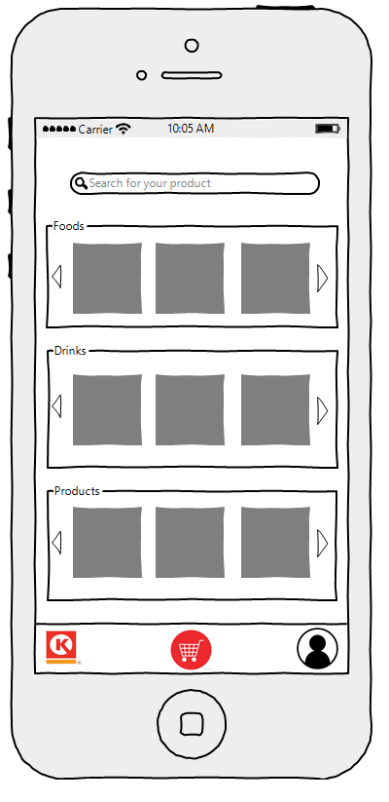Step 4: Choose the time to come or wait until your number appear and take it.

The home page of this application where the customers search products and see list products was grouped.

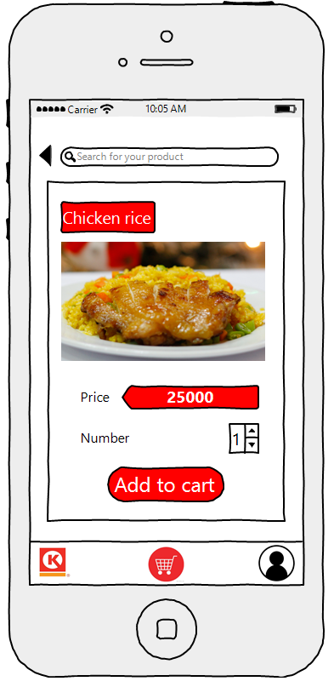

When the customer chooses icon cart, application shows them the cart interface, they can see what they have chosen and can confirm to buy them.

When the customer choose a product application will show you product information and they can add to cart.

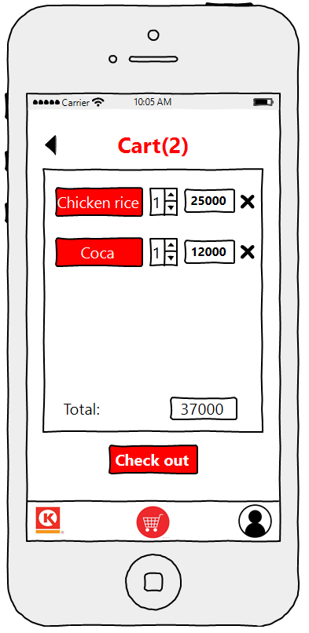

The most important of this page is the customer after confirm to buy products, they need to choose the time when they will come and take them 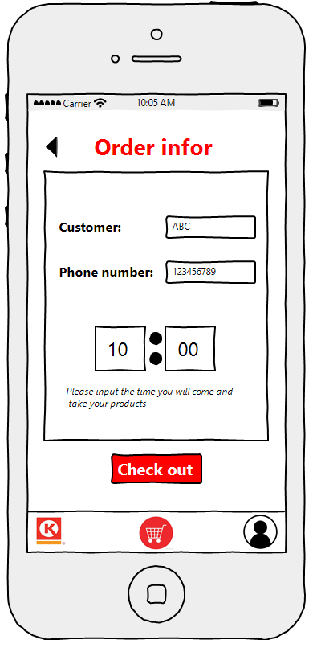

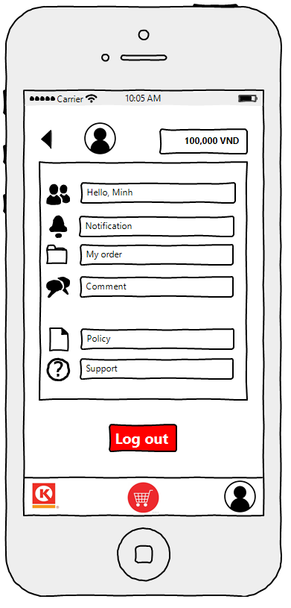

This is the page show personal information of customer, the customer can search for service and the Circle K can have the information of customer for helping them.

1. **Test.**

**How to promote customer to use new application?**

* Giving customer code to discount to encourage people to use the application.
* Promote the new application on social network.
* Make some posters before the storefront.
* Staffs have to inform customers about the app and its advantages.

**Which customers will receive when they use this application?**

* The customer will save the time for paying products or waiting for their foods/drinks. (It’s will be suitable with the mostly customers of convenient store are young generation. They come buy and go before).
* The customers don’t have to come to the store, they can see the good in the store by using this application. (Save time)

**Which Circle K will receive when their customers use this application?**

* With the application, the Circle K can define the information about which product is hot trend or which foods or drinks will be order a lot in a period and staffs can ready to supply them.
* Less work for staff, easy to train and can start their job quickly (part-time job).
* Control the internet connection help Circle K limits the time people use the seat for their personal things.
* Be more proactive start make advertise and bring varietal merchandise to customer. Improve the way of shopping and engage more consumers.

1. **Conclusion.**

After the assignment, the experience was take:

* The fastest way to understand the service of our customers - Circle K is become their customers then interview their customers.
* Take time to watch process of other customers and then try to be a customer to see is it always the same process or not, what is the different.
* Before interview, make a list of questions, focus on what we concern after we have used the service. (Why – When – Who + your concern + different +?)
* Questions should be short and direct to the problem.
* Eye-contact when asking questions, it makes your interviewee tell you the truth and longer.
* Have something to prove that you are the person you claim to be or the interviewees will try to run away from you as fast as possible.
* Brainstorming all possibilities reason relate to the problems, then select and put them in a group based on what you have experience and information from the interview.
* Take a look of Circle K competitors, see whether if they have the same problems or not and how they face to it.
* Discuss in group to find out the solution, ask our friends and acquaintance about our suggestions, notice how they receive and react with our solutions.
* To increase the percentage of success of our solution, we concern about if we use our suggestion, is there any new issues created, can we handle with them, is there any trade-off we have to deal with.

1. **Preference**

<https://www.circlek.com.vn/en/>