April 10th, 2018

Group 6 members:

Nguyen Binh minh - 16943794 – 1459034.

Pham Huynh tri minh -16942517 – 1459036.

Tran gia linh - 1694399 – 1459031.

Assignment 1

Group 6: Circle K



Contents

Introduction 2

DT1: Empathize 3

Observing (in time order): 0

Summary: 1

DT2: Define 3

DT3: Ideate 5

DT4: Prototype 6

Features 6

User Interface 7

DT5: Test 10

Conclusion 11

Preference 12

**Circle K – Group 6**

# Introduction

The purpose of this onsite project is observing holistically the services process along with the users’ interactions and start thinking how to improve or innovate the services. Circle K, where we conducted the project, is a convenience store brand, providing a diversified range of genuine products and the most convenient services at affordable price.

**Overview of Circle K:**

* Address: 217 Nguyen Van Cu Street, District 5, Ho Chi Minh City, Vietnam
* Staff: Mostly University students.
* Customer: Surrounded people and students.
* Space: Small (about W x L: 3m x 15m), have some tables to sit, clean and neat.
* Atmosphere: Clean, acceptable and fresh.
* Product & Price: Variety (snack, drink, personal stuffs and food) and fair.
* Service: Free internet connection, bill payment (mobile, pre-paid phone card …), Food and Drinks.

After inspect people inside the store, we have noticed some important patterns about the services workflow and the users’ needs. This document bellows will cover five design-thinking areas and the conclusion.

# DT1: Empathize

To design a new solution or idea, we will act as customers to use the services and interview some customers in order to fully understand the service process of the convenience store.

There are two types of customer: Take away and Eat in the store. Students from high school, university and office workers are the main consumers of this Circle K. Because the limited of time, we just interview two students. Below is the conversation in short:

**Nguyen Phuong Thao** – 2nd year student in Saigon University

Q: The purpose of you when you come to the Circle K?

A: My friend and I come this store to buy drinks and snacks. During this time, we can chat and review the lesson after school.

Q: Why you choose this place to study?

A: We do not need to buy expensive things, this store is near our school, and it has tables, chair and we feel comfortable with air condition.

Q: How do you feel about the staffs in here?

A: They are young, maybe same age with us. Sometimes, they are friendly with customers, sometimes not. They make the food a little bit slow. The seats are often unavailable due to people come to study, chat or play game for several hours, so I have to bring my food back to my school to eat.

**Le Manh Khang** – Student in High school.

Q: Why you choose this store for buying products?

A: This store is near my school and the food are cheap.

Q: Near this store, is Family mart and it has more type of food, why you choose Circle K?

A: In this week, Circle K have the event when you buy product and pay more than 30k VND, you have a chance to receive a gift.

Q: If this store does not have this event, will you choose this store in the future?

A: I think not because I have more choice in buying food in Family mart. Moreover, the door is sometimes hard to fully open (the way of the store is too small) and the staff is very slow at noon because they cannot find the price tag or do not know where to get material to make food.

## Observing (in time order):

* **Circle K staffs:**

There are 3 staffs are working at the moment we come in. They are students; young and new (We have visited this store many times before). Their jobs are checkout, cook, fill stock, clean the floor, put a price tag on goods, bring merchandise into storage…

🡺 There are few staffs but many works to do, which make them sometime overloaded. Take a long time to deal with problem such as find price tag for fast food, fill stocks or cook the fast food.

* **Phuong Thao (Eat in the store):**
  + Take time to walk and see all the shelves, then start decide what to buy.
  + Talking with her friends when she found some interesting products.
  + Read the product detail (nutrition, price, expired day…) before choosing.
  + Get a third Cola can in the queue, not the first.
  + Get in line, complain how long the line is and say about the experience when buying stuffs.
  + Order the cooked food in cashier at the end.
  + Take a seat and wait about 10 minutes to get her dish.

**🡺** She seems to be enjoyed when going around and choosing goods but not waiting to pay her bill. At the time we leave, she’s still sitting there. Look like she planned to have her lunch then study here for several hours.

* **Manh Khang (Take away):**
  + Parking in front of the door.
  + Take time to open the door because the line has blocked it.
  + Find and grab snacks / drinks quickly.
  + Get in line and order the cooked food.
  + Walk around; look at his watch many times.
  + Get his meal after 10 minutes and go out.

🡺 He is very hurry. He knows what he need to buy so he pick up all his stuffs quickly, get in a line as fast as possible. He seems to be nervous while waiting for his food.

## Summary:

|  |  |  |  |
| --- | --- | --- | --- |
| **Category** | **Phuong Thao** | **Manh Khang** | **Circle K** |
| **Type** | - Eat at store. | - Take away. | - Staffs |
| **Characteristic** | - Female, young, student, wear glasses, long hair, like to study, careful and shy. | - Male, young, student, hurry and annoyed. | - Student, healthy, young, new and lack of skills. |
| **Action** | - Look around.  - Check detail and appearance of products before choosing.  - Order and wait for the meal. | - Parking.  - Find and grab necessary stuffs.  - Order and wait for the meal. | - Checkout.  - Cook the fast food.  - Fill stock.  - Clean the floor  - Put a price tag on goods.  - Bring merchandise into storage. |
| **Where bad experience happens?** | - Get in line.  - Wait for cooked food. | - Open the door.  - Get in line.  - Wait for cooked food. | - N/A |
| **Why customers come here?** | - Cooked food.  - Near school.  - Place to study with air condition and free network connection. | - Near school.  - Event. | - N/A |
| **Feeling** | - Deliberate, enjoy, patient and annoyed. | - Hurry, nervous and uncomfortable. | - N/A |
| **What customer needs?** | - Gifts, saving money.  - Nutritious food and drinks.  - Place to study.  - Fast response. | - Gifts, saving money.  - Food, snack and drinks.  - Fast response. | - N/A |

# DT2: Define

So far we have observed the process of the Circle K staffs and their customers, we clarify that there are two types of needs: Place to eat & work and Take Away. We will analyze these two types to see what problems the customers is facing with.

First is Place to eat & work. The consumer is usually students from local high schools and university. These students need a place to take a break at lunch and study in-group with an inexpensive price. The reasons why Circle K become their destination are the environment. Just buy a coke or a dish, a customer can sit as long as he/she wants under air-condition and free internet connection. Circle K also provide some electrical outlet so customers can use the laptop without worry run out of battery. However, these equipment leads to a problem: Not enough seats. Many other people who want to eat their purchases in store and leave cannot do it because all tables are abused too long. In the conversation with Nguyen Phuong Thao, she had pointed out that bad experiment and she had to bring her food back to her school.

Second is Take Away. During the observing, we saw many kinds of customer choose this way such as Foreigner Backpacked, student, office worker and some street food sellers. They are hurry to find goods and get line as fast as they can to pay a bill. Looks like they know the process of checkout will cost long time. Both of the interviewees complain about the speed of this process is too slow. We noticed that only when the customer order the fast food, the staff start to make it from the beginning. Moreover, the staffs sometimes couldn’t find the material to cook. As we have described above, this is a part-time job so the staffs are changed over the time so they might lack of skills and knowledge about the arrangement of the store. However, there is no doubts that these issues slow down the checkout process.

Additionally, the way the Circle K arranges the store is not good enough, less space for parking and lining up. Some customers feel annoyed about it.

Overall, the two main problems that Circle K customers deal with are lack of seats and the speed of checkout process is too slow because of various reasons from human, physic and location. These issues may affect to the loyalty, satisfy of customer and the income negatively. In the next section, we will discuss about the solution to improve the services in Circle K.

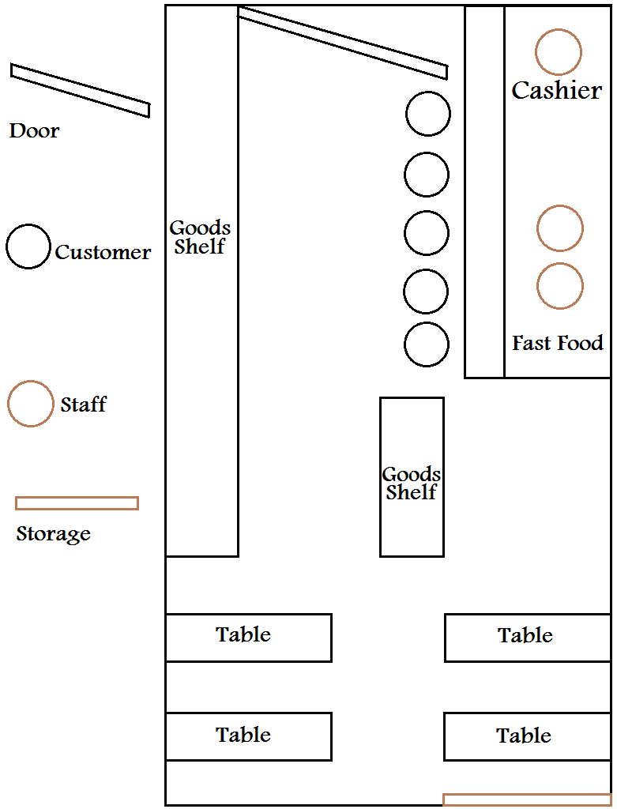

Figure 1: Circle K map

# DT3: Ideate

In the DT2: Define, we was interpreting the cause of two problems: Lack of seats and the speed of checkout process. For the first problem, lack of seats, we don’t have any good IT suggestion to cope with except limited internet connection. This issue is more related to the physic equipment with simple solution: extend the store and buy more tables. Nevertheless, by limited the internet connection, it can somehow enhance the situation since the network is important to suffer the internet, play game or chat, which consume time and keep the customer stay at store longer. In addition, Circle K should use slide-door and re-arrange their store to make it more convenient and create more space to place tables.

In another hand, we have many ideas to solve the speed problems. Imaging that there is an application, what records all of the transactions in specific time like morning, noon, afternoon, night and midnight. Based on the collected information, the staff can predict which product will be ordered to prepared more or put them in the top of the shelf. Furthermore, put the nametag on each shelf, place, refrigerator … to be help staffs and customers locate the need faster. Another thing is provide the FAQ or instructions so the customer can do things by themselves, reduce the tasks and help staffs focus more on the checkout process. If it is possible, customers are able to shopping online then arrive and pick up their stuffs.

Beside of the application, we also come up with an idea of no-staffs convenience store. Take Amazon Go for example, customers only need to scan their devices or QR code and start shopping. Many cameras and sensors will take responsibility to capture, calculate and purchase for each person immediately when they come out. This idea is very modern and intelligent but not fit for Circle K Vietnam due to many reasons such as Vietnamese prefer cash than card, customers are mainly students, the size of this store and some limited of technology.

After discuss in team, we believe that the speed problem is more essential to deal with and decide to use the application to recommend and demonstrate the UI/UX along with some main features in prototype levels in the section below.

# DT4: Prototype

## Features

* Record and export the statistic of products consumption by time (morning, noon, afternoon, night and midnight).
* Allow customers to pre-order goods and pick up when they arrived.
* Payment: via telecom network (Mobifone – Viettel – Vinaphone), credit card/ ATM card and cash.
* Push notification when Circle K run a promotion (Encourage people to use application and come to shopping).
* Print a bill with the Wi-Fi code to access the internet for 30 minutes.
* Provide the map of each store so customer can find their necessary stuff quickly (Optional: the size of the store we have come is not big enough to use this feature).

## User Interface

With the application, the steps to use it will be:

Step 1: Create an account.

Step 2: Connected the account with bank account or recharge money in the account. If you are at the store, ask staff to confirm your order and pay by cash.

Step 3: Choose the food/drinks.

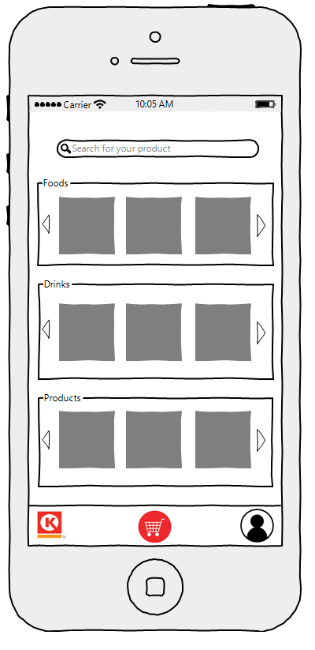Step 4: Choose the time to come or wait until your number appear and take it.

The home page of this application where the customers search products and see list products was grouped.

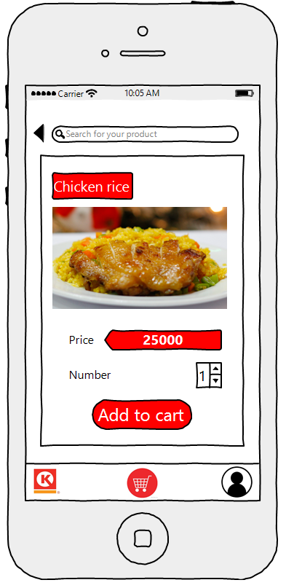

When the customer chooses icon cart, application shows them the cart interface, they can see what they have chosen and can confirm to buy them.

When the customer choose a product application will show you product information and they can add to cart.

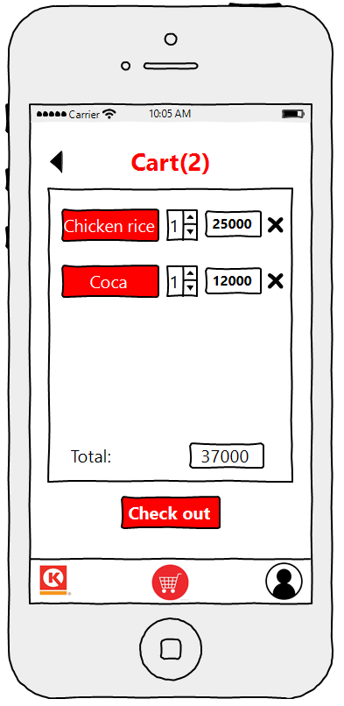

The most important of this page is the customer after confirm to buy products, they need to choose the time when they will come and take them 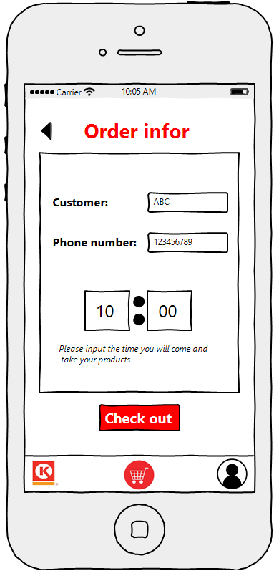

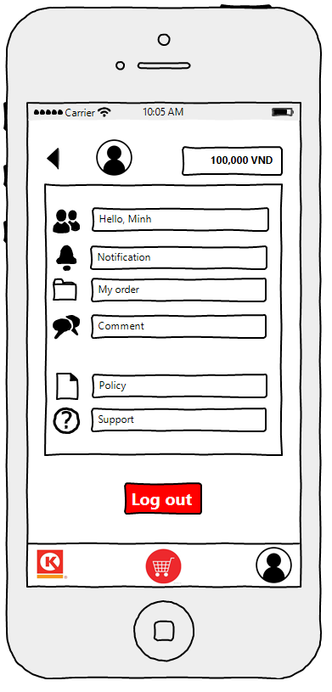

This is the page show personal information of customer, the customer can search for service and the Circle K can have the information of customer for helping them.

# DT5: Test

**How to promote customer to use new application?**

* Giving customer code to discount to encourage people to use the application.
* Promote the new application on social network.
* Make some posters before the storefront.
* Staffs have to inform customers about the app and its advantages.

**Which customers will receive when they use this application?**

* The customer will save the time for paying products or waiting for their foods/drinks. (It’s will be suitable with the mostly customers of convenient store are young generation. They come buy and go before).
* The customers don’t have to come to the store, they can see the good in the store by using this application. (Save time)

**Which Circle K will receive when their customers use this application?**

* With the application, the Circle K can define the information about which product is hot trend or which foods or drinks will be order a lot in a period and staffs can ready to supply them.
* Less work for staff, easy to train and can start their job quickly (part-time job).
* Control the internet connection help Circle K limits the time people use the seat for their personal things.
* Be more proactive start make advertise and bring varietal merchandise to customer. Improve the way of shopping and engage more consumers.

# Conclusion

After the assignment, the experience was take:

* The fastest way to understand the service of our customers - Circle K is become their customers then interview their customers.
* Take time to watch process of other customers and then try to be a customer to see is it always the same process or not, what is the different.
* Before interview, make a list of questions, focus on what we concern after we have used the service. (Why – When – Who + your concern + different +?)
* Questions should be short and direct to the problem.
* Eye-contact when asking questions, it makes your interviewee tell you the truth and longer.
* Have something to prove that you are the person you claim to be or the interviewees will try to run away from you as fast as possible.
* Brainstorming all possibilities reason relate to the problems, then select and put them in a group based on what you have experience and information from the interview.
* Take a look of Circle K competitors, see whether if they have the same problems or not and how they face to it.
* Discuss in group to find out the solution, ask our friends and acquaintance about our suggestions, notice how they receive and react with our solutions.
* To increase the percentage of success of our solution, we concern about if we use our suggestion, is there any new issues created, can we handle with them, is there any trade-off we have to deal with.
* Research on the Internet with key words: Convenience store problem, Speed problem, working at convenience store…

# Preference

Introduction:

<https://www.circlek.com.vn/en/>

Empathize:

<https://wow24-7.io/blog/what-role-does-the-representative-play-in-providing-a-positive-customer-service-experience>

<http://www.infoentrepreneurs.org/en/guides/know-your-customers--needs/>

<https://digitalbrandinginstitute.com/5-steps-better-understanding-customers/>

Define:

<https://www.mindtools.com/pages/article/newTMC_80.htm>

<https://www.siriusdecisions.com/blog/fiveeasystepstoanalyzeanyproblem>

<https://www.shopify.com/enterprise/94678726-the-need-for-speed-why-customer-service-needs-to-be-faster-than-ever>

<http://www.cbc.ca/news/business/grocery-checkout-supermarket-shopping-loblaws-superstore-metro-sobeys-dementia-autism-social-anxiety-1.3954847>

Ideate:

<http://fortune.com/2017/03/28/amazon-go-cashier-free-store/>

https://www.quickeselling.com/top-10-benefits-of-online-mobile-app-shopping-that-make-your-life-easy/

Test:

<https://www.thebalance.com/tips-to-increase-retail-sales-2890274>

<https://www.goebt.com/easy-ways-to-enhance-your-convenience-or-grocery-store/>