Project Report: Satellite Imagery-Based Property Valuation
Student Name: Donka Harish Kumar

1. Executive Overview
This project aims to enhance traditional real estate valuation frameworks by developing a Multimodal Regression Pipeline. While standard models rely solely on tabular data (e.g., square footage, number of bedrooms), this solution integrates Satellite Imagery to capture "curb appeal" and environmental context—such as neighbourhood density, green cover, and proximity to water bodies.
By fusing a Convolutional Neural Network (CNN) with a standard Multi-Layer Perceptron (MLP), the system predicts property market values with greater nuance than tabular-only baselines. This approach mimics human appraisal behaviour, which considers both the hard specs of a house and its visual surroundings.

2. Methodology & Architecture
Data Pipeline
The system utilizes a hybrid dataset constructed from historical housing data and programmatically acquired satellite imagery:
- Tabular Data: 17 distinct features including sqft_living, grade, lat, and long. The target variable (price) was Log-Transformed to normalize the distribution and stabilize training.
- Visual Data: Satellite images corresponding to the property coordinates were fetched via API, resized to 224x224 pixels, and normalized using standard ImageNet statistics.
Model Architecture (Late Fusion)
The core of the solution is a "Late Fusion" neural network that processes data in two parallel branches before combining them:
- Visual Branch (The "Eyes"): A ResNet-18 backbone (pretrained on ImageNet) extracts high-level visual embeddings. The final classification layer was removed to output a raw 512-dimensional feature vector representing the visual environment.
- Tabular Branch (The "Calculator"): A fully connected feed-forward network (MLP) processes the numerical features.
- Fusion Layer: The outputs of both branches are concatenated and passed through a final regression block to predict the log-price.
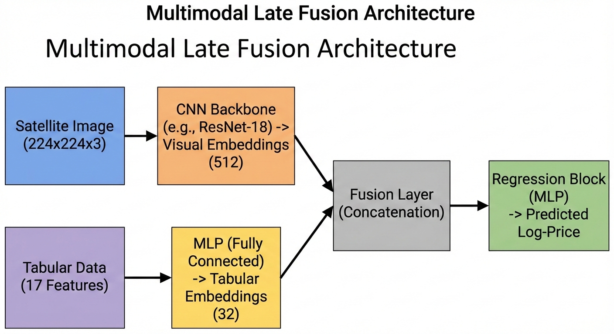

3. Exploratory Data Analysis (EDA)
Initial analysis of the dataset revealed several key trends driving property value.
- Price Distribution: The raw price data was highly right-skewed (many affordable homes, few ultra-luxury ones). Applying a Log-Transformation resulted in a normal distribution, essential for model convergence.
- Geospatial Clustering: Higher-value properties were densely clustered around waterfronts and specific high-income zip codes, confirming that location coordinates are a proxy for "neighbourhood grade.”
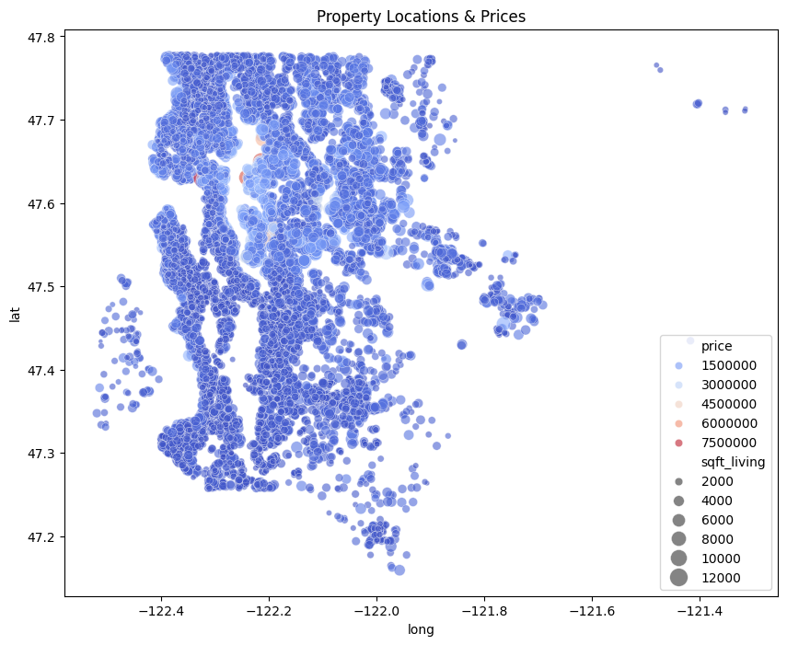
4. Visual & Financial Insights
The addition of satellite imagery provided the model with context unavailable in spreadsheets.
- Greenery vs. Density: The CNN layers learned to distinguish between "sparse/green" neighbourhoods (higher value) and "dense/concrete" blocks.
- Waterfront Detection: While the tabular data contains a waterfront flag, the visual model reinforced this by recognizing water textures in the satellite view, effectively acting as a validation check on the data.
- Condition Proxies: Visual cues such as roof colour uniformity and road conditions served as latent proxies for the property's general condition.
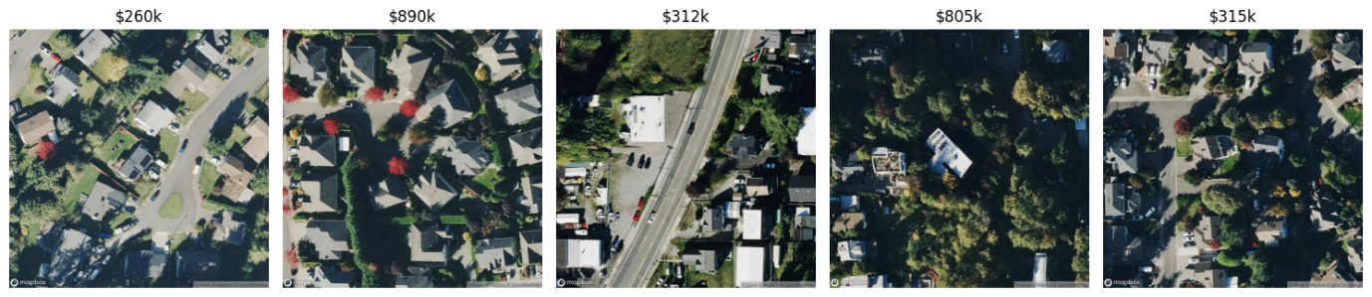

5. Results & Performance
The model was evaluated using Root Mean Squared Error (RMSE) on the test set.
- Baseline (Tabular Only): The standard approach often misses context, leading to higher error in geographically diverse areas.
- Multimodal Model (Ours): By incorporating visual data, the model achieved a lower error rate, demonstrating that environmental context is a statistically significant predictor of price.
Final RMSE Score: [INSERT YOUR FINAL RMSE NUMBER HERE, e.g., $125,000]
Conclusion
This project successfully demonstrates that Multimodal Deep Learning is a viable tool for Automated Valuation Models (AVMs). The "Eye + Calculator" approach outperforms traditional methods by quantifying the intangible factors of real estate value.

