The Uganda Automotive Industry

James Byansi, Paul Isaac Musasizi, Allan Muhumuza
Kiira Motors Corporation
P.O. Box 29905 Kampala (Uganda)
E-mail: [jbyansi, pmusasizi, allan.muhumuza] @kiiramotors.com

Abstract

The Uganda Automotive Industry has gone through several shifts since 1885 informed mainly by domestic market forces with very limited policy interventions directed at the automotive industry. The colonial era transport needs and governance structures resulted into growth of a nuclear automotive market with hubs in major regional cities at the time for purposes of administration and resource extraction. The nuclear industry developed in the post-independence era with the emergence of over six SKD assembly plants all located in Kampala for strategic reasons. The Idi Amin Era was characterized with gross mismanagement of the economy and rapid deterioration of the wider Uganda Manufacturing Sector resulting into backtracking on earlier intervention for automotive value addition. Prior to this Uganda Market was served with New Vehicles imported mainly from European OEMs. Post Amin there was a total market shift to used vehicles imported as FBUs from Japan with a significantly low acquisition cost. The Automotive Market since the 1980’s has been dominated by these imported second vehicles representing over 85% of the annual new registrations with Government being the main consumer of Brand New Vehicles.

The year 2014 saw over 40,000 Vehicles registered in Uganda this excluding 2-3 wheelers. The average CIF of imported Vehicles in Uganda in the period 2013/2015 stood at US$ 493 million a significant factor in the increased balance of trade deficit. A study by UNEP in 2015 established that the average carbon dioxide emission increased from 465 g/km in 2005 to 503g/km in 2014 while the average fuel efficiency declined from
12.52 L/100km in 2005 to 13.73 L/100Km in 2014. These environmentally unfriendly and counterproductive
trends can be attributed to the advanced average age 16 Year at Registration of the Uganda Vehicle Fleet. Importing vehicles as FBU without any Domestic Value Addition inadvertently contributes to unemployment/underemployment and does not help the desired industrialization interventions toward middle income status prospected in Uganda’s Vision 2040. Post 2010 in the Vision 2040 Era Government of Uganda has invested in Kiira Motors Corporation to set up a Vehicle manufacturing plant as a step toward establishing vehicle manufacturing capabilities in Uganda for Job and wealth creation.

This paper is presents in four sections a synopsis of the history of the automotive industry in Uganda with emergence of manufacturing capabilities in the colonial era mostly prompted by the need for transportation of cash crops (tobacco, coffee and cotton; the post-colonial development plans with initiatives to stimulate manufacturing in Uganda which facilitated minimal SKD assembly of vehicles mainly due to price advantages in cheap local assembly labor in Kampala in comparison to Shipping cost;, the economic demise from the civil unrest era which saw manufacturing plummet exponentially; the revitalization of manufacturing as a key economic driver in the liberalization era; the innovation and emergence of local value addition enterprises and eventually the Vision 2040 era which has brought forth several policy enactments and government initiative geared towards fostering emergence of capabilities for local value addition in the automotive industry. The paper further analyses current state covering the existing national policies and regulations in the auto industry; statistical data on consumption trends across the years and identifies the main players across the sectors relevant to vehicles in Uganda. Challenges, Opportunities and Future Plan for the Uganda Automotive Industry are also presented.

Keywords: Kiira Motors Corporation, Domestic Value Addition, Automotive Industry Value Chain, Industrialization, local value addition, National Policy.
1. HISTORY OF UGANDA AUTOMOTIVE INDUSTRY

1.1 Colonial Era 1885-1962

During the year 1885, Carl Benz developed the first automobile‟ Benz, Carl Friedrich (c1925), this coincidentally overlaps with the advent of the first European explorers in Uganda which was then an ensemble of kingdoms in the interlacustrine region. These kingdoms were economically characterized with Afro -Arab trade which had embellished the region with iron tools that were used mostly in agriculture and warfare. Transportation was through physical carrying of produce and goods by the lower social class locally referred to as „bakopi‟ who carried goods from the inland to the East African coastal merchants. As British occupancy in Uganda sprawled and was formalized by the signing of the 1900 agreement that saw Uganda become a British protectorate. Expansion of colonial administration directly meant administrators needed mobility but more importantly, Uganda was a commercial hub for cotton and coffee production. These high value commodities were transported by rail to the coast. Inevitably the high demand for these commodities birthed a requirement for transportation of these goods from agricultural towns of Soroti and Arua plus other agricultural trading centers in Uganda.

The earliest company to hold a vehicle dealership was in 1908 (Griffiths, 1968) having been primarily formed to import cotton seed and plant cotton. In 1922, having developed into a general trading company it acquired the Ford franchise. The British Motor Corporation was also a general trading company dealing in bicycles and caterpillar tractors.

By independence, up to six major dealerships had set up operations in Uganda but majorly based in Nairobi and starting out as small repair garages, graduating into second hand car spare parts sales and subsequently engaging in component assembly plants plus carriage building yards. Commercial vehicle assembly in Uganda dates back to 1950 with seven local assemblers for SKD Lorries and buses the seventh being the Ministry of works. SKD assembly here employed a fork lift, several jacks, tools and sometimes an overhead lifting system. The assembly kit here included the engine, gearbox, drive shaft, chassis, axles, wheels and cab. Locally built bodies would be later added. In all cases, the assembly part was merely part of a repair workshop. The labor force varied from 10 and 40 men per plant of which 5 to 10 are skilled, Griffiths (1968). By 1967 output in Kampala ranged from 35 to 220 units with an average of 115 per plant.

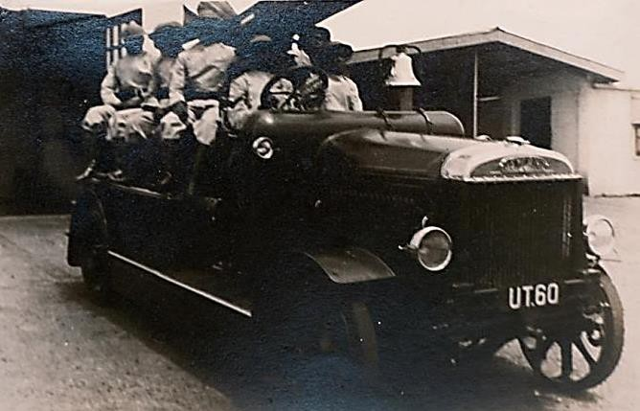Colonial industrial policy assumed significance only in the post-Second World War period. Colonial Development and Welfare Act of 1940 was amended by Britain in 1945 and £120 million were reserved for the
„development of the resources of the colonies. Two categories of industries emerged in 1936 namely the processing industries and manufacturing enterprises. £1.6 million was committed to facilitate the sustenance of manufacturing Uganda‟s first development plan which was devised 1936-1942

Dr. E.B Worthington who was appointed by Governor
John Harthon Hall (1945-1952) emphasized economic

Figure 1; A Leyland Fire Brigade Engine in
Entebbe, 1913
Source; Uganda National Archives
development over social development in reviewing the
1936 development plan. The attributes of Worthington‟s
plan that had any semblance to automotive development
was mostly the need for mechanized agriculture and reinforcement of technical training for maintenance workshop operators. There was no direct emphasis on developing capacity for local manufacturing of any components for automobiles.

The most important outcome of colonial growth was the construction of the Owen Falls Dam and the establishment of Uganda Development Corporation (UDC) in 1952. The dam was meant to provide cost-
effective hydro-electricity for industrial development. UDC fostered growth in the manufacturing sector through:

• Attracting new industries to Uganda by the offer of advice and capital participation.
• Provision of overseas businessmen [and women] with reliable basic data on industrial conditions and requirements
• Advising on the selection of suitable factory sites
• Acting as go-between with the numerous Government departments that might be involved.
• Furnishing economic or technical research into specific marketing or production problems

Expectations from overseas investors were: technical expertise, managerial skills, and some capital. Of the
1,176 factories subject to the Factories Ordinance of 1957, 233 were in the metal and engineering sub-sector.
This sub-sector was dominated by motor vehicle and plant repairing (with 148 firms).

1.2 Post-Independence Era 1962-1970

Uganda was premised under a post-independence five year development plan (1961-1965) in which industrialization did not feature prominently. However in the second five year plan prominence was given to industrialization. Manufacturing was planned to grow at twice the rate of growth from 5.7% in 1966 to 11.6% in 1981. The projected value added however still focused on food processing, though the Economic Commission of Africa identified several industrial development priorities engulfing clothing, wood and cork, furniture and fixtures, foot wear, rubber products, iron and steel.

The ECA‟s proposals were closer to the industrial priorities of successful Asian manufacturers such as Taiwan, in the 1950‟s and 1960‟s. The projected value however emphasized food processing estimated at 35.2 million by 1975.

By the time Uganda obtained political independence in 1962, the colonial state, as already hinted, had established key developmental infrastructure. The state had also initiated a culture of coordinated industrial development through strategic partnerships. However, a 1961 study describes Uganda‟s economy as a poor agrarian economy, dominated by the „African farm enterprise‟ observing that industrial deepening had not yet taken place by the early 1960s. The African farming sector contributed 60 percent of the 342USD million GDP of Uganda.

The Factories Ordinance of 1957, and the Foreign Investment (Protection) Act of 1964 were pivotal interventions in availing a frame work instituted by UDC to attract and grow capacity for manufacturing industries in major industrial towns in Uganda Jinja being the focal area.

In 1968, except for Fiat and Leyland, all motor dealers were locally financed; overseas manufacturers offered no capital investment. Initiative in obtaining the leadership was sill from the local enterprise.

Up to 15 dealerships are based in Kampala though allowed to sell their product across the country. Only one branch in Jinja and Mbale. This is because 8 percent of all vehicles in Uganda were registered in Kampala. Due to the centralized purchasing power. Trade-ins were not accepted, police testing of these vehicles was also based in Kampala.

SKD Assembly in Kampala

In 1967 the shipping policy specified that shipping space was charged according to cubic measure. A lorry on wheels could take up as much as four times the volume of an SKD pack for the same vehicle. Savings on shipping costs were up to 50% per Unit savings of up to £80 per unit were far more than the local cost of assembly at between £30 and £40 per unit. Total investment of land and buildings was between £5,000 and
£50,000 per plant.
In 1968, Assembly plants at Kireka, Portbell, and only three assembly plants at the time have access to rail. Local body building was mainly facilitated by timber due to the growth of the freight and customs charges and a cheap local product. One wooden body builder, one metal body builder. Body building companies were independent of the dealerships/assemblers but are tied to them by virtue of location.

Uganda Batteries limited (UBL) was first registered in 1967 and started out in importation of automobile batteries and eventually developed capacity for local manufacturing and is the go to local manufacturer to date. The company has evolved with an innovative product range with applications in the solar energy industry.

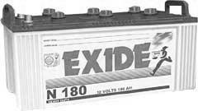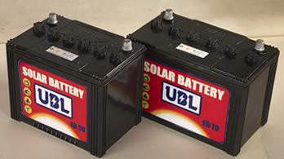Figure 2; The product range of batteries made by UBL for automotive and solar applications
Source; Multiple Sources
In 1968 the only semblance of component manufacture was the bicycle tire manufacturing factory in Jinja with no growth plans of expanding to car and truck tires. The overall challenge to the motor industry in this era is that of scale, significant growth in the industry to a scale where development of the car industry becomes feasible was still very low. Governmental support was rendered through increasing the existing tariff differential between assembled and unassembled vehicles and further more defragmentation of the already small markets within east Africa. The bestselling brand Peugeot sold only 1100units in 1967 the prospect of a centralized large scale assembly plant was geographically suiting Jinja or Kampala.

Jinja for the realized infrastructure of the Owen falls dam and Kampala from the embryonic motor industry of Uganda being firmly rooted in Kampala in response to the overwhelming centripetal location factors with focus for commercial and industrial growth in developing countries. By the time Uganda got her independence in 1962, there were about 12,000 cars. Most of them were either owned by Europeans or government officials. This is much fewer than the 21,000 vehicles that are now bought by Ugandans every year.

In the following years, 1963-65, at least 130 cars were imported on average each year for private use. The government remained the biggest importer of cars with an annual average of 400. These included types like the Vauxhall, Anglia, Mini-Fiat, Minor, Ford, Cortina, Dodge, Peugeot, Fiat Mirafiori and VW Beetles and Land Rovers. There were also Ford Escort, the VW Combi, Renault, Citroen, Mercedes Benz, Opel, Isuzu and Mitsubishi. Luxury brands like Rolls-Royce were reserved for dignitaries like the Kabaka of Buganda and heads of stet of Uganda.

Commercial Vehicle segments grew at a more exponential rate with manufacturers namely Bedford, Fiat, Austin, as compared to today‟s Fuso and Mercedes Benz trucks dominating the market. Unlike today however, most of the vehicles imported in the country were brand new mainly from Europe.

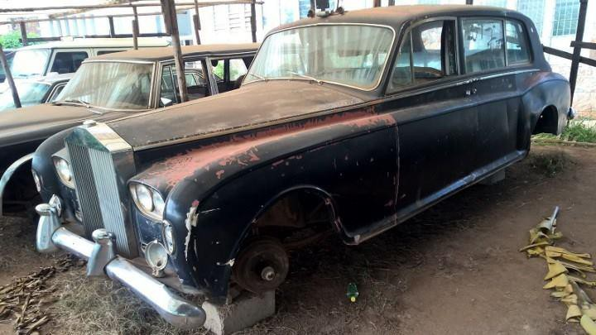Figure 3 ; the Rolls Royce Phantom V 1961 that lies in ruin at the Uganda Museum, it was used by heads of state; Sir Andrew Cohen, Ben Kiwanuka, Milton Obote and Idi Amin Dada
1.3 Civil Unrest Era 1970-1985

Between the 1970s and mid‐1980s, Uganda suffered long periods of political turbulence ‐ amounting at times to civil war ‐ and poor economic management.

Major dealerships between 1970 and 1980 were Spear Motors, Afro Motors and Uganda Motors. In the 70s, pick-up trucks fitted with a box body at the back started operating. They were called “Matatus” Most of them were actually Peugeot 204s. Again, they operated alongside buses, mainly run by Uganda Transport Company (UTC). The government transport company had been set up in 1975 by Idi Amin.

Major declining factors of the economy in this period:

i. Inflation discouraged operators of vehicle dealerships. ii. Rigid price regulation often from state instruction
iii. Overvalued currency.

Amin’s Foreign Investment Decree of 1977

The development crisis in Uganda began in the 1970s with the rise to power of Idi Amin (1971-1979). It destroyed the economy, disorganized the industrial and other economic infrastructure, and triggered a spiral of economic mismanagement. Records of the 1970s and 1980s reveal a virtual absence of heavy industries. Uganda registered declining output in both light industries and the potential growth poles for heavy industrialization.

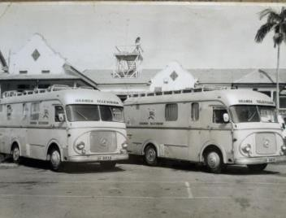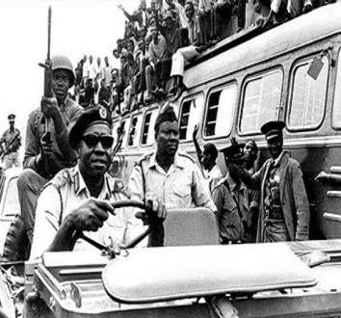The military was the focal area of development this period emphasized with armored vehicles and war machines imported from Russia.

Uganda Television’s Mercedes Benz specialized news crew vans. Mostly for airing public events
President. Idi Amin Dada driving a jeep wrangler 1970, in the back ground is a UTC bus.

Figure 4; Multiple Sources
The Mercedes 1 1971 owned by president Amin dada

1.4 The Liberalization Era 1990-2010

Since the restoration of peace and institutional stability in 1986/87, Uganda has pursued a comprehensive and ambitious reform agenda. With the Economic Recovery Program (ERP) of 1987 and the Rehabilitation and Development Plan (RDP) of 1993, the authorities have begun again to capitalize on the country's natural assets of fertile soils and a moderate climate and to rehabilitate its once well‐developed infrastructure.

1.4.1 Policy interventions to foster manufacturing and industrialization

There was an emergence of policy interventions that emphasized manufacturing as a key economic driver after the liberalization of Uganda, political stability inadvertently created an environment why strategic plans could be implemented to further foster growth through industrialization. Pivotal interventions during this period are the Uganda Industrialization Policy and Framework, 1994-99, and Uganda Investment Statute of
1991

Uganda Investment Authority. – 1991; UIA was set up to define the needs to define generic and high value
added manufacturing industries into Uganda‟s liberalized industrial policies.
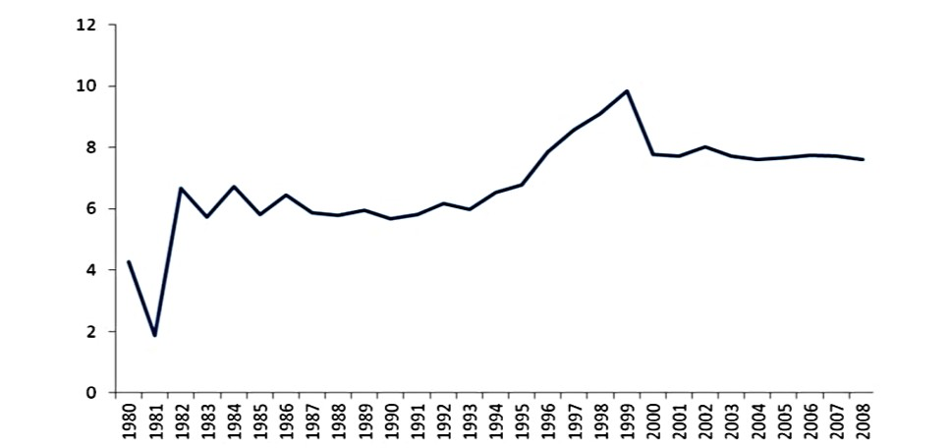The Uganda Investment Code; the second schedule of the Uganda investment code, 1991 amended in 1994 identifies 24 priorities. Iron and steel industry comes fourth, high technology industry is the last on the list. Signifying how supporting industrial institutions to the automotive assembly or manufacturing were not prioritized.

Figure 5; Manufacturing as a share of GDP, 1980-2008
Source; World Bank – 2009 World Economic Growth Report
1.4.2 Current Structure of Manufacturing in Uganda

Scherer and Adams and Brock (2005) classifications by level of production which consists of the following classifications:

Classification | Basis for classification
Primary | Agriculture both subsistence and commercial, mining, forestry, farming, sector diminishes as countries develop
Secondary | Value addition takes place and include manufacturing processing and construction activities include metal work  ,automobile production ,textile production, chemical and engineering industries aerospace manufacturing energy utilities engineering, breweries and bottlers, ship building.
Tertiary | Service industry that provides services to the public and private sectors., key activities include retail and whole sale sales, transportation and distribution, entertainment, restaurants, clerical services, media, tourism, insurance, banking and finance, health care and law.
Quaternary | Intellectual activities that include culture, libraries, scientific research, education and information technology.
1.4.3 Industrial Sector Performance 2000-2011

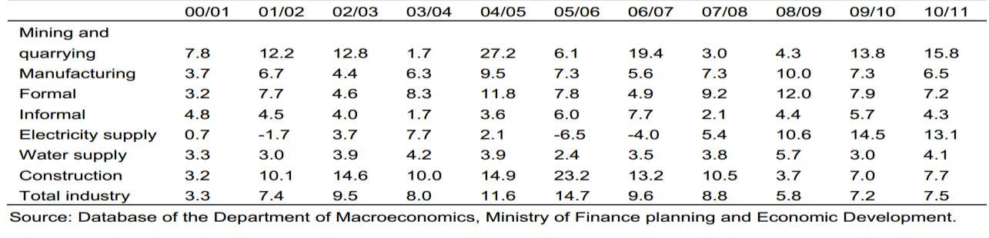With major reforms and rehabilitation in the 1980s and 1990s and other initiatives, the industrial sector experienced steady growth with an average of 7 per cent and reaching 15 per cent in 2005/06 (Table 1). This growth was mainly driven by the construction, mining, quarrying, and the manufacturing sub-sectors.

Figure 6; the contribution of GDP growth at constant 2002 prices

One common characteristic of the manufacturing sector in the current state is limited value addition. Although the manufacturing sector is diverse in terms of composition, it is characterized by processing of raw materials and very few capital goods industries with very low utilization of manufacturing capacity.
Uganda attracted substantial foreign direct investment (FDI) between 1991 and 2009 with the largest proportion going into the industrial sector which partly explains the growth and contribution to GDP by the sector.

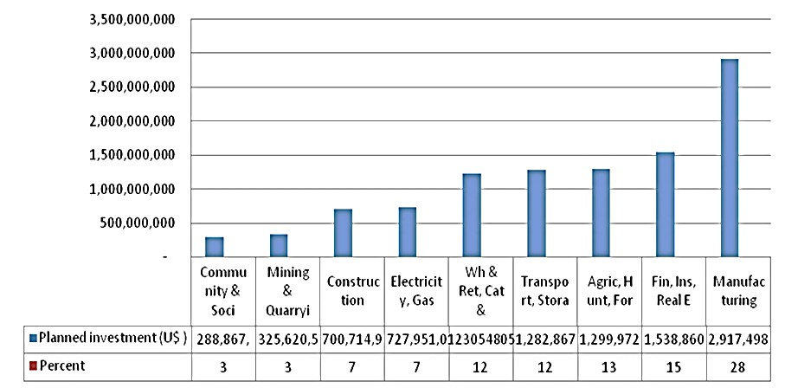Table 3: Cumulative flow of investment in Uganda between 1991 and
2009 (US$)
1.4.4 Emergence of Informal Value Addition Enterprises and Innovation

The stabilized political environment saw forth the emergence of local crafts men manufacturing though on a small scale spare parts and reconditioning of vehicle components.

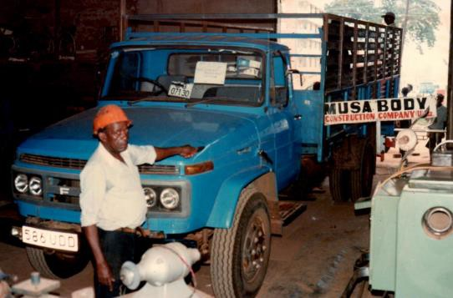Musa Body Group; Musa Wakibi (Musa body first registered in 1957) was hailed for his skill in making wooden car bodies in the suburb of Katwe in downtown Kampala. Musa Body products included electrical appliances, fire fueled ovens, wheat mixes, rice hullers, wheel chairs, car bodies, and maize mills. He is also remembered for fabricating a car and naming it “Uganda 1‟‟. Everything on this car was made in Katwe except the engine tyres and glasses.

Figure 8; A lorry carriage body and the Uganda 1 car made by Musa Body Engineering Inc.’
Source; https://musabodyfoundation.files. - Kasifa Nabatanzi

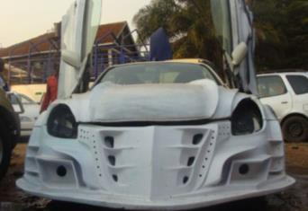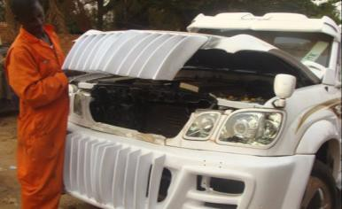Body modification workshops; there has been an extension of services by auto repair workshops, the most commercially viable thus far is Godfrey Namunye‟s body modification workshop where ordinary vehicles are modified for on average USD 3,000 fiber glass in the core material used to build onto or repair the car bodies. The clientele ranges from local celebrities, pastors and

Figure 10; Godfrey Namunye’s Body modification workshop at Makerere Kavule
Source; http://www.bbc.com/news/world-africa-26297365
Rubaga bus body builders; bus body builders mainly starting out as repair workshops are seen to emerge among workshops in Rubaga, local crafts men with training from bus building plants in Nairobi have trickled
into the industry mainly due to cost comparisons with having to transport buses to Nairobi for body repair works. The bulk of works done in Rubaga is refurbishment and rebuilding accident bus bodies.

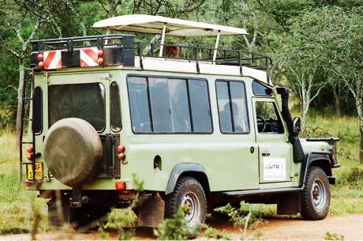Jussy Coaches and Pro-Ride (Chipper Adams) are also actively involved in bus body building and SUVS modification for recreational vehicles respectively.Tourist vehicle modifications of Land Rover and Land Cruiser vehicles is currently done by

Figure 10; A tourist vehicle with body modifications done locally from a 1998 Toyota land cruiser.
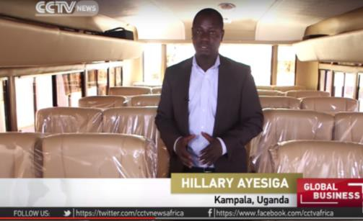Source; prime safaris.com, Monitor.co.ug

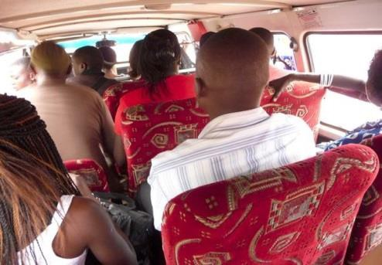.
Figure 11; L-a service van transformed into a Passenger service vehicle
in kampala city. R- a locally crafted Kayoola solr bus interior by kibuli Fabricators.
Source; Multiple sources

Three Wheeler and Two Wheeler Assembly Plants

Wavah Bikes: GM Tumpeco extended its operations to assemble three wheeler carriage motor cycles; it‟s a
response to the need for affordable means of transportation of goods to remote areas.

TVS Motorcycles; TVS Motor Company is set to start as assembly line that will roll out products tailored for the region.

Henkel Fiber glass makes cabin covers and CCLE Tyre Company is operational manufacturing motorcycle tyres in Mukono.

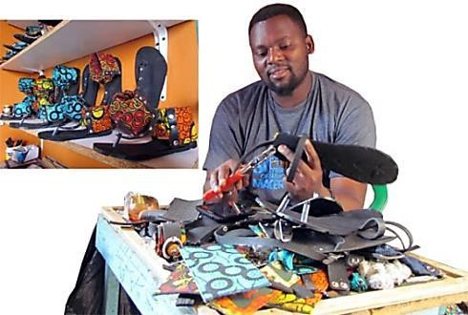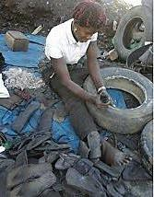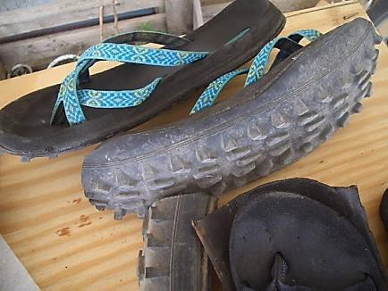Recycling industry from car tyres; the local name for sandals made out of old car tyres (lugabire) is a prominent industry in Uganda in the informal sector making use of used car tyres.

Figure 10; footwear locally referred to as “Lugabire” and other bi-products of recycled car tyres.
Source; Multiple sources.
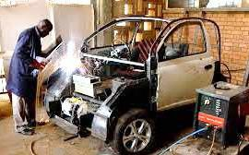1.4.5 Innovation from Academic Institutions

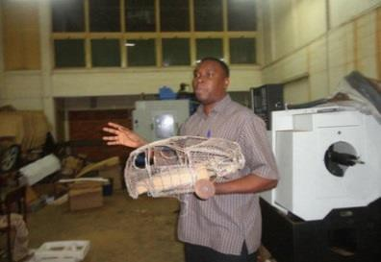Vehicle Design Project, Makerere University; the vehicle design project at Makerere University produced the first electric car made in Africa.

Mr. Paul Isaac Musasizi ( currently CEO- Kiira Motors Corporation) displays a scaled wire model of the Kiira EV
Fabrication of the Kiira EV at CEDAT
– Makerere University

Source; multiple sources
He Y.K Museveni – President of Uganda Launches the Kiira EV in November 2011.

The MV Mulimi; Mechanized agriculture remains a focal development goal and initiatives from agricultural engineering students at the Makerere University Institute of Agricultural Research brought forth the MV Mulimi innovation in January 2016

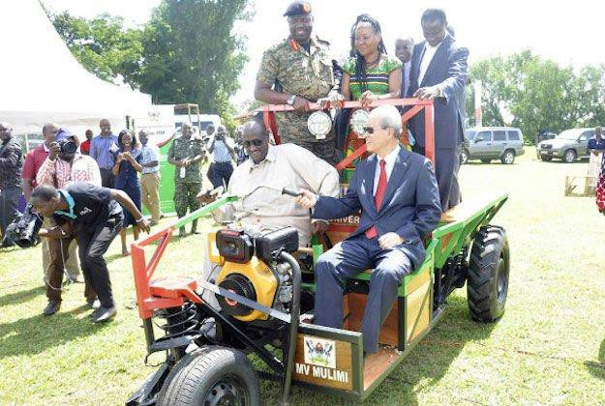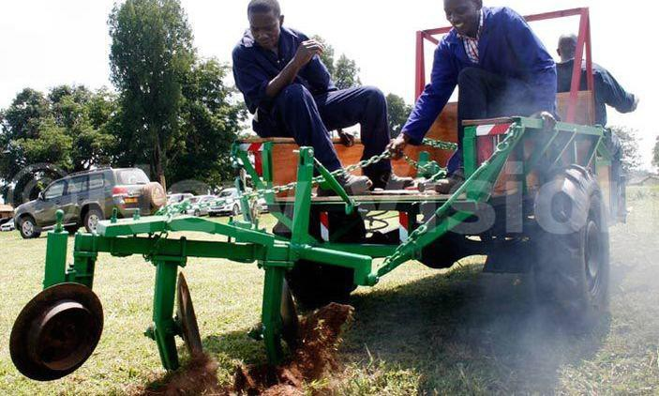Gen Saleh (L) & Chinese Ambassador Zhao
Yali test drive the MV Mulimi
The Makerere University Researchers test ploughing using the MV Mulimi prototype tractor.
Source; http://www.newvision.co.ug
The Kyambogo University Biofuels Vehicle; In 2014 Kyambogo University Department of Mechanical Engineering exhibited a Vehicle converted from traditional focil fuels to Ethanol-Based Bio-Fuels a major milestone in Bio Fuels for Mobility Research a part of the prospected alternative energy for mobility initiatives in Uganda.
1.4.6 Training institutions

There are a number of specialized automotive workshops and training institutions in Uganda.

i. Nakawa vocational training institute ii. Kyambogo university
iii. The Spear Motors Training Centre
iv. Cooper Motors Company training and repair workshop

CMC Quick Lane tyre and auto center mechanics servicing a vehicle.
Trainees at the Spear Motors
Training and apprenticeship center
Source; multiple sources
Nakawa vocational training center
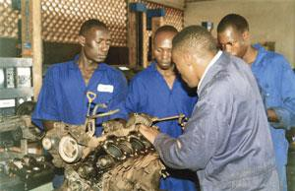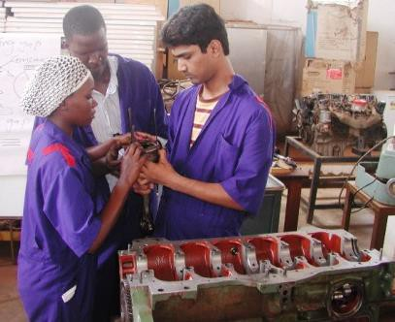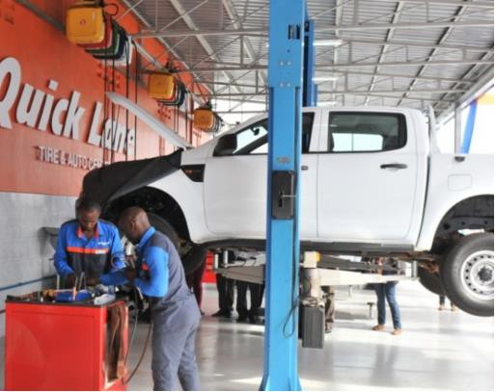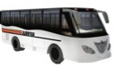The Majority of garages within urban centers in Uganda also offer informal training by way of apprenticeship in automotive repair.

1.5 The Vision 2040 Era

Vision 2040 prospects the transformation of Uganda into a competitive upper-middle–income country within
30 years. It highlights the importance of manufacturing and value addition in enabling the development of an
export-led and internationally competitive economy for job and wealth creation. The development of a robust manufacturing sector is expected to make significant contribution to economic transformation and harness the vibrant mining and oil sub-sectors, good weather and agricultural potential, a young and expanding population, and a strategic location at the heart of regional trading blocs.

It is under execution through NPPs focusing on growth within the National Development Plan II, “Strengthening Uganda‟s Competitiveness for Sustainable Wealth Creation, Employment and Inclusive Growth”, with specific emphasis on Science, Technological Innovation and Industrialization.

1.5.1 Manufacturing and Industrialization Key Realization of Vision 2040

1.1.1.1 East African Community Motor Vehicle Policy Interventions
The 17th summit of East African Community (EAC) Heads of State directed the council to expedite the
process and report to the 18th Summit. This was in follow-up with the 67th Summit directive to the council of ministers to study the modalities for promotion of motor vehicle assembly in the region and to reduce the importation of used motor vehicles from outside the community and report to the 17th summit.

1.1.1.2 Kiira Motors Corporation
Kiira Motors Corporation aspires to provide brand new locally assembled vehicles to substitute the imported
vehicles dominating traffic in Uganda and the east African region.

Pick-Up Trucks SUV’s LDT, MDT and Buses Sedans

Figure 11: KMC Market Entry Product Mix (Source:[2])
1.1.1.3 The Value Proposition of Automotive Manufacturing in Uganda
Used vehicles represent over 80% of the domestic and regional market with an estimated average CIF value of
USD 493 Million in Uganda and over USD 2.82 Billion in the EAC. Domestic import substitution is the short and medium term goal with the ultimate goal being export of internationally competitive automotive products and aligned services. Developing automotive manufacturing capabilities in Uganda will go a long way to catalyze industrialization leading to savings in foreign exchange; improvement of the balance of trade; economic diversification; development of vital infrastructure; the attraction of foreign direct investment and
development of important skills relevant for developing a sustainable automotive value chain in Uganda thereby contributing to job and wealth creation

1.1.1.4 The Automotive Industry Value Chain
The Automotive Industry Value Chain is typically a diverse entrepreneurship ecosystem with a wide range of
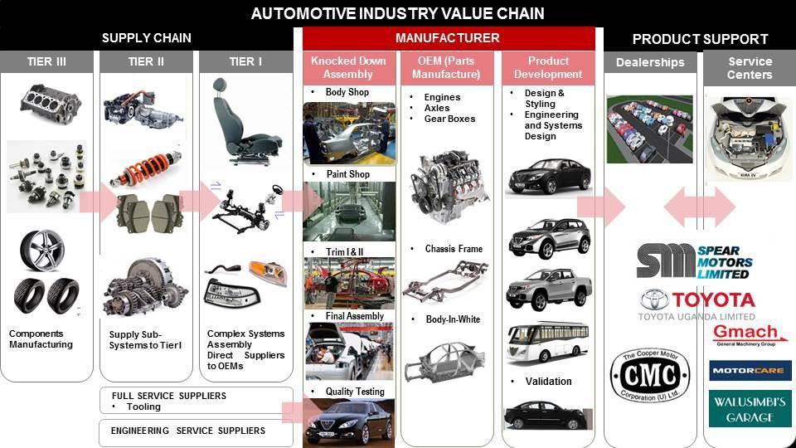business opportunities for Value Chain Actors from Parts Manufacturing (Metal, Exiles, Leather, Plastics, Rubber…), Engineering and Vehicle Product Development; Assembly; Vehicle Retail & Distribution; Vehicle Servicing; and Logistics & Supply Chain Business Opportunities. The Uganda Automotive Industry Value Chain is primarily dominated by the product support tier involved in the retail and distribution of Motor Vehicles (dealerships).

Uganda Auto Industry Value Chain

Source; Kiira Motors Automotive industry Development Policy Study.
2. CURRENT STATE OF AUTOMOTIVE INDUSTRY

2.1 National Policy Initiatives

2.1.1 Import Regulations
Uganda introduced an environmental levy of up to 50 per cent of Customs duty on the value of cars aged 10 years or more in the past financial year.

2.1.2 Periodic Road Worthiness Tests- SGS
Safety and road worthiness is a key concern for consumers as rampant accidents are mostly due to non- compliant vehicle conditions on the roads. SGS is a private company contracted by the government of Uganda to carry out periodic inspection of vehicles for road worthiness tests and construction of the inspection and testing facility is underway in Buloba along Mityana Road.

2.2 Employments in the Automotive Industry

The auto industry currently has formal and informal modes of employments with statistics showing informal employment in auto repair workshops and the sale of spare parts. Dealerships are also split between formal and informal operations with used vehicles as a majority in the former and brand new vehicles in the latter. There are no verifiable employments statistics for the Uganda Automotive Industry

2.3 Imports and Export of Automotive Products

2.3.1 Uganda’s Vehicle Imports

Passenger Vehicles import value of US$ 207 Million was registered in 2015. The total import value of all goods from japan US$ 336M where Uganda imports the most used vehicles from.

2.3.2 Import Value

The Uganda total import value has increased from US$ 998 Million in 2000 to US$ 6.03 Billion in 2014, with the vehicle import value increasing from US$ 89.7 Million in 2000 to US$ 598 Million in 2014. Japan is the leading vehicle import origin for Uganda.

U G AN D A P AS S E N G E R V E H IC L E & T R U C K S IM P O R T V AL U E 2 0 1 3
171,019,359
33,591,259
10,646,724
9,930,731
5,709,649
3,900,475
3,436,715
3,331,886
3,323,391
2,914,208
1,836,855
1,189,009

The bulk of imported vehicle spare parts are used so as to service the huge grey market in Uganda.
2.3.3 Vehicle Registration Factsheet 2002-2012

Price is a major reason for the consumer preference to second hand vehicles that command in excess of 80 percent of passenger related vehicles in Uganda. The growing middle class in the East African region is driving growth in this sector with a demand for small cars. Major franchises have been set up to meet the demand1, but are facing major competition from imported second hand vehicles from Europe and Far East countries.

Type of Vehicle | 2002/03 | 2003/04 | 2004/05 | 2005/06 | 2006/07 | 2007/08 | 2008/09 | 2009/10 | 2010/11 | 2011/12
Car | 6,469 | 6,743 | 9,457 | 9,622 | 10,029 | 12,290 | 9,712 | 8,190 | 7,930 | 8,552
Mini Bus | 205 | 224 | 110 | 158 | 169 | 261 | 253 | 223 | 403 | 178
Pick Up | 4,254 | 3,594 | 4,072 | 3,814 | 3,329 | 3,902 | 2,601 | 2,269 | 2,345 | 2,216
Van | 1,871 | 1,695 | 2,561 | 2,093 | 1,811 | 2,754 | 2,508 | 2,236 | 1,988 | 1426
Bus | 87 | 49 | 65 | 62 | 95 | 210 | 250 | 197 | 167 | 231
Lorry | 813 | 834 | 1,188 | 1,548 | 1,828 | 2,594 | 3,465 | 3,770 | 3,588 | 3,074
Tractor | 228 | 233 | 444 | 189 | 185 | 252 | 413 | 711 | 745 | 828
Trailer | 107 | 158 | 205 | 415 | 283 | 243 | 239 | 375 | 521 | 569
Tanker | 25 | 23 | 21 | 40 | 45 | 66 | 85 | 97 | 103 | 70
SUV | 2,245 | 2,767 | 3,212 | 4,015 | 4,546 | 6,427 | 8,898 | 14,795 | 16,470 | 15,136
Semi-Trailer | 2 |  | 11 | 36 | 14 | 49 | 23 | 31 | 26 | 6
Fork Lift | 23 | 27 | 12 | 32 | 50 | 38 | 25 | 53 | 91 | 63
Earth  Equipment | 69 | 137 | 214 | 144 | 175 | 259 | 424 | 385 | 422 | 463
Ambulance | 5 | 20 | 51 | 12 | 34 | 26 | 28 | 35 | 29 | 42
Omni Bus | 3 | 146 | 101 | 13 | 7 | 17 | 17 | 29 | 46 | 19
Tipper | 217 | 686 | 656 | 151 | 952 | 1,281 | 1,635 | 1,661 | 1,599 | 1,078
TOTAL | 16,623 | 17,336 | 22,380 | 22,344 | 23,552 | 30,669 | 30,576 | 35,057 | 36,473 | 33,951
Table 3: Summary of Vehicle statistics in Uganda (source: Kiira Motors Business Case 2014)
Statistics show that 60% of vehicles on Ugandan roads are passenger vehicles.

2.3.4 Government Fleet Registrations Factsheet 2000-2014

Government remains the most dominant consumer of brand new vehicles in Uganda.

YEAR | CARS | PICK UPS | VANS | LORRIES | TRACTORS | TRAILERS | SUV | TIPPERS | EQUIPMENTS | AMBULANCES | MIINI BUSES | BUSES | WATER BOUSER | SEMI-TRAILER | GABBEG TRUCKS | LOW BED | TOTAL
2000 | 7 | 245 |  | 4 | 16 | 13 | 86 | 74 | 40 | 1 | 16 | 1 |  |  |  |  | 1,881
2001 | 12 | 203 |  | 8 | 5 |  | 205 | 4 | 2 | 22 | 20 | 4 |  |  |  |  | 965
2002 | 13 | 248 |  | 13 | 6 | 6 | 189 | 17 | 4 |  | 9 | 4 | 1 |  |  |  | 1,667
2003 | 7 | 313 | 1 | 7 | 4 | 3 | 142 | 40 | 9 | 6 | 10 |  |  |  |  |  | 1,289
2004 | 18 | 343 | 1 | 14 | 14 | 9 | 127 | 9 | 11 | 16 | 10 | 4 |  |  |  |  | 1,031
2005 | 13 | 291 |  | 3 | 6 | 3 | 192 | 7 | 1 |  | 6 | 5 |  |  |  |  | 1,348
2006 | 12 | 244 | 3 | 5 | 2 | 2 | 153 | 4 | 1 | 31 | 20 | 3 |  |  |  |  | 1,571
2007 | 76 | 359 |  | 8 | 2 | 3 | 181 | 11 | 6 | 27 | 26 | 1 |  |  |  |  | 3,131
2008 | 14 | 300 | 1 | 8 | 36 | 29 | 174 | 2 | 13 | 41 | 20 | 5 |  |  |  |  | 2,316
2009 | 23 | 336 | 2 | 8 | 18 | 3 | 204 | 32 | 18 | 0 | 28 | 1 |  |  | 30 |  | 2,787
2010 | 83 | 524 | 4 | 22 | 4 |  | 251 | 2 | 12 | 3 | 17 | 9 |  |  |  |  | 2,623
2011 | 12 | 636 | 8 | 24 | 6 | 10 | 145 | 56 | 4 | 14 | 22 | 13 |  | 1 |  |  | 3,073
2012 | 16 | 158 |  | 15 | 178 | 168 | 95 | 313 | 275 | 30 | 13 | 5 | 12 | 6 | 22 | 2 | 2,205
2013 | 8 | 198 |  | 2 | 3 | 29 | 90 |  | 1 | 4 | 20 |  |  |  |  |  | 899
2014 | 19 | 234 |  | 1 | 26 | 28 | 111 | 2 | 8 | 3 | 11 | 5 |  |  |  |  | 1,057
Table 4; Uganda government fleet stocking Source; Uganda Revenue Authority

1 The Economic commission of Africa in Zambia 1965 emphasized the need for industrialization and economic transformation in the whole of Eastern Africa
2.3.5 Type of CVs used in Different Vehicle Hubs in Uganda

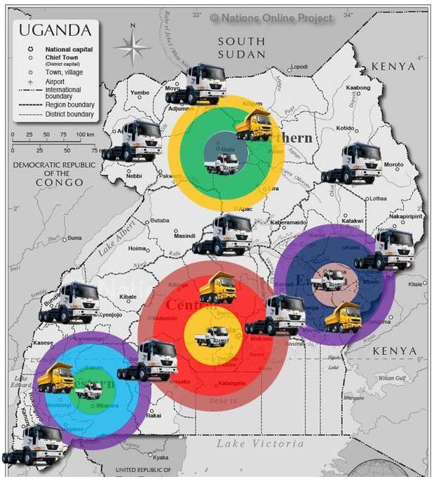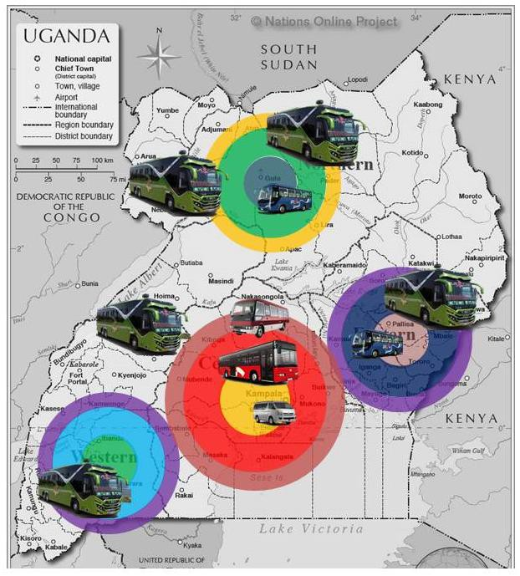Trucks- Hubs in terms of usage in Uganda Buses – Hubs along major transportation routes in
Uganda
Source; Buses and Trucks Market survey, UDC -2015
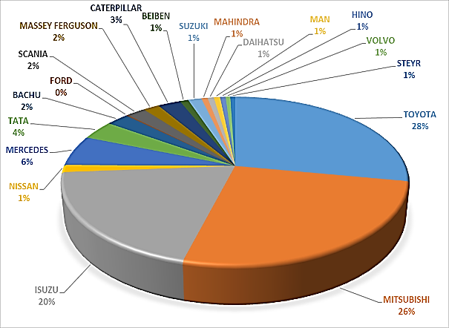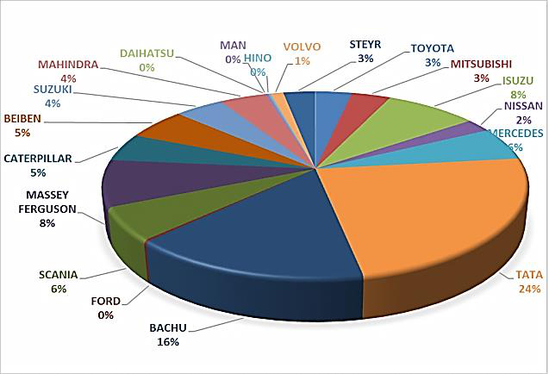2.3.6 Commercial vehicles market share distribution

New Vehicles Used vehicles
Source; Buses and Trucks Market survey, UDC -2015

2.5 Main Stakeholders in the Industry

According to Freeman (1984) a stakeholder in an organization is any group or individual who can affect or is affected by the achievement of the organization's objectives. Challenges and opportunities

Summary of primary and secondary stakeholders in the Ugandan automotive industry.

Primary Stakeholders | Secondary Stakeholders
• Component and Systems Suppliers  • International OEMs  • Vehicle Assemblers & Body Builders  • Vehicle Service Centres & Dealerships  • Government, Parliament and Regulators  • Industry Association and Agencies and Labor Unions  • Vehicle Owners and Customers | • Engineering Service Suppliers  • Tooling and Machinery Companies  • Financial Institutions Insurance Companies  • Education and Training Institutions  • Professional Registration Bodies  • Logistics Companies  • Press & Media Groups

3. MAIN CHALLENGES AND OPPORTUNITIES

3.1 Challenges

Second Hand Imports; 85registed in Uganda annually are used vehicles with an average age of 16 years. These vehicles still remain a key conduit of Ugandan currency flowing offshore in an area where it could have been retained if there was local capacity for vehicles manufacturing.

Counterfeit Spare Parts; the auto industry has witnessed an unregulated influx of counterfeit spare parts for
Japanese brands. This prevalence has taken advantage of the lack of regulation on spare parts imports.

Safety Standards; the industry suffers from lack of formal standards for safety or safety checks for vehicle imports. There is still a deficit for regulation based on safety ratings on a national and regional level.

High Emissions; old used cars remain on the radar as the footprint of their toxic emissions remains at a record high in east African cities and Kampala is not unique to this anomaly.

City | Emissions (Ton/year)
 | PM10 | PM2.5 | NOx | SOx | VOC | Benzene
Kampala | 618 | 556 | 3984 | 1747 |  | 610
Dar-Es-Salaam | 442 | 398 | 1250 | 2851 |  | 436
Nairobi | 10,300 | 9270 | 66392 | 114 | 199325
Figure 15; Vehicle Emissions in East African cities
Source; World Bank 2009 final report sub-Saharan Africa refinery report

Informal enterprises with limited local Value addition; Most of the initiatives that are aimed at local capacity for value addition (body builders, parts manufacturers, still exist in an informal setting with no platform for intellectual engagement.

Technical competencies; training institutions are still underpinned by the need to avail technicians to servive the more popular used vehicles on the road due to the numbers. This has in turn created a deficit for highly trained technicians who can interact with more recent technologies.

Infrastructure; the sprawl of industries to support automotive manufacturing requires highly developed and integrated infrastructure in the

3.2 Opportunities

Emergence of a Lower Middle Class with increasing Purchasing Power; Uganda has birthed an emergence of a lower middle class which continuously witnesses growth in purchasing power. High quality goods are there for sought by this population and the automotive cosmos is not spared as the market is expanding.

Regional Economic Integration; the economic integration within regional markets with the east African community and COMESA are opportunities for Uganda to access markets with goods for export and vehicles made in Uganda shall be a unique and valuable addition to Uganda‟s sectorial profile.

Linkages with other Sectors; Automotive manufacturing is poised to foster integration across multiple sectors as it will catalyze backward and forward linkages with other sectors, these include oil by-products; the Steel and Sheet Glass Industries for Body Parts; Textiles and Leather Industries for Interior Trim Components; amongst others. The requisite environment alone already has supporting infrastructure underway with prospects of expansion across the board. These include; among others; Power Plants; Standard Gauge Rail; Roads; National Fiber Optics Infrastructure as demand is created for the related services.
Environmental Stewardship; repealing the emissions spilled by the gray market vehicles is not only an opportunity to attend to the obligation to preserve and conserve the environment but also a responsibility of the citizens of Uganda and the region. The manufacture of Vehicles in Uganda will provide fuel efficient and environmentally friendly transportation technology

Contribution to Gross Domestic Production; the contribution to GDP resulting from the Capital Expenditure is estimated at 15.66 Million US Dollars. The contribution to Production resulting from the KMC operational expenditure for the period 2019/2028 is estimated to be over 28.28 million US Dollars per annum. This growth can be exponential as other players plug into automotive manufacturing with local value addition.

Employment; the auto industry can greatly contribute to lessening the 53% unemployment rates among youths in Uganda, KMC alone is premised to avail 0ver 2,000 Jobs considering direct and indirect employment.

4. GOVERNMENT’S FUTURE PLANS FOR THE AUTOMOTIVE INDUSTRY

Government has already taken initial steps to developing the Uganda Automotive Industry through the establishment of Kiira Motors Corporation. The Kiira Motors production plant in Jinja is expected to start operation in 2018 and will have an installed capacity of 60,000 vehicles per year with prospects of creating over 2,000 jobs. This plant will be producing Pickups, SUVs, Sedans, Light & Medium Duty Trucks, and Buses in partnership with a reputable International Automotive OEM. So far, three Concept Vehicles; the Kiira EV, the Kiira SMACK & the Kayoola Solar Bus have been developed, making Uganda a proud model of Science and Technology Innovations in Africa.

i. The Buy Uganda Build Uganda (BUBU) Policy that encourages the consumption of locally produced goods and services. It stipulates that 20% of Government procurement by value should consist of local products and services while 50% of local products should conform to national standards.
ii. The East African Community Industrialization Strategy 2012-2032: Structural Transformation of the Manufacturing Sector through High Value Addition and Product Diversification based on Comparative and Competitive Advantages of the Region
iii. Joint Communique: 16th Ordinary Summit of the East African Community Heads of State of 20th
February 2015 “directed the EAC Council of Ministers to study the modalities for promotion of motor vehicle assembly in the region, and to reduce the importation of used motor vehicles from outside the community, and to report progress to the 17th Summit. The 17th Heads of State Summit of 2nd March
2016 took note of the Progress and Road Map towards Finalization of the Comprehensive Study on Automotive Industry in the EAC Region; and directed the Council to expedite the process and report to the 18th Summit in November 2016 with plausible policy options.
iv. National Development Plan II, “Strengthening Uganda‟s Competitiveness for Sustainable Wealth Creation, Employment and Inclusive Growth” (Section 10.2 Industrial Development) with specific emphasis on Science, Technological Innovation and Industrialization.
v. The National Trade Policy; Trading out of Poverty, into Wealth and Prosperity
vi. The National Industrial Policy: A framework for Uganda‟s Transformation, Competitiveness and
Prosperity;
vii. National Standards and Quality Policy (NSQP) 2012 that necessitates all products produced to conform to set standards and quality assurance measures

Foundation of the Uganda Automotive Industry Development Policy

The Uganda Automotive Industry sustainability is underpinned by the development of policy for global competitiveness with export-oriented manufacturing as a goal not limiting this industrial intervention to import substitution. The promotion of the Uganda Automotive Industry is premised against the Value
Proposition for Domestic Automotive Value Addition; Enhanced Environmental Stewardship (Air Quality);
and Improvement in National Balance of Trade.

The Uganda Automotive Industry Development Policy should primarily provide for the management of Key Stakeholders. Stakeholders are individuals or groups with an interest in the project, programme or portfolio because they are involved in the work or affected by the outcomes. The entire Automotive Industry Value Chain (Parts Suppliers, Manufacturing, Product Development; Dealerships; and Service Centers) therefore must be meticulously studied to inform the development of a relevant and beneficial Uganda Automotive Industry Development Policy.

The Uganda Automotive Industry Development Policy should be carefully crafted to address three aspects of the nascent Automotive Manufacturing Industry in the Uganda:

i. Regulation of Vehicle Imports to Phase Out Second Vehicle Imports and Promotion of Automotive
Exports
ii. Structures for Incentivizing Domestic Automotive Industry Value Chain Actors iii. Quality Standards in terms of Safety and Enhanced Environmental

For God and My Country
REFERENCES

i. http://www.theeastafrican.co.ke/business/East-Africa-moves-to-curb-used-car-imports/2560-3245604- view-printVersion-15d7loyz/index.html
ii. http://www.eac.int/sectors/investment-promotion-and-private-sector-development/why-east-
africa/investment-opportunities/manufacturing
iii. http://citifmonline.com/2015/12/08/uganda-to-set-up-first-car-assembling-plant-with-chinese-cash/
iv. http://www.monitor.co.ug/Business/Commodities/688610-740816-ydq39sz/index.html
v. http://www.newvision.co.ug/new_vision/news/1433362/uganda-start-manufacturing-car-spare
vi. http://www.voanews.com/a/chinese-factory-tries-to-sell-trucks-to-wary-ugandans/1688199.html
vii. www.citifmonline.com
viii. http://www.newvision.co.ug/new_vision/news/1433362/uganda-start-manufacturing-car-spare
ix. http://www.voanews.com/a/chinese-factory-tries-to-sell-trucks-to-wary-ugandans/1688199.html
x. http://www.livemint.com/Companies/rp0wI5wOoUONlDxythLzPN/TVS-sets-up-assembly-plant-in-
Uganda-to-roll-out-2-new-prod.html
xi. http://www.oica.net/category/economic-contributions/auto-jobs/
xii. http://allafrica.com/stories/200305140348.html
xiii. https://www.hks.harvard.edu/m-
rcbg/CSRI/publications/report_29_Harvard%20EO%20Dialogue%20Summary%2020071018.pdf
xiv. https://www.hks.harvard.edu/m- rcbg/CSRI/publications/report_17_EO%20Framing%20Paper%20Final.pdf
xv. http://www.hbs.edu/faculty/Publication%20Files/2010-0722_Rwanda_RDBLecture_27e661aa-c1c5-
4db0-bd13-263fb6c53bcd.pdf
xvi. How should Uganda grow? Ricardo Hausmann, Brad Cunningham, John Matovu, Rosie Osire and
Kelly Wyett CID Working Paper No. 275 January 2014
http://growthlab.cid.harvard.edu/files/growthlab/files/cid_working_paper_275.pdf
xvii. Uganda Labour Market Profile 2014 http://www.ulandssekretariatet.dk/sites/default/files/uploads/public/PDF/LMP/lmp_uganda_2014_fin al_version.pdf
xviii. CICERO Working Paper 2001:09 Globalization of the automobile industry in China - https://www.duo.uio.no/bitstream/handle/10852/32767/1381.pdf?sequence=1
xix. http://digitalcommons.ilr.cornell.edu/cgi/viewcontent.cgi?article=1394&context=key_workplace
xx. Growth accelerations in developing countries: Uganda and Cambodia compared. Andre Leliveld.
http://www.institutions-africa.org/trackingdevelopment_archived/resources/docs/leliveld-revised-
plusabs.pdf
xxi. . AFRICA'S TECHNOLOGY GAP Case Studies on Kenya, Ghana, Uganda and Tanzania http://unctad.org/en/docs/iteipcmisc13_en.pdf
xxii. Work in progress Productive employment and transformation in Uganda Bruce Byiers ( 2015)
https://www.odi.org/sites/odi.org.uk/files/odi-assets/publications-opinion-files/9494.pdf
xxiii. https://jobs.jumia.ug/en/jobs-ug/all/automotive/

