Feiying Electric Vehicles Uganda launches electric bikes in Uganda.

By Techjaja Staff
-
December 14, 2016

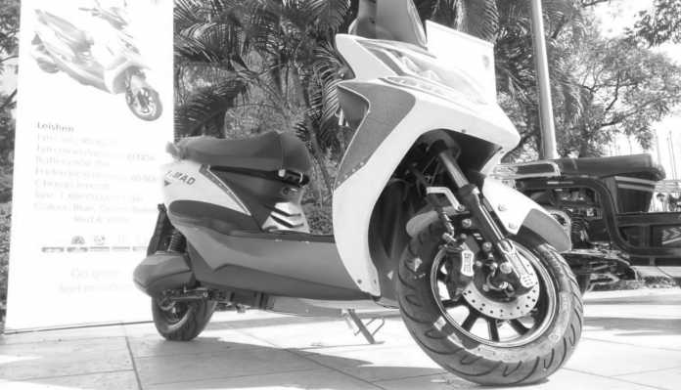The Leishen electric bike. Image Credit: Onyait Odeke
Join Techjaja on telegram
The bikers and boda-boda drivers are in for a treat this festive season as Feiying Electric Vehicles Uganda has today launched the first ever electric bikes in Uganda. The bikes were launched at Serena conference by the Chinese company that hopes to change the scene of biking in Uganda. The aim is for Ugandan motorbike-riders to rely on an all electrically charged bike and eliminate the use of fuel that current powers most vehicles.
- Advertisement -
At the beginning of last year, we saw a concept eletric smartscooter at CES bike called Gogoro and we believed such technology would come to Uganda one day. Although Feiying’s bikes are not smart like the Gogoro, they promise a completely fuel-less riding experience. Feiying launched five different kinds of electric motor vehicles namely: the Turu , Quan Neng Wang, Leishen, Gogo and VJR, all built to satisfy the different segments of motorbike enthusiasts.
For example, the Quan Neng Wang will have an endurance mileage of about 100-120km and has a charge time of about 8 hours, for a battery capacity of 70V 30A, so just like your smartphone, and over night charge will do the trick. Since there is no charging station infrastructure, expect a hike in that YAKA/UMEME bill. The bikes are manufactured by a company called Kenaier and their batteries will lasts for about 1.5 years before one will need to replace it.
- Advertisement -

The prices of these bikes all range from UGX 3.6 to 3.1 million with the Turu , Quan Neng Wang and Leishen, costing UGX 3.65 m, 3.6 m and UGX 3.35m respectively. And the , Gogo and VJR will each cost UGX 3.1 million.

