MINISTRY OF TRADE, INDUSTRY AND COOPERATIVES
STATUS OF THE SUGAR INDUSTRY IN UGANDA

- Introduction
The sugar industry is one of the fastest growing industries in the economy of Uganda under the manufacturing sector contributing about UGX 500 billion in taxes annually and employing over 100,000 Ugandans directly. It also produces over 150 MW of electricity from bagasse of which about 70MW is supplied to the national grid. Currently there are 20 licensed sugar mills in the country although only 14 are in operation since Atiak sugar is currently lacking sugarcane and Kasanda sugar is still test running their mill.

Table 1: Operational Sugar Mills and Crushing Capacities
S.No. | Name of the factory |  | Crushing Capacity (TCD) | District
1 | Kakira Sugar Works Ltd |  | 8000 | Jinja
2 | Kinyara Sugar Works Limited |  | 9000 | Masindi
3 | SCOUL- Lugazi |  | 5000 | Buikwe
4 | Hoima Sugar Limited |  | 5000 | Hoima
5 | Mayuge Sugar Industries Ltd |  | 5000 | Mayuge
6 | GM Sugar Limited |  | 3500 | Buikwe
7 | Kamuli Sugar Limited |  | 3500 | Kamuli
8 | Kiryandongo Sugar Limited |  | 3500 | Kiryandongo
9 | Victoria Sugar Works |  | 3000 | Luwero
10 | Sugar & Allied Industries |  | 2500 | Kaliro
11 | Bugiri Sugar Limited |  | 2500 | Bugiri
12 | Kyenjojo Sugar Limited |  | 2000 | Kyenjojo
13 | Atiak Sugar |  | 1650 | Amuru
14 | Bwendero Sugar |  | 1000 | Hoima
15 | Kasanda Sugar Limited |  | 1500 | Kasanda
16 | Uganda Farmers Crop Industries Ltd-Sezibwa Sugar |  | 500 | Buikwe
 | Total |  | 57,150

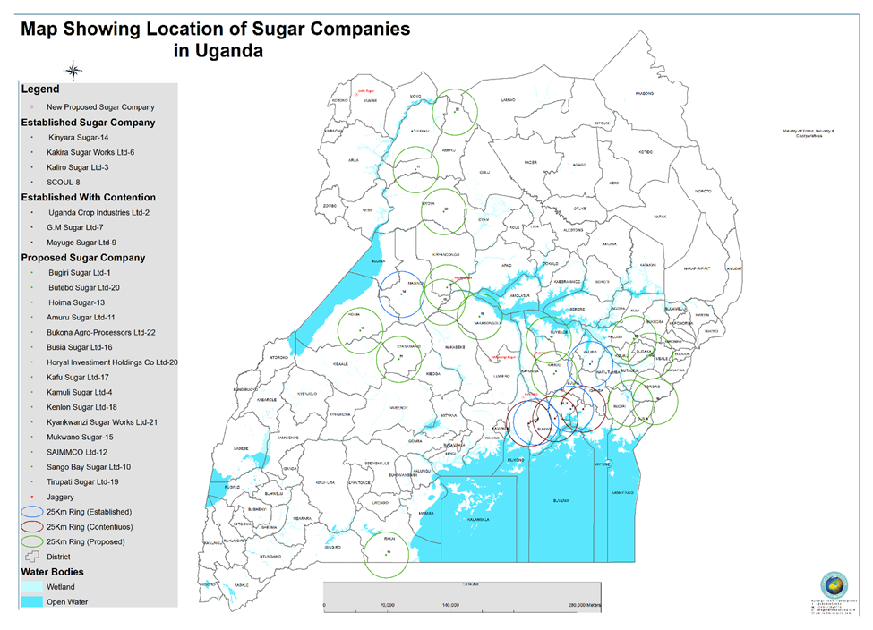

2.0 Sugar production trends in Uganda
Over the last 15 years sugar production has been increasing by nearly 12% annually culminating into record annual production of over 431,000 metric tons in 2014 and the sector is steadily improving its productivity. The production and consumption trends are shown in Table 3 below.
Table 2: Sugar production and consumption trends
Year | 2014 | 2015 | 2016 | 2017 | 2018 | 2019 | 2020 | 2021 | 2022 | 2023 | 2024
Productn. (MT) | 431,415 | 418,882 | 420,000 | 408,000 | 416,000 | 500,000 | 580,000 | 600,000 | 620,000 | 495,000 | 610,000
Consumn. (MT) | 320,000 | 350,000 | 360,000 | 362,000 | 365,000 | 366,000 | 380,000 | 410,000 | 460,000 | 445,000 | 460,000

The statistics of sugar production in the country reveals a decline in annual production from about 431,415 metric tons in 2014 to 416,000 metric tons in 2018. This decline was attributed to lack of mature sugar cane supply to the mills amidst the increased installed capacities. However in 2019 production bounced back to 500,000 tons with good harvest of cane leading to oversupply of cane by outgrowers. In 2022 sugar production was about 620,000 metric tons but declined to 495,000 metric tons in 2023.
3.0 Investment in production of Industrial Sugar
The Ministry has given seven (7) millers namely; Kinyara sugar Limited, Kakira sugar Ltd, GM Sugar, Sugar Corporation of Uganda Limited Lugazi, Mayuge Sugar, Sezibwa sugar Limited and Kamuli Sugar Limited letters of No Objection to set up refineries to produce Industrial Sugar.
Kinyara Sugar started producing 6,000 tons of industrial sugar per month since February 2022 while GM Sugar Limited started production of 150 tons per day in February 2023. Kinyara has now increased production to 90,000 tons per annum.

3.1 Production of Industrial Refined Sugar
Kinyara Sugar Limited invested over USD 15 million in a sugar refinery and produces 90,000 tons of refined industrial sugar annually. GM Sugar has also installed a refinery and concluded the test runs.
The Ministry also gave another three (3) millers namely, Sugar Corporation of Uganda Limited Lugazi, Mayuge Sugar and Kamuli Sugar letters of No Objection to set up refineries to produce Industrial Sugar.

- Sugar sector Associations
4.1 Millers Associations
- The Uganda Sugar Manufacturers Association (USMA) was formed by the three traditional big millers of Kakira Sugar Works Limited, SCOUL-Lugazi and Kinyara Sugar Limited and later joined by Hoima Sugar and Kiryandongo Sugar.

- Millers Association of Sugarcane (MAS) with a membership of 8 millers namely: Mayuge Sugar, GM Sugar, Kamuli Sugar, Kaliro Sugar, Kyenjojo Sugar, Bwendero Sugar,Victoria Sugar, Bugiri Sugar and Sezibwa Sugar.
Atiak Sugar currently doesn’t belong to any of the associations
4.2 Out growers associations
- Uganda National Sugarcane Growers Association (UNASGA)
- Greater Busoga Sugarcane Growers Cooperative Union (GBSCGU)
- Busoga Sugarcane Growers Association (BSGA)
- Greater Mukono Sugarcane Out-growers Cooperative Society Limited
- Kayunga Sugarcane Out-growers Cooperative Society Limited
- Masindi Sugarcane Growers Association Limited (MASGAL)
- Bunyoro Sugarcane Farmers’ Cooperative Union
- Atiak Sugar Plantation Outgrowers Cooperative Society Limited
- Gem Pacilo Farmers’ Cooperative Society Limited
- Ayuu Alali Sugarcane Outgrowers Cooperative Society
- Busedde Sugarcane Cooperative Society Limited
- GM Sugarcane Out growers Cooperative society Limited
- Lugazi Sugarcane Out growers Cooperative society Limited
- Bukooli Sugarcane Cooperative Society Limited

- Status of legal, policy and regulatory framework in the subsector
5.1 Policies:
The National Sugar Policy was approved in August 2010 with a mission to develop and sustain growth of the sugar industry in Uganda and with the ultimate aim of creating wealth, employment and enhancing social transformation.
One of the major objectives of National Sugar Policy 2010 was to “Establish cane growing zones for the mills to be within economic growing distance of large land suitable for cane growing.
The specific objectives are to:
(i) Establish a sugar sector regulatory mechanism to oversee, monitor and possibly arbitrate in respect to major issues concerning the sugar sector.
(ii) Establish cane growing zones for the mills to be within economic growing distance of large land suitable for cane growing.
(iii) Provide a framework for product pricing based on market forces.
(iv) Promote research and development into all aspects of sustainable sugarcane growing, sugar processing and value addition to by-products, in order to support the growth and productivity of the sector.
v) Promote sustainable land management practices in order to improve productivity of land and protect against destruction of the surface of land.
(vi) Review the role of the sugar industry in order to formulate future plans for expansion of cane growing, sugar production and product revenue sharing.
(vii) Develop relevant and meaningful social responsibility development projects within sugarcane growing areas
5.2 Sugar Act
The amended sugar act was gazetted in June 2025 and provides for establishment of the Uganda Sugar Industry Stakeholders’ Council composed of:
- Chairman
- 4 farmers
- 3 millers
- 3 Government representatives from Ministries responsible for; Finance, Agriculture and Industry

5.2.1 Licensing of Sugar Mills
Prior to licensing, applicants must fulfill the conditions of minimum nucleus estate, zoning requirements and potential for out-growers. Furthermore, project promoters must submit detailed business plans and project proposals against which government decides on viability of the project. This is to further emphasize the importance of availability of adequate supply of raw materials and to assess the potential for growth.

5.2.2 Expansion/Diversification of sugar mills
Sugar manufacturing is capital intensive and is characterized with significant economies of scale. Therefore as an economy we stand to gain more from large mills than from small mills. However, as we promote industrialization we must encourage establishment of mills, and those starting small should not be locked out of the sector. As a compromise therefore, a detailed criteria has been elaborated to take into account availability of raw materials, role of out-growers and by-products before expansion is approved. This is to ensure logical and organized growth of the sector. In this respect, at licensing it is imperative that potential for growth is put into consideration. This will ensure that as new players get into the sector, earlier players are not disadvantaged.
5.2.3 Sugar Industry agreements
The act provides for all business transactions between stakeholders to be secured with agreements; such as cane production, purchase, harvesting and transport agreements and these must be enforceable.

5.2.4 Sugar Industry Research Institute.
Currently Uganda does not have a research institute for sugar cane and sugar technology. Research is being done by individual sugar mills unlike other sugar producing countries such as South Africa, Mauritius, Swaziland and Malawi among others.
Uganda’s sugarcane is grown under rain fed cultivation and matures at 18 months and yielding an average recovery of 8.86% as against 12% by other African countries mentioned above.
The act seeks to establish a national research institute to promote research and development of sugar cane varieties in order to come up with cane that is early maturing; high yield; and low fiber and high polarity.

The amended sugar act also provides for cane pricing formula to ensure equitable share of proceeds in all transactions. This formula is based on international practices. Cane pricing has always been a contentious issue between the farmer and the miller and this formula intends to address this problem and any negotiations shall be expedited by the Committee of the Council established to look at cane pricing which shall be composed of Government, millers and farmer representatives.
5.2.5 Sugar cane pricing/formula
Pc = Ps x R x D
Where: Pc = Price of Sugar Cane per ton
Ps = Average market price of Sugar per ton
R = Rendement (Tons of sugar made per every 100 tons of cane)
D = Percentage to be negotiated by concerned parties as decided by the Council and the minimum shall be 50%
The above formula takes into account prevailing market prices which also is a function of Global sugar prices per ton.
The 50% minimum percentage in the formula is to protect farmers to ensure that millers pay fairly uniform sugar cane price per ton. Currently, the payment farmers receive per ton this percentage ranges between 45-50%, the lower one is at Bunyoro region and the higher is at Busoga and Mukono region. The negation will be done by the Cane Payment Committee which the Sugar Board will establish once it is established.

6.0 Challenges affecting the Sector
- Non-binding cane production contracts: There is increasing demand for sugar cane by the millers from the out growers leading to breach of contractual arrangements between the two parties.
- Cane poaching and diversion: Due to the proximity of mills and production expansion programs, there are increased cases of cane poaching and diversion to neighboring mills especially in the Busoga region.
- The low cane yield per hectare and the sugar yield per ton of sugar cane
- Improper agricultural management practices. The cane harvested is usually very young in age, which has low productivity. Good cane yields cane only be achieved with cane age around 16-18months for mature cane.
- High costs of sugar production
- Low sugarcane prices for outgrowers
- Reduced support of the outgrowers by the sugar millers
The following are the major causes of low cane yields and sugar productivity.
- Lack of control of growing conditions (climate, temperature and soil humidity) during cane maturity period.
To achieve high yield of good quality sugar cane requires good rains during growing and some dry spell during 2-3months towards maturity to enable accumulation of sucrose in the cane before processing. In Uganda, cane is grown on natural rain entirely with two rain seasons and it is not possible to control the amount of water entering the sugar cane during maturity due to our natural climatic conditions. That is why the sugar yields per ton of sugar cane are always higher (9% -10%) in dry seasons than in rainy seasons.
Countries that grow cane under both under conditions of natural rain and irrigation such as Swaziland, South Africa and Malawi achieve higher yields because they can practically control field water and moistures conditions effectively during maturity period.
In practice, cane fields are higher by approximately 30%-40% when grown under irrigation and lower when under field is 100% natural rain fed.

- Inadequate application of field inputs required to increase productivity.
On average, the quantity of farm inputs namely, fertilizers which increases productivity per unit area, lime to neutralize acidic soils and biocides for diseases control are below target. In addition poor and untimely weeding affects cane yield and particularly the out growers are affected because it is costly to maintain sugar cane fields. Generally, the cane yields from outgrowers is lower than the ones from nucleus estates of about 15%-20%.

- Poor cane varieties which have low sucrose content.
Over 75% of the cane varieties are old varieties and are of poor quality. These cane varieties take long to mature (18months) , have low sucrose content of about (10%-12%) and higher fibre content (about 17%-19%) which affects sucrose extraction during processing at the mills.
In Swaziland and South Africa, developed new cane varieties that mature within 10-12months ,low fibre content (14%-15%,) and high sucrose content (13%-14%). 90% of the sugar cane is grown under irrigation which enables control of the moisture during maturity period. Thus the field yield area is very high and higher recoveries at the factory due to low fiber and modern processing technologies, hence low cost of production.

- Limited knowledge on good agricultural practices
Extension services to sugar cane out growers has been lacking especially from District and Regional Agricultural services including support for farm inputs by Ministry of Agriculture, Animal Industry and Cooperatives. 60%-80% of sugar cane supplied to mills comes from out growers and there is need enhance their capacities with from extension services and provision of farm inputs.

- Low overall recoveries
Sugar recoveries in some of the sugar mills is below average of 8% due the following major reasons; low cane quality and inefficient factory recoveries both at the milling and process sections due to poor technologies.

7.0 Conclusion
The sugar cane varieties are of poor quality resulting into very low sugar yields. Research into new sugar cane varieties, which mature early, with high sucrose content, disease resistant and low fibre should be pursued by the National Sugar Research Institute as suggested in the Sugar (Amendment) Act 2025.

The implementation of the Sugar Act 2025 as amended and setting up a Sugar Industry Stakeholders Council shall help regulate the sector and make it competitive and self-sustaining while creating more jobs and revenue for the Government.

