PROJECT REPORT
JOB APPLICATION TRACKING SYSTEM

1 INTRODUCTION
  - Overview

Allows recruiters to match job requisitions to the job-posting sites and the social media channels most appropriate for specific candidates.

  - Purpose

Employment is very important in today's times. Today's youth are looking for employment. An applicant tracking system (ATS) is software that manages the recruiting and hiring process, including job postings and job applications.

- PROBLEM DEFINITION & DESIGN THINKING

  - Empathy Map

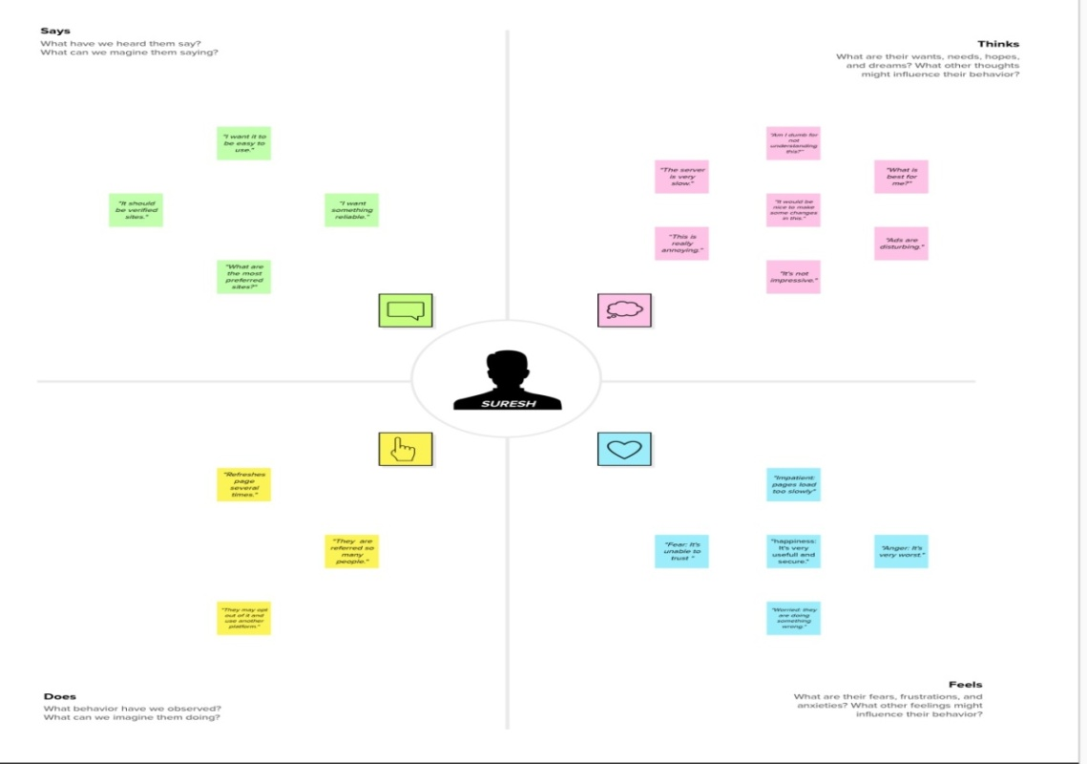

  - Ideation & Brainstorming Map

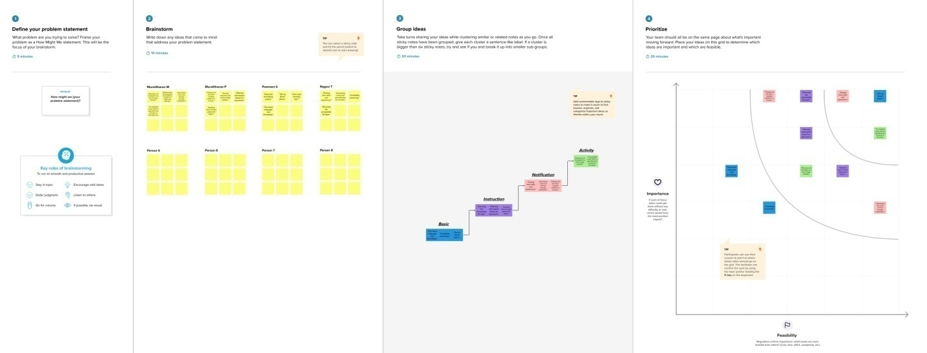

- RESULT

  - Data Model:

Object Name | Fields in the Object
Recruiter
  Field label | Data type
  Job Title | Text (30)
  Recruiter Number | Auto Number
Job
  Field label | Data type
  Location | Text (30)
  Job Number | Text (80)
Candidate
  Field label | Data type
  Candidate Name | Text (16)
  Candidate Number | Auto Number
Job Application
  Field label | Data type
  Job Application Name | Text (18)
  Job Application Number | Auto Number
Tab
  Field label | Data type
  Tab Number | Auto Number

  - Activity & Screenshot

Milestone 1 : Salesforce

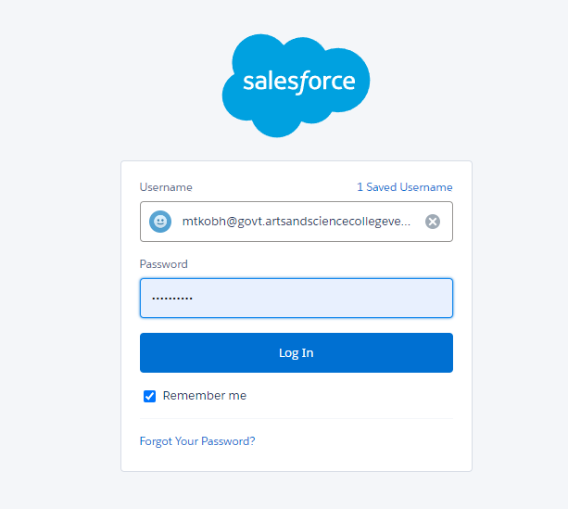
Milestone 2 : Object
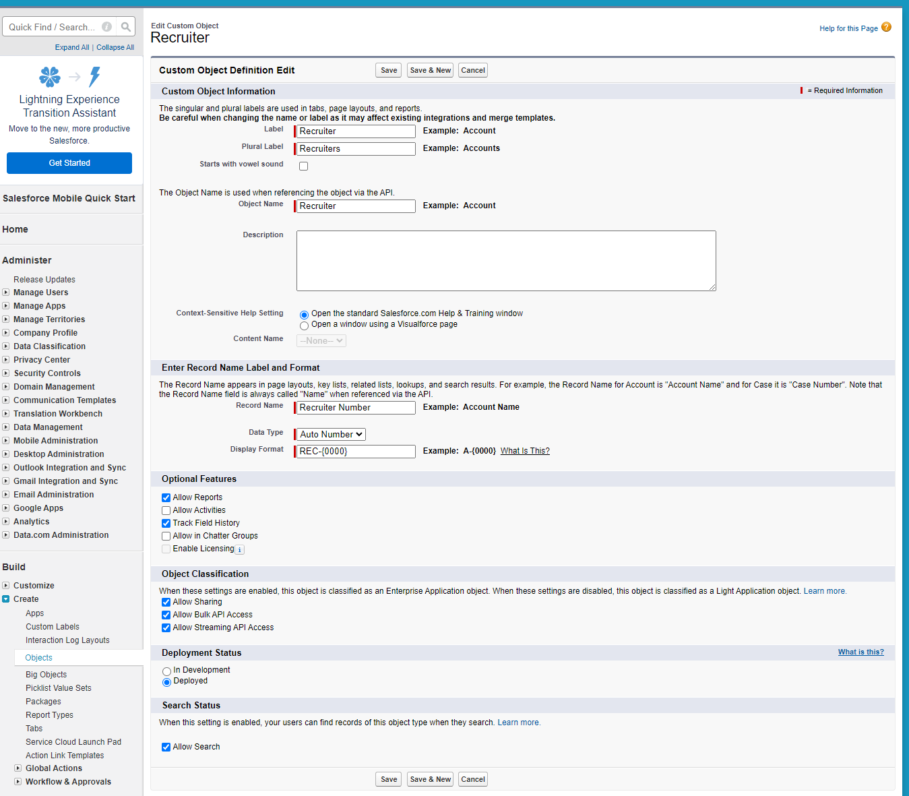

Milestone 3 : Tab
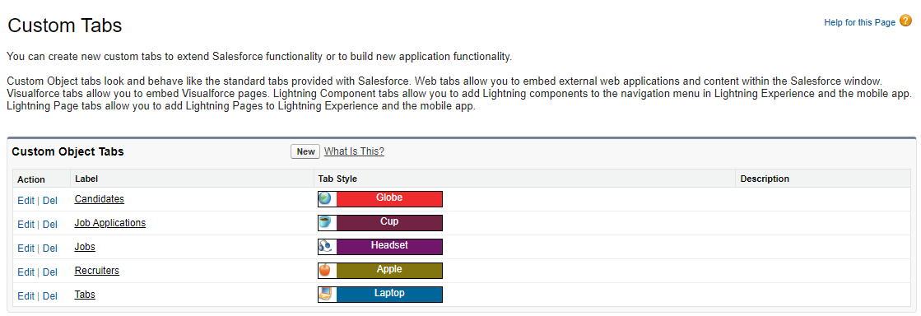
Milestone 4 : Field

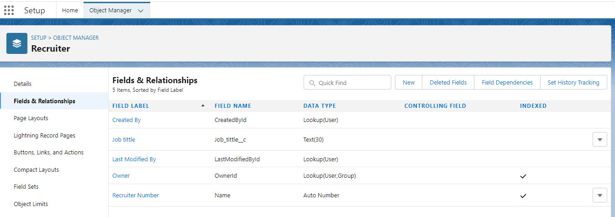

Milestone 5 : Profile

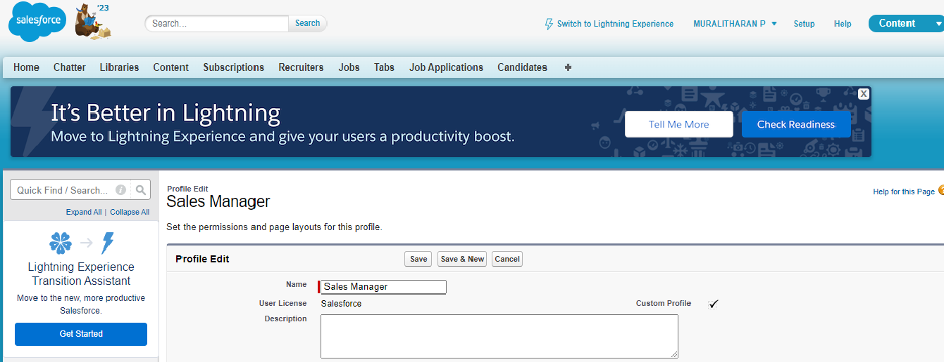

Milestone 6 : User

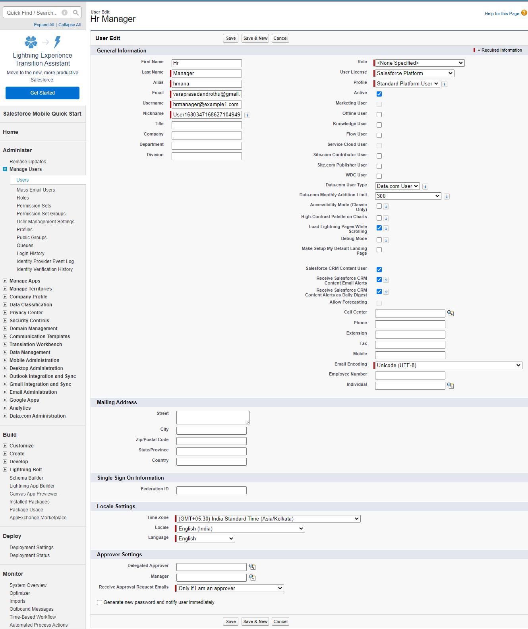

Milestone 7 : Sharing Rules
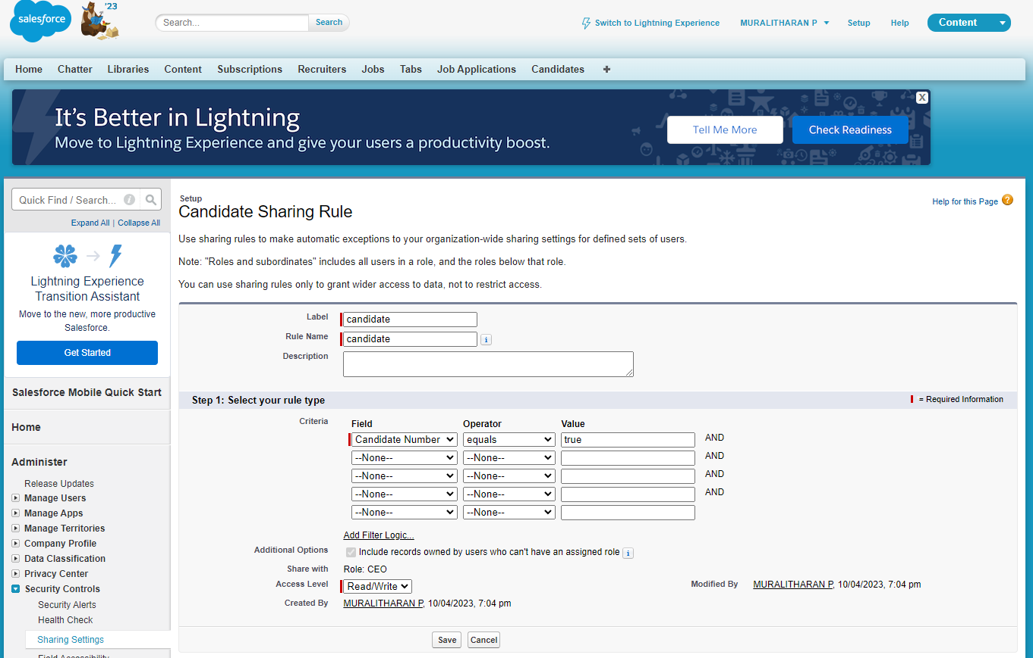

Milestone 8 : Reports

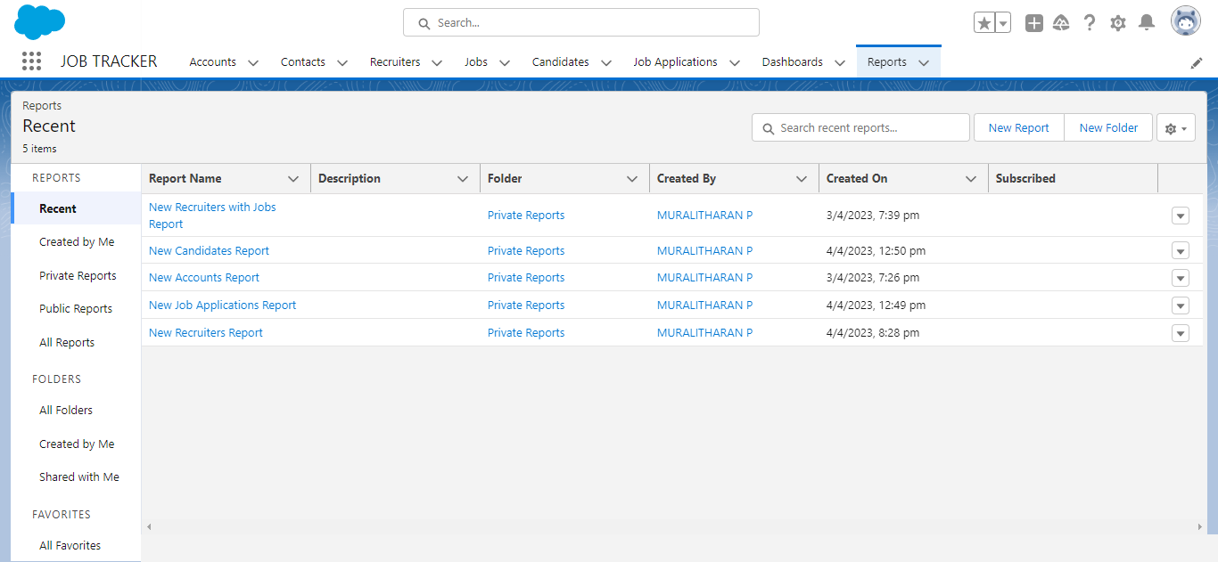

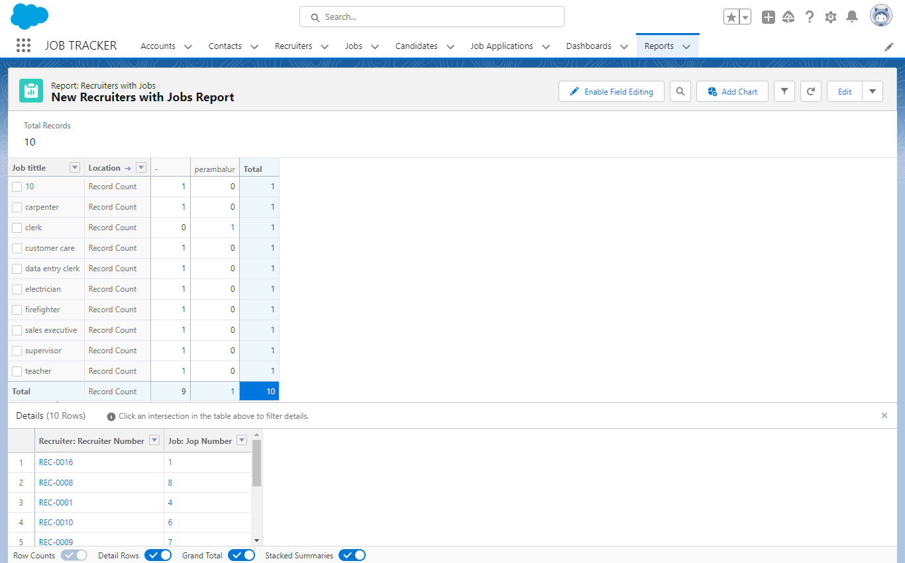

- TRAILHEAD PROFILE PUBLIC URL

Team Lead - https://trailblazer.me/id/mdharan33
Team Member 1 - https://trailblazer.me/id/murap8
Team Member 2 - https://trailblazer.me/id/pooms1
Team Member 3 - https://trailblazer.me/id/rtamilselvan
Team Member 4 - https://trailblazer.me/id/pdharshinim

- ADVANTAGES & DISADVANTAGE

Advantages | Disadvantages
Saves Times | Harder to Integrate
Seamless Searching | Limit Potential Candidates
Wealth of Data | Only Focuses On Data/Analytical Information
Customizable Screening | Open to Manipulation

- APPLICATIONS

- Distribution/warehousing/manufacturing
- Yard management
- Fleet management
- Person tracking
- GPS tracking
- Real-time locating systems (RTLS)

- CONCLUSION

Applicant Tracking System for recruiters is a very effective hiring solution that most of the successful recruiters utilize. Because without it, there is a good chance that your process of moving applicants through different stages can become very difficult.

- FUTURE SCOPE

Increase visibility into the hiring cycle for the entire recruiting team, and
increase opportunities for communication throughout the candidate journey.

