Table of Contents

Sample Outputs 2

Login 2

Register 3

Sidebar 4

Modify 5

Order 6

Manage menu 8

Manage User 9

Toggle buttons 10

Search Bar 11

Verification 12

Receipt 13

Sample Codes 14

Additional Features 16

Assumptions 18

References 18

# Sample Outputs

## Login

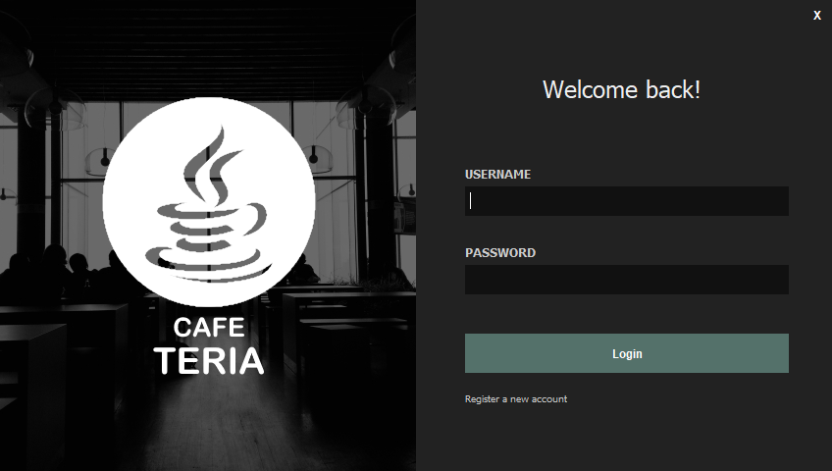

Figure 1: Login Screen

This is the first screen that is displayed when the program is run. The user must enter login details in order to use the system. If the user does not have an account on the system, he/she may register an account using the button below.

## Register

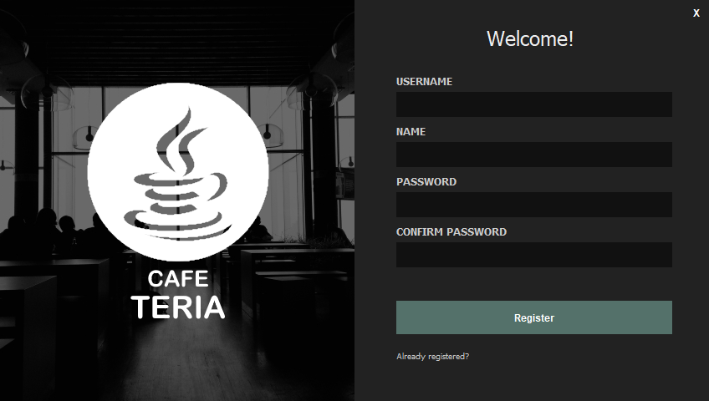

Figure 2: Register Screen

This is the register screen of the program. On this screen, users can enter their details and register into the system. Before the user is added into the database, a staff needs to verify the information (see below). After verifying, the user can then register the details and login.

## Sidebar

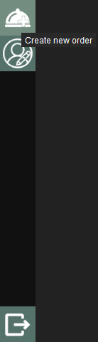 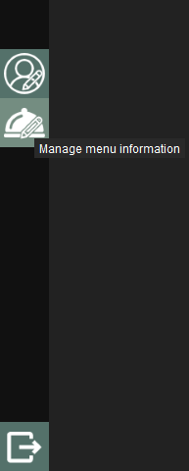 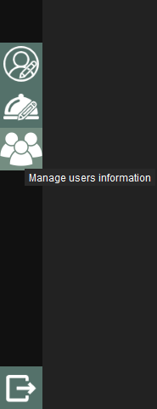

Figure 3: Sidebar (Customer, Staff, Admin)

This is the sidebar panel that allows users to use the different functions of the program. The sidebar displays buttons based on the user’s role. Hovering over the buttons show more information on what panel it directs to. The logout button at the bottom of the sidebar will send the user to the login screen.

## Modify

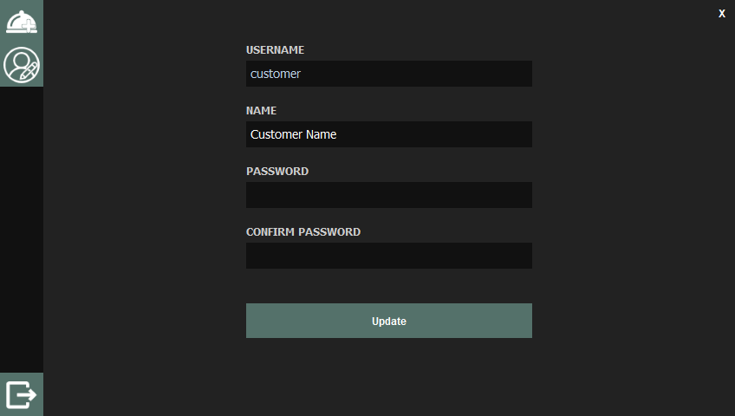

Figure 4: Modify Screen

This is the modify screen. This screen allows users to modify their own name and password. It works similar to the register screen, however, updating details does not require a staff verification.

## Order

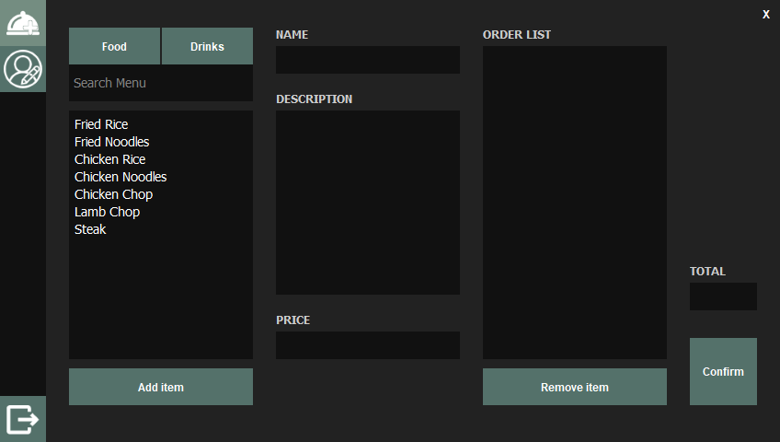

Figure 6: Order Screen

The order screen is used to place an order of food and drinks. Users will add items into the order list using the menu on the left. The total field displays the total price of the order list. Once the user finishes his order, pressing the confirm button will display the verification screen. Just like registering, ordering also requires staff verification.

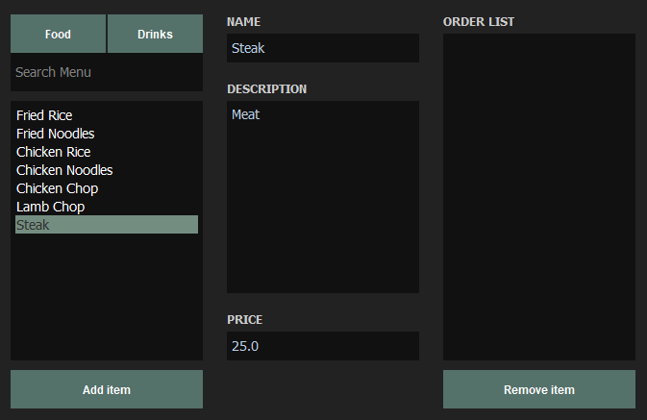

Figure 7: Selected Item in Order Screen

When users select an item in the menu list, it highlights and displays more information such as description and price.

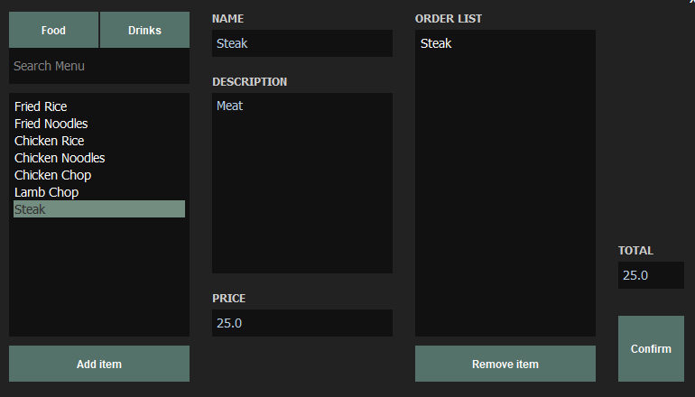

Figure 8: Add Item in Order List

Pressing the add item button will add the selected item into the order list. Pressing the remove item button will remove the selected item from the order list.

## Manage menu

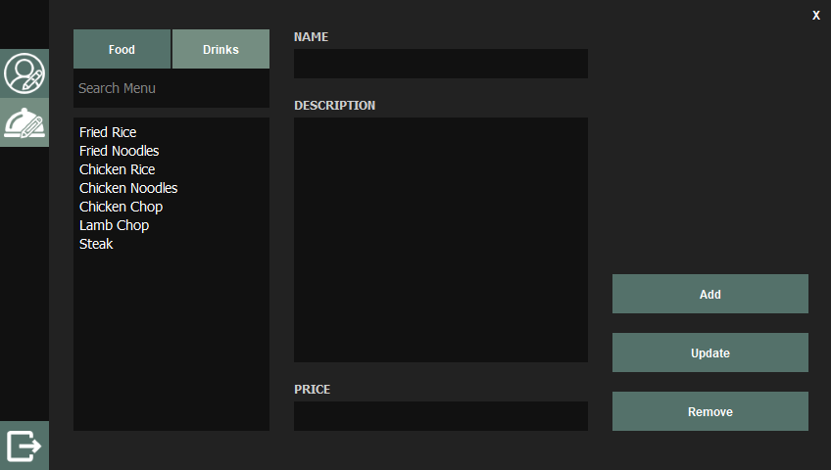

Figure 9: Manage Menu Screen

The manage menu screen can only be accessed by staff and admins. Here the user can add, update and remove items from the menu list. To add an item the user only needs to enter details into the text fields. To update, users may select an item in the list which will display the details in the fields. The user can then change the details and click the update button. To remove an item, the user will only need to select the item and click the remove button.

## Manage User

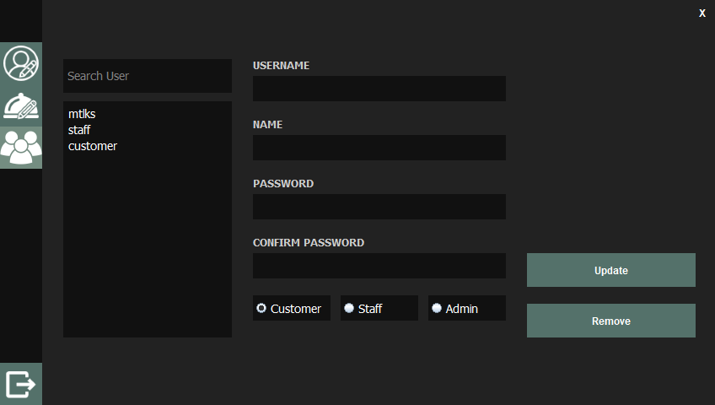

Figure 10: Manage User Screen

The manage user form only can be accessed by admins. Here admins can update and remove users from the system. Admins can also set the role of each user. If there is only one admin in the system, the admin will not be able to remove his admin role or account. If there are more than one admin, the admin may remove his admin role or his account, but he will be logged out right after.

## Toggle buttons

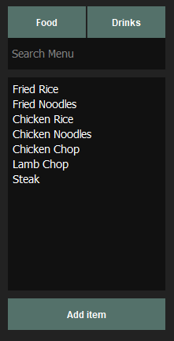 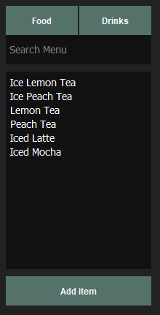

Figure 11: Toggle Button

There are two buttons on the top of the menu found in Order and Manage Menu. These buttons allow the user to switch between food and drinks in the menu.

## Search Bar

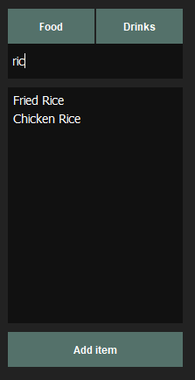 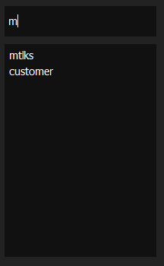

Figure 12: Search Bar

The search bar found in Order, Manage Menu and Manage User allows the user to find items in the list that contains a certain text. This makes it easier for the user search for items, especially if there are many items in a list.

## Verification

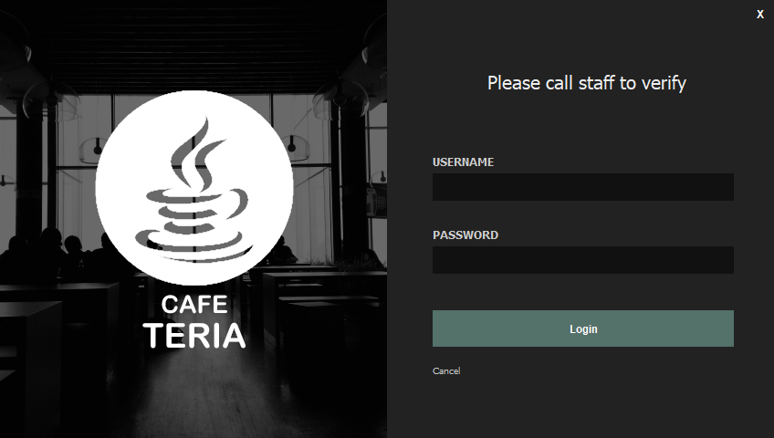

Figure 13: Verification Screen

This is the verification screen that is displayed after a user tries to register or order. This works similar to the login screen but only allows staff or admins to login.

## Receipt

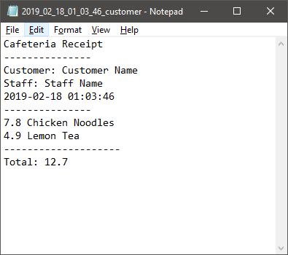

Figure 14: Receipt

This is a receipt generated by the system after a customer confirms an order and a staff verifies it. The receipt shows the name of the customer who placed the order and the name of the staff who verified the order.

# Sample Codes

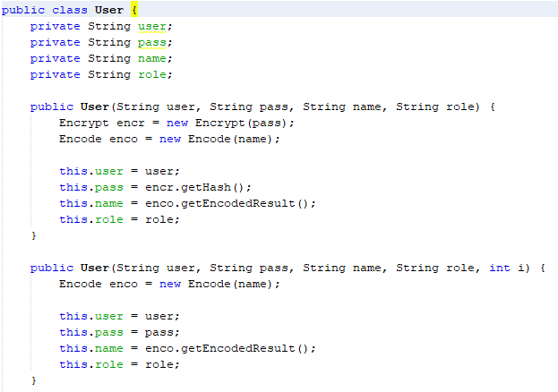

Figure 15: User class

This is a class that contains details of users. This class makes sure that the data entered is changed so that errors do not occur. It also makes it easy to input into a text file as it has a toString() function.



Figure 16: User object

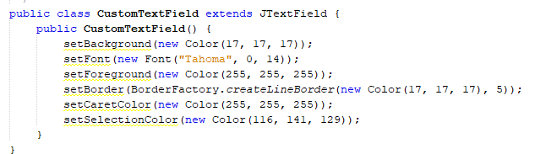

Figure 17: Custom Text Field

This is a class that extends from JTextField. This class is used to set a standard for how the text fields in the form looks.

# Additional Features

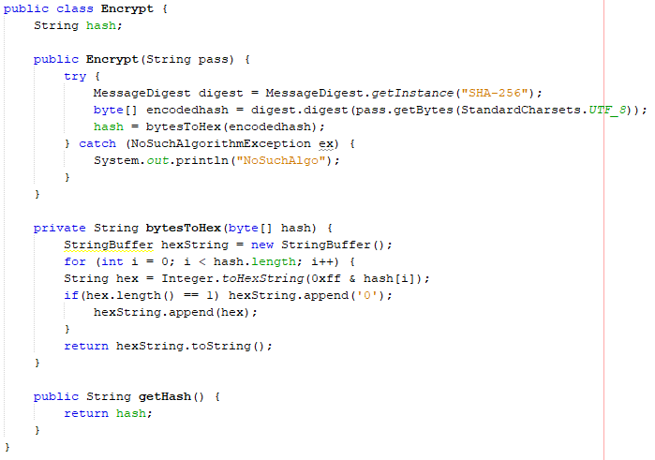

Figure 18: Encrypt

This class encrypts a string using SHA-256. This is so that passwords are not saved in the text file as plain text and instead stored as a hash.

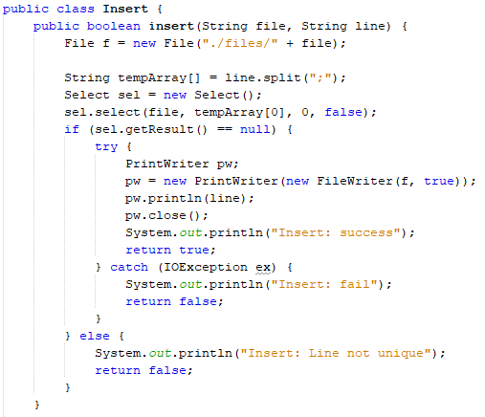

Figure 19: Insert

The system also has functions that are similar to SQL statements. These functions make it easier to read/write from text files and is reusable. The example above shows the Insert class and one of the methods.

# Assumptions

This system assumes that the payment made by the customer is handled manually. It is also assumed that there will always be a staff in the cafeteria for verification purposes.

# References

Baeldung. (2019). SHA-256 Hashing in Java | Baeldung. [online] Available at: https://www.baeldung.com/sha-256-hashing-java [Accessed 18 Feb. 2019].

Graywolf. (2019). java swing JTextField set PlaceHolder. [online] Available at: https://stackoverflow.com/questions/16213836/java-swing-jtextfield-set-placeholder [Accessed 18 Feb. 2019].