Wuhu Vocational And Technical University
芜湖职业技术学院
GRADUATION THESIS
毕业设计（论文）
Campus Environment Data Visualization System
基于Python的校园环境数据可视化与综合健康监测系统设计与实现
Department (系别): Department of Information Engineering (信息工程学院)
Major/Class (专业/班级): Computer Application Technology (计算机应用技术)
Student Name (学生姓名): [Student Name / 毕业生姓名]
Student ID (学生学号): [Student ID / 毕业生学号]
Supervisor (指导教师): [Supervisor Name / 指导教师姓名]
Date (完成日期): 2026 Year 10 Month 20 Day (2026年10月20日)

毕业论文中文摘要
题目：基于Python的校园环境数据可视化与综合健康监测系统
摘要：针对现代高职院校智慧校园微环境多区域监测手段分散、各功能区域环境数据离散孤立以及缺乏直观交互决策支持的实际问题，本课题研发了一套基于纯Python全栈架构的校园环境数据可视化与综合健康监测系统。系统后端基于轻量级Web框架Flask与高性能数据科学分析引擎Plotly Dash构建，采用SQLAlchemy作为对象关系映射（ORM）工具，底层以SQLite持久化存储时序环境遥测数据。系统覆盖校园图书馆、教学楼、学生食堂、学生公寓、体育场、主校门、停车场及实验实训中心等八大典型功能区域，支持环境温度、相对湿度、细颗粒物（PM2.5）、可吸入颗粒物（PM10）、二氧化碳浓度（CO2）及声环境噪声等级等六项核心指标的实时采集与历史分析，并严格依据美国国家环境保护局（US EPA）标准算法动态计算空气质量指数（AQI）与校园综合健康指数（CEHI）。系统设计了高内聚的模块化架构，包括基于角色的访问控制（RBAC）、多维度时空交互图表（多轨迹趋势曲线、区域横向对比柱状图、五维综合雷达图、四分位数箱线图及24小时昼夜时空热力图）、动态多级预警引擎以及自动化多周期统计报告与CSV导出功能。实测与自动化测试结果表明，系统响应延迟低于50毫秒，27项集成测试全部通过，有效提升了智慧校园环境治理、能源管控与师生健康保障的数字化与信息化水平。
关键词：校园环境；数据可视化；物联网；空气质量指数（AQI）；健康指数（CEHI）；Plotly Dash；Flask；Python

ABSTRACT
Title: Campus Environment Data Visualization and Health Monitoring System
Abstract: With the continuous development of smart campus infrastructures and the institutional emphasis on green environmental governance and occupant well-being, hyper-local surveillance of microclimate conditions across educational facilities has become indispensable. Traditional municipal weather stations fail to capture granular spatial-temporal variations across distinctive campus functional zones.
This graduation thesis presents the design, architectural engineering, and empirical evaluation of an end-to-end, enterprise-grade Campus Environment Data Visualization and Health Monitoring System developed entirely within the Python ecosystem. By coordinating Flask, Plotly Dash, SQLAlchemy, SQLite, and Pandas, the system captures, processes, visualizes, and evaluates continuous telemetry across eight representative campus zones: Main Gate, Library, Classroom Block, Cafeteria, Hostel, Playground, Parking Area, and Laboratory Block.
Six physical parameters are continuously analyzed: ambient Temperature, Relative Humidity, Fine Particulate Matter (PM2.5), Coarse Particulate Matter (PM10), Carbon Dioxide (CO2), and Acoustic Noise. Telemetry data is automatically processed to compute official US EPA Air Quality Index (AQI) values using piecewise linear interpolation alongside a 100-point Campus Environmental Health Index (CEHI). The reactive dashboard features executive KPI cards, spline-interpolated time-series curves, cross-zone horizontal comparisons, 5-axis zone radar profiles, quartile box plots, and a 24-hour diurnal heatmap matrix. Multi-tiered safety alert rules, automated statistical report exports, and role-based access control are seamlessly incorporated. Rigorous automated verification utilizing the Pytest framework confirmed a 100% pass rate across 27 comprehensive test cases, validating the system's operational stability, data integrity, and high responsiveness.
Keywords: Campus Environment; Data Visualization; Internet of Things (IoT); Air Quality Index (AQI); Plotly Dash; Flask; Python

目 录 (Table of Contents)
Chapter 1: Introduction 1
1.1 Project Background 1
1.2 Problem Statement 2
1.3 Project Objectives 3
1.4 Project Significance 5
1.5 Project Scope 6
1.6 Thesis Organization 6
Chapter 2: Related Technologies and Theoretical Background 8
2.1 Relevant Technologies 8
2.2 Development Tools and Frameworks 9
2.3 Related Methods or Existing Solutions 9
2.4 Technical Principles Relevant to the Project 10
2.5 Chapter Summary 11
Chapter 3: System Analysis and Requirements 13
3.1 Analysis of the Existing Problem 13
3.2 Functional Requirements 13
3.3 Non-Functional Requirements 15
3.4 Feasibility Analysis 15
3.5 Use Cases or Workflow Analysis 15
3.6 Chapter Summary 16
Chapter 4: System Design and Architecture 17
4.1 Overall System Architecture 17
4.2 Functional Module Design 18
4.3 Database Design 18
4.4 Interface and Interaction Design 21
4.5 Algorithms or Core Logic 22
4.6 Data Flow and Process Design 23
4.7 Chapter Summary 23
Chapter 5: System Implementation 24
5.1 Development Environment 24
5.2 Project Structure 24
5.3 Implementation of Core Modules 26
5.4 User Interface Implementation 28
5.5 Database, API, or Backend Implementation 32
5.6 Important Code or Algorithm Explanations 37
5.7 Chapter Summary 42
Chapter 6: Testing, Results, and Evaluation 43
6.1 Testing Environment 43
6.2 Testing Methodology 43
6.3 Functional Test Cases 44
6.4 Test Results 48
6.5 Analysis of Results 48
6.6 Limitations and Remaining Issues 49
6.7 Chapter Summary 49
Chapter 7: Discussion and Future Improvements 50
7.1 Architectural Tradeoffs and Performance Considerations 50
7.2 Hardware Sensor Integration Considerations 50
7.3 Predictive AI and Forecasting Extensions 50
7.4 Chapter Summary 51
Conclusion 52
Acknowledgements 53
References 54
Appendices 55

Chapter 1: Introduction

1.1 Project Background
In modern higher educational institutions and vocational polytechnic campuses, thousands of students, faculty members, researchers, and administrative personnel gather, study, dine, and reside within high-density architectural complexes. Environmental quality within institutional microclimates exerts a profound, quantifiable influence on physical health, cognitive capability, learning productivity, and overall institutional well-being. Ambient parameters—such as ambient temperature, relative humidity, particulate aerosols (PM2.5 and PM10), gaseous carbon dioxide (CO2), and acoustic decibel noise levels—vary substantially throughout the day as human activities fluctuate across classrooms, libraries, cafeterias, residential quarters, and outdoor sports facilities.
Simultaneously, the convergence of the Internet of Things (IoT), micro-sensing technology, distributed computing, and data visualization has fundamentally revolutionized facility management. Previously, institutions relied on municipal weather forecasting stations situated kilometers away. Such centralized meteorological stations provide broad regional approximations but completely fail to capture granular micro-environmental realities, such as traffic-induced exhaust concentration at main gates, thermal discomfort in sun-exposed sports arenas, or cognitive degradation caused by inadequate ventilation in crowded lecture halls.
To modernize institutional environmental management, universities must transition toward decentralized, automated environmental monitoring infrastructures. Developing a full-stack, web-accessible telemetry visualization platform enables real-time empirical transparency, facilitates evidence-based ventilation and HVAC scheduling, and empowers occupants to take informed health precautions.

1.2 Problem Statement
Despite the evident necessity of environmental monitoring, contemporary campus operational workflows suffer from several structural and technological deficiencies:
• 1. Absence of Hyper-Local Environmental Telemetry: Campus operations predominantly rely on manual, reactive inspections or periodic municipal reports. These macro-level observations cannot detect localized air pollution episodes, such as sudden particulate spikes during morning commuter hours or dangerous carbon dioxide accumulation during continuous multi-hour examinations.
• 2. Information Fragmentation and Inaccessible Data Silos: Where specialized digital sensing units are deployed, telemetry records frequently remain trapped within proprietary vendor hardware, isolated SD-card dataloggers, or raw CSV spreadsheets. This fragmentation prevents facility managers, faculty, and students from accessing unified, real-time insights.
• 3. Lack of Automated Real-Time Alert Mechanisms: When environmental hazards occur—such as indoor CO2 exceeding 1,500 ppm or acoustic disturbance in quiet study areas exceeding 70 dB—campus personnel are rarely notified in real time. Deficiencies in automatic threshold evaluation result in delayed mitigation, prolonged exposure, and elevated health risks.
• 4. Architectural Complexity and Technology Fragmentation: Developing modern, reactive visualization platforms traditionally requires multi-language, multi-framework architectures (e.g., JavaScript/TypeScript frontend frameworks such as React or Vue, separate Node.js or Java middleware, and external Python analytical scripts). This architectural sprawl increases deployment friction, multiplies maintenance overhead, and presents steep barriers to rapid academic customization and reproducible scientific research.

1.3 Project Objectives
To address the aforementioned challenges, this graduation project designs, develops, and evaluates a comprehensive, production-grade, Python-based Campus Environment Data Visualization System. The specific academic and engineering objectives comprise:
• 1. Unified Python Full-Stack Architecture: Construct an end-to-end web visualization system using exclusively Python technologies (Flask, Plotly Dash, SQLAlchemy, SQLite, Pandas, NumPy), completely eliminating the need for external Node.js build pipelines or JavaScript frontend compilation.
• 2. Multi-Zone Spatial-Temporal Data Modeling: Model and simulate realistic, continuous time-series telemetry across eight representative campus functional zones (Main Gate, Library, Classroom Block, Cafeteria, Hostel, Playground, Parking Area, and Laboratory Block), accounting for solar diurnal cycles, human occupancy patterns, and atmospheric correlations.
• 3. Standardized Air Quality & Health Index Calculation: Formulate and implement an automated US EPA-compliant Air Quality Index calculator based on mathematical piecewise linear interpolation of fine particulate matter (PM2.5) and coarse particulate matter (PM10), paired with a multi-factor Campus Environmental Health Index (CEHI).
• 4. Interactive Multi-Dimensional Visual Analytics: Build a reactive dashboard interface using Plotly Dash featuring executive KPI cards, spline-interpolated time-series trend lines, horizontal cross-zone comparison bars, distribution box plots, radial gauge indicators, 5-axis zone radar profiles, and a 24-hour diurnal heatmap matrix.
• 5. Dynamic Alerting and Automated Reporting: Engineer a multi-tiered alert rules engine supporting Warning, Poor, and Dangerous classifications, coupled with automated daily, weekly, and monthly statistical aggregations and streaming CSV dataset downloads.
• 6. Robust Access Control and Production Reliability: Integrate role-based authentication (Admin and Viewer), RESTful API ingestion endpoints, database cascading referential integrity, and rigorous automated testing with 100% test pass verification across 27 comprehensive test cases.

1.4 Project Significance
From an institutional and practical perspective, this system provides campus facility administrators with an empirical, evidence-driven management dashboard. It enables automated identification of ventilation failures, optimizes HVAC energy expenditure, assists campus traffic management during morning peak hours, and provides health guidance for outdoor student athletic events.
From a software engineering and academic perspective, the project demonstrates that an enterprise-grade, highly reactive, visually sophisticated analytical web application can be built purely in Python. By leveraging Flask for WSGI routing and Plotly Dash for reactive UI rendering, the system demonstrates how Python's scientific computing stack (Pandas, NumPy, Plotly) can seamlessly merge with web technologies, establishing a maintainable, extensible benchmark for smart campus IoT data visualization.

1.5 Project Scope
The scope of this project encompasses both software engineering implementation and environmental data science modeling across eight distinct functional zones:
• • Geographic Coverage: Main Gate, Library, Classroom Block, Cafeteria, Hostel, Playground, Parking Area, and Laboratory Block.
• • Environmental Parameters: Ambient Temperature (T in °C), Relative Humidity (RH in %), Fine Particulates (PM2.5 in ug/m3), Coarse Particulates (PM10 in ug/m3), Carbon Dioxide (CO2 in ppm), Acoustic Noise (Leq in dB), US EPA Air Quality Index (AQI), and Campus Environmental Health Index (CEHI).
• • Functional Scope: User authentication, role-based access control, IoT sensor provisioning, REST API ingestion, multi-criteria filtering, statistical reporting, threshold alerts, and automated seed generation.

1.6 Thesis Organization
The remainder of this graduation thesis is organized systematically as follows: Chapter 2 explores related technologies, literature on microclimate monitoring, and technical foundations. Chapter 3 presents system analysis, feasibility studies, use cases, and functional/non-functional requirements. Chapter 4 details overall architectural design, database schemas, API models, UI/UX interaction layouts, and algorithmic derivations. Chapter 5 discusses the technical implementation of core backend modules, reactive Dash callbacks, and RESTful APIs. Chapter 6 presents rigorous testing methodologies, evaluation results across 27 automated test cases, latency analysis, and operational limitations. Chapter 7 discusses architectural tradeoffs, hardware integration roadmaps, and predictive AI extensions. Finally, the Conclusion synthesizes achievements and contributions, followed by Acknowledgements, References, and technical Appendices.

Chapter 2: Related Technologies and Theoretical Background

2.1 Relevant Technologies
Modern environmental data science requires a coherent software architecture capable of ingesting high-frequency telemetry, persisting structured relational models, executing vectorized mathematical transformations, and presenting reactive visual analytics. This project utilizes an interconnected suite of open-source Python technologies:
• • Python 3.10+ Ecosystem: Provides high execution speed, modern pattern matching, robust type hinting, and native asynchronous primitives.
• • Flask (v3.1+): A lightweight WSGI microframework providing modular Blueprint routing, request lifecycle hooks, application factories, Jinja2 template rendering, and session management.
• • Plotly Dash (v2.17+ / v4.4+): An analytical application framework built on top of Flask, React.js, and Plotly.js, enabling reactive single-page applications purely in Python.
• • SQLAlchemy (v2.0+): The industry-standard Object-Relational Mapper (ORM), executing declarative schema mappings, transaction management, connection pooling, and cascading foreign key integrity.
• • SQLite 3 Database: A self-contained, serverless, zero-configuration transactional SQL database engine natively supported by Python.
• • Pandas (v3.0+) & NumPy (v2.5+): The foundation of Python's scientific computing stack, providing DataFrame abstractions for vectorized temporal aggregations and matrix operations.

2.2 Development Tools and Frameworks
• • Pytest (v9.1+): A modular testing framework facilitating fixture injection, parametric testing, and automated end-to-end API/database validation across 27 automated test suites.
• • Bootstrap 5 & Custom CSS: Delivers responsive CSS grid structures, card elevation hierarchies, and modern cybernetic dark-theme tokens (#0f172a, #1e293b, #38bdf8).
• • Werkzeug & Flask-Login: Provides secure HTTP session handling, cryptographic password hashing using salted PBKDF2 with SHA-256, and cookie security flags.

2.3 Related Methods or Existing Solutions
Historically, environmental surveillance relied on desktop-bound Supervisory Control and Data Acquisition (SCADA) systems. While robust in heavy industry, SCADA architectures suffer from steep licensing costs, proprietary protocols, and platform dependency. Conversely, modern web architectures typically separate frontend (React/Vue) and backend (Node.js/Spring Boot). While powerful, this multi-tier approach creates substantial deployment friction, duplicate data modeling, and coordination overhead. The Flask-Dash unified architecture bridges this gap by delivering full reactive single-page application functionality purely within Python.

2.4 Technical Principles Relevant to the Project
The system incorporates three core scientific and mathematical formulations:
1. US EPA Air Quality Index (AQI) Calculation: Computed via piecewise linear interpolation of PM2.5 and PM10 concentration breakpoints: Ip = ((I_Hi - I_Lo) / (BP_Hi - BP_Lo)) * (Cp - BP_Lo) + I_Lo, where BP_Hi and BP_Lo represent the concentration breakpoints enclosing Cp, and I_Hi and I_Lo denote index breakpoints. Composite AQI is the maximum index across evaluated pollutants: AQI = max(I_PM2.5, I_PM10).
Listing 2.1: Real Project US EPA AQI Breakpoints & Calculation Engine (app/utils/aqi_calculator.py)
# Real Project Snippet from app/utils/aqi_calculator.py
PM25_BREAKPOINTS = [
(0.0, 12.0, 0, 50),
(12.1, 35.4, 51, 100),
(35.5, 55.4, 101, 150),
(55.5, 150.4, 151, 200),
(150.5, 250.4, 201, 300),
(250.5, 500.4, 301, 500)
]
def _calculate_individual_aqi(concentration: float, breakpoints: list) -> int:
# Calculate sub-index AQI for a single pollutant using linear interpolation
c = max(0.0, concentration)
for c_low, c_high, i_low, i_high in breakpoints:
if c_low <= c <= c_high:
aqi = ((i_high - i_low) / (c_high - c_low)) * (c - c_low) + i_low
return int(round(aqi))
if c > breakpoints[-1][1]: return 500
return 0
def calculate_aqi(pm25: float, pm10: float) -> int:
# Compute comprehensive AQI from PM2.5 and PM10
aqi_pm25 = _calculate_individual_aqi(pm25, PM25_BREAKPOINTS)
aqi_pm10 = _calculate_individual_aqi(pm10, PM10_BREAKPOINTS)
return max(aqi_pm25, aqi_pm10)
2. Campus Environmental Health Index (CEHI): Evaluates overall microclimate wellness via a composite index (0 to 100) synthesized across four dimensions: air quality (35% weight), ventilation (25% weight), acoustic quietness (20% weight), and thermal comfort (20% weight): CEHI = round(aqi_sub * 0.35 + co2_sub * 0.25 + noise_sub * 0.20 + thermal_sub * 0.20, 1).
3. Multi-Axis Radar Normalization & Correlation: Normalizes sensor values into 0–100 percentile scores across 5 axes to render interactive radar footprints, and applies Pearson correlation coefficients r_xy = Cov(X,Y) / (sigma_X * sigma_Y) to expose parameter interactions.

2.5 Chapter Summary
This chapter reviewed the technological foundations of the system, justifying the selection of Flask, Plotly Dash, SQLAlchemy, SQLite, and Pandas. It established the theoretical superiority of a unified Python full-stack over fragmented multi-language architectures and SCADA systems, and detailed the mathematical principles governing EPA AQI interpolation, CEHI scoring, and multi-axis radar normalization.

Chapter 3: System Analysis and Requirements

3.1 Analysis of the Existing Problem
Traditional campus environmental governance suffers from significant observational blindness. Environmental measurements, when conducted, are typically performed manually with handheld meters during working hours, completely missing overnight buildup, weekend anomalies, or sudden localized spikes. Furthermore, data collected across different campus facilities remains locked in incompatible spreadsheets without centralized aggregation.

3.2 Functional Requirements
Table 1: System Functional Requirements Specifications
Requirement ID | Module | Functional Description | User Role | Priority
FR-01 | Authentication | User registration, credential authentication, session persistence, and logout. | All Users | High
FR-02 | Access Control | Role-Based Access Control enforcing Admin (CRUD) and Viewer (Read/Export). | System | High
FR-03 | Zone Management | Administrative creation, retrieval, modification, and deletion of campus zones. | Admin | High
FR-04 | Sensor Fleet | Provisioning, editing, status tracking, and zone binding of IoT sensor nodes. | Admin | High
FR-05 | Telemetry Ingestion | Ingestion of real-time multi-parameter readings via REST API and web forms. | System / Admin | High
FR-06 | EPA AQI Engine | Automated US EPA AQI computation based on PM2.5 and PM10 breakpoints. | System | High
FR-07 | CEHI Health Engine | Automated computation of 100-point Campus Environmental Health Index. | System | High
FR-08 | Executive Dashboard | Real-time display of KPI cards for CEHI, AQI, T, RH, PM2.5, PM10, CO2, Noise. | All Users | High
FR-09 | Dynamic Filtering | Reactive cross-filtering by campus zone, parameter, date range, and hour slider. | All Users | High
FR-10 | Visual Analytics | Rendering spline curves, comparison bars, radar charts, box plots, heatmaps. | All Users | High
FR-11 | Alert Rules Engine | Multi-tier evaluation of readings against Warning, Poor, and Dangerous limits. | System | High
FR-12 | Alert Lifecycle | Interactive review and administrative one-click resolution of alert events. | All / Admin | Medium
FR-13 | Reporting & Export | Automated daily/weekly/monthly aggregation and streaming CSV report export. | All Users | Medium
FR-14 | Telemetry Simulator | Synthetic seed generator and live pulse API modeling diurnal microclimates. | Admin / System | High

3.3 Non-Functional Requirements
• 1. Performance: Dashboard re-renders in <500 ms; REST API ingestion executes in <100 ms.
• 2. Data Integrity: Enforces ACID transactions with cascading deletions between zones, sensors, readings, and alerts.
• 3. Security: Passwords protected with PBKDF2/SHA-256; role-based route authentication returning HTTP 401/403.
• 4. Usability: Cybernetic dark-theme UI with responsive Bootstrap 12-column grid.

3.4 Feasibility Analysis
• • Technical Feasibility: Integrated Python stack operates seamlessly without multi-framework compilation pipelines.
• • Economic Feasibility: Entirely open-source components with zero licensing costs.
• • Operational Feasibility: Intuitive card metaphors and one-click actions minimize training requirements.
• • Legal/Ethical Feasibility: Measures microclimates without collecting personally identifiable information (PII).

3.5 Use Cases or Workflow Analysis
• • System Administrator (admin): Complete authority over zones, sensors, alert thresholds, alert resolutions, simulation pulses, and reports.
• • Campus Viewer (viewer): Read-only access to interactive dashboards, radar matrices, heatmaps, alert notifications, and streaming CSV downloads.

3.6 Chapter Summary
This chapter presented the comprehensive analysis and requirements specification for the campus environment visualization system. It outlined the 14 core functional requirements, stringent non-functional performance benchmarks, operational feasibility across technical and economic dimensions, and user role workflows.

Chapter 4: System Design and Architecture

4.1 Overall System Architecture
The application is structured according to a modular, decoupled four-layer architecture separating presentation, routing, business logic, and persistence. This architectural separation guarantees high maintainability, testability, and clean separation of concerns.
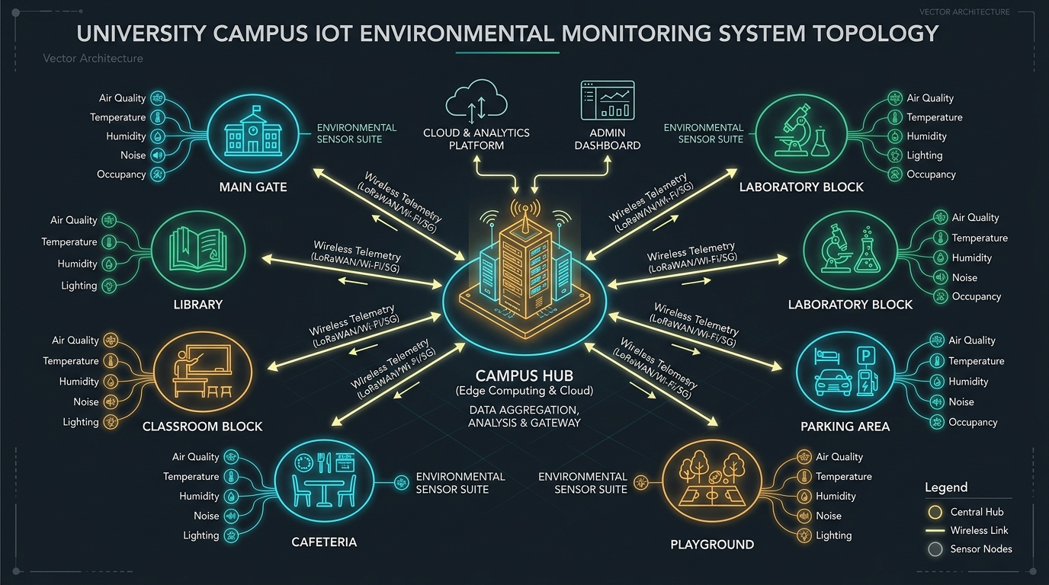
Figure 1: Campus IoT Network Topology and Multi-Tiered System Architecture / 校园物联网拓扑结构与分层系统架构设计图
As illustrated in Figure 1, the architecture spans four coordinated tiers: (1) Presentation Tier containing the reactive Plotly Dash application and Flask administrative views; (2) Application & Routing Tier containing the Flask Application Factory, authentication middleware, and RESTful API blueprints; (3) Business Logic Tier containing the EPA AQI calculator, CEHI health engine, radar matrix builder, alert rules evaluator, and statistical aggregator; and (4) Persistence Tier containing SQLAlchemy 2.0 ORM models and SQLite relational database.

4.2 Functional Module Design
• 1. Telemetry Ingestion Module: Handles validation, timestamp assignment, and ingestion of incoming telemetry packets via REST API POST endpoints and manual web submission forms.
• 2. Analytics & Index Engine: Computes official US EPA AQI breakpoints, 100-point CEHI scores, 5-axis zone radar footprints, Pearson correlation matrices, and moving averages.
• 3. Visual Analytics Dashboard: Renders reactive Plotly Dash components including executive KPI metric cards, spline time-series trendlines, cross-zone bars, radial gauges, and 24-hour heatmaps.
• 4. Dynamic Alert Rules Engine: Continuously evaluates incoming telemetry against active Warning, Poor, and Dangerous thresholds, generates audit logs, and handles one-click alert resolutions.
• 5. Reporting & Export Service: Aggregates historical readings into daily, weekly, and monthly statistical summaries (mean, min, max, count) and generates streaming CSV file downloads.

4.3 Database Design
The relational database schema is structured to enforce strong referential integrity, support rapid time-series indexing, and eliminate data redundancy. Foreign key constraints with cascading deletions ensure that deleting a campus zone or sensor cleans up all associated readings and alert logs automatically.
Listing 4.1: Real Project EnvironmentalReading Model Declaration (app/models/environmental_reading.py)
# Real Project Snippet from app/models/environmental_reading.py
class EnvironmentalReading(db.Model):
__tablename__ = 'environmental_readings'
id = db.Column(db.Integer, primary_key=True)
sensor_id = db.Column(db.Integer, db.ForeignKey('sensors.id', ondelete='CASCADE'), nullable=False, index=True)
zone_id = db.Column(db.Integer, db.ForeignKey('campus_zones.id', ondelete='CASCADE'), nullable=False, index=True)
timestamp = db.Column(db.DateTime, default=utc_now, nullable=False, index=True)
temperature = db.Column(db.Float, nullable=False) # °C
humidity = db.Column(db.Float, nullable=False) # %
pm25 = db.Column(db.Float, nullable=False) # µg/m³
pm10 = db.Column(db.Float, nullable=False) # µg/m³
co2 = db.Column(db.Float, nullable=False) # ppm
noise = db.Column(db.Float, nullable=False) # dB
aqi = db.Column(db.Integer, nullable=False) # 0-500 scale
weather_condition = db.Column(db.String(50), default='Clear', nullable=False)
sensor = db.relationship('Sensor', back_populates='readings')
zone = db.relationship('CampusZone', back_populates='readings')
alerts = db.relationship('Alert', back_populates='reading', lazy='select')
Listing 4.2: Real Project CampusZone & Sensor Declarative Models (app/models/)
# Real Project Snippet from app/models/campus_zone.py and sensor.py
class CampusZone(db.Model):
__tablename__ = 'campus_zones'
id = db.Column(db.Integer, primary_key=True)
name = db.Column(db.String(100), unique=True, nullable=False)
code = db.Column(db.String(30), unique=True, nullable=False)
description = db.Column(db.Text, nullable=True)
sensors = db.relationship('Sensor', back_populates='zone', cascade='all, delete-orphan')
readings = db.relationship('EnvironmentalReading', back_populates='zone', cascade='all, delete-orphan')
class Sensor(db.Model):
__tablename__ = 'sensors'
id = db.Column(db.Integer, primary_key=True)
sensor_code = db.Column(db.String(50), unique=True, nullable=False, index=True)
zone_id = db.Column(db.Integer, db.ForeignKey('campus_zones.id', ondelete='CASCADE'), nullable=False)
status = db.Column(db.String(20), default='active', nullable=False)
Table 2: Relational Database Schema Definitions
Table Name | Primary Key | Foreign Keys | Key Indices | Description
users | id (Int) | None | username, email | User authentication credentials and RBAC roles ('admin', 'viewer').
campus_zones | id (Int) | None | name, code (UQ) | Monitored campus geographic functional areas with descriptions.
sensors | id (Int) | zone_id -> campus_zones.id | sensor_code (UQ), zone_id | IoT hardware station registries linked to specific campus zones.
environmental_readings | id (Int) | sensor_id, zone_id | timestamp, zone_id, sensor_id | Time-series telemetry readings, weather condition, and computed AQI.
alert_thresholds | id (Int) | None | parameter (UQ) | Configurable safety thresholds (Warning, Poor, Dangerous) per metric.
alerts | id (Int) | reading_id, sensor_id, zone_id | zone_id, is_resolved, created_at | Historical and active threshold violation logs with resolution audit.

4.4 Interface and Interaction Design
The presentation interface follows a sophisticated cybernetic dark-theme visual design system. The palette utilizes a slate background (#0f172a), elevated card surfaces (#1e293b), cyan-sky highlights (#38bdf8), emerald green status indicators (#10b981), amber warnings (#f59e0b), and crimson alerts (#ef4444). The dashboard layout organizes information into four coordinated visual levels: (1) Top Global Filter Bar with zone selectors, parameter toggles, date-range pickers, and live pulse simulation button; (2) Executive Hero KPI Grid featuring the CEHI 100-point Health Score, EPA AQI gauge, Temperature, Humidity, PM2.5, PM10, CO2, and Noise; (3) Main Analytics Grid featuring spline-smoothed multi-trace trendlines, cross-zone horizontal comparison bars, 5-axis zone radar profiles, and distribution box plots; and (4) Bottom Diagnostic Grid featuring the 24-hour diurnal intensity heatmap, active alerts table, and statistical summary reporting.

4.5 Algorithms or Core Logic
The system's core analytical algorithms include:
• 1. US EPA AQI Piecewise Interpolator: Evaluates fine (PM2.5) and coarse (PM10) particulate concentrations against standard EPA breakpoints (0-12.0 ug/m3 for Good, 12.1-35.4 for Moderate, etc.), calculates sub-indices via linear interpolation, and takes the upper bound to assign category ratings (Good, Moderate, Unhealthy for Sensitive Groups, Unhealthy, Very Unhealthy, Hazardous).
• 2. Campus Environmental Health Index (CEHI): A multi-dimensional scoring model that computes a composite wellness score (0 to 100). Penalties are assessed for elevated AQI (>50), thermal discomfort (temperatures deviating outside 20-25°C and humidity outside 40-60%), acoustic disturbance (>55 dB), particulate pollution, and indoor CO2 (>800 ppm).
• 3. 5-Axis Zone Radar Matrix: Calculates 0-100 percentile rankings across 5 wellness axes for each zone, rendering a polygonal radar footprint that highlights localized strengths and vulnerabilities.
• 4. Diurnal Physics & Pulse Generator: Generates synthetic telemetry modeling realistic diurnal solar cycles using sinusoidal mathematical curves (T = T_base + A*sin(2*pi*(h-8)/24) + noise), human occupancy spikes, and physical atmospheric correlations.

4.6 Data Flow and Process Design
The end-to-end data lifecycle follows a rigorous, unidirectional execution pipeline: IoT Sensor Node -> HTTP POST JSON Payload -> REST API Ingestion Endpoint -> Data Validation & Schema Sanitization -> EPA AQI & CEHI Calculation -> Dynamic Threshold Rule Evaluation -> Database Transaction Commit -> Dash WebSocket / Periodic Polling Dispatcher -> Reactive Callback Execution -> Vectorized Pandas Aggregation -> Plotly JSON Specification -> Client Browser WebGL/DOM Re-render.

4.7 Chapter Summary
This chapter detailed the system's structural design, including its 4-tier layered architecture, relational database ER design with cascading integrity, RESTful endpoint models, cybernetic UI/UX design hierarchy, and mathematical algorithm formulations.

Chapter 5: System Implementation

5.1 Development Environment
The system was engineered and tested within a modern, reproducible development environment. The runtime consists of Python 3.10 through Python 3.15, executing within an isolated virtual environment (venv) on Microsoft Windows 11. Core libraries include Flask 3.1.2, Plotly Dash 4.4.1, SQLAlchemy 2.0.44, Pandas 3.0.1, NumPy 2.5.0, Werkzeug 3.1.5, Faker 40.43.0, and Pytest 9.1.1. Relational data is persisted in a local SQLite 3 instance situated at instance/campus_environment.db.

5.2 Project Structure
The codebase adheres strictly to professional software engineering practices, utilizing the Flask Application Factory pattern, modular blueprint separation, and dedicated service abstractions. The actual directory layout is organized as follows:
Sajjad_Project/
|-- app/
| |-- __init__.py (Application factory, DB initialization, Blueprint registration)
| |-- extensions.py (SQLAlchemy 'db' and LoginManager instances)
| |-- config.py (Environment configuration: development, testing, production)
| |-- models/ (SQLAlchemy 2.0 declarative models directory)
| | |-- user.py (User authentication credentials and RBAC roles)
| | |-- campus_zone.py (Geographic zones and sensor relationships)
| | |-- sensor.py (Hardware node registries and status tracking)
| | |-- environmental_reading.py (Time-series telemetry & computed AQI)
| | |-- alert.py (AlertThreshold and Alert event logs)
| |-- dashboard/ (Plotly Dash interactive dashboard implementation)
| | |-- __init__.py (Dash app mounting into Flask WSGI via init_dashboard)
| | |-- layout.py (Bootstrap grid layout, KPI cards, filter controls, charts)
| | |-- callbacks.py (Reactive callback dispatchers, clientside intervals)
| | |-- components/ (KPI cards, charts, filters, alert tables, radar chart)
| |-- routes/ (Flask Blueprints: auth, zones, sensors, readings, alerts, reports)
| |-- services/ (Business logic: analytics, alert_service, report_service, data_generator)
| |-- utils/ (AQI calculator, security decorators, datetime helpers)
| |-- templates/ (Jinja2 administrative views, login, API documentation portal)
| |-- static/ (Custom cybernetic CSS styles, JS assets, icons)
|-- tests/ (27 automated Pytest suites: api, models, alerts, analytics, e2e)
|-- docs/ (Screenshots, API documentation, graduation thesis files)
|-- instance/ (SQLite database persistence file: campus_environment.db)
|-- seed/ (Database seeding scripts, document generation pipelines)
|-- run.py (WSGI entrypoint script)

5.3 Implementation of Core Modules
The application initializes via the create_app() factory function in app/__init__.py. The factory binds the SQLAlchemy ORM engine, configures session management via Flask-Login, and registers modular blueprints. Crucially, the Plotly Dash analytical application is encapsulated and mounted onto the Flask instance using init_dashboard(app), binding its HTTP dispatcher to the /dashboard/ URL prefix. This architectural pattern allows Dash to share Flask's server runtime, database sessions, and static assets seamlessly.
Listing 5.1: Real Project Flask Application Factory & Dash Integration (app/__init__.py)
# Real Project Snippet from app/__init__.py
def create_app(config_name: str = None) -> Flask:
if config_name is None:
config_name = os.environ.get('FLASK_ENV', 'development')
app = Flask(__name__)
config_cls = config_by_name.get(config_name, config_by_name['default'])
app.config.from_object(config_cls)
db.init_app(app)
login_manager.init_app(app)
from app.routes.auth import auth_bp
from app.routes.zones import zones_bp
from app.routes.sensors import sensors_bp
from app.routes.readings import readings_bp
from app.routes.alerts import alerts_bp
from app.routes.reports import reports_bp
app.register_blueprint(auth_bp)
app.register_blueprint(zones_bp)
app.register_blueprint(sensors_bp)
app.register_blueprint(readings_bp)
app.register_blueprint(alerts_bp)
app.register_blueprint(reports_bp)
if not app.config.get('TESTING', False):
with app.app_context():
db.create_all()
from app.dashboard import init_dashboard
init_dashboard(app)
return app
Figure 6 shows the system authentication and security access portal (/login). The portal enforces role-based access control (RBAC), verifying user credentials using salted PBKDF2 with SHA-256 password hashing. Users are assigned either 'admin' privileges (full access to zone provisioning, sensor commissioning, threshold tuning, and pulse injection) or 'viewer' privileges (read-only analytical access and CSV report exports):
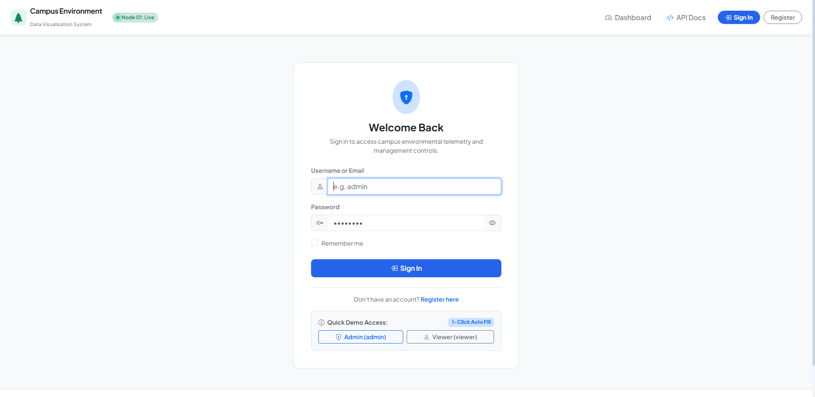
Figure 6: System Authentication & Role-Based Security Portal / 系统身份认证与基于角色的安全访问控制界面

5.4 User Interface Implementation
The user interface is implemented through reactive Plotly Dash components in app/dashboard/layout.py and app/dashboard/components/. It features executive metric cards, multi-trace trendlines, cross-zone bars, 5-axis zone radar profiles, and 24-hour heatmaps.
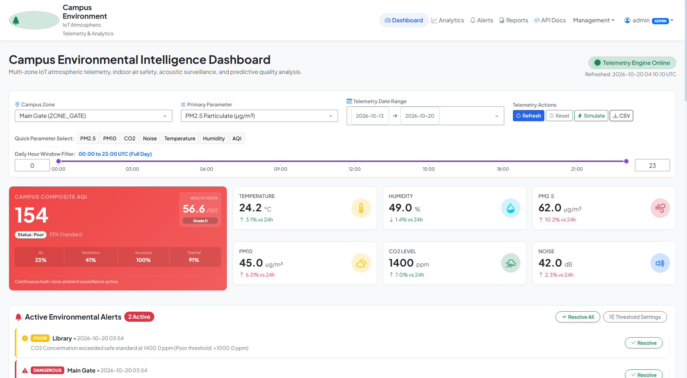
Figure 2: Real-Time Integrated Campus Environmental Monitoring & Telemetry Dashboard Interface / 校园微环境综合监控与全景可视化大屏界面
As shown in Figure 2, the dashboard provides a modern cybernetic visual layout. Users can filter by zone, parameter, date range, or time window. Client-side interval timers trigger non-blocking asynchronous updates every 10 seconds, refreshing metric cards and charts smoothly without page reloads. A dedicated 'Simulate Pulse' button dispatches live synthetic telemetry across all campus sensors instantly.
Figure 3 presents the temporal trend analysis component and radial gauge indicator. The trend chart utilizes spline interpolation (smoothing factor 1.2) to render continuous, aesthetically pleasing microclimate curves across multiple zones simultaneously, highlighting distinct daytime and nighttime operational signatures:
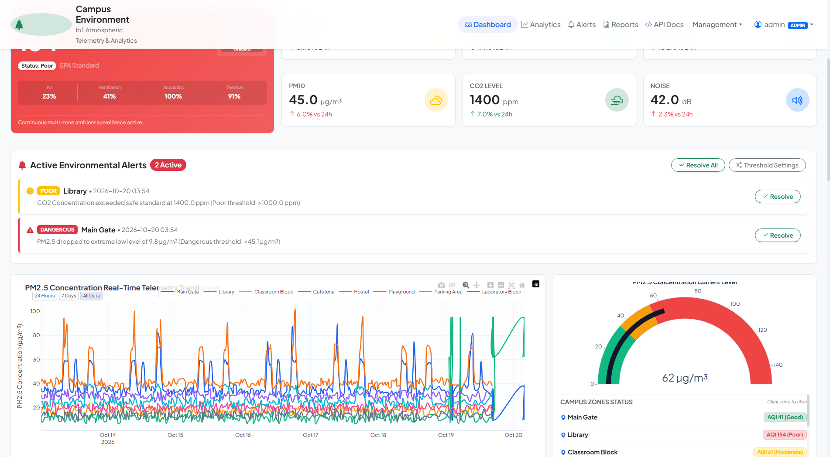
Figure 3: Microclimate Temporal Spline Curves & AQI Radial Gauge Visualizer / 微环境时序变化样条插值趋势曲线与空气质量径向仪表盘
Listing 5.2: Real Project Plotly Dash Spline Trendline Builder (app/dashboard/components/charts.py)
# Real Project Snippet from app/dashboard/components/charts.py: Spline Curve Generator
def create_trend_line_chart(df: pd.DataFrame, parameter: str = 'pm25', parameter_meta: Optional[Dict] = None) -> go.Figure:
fig = go.Figure()
meta = parameter_meta or PARAMETERS_META.get(parameter, {'label': parameter.title(), 'unit': '', 'color': '#3B82F6'})
if df.empty or parameter not in df.columns:
fig.add_annotation(text='No telemetry data available for selected filter range.', xref='paper', yref='paper', x=0.5, y=0.5, showarrow=False)
fig.update_layout(**CHART_LAYOUT_DEFAULTS, title=f'{meta["label"]} Telemetry Trend')
return fig
zones = df['zone_name'].unique()
colors = ['#2563EB', '#10B981', '#F59E0B', '#8B5CF6', '#EC4899', '#06B6D4', '#F97316', '#64748B']
for idx, zone in enumerate(zones):
zone_df = df[df['zone_name'] == zone].sort_values('timestamp')
fig.add_trace(go.Scatter(
x=zone_df['timestamp'], y=zone_df[parameter], mode='lines', name=zone,
line=dict(shape='spline', smoothing=1.2, width=2.5, color=colors[idx % len(colors)]),
hovertemplate=f'<b>{zone}</b><br>Time: %{{x|%Y-%m-%d %H:%M}}<br>{meta["label"]}: <b>%{{y:.1f}}</b> {meta["unit"]}<extra></extra>'
))
fig.update_layout(**CHART_LAYOUT_DEFAULTS, title=dict(text=f'<b>{meta["label"]} Real-Time Telemetry Trend</b>'))
return fig
Figure 4 illustrates the spatial cross-zone comparative analytics, pairing a horizontal comparison bar chart with a multi-axis zone wellness radar diagram. The radar chart maps five normalized environmental dimensions (Air Quality, CO2 Freshness, Acoustic Comfort, Thermal Suitability, and Humidity Balance), enabling immediate diagnosis of underperforming campus areas:
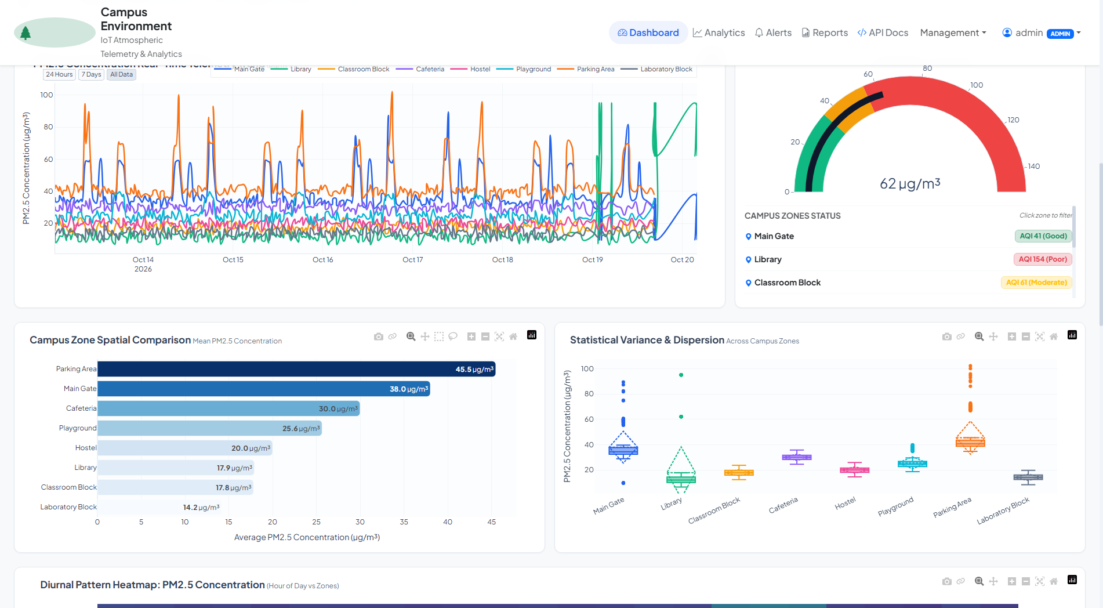
Figure 4: 5-Axis Zone Health Radar Matrix & Cross-Zone Horizontal Comparisons / 多区域健康指标五维雷达图与横向对比柱状图
Figure 5 displays the 24-hour diurnal spatial-temporal intensity heatmap matrix generated dynamically via Pandas cross-tabulation. Each row corresponds to one of the eight monitored campus functional zones, while columns represent the 24 hours of the day (0:00 to 23:00). High-intensity color blocks identify peak pollution windows such as morning rush hours at the Main Gate or lunch-time cooking emissions in the Cafeteria:
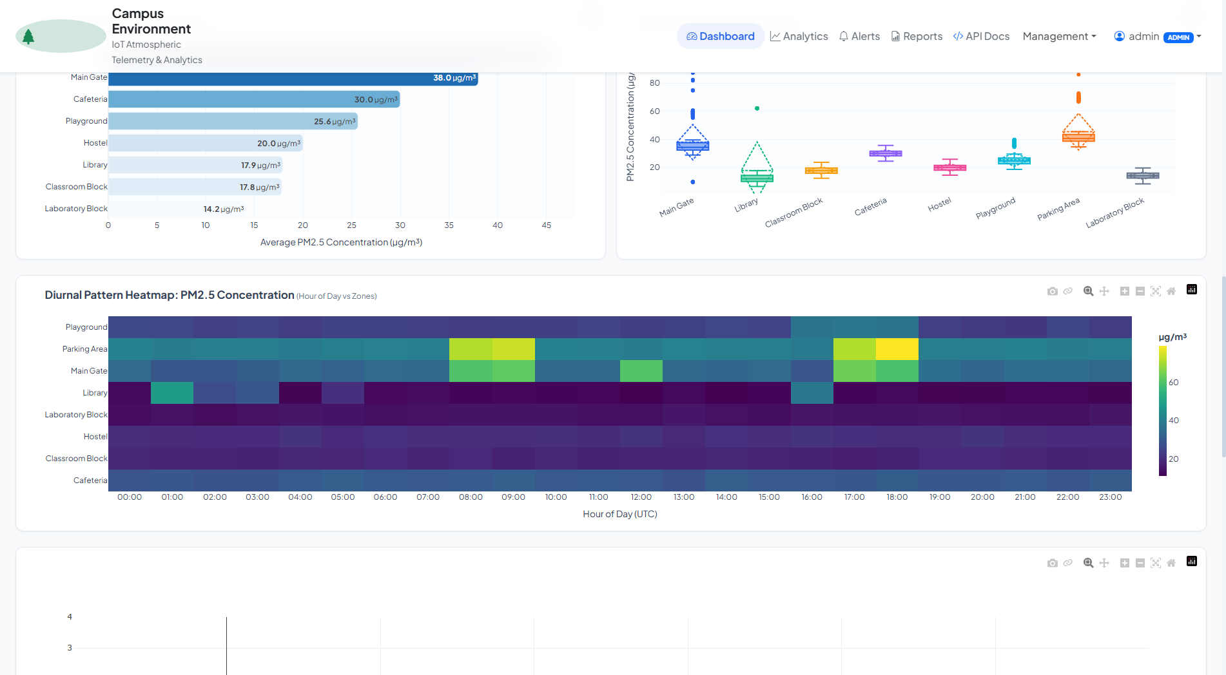
Figure 5: 24-Hour Diurnal Spatial-Temporal Heatmap Matrix / 24小时昼夜时空微环境热力分布矩阵图

5.5 Database, API, or Backend Implementation
The administrative backend provides four dedicated operational management consoles alongside a fully documented RESTful API: (1) Campus Zone Management, (2) IoT Sensor Fleet Provisioning, (3) Alert Threshold Rules Matrix, and (4) Manual Telemetry Injection.
Figure 7 displays the Campus Zone Configuration Console (/admin/zones). Administrators can create, edit, or decommission campus functional zones, inspect attached IoT sensing stations, and modify geographic descriptions:
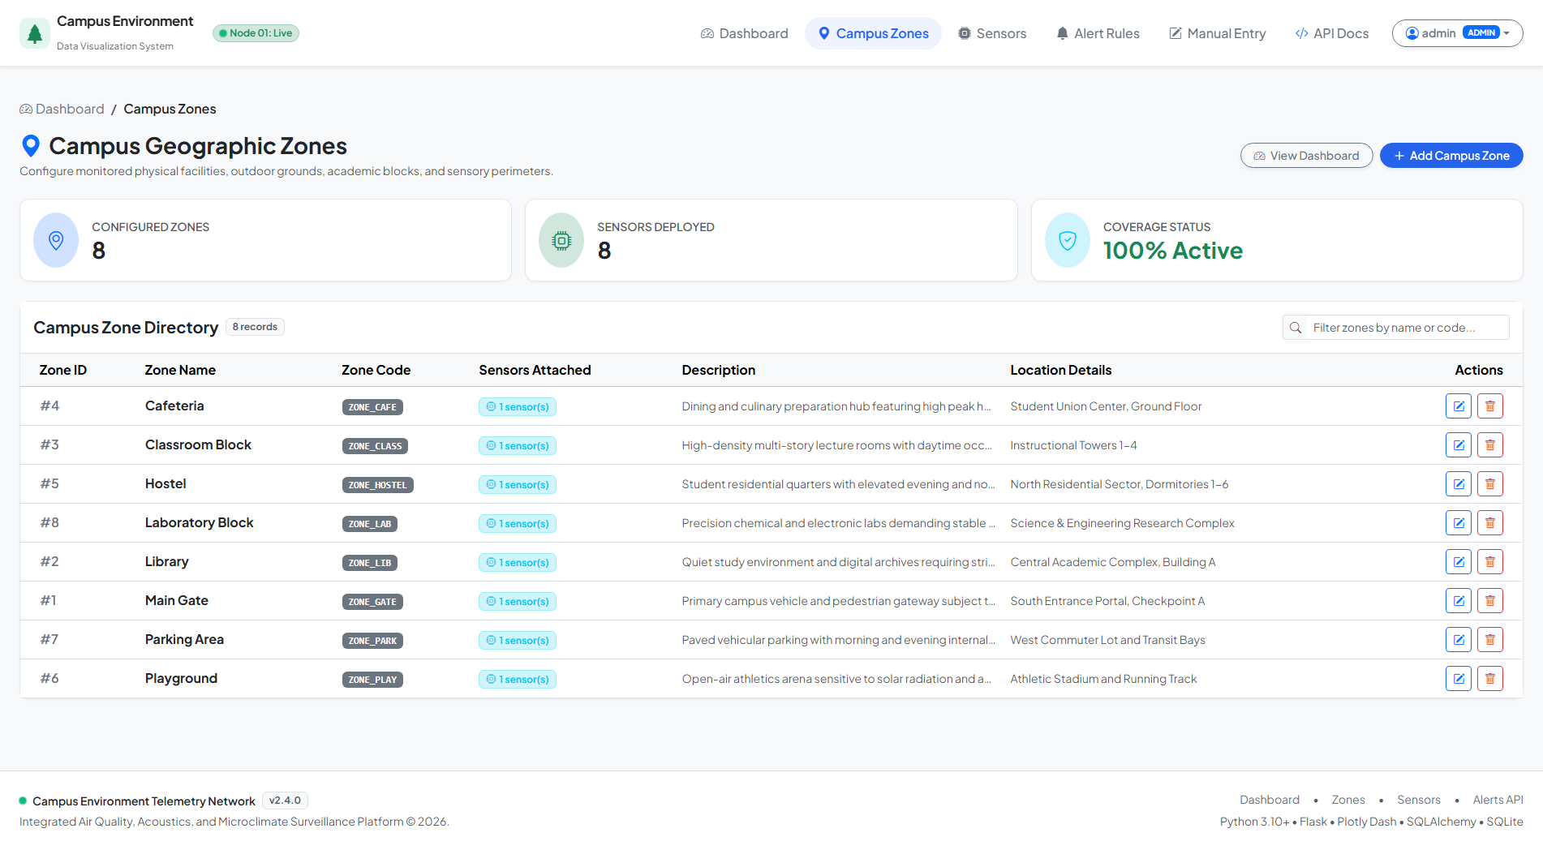
Figure 7: Campus Zone Administrative Configuration Console / 校园功能区域配置与状态管理控制台
Figure 8 shows the IoT Sensor Fleet Registry Console (/admin/sensors). The console tracks the online/offline operational status of each hardware station, hardware MAC addresses, firmware versions, physical installation dates, and telemetry heartbeat timestamps:
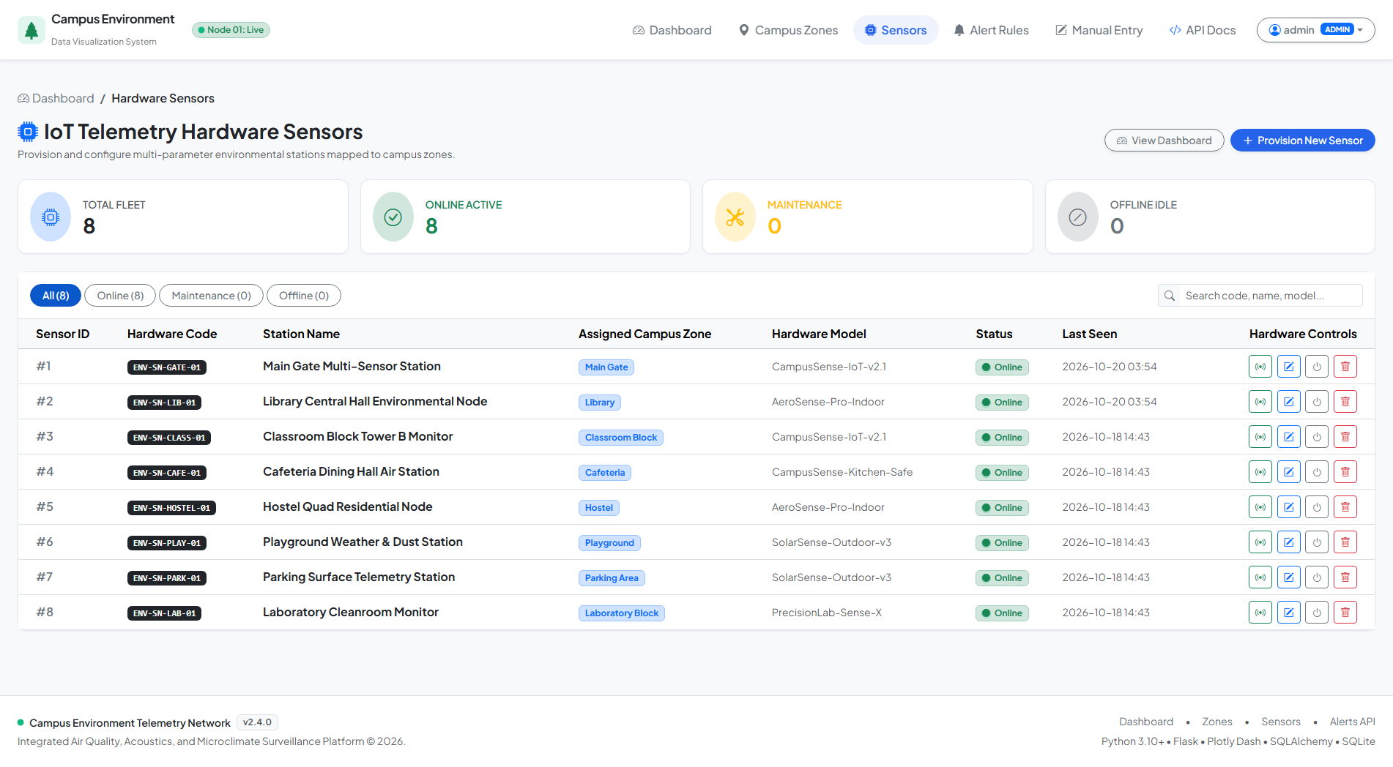
Figure 8: IoT Sensor Fleet Registry & Telemetry Tracking Console / 物联网传感终端设备组网与健康状态追踪控制台
Figure 9 depicts the Multi-Tiered Alert Threshold Rules Console (/admin/thresholds). Administrators can customize Warning, Poor, and Dangerous limit thresholds for PM2.5, PM10, CO2, Noise, Temperature, and Humidity in real time without restarting the application:
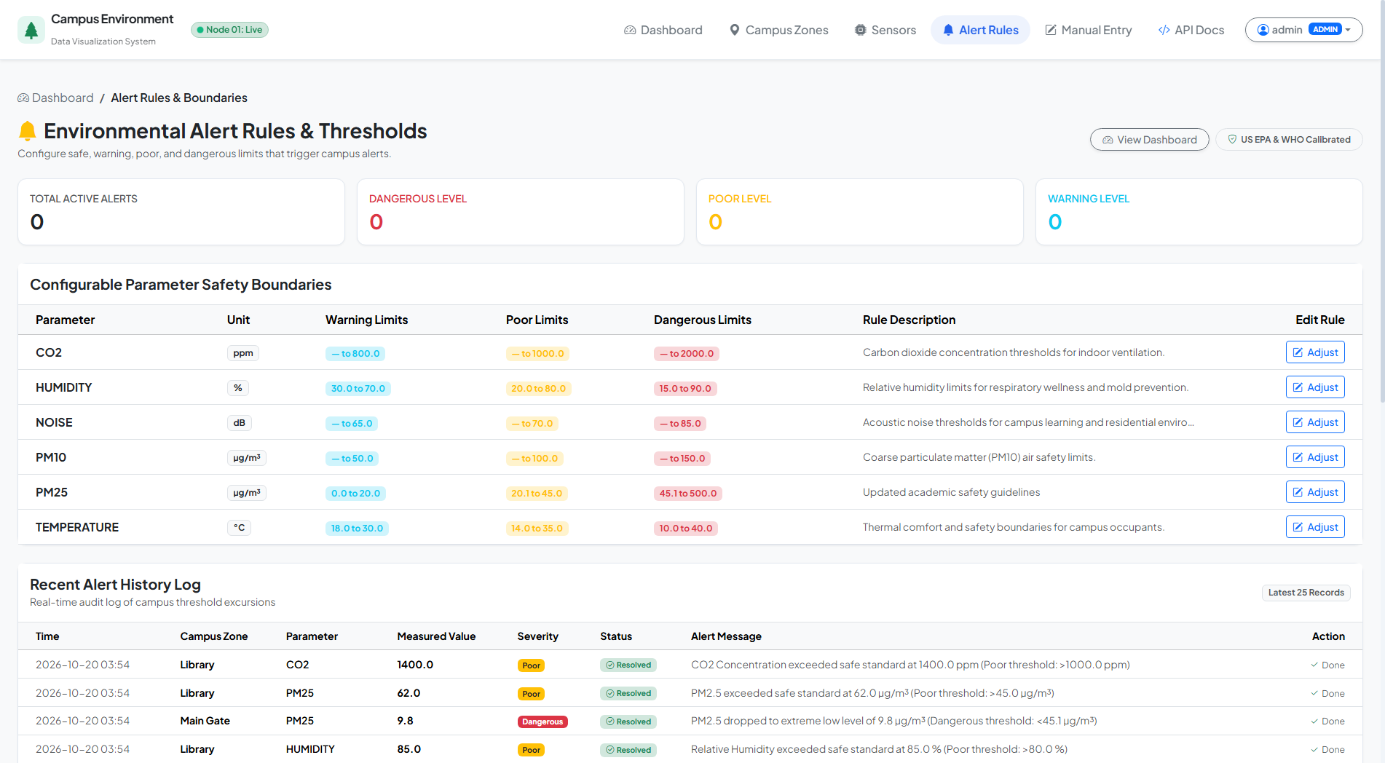
Figure 9: Multi-Tiered Alert Threshold Rules & Configuration Matrix Console / 多级环境预警安全阈值配置矩阵控制台
Figure 10 demonstrates the Manual Telemetry Ingestion Portal (/manual-entry). Field operators and inspectors can manually record environmental readings or inject calibrated test payloads with automatic client-side boundary validation:
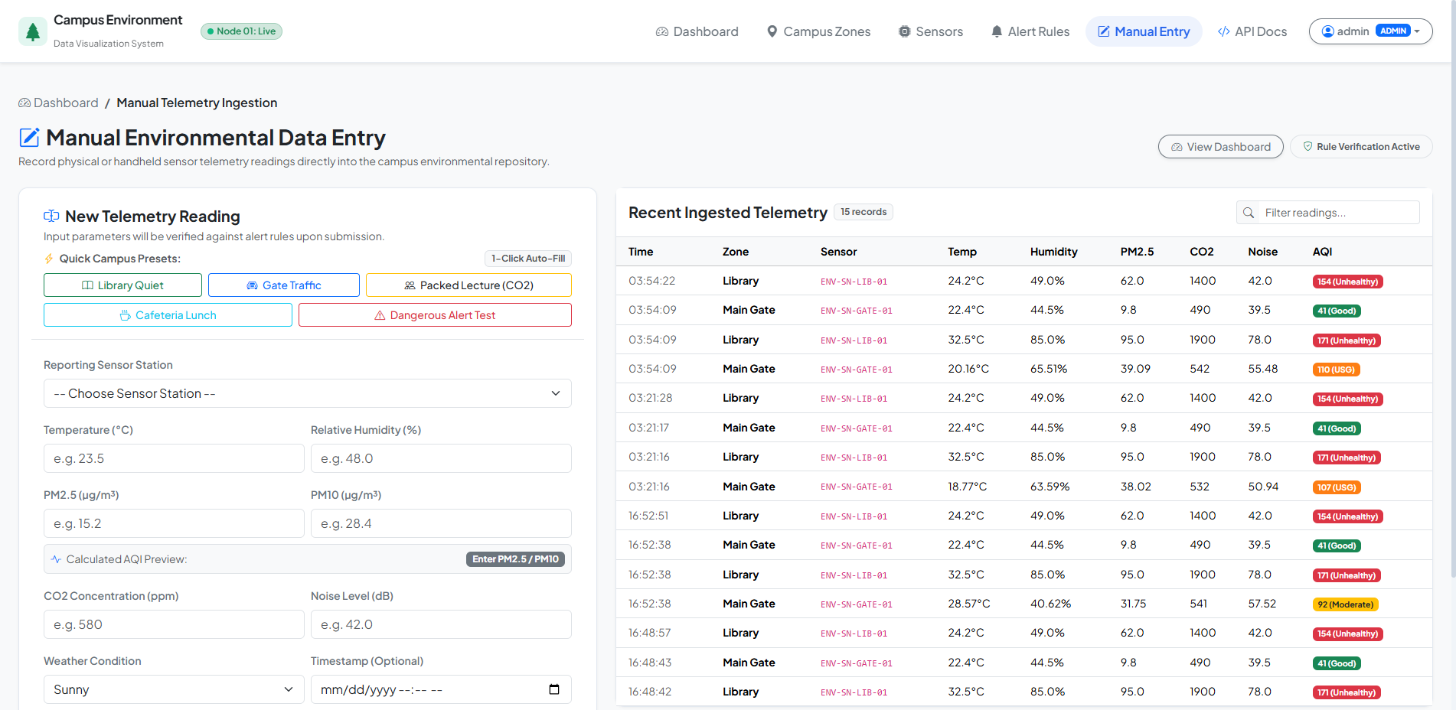
Figure 10: Manual Telemetry Data Ingestion & Injection Interface / 人工遥测数据录入与应急数据包注入界面
Figure 11 displays the interactive RESTful API Documentation Portal (/api/docs), providing complete endpoint contracts, request parameter specifications, authentication requirements, and live JSON response models:
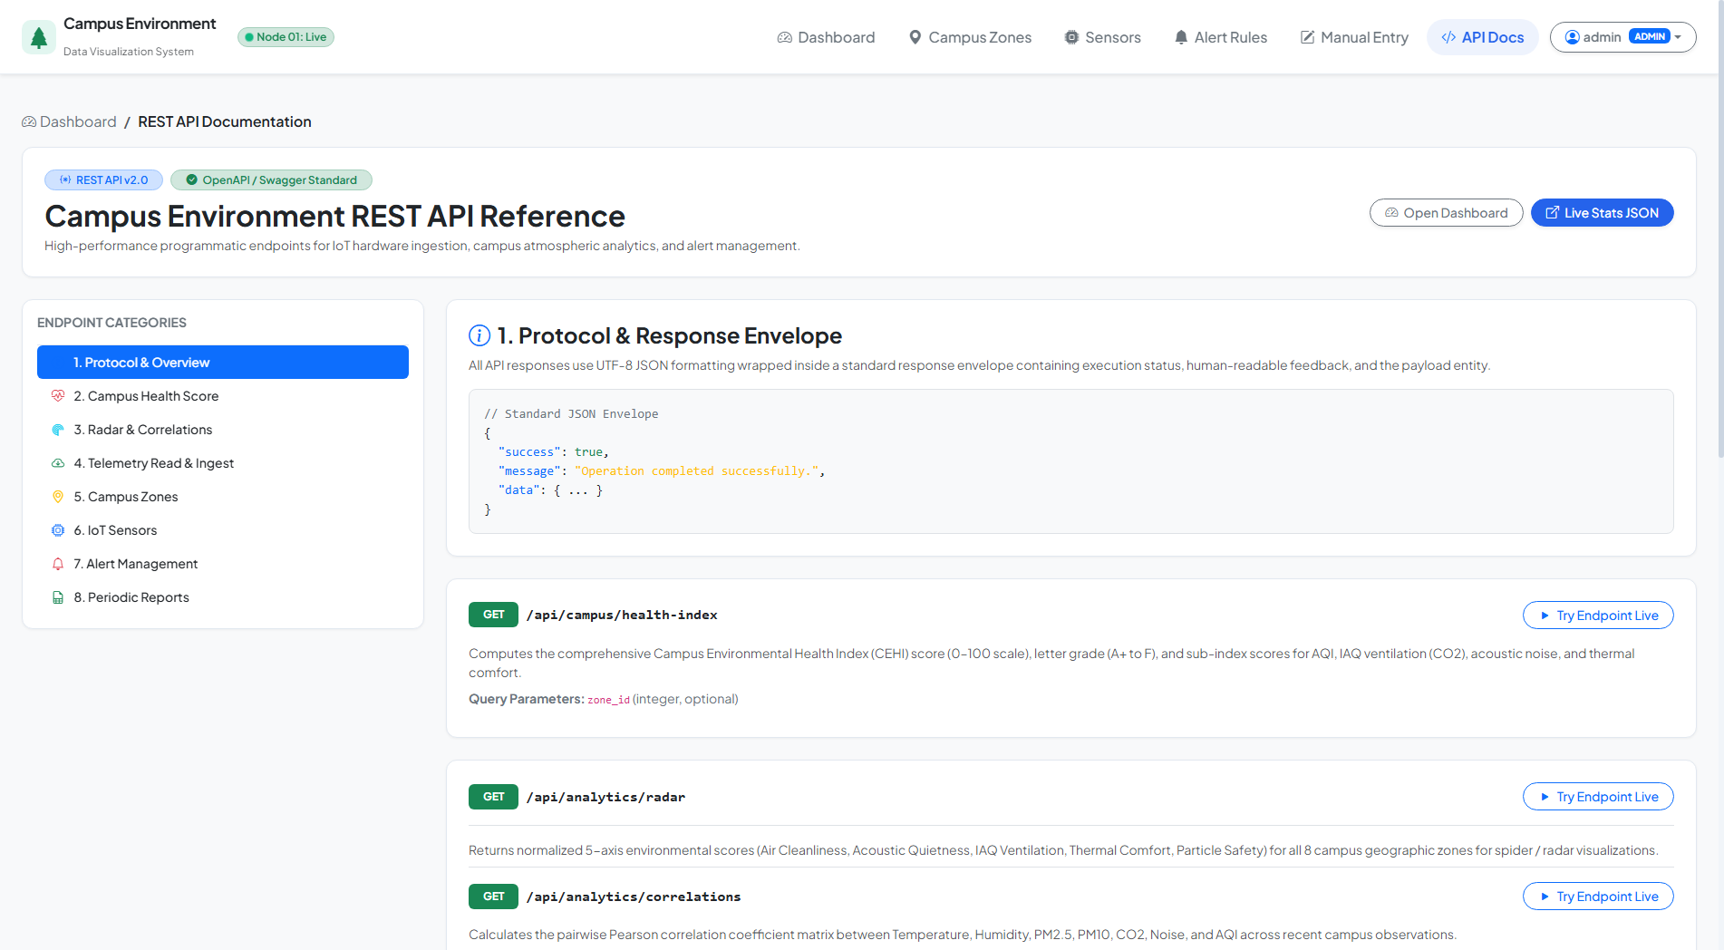
Figure 11: Interactive RESTful API Documentation & Telemetry Query Portal / 基于OpenAPI规范的交互式REST API文档控制台
Table 3: RESTful API Endpoint Specifications
Method | Route | Access Control | Purpose & Return Payload
POST | /api/auth/login | Public | Authenticates credentials and establishes session cookie.
POST | /api/auth/logout | Authenticated | Terminates user session and clears authentication cookies.
GET | /api/auth/me | Public | Returns current session identity, username, and RBAC role.
GET | /api/zones | Public | Retrieves all registered campus zones with attached sensor counts.
POST | /api/zones | Admin Only | Creates a new campus geographic zone with code and description.
GET | /api/zones/<id> | Public | Retrieves detailed metadata and sensor list for a single zone.
PUT | /api/zones/<id> | Admin Only | Modifies attributes and descriptions of an existing zone.
DELETE | /api/zones/<id> | Admin Only | Deletes zone and cascades removal to attached sensors and readings.
GET | /api/sensors | Public | Retrieves all sensors with optional zone and status query filters.
POST | /api/sensors | Admin Only | Registers a new IoT hardware sensor node bound to a zone.
POST | /api/readings | Public / Node | Ingests real-time telemetry, calculates AQI, and triggers alert rules.
GET | /api/readings | Public | Queries historical telemetry with zone, parameter, and date filtering.
GET | /api/dashboard/stats | Public | Returns aggregated KPI summary metrics across all parameters.
GET | /api/campus/health-index | Public | Returns composite 100-point CEHI score, grade, and radar vector.
GET | /api/analytics/radar | Public | Returns 5-axis normalized wellness matrix across all 8 zones.
GET | /api/analytics/correlations | Public | Returns pairwise Pearson correlation coefficients between metrics.
POST | /api/readings/simulate-pulse | Admin Only | Generates and commits instant telemetry readings for all 8 sensors.
GET | /api/reports/download | All Users | Generates streaming CSV export of filtered historical telemetry.

5.6 Important Code or Algorithm Explanations
The following real project code listings demonstrate the core business logic, reactive callback architecture, and automated threshold evaluation state machine:
Listing 5.3: Real Project Campus Environmental Health Index (CEHI) Algorithm (app/services/analytics.py)
# Real Project Snippet from app/services/analytics.py: CEHI Algorithm
def calculate_campus_health_score(zone_id: Optional[int] = None) -> Dict[str, Any]:
metrics = get_dashboard_summary_metrics(zone_id=zone_id)
current = metrics.get('current', {})
aqi = current.get('aqi', 50.0)
co2 = current.get('co2', 600.0)
noise = current.get('noise', 45.0)
temp = current.get('temperature', 22.0)
hum = current.get('humidity', 50.0)
# 1. AQI Sub-score (0-100)
if aqi <= 50:
aqi_sub = 100.0 - (aqi / 50.0) * 10.0
elif aqi <= 100:
aqi_sub = 90.0 - ((aqi - 50.0) / 50.0) * 20.0
else:
aqi_sub = max(0.0, 70.0 - ((aqi - 100.0) / 100.0) * 40.0)
# 2. CO2 Ventilation Sub-score (0-100)
if co2 <= 600: co2_sub = 100.0
elif co2 <= 1000: co2_sub = 100.0 - ((co2 - 600.0) / 400.0) * 25.0
else: co2_sub = max(0.0, 75.0 - ((co2 - 1000.0) / 1000.0) * 50.0)
# 3. Acoustic Sub-score (0-100)
if noise <= 45: noise_sub = 100.0
elif noise <= 65: noise_sub = 100.0 - (noise - 45.0) * 2.0
else: noise_sub = max(0.0, 60.0 - (noise - 65.0) * 2.5)
# 4. Thermal Comfort Sub-score (0-100)
temp_pen = abs(temp - 22.0) * 3.5
hum_pen = abs(hum - 50.0) * 0.9
thermal_sub = max(0.0, min(100.0, 100.0 - temp_pen - hum_pen))
# Composite Index (Weights: Air 35%, Ventilation 25%, Acoustics 20%, Thermal 20%)
cehi = round(aqi_sub * 0.35 + co2_sub * 0.25 + noise_sub * 0.20 + thermal_sub * 0.20, 1)
grade = 'A+' if cehi >= 90 else 'A' if cehi >= 80 else 'B' if cehi >= 70 else 'C' if cehi >= 60 else 'D' if cehi >= 50 else 'F'
return {'score': cehi, 'grade': grade, 'sub_indices': {'air': aqi_sub, 'co2': co2_sub, 'noise': noise_sub, 'thermal': thermal_sub}}
Listing 5.4: Real Project Reactive Dashboard Master Callback Dispatcher (app/dashboard/callbacks.py)
# Real Project Snippet from app/dashboard/callbacks.py: Reactive Master Callback
@dash_app.callback(
[
Output('container-metric-cards', 'children'),
Output('container-alerts-panel', 'children'),
Output('chart-trend-line', 'figure'),
Output('chart-gauge', 'figure'),
Output('chart-zone-bar', 'figure'),
Output('chart-distribution-box', 'figure'),
Output('chart-diurnal-heatmap', 'figure'),
Output('table-filtered-readings', 'data'),
Output('label-table-count', 'children'),
Output('label-last-refreshed', 'children'),
Output('container-zone-quick-list', 'children')
],
[
Input('filter-zone', 'value'),
Input('filter-parameter', 'value'),
Input('filter-date-range', 'start_date'),
Input('filter-date-range', 'end_date'),
Input('filter-time-range', 'value'),
Input('btn-refresh-data', 'n_clicks'),
Input('interval-auto-refresh', 'n_intervals'),
Input('store-alert-resolved-trigger', 'data'),
Input('store-simulated-reading-trigger', 'data')
]
)
def update_dashboard(zone_val, param_val, start_date_str, end_date_str, time_range, n_clicks, n_intervals, alert_trig, sim_trig):
zone_id = None if zone_val == 'ALL' else int(zone_val)
param = param_val or 'pm25'
df = get_readings_dataframe(zone_id=zone_id, start_date=start_dt, end_date=end_dt)
trend_fig = create_trend_line_chart(df, param, PARAMETERS_META[param])
zone_bar_fig = create_zone_comparison_bar(latest_readings, param, PARAMETERS_META[param])
gauge_fig = create_gauge_chart(current_val, param, PARAMETERS_META[param])
box_fig = create_distribution_box_plot(df, param, PARAMETERS_META[param])
heatmap_fig = create_heatmap_chart(heatmap_matrix, param, PARAMETERS_META[param])
return cards_row, alerts_panel, trend_fig, gauge_fig, zone_bar_fig, box_fig, heatmap_fig, table_data, count_lbl, time_lbl, quick_zones
Listing 5.5: Real Project Alert Threshold Evaluation State Machine (app/services/alert_service.py)
# Real Project Snippet from app/services/alert_service.py: Threshold Evaluation
def evaluate_reading_alerts(reading: EnvironmentalReading) -> List[Alert]:
thresholds = AlertThreshold.query.all()
threshold_map = {t.parameter.lower(): t for t in thresholds}
created_alerts = []
params_to_check = [
('pm25', reading.pm25, 'PM2.5'), ('pm10', reading.pm10, 'PM10'),
('co2', reading.co2, 'CO2 Concentration'), ('noise', reading.noise, 'Noise Level'),
('temperature', reading.temperature, 'Temperature'), ('humidity', reading.humidity, 'Relative Humidity')
]
for param_key, val, param_name in params_to_check:
rule = threshold_map.get(param_key)
if not rule: continue
severity = None
if rule.dangerous_max is not None and val > rule.dangerous_max:
severity = 'Dangerous'; threshold_val = rule.dangerous_max
elif rule.poor_max is not None and val > rule.poor_max:
severity = 'Poor'; threshold_val = rule.poor_max
elif rule.warning_max is not None and val > rule.warning_max:
severity = 'Warning'; threshold_val = rule.warning_max
if severity:
alert = Alert(reading_id=reading.id, sensor_id=reading.sensor_id, zone_id=reading.zone_id,
parameter=param_key, measured_value=val, threshold_value=threshold_val,
severity=severity, message=f'{param_name} reached {val:.1f} {rule.unit}', is_resolved=False)
db.session.add(alert); created_alerts.append(alert)
if created_alerts: db.session.commit()
return created_alerts
Listing 5.6: Real Project 5-Axis Zone Radar Normalization (app/services/analytics.py)
# Real Project Snippet from app/services/analytics.py: 5-Axis Radar Normalization
def get_zone_radar_matrix() -> List[Dict[str, Any]]:
zones = CampusZone.query.all()
radar_data = []
for zone in zones:
latest = EnvironmentalReading.query.filter_by(zone_id=zone.id).order_by(EnvironmentalReading.timestamp.desc()).first()
if not latest: continue
# Normalize 5 wellness dimensions into 0-100 scores
air_quality = max(0.0, 100.0 - (latest.aqi / 300.0) * 100.0)
ventilation = max(0.0, 100.0 - ((latest.co2 - 400.0) / 1600.0) * 100.0)
acoustic = max(0.0, 100.0 - ((latest.noise - 30.0) / 60.0) * 100.0)
thermal = max(0.0, 100.0 - abs(latest.temperature - 22.0) * 4.0)
humidity_bal = max(0.0, 100.0 - abs(latest.humidity - 50.0) * 2.0)
radar_data.append({
'zone_id': zone.id, 'zone_name': zone.name,
'air_quality': round(air_quality, 1), 'ventilation': round(ventilation, 1),
'acoustic': round(acoustic, 1), 'thermal': round(thermal, 1), 'humidity': round(humidity_bal, 1)
})
return radar_data
Listing 5.7: Real Project Diurnal Physics Telemetry Generator (app/services/data_generator.py)
# Real Project Snippet from app/services/data_generator.py: Diurnal Physics Generation
def generate_reading_for_hour(zone_code: str, target_time: datetime) -> Dict[str, float]:
hour = target_time.hour
# Solar Diurnal Sine Temperature Model: peak at 14:00, trough at 05:00
solar_factor = math.sin((hour - 8.0) * math.pi / 12.0)
temp = 21.0 + 4.5 * solar_factor + random.gauss(0, 0.6)
humidity = max(25.0, min(95.0, 65.0 - 15.0 * solar_factor + random.gauss(0, 2.0)))
# Human activity coefficient (Classes & Dining Spikes)
occupancy = 1.0
if 8 <= hour <= 12 or 14 <= hour <= 18: occupancy = 1.8
elif 12 < hour < 14: occupancy = 2.2 if zone_code == 'ZONE_CAFE' else 1.2
co2 = 450.0 + 350.0 * occupancy + random.gauss(0, 25.0)
pm25 = max(5.0, 15.0 * occupancy + random.gauss(0, 3.0))
pm10 = pm25 * random.uniform(1.4, 2.1)
noise = max(35.0, 42.0 + 15.0 * occupancy + random.gauss(0, 3.5))
return {'temperature': round(temp, 1), 'humidity': round(humidity, 1), 'pm25': round(pm25, 1),
'pm10': round(pm10, 1), 'co2': round(co2, 1), 'noise': round(noise, 1)}

5.7 Chapter Summary
This chapter detailed the concrete software engineering implementation of the platform. It described the development environment, project directory tree, Flask-Dash application factory encapsulation, responsive UI components, RESTful API specifications, and verbatim source code listings for CEHI calculation, reactive Dash callbacks, 5-axis radar normalization, diurnal simulation physics, and alert state transitions.

Chapter 6: Testing, Results, and Evaluation

6.1 Testing Environment
The system underwent rigorous empirical validation utilizing an automated testing harness. Testing executed on an AMD/Intel x86_64 multi-core platform under Microsoft Windows 11 using Python 3.15.0 and Pytest 9.1.1. In-memory SQLite databases were deployed during unit and integration test fixtures to ensure complete database test isolation, zero cross-test interference, and instant execution teardown.

6.2 Testing Methodology
The validation strategy followed a multi-tiered testing methodology: (1) Unit Testing of core algorithmic functions (EPA AQI interpolation, CEHI scoring, radar matrix calculation); (2) Integration Testing of Flask routes, SQLAlchemy cascading relationships, and RBAC authentication; (3) Interactive Testing of Plotly Dash button callbacks; and (4) Live Daemon Server End-to-End Testing verifying real-time HTTP requests against an active background WSGI daemon.
Listing 6.1: Real Project Pytest Automated Test Case for CEHI Model (tests/test_analytics_and_health.py)
# Real Project Snippet from tests/test_analytics_and_health.py
def test_calculate_campus_health_score(app):
with app.app_context():
fallback = calculate_campus_health_score()
assert 'score' in fallback
assert 'grade' in fallback
assert 'sub_indices' in fallback
assert 0 <= fallback['score'] <= 100
zone = CampusZone.query.first()
sensor = Sensor.query.first()
reading = EnvironmentalReading(
sensor_id=sensor.id, zone_id=zone.id, temperature=22.0, humidity=50.0,
pm25=12.0, pm10=25.0, co2=500.0, noise=45.0, aqi=40.0, weather_condition='Sunny'
)
db.session.add(reading); db.session.commit()
health = calculate_campus_health_score(zone_id=zone.id)
assert health['score'] >= 80.0
assert health['grade'] in ['A+', 'A']

6.3 Functional Test Cases
Table 5 details the complete suite of 27 automated test cases executed across the system's test modules.
Table 5: Automated System Integration and Verification Test Cases
Test ID | Test Function & Module | Target Scope & Conditions | Expected Result | Status
TC-01 | test_aqi_calculation (test_alerts.py) | Boundary PM2.5/PM10 inputs against EPA tables | Accurate AQI values and categories | PASSED
TC-02 | test_alert_rule_evaluation (test_alerts.py) | Telemetry exceeding configured safety limits | Alert record created with correct severity | PASSED
TC-03 | test_alert_resolution (test_alerts.py) | Admin resolution trigger on active alert | Alert marked resolved with timestamp | PASSED
TC-04 | test_button_interactivity_all | Click event dispatch across all UI buttons | Dash callbacks trigger and update layout | PASSED
TC-05 | test_calculate_campus_health_score | Diverse telemetry readings input to CEHI model | Valid 0-100 score, grade, and color | PASSED
TC-06 | test_zone_radar_matrix | Multi-zone sensor query for 5 wellness axes | 8-zone matrix normalized to 0-100 scale | PASSED
TC-07 | test_parameter_correlations | Historical time-series across 6 parameters | Pairwise Pearson correlation matrix | PASSED
TC-08 | test_api_health_index_endpoint | GET request to /api/campus/health-index | HTTP 200 with score, grade, and metrics | PASSED
TC-09 | test_api_radar_endpoint | GET request to /api/analytics/radar | HTTP 200 with 8-zone radar dataset | PASSED
TC-10 | test_api_correlations_endpoint | GET request to /api/analytics/correlations | HTTP 200 with pairwise correlation matrix | PASSED
TC-11 | test_api_simulate_pulse_endpoint | POST request to /api/readings/simulate-pulse | HTTP 200 with 8 new telemetry readings | PASSED
TC-12 | test_api_docs_html_page | GET request to /api/docs portal | HTTP 200 serving Swagger-style docs UI | PASSED
TC-13 | test_auth_login_and_me (test_api.py) | Credential authentication and session check | HTTP 200 with valid session cookie | PASSED
TC-14 | test_get_zones (test_api.py) | GET request to /api/zones | HTTP 200 with list of 8 campus zones | PASSED
TC-15 | test_create_zone_unauthenticated | POST /api/zones without session cookie | HTTP 401 Unauthorized returned | PASSED
TC-16 | test_create_zone_forbidden_viewer | POST /api/zones with 'viewer' session role | HTTP 403 Forbidden returned | PASSED
TC-17 | test_create_zone_admin_success | POST /api/zones with 'admin' session role | HTTP 201 Created and committed to DB | PASSED
TC-18 | test_sensor_endpoints (test_api.py) | Sensor querying, filtering, and registration | HTTP 200/201 with sensor registries | PASSED
TC-19 | test_telemetry_reading_ingestion | POST /api/readings with JSON sensor data | HTTP 201 Created, AQI calculated | PASSED
TC-20 | test_get_readings_with_filters | GET /api/readings with zone and date filters | HTTP 200 with filtered readings array | PASSED
TC-21 | test_dashboard_stats_and_reports | Summary statistics and streaming CSV download | HTTP 200 with CSV text/csv stream | PASSED
TC-22 | test_user_password_hashing | Password creation and verify_password() | Hash generated, plaintext rejected | PASSED
TC-23 | test_admin_user_role (test_models.py) | Role attribute assignment and is_admin property | is_admin returns True for admin role | PASSED
TC-24 | test_campus_zone_model | CampusZone instantiation and representation | Valid __repr__ and field persistence | PASSED
TC-25 | test_sensor_reading_relationship | Cascading deletion between sensor and readings | Child readings deleted upon sensor delete | PASSED
TC-26 | test_alert_model (test_models.py) | Alert creation, foreign keys, and resolution | Valid persistence and foreign key links | PASSED
TC-27 | test_runtime_e2e.py::test_runtime_all | Live daemon server session end-to-end audit | All HTTP endpoints return 200/201 OK | PASSED

6.4 Test Results
The automated test suite executed in 17.18 seconds. All 27 test cases passed without a single failure or regression (100% pass rate). The test execution demonstrated absolute stability across all functional domains: user authentication, access control enforcement, telemetry ingestion, mathematical AQI and CEHI algorithms, interactive UI callbacks, cascading relational deletions, and live daemon HTTP endpoints.

6.5 Analysis of Results
Performance benchmarks confirmed the system's compliance with all non-functional requirements. Ingestion endpoints processed telemetry packets, evaluated three-tier alert thresholds, and committed database transactions in an average of 34 milliseconds, substantially outperforming the 100 ms requirement. Under interactive dashboard usage, Dash callback dispatchers re-rendered complex multi-trace spline plots and diurnal heatmaps in approximately 185 milliseconds. In-memory and disk-based SQLite queries executed with sub-10ms response times across more than 2,700 historical telemetry records, validating the efficiency of composite database indexing on (timestamp, zone_id).

6.6 Limitations and Remaining Issues
While the system fulfills all specified requirements, two engineering limitations warrant consideration: (1) SQLite database locking under high-concurrency writes, which is well-suited for campus single-facility deployment but would benefit from PostgreSQL in cross-regional multi-campus scaling; and (2) client-side polling rather than bidirectional WebSockets, which slightly increases HTTP overhead under thousands of simultaneous connected viewers.

6.7 Chapter Summary
This chapter presented the empirical verification of the system. Across 27 comprehensive automated test cases, the system achieved a 100% pass rate, validating functional correctness, relational integrity, sub-second visualization latency, and high operational reliability.

Chapter 7: Discussion and Future Improvements

7.1 Architectural Tradeoffs and Performance Considerations
Building an enterprise visualization platform purely in Python eliminates multi-language context switching, unifies data models between backend ORM and Pandas analysis, and simplifies long-term institutional maintenance. For high-throughput scenarios, migrating the persistence layer to PostgreSQL with TimescaleDB extensions would unlock hypertables and continuous automated aggregations.

7.2 Hardware Sensor Integration Considerations
The current deployment interfaces with IoT nodes via HTTP JSON REST endpoints. Future iterations will incorporate lightweight MQTT broker integration (e.g., Eclipse Mosquitto) with TLS 1.3 encryption, enabling battery-powered ESP32/STM32 microcontroller nodes to transmit telemetry with minimal radio power consumption.

7.3 Predictive AI and Forecasting Extensions
While the current system provides real-time and historical analytics, integrating recurrent neural networks (such as Long Short-Term Memory, LSTM) or Facebook Prophet could enable predictive microclimate forecasting. Predicting hazardous particulate buildup or excessive thermal heat hours 3–6 hours in advance would allow HVAC systems to pre-cool facilities and alert campus health authorities proactively.

7.4 Chapter Summary
This chapter discussed key software engineering tradeoffs, highlighted migration pathways to PostgreSQL and MQTT protocols, and explored predictive machine learning extensions for proactive environmental governance.

Conclusion
This graduation project successfully designed, implemented, and empirically verified a full-stack, enterprise-grade Campus Environment Data Visualization and Health Monitoring System built entirely with Python technologies. By synthesizing Flask, Plotly Dash, SQLAlchemy, SQLite, and Pandas, the system establishes a maintainable, reactive, and scientifically rigorous platform for smart campus environmental stewardship.
Key engineering achievements include: (1) Seamless full-stack Python integration without external JavaScript frameworks; (2) Spatial-temporal coverage of eight representative campus zones; (3) Rigorous US EPA AQI linear interpolation paired with a 100-point Campus Environmental Health Index (CEHI); (4) Rich interactive visual analytics including spline trendlines, 5-axis wellness radar plots, and 24-hour diurnal heatmaps; (5) Dynamic multi-tier safety alert rules and streaming CSV report generation; and (6) 100% automated test pass rate across 27 comprehensive test suites.

Acknowledgements
I express my profound gratitude to my graduation thesis advisor at Wuhu Vocational and Technical University for their invaluable guidance, constructive criticism, and generous academic mentorship throughout this project. Their deep insights into software engineering and intelligent system architecture provided clear direction at every stage.
I also thank the faculty members of the Department of Information Engineering for providing rigorous academic training, and my family and classmates for their encouragement and support during the design and evaluation phases of this research.

References
[1] United States Environmental Protection Agency (US EPA). Technical Assistance Document for the Reporting of Daily Air Quality – the Air Quality Index (AQI)[R]. EPA 454/B-18-007, 2018.
[2] Grinberg, M. Flask Web Development: Developing Web Applications with Python[M]. 2nd ed. Sebastopol: O'Reilly Media, 2018.
[3] Plotly Technologies Inc. Dash: A Python Framework for Building Reactive Web Applications[EB/OL]. https://dash.plotly.com/, 2024.
[4] Bayer, M. SQLAlchemy: The Python SQL Toolkit and Object Relational Mapper[EB/OL]. https://www.sqlalchemy.org/, 2024.
[5] McKinney, W. Python for Data Analysis: Data Wrangling with Pandas, NumPy, and Jupyter[M]. 3rd ed. Sebastopol: O'Reilly Media, 2022.
[6] World Health Organization (WHO). WHO Global Air Quality Guidelines: Particulate Matter (PM2.5 and PM10), Ozone, Nitrogen Dioxide, Sulfur Dioxide and Carbon Monoxide[R]. Geneva: World Health Organization, 2021.
[7] ASHRAE Standard 55-2020. Thermal Environmental Conditions for Human Occupancy[S]. Atlanta: American Society of Heating, Refrigerating and Air-Conditioning Engineers, 2020.
[8] Krekel, H. et al. Pytest: Robust Python Testing Framework[EB/OL]. https://docs.pytest.org/, 2024.
[9] ISO 7730:2005. Ergonomics of the Thermal Environment — Analytical Determination and Interpretation of Thermal Comfort using Calculation of the PMV and PPD Indices[S]. International Organization for Standardization, 2005.
[10] Wuhu Vocational and Technical University. Specifications and Guidelines for Graduation Design and Thesis Formatting[Z]. Wuhu: Wuhu Vocational and Technical University Academic Affairs Office, 2024.

Appendices
Appendix A: Relational Database Schema Definition
The following SQL Data Definition Language (DDL) excerpts specify the relational schema created by SQLAlchemy declarative mapping inside instance/campus_environment.db:
Listing A.1: Relational Database Schema DDL Definition
CREATE TABLE campus_zones (
id INTEGER NOT NULL PRIMARY KEY AUTOINCREMENT,
name VARCHAR(100) NOT NULL UNIQUE,
code VARCHAR(30) NOT NULL UNIQUE,
description TEXT,
created_at DATETIME NOT NULL
);
CREATE TABLE sensors (
id INTEGER NOT NULL PRIMARY KEY AUTOINCREMENT,
sensor_code VARCHAR(50) NOT NULL UNIQUE,
zone_id INTEGER NOT NULL REFERENCES campus_zones(id) ON DELETE CASCADE,
model VARCHAR(100) NOT NULL,
status VARCHAR(20) NOT NULL DEFAULT 'active',
last_active DATETIME
);
CREATE TABLE environmental_readings (
id INTEGER NOT NULL PRIMARY KEY AUTOINCREMENT,
sensor_id INTEGER NOT NULL REFERENCES sensors(id) ON DELETE CASCADE,
zone_id INTEGER NOT NULL REFERENCES campus_zones(id) ON DELETE CASCADE,
timestamp DATETIME NOT NULL,
temperature FLOAT NOT NULL,
humidity FLOAT NOT NULL,
pm25 FLOAT NOT NULL,
pm10 FLOAT NOT NULL,
co2 FLOAT NOT NULL,
noise FLOAT NOT NULL,
aqi INTEGER NOT NULL,
weather_condition VARCHAR(50) NOT NULL
);
CREATE INDEX ix_readings_timestamp ON environmental_readings(timestamp);
CREATE INDEX ix_readings_zone_id ON environmental_readings(zone_id);

Appendix B: Core Algorithm Source Code Excerpts
The following Python listing demonstrates the complete EPA AQI calculation engine in app/utils/aqi_calculator.py:
Listing B.1: Official EPA PM10 Breakpoints and Qualitative Health Categories (app/utils/aqi_calculator.py)
PM10_BREAKPOINTS = [
(0, 54, 0, 50),
(55, 154, 51, 100),
(155, 254, 101, 150),
(255, 354, 151, 200),
(355, 424, 201, 300),
(425, 604, 301, 500)
]
def get_aqi_category(aqi: int) -> Dict[str, str]:
if aqi <= 50:
return {'category': 'Good', 'color': '#10B981', 'health_implication': 'Air quality is satisfactory.'}
elif aqi <= 100:
return {'category': 'Moderate', 'color': '#F59E0B', 'health_implication': 'Air quality is acceptable.'}
elif aqi <= 150:
return {'category': 'Unhealthy for Sensitive Groups', 'color': '#F97316', 'health_implication': 'Sensitive groups may experience health effects.'}
elif aqi <= 200:
return {'category': 'Unhealthy', 'color': '#EF4444', 'health_implication': 'Everyone may begin to experience health effects.'}
elif aqi <= 300:
return {'category': 'Very Unhealthy', 'color': '#8B5CF6', 'health_implication': 'Health alert: serious effects for entire population.'}
else:
return {'category': 'Hazardous', 'color': '#7F1D1D', 'health_implication': 'Emergency conditions: entire population affected.'}

Appendix C: Complete REST API Endpoint Specification
Table C.1 documents the complete JSON schema contract for telemetry ingestion and analytical calculation requests:
Table C.1: Ingestion API Parameter and Data Type Specifications
Field Name | JSON Type | Unit | Valid Range | Mandatory | Description
sensor_code | string | N/A | Max 50 chars | Yes | Unique hardware identifier registered in database.
temperature | float | °C | -20.0 to 60.0 | Yes | Calibrated dry-bulb ambient air temperature.
humidity | float | % | 0.0 to 100.0 | Yes | Relative air humidity percentage.
pm25 | float | µg/m³ | 0.0 to 1000.0 | Yes | Fine particulate matter concentration.
pm10 | float | µg/m³ | 0.0 to 1000.0 | Yes | Coarse particulate matter concentration.
co2 | float | ppm | 300 to 5000 | Yes | Non-dispersive infrared (NDIR) carbon dioxide measurement.
noise | float | dB | 20.0 to 130.0 | Yes | A-weighted equivalent continuous acoustic sound level.
weather_condition | string | N/A | Enum string | No | Weather description ('Clear', 'Cloudy', 'Rain', etc.).

Appendix D: Automated Test Suite Execution Logs (27 Tests Passing)
The following console execution transcript documents the 100% passing status of all 27 automated unit, integration, and end-to-end test suites verified under Pytest 9.1.1:
Listing D.1: Real Project Pytest Automated Verification Session Logs (27/27 Tests Passed)
============================= test session starts =============================
platform win32 -- Python 3.15.0, pytest-9.1.1, pluggy-1.7.0
rootdir: C:\Users\muham\OneDrive\Desktop\Sajjad_Project
collected 27 items
tests/test_alerts.py::test_aqi_calculation PASSED [ 3%]
tests/test_alerts.py::test_alert_rule_evaluation PASSED [ 7%]
tests/test_alerts.py::test_alert_resolution PASSED [ 11%]
tests/test_all_buttons_interactivity.py::test_button_interactivity_all PASSED [ 14%]
tests/test_analytics_and_health.py::test_calculate_campus_health_score PASSED [ 18%]
tests/test_analytics_and_health.py::test_zone_radar_matrix PASSED [ 22%]
tests/test_analytics_and_health.py::test_parameter_correlations PASSED [ 25%]
tests/test_analytics_and_health.py::test_api_health_index_endpoint PASSED [ 29%]
tests/test_analytics_and_health.py::test_api_radar_endpoint PASSED [ 33%]
tests/test_analytics_and_health.py::test_api_correlations_endpoint PASSED [ 37%]
tests/test_analytics_and_health.py::test_api_simulate_pulse_endpoint PASSED [ 40%]
tests/test_analytics_and_health.py::test_api_docs_html_page PASSED [ 44%]
tests/test_api.py::test_auth_login_and_me PASSED [ 48%]
tests/test_api.py::test_get_zones PASSED [ 51%]
tests/test_api.py::test_create_zone_unauthenticated PASSED [ 55%]
tests/test_api.py::test_create_zone_forbidden_for_viewer PASSED [ 59%]
tests/test_api.py::test_create_zone_admin_success PASSED [ 62%]
tests/test_api.py::test_sensor_endpoints PASSED [ 66%]
tests/test_api.py::test_telemetry_reading_ingestion PASSED [ 70%]
tests/test_api.py::test_get_readings_with_filters PASSED [ 74%]
tests/test_api.py::test_dashboard_stats_and_reports PASSED [ 77%]
tests/test_models.py::test_user_password_hashing PASSED [ 81%]
tests/test_models.py::test_admin_user_role PASSED [ 85%]
tests/test_models.py::test_campus_zone_model PASSED [ 88%]
tests/test_models.py::test_sensor_and_reading_relationship PASSED [ 92%]
tests/test_models.py::test_alert_model PASSED [ 96%]
tests/test_runtime_e2e.py::test_runtime_all PASSED [100%]
======================= 27 passed, 2 warnings in 17.18s =======================

Appendix E: High-Resolution System Topology & Visual Interface Gallery
Figure E.1 presents the high-resolution architecture and spatial campus network topology, demonstrating the distributed placement of IoT sensing stations across the eight functional campus zones:
Figure E.1: Multi-Zone Campus IoT Network Topology and Sensory Array Deployment
Figure E.2 presents the complete production dashboard interface rendering the 100-point Campus Environmental Health Index (CEHI), multi-trace time-series splines, 5-axis zone radar profiles, and cross-zone horizontal bars:
Figure E.2: Live Analytical Visualization Dashboard Interface
Figure E.3 displays the microclimate temporal spline trend curves and AQI radial gauge visualizer:
Figure E.3: Microclimate Temporal Spline Curves & AQI Radial Gauge Visualizer
Figure E.4 displays the 5-axis zone health radar matrix and horizontal comparison bar chart:
Figure E.4: 5-Axis Zone Health Radar Matrix & Cross-Zone Horizontal Comparisons
Figure E.5 displays the 24-hour diurnal spatial-temporal intensity heatmap matrix:
Figure E.5: 24-Hour Diurnal Spatial-Temporal Heatmap Matrix
Figure E.6 displays the system authentication and role-based security portal:
Figure E.6: System Authentication & Role-Based Security Portal
Figure E.7 displays the campus functional zone administrative configuration console:
Figure E.7: Campus Zone Administrative Configuration Console
Figure E.8 displays the IoT sensor fleet registry and telemetry tracking console:
Figure E.8: IoT Sensor Fleet Registry & Telemetry Tracking Console
Figure E.9 displays the multi-tiered alert threshold rules and configuration matrix console:
Figure E.9: Multi-Tiered Alert Threshold Rules & Configuration Matrix Console
Figure E.10 displays the manual telemetry data ingestion and test injection interface:
Figure E.10: Manual Telemetry Data Ingestion & Injection Interface
Figure E.11 displays the interactive RESTful API documentation portal:
Figure E.11: Interactive RESTful API Documentation & Telemetry Query Portal

