

📱 COURSE: AKM-101

TITLE: Zimbabwe’s Buried Treasure: The Big Three

Target Audience: Aspiring Miners, Landowners, Youth Prospectors.
Estimated Time: 45 Minutes.
Goal: To equip learners with the visual skills to identify the three most profitable rock formations in Zimbabwe.

INTRODUCTION: The Billion-Dollar Basement

"Welcome to the basement of the world. Zimbabwe sits on the 'Zimbabwe Craton,' a piece of Earth's crust that has been stable for over 2.5 billion years. This stability is why we have so many minerals. While other countries have soil, we have a bank vault. In this module, you will learn the combination to open it."

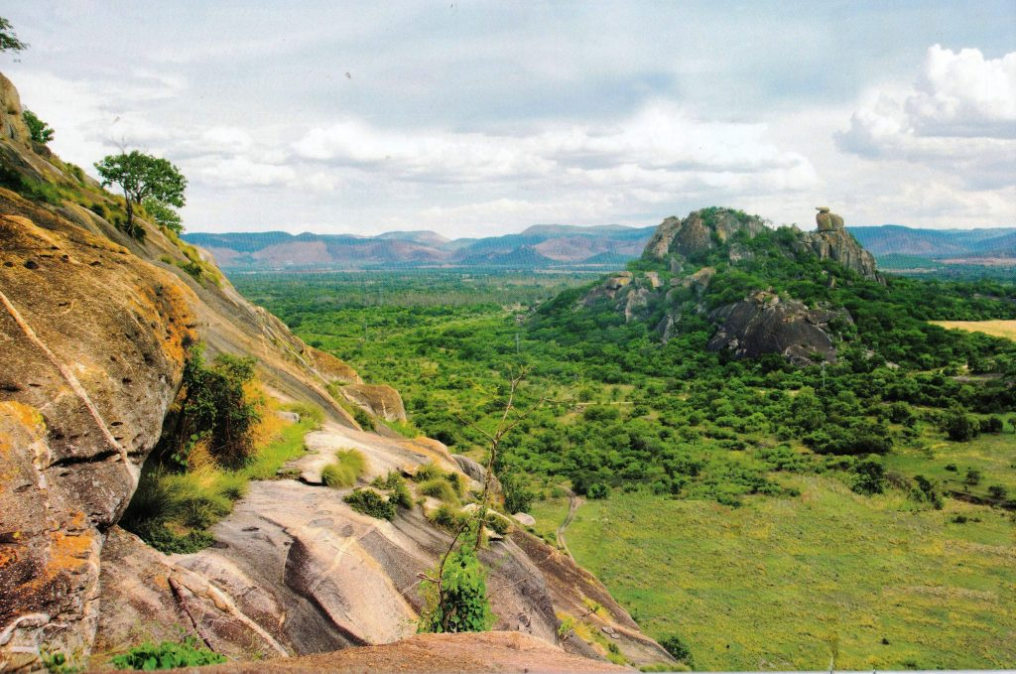
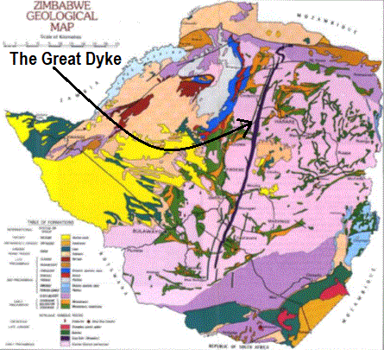

The "spine" is the Great Dyke (Platinum), and the "irregular shapes" are the Greenstone Belts (Gold).

UNIT 1: THE GREAT DYKE (The Platinum Spine)

1. The geography
The Great Dyke is not a wall; it is a massive, linear geological feature that splits Zimbabwe almost in half, running 550km North to South (from the Zambezi Valley to the Limpopo). It varies from 3km to 12km wide.
2. The Visual Identifiers (How to spot it)

- The Landscape: It often appears as a range of prominent hills or ridges.
- The "Snake" Effect: Because the soil is rich in magnesium (Serpentine soil), it is toxic to many large trees. If you see a hill covered only in short grass while the surrounding area has thick bush, you are likely on the Dyke.
- The Rocks: Look for Pyroxenite (dark, coarse-grained) and Chromite seams (heavy, black layers that look like coal but are much heavier).

3. The Reward (What’s inside?)
- PGMs (Platinum Group Metals): Platinum, Palladium, Rhodium.
- Chrome: Zimbabwe holds the world’s largest high-grade chromite reserves here.

💡 Pro Tip: “If the trees stop growing, the value starts flowing.”

UNIT 2: THE GREENSTONE BELTS (The Gold Fields)

1. The geography
These are the "Gold Belts." They look like deformed islands floating in a sea of Granite. Major towns like Kadoma, Kwekwe, Gweru, Bulawayo, and Bindura are built right on top of them.
2. The Visual Identifiers (How to spot it)
- The "Green" Rock: The host rock is often Basalt or Andesite that has been metamorphosed into Chlorite Schist. It has a distinct dull green or grey-green color.
- The Quartz Sign: Gold in Zimbabwe is almost always associated with Hydrothermal Quartz Veins.
  - Rule of Thumb: If you see white "glassy" rocks (Quartz) trapped inside green "layered" rocks (Schist), sample it immediately.
- Ancient Workings: Look for shallow pits or depressions in the ground. Our ancestors mined these belts for centuries; they rarely missed a spot.

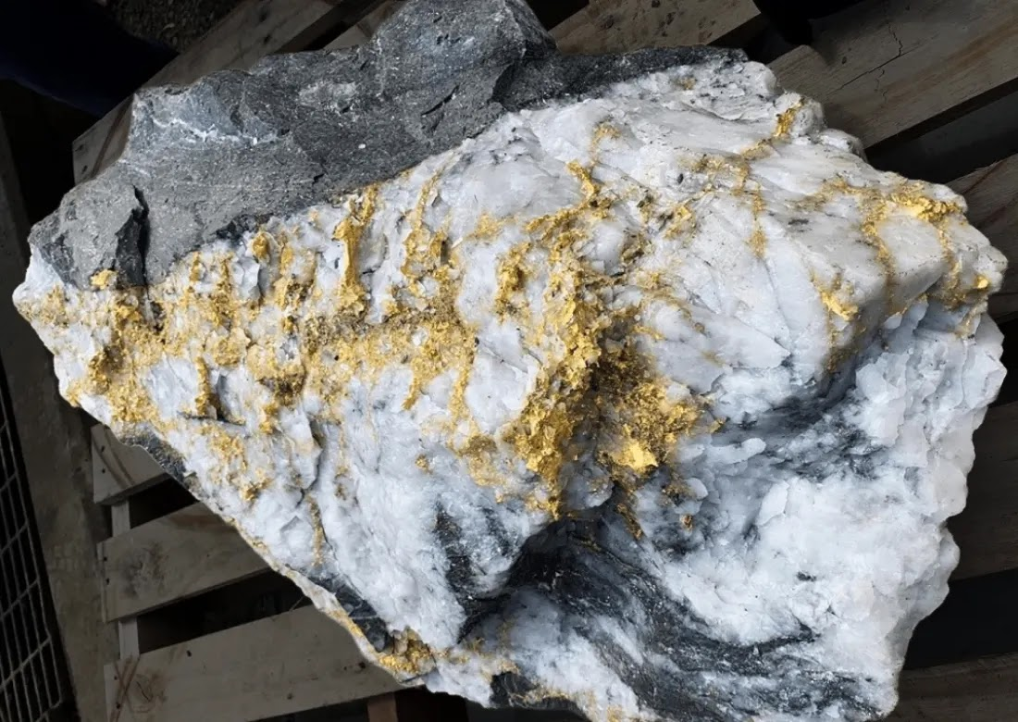

Caption: The white Quartz vein cutting through the rock is where the gold hides

3. The Reward
- Gold: Both primary (in the rock) and alluvial (washed into nearby rivers).
- Copper & Nickel: Often found alongside gold in these belts.

UNIT 3: PEGMATITES (The Battery Rocks)

1. The geography
Pegmatites are "intruder" rocks. They formed when hot liquid magma forced its way into cracks in older rocks and cooled very slowly. This slow cooling allowed huge crystals to grow. They are found on the edges of Greenstone belts (e.g., Bikita, Kamativi, Mutoko).
2. The Visual Identifiers (How to spot it)
- The Texture: "Coarse-grained." Unlike other rocks where grains are like sand, Pegmatite grains can be the size of your fist.
- The Sparkle: Look for Mica. These are shiny, silver, or purple flakes that peel off like plastic sheets.
- The Colors:
  - Purple/Lilac Mica: Indicates Lepidolite (Lithium).
  - Dirty White Crystals: Indicates Spodumene (Lithium).
  - Black Heavy Specks: Indicates Tantalite or Tin.

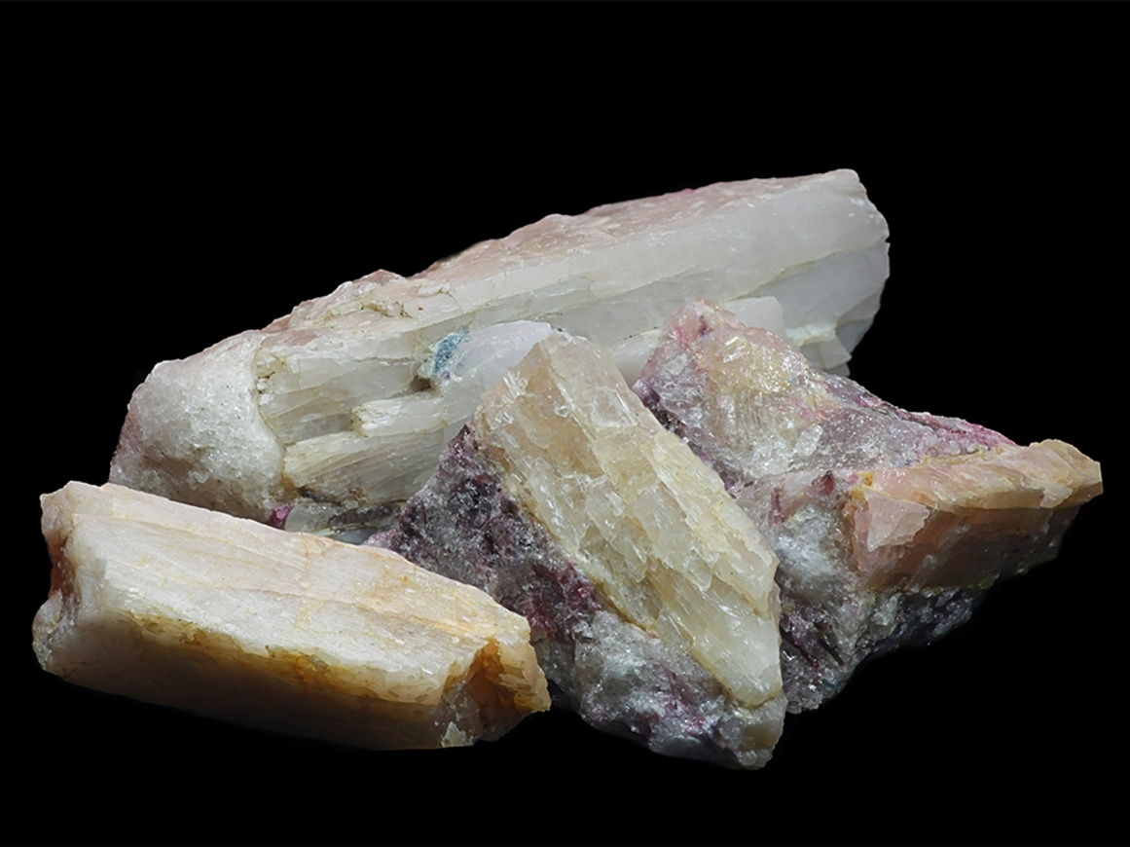
Caption: Large, blocky crystals in a white matrix—classic Lithium ore.

3. The Reward
- Lithium: The "White Gold" for EV batteries.
- Tantalite: Used in mobile phones.
- Gemstones: Tourmaline, Aquamarine, and Garnet often grow in pegmatites.

PRACTICAL ASSIGNMENT: THE FIELD SCOUT

To pass this module and earn your 500 XP, you must complete the following Digital

Gig:
Step 1: The Virtual Survey
Open the NMIH Map Layer on your dashboard. Toggle the "Geology" view. Are you currently sitting on Granite (Pink), Greenstone (Green), or the Dyke (Purple)?
Step 2: The Ground Truth
Go outside. Find a rock that is NOT a common garden stone.
- Crack it open (with safety goggles).
- Is it shiny/layered (Schist)? Is it crystalline/white (Pegmatite)? Is it dark/heavy (Dyke)?
Step 3: The Upload
Take a close-up photo (macro mode) of the fresh break. Upload it to the "My Finds" section. Our AI will classify it for you.

MODULE SUMMARY (Downloadable Cheat Sheet)
Rock Formation | Main Colour | Key Feature | Target Mineral
Great Dyke | Dark / Rusty | Grassy ridges, few trees | Platinum, Chrome
Greenstone | Grey / Green | White Quartz Veins | Gold, Copper
Pegmatite | White / Pink | Large Crystals, Sparkly Mica | Lithium, Tin

[Next Step Button]
“Proceed to Quiz to Unlock Module AKM-102”

📝 QUIZ: CAN YOU READ THE ROCKS?
Module: AKM-101 | Time Limit: 5 Mins | Pass Mark: 4/5

Q1: You are walking in a bushy area, but you notice a long ridge of hills where the trees have suddenly stopped growing, replaced by short grass. The soil is reddish-brown. Which geological feature are you likely standing on? A) A Greenstone Belt B) The Great Dyke C) A Granite Craton D) A Coal Bed
Q2: You break open a grey-green rock and find a vein of white, glassy material running through it. This is the classic "signature" for which mineral? A) Lithium B) Platinum C) Gold D) Diamond
Q3: Pegmatites are famous for hosting "Battery Minerals." Which two specific minerals should you look for in these white, coarse-grained rocks? A) Gold and Silver B) Spodumene and Lepidolite C) Chrome and Nickel D) Coal and Gas
Q4: Which of these is NOT one of the "Big Three" rock formations we study for Zimbabwe's mineral wealth? A) The Great Dyke B) Greenstone Belts C) Pegmatites D) Sandstone Aquifers
Q5: Why do we look for "Plant Stress" (yellowing leaves or stunted growth) when prospecting? A) It shows the plants are thirsty. B) It indicates the soil might contain high concentrations of minerals like Copper or Lithium. C) It means there is no gold in the area. D) It is just a sign of winter.

