

📱 Course: AKM-102

MODULE: THE EYE IN THE SKY

Status: Technical Skills | XP Reward: 600 XP | Badge: The Data Miner

👋 Welcome, Data Miner!
You have learned how to identify rocks with your eyes (AKM 101). Now, you are going to learn how to see them from space. The NMIH platform uses satellites to scan Zimbabwe every day. But satellites don't see "colors" like we do; they see "signatures."
Your Mission: Learn to read the NMIH "Heat Maps" and verify if what the satellite sees is actually there.

UNIT 1: HOW SATELLITES "SEE" (Spectral Reflectance)

The Science of Light.

1. The Concept
When sunlight hits the earth, everything reflects it differently.
- Green Grass absorbs Red light and reflects Green light.
- Water absorbs almost everything (looks dark).
- Gold-bearing soil reflects light in a very specific, unique pattern.
We call this a "Spectral Signature." It’s like a fingerprint made of light.
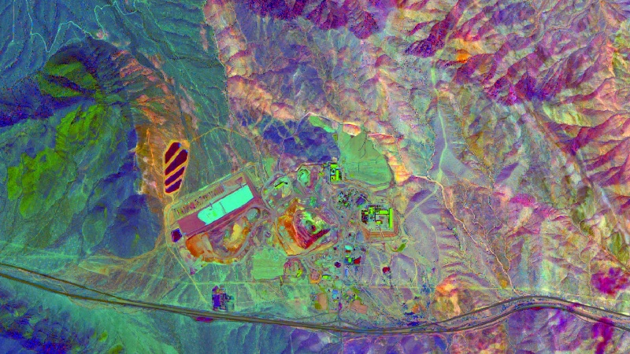
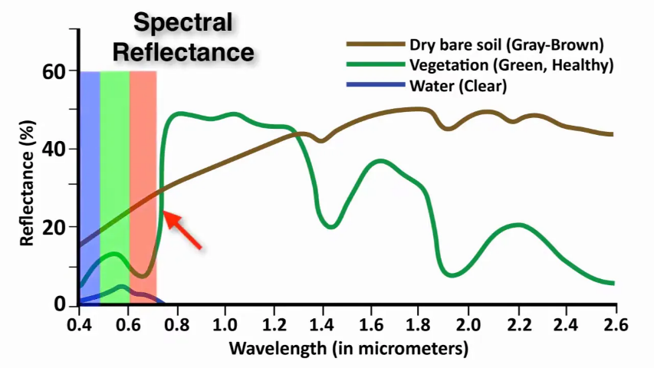

Caption: Notice how the line for "Soil" spikes differently than "Vegetation." That spike tells us where to dig.

2. The NMIH Advantage
Our satellites don't just take pictures; they measure these invisible signatures. When you look at the NMIH Dashboard, you aren't seeing a photograph; you are seeing a map of "reflected energy."

UNIT 2: DECODING THE COLORS (False Colour Imagery)
Why is the grass red?
1. False Color Composites
To make minerals easier to spot, we change the colours on the map. This is called "False Color."
- If the map is "Standard" (True Colour): Trees are green, dirt is brown. Hard to see details.
- If the map is "Infrared" (False Colour):
  - Healthy Vegetation turns Bright Red (because plants reflect infrared light strongly).
  - Bare Ground / Rocks turn Cyan or Blue.
  - Iron-Rich Soil (Minerals) often turns Yellow or Ochre.
2. The "Heat Map" Overlay
On the NMIH Dashboard, we overlay a "Heat Map" (glowing orange/red blobs).
- What it means: The AI has detected a high probability of a specific mineral (e.g., Lithium).
- What you must do: Go to the center of the "Hot Spot" and check the ground.

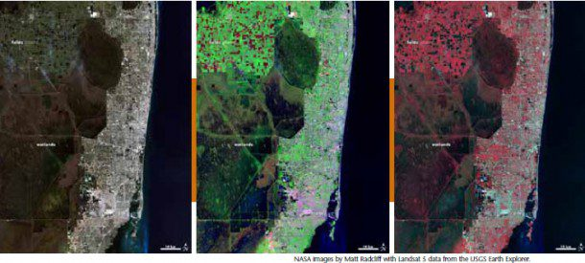
Caption: Left: Normal view. Right: False color view revealing rock structures hidden by grass.

UNIT 3: GROUND TRUTHING (The Human Factor)

Why we need YOU.

1. The Problem with Satellites
A satellite can see a "Yellow Pixel" and think, "This is Gold-bearing soil." But it might actually be:
- A rusty tin roof.
- A pile of burning bricks.
- Dry red clay with no minerals.

2. Your Job: Validation
This is called Ground Truthing.
- The Mission: The App guides you to a specific GPS coordinate (a pixel on the map).
- The Action: You look at the ground. Is it a rock outcrop? Is it a house? Is it a riverbed?
- The Data: You verify the find. If the satellite was right, you earn a bonus. If the satellite was wrong, you teach the AI to be smarter next time.

🏆 FIELD CHALLENGE (The Gig)

Complete this task to earn your "Data Miner" Badge and unlock Level 3.

Task: The Reality Check

- Open the NMIH App and switch to "Satellite View."
- Identify a distinct feature on the map nearby (e.g., a large tree, a dirt road, or a rocky patch).
- Walk to that spot.
- Compare: Does the shape on the screen match the shape on the ground?
- Report: Take a photo of the feature and tag it: "Confirmed: This is a granite outcrop, not a house."

📝 QUIZ: DECODE THE MAP

Module: AKM-102 | Time Limit: 5 Mins | Pass Mark: 4/5
Q1: What is "Spectral Reflectance"?
A) A type of ghost.
B) The unique way different materials (rocks, water, plants) reflect sunlight.
C) A map that shows property boundaries.
D) The reflection of the satellite in a river.
Q2: On a "False Color Infrared" map, healthy thick vegetation usually appears as which color?
A) Green
B) Black
C) Bright Red
D) Invisible
Q3: Why do we need "Ground Truthing"?
A) Because satellites can mistake a rusty roof for mineral-rich soil.
B) Because the satellites are broken.
C) To exercise the miners.
D) To make the map look pretty.
Q4: If the NMIH Dashboard shows a glowing orange "Heat Map" over your land, what does it mean?
A) The ground is physically hot (fire).
B) The AI has detected a high probability of minerals in that spot.
C) Someone has stolen the land.
D) It is a no-go zone.
Q5: A "Spectral Signature" is best described as:
A) A handwritten autograph by the miner.
B) A fingerprint made of light that identifies a material.
C) The license plate of the satellite.
D) The price of the mineral.

SUBMIT ANSWERS & CLAIM 600 XP

