

📱Course: AKM-103

MODULE: READING THE LAND (Topography)

Status: Technical Skills | XP Reward: 600 XP | Badge: The Pathfinder

👋 Welcome, Pathfinder!
Gold and heavy minerals don't just stay where they were born; they move. Rain, wind, and time wash them down slopes and trap them in valleys. To find them, you don't just need to look at the rocks; you need to look at the Shape of the Earth.
Your Mission: Learn to read Contour Lines and Digital Elevation Models (DEMs) to predict where alluvial deposits are hiding.

UNIT 1: THE LANGUAGE OF HILLS (Contour Lines)

How to see 3D shapes on a 2D screen.

1. What is a Contour Line?
Imagine slicing a hill horizontally into layers, like a loaf of bread. A contour line connects every point that is at the exact same height (elevation) above sea level.
2. The Golden Rules:
- Lines Close Together = STEEP: If the lines are bunched up tight, it’s a cliff or a steep slope. Hard to climb, good for "source" rocks.
- Lines Far Apart = FLAT: If the lines are spaced out, the ground is flat or gently rolling. This is where sediments settle.
- Circles = PEAKS: Small closed circles usually mark the top of a hill.

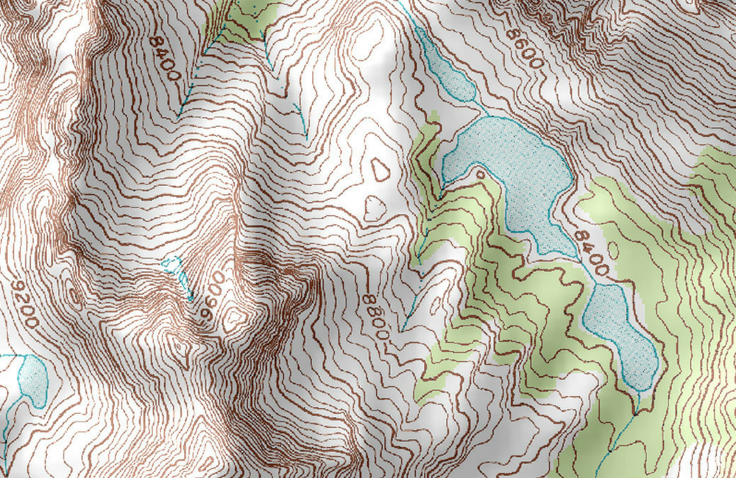
Caption: The Map View. Left: The Side View. Notice how the lines tell you how steep the climb is.

UNIT 2: DIGITAL ELEVATION MODELS (DEM)

The NMIH "Rainbow" Map.

1. The Color Code
On the NMIH Dashboard, we use a DEM (Digital Elevation Model). Instead of just lines, we use colors to show height instantly.
- White/Red: High Elevation (Mountains/Ridges).
- Green/Yellow: Slopes.
- Blue: Low Elevation (Valleys/Riverbeds).

2. Why it Matters:
Water always flows from Red (High) to Blue (Low). If you are looking for Alluvial Gold (gold washed into rivers), you look for the "Blue" zones at the bottom of the "Red" hills.

UNIT 3: CHASING THE FLOW (Drainage Analysis)
Follow the water, find the gold.
1. The Drainage Channel
Minerals are heavy. When rain washes soil down a hill, the light dust floats away, but the heavy Gold, Tin, and Tantalite get trapped in Drainage Channels (rivers, streams, or dry gullies).
2. The "Trap" Spots
You don't just dig anywhere in the river. You dig where the water slows down:
- Inside of Bends: Water moves slower on the inside curve of a river. Gold drops there.
- Behind Large Boulders: Heavy minerals get trapped behind big rocks in the stream.
- Confluence: Where two streams meet, the water creates a "swirl" that drops heavy sediments.

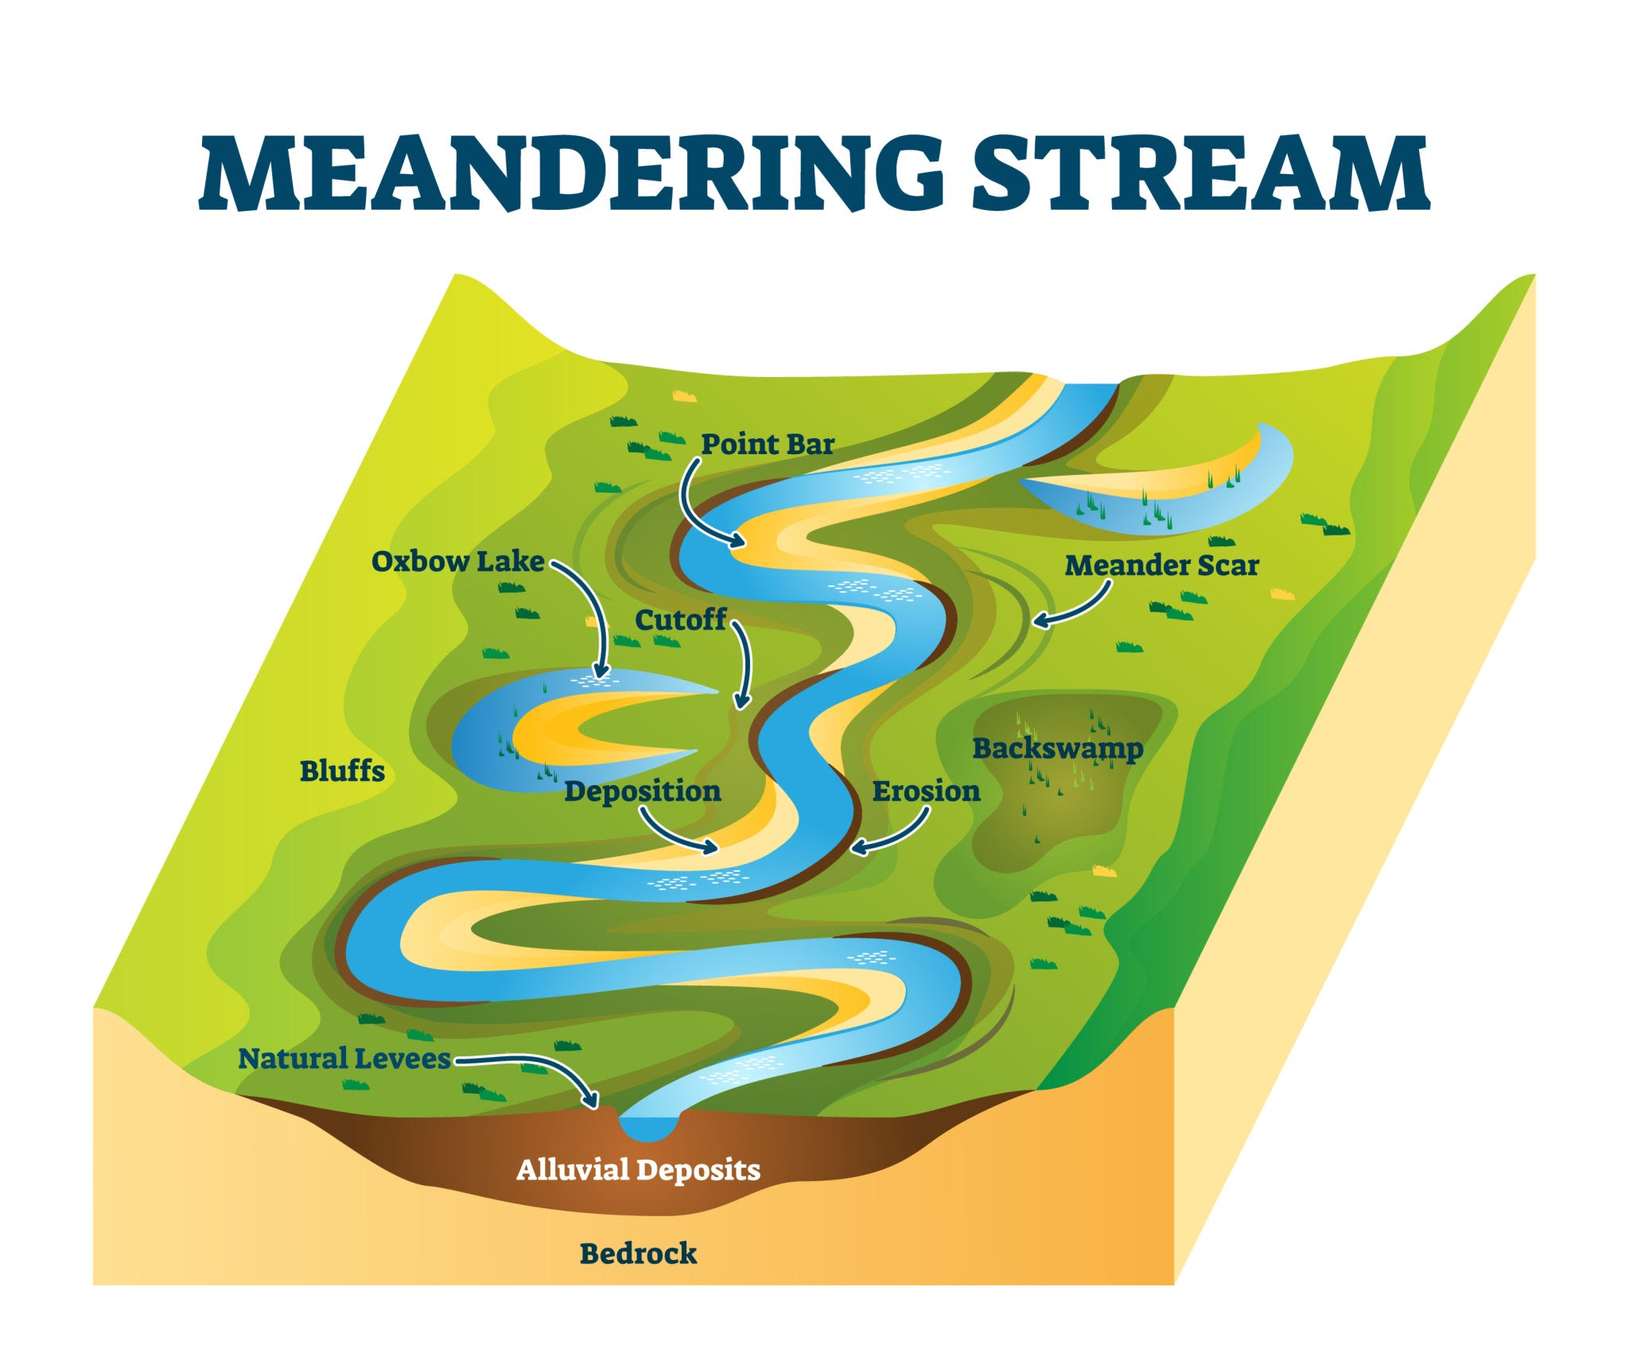
Getty Images
Caption: The "Inside Bend" (Point Bar) is where the treasure settles. The outside bend is where erosion happens.

🏆 FIELD CHALLENGE (The Gig)
Complete this task to earn your "Pathfinder" Badge.
Task: Map the Flow
- Open the NMIH App and look at the Terrain View of your claim.
- Identify the Highest Point (Peak) and the Lowest Point (Valley/Stream).
- Walk to the Lowest Point (the drainage channel).
- Take a photo of the stream bed or dry gully.
- Tag it: "Drainage Channel Identified – Potential Alluvial Trap."

📝 QUIZ: MASTER OF MAPS

Module: AKM-103 | Time Limit: 5 Mins | Pass Mark: 4/5

Q1: On a topographic map, what does it mean if the contour lines are very close together?
A) The ground is very flat.
B) It is a steep slope or cliff.
C) It is a river.
D) The map is broken.
Q2: Gravity moves minerals. If you are looking for "Alluvial Gold" that has been washed away by rain, where should you look?
A) At the very top of the highest peak.
B) On the steep side of the cliff.
C) In the valleys and drainage channels below the hills.
D) In the clouds.
Q3: In a river, where does heavy gold usually settle?
A) On the inside of a bend where water moves slower.
B) On the outside of a bend where water moves fast.
C) Floating on top of the water.
D) It never settles.
Q4: On the NMIH Digital Elevation Model (DEM), the color Blue usually represents:
A) The highest mountain peaks.
B) Fire and heat.
C) Low elevation areas like valleys and water.
D) Vegetation.
Q5: A "Drainage Channel" is important to a prospector because:
A) It is a good place to hide.
B) It acts like a natural sluice box, trapping heavy minerals washed down from the surrounding area.
C) It is the only place to find diamonds.
D) It is where you park your car.

SUBMIT ANSWERS & CLAIM 600 XP

