

Course: AKM-201

MODULE: DIGITAL CLAIM PEGGING

Status: Level 2 (Technical) | XP Reward: 800 XP | Badge: The Surveyor

👋 Welcome to Level 2!

You know what to look for (Geology). You know where to look (Terrain). Now, you need to claim it. In the past, you needed an expensive surveyor with a theodolite to mark a mine. Today, you have a precision tool in your pocket: Your Smartphone.
Your Mission: Learn to use the NMIH App’s GPS mode to "Virtually Peg" a site and create a digital boundary file that the Ministry of Mines can accept.

UNIT 1: THE OLD WAY VS. THE SMART WAY

Why "Digital Pegging" is the future.

1. The Problem:
Traditional "Physical Pegging" involves putting metal stakes in the ground.
- Risk: Stakes get stolen, moved by rains, or hidden by grass.
- Cost: Hiring a surveyor costs hundreds of dollars.

2. The Solution: Geofencing
A "Digital Peg" is a GPS Coordinate (Latitude/Longitude) stored in the cloud. It cannot be moved, stolen, or lost.
- Accuracy: The NMIH App averages GPS signals to get accuracy down to 3 meters.
- The "Shapefile": Instead of just 4 stakes, we create a digital polygon (a shape) that shows exactly how many hectares you own.
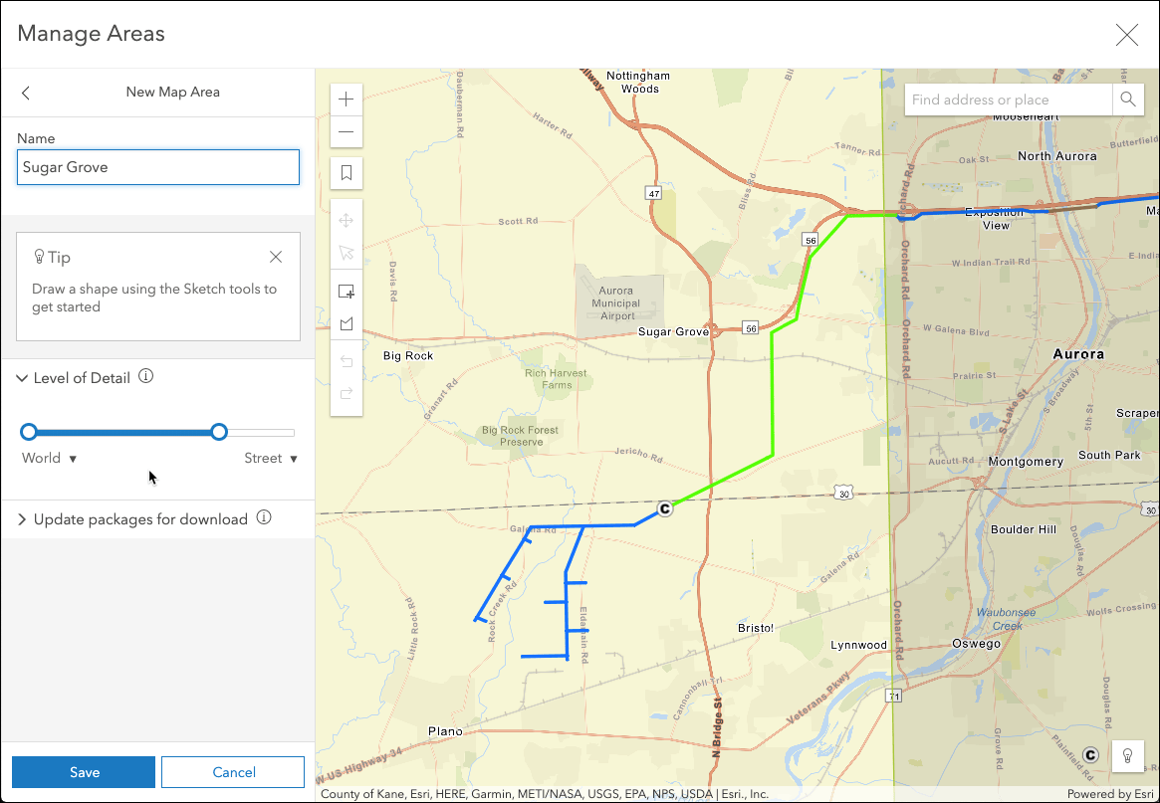
Caption: Connecting the dots. As you walk, the line draws itself.

UNIT 2: WALKING THE LINE (Field Technique)

How to capture a professional boundary.

1. The "Corner" Rule
Mining claims in Zimbabwe are usually rectangular blocks (e.g., 200m x 200m).
- Step 1: Stand exactly at Corner A (The Starting Post).
- Step 2: Wait 30 seconds for the GPS to "Lock" (Accuracy < 5m).
- Step 3: Drop a "Digital Pin."

2. The "Walk"
Don't just run. Walk steadily in a straight line to Corner B. The App tracks your "Track Log."
- Warning: If you walk around a large bush or termite mound, your boundary line will look crooked. Pause the track, walk around, and resume.
3. The Verification
Once you close the loop (return to Corner A), the App will calculate the Area.
- Example: "You have enclosed 9.8 Hectares." (This tells you if you are within the legal size for a Gold Block).

UNIT 3: LEGAL FORMATS (GPX & KML)
Speaking the Government's Language.
1. The Output
The Ministry of Mines uses GIS software. They don't want a drawing on paper; they want a Shapefile.
- GPX (GPS Exchange Format): The raw data of your walk.
- KML (Keyhole Markup Language): The file used by Google Earth.
2. The NMIH Advantage
When you finish your walk on the Akello App, we automatically convert your walk into a .KML file. You can email this directly to the Ministry or a potential investor to say: "Here is exactly what I own."
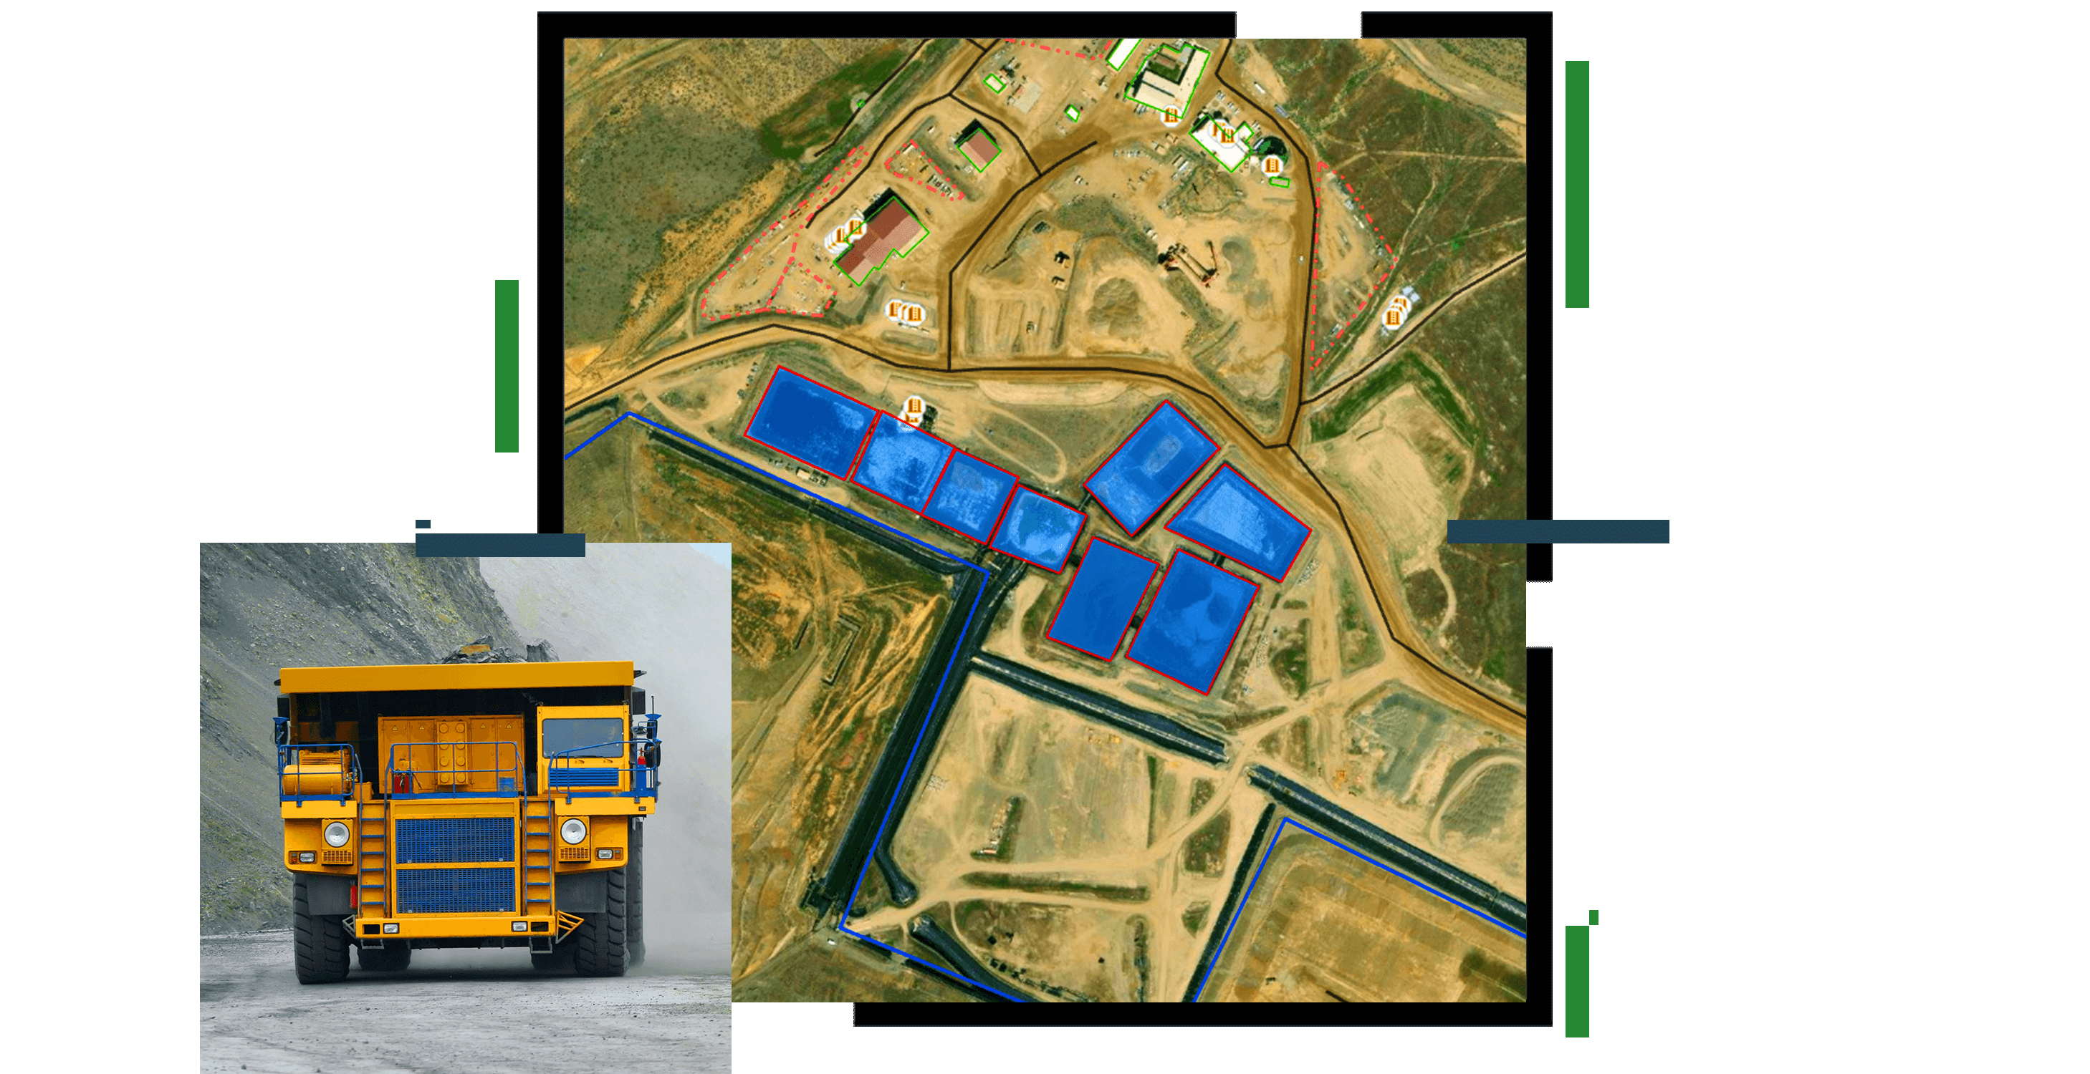
Caption: This is what the investor sees. A verified, professional boundary line.

🏆 FIELD CHALLENGE (The Gig)
Complete this task to earn your "Surveyor" Badge.
Task: The Virtual Peg
- Go to an open space (even a football field or your garden).
- Open the NMIH App > Select "New Survey."
- Walk a square of at least 20 meters x 20 meters.
- Drop a pin at all 4 corners.
- Save & Upload: The App must show a "Closed Loop" (Polygon).
[BUTTON: START SURVEY MODE]

📝 QUIZ: THE DIGITAL SURVEYOR

Module: AKM-201 | Time Limit: 5 Mins | Pass Mark: 4/5

Q1: Why is a "Digital Peg" (GPS Coordinate) often better than a physical metal stake?
A) It is shinier.
B) It cannot be stolen, moved, or hidden by grass.
C) It weighs more.
D) It attracts lightning.
Q2: When marking a corner of your claim, why should you stand still for 30 seconds before dropping the pin?
A) To catch your breath.
B) To let the GPS satellites "Lock on" and improve accuracy (Triangulation).
C) To take a selfie.
D) To scare away animals.
Q3: What happens if you walk around a large termite mound while recording your boundary line?
A) Nothing.
B) Your legal boundary line will look crooked/curved, which might cause disputes.
C) The phone will turn off.
D) You earn extra points.
Q4: Which file format is commonly used to show mining boundaries on Google Earth?
A) .MP3
B) .KML or .KMZ
C) .JPG
D) .PDF
Q5: If the Ministry of Mines requires a "Gold Block" to be 10 Hectares, how does the App help you?
A) It automatically calculates the Area size as you close the loop.
B) It buys the land for you.
C) It predicts the gold price.
D) It calls a lawyer.

SUBMIT ANSWERS & CLAIM 800 XP

