

📱Course: AKM-202

MODULE: THE PERFECT DATA GIG

Status: Level 2 (Technical) | XP Reward: 800 XP | Badge: The Data Pro

👋 Welcome, Future Earner!

You know how to peg a claim. Now, you will learn how to turn that claim into cash—without digging a single hole. The NMIH pays for "Ground Truth" data, but only if that data is Verified and High Quality.
Your Mission: Learn the strict protocols for taking scientific photos and tagging "Point Features" so your work is accepted by the NMIH Algorithm.

UNIT 1: THE "GOLD STANDARD" PHOTO

Bad photos = No Pay.

1. The "Macro" Shot (Close-Up)
When photographing a rock for analysis:
- Protocol: Place a common object (coin, pen, or lens cap) next to the rock.
- Why: The AI needs "Scale." Is that speck of gold the size of a grain of sand or a golf ball? Without a scale reference, the data is useless.
- Lighting: Sun behind you. No shadows falling across the sample.

2. The "Landscape" Shot (Context)
When photographing a site:
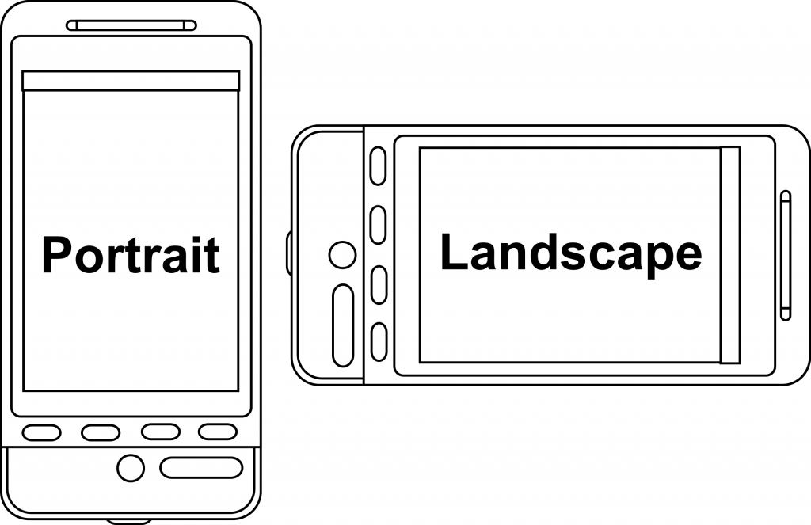

- Protocol: Hold the phone horizontally (Landscape mode). Capture the horizon.
- Why: We need to see the "Dip and Strike" of the land. Is the rock layer tilting left, or right?

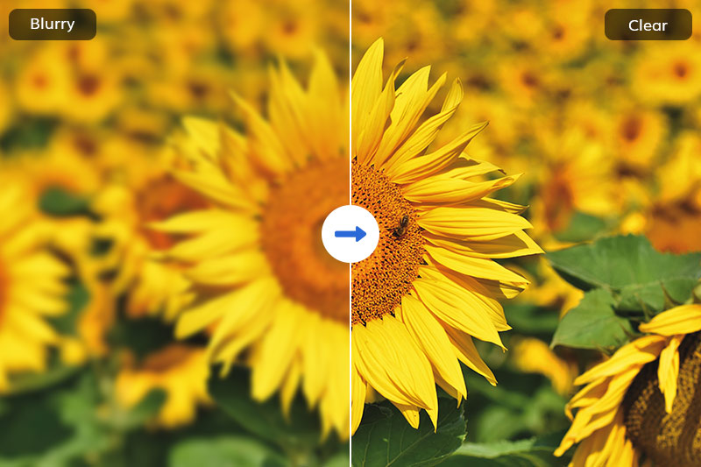
Caption: Left: REJECTED (Blurry, no scale). Right: ACCEPTED (Clear, Coin for scale).

UNIT 2: POINT FEATURES VS. POLYGONS
Speaking the Language of GIS.
1. Point Features (The "What")
A "Point" is a specific object at a specific coordinate.
- Examples: An old mine shaft, a specific outcrop, a water well, or a boundary peg.
- Action: You stand ON it and tag it.
2. Polygons (The "Where")
A "Polygon" is an area.
- Examples: A swampy zone, a tailings dump, or a zone of red soil.
- Action: You walk AROUND it to define the edges.
3. Metadata (The Secret Sauce)
The photo is not enough. You must add tags in the App:
- Lithology: (e.g., "Granite")
- Condition: (e.g., "Weathered")
- Visible Mineral: (e.g., "Pyrite/Fool's Gold")

UNIT 3: THE VERIFICATION ALGORITHM

How to get paid faster.

1. The GPS Timestamp
The App checks the time.
- Rule: You cannot upload a photo from your gallery taken 3 weeks ago. You must take it LIVE within the App. This prevents fraud.

2. The "Tilt" Check
The App records the angle of your phone.
- Rule: If you point the camera straight down at your feet (dirt), the AI might flag it as "Low Value." Point it at the Feature.
3. The Rejection Criteria
Your Gig will be rejected if:
- The GPS accuracy is >10 meters.
- The image is blurry.
- The metadata tags contradict the image (e.g., tagging "Water" on a photo of dry sand).

🏆 FIELD CHALLENGE (The Gig)
Complete this task to earn your "Data Pro" Badge.
Task: The Perfect Upload
- Find a rock or distinct feature.
- Place a coin/pen next to it for scale.
- Open NMIH App > New Data Point.
- Take the photo (ensure lighting is good).
- Tag It: Select "Rock Outcrop" and guess the type.
- Upload: Wait for the "Verified" tick.
[BUTTON: UPLOAD SAMPLE]

📝 QUIZ: QUALITY CONTROL

Module: AKM-202 | Time Limit: 5 Mins | Pass Mark: 4/5

Q1: Why must you place a coin or pen next to a rock when taking a close-up photo?
A) To show how rich you are.
B) To provide "Scale" so the AI knows the size of the grains/crystals.
C) To block the sun.
D) It is a superstition.
Q2: Which of these will cause your Data Gig to be REJECTED?
A) Taking the photo in Landscape mode.
B) Uploading a blurry photo from your gallery taken 2 months ago.
C) Standing too close to the rock.
D) Wearing a hat.
Q3: What is the difference between a "Point Feature" and a "Polygon"?
A) A Point is a single object (like a shaft); a Polygon is an area (like a swamp).
B) A Point is for gold; a Polygon is for silver.
C) Points are worth more money.
D) There is no difference.
Q4: For a "Context" shot of the landscape, where should the sun be?
A) Directly in your eyes.
B) Behind you, shining on the object.
C) It doesn't matter.
D) It should be nighttime.
Q5: Why does the NMIH App prevent you from uploading old gallery photos?
A) To save space.
B) To ensure "Data Integrity" and proof that you are physically on site right now.
C) To annoy you.
D) Because old photos have viruses.

SUBMIT ANSWERS & CLAIM 800 XP

