

📱Course: AKM-301

MODULE: MINING & THE LAW (EMA COMPLIANCE)

Status: Level 3 (Compliance) | XP Reward: 1000 XP | Badge: The Steward

👋 Welcome to Level 3!

You know how to find minerals (Level 1) and how to peg your land (Level 2). But finding gold is useless if the Government shuts you down.
In Zimbabwe, the Environmental Management Agency (EMA) monitors all mining. If you mine responsibly, they are your partner. If you destroy the river, they are your "Game Over."
Your Mission: Learn the "Golden Rules" of Zimbabwean Environmental Law to keep your mine open, safe, and profitable.

UNIT 1: THE 30-METER RULE (River Protection)
The most common reason miners get fined.
1. The Law
Under the Environmental Management Act, it is ILLEGAL to mine, farm, or dig within 30 meters of the highest flood level of a river or stream bank.
2. Why? (Siltation)
When you dig near a river, loose soil washes into the water when it rains. This is called Siltation. It kills fish, blocks dams, and destroys the water source for downstream farmers.
- The Penalty: Heavy fines (Level 14) and confiscation of equipment.

3. The Correct Method
- Measure 30 huge steps away from the river bank.
- Dig your trenches there.
- Pump water TO your site; do not take your ore TO the river.

UNIT 2: MANAGING WASTE (The EIA)

Where do the rocks go?

1. The EIA (Environmental Impact Assessment)
Before you start "Commercial Mining," you need an EIA certificate. For "Prospecting," you need an EMP (Environmental Management Plan). This is a promise you make to the government about how you will fix the land.
2. Overburden & Tailings

- Overburden: The soil you dig up to get to the rock. Pile this neatly nearby—you will need it to fill the hole later.
- Tailings: The crushed sand left over after you extract the gold. This must be kept in a lined pit so chemicals don't leak into the groundwater.

UNIT 3: REHABILITATION (Closing the Loop)

Leave it better than you found it.

1. Concurrent Rehabilitation
Don't wait until the mine is finished to fill the holes.
- Rule: "Dig one, Fill one." As you move your trench forward, backfill the hole behind you with the overburden.
- Safety: Open holes are death traps for cattle and people. An open hole is a liability.
2. Fencing
If you have a deep shaft, you must fence it off. A roll of barbed wire is cheaper than a lawsuit. 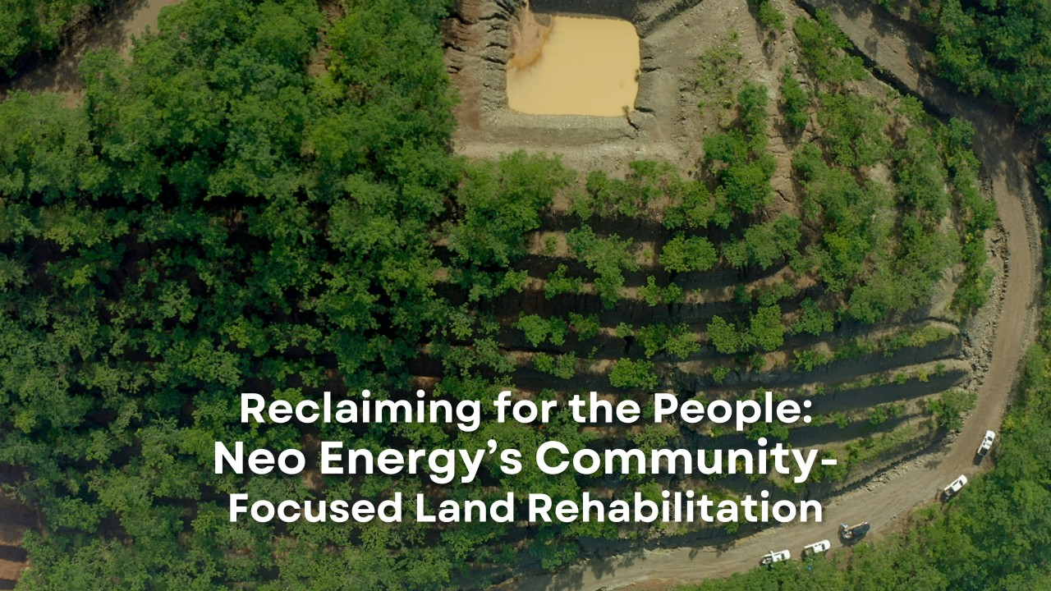
Caption: Top: Dangerous open pits. Bottom: Rehabilitated land ready for farming.

🏆 FIELD CHALLENGE (The Gig)

Complete this task to earn your "Steward" Badge.

Task: The Safety Buffer

- Go to the nearest stream, river, or drainage channel on your site.
- Open the NMIH App (GPS Mode).
- Stand on the riverbank and walk exactly 30 Meters away.
- Drop a "Digital Pin" and label it: "Safety Limit - No Digging."
- Photo: Take a photo looking back at the river to show the safe distance.

[BUTTON: VERIFY BUFFER ZONE]

📝 QUIZ: THE LEGAL MINER

Module: AKM-301 | Time Limit: 5 Mins | Pass Mark: 4/5

Q1: According to EMA regulations, how far must you be from a river bank before you can start digging?
A) 1 Meter.
B) At least 30 Meters.
C) Inside the river.
D) 100 Kilometres.
Q2: What is "Siltation"?
A) A way to filter gold.
B) Loose soil washing into a river, blocking the flow and dirtying the water.
C) A type of tax.
D) A method of selling minerals.
Q3: Why must you backfill (close) your prospecting trenches when you are done?
A) To hide the gold.
B) To prevent animals and people from falling in, and to restore the land for farming.
C) It is not necessary.
D) To make the hole deeper.
Q4: What is an "EMP"?
A) Environmental Management Plan – a document describing how you will protect the environment.
B) Electro-Magnetic Pulse.
C) Empty Mine Pit.
D) Extra Money Payment.
Q5: If you have "Tailings" (waste sand) that might contain chemicals, where should you put them?
A) Dump them in the river.
B) Spread them on the road.
C) In a secure, lined pit or designated tailings dump to prevent groundwater contamination.
D) Feed them to cattle.

SUBMIT ANSWERS & CLAIM 1000 XP

