

📱 Course: AKM-302

MODULE: TIMBER & TREES (Sustainable Forestry)

Status: Level 3 (Compliance) | XP Reward: 1000 XP | Badge: The Ranger

👋 Welcome, Ranger!

Every miner needs wood. You need "props" to hold up the roof of your mine shaft, and you need firewood for cooking or processing. But trees in Zimbabwe are disappearing.
If you cut down an ancient Mopane tree, it takes 100 years to grow back. If you cut a Gumtree, it grows back in 5 years.
Your Mission: Learn the concept of "Sustained Yield" — how to harvest timber today without running out tomorrow.

UNIT 1: KNOW YOUR TREES (Indigenous vs. Exotic)

What to cut and what to save.

1. The Protected Species (The "Do Not Touch" List)
Indigenous trees are the lungs of our country. They are protected by the Forestry Commission.
- Mopane & Teak: These hard woods are famously strong, but illegal to cut for commercial use without a special permit.
- Fruit Trees: Never cut down a fruit-bearing tree (like Mazhanje or Marula) for mine supports.

2. The Solution: Exotic Plantations
For mining supports, you should use Exotic Species (brought from other countries) like Eucalyptus (Gumtrees) or Pine3.
- Why: They grow fast and straight. You can plant a woodlot today and harvest "props" in 4-6 years.

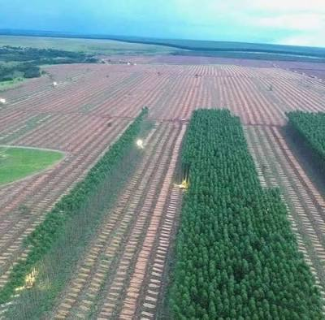

Caption: Left: A Gumtree plantation (safe to harvest). Right: Slow-growing Indigenous bush (Protect this).

UNIT 2: SUSTAINED YIELD

The Banker's Approach to Forests.

1. The Concept
Sustained Yield means you never cut more trees than the forest can grow back in a year
- Bad Mining: Cutting every tree in sight to build a shaft. (Result: Erosion, no wood for next year).
- Smart Mining: Cutting only mature trees and leaving the young ones to grow.

2. The "Normal Forest"
Ideally, your mining lease should have trees of all different ages.
- Zone A: Seedlings (Just planted).
- Zone B: Young Trees (Growing).
- Zone C: Mature Trees (Ready for harvest).
This way, you have a continuous supply of mine props forever5.

UNIT 3: NURSERY PRACTICE

Grow your own supports.

1. The Mine Nursery
You don't need a farm to start a nursery. You just need a shaded corner near your site office.
- Soil: Mix sandy soil with manure (compost).
- Pots: You can use recycled plastic milk bottles or black polythene tubes.
- Seeds: Collect gumtree seeds or buy seedlings from the Forestry Commission.

2. Mine Reclamation
When you finish mining and backfill your trenches (Module AKM-301), you must plant trees on top to stop the soil from washing away. This is called Silviculture6.

🏆 FIELD CHALLENGE (The Gig)

Complete this task to earn your "Ranger" Badge.

Task: The Tree Audit

- Walk through your mining claim.
- Find an Indigenous Hardwood (e.g., Mopane, Acacia, or Teak).
- Take a photo of it.
- Tag it: "Protected Species - Do Not Cut."
- Bonus: If you have planted any trees, photograph your seedling!

[BUTTON: UPLOAD FORESTRY AUDIT]

📝 QUIZ: THE FOREST GUARDIAN

Module: AKM-302 | Time Limit: 5 Mins | Pass Mark: 4/5

Q1: What does "Sustained Yield" mean in forestry?
A) Cutting down trees as fast as possible.
B) Balancing the harvest so that the forest produces timber continuously without running out.
C) Yielding to traffic.
D) Burning the forest.
Q2: Which type of tree is generally recommended for use as "Mine Props" (Support timbers) because it grows fast and is renewable?
A) Ancient Baobab trees.
B) Exotic species like Eucalyptus (Gumtrees).
C) Protected Indigenous Hardwoods.
D) Fruit trees.
Q3: Why is it important to establish a small "Nursery" on a long-term mining site?
A) To grow flowers for decoration.
B) To ensure a future supply of timber and to have trees ready for rehabilitating the land after mining.
C) To attract birds.
D) It is a waste of time.
Q4: Under Zimbabwe's forestry laws, what is the general rule regarding indigenous fruit trees (like Mazhanje/Mahobohobo)?
A) You can cut them for firewood.
B) They should be protected and conserved; cutting them for mine props is destructive.
C) They are poisonous.
D) They stop the gold from growing.
Q5: What is "Silviculture"?
A) The mining of silver.
B) The growing and cultivation of trees.
C) A type of rock.
D) A method of panning gold.

SUBMIT ANSWERS & CLAIM 1000 XP

