

📱 Course: AKM-402

MODULE: THE MASTER PLAN (Strategic Design)

Status: Level 4 (Expert) | XP Reward: 1200 XP | Badge: The Architect

👋 Welcome, Architect!
Amateur miners just dig a hole where they find a rock. Professional miners plan.
If you put your processing plant in the wrong place, you might have to move tons of rock uphill (wasting fuel). If you put your sleeping quarters downwind of the crusher, your workers will get sick from dust.
Your Mission: Use the SEAN Framework (Strategic Environmental Analysis) to design a 5-Year Mine Plan that maximizes profit and safety.

UNIT 1: THE SEAN FRAMEWORK

Thinking before you dig.

1. What is SEAN?
Strategic Environmental Analysis (SEAN) 1 isn't just about trees; it's about seeing the "Big Picture." It balances three things:
- Economic: Where is the gold?
- Social: Where are the people (workers/neighbors)?
- Environmental: Where is the water and waste going?

2. The 10 Steps (Simplified)
We condense the academic SEAN process into one golden rule: "Spot the Conflict."
- Conflict Example: You want to put a Cyanide Tank (Economic) next to the Village Water Well (Social).
- Solution: Move the tank to the other side of the hill.

UNIT 2: ZONING YOUR SITE (The Layout)
Everything has its place.

1. The "Flow" of Rock
Mining is moving heavy material. Design your site so gravity does the work.
- The Shaft (Top): Ore comes out here.
- The Crusher (Middle): Place it downhill from the shaft so you can roll/slide ore to it.
- The Leaching Tanks (Bottom): Place these at the lowest point (but safely contained) so fluids flow naturally.

2. The Wind & Water Rule

- Wind: In Zimbabwe, the prevailing wind often blows from the East/Southeast.
  - Rule: Place your Dusty Crusher and Smelly Chemicals on the West side. Place your Office and Housing on the East (Upwind) side.
- Water: Never place a chemical plant uphill from a river.
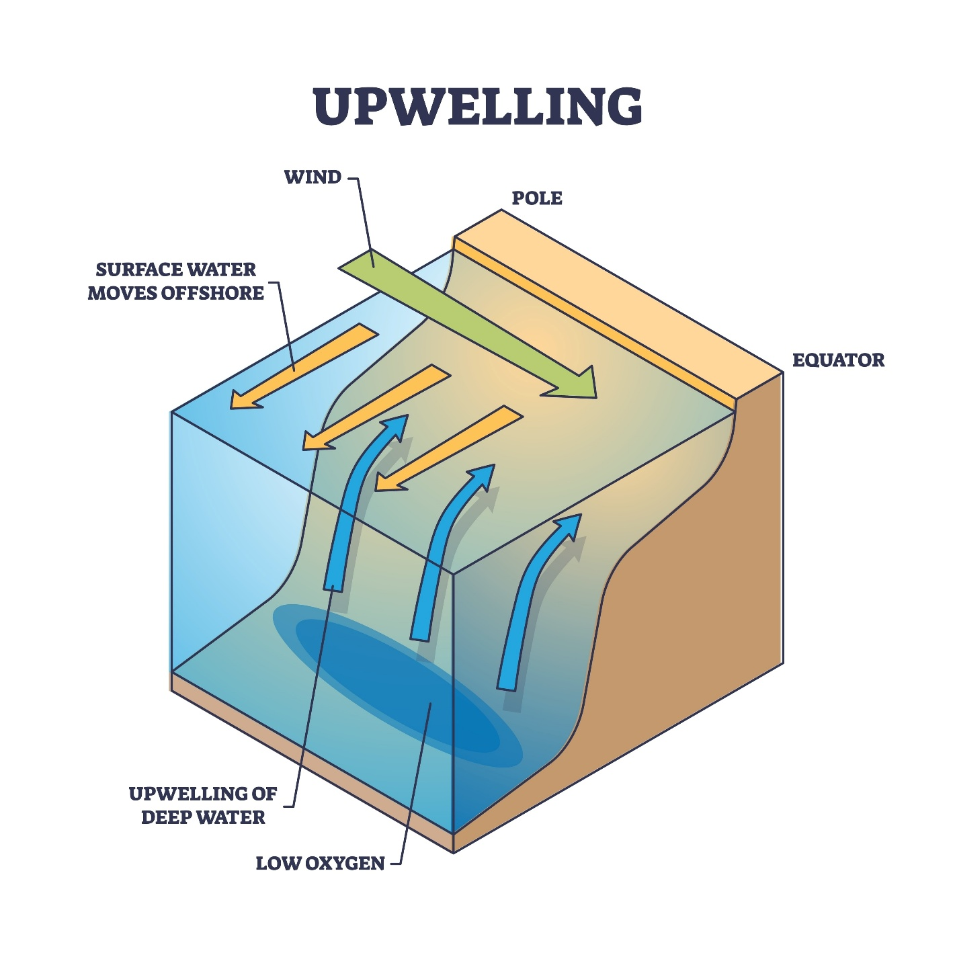
Shutterstock
Caption: Smart Design: The housing (green) is upwind. The processing plant (red) is downhill.

UNIT 3: THE 5-YEAR VISION

Don't build a palace on day one.

1. Phasing Your Growth
Investors want to see a timeline.
- Phase 1 (Months 1-6): Exploration trenches and a temporary tent camp. Low cost.
- Phase 2 (Months 6-24): Sinking the main shaft and installing a small hammer mill.
- Phase 3 (Years 2-5): Building the full Cyanide Leaching Plant and permanent brick housing.

2. Visualization
Use the NMIH App to draw "Zones" on your map.
- Blue Zone: Processing.
- Green Zone: Living.
- Red Zone: Blasting/Danger.

🏆 FIELD CHALLENGE (The Gig)
Complete this task to earn your "Architect" Badge.
Task: The Site Sketch
- Open the NMIH App (Map View) of your claim.
- Use the "Draw Polygon" tool to mark three areas:
  - Zone A (Extraction): Where the shaft will be.
  - Zone B (Processing): Where the mill/crusher goes (check wind direction!).
  - Zone C (Waste/Tailings): A flat area away from water.
- Tag it: "5-Year Development Plan."
[BUTTON: SUBMIT SITE PLAN]

📝 QUIZ: THE STRATEGIST

Module: AKM-402 | Time Limit: 5 Mins | Pass Mark: 4/5

Q1: What does the "SEAN" framework stand for in strategic planning?
A) Strategic Environmental Analysis. 2
B) Save Every Available Nickel.
C) South East Area Network.
D) Seven Eleven And Nine.
Q2: When planning your mine layout, why does "Wind Direction" matter?
A) It helps dry the clothes.
B) You must place noisy/dusty machinery (like crushers) downwind so the dust doesn't blow into your workers' sleeping quarters.
C) It pushes the gold out of the ground.
D) It doesn't matter.
Q3: If you are mining on a hill, where should you place the heavy processing plant (Crusher/Mill)?
A) At the very top, so you have to carry the water up.
B) Uphill from the shaft.
C) Downhill from the shaft, so gravity helps move the heavy rocks to the crusher.
D) In the river.
Q4: What is "Phased Development"?
A) Building everything on the first day.
B) Starting small (e.g., trenches/tents) and expanding to permanent structures (e.g., leach tanks/brick houses) as you make profit.
C) Waiting 5 years before doing anything.
D) Changing the name of the mine every month.
Q5: In a site layout, a "Conflict" occurs when:
A) You put the kitchen next to the toilet.
B) You put the cyanide tanks uphill from the village water source.
C) You put the sleeping quarters next to the loud generator.
D) All of the above.

SUBMIT ANSWERS & CLAIM 1200 XP

