2026 POTRAZ INNOVATION EXPO & CONFERENCE | OFFICIAL EXHIBITOR ARTWORK & PORTFOLIO
TEAM & ORGANIZATION INNOVATION SHOWCASE
 | TAKUNDA NIGEL MHANDU — Lead Innovator & Systems Architect  GIS & Remote Sensing Graduate | National University of Science and Technology (NUST, Bulawayo)  Recent NUST GIS & Remote Sensing graduate specializing in Applied Machine Learning, Deep Learning computer vision, and cloud Earth Observation (Google Earth Engine). Expert in training predictive architectures (Random Forests, neural networks) on multispectral and climate telemetry to build production-grade, inclusive digital solutions for Zimbabwe’s extractive and agricultural sectors.  Contact: mhandutakunda@gmail.com | Theme: Harnessing Local Innovation for Inclusive Development

FLAGSHIP SOLUTION 1: THE NATIONAL MINERAL INTELLIGENCE HUB (SMART MINING)
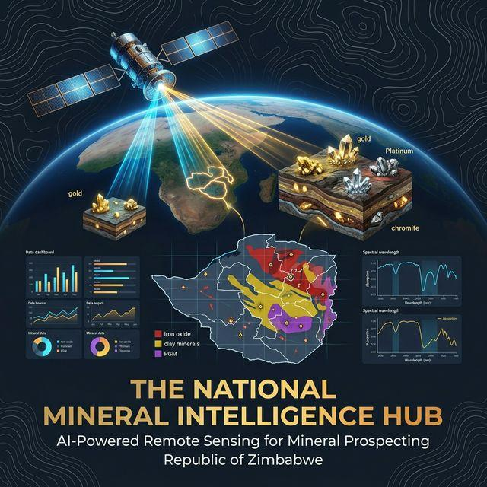 | Digital Mineral Exploration & Value-Chain Modernization  • Multispectral Earth Observation: Sentinel-2 L2A via Google Earth Engine with automated Iron Oxide, Hydrothermal Alteration, Gossan, and NDVI band ratios.  • Artisanal Mining De-risking: Replaces dangerous, capital-wasting 'blind digging' with orbital reef targeting.  • Live Market Telemetry: Real-time price feeds for Gold, Platinum, Palladium & Copper with 15-min caching.  • Decentralized Youth Gig Engine: Empowers STEM graduates to earn mobile income via field ground-truthing.  • Cashless Telecommunications: Instant EcoCash QR merchant payments & P2P wallet settlement.

PROVEN INNOVATION TRACK RECORD & PRODUCTION-READY DEPLOYMENTS
FLAGSHIP SOLUTION 2: AGRISHIELD (CLIMATE & AGRITECH)
 | AgriShield: AI-Driven Agricultural Drought Forecasting & Resilience  Live Cloud System: https://agrishield-1-j2tg.onrender.com/  • Multi-Sensor Drought Analytics: Integrates FLDAS Soil Moisture Index (SMI), CHIRPS Standardized Precipitation Index (SPI), and MODIS/Sentinel-2 Vegetation Condition Index (VCI).  • Machine Learning Forecasting: Trained Random Forest models over a comprehensive longitudinal dataset (Binga District, 2000–2025) for early drought detection.  • Production-Grade Cloud Deployment: Fully deployed and publicly live on Render with automated REST APIs, Docker containerization, and sub-second analytical response.  • Food Security Alignment: Enables rural smallholders and policy makers to prepare for El Niño-induced climatic shocks before total crop failure ensues.

ORGANIZATION TECHNICAL CAPABILITIES & DEPLOYMENT MATURITY
Domain & Competency | Demonstrated Systems & Artifacts | Strategic Value to Zimbabwe & POTRAZ
Cloud Earth Observation & GIS | Sentinel-2, GEE APIs, MODIS, CHIRPS, NumPy band math pipelines | Eliminates multi-million-dollar software and hardware licensing barriers for national industries.
Applied Machine Learning & Deep Learning | Production Random Forest models, neural networks, computer vision for EO | Brings predictive intelligence to extractive and agricultural value-chains.
Telecommunications & FinTech | EcoCash API gateway, QR merchant generation, Gmail SMTP, SMS logging | Bridges remote, unbanked communities with digital financial inclusion and traceable receipts.
Cloud DevOps & Rapid Delivery | Live Render deployments (AgriShield, Mineral Hub), Docker, Streamlit | Demonstrates capability to rapidly prototype, deploy, and maintain robust national public services.

EXHIBITION READINESS STATEMENT: As a NUST (Bulawayo) graduate, our team is proud to showcase live, interactive demonstrations of both The National Mineral Intelligence Hub and AgriShield on home soil at the 2026 POTRAZ Innovation Expo at the ZIEC Grounds in Bulawayo. We welcome partnerships with POTRAZ, industry financiers, mining syndicates, and mobile telecommunications operators to scale these homegrown innovations nationwide.

