*NOTE: Use 32-bit command prompt*

**Steps for migrating PartitionedView Database to NonPartitioned Database.**

1. **Stop all services**

Net stop pipeline

Net stop activityservices

Net stop iisadmin

Net stop w3svc

Net stop msmq

Net stop metrapay

Net stop metratech.fileservice

Net stop billingserver

Net stop MetraTechDataExportService

1. **Close ICE**
2. **Check SQL Server version is greater than or equal 2008**

1. *Check SQL Version*

Connect to the instance of SQL Server, and then run the following query:

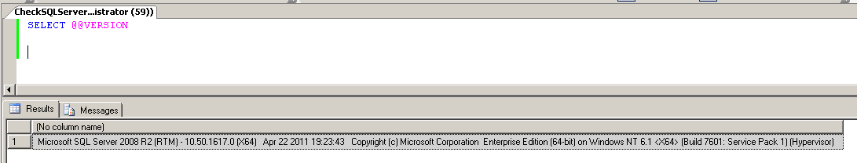

1. *Another ways to determine version of SQL Server.*

How to determine the version and edition of SQL Server and its components:

<http://support.microsoft.com/kb/321185/en-us>

1. **Make backup of the Database**
2. Use MetraNet backup functionality for this:

<http://tiber.metratech.com/Tech%20Doc/CD-Ready%20Sets/6.8.0/MetraNet%20Documentation%20-%20Complete%20Set/index.htm?toc.htm?8462.htm>

1. Another way to backup Database use SQL Server backup functionality:

<http://msdn.microsoft.com/en-us/library/ms186865.aspx>

1. **Check that there is enough space to do copy operations**

You need free space on the disk not less than the biggest Partitioned View Database.

1. *Check databases space*

Connect to the instance of SQL Server, and then run the following query:

sp_helpdb

1. *Check disk space*

From command prompt run:

fsutil volume diskfree disk:

1. **Close database connections and close SQL Server Management Studio**
2. *Close SQL Server Management Studio*
3. *Restart SQL Server Service*

Net stop mssqlserver

Net start mssqlserver

1. **Check that MS SQL Server Install directory is correct in MigrationScript.bat.**
2. Open for edit MigrationScript.bat.
3. Check that **BCP_FOLDER** variable has value of your MS SQL Server installation directory.

*NOTE: Default installation directory for*

*SQL Server 2012 - C:\Program Files\Microsoft SQL Server\110\Tools\Binn  
 SQL Server 2008\R2 - C:\Program Files\Microsoft SQL Server\ 100\Tools\Binn*

1. **Run MigrationScript.bat**

*NOTE: If you run script from command prompt you should set directory to the folder of MigrationScript.bat.*

1. Enter user name to connect to MSSQL Server.
2. Enter Password to connect to MSSQL Server.
3. Enter MSSQL Server name.
4. Enter database for which you need to connect.

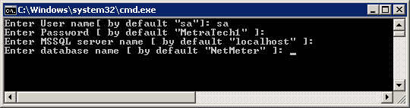

*NOTE: If you don’t enter values, it will use values by default for connection to server.*

1. **Run DeployProductView Hook.**

Open ICE -> Tools -> Synchronize -> Synchronize Database -> Select MetraHook.DeployProductView.1

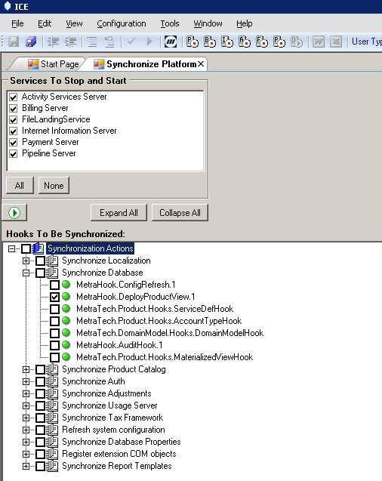

1. **Check that Database is NonPartitioned.**

Connect to the instance of SQL Server, and check the following:

1. All Partitioned View databases are dropped.
2. All views like t_pv_* and t_acc_usage are dropped from NetMeter.
3. Tables like t_uk_* are dropped from NetMeter.
4. Tables like t_pv_* and t_acc_usage with data are created in MetraNet.
5. Table t_partition is empty.
6. Table t_partition_storage is empty.
7. Column b_partitioning_enabled from t_usage_server updated to 'N'.
8. Indexes and primary keys are created for t_pv_* and t_acc_usage tables in NetMeter.
9. **Modify usageserver.xml file to disable partitioning**

Modify the file usageserver.xml ***D:\MetraTech\RMP\Config\UsageServer*** as below

<Partitions>

<!-- Enable partitioning for all usage tables, true or false. -->

<Enable>False</Enable>

<!-- Cycle types supported are Quarterly, Monthly, Semi-Monthly, and Weekly. -->

<Type>Monthly</Type>

<!-- Allocation size of partition database data files in megabytes. -->

<DataSize>100</DataSize>

<!-- Allocation size of partition database log file in megabytes. -->

<LogSize>25</LogSize>

<!-- Storage locations for partition databases. Used in round robin fashion. -->

<StoragePaths>

<!-- Specify at least one storage path when enabling partitioning -->

<Path>c:\datafiles\01</Path>

<Path>c:\datafiles\02</Path>

</StoragePaths>

</Partitions>

**TROUBLESHOOTING**

What to do if MigrationScript not run successfully?

1. Check that all previous steps are done correctly.
2. Restore Database from backup.
3. Run MigrationScript.bat.

OR

1. Check that all previous steps are done correctly.
2. Run MigrationScript.bat

***NOTE:*** *Script will continue migrating data to NonPartitioned database from last successfully migrated table.*

*Migrate information about Product View table you can find in*  ***t_prod_view*** *table, if column* ***b_migrated*** *is set to 1, so Product View table has already migrated successfully. If it set to 0, Product View table is not migrated yet or migrated with errors.*

*If MigrationScript.bat runs successfully* ***b_migrated*** *column will be dropped from* ***t_prod_view*** *table.*