
The Internet Metering Company™

MetraTech Metering SDK User’s Guide
(Draft)
Version 1.1
06/22/98

The following document is provided for information purposes only. All information disclosed herein should be considered confidential and proprietary. This document is the property of MetraTech and may not be disclosed, distributed, or reproduced in part or in whole without the express written permission of MetraTech Corp.

MetraTech Metering SDK User’s Guide

© Copyright 1998 MetraTech Corp. All rights reserved.
This document is being furnished by MetraTech Corp. for information purposes only to licensed users of the MetraTech Metering SDK software product and is furnished on an “AS IS” basis, that is, without any warranties, whatsoever, expressed or implied.
MetraTech, the MetraTech logo, Billing Starts Here, and the Internet Metering Company are trademarks of MetraTech Corp. Other brand and product names are trademarks or registered trademarks of the respective holders. Microsoft and Windows NT are registered trademarks of the Microsoft Corporation.
Information in this document is subject to change without notice and does not represent a commitment on the part of MetraTech Corp. The MetraTech Metering SDK software described in this document is furnished under a license agreement, and may be used only in accordance with the terms of that license agreement. It is a violation of law to copy or use the software except as specifically allowed in the license. No part of this document may be reproduced or retransmitted in any form or by any means, whether electronically or mechanically, including, but not limited to the way of: photocopying, recording, or information recording and retrieval systems, without the express written permission of MetraTech Corp.

Acknowledgments
MetraTech would like to thank Compaq, NetCentric and the MSIX partners for their part in creating the original MSIX protocol specification. Sections that reference MSIX were taken in part from the MSIX/1.0 specification by Alan Blount.

MetraTech Corp.
411 Waverley Oaks Road
Waltham, MA 02154
Tel: (781) 398-2242
Fax: (781) 398-2232
www.metratech.com
Table of Contents

Introduction 6
Overview 6
Features 6
Easy to Integrate 6
Standards Based 6
Secure 6
Robust 6
Failover and Local Mode Support 6
Global 7
Chapter 1: MetraTech Concepts 8
Overview 8
High-level Architecture 8
Communications 9
MSIX 9
Clients and Servers 9
Services 10
Sessions 11
User Defined IDs 11
Chapter 2: Getting Started 12
Overview 12
System Requirements 12
Installing the Metering SDK 12
Testing the Metering SDK After Installation 12
Step1: Find the account information necessary to run the test program. 13
Step 2: Run the test program. 13
Step 3: Enter the test information into the test program. 14
Step 4: Verify that the test program worked by viewing your transaction. 15
Chapter 3: Samples 18
Overview 18
Build Environment 18
Simple Sample 18
Time 19
Header files 19
Application Class 19
Data Collection 20
Initialization 20
Metering Server Specification 21
Metering the Session 21
Main 22
Demo Sample 23
Header files 24
Line Entry Classes 24
Application Class 27
Setup and Shutdown 29
Test Entry Point 29
Sending the Sessions 31
Initializing the Parent 34
Initializing Sub-sessions 34
Parsing the Data File 35
Error Messages 39
Main 39
Chapter 4: Building Services 40
Overview 40
The Process 40
Step 1: Planning 40
To Meter or Not to Meter 40
Atomic or Compound 41
Data Volume 42
Customer Self-help 42
Customer Support 42
Step 2: Filling Out Service Worksheets 43
Service Names 43
Sub-services 43
Properties 43
Step 3: Contacting MetraTech 44
Step 4: Implementation 44
Step 1: Create a project 44
Step 2: Modifying the Code 48
Step 5: Testing the Code 49
Enhancing the code 49
Chapter 5: Technical Support 51
Overview 51
Committed to Your Success 51
Before You Contact Us 51
Online Support 51
FAQs 51
Email 51
Release Notes 51
Developer Support Hotline 51
Appendix 53
Partner Data Sheet 53
Planning Aids 53
Troubleshooting 53
Compile problems 53
Runtime problems 53
Further troubleshooting 54
Error Codes 54
ISO 4217 Currency List 55

Introduction

Overview
The Metering Software Development Kit (SDK) is an object-oriented, cross-platform toolkit that enables independent software vendors (ISVs), systems integrators and hardware manufacturers to integrate their applications seamlessly with a network service provider's (NSP) billing and management systems. The SDK’s small memory footprint and optimized performance make it suitable for use in the most demanding and resource-constrained environments. The SDK sends metering information to a scaleable, highly-distributable Metering Server that persistently stores the data. This enables you to focus on your core technology rather than expending valuable resources on custom development.
MetraTech’s Transaction Pipeline™ technology works with the Metering Server and empowers the NSP’s product manager to quickly create new rating schemes and cross-service plans through an intuitive Graphical User Interface (GUI). All of this is accomplished without the need for any custom development. Better yet, end-users can access the data in real-time through a web-based interface. The SDK enables you to quickly deploy your applications by providing plug-and-play billing capabilities with NSP’s systems.

Features

Easy to Integrate
The SDK is designed to support interfaces for all popular development environments and has a straightforward API that enables service usage such as a voice call to be metered in as little as 20 lines of code. The SDK is provided royalty-free and at no charge. Also, to support partners MetraTech hosts an Internet accessible reference server. This server enables developers to test and debug SDK integration against a stable reference environment.

Standards Based
The SDK uses the Metered Systems Information eXchange (MSIX) standard to communicate with MetraTech's Metering Server. MSIX is an open protocol that provides a common interface for applications to exchange detailed usage information with network billing and management systems. MetraTech's MSIX implementation enables plug-and-play billing capabilities between ISVs and NSPs. For more information on MSIX, see www.msix.org. The site contains the protocol specification, a white paper and a FAQ.

Secure
The SDK uses RSA™ technology to encrypt all communication between the SDK and the Metering Server. As the SDK can be configured to use HTTP/HTTPS as its transport protocol, metered information can be sent through firewalls and/or proxy servers.

Robust
The SDK supports a robust set of transaction types that support metering a wide range of services from voice calls, to fax broadcasts with tens of thousands of recipients, to quality of service (QOS) bandwidth usage, to multicast video broadcasts.

Failover and Local Mode Support
In the event that communication with the primary Metering Server is lost, the SDK has the ability to failover to alternate backup Metering Servers. Using the SDK, a developer can specify a prioritized list of Metering Servers to support failover situations. Furthermore, if no Metering Servers are available due to a network outage, the SDK can be configured to automatically store the data in a local file and forward it as soon as a Metering Server becomes available.

Global
All MetraTech technologies support localization for international applications. The SDK supports the metering of information in any character set via Unicode.

Chapter 1: MetraTech Concepts

Overview
This chapter provides a high-level overview of fundamental MetraTech concepts including:
- High-level Architecture

- Communications
- MSIX
- Clients and Servers
- Services
- Properties
- Units of Measure
- Sessions
- User-Defined IDs

High-level Architecture
MetraTech’s component-based server architecture (see Figure 1: below) provides a scaleable infrastructure to meter, rate, present and bill for usage-based services. The SDK provides a flexible, standards-based mechanism to communicate with the Metering Server.

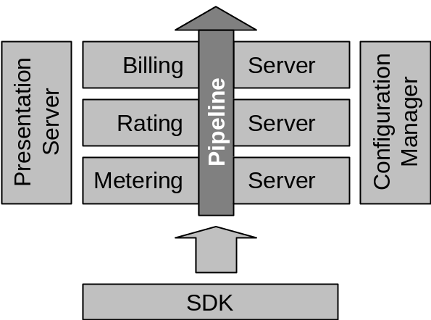
Figure 1: Component-based Server Architecture

Metering Servers and Presentation Servers, described below, are of most interest to the SDK developer:
- Metering Server. The Metering Server is a highly scaleable server that persistently stores detailed usage information. The SDK communicates via MSIX with one or more Metering Servers when metering usage information. Network administrators may deploy a single Metering Server in their network or multiple Metering Servers at strategic locations to improve availability or reduce network traffic. The Metering Server is designed to operate and can be managed in distributed, hostile environments thus placing no deployment constraints on the network administrator.
- Presentation Server. The Presentation Server provides end-users with an HTML-based customer self-help and reporting interface for viewing charges in real-time. This interface is a valuable tool for the developer, as well, for testing and debugging SDK integration. The NSP can easily modify the Presentation Server to customize its look and feel on a service-by-service basis. MetraTech will work with partners to develop default interface templates for common service configurations. These default templates will ship with the Presentation Server to enable out of the box integration.

Communications
The SDK communicates with the Metering Server via the MSIX protocol and, by default, uses HTTP tunneling. Tunneling enables the SDK to leverage SSL for encryption and to pass information through most firewall configurations. A subsequent release of the SDK will allow HTTP tunneling to be optionally disabled in situations where tunneling is not required.

Figure 2: Diagram of MetraTech's Communications Architecture

MSIX
Metered Service Information eXchange (MSIX) is an open protocol designed to enable NSPs to meter detailed usage information and assign charges for value-added services. The protocol provides a common interface for applications to easily exchange detailed usage information with network billing and management systems. MSIX is based on the eXtended Markup Language (XML) which is quickly becoming the de-facto standard for information exchange on the Internet. For more information on MSIX, visit www.msix.org. The site contains the protocol specification, a white paper and a FAQ.
The SDK implements MSIX and insulates the developer from the details of the protocol. The following six MSIX concepts are important for the SDK developer to understand:

Clients and Servers
A network entity is a device that is connected to a network. It may act as an MSIX client or an MSIX server. An entity is an MSIX server if it accepts MSIX sessions and an MSIX client if it generates them. An application server is an entity that provides application services to clients. Application servers are typically clients of MSIX servers.

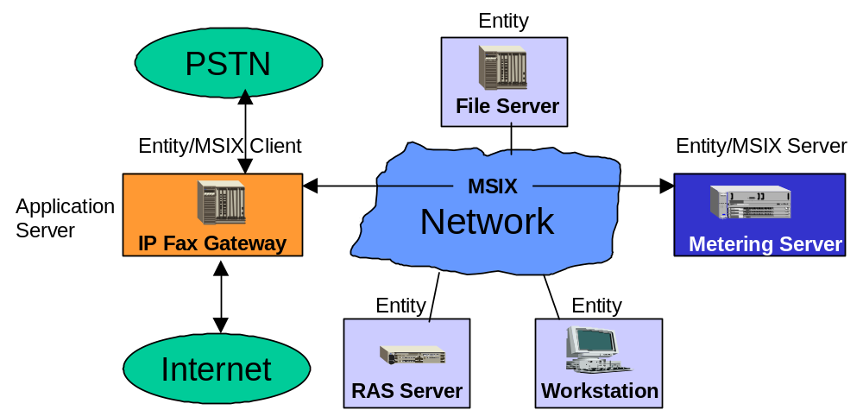
Figure 3: MSIX Clients and Servers

Services
A service is a task that is performed by an application for a client. The task performed may be anything: IP-PSTN fax/voice calls, video streams, quality of service (QoS) routing, virtual private networks (VPN), outsourced remote access, web hosting, data storage, etc.
Services may be either atomic or compound, as defined below. Additional information about Atomic and Compound services can be found in the Atomic or Compound section on page 42.
- Atomic services are those services whose usage may be metered completely in a single transaction. Examples of atomic services are point-to-point faxes, voice calls and video streams.
- Compound service usage involves the composition of multiple services. These services may be atomic services or may themselves be other compound services. Thus, a compound service transaction is composed of a hierarchical collection of related service transactions as can be seen in Figure 4 below. Examples include fax broadcasts, conference calls and multicast video streams. There is no limit on the number of sub-services, the depth of the hierarchy or the type of services encompassed.
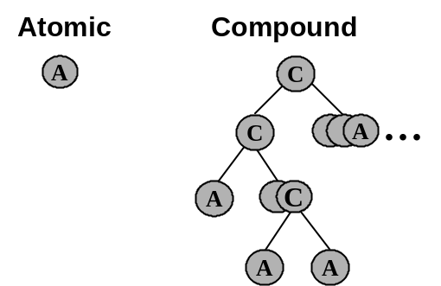
Figure 4: Atomic and Compound Services
Properties
Properties describe the quantities that may be metered for a particular service. A property is represented by a name/value pair, where the name is a unique, human-readable identifier understood within the context of a service. Examples of property names include “bytes-sent” and “duration.” A property therefore, would be represented by the pair “duration=120” or “bytes-set=1024”. MSIX clients communicate usage information by transmitting names and associated values to the Metering Server.
Units of Measure
Because properties do not carry information about the type of data they contain, a separate construct is used to represent this information. Units of measure (UOM) are used to describe numeric properties (non-numeric properties do not have UOMs). A UOM determines the exact interpretation of a numeric quantity by defining measurement units such as “seconds”, “bytes”,
“milliseconds”, “page count”, etc.

Sessions
A session represents the use of a service by a client as a collection of properties. To meter service usage, clients create sessions and add properties to those sessions. Properties may be added to or updated until the session is “closed”.

User Defined IDs
User defined IDs (UIDs) are used to uniquely define MSIX sessions and to create the hierarchies inherent in compound services. UIDS are generated transparently by the SDK for the SDK user.

Chapter 2: Getting Started

Overview
This chapter contains information including:
- System Requirements
- Installing and uninstalling the Metering SDK

- Testing the Metering SDK After Installation

System Requirements
The Metering SDK requires the following:
- Windows NT 4.0 (service pack 3) or higher.
- 5MB of free disk space.
- 32 MB RAM (recommended minimum).
- Microsoft Visual C++ 5.0 is required to build applications that use the Metering SDK.
- Microsoft Internet Explorer (version 3.0 or higher) or Netscape Navigator (version 3.0 or higher).

Installing the Metering SDK
To install the Metering SDK:
- Launch the mtsdk_nt.exe executable (available from partner.metratech.com).
- You will be asked to agree to the Metering SDK license agreement.
- After you have agreed to the license, you will be prompted to indicate the directory in which to store the libraries, DLL, sample code and documentation. You can store these files anywhere you want. For the purposes of this document, we will refer to this directory as INSTALLDIR.
- Next, you will be prompted for the name of the Program Folder where shortcuts to the sample application, documentation and the uninstall application will be created.
- After all files have been installed you will have the option of viewing the README file contained in the Metering SDK. The release notes in this file contain last minute additions to the documentation so it is important that you consult this file if you encounter any problems when using the Metering SDK.

Note:
The installation does not make any changes to the registry or make any modifications to environment variables (e.g., the PATH variable).

Uninstalling the Metering SDK
To remove the Metering SDK from your system, select the Programs → MetraTech Metering SDK → Uninstall Metering SDK menu item from the Start menu.

Testing the Metering SDK After Installation
The SDK contains a test program that meters a very simple service. The service consists of the following properties:
- AccountID
- Description
- Amount
- Amount Unit of Measure (i.e. a currency code, using codes based on ISO 4127 / 3166. Please see the ISO 4217 Currency List on page 56 for a full listing of codes.)

The next four sections describe the steps required to test the installation:

Step1: Find the account information necessary to run the test program.
Before you run the test program, you should know the following:
- Name of the Metering Server
- Username and Password for the Metering Server
- Account Identifier
If you do not have this information, refer to the Partner Data Sheet appendix on page 54.

Step 2: Run the test program.
By default, the Metering SDK installation program creates a shortcut to a console application test program which you can use to test your installation. There the following two ways to run the program:
- Running the test program from the Windows Start menu: The test program can be run by selecting the Programs → MetraTech Metering SDK → Metering SDK Test Program menu item from the Start menu, as shown in Figure 5 below.

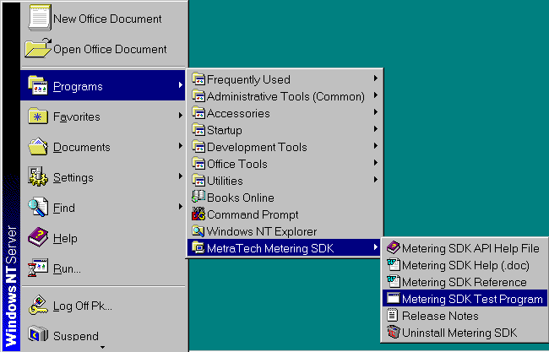
Figure 5: Shortcut to the console test program

- Running the test program from DOS: From DOS, change to the installation BIN directory and type simple.exe, as shown below:

C:\>cd INSTALLDIR\bin
C:\DevTools\MT-SDK\bin>simple.exe

Note:
It is important to change the directory to INSTALLDIR/bin, as simple.exe relies on a DLL on which is in this directory and has not been placed in your PATH.

Step 3: Enter the test information into the test program.
After you launch the test program, you will be prompted to enter the following information:
- Server host name: The name of the destination Metering Server.
- Server username: The username to use when sending sessions to the Metering Server.
- Server password: The password to use when sending sessions to the Metering Server.
- AccountID: The account to which the session will be metered.
- Transaction description: The description of the transaction.
- Amount: The monetary amount assigned to the transaction.
- Unit of measure: The currency of the amount.

Here is an example execution of the test program. User responses are printed in bold font.

C:\DevTools\MT-SDK\bin>simple.exe
MetraTech simple metering example.
Server host name: partner.metratech.com
Server username: partnerCorp
Server password: partnerPass

Account ID: 123

Transaction description: This is a test

Amount (floating point number): 1.28
Unit of measure [USD]: USD
Metering with the following information:
Host: partner.metratech.com
Username: partnerCorp
Password: partnerPass
Account ID: 123
Description: This is a test
Amount (floating point number): 1.28
Currency: USD
The session has been metered!
Press any key to continue...

Please see the Troubleshooting section on page 54 if problems arise when running this test program.

Step 4: Verify that the test program worked by viewing your transaction.
Assuming that the test program returned with success, you should verify that the transaction was metered by following the steps outlined in this section:
- Use an Internet browser, Microsoft Internet Explorer 3.0 (or higher) or Netscape Navigator 3.0 (or higher), to access the Presentation Server’s logon page. Please see the Partner Data Sheet for detailed web address, logon and password information.
- Enter a logon and password and click on the Enter button, as shown in Figure 6 below. This enables the Presentation Server to display metered usage for your particular account. This account will be the same account as that identified by the AccountID that was used to meter the test service.
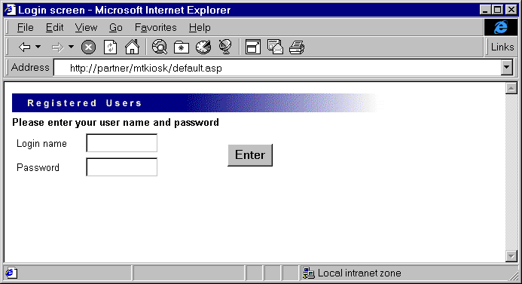
Figure 6: Enter logon and password

- To view your transaction, click on the Usage button, shown in Figure 7 below.
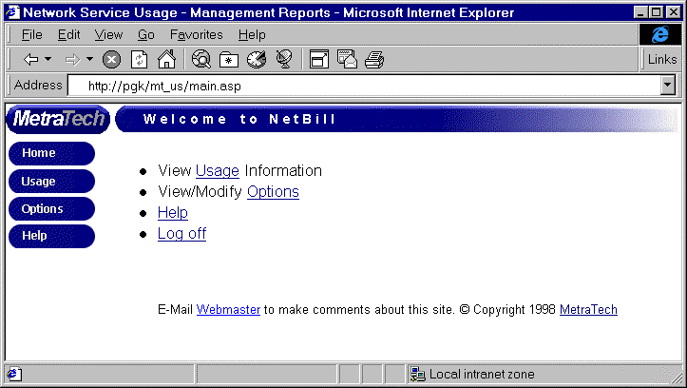Figure 7: The top-level Presentation page

- Click on the arrow icon to the left of the line reading: Miscellaneous Value Added Services, as shown in Figure 8 below.
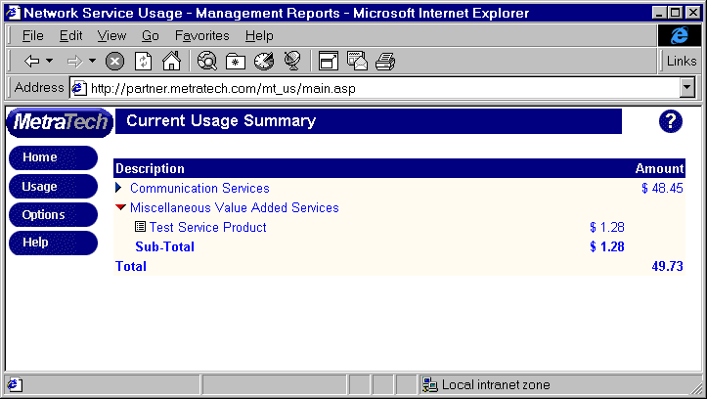
Figure 8: Usage summary

- The browser will display a new line with one or more metered product line items. The product associated with the test program is: Test Service Product. Click on the arrow icon to the left of this line, to display a listing of metered transactions associated with this product.
- On this screen, you should see your test transaction, as shown in Figure 9 below.
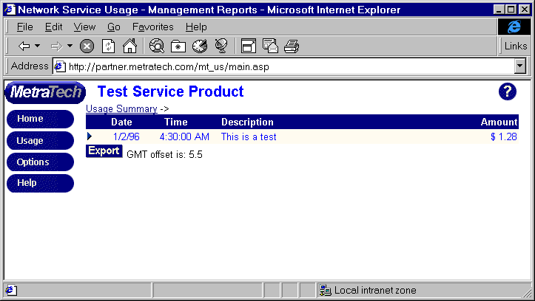
Figure 9: Test service detail

- Please check the Date, Time, Description and Amount fields to verify that the transaction matches what you just metered.
If you do not see your transaction, please check that the AccountID used to send the test matches the AccountID on your Partner Data Sheet.

Chapter 3: Samples

Overview
This chapter explains information about the build environment and also offers a sample case to demonstrate the correct use of the SDK. The sample can be used as a starting point for your own integration with the SDK.
The sections in this chapter are:
- Build environment
- Simple Sample: The first sample called Simple prompts for several properties and meters them as part of the service called metratech.com/TestService. It demonstrates the most basic use of the Metering SDK.
- Header Files
- Application Class
- Data Collection
- Initialization
- Metering Server Specification
- Metering the Session

Build Environment
The current version of the Metering SDK has only been certified for use with the Microsoft Visual C++ compiler. The libraries and DLLs included were built with Microsoft Visual C++ version 5.0.

Helpful Hint:
The following sample has the correct build environment settings. If you want to change the settings, please refer to the Step 4: Implementation section on page 45.

Simple Sample
The most basic sample included with the MetraTech Metering SDK is the Simple example. The Simple example first prompts the user for the server name to use to meter the session, as well as the username and password used for HTTP authentication on this server. It then prompts you for the description, amount and unit of measure. Finally, it meters the session and exits. The following six sections describe the example in more detail.
The MetraTech reference metering server implements metering for a service named metratech.com/TestService. TestService has four properties:
- Description (an ASCII string)
- Amount (a float)
- UOM (meant to be a three letter currency code)
- Time (a time_t value)
Because several companies share the MetraTech reference server, you must also supply a property named AccountID whose value is assigned to you by MetraTech.

Time
The SDK expects that all times are represented in GMT. The programmer must make the appropriate conversion from local time to GMT before submitting time values to the server.

Header files
This directive shown below includes the single header file required by users of the Metering SDK. mtsdk.h must be within your include path. See step 1 in the Build Environment section on page 18 for details about how to add this file to your include path. The project file for the Simple example already has the file in its include path.

#include <mtsdk.h>

The header file sdk_msg.h holds the definition for each of the error codes that are stored in sdk_msg.dll. This header file needs to be included to interpret error codes returned from the Metering SDK. The simple sample does not include this file.

Application Class
The application class descriptions are listed below, followed by the sample code.
- The SimpleMeter class is the main application class.
- The TestSimple function is the entry point to the sample, called by main().
- PrintError prints any error if one occurs.
- It holds a MTMeter object used to create metering objects and a MTMeterHTTPConfig object to configure the MTMeter object.
- MeterIt is called by TestSimple to send the data read from the user to the Metering Server using the SDK. It does the real work of the application.

class SimpleMeter
{
public:
SimpleMeter() : mMeter(mConfig)
{ }

void TestSimple(int argc, char * argv[]);

private:

MTMeterError * MeterIt(const char * host, const char * username,
const char * password, const char * accountId,
const char * desc, float amount,
const char * currency);

void PrintError(const char * prefix, const MTMeterError * err);

MTMeterHTTPConfig mConfig;

MTMeter mMeter;
};

Data Collection
The TestSimple function is called by main(). Its job is to prompt the user for the information necessary to submit a TestService session. C++ iostreams are used for input and output. To keep the example as simple as possible, emphasis has been placed on Metering SDK specific code. More extensive iostream error handling and data validation would normally be required.

void SimpleMeter::TestSimple(int argc, char * argv[])
{
cout << "MetraTech simple metering example." << endl;

cout << "Server host name: ";
char host[256];
cin.getline(host, sizeof(host));

cout << "Server username: ";
char username[256];
cin.getline(username, sizeof(username));

cout << "Server password: ";
char password[256];
cin.getline(password, sizeof(password));

cout << "Account ID: ";
char accountId[256];
cin.getline(accountId, sizeof(accountId));

cout << "Transaction description: ";
char desc[256];
cin.getline(desc, sizeof(desc));

cout << "Amount (floating point number): ";
float amount;
cin >> amount;

char cr;
cin.get(cr);
cout << "Unit of measure [USD]: ";
char currency[10];
cin.getline(currency, sizeof(currency));
if (strlen(currency) == 0)
strcpy(currency, "USD");
// check to see if the user wants to send the session securely
cout << endl << "Do you want the session sent using SSL? [y/n] ";
char sendViaSSL[10];
int bUseSSL=FALSE ;
*sendViaSSL = 0;
cin.getline(sendViaSSL, sizeof(sendViaSSL));

// if no indicator was entered ... do not send the session
// using SSL
if (strlen(sendViaSSL) == 0)
{
bUseSSL = FALSE ;
}
else if (strlen(sendViaSSL) == 1)
{
if (sendViaSSL[0] == 'y' || sendViaSSL[0] == 'Y')
{
bUseSSL = TRUE ;
}
else if (sendViaSSL[0] == 'n' || sendViaSSL[0] == 'N')
{
bUseSSL = FALSE ;
}
else
{
cout << "Invalid response. Not sending the session using SSL."
<< endl ;
bUseSSL = FALSE ;
}
}
else
{
cout << "Invalid response. Not sending the session using SSL."
<< endl ;
bUseSSL = FALSE ;
}

cout << "Metering with the following information:" << endl;
cout << "Host: " << host << endl;
cout << "Username: " << username << endl;
cout << "Password: " << password << endl;
cout << "Account ID: " << accountId << endl;
cout << "Description: " << desc << endl;
cout << "Amount: " << amount << endl;
cout << "Currency: " << currency << endl;
if (bUseSSL == TRUE)
{
cout << "Using SSL to send the session." << endl ;
}
else
{
cout << "Not using SSL to send the session." << endl ;
}

Initialization
Before MeterIt, described below, can be called, TestSimple initializes the Metering SDK using the Startup function. If any errors occur during initialization, GetLastErrorObject is called to return an error object. This error object has been allocated memory which programmers should delete when finished processing the error. Otherwise it will remain valid consuming memory. If MeterIt returns an error, the error is printed for the user to see.

if (!mMeter.Startup())
{
cout << "Could not initialize the SDK." << endl;
return mMeter.GetLastError();
}

Metering Server Specification
For the Metering SDK to meter a session, it must be configured to communicate with a Metering Server. This is accomplished by calling the AddServer method on the MTMeterHTTPConfig object. This method accepts four parameters, a port number, a security mode flag, a username and a password. The port number argument specifies which Metering Server port will be used to communicate metered information. The security mode flag indicates whether secure communication will be used (security mode = TRUE) or not. Since the Metering Server may require authentication, the AddServer method provides a means to specify the credentials to use when communicating with a particular Metering Server. It is possible to call AddServer several times with different information each time. If one of the servers is unavailable when the Metering SDK attempts to submit a session, the next server in the list will be used instead.

// if we are using SSL to send the session ... pass the
// appropriate parameters correctly (port and secure flag)
if (bUseSSL == TRUE)
{
mConfig.AddServer(0, // priority (highest)
host, // hostname
MTMeterHTTPConfig::DEFAULT_HTTPS_PORT, // port (from mtsdk.h)
TRUE, // secure (yes)
username, // username
password); // password
}
// otherwise ... we're not using SSL to send the session ... pass the
// appropriate parameters correctly (port and secure flag)
else
{
mConfig.AddServer(0, // priority (highest)
host, // hostname
MTMeterHTTPConfig::DEFAULT_HTTP_PORT, // port (from mtsdk.h)
FALSE, // secure? (no)
username, // username
password); // password
}
The MeterIt function uses the data read from the user to submit a session to the server. If any error occurs while doing this, the MTMeterError object is returned. If no error occurs, NULL is returned. After the session is metered, the SDK is shutdown by calling the Shutdown function. Finally the sample waits for a key press so the results can be seen before the console window disappears when the application exits.

MTMeterError * err = MeterIt(host, username,
password, accountId,
desc, amount, currency);
if (!err)
cout << "The session has been metered!" << endl;
else
{
PrintError("The session has not been metered: ", err);
delete err;
}

// close the sdk
mMeter.Shutdown();

// pause, in case this is run from a shortcut
cout << "Press any key to continue..." << endl;
(void) GetKey();
return;

Metering the Session
An instance of a MTMeterSession object is created with the CreateSession method. The service name is passed into this method. This service name must match the service name on the metering server.

MTMeterSession * session =
mMeter.CreateSession("metratech.com/TestService");

The value of each property is added to the session using the InitProperty method. InitProperty is an overloaded function that allows any allowable type to be passed in. The reference documentation for InitProperty defines the set of allowable property types. In this example, the Time property is set to the current time. The rest of the properties are added exactly as the user entered them.

// set the session's time field to the current time.
time_t t = time(NULL);

// these property names have to match those on the server
if (!session->InitProperty("AccountID", accountId)
|| !session->InitProperty("Description", desc)
|| !session->InitProperty("Amount", amount)
|| !session->InitProperty("UOM", currency)
|| !session->InitProperty("Time", t))
{
MTMeterError * err = session->GetLastErrorObject();
delete session;

// shutdown the metering library
mMeter.Shutdown();
return err;
}

Next, an attempt is made to Close the session. This passes the value of each property to the Metering Server. All required properties must have been added to the session using InitProperty before Close is called. The server validates the service name and list of properties at this time.
If an error occurs, GetLastErrorObject is called to retrieve a MTMeterError object that will remain valid even after the session object is deleted or further modified. This MTMeterError object must be deleted after it is used.

// send the session to the server
if (!session->Close())
{
MTMeterError * err = session->GetLastErrorObject();
delete session;

// shutdown the metering library
mMeter.Shutdown();
return err;
}

Before MeterIt returns, the session is deleted. This frees up all memory associated with the session and the properties it contains.

delete session;
// success! no error to return
return NULL;
}

The session has been metered and no error has occurred.

Main
The main function invokes the test.

int main(int argc, char * argv[])
{
SimpleMeter meter;
meter.TestSimple(argc, argv);
return 0;
}

Demo Sample
The Demo sample application demonstrates more advanced usage of the Metering SDK. It demonstrates a compound service that contains an unlimited number of atomic services.
The demo sample takes its input from a “log file” that is generated by combining output from fictitious fax and email servers. Depending on the contents of the log file, the demo program meters either an atomic session or a compound session. If the file only contains a single log entry, an atomic session is created. If multiple entries are present, a compound session is created. The compound session can contain an unlimited number of faxes and/or emails. The log file entries have the following format:

FAX|Test fax|OK|123-45|code1|HIGH|120|14400|5|3|1|617|5550607|20
EMAIL|Test email|OK|A82F16E7008C|codeB|HIGH|1234|test@abc.com

A line starting with FAX is followed by the following fields:
- Subject – a user-defined description string.
- Status – the status of the fax. For example, “OK”, “FAILED”, etc.
- Tracking ID – the fax server’s internal reference to the fax. For example, 123-45, 19.77, etc.
- Billing code - arbitrary string used to distinguish faxes on a bill.
- Priority – the fax’s priority. For example, “HIGH”, “LOW”, etc.
- Duration – the number of seconds it took to send the fax.
- Modem speed – bps used to send the fax. Example 14,400.
- Attempts – number of attempts required to transmit the fax.
- Pages – total number of pages in the fax.
- Country code – fax number country code, 1 for the US.
- Area code – fax number area code.
- Local number – fax number local number.
- Setup duration – number of seconds to connect to the fax machine.

A line starting with EMAIL is followed by the following fields:
- Subject – a user-defined description string.
- Status – email status. For example, “OK”, “FAILED”, etc.
- Tracking ID – email server’s internal reference to the email. For example, A82F16E7008C.
- Billing code - arbitrary string used to distinguish emails on a bill.
- Priority – the email’s priority. For example, “HIGH, “LOW”, etc.
- Bytes - number of bytes in the email.
- Recipient email – the recipient’s email address.

The demo application expects four arguments on the command line and accepts a fifth, optional argument.
- Server name – Name of metering server.
- Username – HTTP authorization. Use “” if no authorization required.
- Password – HTTP authorization. User “” if no authorization required.
- Account ID – Metering server account ID.
- Filename [optional] – Name of data file. If not present, Demo reads from stdin.

Header files
The Demo application, like all applications that use the Metering SDK, requires mtsdk.h. Two classes from the Standard Template Library, list and string, are used to manage the application’s list of fax or email entries. The Standard Template Library is available with Microsoft Visual C++ and must be installed in order to build the demo application. Demo also requires two headers for input/output, iostream.h and stdio.h.

// metering object definitions
#include <mtsdk.h>

// standard template library list class used to keep list of transactions
#include <list>
// STL string used to store strings in entry objects
#include <string>

// I/O
#include <iostream.h>
#include <stdio.h>

Line Entry Classes
As the data file is read, each entry is added to a list by creating either FaxEntry or EmailEntry classes. The BroadcastEntry class is the base class for these two classes. BroadcastEntry simply has an abstract virtual function GetType that returns either FAX or EMAIL. This function is used to distinguish FaxEntries from EmailEntries when they are placed in a list. The FaxEntry and EmailEntry classes have a member for each field of the data file. The classes expose accessor functions for each member variable. The data members in these classes are not modified after the class is constructed, so no mutators are required. The STL string class is used to hold strings in the FaxEntry and EmailEntry classes.

/******************************************** BroadcastEntry ***/

//
// base class for either a fax or an email sent out.
// subclasses must implement GetType so that BroadcastEntry
// objects can go in heterogeneous lists.
//
class BroadcastEntry
{
public:
// virtual destructor
~BroadcastEntry()
{ }

// only possible to return one of these type from GetType
enum Type
{
FAX,
EMAIL
};

// return FAX or EMAIL in subclass
virtual Type GetType() const = 0;
};

/************************************************** FaxEntry ***/

//
// Data from one row in the data file that specifies a FAX transaction
//
class FaxEntry : public BroadcastEntry
{
public:
// constructor
FaxEntry(const char * subject, const char * status, const char * trackingId,
const char * billingCode, const char * priority, int duration,
int modemSpeed, int attempts, int pages, int countryCode,
int areaCode, int localNum, int setupDuration) :
m_Subject(subject), m_Status(status), m_TrackingId(trackingId),
m_BillingCode(billingCode), m_Priority(priority), m_Duration(duration), m_ModemSpeed(modemSpeed), m_Attempts(attempts), m_Pages(pages),
m_CountryCode(countryCode), m_AreaCode(areaCode), m_LocalNum(localNum), m_SetupDuration(setupDuration)
{ }

// this is a fax entry
virtual Type GetType() const
{ return FAX; }

//
// accessors
//
const char * GetStatus() const
{ return m_Status.c_str(); }

const char * GetSubject() const
{ return m_Subject.c_str(); }

const char * GetTrackingId() const
{ return m_TrackingId.c_str(); }

const char * GetBillingCode() const
{ return m_BillingCode.c_str(); }

const char * GetPriority() const
{ return m_Priority.c_str(); }

int GetDuration() const
{ return m_Duration; }

int GetModemSpeed() const
{ return m_ModemSpeed; }

int GetAttempts() const
{ return m_Attempts; }

int GetPages() const
{ return m_Pages; }

int GetCountryCode() const
{ return m_CountryCode; }

int GetAreaCode() const
{ return m_AreaCode; }

int GetLocalNum() const
{ return m_LocalNum; }

int GetSetupDuration() const
{ return m_SetupDuration; }

private:
// members which are read from the data file
std::string m_Status;
std::string m_Subject;
std::string m_TrackingId;
std::string m_BillingCode;
std::string m_Priority;
int m_Duration;
int m_ModemSpeed;
int m_Attempts;
int m_Pages;
int m_CountryCode;
int m_AreaCode;
int m_LocalNum;
int m_SetupDuration;
};

/************************************************ EmailEntry ***/

//
// Data from one row in the data file that specifies an EMAIL transaction
//
class EmailEntry : public BroadcastEntry
{
public:
// constructor
EmailEntry(const char * subject, const char * status,
const char * trackingId,
const char * billingCode, const char * priority, int bytes,
const char * email) :
m_Subject(subject), m_Status(status), m_TrackingId(trackingId),
m_BillingCode(billingCode), m_Priority(priority), m_Bytes(bytes),
m_Email(email)
{ }

// this is an email transaction
virtual Type GetType() const
{ return EMAIL; }

//
// accessors
//
const char * GetStatus() const
{ return m_Status.c_str(); }

const char * GetSubject() const
{ return m_Subject.c_str(); }

const char * GetTrackingId() const
{ return m_TrackingId.c_str(); }

const char * GetBillingCode() const
{ return m_BillingCode.c_str(); }

const char * GetPriority() const
{ return m_Priority.c_str(); }

int GetTotalBytes() const
{ return m_Bytes; }

const char * GetEmail() const
{ return m_Email.c_str(); }

private:
// members read from the data file
std::string m_Status;
std::string m_Subject;
std::string m_TrackingId;
std::string m_BillingCode;
std::string m_Priority;
int m_Bytes;
std::string m_Email;
};

Application Class
The DemoMeter class is the main application class. It contains the MTMeterHTTPConfig and MTMeter classes used to submit sessions to the metering sever.
- Test – called by main. The main entry-point to the application.
- Setup – adds the reference to the metering server to the MTMeterHTTPConfig object and initializes the Metering SDK properly.
- Cleanup – shuts down the Metering SDK after all sessions have been submitted.
- InitBroadcast – initializes a parent session of type “metratech.com/fax_broadcast” after it has been created. InitBroadcast initializes each property of the session.
- InitEmailSession – initializes a “metratech.com/fax_to_email” type session with the values read from a line in the data file.
- InitFaxSession – initializes a “metratech.com/fax” type session with values read from a line in the data file.
- DataFileTest – called by Test to do most of the work of the demo after the data file has been parsed.
- ParseFile – parses the data file and add each entry to the m_Entries member variable.
- ParseInt – called by ParseFile to parse an integer read from the data file.
- AddEntry – called by ParseFile to add either a FaxEntry or EmailEntry to the m_Entries member variable.
- PrintError – prints an MTMeter error if one occurs.

/************************************************* DemoMeter ***/

// application class
class DemoMeter
{
public:
// mConfig needs to be constructed before mMeter, so it's listed
// first in the class definition
DemoMeter() : mMeter(mConfig)
{ }

// enty point called from main
void Test(int argc, char * argv[]);

private:
// initialize the metering objects.
// return an error object if an error occurred.
MTMeterError * Setup(const char * host, const char * username,
const char * password);

// clean up the metering objects
void Cleanup();

// initialize a broadcast session
MTMeterError * InitBroadcast(const char * accountId,
MTMeterSession * session);

// initialize an email session
MTMeterError * InitEmailSession(const char * accountId,
MTMeterSession * session,
EmailEntry * fax);

// initialize a fax session
MTMeterError * InitFaxSession(const char * accountId,
MTMeterSession * session,
FaxEntry * fax);

// called by Test to do most of the work
// of the demo after the data has been parsed.
MTMeterError * DataFileTest(const char * server, const char * username,
const char * password,
const char * accountId);

// parse the data file, calling AddEntry for each row
BOOL ParseFile(FILE * fp);

// parse an integer from the data file
BOOL ParseInt(const char * intStr, int & intVal);

// add an entry to the list - one entry per row
void AddEntry(BroadcastEntry * entry)
{ m_Entries.push_back(entry); }

private:
// this STL list holds one entry per row in the data file
std::list<BroadcastEntry *> m_Entries;

// print an error if there is one
void PrintError(const char * prefix, const MTMeterError * err);

// configuration object
MTMeterHTTPConfig mConfig;

// the entry point to the Metering SDK - all Metering objects
// are created from here.
MTMeter mMeter;
};

Setup and Shutdown
Setup initializes the Metering SDK, supplying the information about the metering server that was entered on the command line by the user. Cleanup is called after all sessions have been metered.

MTMeterError * DemoMeter::Setup(const char * host, const char * username,
const char * password)
{
// add a single server to use
mConfig.AddServer(0, // priority (HIGH)
host, // hostname
MTMeterHTTPConfig::DEFAULT_HTTP_PORT, // port (plaintext HTTP)
FALSE, // secure? (no)
username, // username
password); // password

// initialize the SDK
if (!mMeter.Startup())
return mMeter.GetLastErrorObject();

return NULL;
}

void DemoMeter::Cleanup()
{
// close the sdk
mMeter.Shutdown();
}

Test Entry Point
Test is the main entry point to the test application. Test is called immediately by main. After parsing the command line arguments supplied by the user and initializing the Metering SDK, Test parses the data file. The data comes from either a file specified by the user on the command line or from stdin. DataFileTest is called after the data file is parsed to send the appropriate sessions to the metering server. Finally, the list of entries from the data file is cleared and the Metering SDK is shut down.

void DemoMeter::Test(int argc, char * argv[])
{
// usage: servername username password accountid filename

if (argc != 6)
{
cout <<
"usage: demo servername username password accountid inputfile" << endl;
return;
}

const char * server = argv[1];
const char * username = argv[2];
const char * password = argv[3];
const char * accountId = argv[4];
const char * file = argv[5];

// open the data file ...
FILE *fp = fopen(file, "r");
if (!fp)
{
cout << "Unable to open file " << file << endl;
return;
}

MTMeterError * err = NULL;
BOOL okay = TRUE;

// set everything up
err = Setup(server, username, password);
okay = (err == NULL);

if (okay)
{
// print some info back to the user
cout << "server: " << server << endl;
cout << "username: " << username << endl;
cout << "password: " << password << endl;
cout << "account ID: " << accountId << endl;

// parse the datafile
BOOL parseResult = ParseFile(fp);
if (!parseResult)
{
cout << "Unable to parse data file." << endl;
okay = FALSE;
}
// close the file
if (file)
fclose(fp);
}

if (okay)
{
// run the test
err = DataFileTest(server, username, password, accountId);
okay = (err == NULL);
}

Cleanup();

// clear out the list of entries
std::list<BroadcastEntry *>::iterator it;
for (it = m_Entries.begin(); it != m_Entries.end(); it++)
{
BroadcastEntry * entry = *it;
delete entry;
}

if (err)
{
PrintError("Test failed", err);
delete err;
}
}

Sending the Sessions
DataFileTest uses all the information supplied by the user and the data parsed from the data file to submit appropriate sessions to the Metering Server. If the data file contains a single entry, then DataFileTest sends a single atomic session to the Metering Server. If there is more than one entry in the data file, they are all grouped under a compound metratech.com/fax broadcast session. This method demonstrates how different types of sessions can be grouped together under a single parent.
If only one entry appears in the data file, CreateSession is called to create either a metratech.com/fax or metratech.com/fax_to_email session. InitFaxSession or InitEmailSession is called to set the appropriate properties for the session.
If the data file contains more than one entry, CreateSession is called to create the parent metratech.com/fax_broadcast session and CreateChildSession is called to create metratech.com/fax or metratech.com/fax_to_email sub-sessions appropriately.
In either case, Close is called once to submit the sessions to the server and the session is deleted. If a compound session has been sent, only the parent session needs to be deleted to delete all of the children. Calling Close on the parent also closes all the sub-sessions.
The number of fax and email recipients sent as part of a broadcast are set after these properties have been initialized. It would also have been possible to call Close on each child session as they were being sent to the server, updating the number of faxes and email each time. Properties in the parent can be modified until the parent is closed.

MTMeterError * DemoMeter::DataFileTest(const char * server,
const char * username,
const char * password,
const char * accountId)
{
MTMeterError * error;
std::list<BroadcastEntry *>::iterator it;
if (m_Entries.size() == 1)
{
// a single entry - don't make it part of a broadcast
it = m_Entries.begin();

// was it a fax or email?
BroadcastEntry * entry = *it;
FaxEntry * fax = NULL;
EmailEntry * email = NULL;

if (entry->GetType() == BroadcastEntry::FAX)
fax = (FaxEntry *) entry;
else if (entry->GetType() == BroadcastEntry::EMAIL)
email = (EmailEntry *) entry;

// create and initialize a session with the appropriate name
MTMeterSession * session;
if (fax)
{
session = mMeter.CreateSession("metratech.com/fax");
error = InitFaxSession(accountId, session, fax);
}
else
{
session = mMeter.CreateSession("metratech.com/fax_to_email");
error = InitEmailSession(accountId, session, email);
}

// close the session
if (!error)
{
if (!session->Close())
error = session->GetLastErrorObject();
}

delete session;

// print message indicating which atomic was sent
if (error)
return error;
else
cout << (fax ? "Fax" : "Email") << " sent." << endl;
}
else
{
// more than one entry - create a parent to hold them all

// create the parent
MTMeterSession * parent = mMeter.CreateSession("metratech.com/fax_broadcast");

// initialize the broadcast parent session
error = InitBroadcast(accountId, parent);
if (error)
return error;

// keeps counts of the different types of children
int faxes = 0;
int emails = 0;

// now add all the children
for (it = m_Entries.begin(); it != m_Entries.end(); it++)
{
BroadcastEntry * entry = *it;
FaxEntry * fax = NULL;
EmailEntry * email = NULL;

// was it a fax or an email?
if (entry->GetType() == BroadcastEntry::FAX)
fax = (FaxEntry *) entry;
else if (entry->GetType() == BroadcastEntry::EMAIL)
email = (EmailEntry *) entry;

MTMeterError * error;

// initalize the appropriate type and keep count
MTMeterSession * session;
if (fax)
{
session = parent->CreateChildSession("metratech.com/fax");
error = InitFaxSession(accountId, session, fax);
faxes++;
}
else
{
session = parent->
CreateChildSession("metratech.com/fax_to_email");
error = InitEmailSession(accountId, session, email);
emails++;
}

if (error)
break;
}

// update the properties of the parent that have changed
if (!error)
{
if (!parent->SetProperty("NumEmailRecips", emails)
|| !parent->SetProperty("NumEmailsSent", emails)
|| !parent->SetProperty("NumFaxesSent", faxes)
|| !parent->SetProperty("NumFaxRecips", faxes))
error = parent->GetLastErrorObject();
}

// send the broadcast out
if (!parent->Close())
error = parent->GetLastErrorObject();

delete parent;

if (error)
return error;
else
cout << "Broadcast sent." << endl;
}

// no error
return NULL;
}

Initializing the Parent
The InitBroadcast method initializes each property in a metratech.com/fax_broadcast session. Several of the properties have been hard-coded to keep the demo as clean as possible. Each time field is set to the current time.
The NumEmailRecips, NumEmailsSent, NumFaxesSent and NumFaxRecips properties are all initialized to 0. They are later updated with the correct values after all the sub-sessions have been created and counted.

MTMeterError * DemoMeter::InitBroadcast(const char * accountId,
MTMeterSession * session)
{
//
// hard code some of the fields for purposes of the demo
//

// billing code is user defined - it could be used to seperate items for some reason
const char * billingCode = "demo";

// the tracking code would be a server generated code
// to identify the broadcast
const char * trackingId = "123-456";

// set priority to high.
const char * priority = "HIGH";

// create a subject for the broadcast
const char * subject = "Demo broadcast";

// set all times to current time
time_t now = time(NULL);

// not all properties are set to their final values, but we have to
// call InitProperty on each field

if (!session->InitProperty("AccountID", accountId)
|| !session->InitProperty("BillingCode", billingCode)
|| !session->InitProperty("EndTime", now)
|| !session->InitProperty("LastError", 0)
|| !session->InitProperty("NumEmailRecips", 0) // updated later
|| !session->InitProperty("NumEmailsSent", 0) // updated later
|| !session->InitProperty("NumFaxesSent", 0) // updated later
|| !session->InitProperty("NumFaxRecips", 0) // updated later
|| !session->InitProperty("Priority", priority)
|| !session->InitProperty("ScheduledTime", now)
|| !session->InitProperty("StartTime", now)
|| !session->InitProperty("Subject", subject)
|| !session->InitProperty("TrackingID", trackingId)
)
return session->GetLastErrorObject();
return NULL;
}

Initializing Sub-sessions
The InitFaxSession and InitEmailSession methods are called after the sub-sessions are created. All time fields are initialized to the current time. The rest of the properties are set from the FaxEntry or EmailEntry objects.
MTMeterError * DemoMeter::InitFaxSession(const char * accountId,
MTMeterSession * session, FaxEntry * fax)
{
// set all times to current time
time_t now = time(NULL);

// set all the properties of the fax session
if (!session->InitProperty("AccountID", accountId)
|| !session->InitProperty("BillingCode", fax->GetBillingCode())
|| !session->InitProperty("CallDuration", fax->GetDuration())
|| !session->InitProperty("FirstDialTime", now)
|| !session->InitProperty("LastError", 0)
|| !session->InitProperty("ModemSpeed", fax->GetModemSpeed())
|| !session->InitProperty("NumberAttempts", fax->GetAttempts())
|| !session->InitProperty("NumberPages", fax->GetPages())
|| !session->InitProperty("Priority", fax->GetPriority())
|| !session->InitProperty("RecipFaxNumCC", fax->GetCountryCode())
|| !session->InitProperty("RecipFaxNumAC", fax->GetAreaCode())
|| !session->InitProperty("RecipFaxNumLN", fax->GetLocalNum())
|| !session->InitProperty("ScheduledTime", now)
|| !session->InitProperty("SetupDuration", fax->GetSetupDuration())
|| !session->InitProperty("StartTime", now)
|| !session->InitProperty("Status", fax->GetStatus())
|| !session->InitProperty("Subject", fax->GetSubject())
|| !session->InitProperty("SubmissionTime", now)
|| !session->InitProperty("TrackingID", fax->GetTrackingId())
)
return session->GetLastErrorObject();
return NULL;
}

MTMeterError * DemoMeter::InitEmailSession(const char * accountId,
MTMeterSession * session, EmailEntry * email)
{
// set all times to current time
time_t now = time(NULL);

// set all the properties of the email session
if (!session->InitProperty("AccountID", accountId)
|| !session->InitProperty("BillingCode", email->GetBillingCode())
|| !session->InitProperty("NumberBytes", email->GetTotalBytes())
|| !session->InitProperty("Priority", email->GetPriority())
|| !session->InitProperty("RecipEmail", email->GetEmail())
|| !session->InitProperty("Status", email->GetStatus())
|| !session->InitProperty("Subject", email->GetSubject())
|| !session->InitProperty("TrackingID", email->GetTrackingId())
)
return session->GetLastErrorObject();

return NULL;
}

Parsing the Data File
ParseFile is used to read each entry from the data file. Each line in the file creates either a FaxEntry or an EmailEntry object that is added to the list of entries. Blank lines and lines beginning with the # character are ignored. Fields in the file are separated with the | character.
In a full application, more thorough error checking and validation would be used on each entry read from the data file.
BOOL DemoMeter::ParseFile(FILE * fp)
{
// buffer for the current line
char line[256];

while (true)
{
// read the line
if (fgets(line, sizeof(line), fp) == NULL)
return TRUE; // OK - we're at the end of the file

if (line[strlen(line) - 1] != '\n')
return FALSE; // unterminated line
// strip out the last \n
line[strlen(line) - 1] = '\0';

// ignore blank lines or lines that start with #
if (strlen(line) == 0 || line[0] == '#')
continue;

// separate at | character
char seps[] = "|";
char *token;

token = strtok(line, seps);
if (strcmp(token, "FAX") == 0)
{
// line starts with FAX
const char * subject;
const char * status;
const char * trackingId;
const char * billingCode;
const char * priority;
int duration;
int modemSpeed;
int attempts;
int pages;
int countryCode;
int areaCode;
int localNum;
int setupDuration;

// subject
if (!(token = strtok(NULL, seps)))
return FALSE;
subject = token;

// status
if (!(token = strtok(NULL, seps)))
return FALSE;
status = token;

// tracking ID
if (!(token = strtok(NULL, seps)))
return FALSE;
trackingId = token;

// billing code
if (!(token = strtok(NULL, seps)))
return FALSE;
billingCode = token;

// priority
if (!(token = strtok(NULL, seps)))
return FALSE;
priority = token;

// duration
if (!(token = strtok(NULL, seps)))
return FALSE;
if (!ParseInt(token, duration))
return FALSE;

// modemspeed
if (!(token = strtok(NULL, seps)))
return FALSE;
if (!ParseInt(token, modemSpeed))
return FALSE;

// attempts
if (!(token = strtok(NULL, seps)))
return FALSE;
if (!ParseInt(token, attempts))
return FALSE;

// pages
if (!(token = strtok(NULL, seps)))
return FALSE;
if (!ParseInt(token, pages))
return FALSE;

// country code
if (!(token = strtok(NULL, seps)))
return FALSE;
if (!ParseInt(token, countryCode))
return FALSE;

// area code
if (!(token = strtok(NULL, seps)))
return FALSE;
if (!ParseInt(token, areaCode))
return FALSE;

// local number
if (!(token = strtok(NULL, seps)))
return FALSE;
if (!ParseInt(token, localNum))
return FALSE;

// setup duration
if (!(token = strtok(NULL, seps)))
return FALSE;
if (!ParseInt(token, setupDuration))
return FALSE;

// create a new entry an store it
AddEntry(new FaxEntry(subject, status, trackingId, billingCode, priority, duration, modemSpeed, attempts, pages, countryCode, areaCode, localNum, setupDuration));
}
else if (strcmp(token, "EMAIL") == 0)
{
// line starts with EMAIL
const char * subject;
const char * status;
const char * trackingId;
const char * billingCode;
const char * priority;
int bytes;
const char * recipEmail;

// subject
if (!(token = strtok(NULL, seps)))
return FALSE;
subject = token;

// status
if (!(token = strtok(NULL, seps)))
return FALSE;
status = token;

// tracking ID
if (!(token = strtok(NULL, seps)))
return FALSE;
trackingId = token;

// billing code
if (!(token = strtok(NULL, seps)))
return FALSE;
billingCode = token;

// priority
if (!(token = strtok(NULL, seps)))
return FALSE;
priority = token;

// number of bytes
if (!(token = strtok(NULL, seps)))
return FALSE;
if (!ParseInt(token, bytes))
return FALSE;

// recipient email
if (!(token = strtok(NULL, seps)))
return FALSE;
recipEmail = token;

// create a new entry an store it
AddEntry(new EmailEntry(subject, status, trackingId, billingCode,
priority, bytes, recipEmail));
}
else
return FALSE; // unrecognized type
}
return TRUE;
}

BOOL DemoMeter::ParseInt(const char * intStr, int & intVal)
{
// parse the int and error check
char * endp;
intVal = strtol(intStr, &endp, 10);
return (endp == intStr + strlen(intStr));
}

Error Messages
PrintError outputs any error messages generated by the Demo application. GetErrorMessage is first called with a size of zero to get the size of the buffer required to hold the error message. GetErrorMessage is then called again populate the buffer. The buffer is deleted after the message is printed.

void DemoMeter::PrintError(const char * apPrefix,
const MTMeterError * apErr)
{
// get message size
int size = 0;
apErr->GetErrorMessage((char *) NULL, size);
// create a buffer that size
char * buf = new char[size];
// get the message
apErr->GetErrorMessage(buf, size);
// print it
cerr << apPrefix << ": "
<< hex << apErr->GetErrorCode() << dec << ": " << buf << endl;
delete buf;
}

Main
Main constructs a single DemoMeter object and calls its main entry point, Test.

int main(int argc, char * argv[])
{
DemoMeter meter;
meter.Test(argc, argv);
return 0;
}

Chapter 4: Building Services

Overview
This chapter describes how to create services and builds on topics presented in the MetraTech Concepts section of this document. While this section provides a good overview of many of the variables to consider when creating services, it does not cover all the business models that NSPs are looking to deploy. MetraTech partners with both ISVs and NSPs to determine the best way to fit services into targeted business models.

The Process
The process of building your own service is straightforward and can be done in as little as one day for simple services. The 5-step process is listed below. A detailed explanation of each step is provided in this section:
- Planning: Determine what services and service properties you are going to define.
- Filling Out Service Worksheets: Fill out the included Excel-based service detail worksheets.
- Contacting MetraTech: Email the worksheets to sdk_support@metratech.com.
- Implementation
- Testing: Test that the integration works, including the web presentation of the transactions.

Step 1: Planning
The first step in planning a new service is to identify the application-level tasks that your server provides for a client. Application-level tasks are best thought of in terms of data flows in which specific events generate data that is suitable for metering, rating, presentation and billing. While most servers typically write all of the data required for billing to log files, the data is usually intermixed with a significant amount of unrelated information and may be scattered across multiple log files. Thus, the issue is not that the data does not exist, but rather that it exists at the system-level instead of at the application-level.
Thinking at the application-level is important for two reasons: (1) end-users typically understand and are willing to pay for application-level charges, and (2) it is typically very difficult for any third-party system to distill application-level transactions from system-level data. When planning your services, you should always consider the following issues, described in the next four sections of this chapter:
- To Meter or Not to Meter
- Atomic or Compound
- Data Volume
- Customer self-help
- Customer Support

To Meter or Not to Meter
Many ISVs wonder if they should meter certain services because they can’t imagine an NSP actually billing customers for it. In many situations this may be the case, but you should keep in mind that while an NSP may not conceptually want to bill for a given service, they may rely on billing plans to prevent excessive use by charging abusers once they cross a normal use threshold.
For example, imagine a universal messaging service that has fax, voice, video, pager and email capabilities. Most people would assume that everything but email should be metered because email is “free.” While this is typically true, spamming is still a common practice and email files containing attachments are increasing in size. One can easily imagine an NSP creating a plan that allows users to send 5,000 emails and 100MB of traffic per month for “free” as part of a messaging service, but then applying usage-based charges for anything above those usage levels. If the NSP does not want to meter the service, they can always disable it.
Data volume is a common concern with metering high-volume services. While not discussed in this document, MetraTech’s Pipeline Server has the ability to summarize this type of data into a single counter on a per account basis to reduce the volume of data stored in the database.

Atomic or Compound
In many cases application-level services encompass multiple system events. When this occurs you should determine which, if any, system events can be collapsed into a single MSIX session. Collapsing multiple system events into a session is a more efficient, but often less flexible way of describing service usage. The following three scenarios should provide some insight into this issue:
- Scenario 1: Imagine a fax system in which a gatekeeper logs the caller’s ID, the assigned QoS and the IP address of the IP-PSTN (public switched telephone network) gateway. The gateway, on the other hand, logs the caller’s ID, the start time and the end time.
Clearly there are two system-level events on two separate platforms, but there is only one application-level event. If we assume that the NSP will want a rating algorithm that takes into account the start time, the elapsed time and the QoS level, the two system events will need to be joined to create an application event. This could be done in one of two ways: (1) create a compound session that contains a “gate keeper” session and a “gateway” session or (2) collapse the two system events into a single session. In this scenario, it is recommended that the sessions be collapsed because the added complexity of a compound session adds no value.
- Scenario 2: Imagine that this same system has the ability to retry sending faxes if there is a transmission problem or the destination fax machine is busy or out of paper.
This scenario has all of the complexities of the first scenario, but now the single application event that we created at the end of scenario one is capable of generating N other application events where N is the number of retries. Furthermore, each of these retries might incur PSTN charges. While these attempts could be collapsed into a single session that had a NumberRetrySeconds property, it is recommended that each retry is given its own session for the following reasons (1) each retry could generate a charge that the user would like to understand (2) the user might want to know why the fax took so long to go through, and (3) the NSP might want to reconcile their records with their telco provider. It should be noted that this retry session might be defined to be a subset of the data contained in the initial attempt to reduce data volume.
- Scenario 3: Imagine that this same system has the ability to send fax broadcasts to an unlimited number of recipients.
This scenario obviously lends itself to a compound session that contains the type of sessions that we created in the second scenario. The question is what properties, if any, can be added to the compound session to provide summary-level data. It is suggested that properties like NumberSuccessful, NumberFailed, etc. be added to provide high-performance, top-level views of the compound session.

Data Volume
The metering server is scaleable and has the ability to filter and summarize data before persistently storing it, but it is not a replacement for a generic log file. Careful consideration should be given to the services and properties that you choose to meter. Data volume issues usually arise around services that persist over a long period of time.
A good example of this is a webserver. Many web-hosting providers are beginning to charge for the bandwidth used during the course of a month. Generating an MSIX session for every server response would degrade the performance of the web server as well as place a high burden on the metering server. A better implementation would be to maintain an in-memory bandwidth counter and generate sessions on a configurable, time-based interval. Some NSPs might want a daily interval to enable end-users to see their bill on a daily basis and enable them to run daily trending reports whereas another NSP might want an hourly interval to enable time-of-day rating. The important point is to find a reasonable balance between data volume and data resolution and provide the NSP with flexible configuration options.

Customer Self-help
One of the primary value propositions of online billing systems is to reduce the number of inbound customer service calls. In many cases services can be defined to include information that is useful to the end-user that is not used in the rating process or in legacy paper billing systems. The information was not typically included in paper-based bills because there was not enough room to fit the data into a single line item. The Presentation Server has a sophisticated data navigation interface that provides summary-level information which, when clicked on, presents all of the detail associated with a session. This type of presentation can often enable users to answer their own questions without the need to call a customer service representative. Before adding a property to a service, however, you should weigh the value of the data with respect to the increase in data volume.
For example, adding a subject, a recipient name and a baud rate property to the above fax scenarios would provide the end-user with data that might prevent a customer service call. The subject and recipient name would help the user identify the fax better than the recipient’s fax number and the baud rate would explain the wide variations in cost for broadcast faxes sent to the same area code. The baud rate property is important because most fax services rate on a per minute basis and the duration of the fax is highly dependent on the baud rate of the recipient’s machine (something the end-user and the NSP have no control over). Fax machines vary from 2,400 to 14,000 baud which results in a rating variation of about 600%.

Customer Support
Not all end-users have access to the Presentation Server and therefore any data that is available via the Presentation Server is helpful to a customer support representative (CSR) as well. In addition to these properties, however, you might want to add additional properties that the CSR has access to but are not visible to the end user (the Presentation Server enables NSPs to determine which fields an end-user has access to). These fields can be very important when a CSR needs to solve a problem or evaluate providing a credit to an unhappy customer. This type of data will become increasingly important as customers look to NSPs to provide proof that they are maintaining their service-level agreements.
For example, imagine a video conferencing service where the user can choose from several levels of quality. While the video conferencing server could easy meter the packet loss rate, an NSP may not choose to expose this information to the end-user via the Presentation Server. However, if a customer calls and complains about poor image quality, the CSR will have the ability to make a decision based on facts rather than the user’s impression.

Step 2: Filling Out Service Worksheets
Worksheets and samples have been included with the SDK installation to facilitate the creation of your own services. Please refer to the Planning Aids appendix on page 54 for further details. Before filling out these sheets you need to understand the following service details:

Service Names
Service names are designed to be globally unique. They are composed of two or more elements separated by single slashes (“/”). This first element is the Internet domain name of the organization that is defining the service and subsequent elements are alphanumeric strings, without whitespace and optionally with dashes or underscores. For example, if MetraTech were to define fax, voice and video services, their service names would be metratech.com/fax, metratech.com/voice and metratech.com/video respectively. Vendors are responsible for maintaining their own namespace of services underneath their domain name element.
The general representation for service names is as follows:
vendor_domain_name/service/service…

Sub-services
Compound services by definition contain other services. When listing sub-services, use their fully qualified service names.

Properties
Services are composed of one or more properties. As described earlier, clients communicate metering information to servers via properties. Clients provide name/value pairs in the information sent to the server. In addition to name and value, properties are represented on the server using several other elements. Each property is composed of the following elements:
Name: Property names are strings of alphabetic and/or numeric characters, lacking whitespace and starting with an alphabetic character. While names are case insensitive, MetraTech recommends a mixed case implementation.
Type: Property types are restricted to those listed in Figure 10 below.

Type | Description
STRING | Arbitrary-length character string
UNISTRING | Arbitrary-length Unicode character string, base64 encoded
INT32 | String representation of 4-byte signed integer
FLOAT | String representation of 4-byte IEEE floating point number
DOUBLE | String representation of 8-byte IEEE floating point number
TIMESTAMP | ISO8601 date string, as defined in appendix
Figure 10: Property Types

Value: The value of the property.
Length: The maximum length of a string or unistring value. Valid ranges are from 1 to 255.
UOM: Units of measure (UOM) describe numeric properties (non-numeric properties do not have UOMs). A UOM determines the exact interpretation of a numeric quantity by defining measurement units such as “seconds”, “bytes”, “milliseconds”, etc. UOMs are defined by the MSIX client and are limited to 18 characters.
Required: Indicates if the property is required. If a property is required and not passed by the SDK client, an error is generated. If the property is not required and not specified, the default value is used.
Default: The default value of property. This value is used when the property is not required and not specified.
Description: The property description is a free-form field used for on-line help. It is limited to 80 characters.

Step 3: Contacting MetraTech
When you have completed the Service Worksheets, email them to sdk_support@metratech.com. A MetraTech representative will review the services, create the appropriate database objects and generate customized Presentation Server web pages and notify you when the changes are completed. In a future release, you will be able to do this directly through the SDK.

Step 4: Implementation
Before implementing your own service:
- Read and understand the Samples section of this document (page 17), which describes in detail how to build the Simple test service. This sample shows how a session for the service called “metratech.com/TestService” can be submitted. We will use this as a starting point for implementing our own metered service.
- Plan your service.
- Register your service with MetraTech support personnel who will give you a server address and user name and password for testing your service. Once your service has been created on the reference server, you can begin submitting sessions.
This sample can be used as a starting point for your own code. The Advanced sample shows more advanced usage and can be used as a template if you want to save unfinished sessions or use compound sessions.
This section is divided into four steps:
- Create a project
- Modify the code
- Test the code
- Enhance the code

Step 1: Create a project
There are 11 steps described in this section to create a project. The first step in implementing your service is to create an environment with the appropriate compilation settings. As a shortcut, we will copy the simple project from the Samples section, rename the files and start compiling.
- Make a new directory. For the purposes of this explanation we will call it MyService.
- Copy the simple sample source files into MyService.
- Open Visual C++ and create a new project.
- Add MyService.cpp to the project by selecting the Project → Add to Project → Files… menu item.
- Add the directory containing the file mtsdk.h to the project’s include path as shown in Figure 11 below:
- Select the Project → Settings menu item to invoke the Project Settings dialog.
- Select the C/C++ tab.
- Select the Preprocessor item in the Category combo box.
- Select the All Configurations item in the Settings For combo box.
- Add the relatively-pathed directory to the Additional include directories text field.

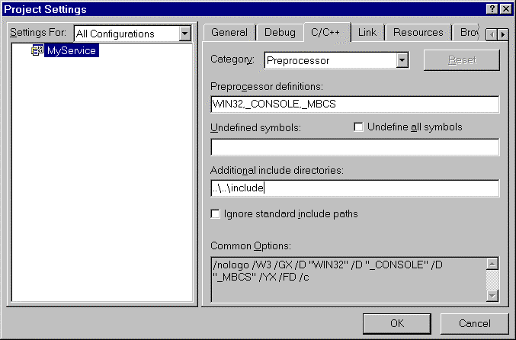
Figure 11: Add the directory containing the file mtsdk.h to the project’s include path

- Modify the project so that it uses the Multithreaded DLL run-time library as shown in Figure 12 below:
- Select the Project → Settings menu item to invoke the Project Settings dialog.
- Select the C/C++ tab.
- Select the Code Generation item in the Category combo box.
- Select the Win32 Debug item in the Settings For combo box.
- Select the Debug Multithreaded DLL
- Select the Win32 Release item in the Settings For combo box.
- Select the Multithreaded DLL

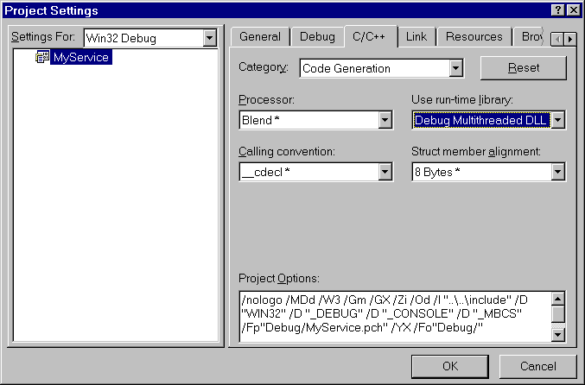
Figure 12: Modify the project so that it uses the Multithreaded DLL run-time library

- Add the mtsdkd.lib and mtsdk.lib import libraries to your project:
- Select the Project → Add to Project → Files…menu item.
- Browse to the INSTALLDIR/lib and add both library files.

- Configure your import libraries as shown in Figure 13 below:
- Select the Project → Settings menu item to invoke the Project Settings dialog.
- Select the Win32 Debug item in the Settings For combo box.
- Select mtsdk.lib (the release version of the library).
- Check the Exclude file from build check box.
- Select the Win32 Release item in the Settings For combo box.
- Select mtsdkd.lib (the debug version of the library).
- Check the Exclude file from build check box.

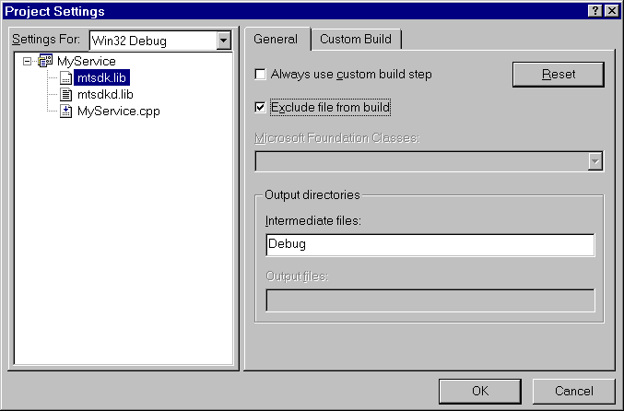
Figure 13: Configure your import libraries

- Next, build the project by pressing F7, or by selecting the Build → Build MyService.exe menu item as shown in Figure 14 below:

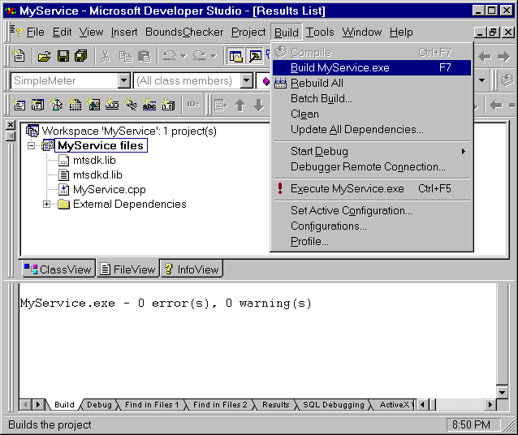
Figure 14: Build the project

- The default build setting will be Debug. The resulting MyService.exe will be generated in a generated directory named Debug. Before executing MyService.exe, it is important that mtsdk.dll and sdk_msg.dll are in the PATH. This can be done in one of two ways:

- Copy the DLLs to the Debug directory.
- Place the INSTALLDIR/bin directory in the system PATH

- Test MyService.exe by running it. Follow the steps outlined in the Getting Started section on page 11 to verify that the transaction was correctly metered.

Step 2: Modifying the Code
The next step in implementing your own service is to modify the code contained in MyService.cpp so that it implements the service as defined in the Planning section on page 41. The mtsdk.h file and the API Documentation Help file are useful resources for this section.
The key things to modify in MyService.cpp are:
- Where to send the metered-service data
- Where to get the data for the metered-service
- Adding the session data

Where to send the metered-service data
Before creating new sessions, the Startup method is called. Startup must be called once before you will be able to call any other Metering SDK functions. A call to AddServer specifies where sessions are submitted. In the Simple example, some of this information is read from the user; some is hard-coded. In most applications, this information will come from a set of registry variables or an initialization file.

Where to get the data for the metered-service
In the Simple example, all the data for the metered service was read from the user. In order to instrument your service, you will definitely want to change this. In the Simple example, the data sourcing occurs in the TestSimple function.

Adding the session data
In the Simple example, the session is sent to the server in the function called MeterIt. This code should be modified to meter your service.
To meter a session, the CreateSession method is called to return a MTMeterSession object that is used to collect properties. Properties represent the information being metered such as call duration, byte count and bandwidth. The InitProperty method is called for each property name defined with a service. The appropriate overloaded version of InitProperty must be called so the property matches the type specified in the Service Definition Matrix (completed in the Planning Phase). Because the service definition lives on the server and is unknown by the Metering SDK, you should be careful to use the correct property names and types or the server will reject your sessions.

Step 5: Testing the Code
The next step to get our service up and running is to compile and test the new service:
- To compile the code, press F7.
- To test it, press F5 (this will run your application in the debugger).

Warning!
Make sure you have registered your service with MetraTech. Otherwise, the call to Close will fail. Please consult the Partner’s Data Sheet for details on who to contact to register your new service.

- Having registered the service with MetraTech’s reference server, you should be ready for your first end-to-end test.
- Execute your code, noting the values of the properties being set.
- Using your Internet browser, browse to the reference server and log onto the Presentation Server. Unless otherwise specified, your transaction will appear under the Miscellaneous Grouping. Browse to your transaction. Verify that the properties displayed match the properties that you set.

Enhancing the code
We have used the Simple example as a starting point to get our service instrumented. We did this to get instant gratification and to ensure that the simple case works before complicating the service too much. It is likely that you will want to modify the structure of the code to integrate more closely with your software.
After all the properties for a service have been added correctly, either Save or Close may be called. Save stores a copy of the session and its properties on the server but still allows modification of any of its properties before sending the session back to the server. The intended use for Save is for events that span a long period of time. In this scenario, there is an increased risk that the network entity providing the service might fail before metering usage information. Without the ability to checkpoint session information with the Save method, important usage information might be lost. If Save is called, the GetProperty and SetProperty methods may be called to modify property values. If any property values are changed, Save can be called any number of times again before Close is finally called. InitProperty may not be called once a session has been saved.
Calling Save for an MTMeterSession is not required. Normally InitProperty is called to add the appropriate properties before Close is called. Close sends the session and its properties to the server and restricts any further changes. Once a session is marked closed, the server is allowed to begin further processing on it. It is not possible to modify a session’s properties once it has been closed.
Some services are hierarchical in nature with a “parent” service being composed of multiple component “child” services. In this case, a parent session is opened using CreateSession and each child session is opened using CreateChildSession on the parent session object. The session returned from CreateChildSession is linked to its parent session. Deleting a parent session will delete all of its children. You can create any number of children with CreateChildSession. Child sessions can in turn have other children.
If Save is called on a parent session, any children that need to be saved are saved as well. CreateChildSession can still be called from this parent session to create new children. If Close is called on a parent session, all of its children will be closed. No more child sessions can be created from a closed parent. Calling either Save or Close on a child session will save all of its parents, still allowing new children to be created.

Chapter 5: Technical Support

Overview
This chapter gives you information about obtaining technical support from MetraTech:
- Committed to Your Success
- Before You Contact Us
- Online Support
- FAQs
- Email
- Release Notes
- Developer Support Hotline

Committed to Your Success
MetraTech is committed to supporting its partners. We offer high quality on-line and telephone support to provide you with the information that you need, when you need it.

Before You Contact Us
In many situations, you can get immediate answers to your technical questions without contacting our Developer Support Center. The Troubleshooting section of this manual and MetraTech's On-line Support Options can help isolate, resolve or provide work arounds for problems you may encounter in developing your application.

Online Support
On-line support is provided free of charge 24 hours a day via MetraTech’s password-protected partner site (partner.metratech.com). There are currently the following three channels for on-line support:

FAQs
Frequently Asked Questions about the SDK are available on the SDK FAQ web page. FAQs provide quick, targeted answers to common questions regarding installation, development and end-user issues.

Email
Questions can be directed to MetraTech Customer Services via email at sdk_support@metratech.com. We'll provide responsive acknowledgement and best-effort turnaround. If you require a more immediate response, please use the Developer Support Hotline.

Release Notes
Release notes provide you with information regarding points of interest in the product. While release notes are shipped with each tool kit, the SDK Release Notes web page is kept up to date with information that did not make the initial release of the product.

Developer Support Hotline
In addition to the free on-line support, you also have the option of calling MetraTech Customer Services. Your call is answered by a Customer Service Representative who gathers key information and assigns your incident a case number before routing it to the appropriate Developer Support Engineer. This identifier allows us to prioritize and track your case, and it helps to share additional information as the case is resolved. Please make sure you record the reference number of your question or request for assistance. It will help make additional calls on that case quicker and more efficient.
The Developer Support Hotline, (781) 398-2242, is available from 10AM-6PM Eastern Standard Time, Monday through Friday.

Appendix

Partner Data Sheet
The Partner Data Sheet provides the information that you need to integrate with MetraTech’s reference server and access MetraTech’s partner extranet. If you have not received your Partner Data Sheet yet, please contact please MetraTech’s customer support group.

Planning Aids

The following two Excel spreadsheets are included in the SDK installation to facilitate the planning of your services:

- sample.xls: Sample service definitions
- template.xls: A service definition template

These files are located in the INSTALLDIR/doc directory. A detailed explanation for each field and column is provided in Step 2: Filling Out Service Worksheets on page 44.

Troubleshooting
Consult the release notes that came with the Metering SDK installation for possible last minute changes that might affect the behavior of the Metering SDK. This section contains some general suggestions to help you get your application working correctly.

Compile problems
If you are having problems compiling an application using the Metering SDK, this checklist contains tips to help you compile.
- Are you able to compile the Simple sample? See Chapter 3: Samples for instructions on how to compile the simple sample.
- Is the compiler complaining that it can’t find the header file mtsdk.h or sdk_msg.h? If so, make sure you have added the directory containing these files to your include path, for both Debug and Release versions of your application.
- Is the linker complaining about an undefined entry point? If so, make sure you’ve added mtsdk.lib for the release version and mtsdkd.lib for the debug version of your project.
- Have you specified the Debug Multithreaded DLL version of the C runtime library for the debug version of your project?
- Have you specified the Multithreaded DLL version of the C runtime library for the release version of your project?

Runtime problems
If you’ve successfully compiled your application which uses the Metering SDK but you’re unable to run it, this checklist has information to help your diagnose your problem.
- Can you run the Simple sample? The simple.exe application does a basic test of the Metering SDK. It tests that you have connectivity to the metering server, that you have privileges to submit sessions to the server, and that you can load the required DLLs. You should get this sample working before you attempt to debug your own application.
- Are mtsdk.dll and sdk_msg.dll both in your path? If not, you must either move these DLLs to a directory that is in your path or add the directory that holds them to your path.
- Have you called the Startup method of the MTMeter object before calling other metering SDK functions?
- Is your session created properly? Make sure you’ve initialized each property associated with the service as it’s defined on the metering server. Also be sure that you have initialized the properties with the correct data type.
- Have you forgotten a property or added too many properties? You must have exactly the same properties for your session as defined by the service definition.
- Are your property names and service names spelled correctly? These names are case sensitive and must have the same capitalization as the metering server’s service definition.

Further troubleshooting
If a method of the Metering SDK is not working for you, examine the return code and error messages contained in the error object returned from GetLastErrorObject. The GetErrorMessageEx method of the MTMeterError class sometimes returns additional information that might help diagnose the source of an error.
If your application still doesn’t run correctly, the diagnostic logging capability of the Metering SDK can help diagnose problems. The EnableDiagnosticLogging method of the MTMeter class allows you to get a trace of the calls made to the SDK as well as some internal debugging messages.
If you are still unable to solve your problem you will need to contact MetraTech at sdk_support@metratech.com. Supplying MetraTech with the output of the diagnostic logging can help MetraTech determine what the problem is and determine if a bug fix is necessary.

Error Codes
Symbolic Name | Description
MT_ERR_PARENT_COMMITTED | Parent session already committed.
MT_ERR_NO_PROPERTY | Property does not exist.
MT_ERR_DUPLICATE_PROPERTY | Property already exists.
MT_ERR_MESSAGE_MODULE_NOT_FOUND | Error message module not found.
MT_ERR_BAD_HTTP_RESPONSE | Bad HTTP response.
MT_ERR_PARSE_ERROR | Unable to parse message.
MT_ERR_NOT_INITIALIZED | Not initialized.
MT_ERR_SERVER_ERROR | Unknown server error.
MT_ERR_UNKNOWN_SERVICE | Server has no knowledge of this service.
MT_ERR_BAD_PROPERTY | A property is invalid.
MT_ERR_NO_HOSTS | No metering servers added.
Figure 15: Error Codes

ISO 4217 Currency List
This is a list of global currencies and their three-character ISO 4217 currency code. Note that in most cases, the ISO 4217 currency code is composed of the country's two-character ISO 3166 country code plus a one-character currency designator. For example, the code for Canadian Dollars is simply Canada's two-character ISO 3166 code (CA) plus a one-character currency designator (D). For more information on ISO standards, refer to the ISO website (http://www.iso.ch/).

ADP Andorran Peseta  AED United Arab Emirates Dirham  AFA Afghanistan Afghani  ALL Albanian Lek  ANG Netherlands Antillian Guilder  AOK Angolan Kwanza  ARA Argentinian Austral  ATS Austrian Schilling  AUD Australian Dollar  AWG Aruban Florin  BBD Barbados Dollar  BDT Bangladeshi Taka  BEF Belgian Franc  BGL Bulgarian Lev  BHD Bahraini Dinar  BIF Burundi Franc  BMD Bermudian Dollar  BND Brunei Dollar  BOB Bolivian Boliviano  BRC Brazilian Cruzeiro  BSD Bahamian Dollar  BTN Bhutan Ngultrum  BUK Burma Kyat  BWP Botswanian Pula  BZD Belize Dollar  CAD Canadian Dollar  CHF Swiss Franc  CLF Chilean Unidades de Fomento  CLP Chilean Peso  CNY Yuan (Chinese) Renminbi  COP Colombian Peso  CRC Costa Rican Colon  CSK Czech Koruna  CUP Cuban Peso  CVE Cape Verde Escudo  CYP Cyprus Pound  DDM East German Mark (DDR)  DEM Deutsche Mark  DJF Djibouti Franc  DKK Danish Krone  DOP Dominican Peso  DZD Algerian Dinar  ECS Ecuador Sucre  EGP Egyptian Pound  ESP Spanish Peseta  ETB Ethiopian Birr  FIM Finnish Markka  FJD Fiji Dollar  FKP Falkland Islands Pound  FRF French Franc  GBP British Pound  GHC Ghanaian Cedi  GIP Gibraltar Pound  GMD Gambian Dalasi  GNF Guinea Franc  GRD Greek Drachma  GTQ Guatemalan Quetzal  GWP Guinea-Bissau Peso  GYD Guyanan Dollar  HKD Hong Kong Dollar  HNL Honduran Lempira  HTG Haitian Gourde  HUF Hungarian Forint  IDR Indonesian Rupiah  IEP Irish Punt  ILS Israeli Shekel  INR Indian Rupee  IQD Iraqi Dinar  IRR Iranian Rial  ISK Iceland Krona  ITL Italian Lira  JMD Jamaican Dollar  JOD Jordanian Dinar  JPY Japanese Yen  KES Kenyan Schilling  KHR Kampuchean (Cambodian) Riel  KMF Comoros Franc  KPW North Korean Won | KRW (South) Korean Won  KWD Kuwaiti Dinar  KYD Cayman Islands Dollar  LAK Lao Kip  LBP Lebanese Pound  LKR Sri Lanka Rupee  LRD Liberian Dollar  LSL Lesotho Loti  LUF Luxembourg Franc  LYD Libyan Dinar  MAD Moroccan Dirham  MGF Malagasy Franc  MNT Mongolian Tugrik  MOP Macau Pataca  MRO Mauritanian Ouguiya  MTL Maltese Lira  MUR Mauritius Rupee  MVR Maldive Rufiyaa  MWK Malawi Kwacha  MXP Mexican Peso  MYR Malaysian Ringgit  MZM Mozambique Metical  NGN Nigerian Naira  NIC Nicaraguan Cordoba  NLG Dutch Guilder  NOK Norwegian Kroner  NPR Nepalese Rupee  NZD New Zealand Dollar  OMR Omani Rial  PAB Panamanian Balboa  PEI Peruvian Inti  PGK Papua New Guinea Kina  PHP Philippine Peso  PKR Pakistan Rupee  PLZ Polish Zloty  PTE Portuguese Escudo  PYG Paraguay Guarani  QAR Qatari Rial  ROL Romanian Leu  RWF Rwanda Franc  SAR Saudi Arabian Riyal  SBD Solomon Islands Dollar  SCR Seychelles Rupee  SDP Sudanese Pound  SEK Swedish Krona  SGD Singapore Dollar  SHP St. Helena Pound  SLL Sierra Leone Leone  SOS Somali Schilling  SRG Suriname Guilder  STD Sao Tome and Principe Dobra  SUR USSR Rouble  SVC El Salvador Colon  SYP Syrian Potmd  SZL Swaziland Lilangeni  THB Thai Bhat  TND Tunisian Dinar  TOP Tongan Pa'anga  TPE East Timor Escudo  TRL Turkish Lira  TTD Trinidad and Tobago Dollar  TWD Taiwan Dollar  TZS Tanzanian Schilling  UGS Uganda Shilling  USD US Dollar  UYP Uruguayan Peso  VEB Venezualan Bolivar  VND Vietnamese Dong  VUV Vanuatu Vatu  WST Samoan Tala  YDD Democratic Yemeni Dinar  YER Yemeni Rial  YUD New Yugoslavia Dinar  ZAR South African Rand  ZMK Zambian Kwacha  ZRZ Zaire Zaire  ZWD Zimbabwe Dollar

Index

A
AccountID, 15, 18
Adding session data, 50
AddServer, 22
Application class, 20, 28
Architecture
High level, 8
Atomic, 42
Atomic services, 10
B
Billing and management system, 6
Build environment, 19, 20, 21, 23
Building process, 41
Building services, 41
C
Class
Application, 20, 28
Client
MSIX, 9
Clients, 9
Close, 23
Close command, 51
Code
Enhancing, 51
Modifying, 49
Testing, 50
Compiler
Microsoft Visual C++, 19
Componenty-based server architecture
(Diagram), 8
Compound, 42
Compound service, 10
Compound services, 11
Contacting MetraTech, 45, 52
CreateChildSession, 51
CreateSession, 51
Creating a project, 45
Customer self-help, 43
Customer support, 43
D
Data collection, 21
Data storage, 10
Data volume, 42, 43
E
Email, 52
Encryption, 6, 9
Enhancing code, 51
Error codes, 55
F
Failover support, 7
FAQ, 52
About MSIX, 9
Fax, 10
Features - SDK, 6
Files
Header, 20, 25
Firewall configurations, 9
G
GeProperty, 51
GetLastErrorObject, 23
H
Header files, 20, 25
Help
Customer self-help, 43
HTML-based customer help, 9
High level architecture, 8
HTML-based customer self-help, 9
HTTP Tunneling, 9
I
Initialization, 21
InitProperty, 23
Installation
SDK, 12
Testing, 13, 15, 18
Integration - easy, 6
IP-PSTN, 42
IP-PSTN fax, 10
L
Local support, 7
M
Metered service data
Getting, 50
Metering (or not metering), 41, 42
Metering server, 6, 8, 9
Metering server specification, 22
Metering the session, 23
MeteringSession, 23
MeterIt, 22
MetraTech
Contacting, 45, 52
Microsoft Visual C++ Compiler, 19
Modifying code, 49
MSIX, 9, 43
MSIX standard, 6
MTMeterError, 23
MTMeterHTTPConfig, 22
MTMeterSession, 51
N
Network billing ystem, 6
Network server provider, 9
Network Service Provider, 6
New services
Planning, 41
Notes
Release, 52
NSP, 42
O
Online support, 52
Outsourced remote access, 10
P
Planning new services, 41
Presentation Server, 9, 15
Project
Creating, 45
Properties, 11, 44
Property type restrictions, 44
Q
Quality of service routing, 10
R
Readme file, 12
Release notes, 52
Remote access
Outsourced, 10
Requirements
System, 12
RSA technology, 6
S
Sample
Simple, 19
Samples, 19
Save command, 51
SDK
Installation, 12
Uninstall, 12
SDK features, 6
SDK Integration, 6
Security, 6
Server
Metering, 8, 9
Metering specification, 22
MSIX, 9
Presentation, 9, 15
Server architecture, 8
Server communication, 9
Servers, 9
Service data
Metered, 50
Service names, 44
Service worksheets, 44
Services, 10
Atomic, 10
Building, 41
Compound, 10
Services - for use with SDK, 6
Session data, 50
Sessions, 11
SetProperty, 51
Sub-services, 44
Support
Customer, 43
Failover, 7
Local, 7
Metering via unicode, 8
Online, 52
Technical, 53
Support hotline, 53
System requirements, 12
T
Technical support, 53
Testing code, 50
Testing SDK installation, 13
Transaction types, 6
Troubleshooting, 54
Tunneling
HTTP, 9
U
UID, 11
Uninstall SDK, 12
User defined IDs, 11
V
Video streams, 10
Viewing a transaction
During the installation test, 17
Virtual private networks, 10
Voice-calls, 10
Volume
Data, 43
W
Web hosting, 10
X
XML, 9

