HACETTEPE UNIVERSITY DEPARTMENT OF

COMPUTER ENGINEERING

BBM 204 ASSIGNMENT 1



Name Surname – Number

Subject : Analysis of Algorithms

Programming Language : Java

1. **Record Execution Time for each Algorithm**

Since Bitonic Sort can sorting at the powers of two, the tables were created at the powers of 2.

If array size is not equal to the power of two, bitonic sort does not work properly as in the example image

Exp image:

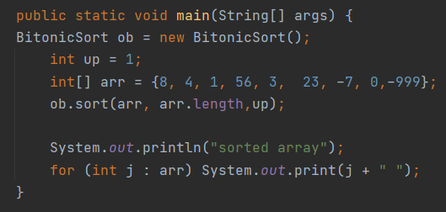



The times recorded in the whole table are in seconds.

* 1. **Random Array (Average)**

|  |  |  |  |  |  |  |
| --- | --- | --- | --- | --- | --- | --- |
| Algorithms/n | 32 | 64 | 128 | 256 | 512 | 1024 |
| Comb Sort | 0.0 | 0.0 | 0.0 | 0.0 | 0.0 | 0.001 |
| Gnome Sort | 0.0 | 0.0 | 0.0 | 0.001 | 0.002 | 0.003 |
| Shaker Sort | 0.0 | 0.0 | 0.0 | 0.001 | 0.002 | 0.001 |
| Stooge Sort | 0.0 | 0.001 | 0.001 | 0.005 | 0.042 | 0.209 |
| Bitonic Sort | 0.0 | 0.001 | 0.0 | 0.0 | 0.0 | 0.0 |

|  |  |  |  |  |  |
| --- | --- | --- | --- | --- | --- |
| Algorithms/n | 2048 | 4096 | 8192 | 16384 | 32768 |
| Comb Sort | 0.001 | 0.001 | 0.001 | 0.001 | 0.002 |
| Gnome Sort | 0.003 | 0.013 | 0.044 | 0.174 | 0.76 |
| Shaker Sort | 0.002 | 0.007 | 0.046 | 0.199 | 1.059 |
| Stooge Sort | 1.869 | 16.782 | 151.04 | 272.284 | 2469.751 |
| Bitonic Sort | 0.0 | 0.001 | 0.002 | 0.003 | 0.007 |

* 1. **All Array Member is 0**

|  |  |  |  |  |  |  |
| --- | --- | --- | --- | --- | --- | --- |
| Algorithms/n | 32 | 64 | 128 | 256 | 512 | 1024 |
| Comb Sort | 0.0 | 0.0 | 0.0 | 0.0 | 0.0 | 0.00 |
| Gnome Sort | 0.0 | 0.0 | 0.0 | 0.0 | 0.0 | 0.00 |
| Shaker Sort | 0.0 | 0.0 | 0.0 | 0.0 | 0.0 | 0.00 |
| Stooge Sort | 0.0 | 0.001 | 0.001 | 0.006 | 0.049 | 0.216 |
| Bitonic Sort | 0.0 | 0.0 | 0.0 | 0.0 | 0.0 | 0.0 |

|  |  |  |  |  |  |
| --- | --- | --- | --- | --- | --- |
| Algorithms/n | 2048 | 4096 | 8192 | 16384 | 32768 |
| Comb Sort | 0.0 | 0.0 | 0.0 | 0.0 | 0.001 |
| Gnome Sort | 0.0 | 0.0 | 0.0 | 0.0 | 0.001 |
| Shaker Sort | 0.0 | 0.0 | 0.0 | 0.0 | 0.0 |
| Stooge Sort | 1.86 | 16.706 | 150.688 | 275.677 | 2479.137 |
| Bitonic Sort | 0.0 | 0.0 | 0.001 | 0.002 | 0.003 |

* 1. **Sorting Descending Array**

|  |  |  |  |  |  |  |
| --- | --- | --- | --- | --- | --- | --- |
| Algorithms/n | 32 | 64 | 128 | 256 | 512 | 1024 |
| Comb Sort | 0.0 | 0.0 | 0.0 | 0.0 | 0.0 | 0.0 |
| Gnome Sort | 0.0 | 0.0 | 0.001 | 0.002 | 0.002 | 0.001 |
| Shaker Sort | 0.0 | 0.0 | 0.0 | 0.001 | 0.001 | 0.001 |
| Stooge Sort | 0.0 | 0.001 | 0.001 | 0.005 | 0.046 | 0.211 |
| Bitonic Sort | 0.0 | 0.0 | 0.0 | 0.0 | 0.0 | 0.0 |

|  |  |  |  |  |  |
| --- | --- | --- | --- | --- | --- |
| Algorithms/n | 2048 | 4096 | 8192 | 16384 | 32768 |
| Comb Sort | 0.0 | 0.0 | 0.001 | 0.001 | 0.002 |
| Gnome Sort | 0.005 | 0.022 | 0.088 | 0.346 | 1.398 |
| Shaker Sort | 0.002 | 0.007 | 0.027 | 0.105 | 0.422 |
| Stooge Sort | 1.872 | 16.817 | 151.692 | 275.246 | 2480.975 |
| Bitonic Sort | 0.0 | 0.0 | 0.001 | 0.002 | 0.004 |

* 1. **Sorting Ascending Array**

|  |  |  |  |  |  |  |
| --- | --- | --- | --- | --- | --- | --- |
| Algorithms/n | 32 | 64 | 128 | 256 | 512 | 1024 |
| Comb Sort | 0.0 | 0.0 | 0.0 | 0.0 | 0.0 | 0.00 |
| Gnome Sort | 0.0 | 0.0 | 0.0 | 0.0 | 0.0 | 0.00 |
| Shaker Sort | 0.0 | 0.0 | 0.0 | 0.0 | 0.0 | 0.00 |
| Stooge Sort | 0.0 | 0.001 | 0.001 | 0.004 | 0.042 | 0.209 |
| Bitonic Sort | 0.0 | 0.0 | 0.0 | 0.0 | 0.0 | 0.0 |

|  |  |  |  |  |  |
| --- | --- | --- | --- | --- | --- |
| Algorithms/n | 2048 | 4096 | 8192 | 16384 | 32768 |
| Comb Sort | 0.0 | 0.0 | 0.0 | 0.001 | 0.001 |
| Gnome Sort | 0.0 | 0.0 | 0.0 | 0.0 | 0.001 |
| Shaker Sort | 0.0 | 0.0 | 0.0 | 0.0 | 0.0 |
| Stooge Sort | 1.867 | 16.742 | 150.896 | 276.118 | 2499.968 |
| Bitonic Sort | 0.0 | 0.0 | 0.001 | 0.002 | 0.003 |

1. **Comb Sort Algorithm**

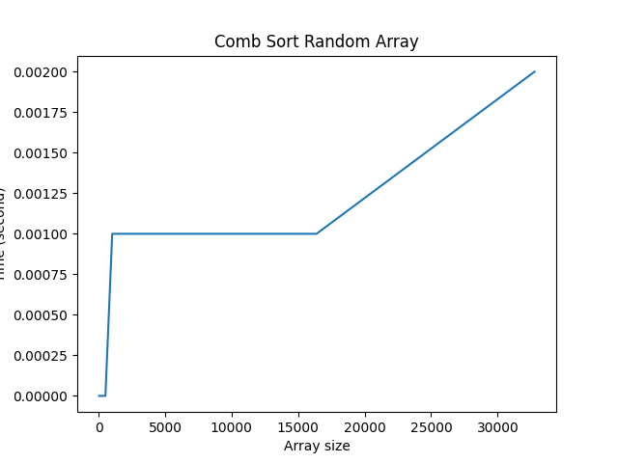

Best case time complexity: Θ(n log n)

Average case time complexity: Ω(n*n/2p), p is a number of increment

Worst case time complexity: O(n*n)

Space complexity: Θ(1) auxillary space

Comb Sort is an in-place sorting algorithm

Comb Sort doesn’t require additional space for sorting the lists.

Comb Sort easy to implement sorting algorithm

Combsort with different endings changes to a more efficient sort when the data is almost sorted (when the gap is small).

Comb sort is not a stable sorting algorithm as it does not sort the repeated elements in the same order as they appear in the input.

Comb Sort has no recursive function calls

1. **Gnome Sort Algorithm**

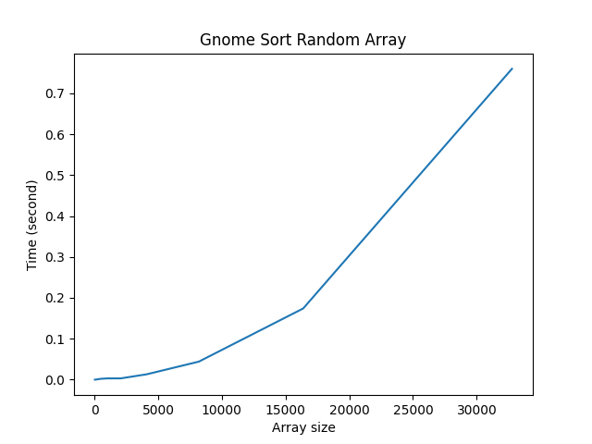

Best case time complexity: Θ(n)

Average case time complexity: Θ (n*n)

Worst case time complexity: Θ (n*n)

Space complexity: Θ(1) auxillary space

Gnome Sort is an in-place sorting algorithm

Gnome Sort does not require any extra storage.

Gnome sort is similar to Insertion sort

Gnome sort is a stable sorting algorithm.

It is conceptually simple, requiring no nested loops.

The average running time is O(n^2). If the list is initially almost sorted, average running time tends towards O(n). Sorting algorithm is adaptive and performs better if the array is already/partially sorted.

1. **Shaker Sort Algorithm**

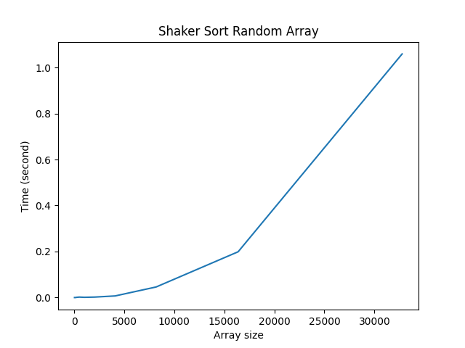

Best case time complexity: Θ(n)

Average case time complexity: Θ(n*n)

Worst case time complexity: Θ(n*n)

Space complexity: Θ(1)

Shaker Sort is an in-place sorting algorithm

Shaker Sort does not require any extra storage.

Best case occurs when array is already sorted.

**Shaker Sort is stable**

1. **Stooge Sort Algorithm**

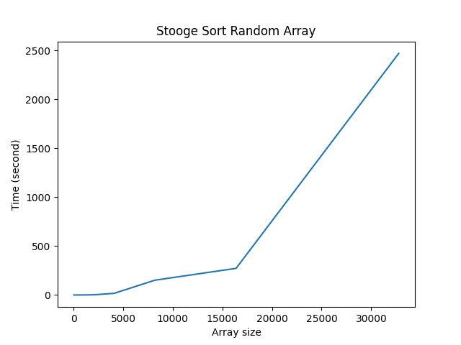

Best-Case time complexity = O(n ^ log(3) /log(1.5))

Average time complexity = O(n ^ log(3) /log(1.5))

Worst-Case time complexity = O(n ^ log(3) /log(1.5))

Worst-case space complexity = O(n)

Stooge Sort has the same time complexity under any case.

Stooge Sort is used to store the input array

Stooge sort is not a stable sorting algorithm. It is because the elements with identical values do not appear in the same order in the output array as they were in the input array.

Stooge sort is not an adaptive sorting algorithm. This is because it does not perform better in the case when the array is already/almost sorted.

1. **Bitonic Sort**

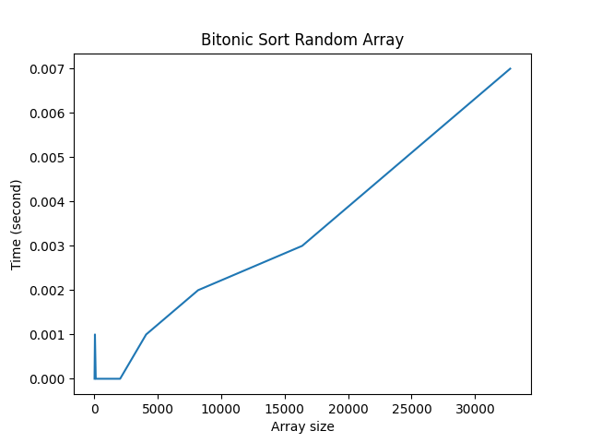

Best case time complexity: Θ(logn*logn) parallel time

Average case time complexity: Θ(logn*logn) parallel time

Worst case time complexity: Θ(logn*logn) parallel time

Worst case time complexity: Θ(n*logn*logn) non - parallel time

Space complexity: Θ(n*logn*logn)

Bitonic sort is not stable.

