HACETTEPE UNIVERSITY DEPARTMENT OF

COMPUTER ENGINEERING

BBM 453 LAB EXPERIMENT



Mehmet Taha USTA – 21527472

Çağlar USLU – 21808388

Group No: 4

1. **Aim of this experiment is to create a wide area network (WAN) as shown in Figure-2**

Group id is 4, we set the IP’s again.

Example : From 10.100.1.254 to 10.104.1.254

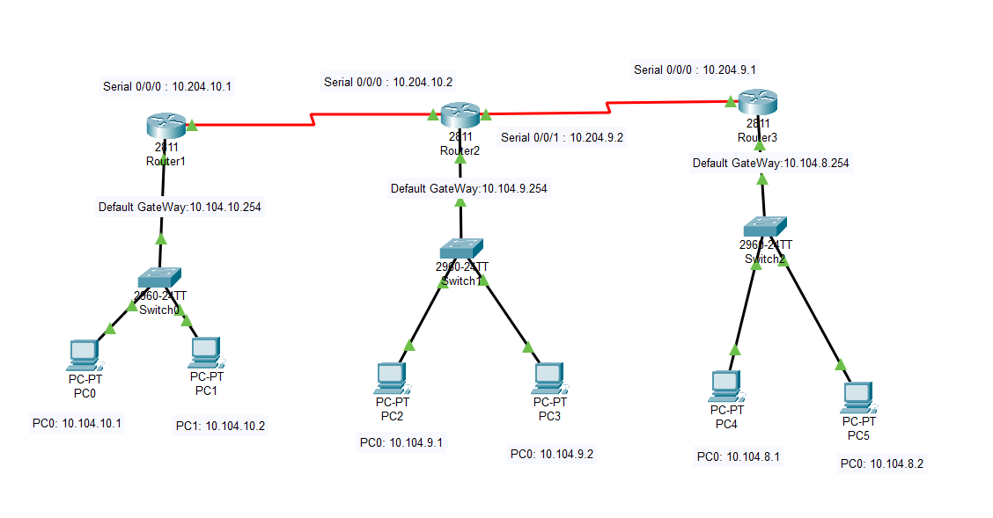

All connections have been made correctly. All connections are green lights.

Router1 FastEthernet0/0 info

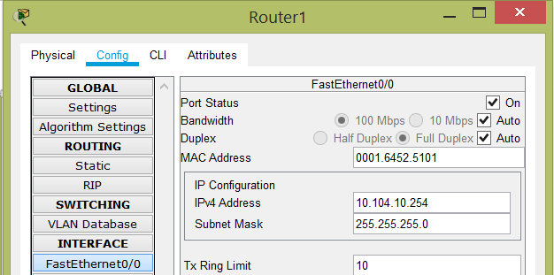

Router1 Serial0/0/0 info

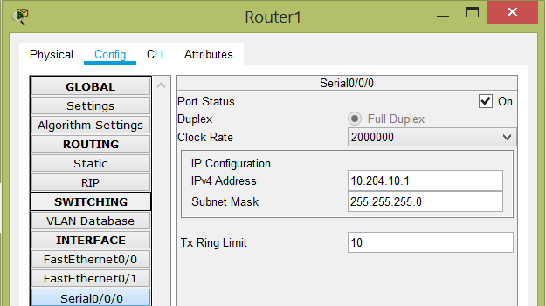

Information of computers connected to the router1

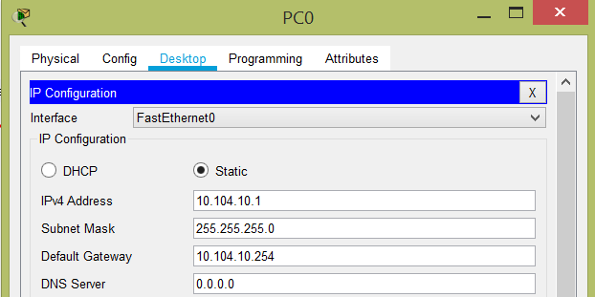

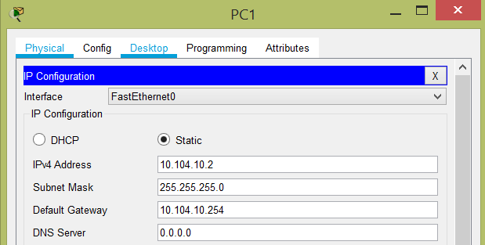

Router1 Static info

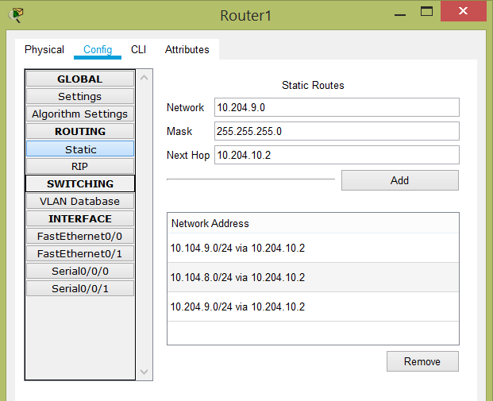

Router2 FastEthernet0/0 info

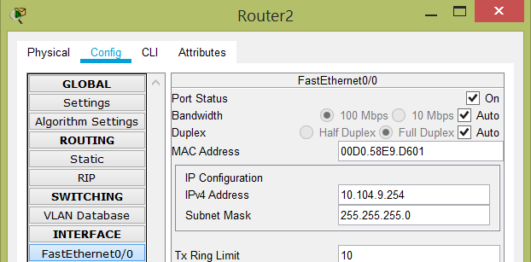

Router2 Serial0/0/0 info

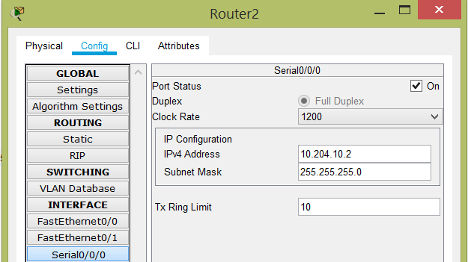

Router2 Serial0/0/1 info

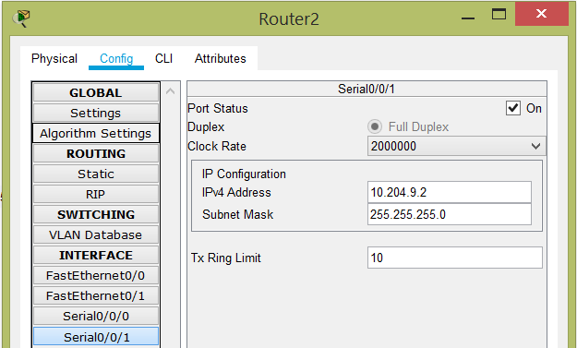

Information of computers connected to the router2

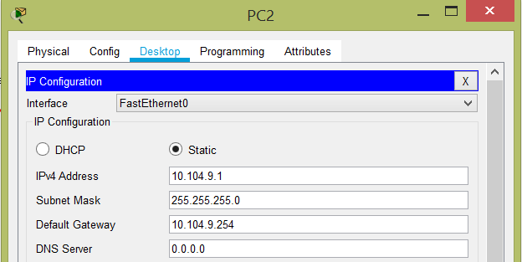

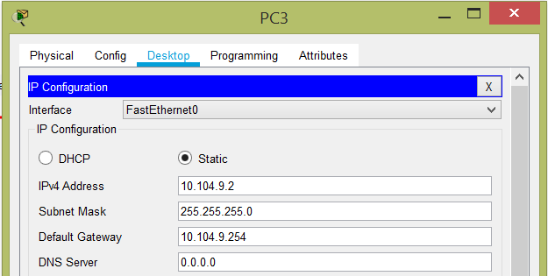

Router2 Static info

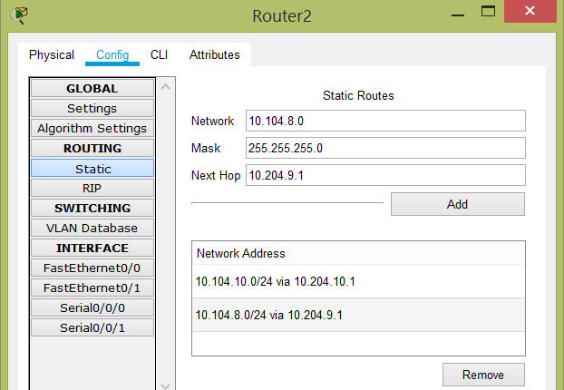

Router3 FastEthernet0/0 info

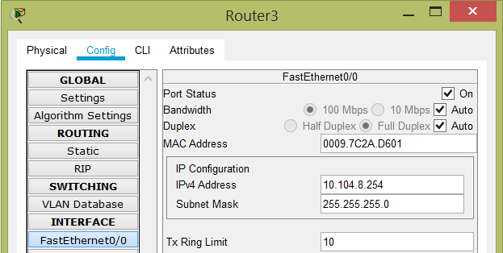

Router3 Serial0/0/0 info

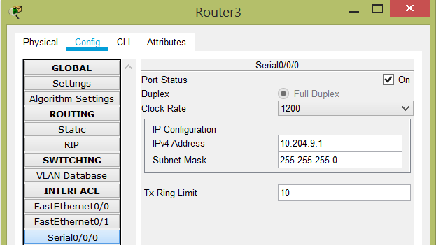

Information of computers connected to the router3

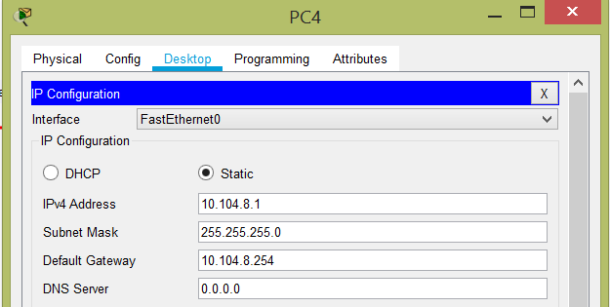

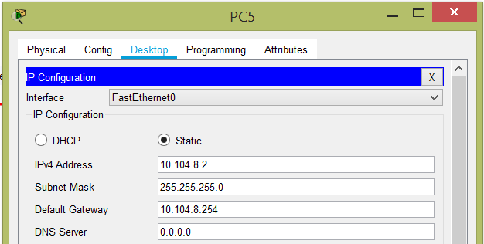

Router3 Static info

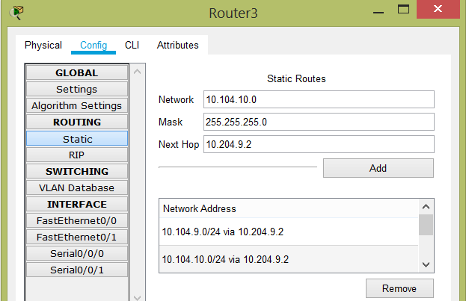

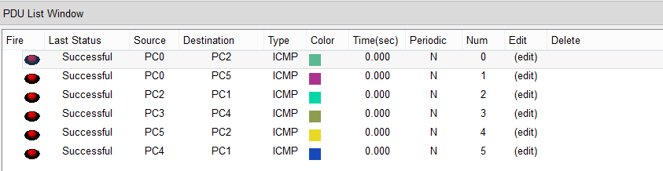

Ping from PC0 to PC4

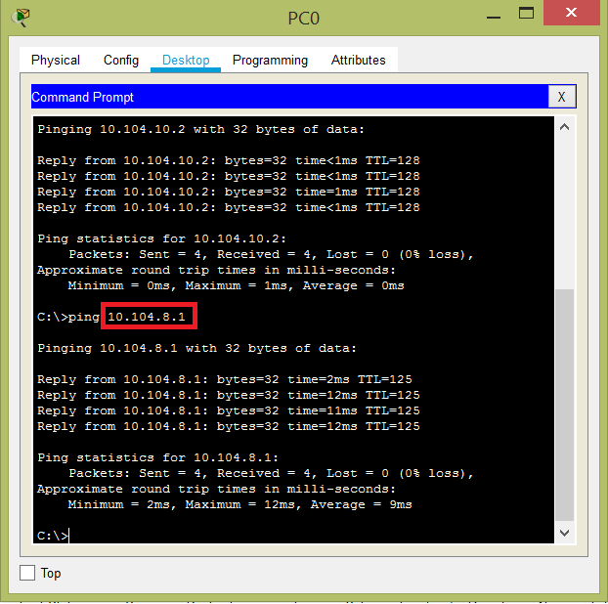

Ping from PC5 to PC1

