HACETTEPE UNIVERSITY DEPARTMENT OF

COMPUTER ENGINEERING

BBM 453 LAB EXPERIMENT



Mehmet Taha USTA – 21527472

Group No: 4

1. **First, you should create lab topology described in the Lab09-Routing Experiment Figure2.**

Group id is 4, we set the IP’s again.

Example : From 10.100.1.254 to 10.104.1.254

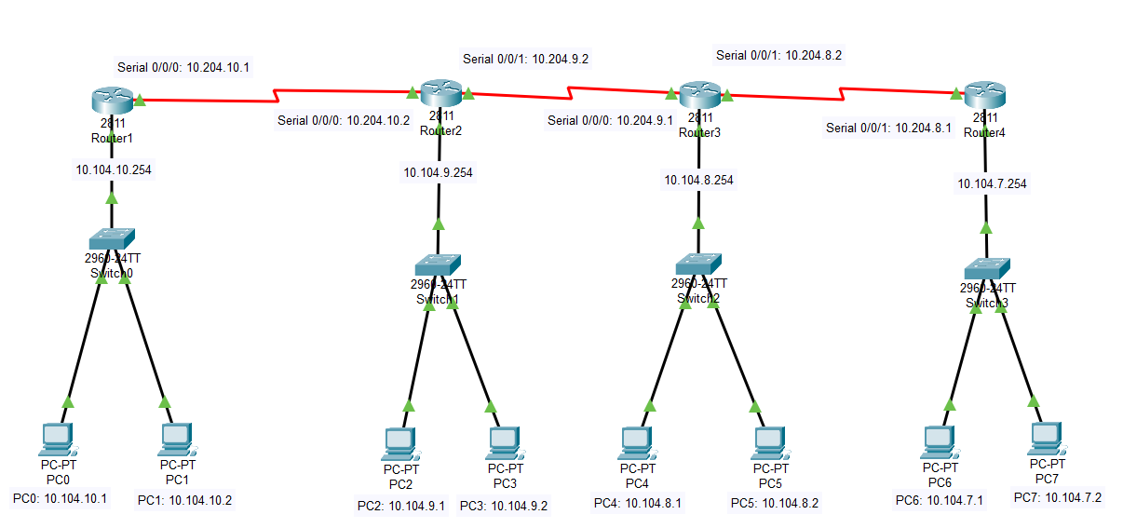

1. **Assign all interfaces (FastEthernet, Serial) described in the Lab Topology.**

All interfaces are shown on the picture in question 1.

PC0: 10.104.10.1

PC1: 10.104.10.2

PC2: 10.104.9.1

PC3: 10.104.9.2

PC4: 10.104.8.1

PC5: 10.104.8.2

PC6: 10.104.7.1

PC7: 10.104.7.2

Router1: 10.104.10.254

Router1 Serial 0/0/0: 10.204.10.1

Router2: 10.104.9.254

Router2 Serial 0/0/0: 10.204.10.2

Router2 Serial 0/0/1: 10.204.9.1

Router3: 10.104.8.254

Router3 Serial 0/0/0: 10.204.9.1

Router3 Serial 0/0/1: 10.204.8.2

Router4: 10.104.7.254

Router4 Serial 0/0/1: 10.204.9.1

1. **All groups should use the same dynamic routing protocols simultaneouly. You have to research about routing protocol commands for Cisco Router.**

**3.1) Routing Information Protocol (RIP)**

RIP is a standardized vector distance routing protocol and uses a form of distance as hop count metric. It is a distance vector. Through limiting the number of hop counts allowed in paths between sources and destinations, RIP prevents routing loops. Typically, the maximum number of hops allowed for RIP is 15. However, by achieving this routing loop prevention, the size of supporting networks is sacrificed. Since the maximum number of hop counts allowed for RIP is 15, as long as the number goes beyond 15, the route will be considered as unreachable.

**3.2) Open Shortest Path First (OSPF)**

OSPF is defined in RFC 2328 which is an interior Gateway Protocol used to distribute routing information within an AS (Autonomous System). Among all the three chosen samples, OSPF is the most widely used routing protocol in large enterprise networks. OSPF is based on link-state technology by using SPF algorithm which calculates the shortest path.

**3.3) Enhanced Interior Gateway Routing Protocol (EIGRP)**

The Enhanced Interior Gateway Routing Protocol (EIGRP) is a hybrid routing protocol which provides significant improvements on IGRP. EIGRP replaced IGRP in 1993 since Internet Protocol is designed to support IPv4 addresses that IGRP could not support. Hybrid routing protocol incorporates advantages of both Link-state and Distance-Vector routing protocols, it was based on Distance-Vector protocol but contains more features of Link-State protocol. EIGRP saves all routes rather than the best route to ensure the faster convergence. EIGRP keeps neighboring routing tables and it only exchange information that it neighbor would not contain. EIGRP is commonly used in large networks, and it updates only when a topology changes but not periodically unlike old Distance-Vector protocols such as RIP.

The following example shows how to enable BFD for all Enhanced Interior Gateway Routing Protocol (EIGRP) neighbors:

Router> enable

Router# configure terminal

Router(config)# router eigrp 123

Router(config-router)# bfd all-interfaces

Router(config-router)# end

The following example shows how to enable BFD for all Intermediate System-to-Intermediate System (IS-IS) neighbors:

Router> enable

Router# configure terminal

Router(config)# router isis tag1

Router(config-router)# bfd all-interfaces

Router(config-router)# end

The following example shows how to enable BFD for all Open Shortest Path First (OSPF) neighbors:

Router> enable

Router# configure terminal

Router(config)# router ospf 123

Router(config-router)# bfd all-interfaces

Router(config-router)# end

The following example shows how to enable BFD for all EIGRP neighbors, using the bfd command in address-family interface configuration mode:

Router> enable

Router# configure terminal

Router(config)# router eigrp my_eigrp

Router(config-router)# address-family ipv4 autonomous-system 100

Router(config-router-af)# af-interface FastEthernet 0/0

Router(config-router-af-interface)# bfd

The following example shows how to enable BFD for all Routing Information Protocol (RIP) neighbors:

Router> enable

Router# configure terminal

Router(config)# router rip

Router(config-router)# bfd all-interfaces

Router(config-router)# end

1. **Configure RIP protocol. Display routing tables and ping from your computer to all other remote computers.**

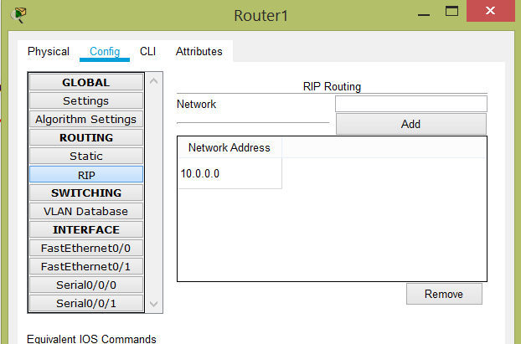

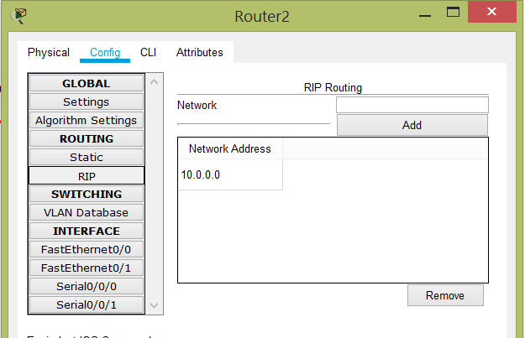

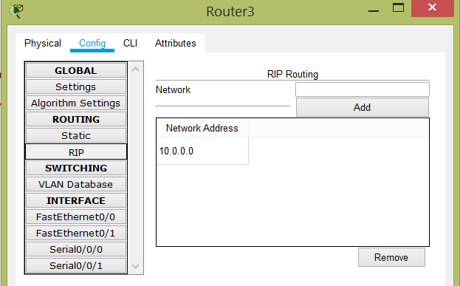

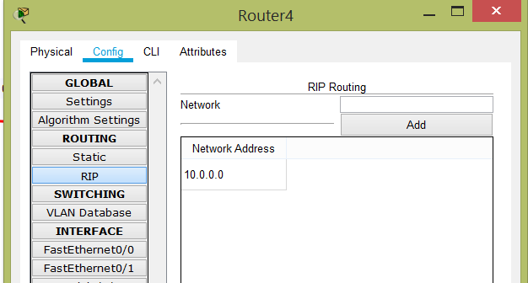

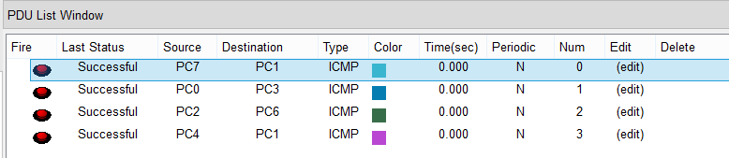

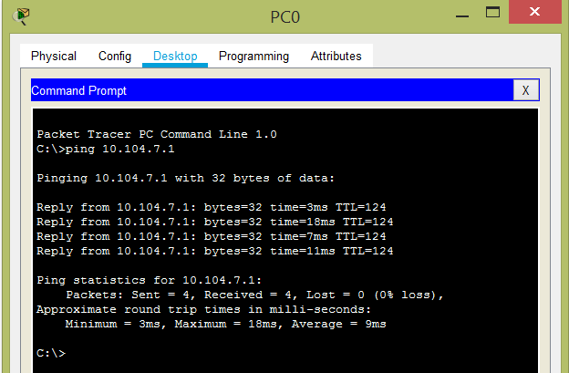

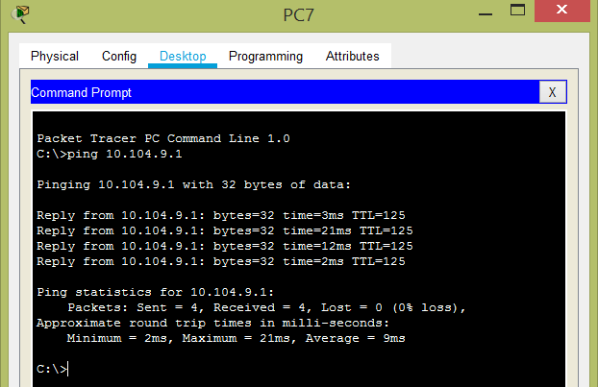

1. **Remove RIP configuration and configure OSPF protocol. Display routing tables and ping from your computer to all other remote computers.**

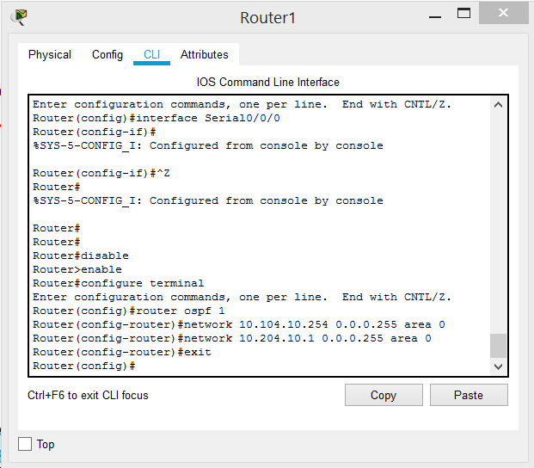

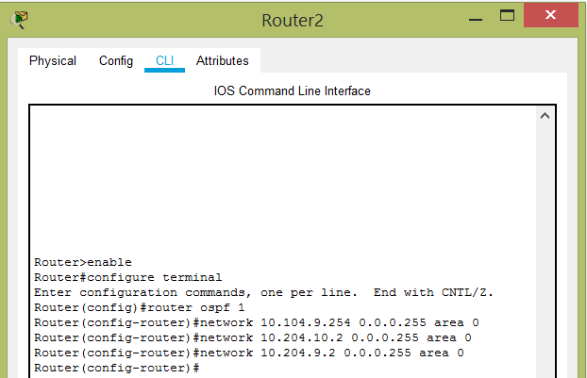

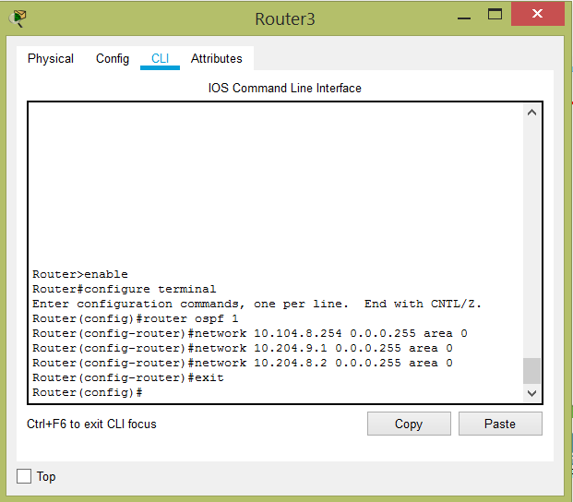

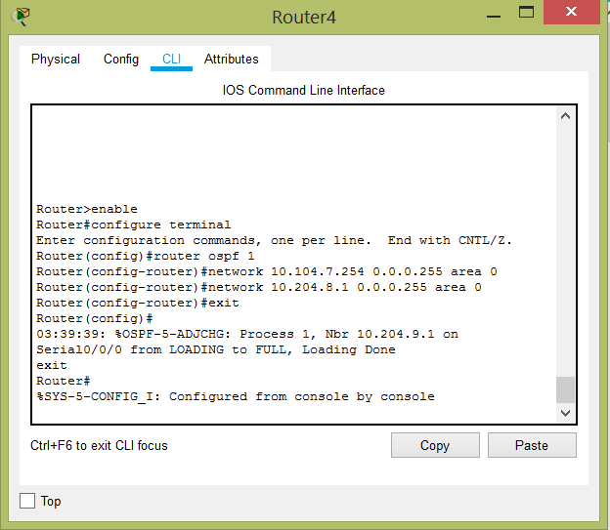

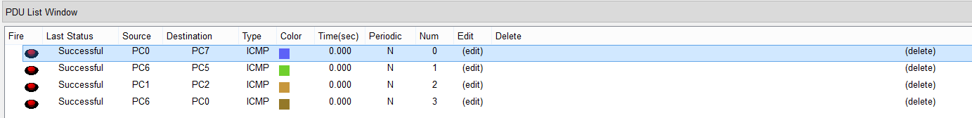

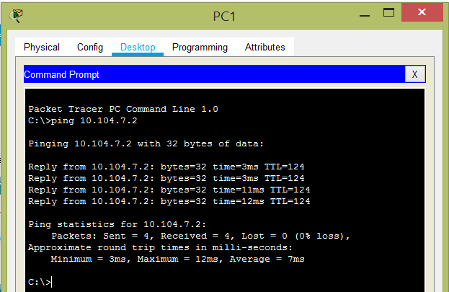

1. **Remove OSPF configuration and configure EIGRP protocol. Display routing tables and ping from your computer to all other remote computers.**

I removed all OSPF configuration.

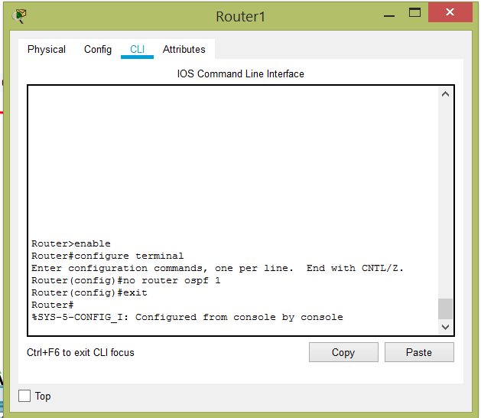

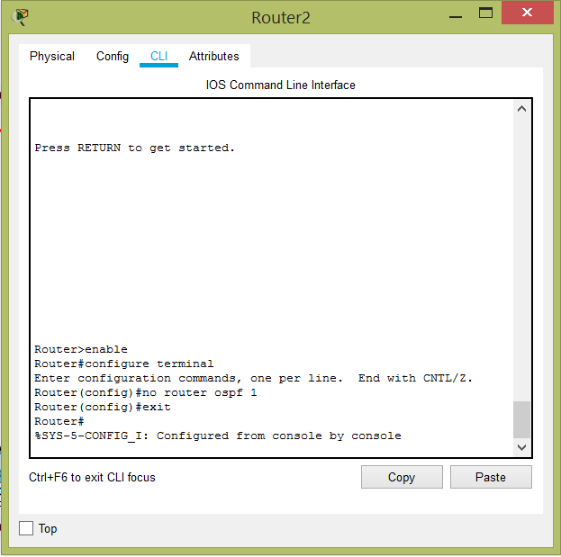

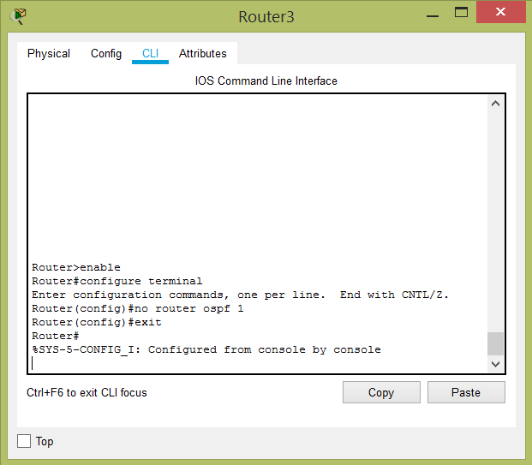

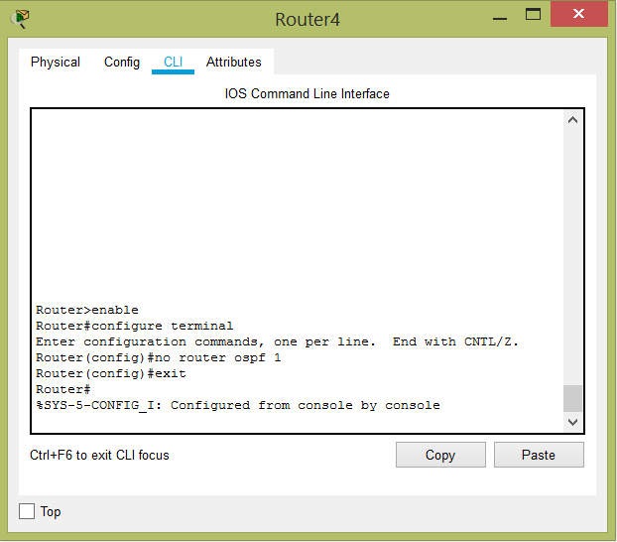

Configure Router

