HACETTEPE UNIVERSITY DEPARTMENT OF

COMPUTER ENGINEERING

BBM 453 LAB EXPERIMENT



Mehmet Taha USTA – 21527472

Group No: 4

1. **Your aim is to configure NAT on your router and translate your PC’s IP address in your group to a single IP from your subnet. After translation process, you will be able to test your address translation with pinging to new IP addresses and using show commands. Another way to test your configuration is to connect remotely to another group’s router and running show user command to see logged in users on that router.**
2. **You are going to use telnet for remote connection. To be able to use telnet, you have to configure necessary password steps for security restrictions. For example try to telnet (from your PC) to another group’s Router (IP address of Serial interface), and understand why you are not able connect to the Router.**
3. **You have to set enable password and telnet password for remote connection.**

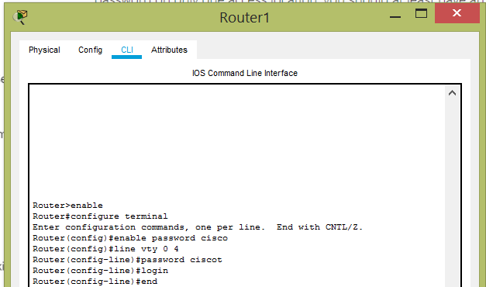

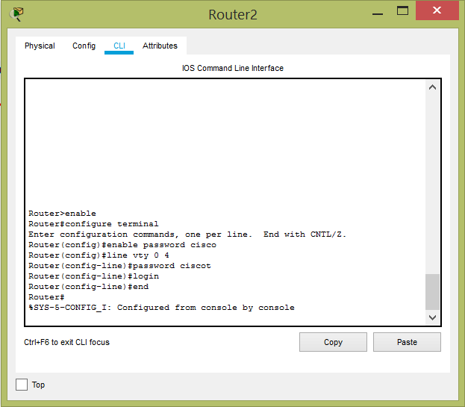

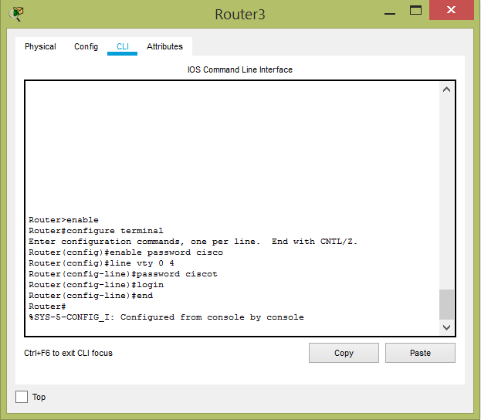

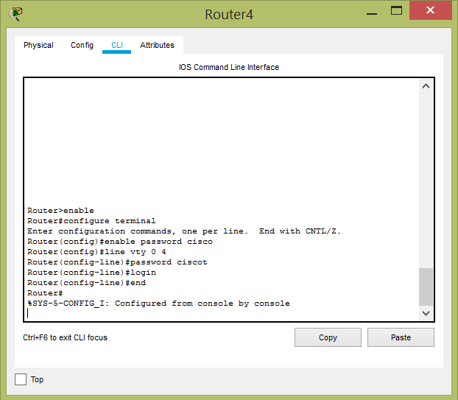

1. **Display your configuration changes on running-config and try logout from Router using disable command and then enable again.**

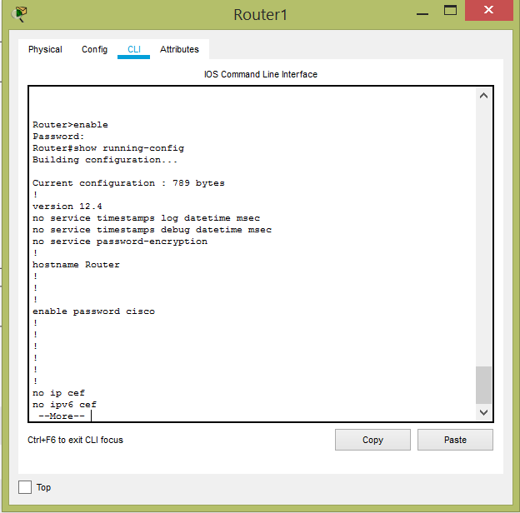

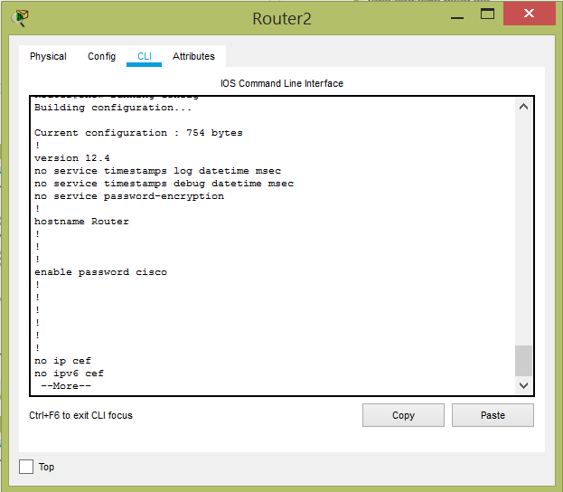

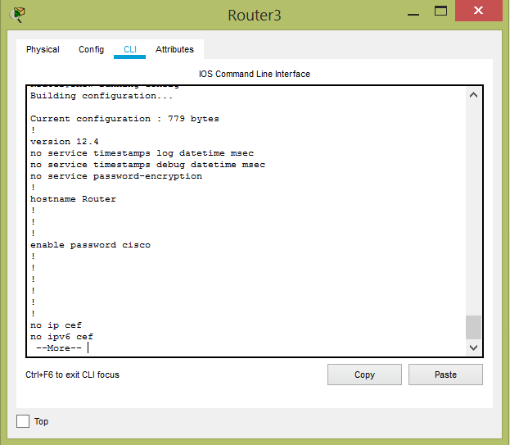

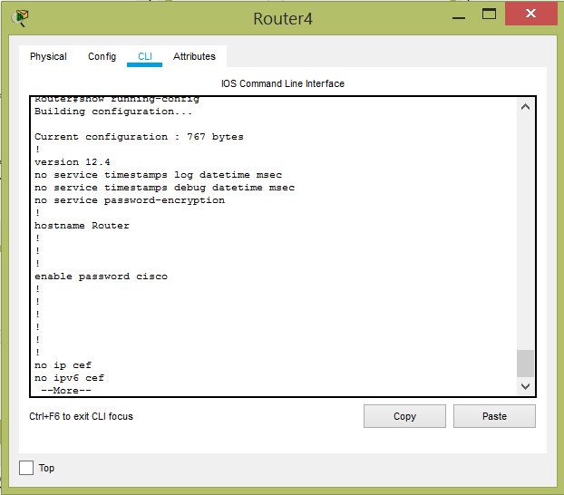

1. **You should observe that all text passwords can be easily seen in config file. That is also a security bug. You should use encryption service for encrypting password texts.**

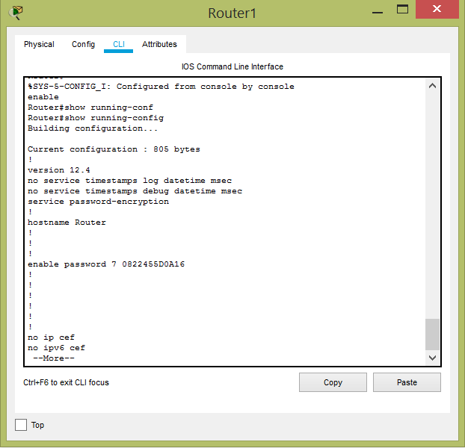

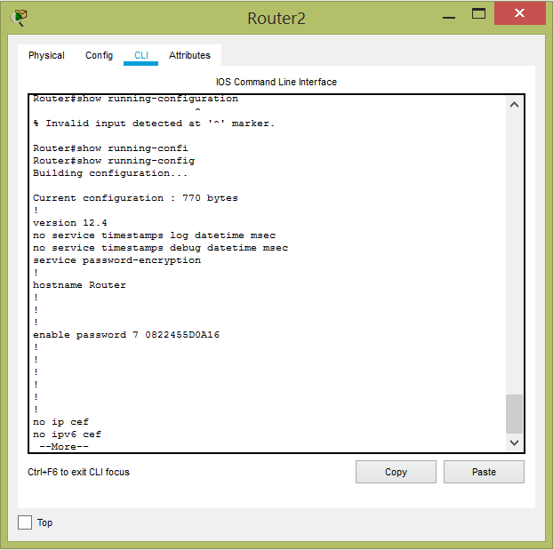

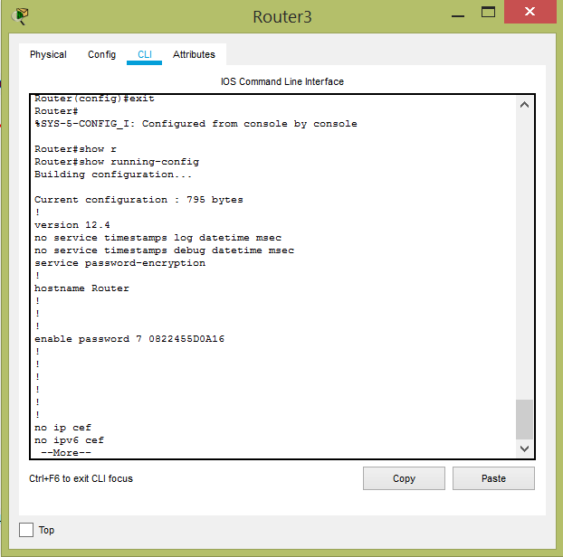

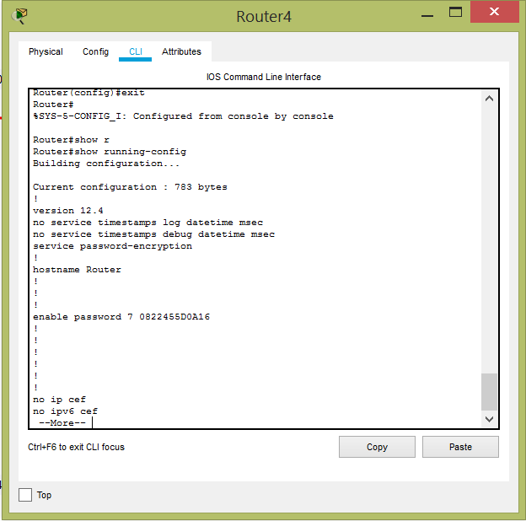

1. **Now you are ready to telnet (from your PC) to another remote Routers. Enter their telnet and enable passwords and login to their router. Use show user command to display logged-in connections on the router in this session. Observe your IP address of your client. The * shows your connection.**

From Pc2 to router2

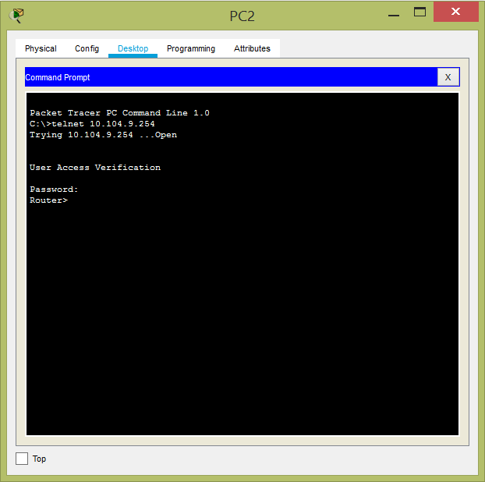

1. **If a router supports address translation (if it has an address translation software), then the connection interfaces to which the address translation is to be applied, must be specified and defined as inside or outside. This is done using the ip nat [inside | outside] command while in the sub-configuration mode.**

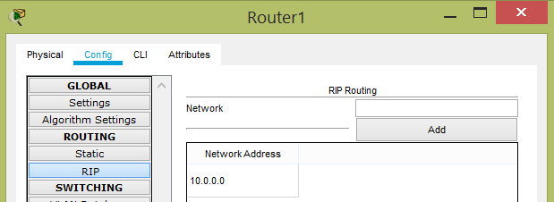

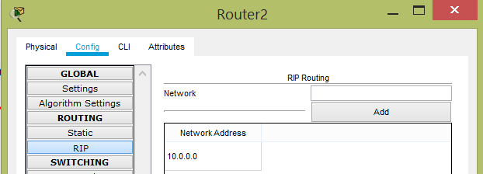

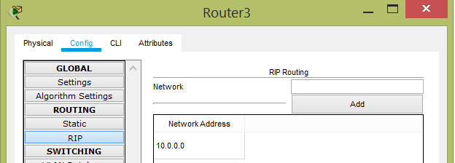

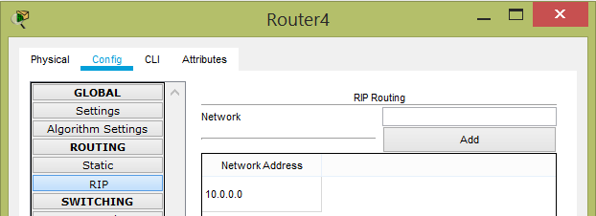

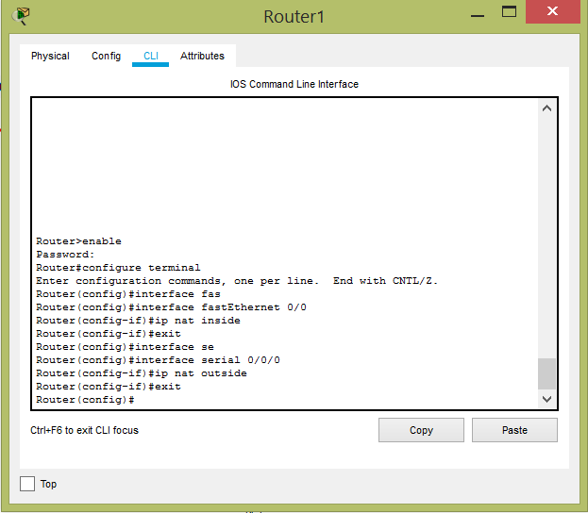

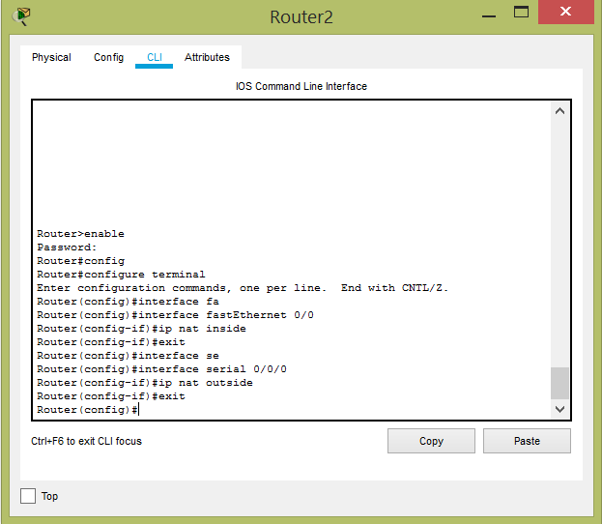

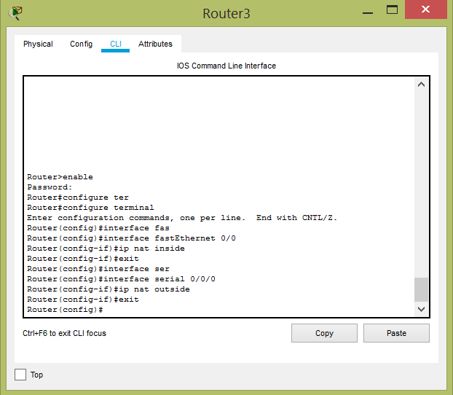

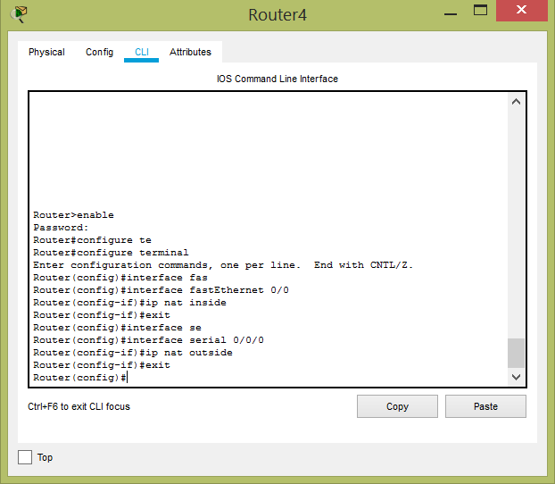

1. **You are going to configure dynamic overloading NAT. Commands are same as dynamic NAT configuration with overload command at the end. You should translate your client IP to another IP from your subnet (for example: 10.100.X.99) using dynamic overloading NAT commands:**

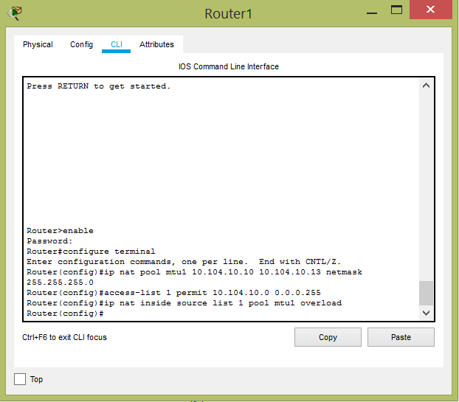

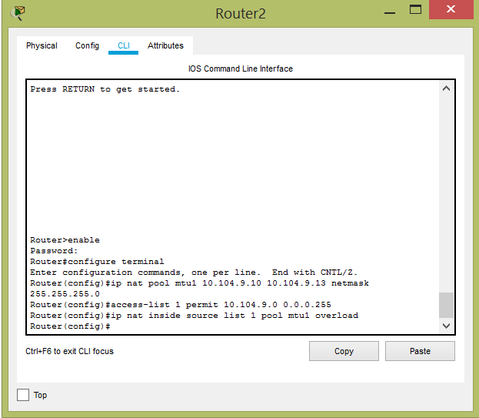

1. **After NAT configuration, try to ping other groups client IP addresses and translated IP addresses. Discuss the results.**

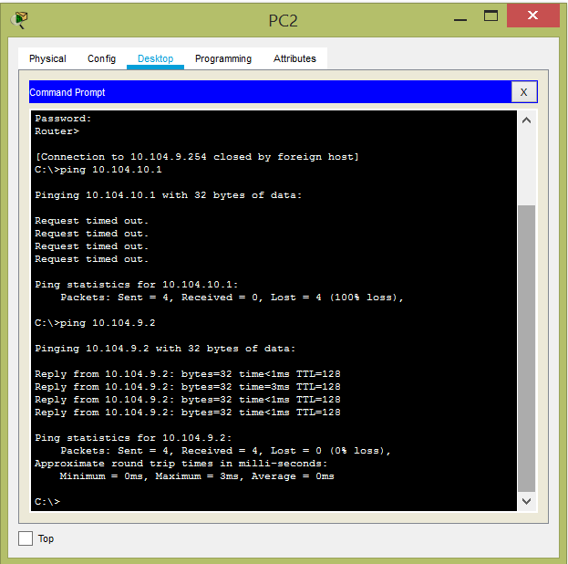

1. **Use show ip nat translation command to show translated IP addresses and port numbers. Discuss each column on the table (inside/outside, local/global). If you didn't see any output, you should successfully ping remote clients and also your PC should be pinged form outside.**
2. **Finally, connect to other remote Routers using telnet, and display connected users and observe your IP address.**

