HACETTEPE UNIVERSITY DEPARTMENT OF

COMPUTER ENGINEERING

BBM 453 LAB EXPERIMENT



Mehmet Taha USTA – 21527472

Çağlar USLU – 21808388

Group No: 4

1. **In the first part, you have to create a LAN using repeater HUBs as shown in Figure-1.**

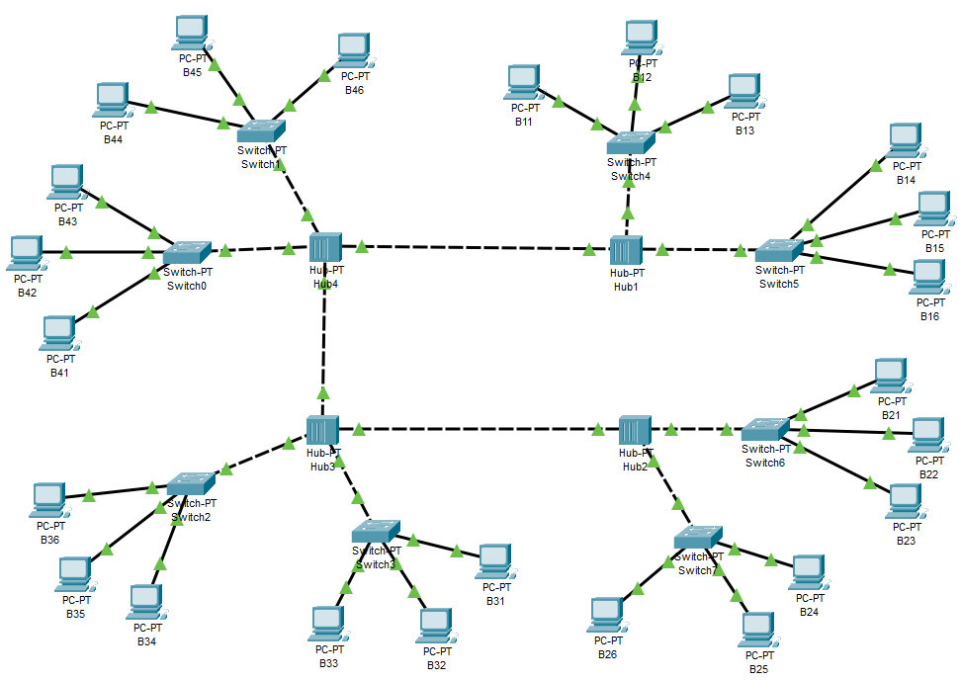

Since the hubs have 4 ports, we used switches to create the scheme given to us (6 computers to 1 hub). Thus, we have provided more than 4 computer connections to 1 hub.

A network switch connects devices within a network (often a local area network, or LAN*) and forwards data packets to and from those devices.

1. **You should prepare straight-through and cross-over network cables, to be able to connect related devices. Cable preparation tools will be explained by your lab instructor.**

Hub to hub -> Copper Cross Over cable

Switch to hub -> Copper Cross Over cable

Pc to switch -> Copper Straight-Through

1. **Assign IP addresses to your computers eth0 adapter as described in the Table-1**

Since our group id is 4, we set the IP’s again.

|  |  |  |
| --- | --- | --- |
| **Group Name** | **IP address** | **Subnet mask** |
| Grup1 | 10.4.10.1 - 10.4.10.6 | 255.255.0.0 |
| Grup2 | 10.4.20.1 - 10.4.20.6 | 255.255.0.0 |
| Grup3 | 10.4.30.1 - 10.4.30.6 | 255.255.0.0 |
| Grup4 | 10.4.40.1 - 10.4.40.6 | 255.255.0.0 |

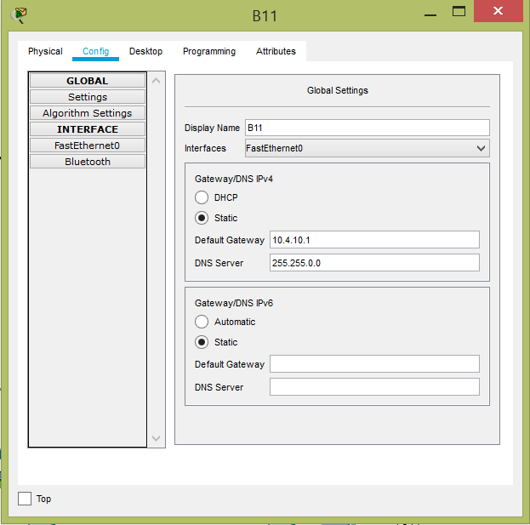

1. **Make sure that your Ethernet interface of your computer is active, and your cable is plugged to your group’s HUB device. Green light on your HUB’s port indicates that there is a physical connnection established between the hub and the end device.**

All connections have been made correctly. The connections are shown in the picture in question 1. All connections are green lights.

1. **Check that you can ping other computers in the local network (using ping <IP address> command).**

Source IP: 10.4.10.1

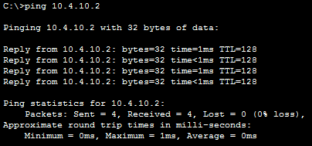

1. **Make sure that there is a connection between HUB devices**

The connections are all green. Connections are correct. The connections are shown in the picture in question 1.

Hub1 PC B11 IP= 10.4.10.1 ~ Hub2 PC B21 IP= 10.4.20.1

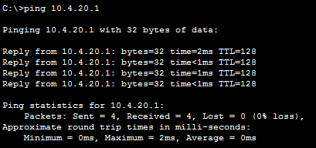

1. **Run Wireshark program and start capturing your active interface (eth0). Before capturing, all computers have to stop pinging (Ctrl+C)**

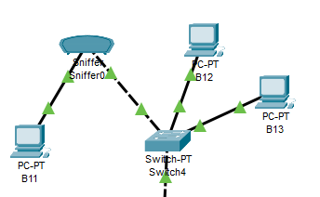

1. **Only one computer (decided by lab instructor, lets call A) will start to ping a destination computer (lets say B), and all others will observe the captured packets on Wireshark.**

We added packet sniffer for wireshark.

Pc B12 Source IP = 10.4.10.2

Pc B11 Target IP = 10.4.10.1

We pinged from 10.4.10.2(PC B12) to 10.4.10.1(PC B11)

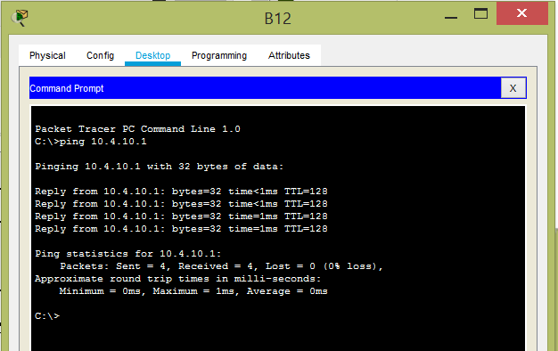

1. **After observing ping packets, computer A will start an FTP connection to the FTP server on B. In the meantime all other computers will observe the connection and login process. (Lab instructor will determine the computer B and configure FTP user settings)**

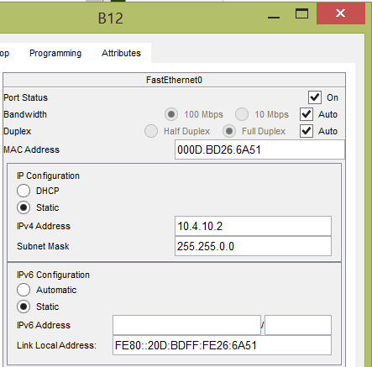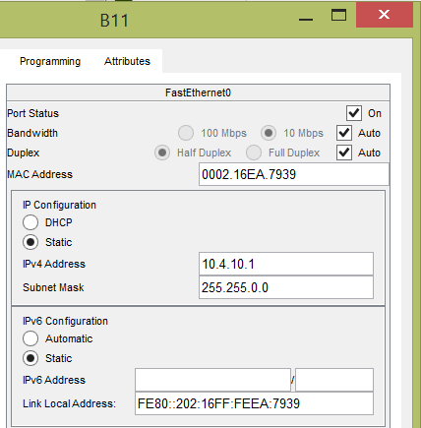

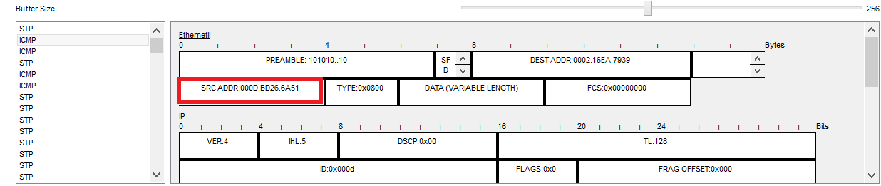

1. **You should mention all steps you have done (with printscreens) and discuss about your observations.**

**Using Switch**

1. **Change the HUB devices with Switches and create same topology described in Figure-1**

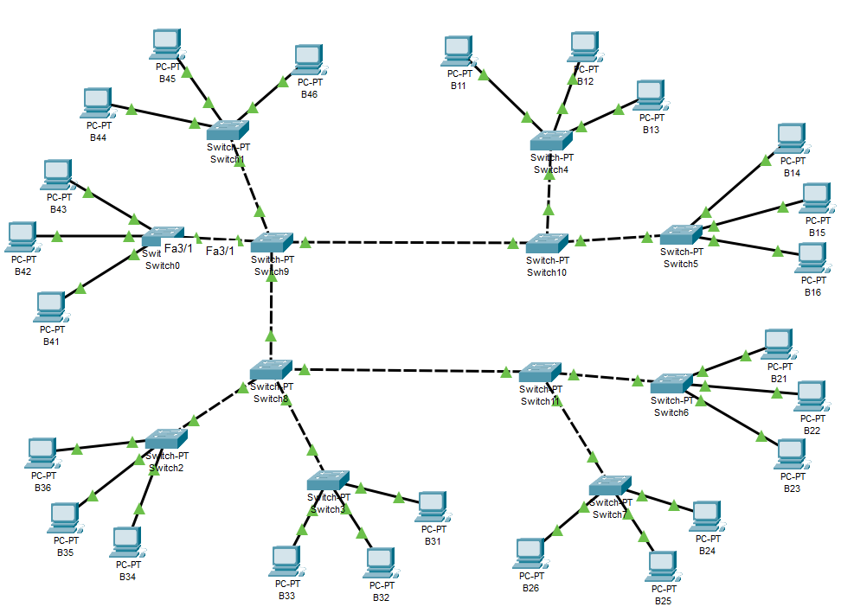

Since the switch have 4 ports, we used switches to create the scheme given to us (6 computers to 1 switch). Thus, we have provided more than 4 computer connections to 1 switch.

1. **Make sure that your Ethernet interface of your computer is active, and your cable is plugged to your group’s Switch device. Green light on your Switch’s port indicates that there is a physical connnection established between the hub and the end device.**

All connections have been made correctly. The connections are shown in the picture in question 11. All connections are green lights.

1. **Check that you can ping other computers in the local network (using ping <IP address> command).**

Source IP: 10.4.10.1

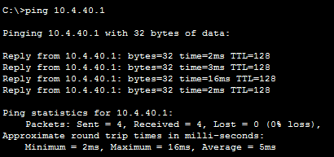

1. **Make sure that there is a connection between Switch devices**

The connections are all green. Connections are correct. The connections are shown in the picture in question 11.

Switch10 PC B11 IP= 10.4.10.1 ~ Switch9 PC B41 IP= 10.4.40.1



1. **Run Wireshark program and start capturing your active interface (eth0). Before capturing, all computers have to stop pinging (Ctrl+C)**

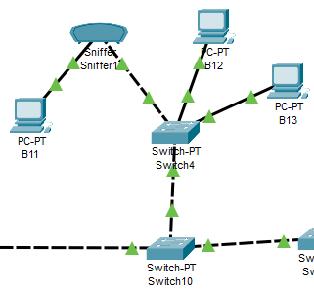

1. **Only one computer (decided by lab instructor, lets call A) will start to ping a destination computer (lets say B), and all others will observe the captured packets on Wireshark.**

We added packet sniffer for wireshark.

Pc B41 Source IP = 10.4.40.1

Pc B11 Target IP = 10.4.10.1

We pinged from 10.4.40.1(PC B41) to 10.4.10.1(PC B11)

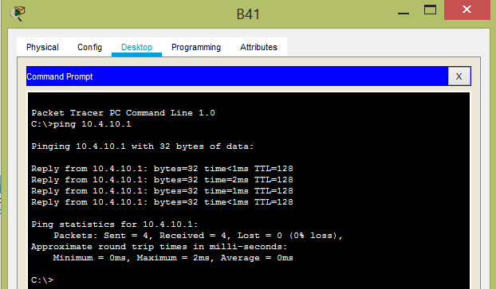

1. **After observing ping packets, computer A will start an FTP connection to the FTP server on B. In the meantime all other computers will observe the connection and login process. (Lab instructor will determine the computer B and configure FTP user settings)**

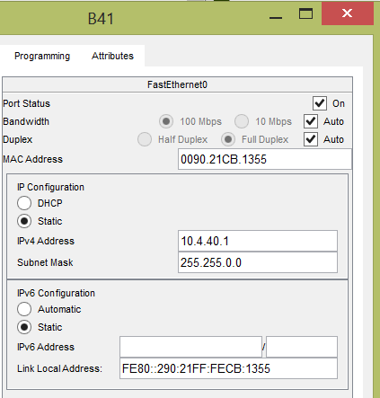 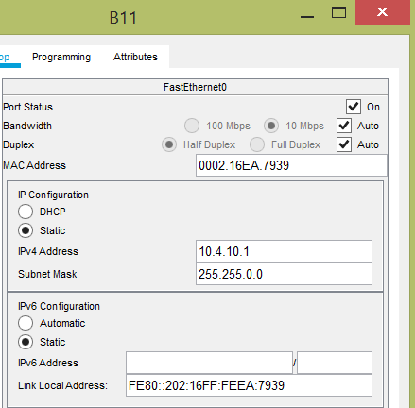

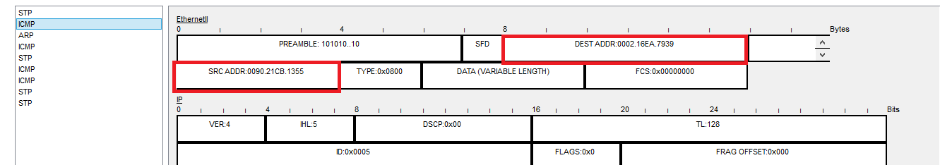

1. **You should mention all steps you have done (with printscreens) and discuss about your observations.**
2. **Discuss the differences between HUB and Switch as you see in the experiments. Reach a conclusion about their working logic.**

A Hub is a networking device that allows you to connect multiple PCs to a single network, whereas a Switch connects various devices together on a single computer network.

A Hub operates on the physical layer, whereas Switch operates on the data link layer.

1. **Describe the protocol other than ICMP that you saw in this scenario which was mentioned in introduction part. And explain why you observe it and associate with the frame sending process in Local Area Network.**

We observed that STP and ARP protocols appeared when we used switches on Experiment.

**STP ->** The Spanning Tree Protocol (STP) is a network protocol that builds a loop-free logical topology for Ethernet networks. The basic function of STP is to prevent bridge loops and the broadcast radiation that results from them. Spanning tree also allows a network design to include backup links providing fault tolerance if an active link fails.

**ARP ->** The Address Resolution Protocol (ARP) is a communication protocol used for discovering the link layer address, such as a MAC address, associated with a given internet layer address, typically an IPv4 address. This mapping is a critical function in the Internet protocol suite.