HACETTEPE UNIVERSITY DEPARTMENT OF

COMPUTER ENGINEERING

BBM 453 LAB EXPERIMENT



Mehmet Taha USTA – 21527472

Çağlar USLU – 21808388

Group No: 4

1. **In this experiment you’re going to create a network similar to one in previous lab. You should virtually group computers as shown in Figure-1 using VLAN configuration on Cisco Switches.**

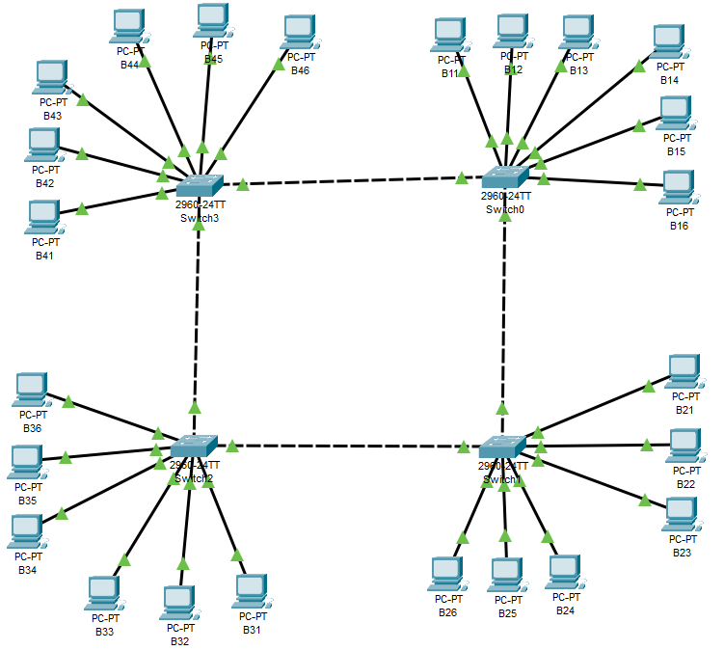

1. **Assign IP addresses to your computers’ eth0 adapter as described in the Table-1 similar to previous Lab. Make sure that all computers are connected to the network and all can be pinged.**

Since our group id is 4, we set the IP’s again.

|  |  |  |
| --- | --- | --- |
| **Group Name** | **IP address** | **Subnet mask** |
| Grup1 | 10.4.10.1 - 10.4.10.6 | 255.255.0.0 |
| Grup2 | 10.4.20.1 - 10.4.20.6 | 255.255.0.0 |
| Grup3 | 10.4.30.1 - 10.4.30.6 | 255.255.0.0 |
| Grup4 | 10.4.40.1 - 10.4.40.6 | 255.255.0.0 |

1. **Switches can be configured via telnet or console connection. We are going to use console connection using console (blue) cable. You should select one computer from your group which has a console cable attached to its onboard serial port. Then just plug the RJ-45 end of the cable to Switch’s console port on the back side.**

Since the packet tracer program is used, there is no need for console connection.

1. **In Unix systems, there is a tool called minicom which can use serial port of the system and send keystrokes to the terminal attached. So enter minicom from console of the computer (which is connected to the switch) and enter into the Cisco device command line interface.**

There is no need for minicom because the packet tracer program is used.

1. **You should see something like: Switch> after pressing Enter for a couple of times.**

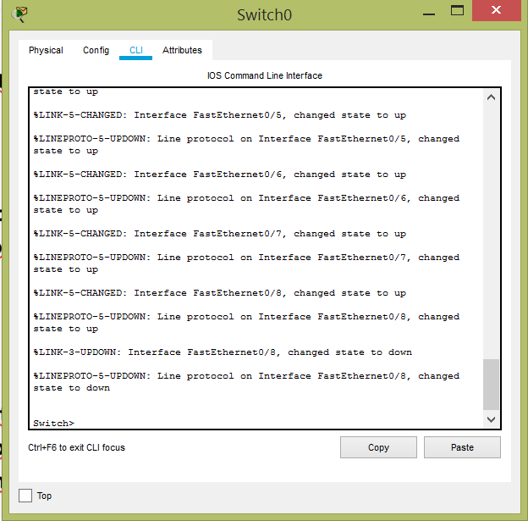

1. **Now you are in the Cisco IOS operating system, and you can only use Cisco commands for configuration or troubleshooting. You can enter ? command and see which commands you can use in that level.**

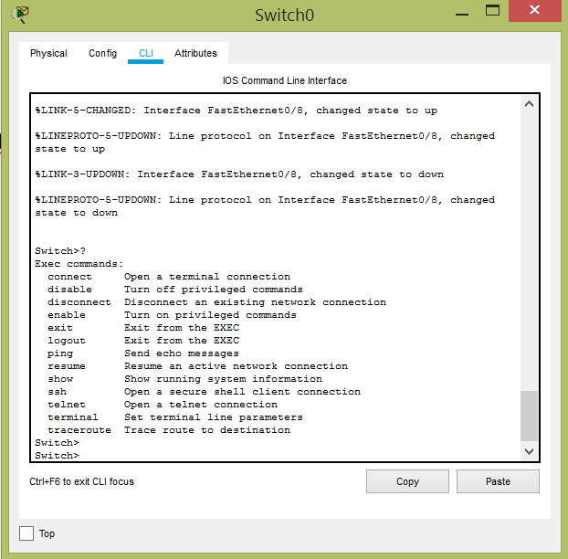

1. **Now you are ready to configure VLAN settings according to Figure-1. You have to associate related ports with described VLANs and define Trunk links between Switch connections.**

“vlan database” command does not work on windows 8.1



Create Vlan 3 and Vlan 4





Configure Vlan3

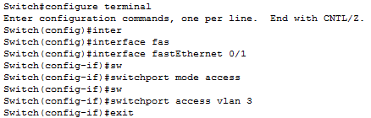

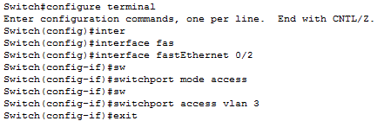

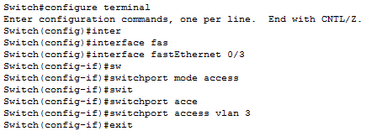

Configure Vlan4

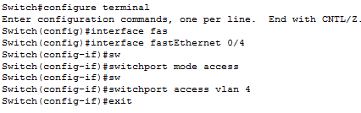

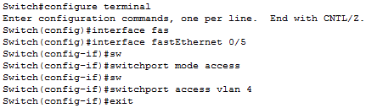

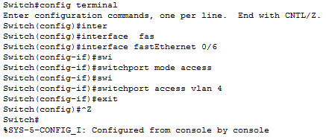

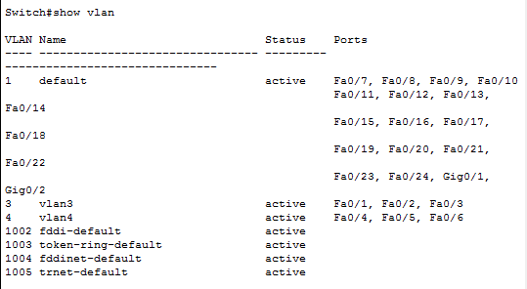

1. **Here is the commands that you are going to use:**

We tried the commands given to us. As seen in Q7, we configured the vlan.

1. **If all four switch configurations were completed, now ping from a computer to one that is in your group but in a different VLAN. And try ping to another group but in the same VLAN..**

**B22 IP = 10.4.20.2 ~ B15 IP = 10.4.10.5**

