HACETTEPE UNIVERSITY DEPARTMENT OF

COMPUTER ENGINEERING

BBM 456 HOMEWORK 6



Mehmet Taha USTA – 21527472

Subject: Download and Install PGP. Create Encrypted and signed message traffic. Propare 3-4 page report with screenshot

1. Kleopatra program must be installed for Windows

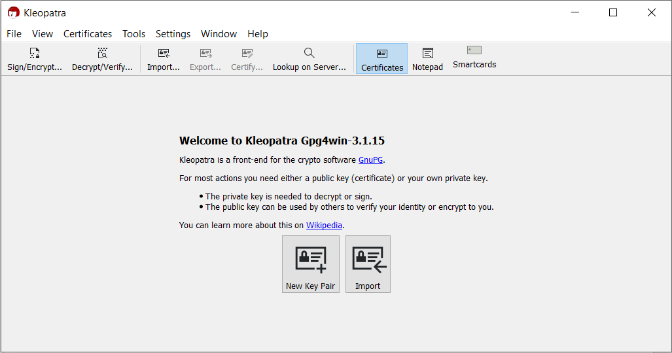

1. Encryption

2.1) New Key Pair

In Encryption, we first need to generate our keys by pressing the New Key Pair button.

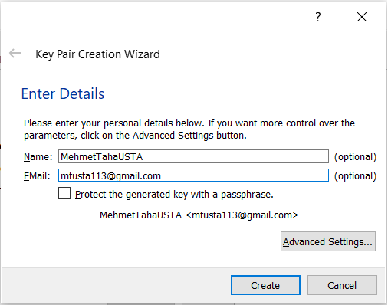

2.2) Key Pair Settings

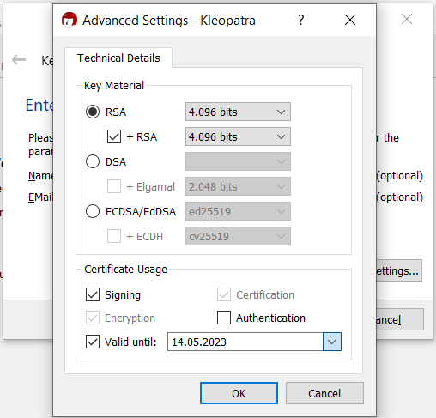

2.3) Generated Keys

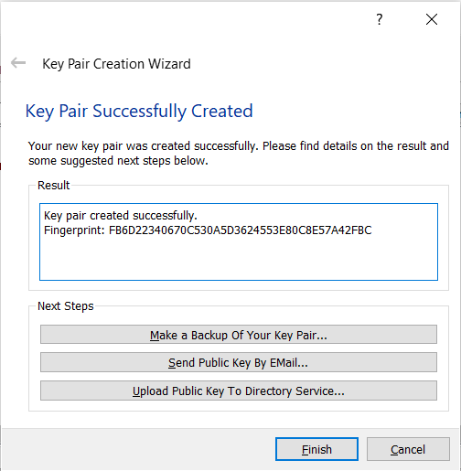

2.4) Exported Public Key

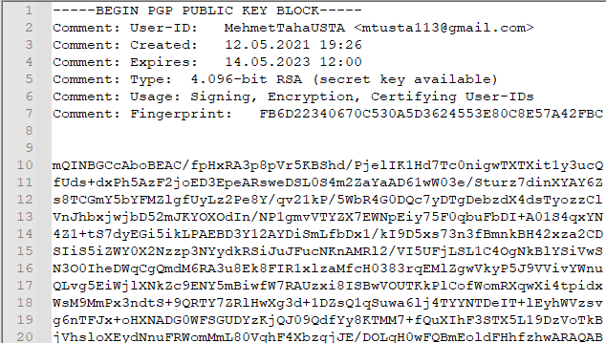

2.5) Exported Private Key

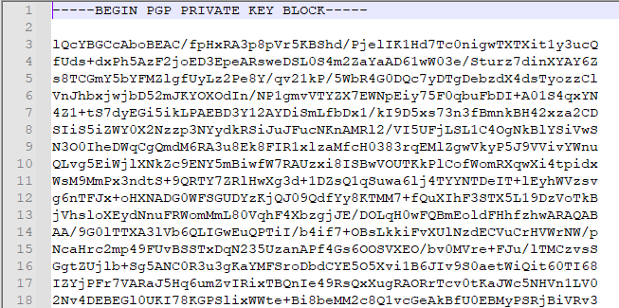

2.6) Message to be encypted

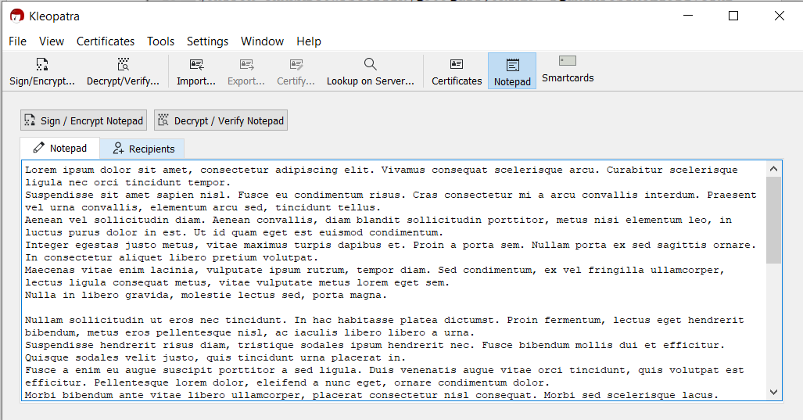

2.7) The message is encrypted with the selected Public Key

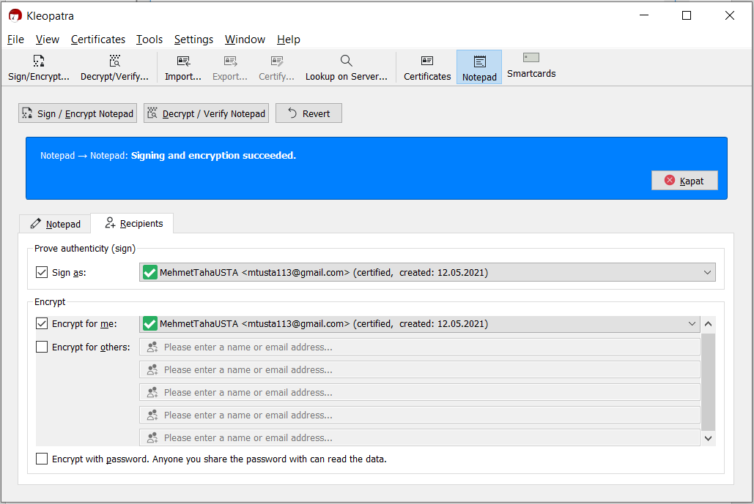

2.8) Encrypted Message

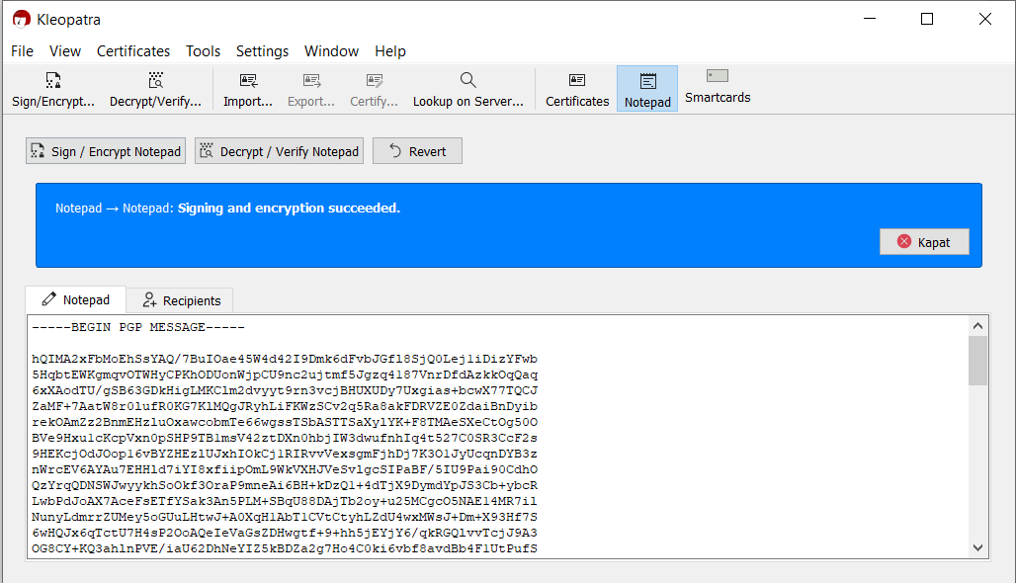

2.9) The decrypted message is obtained by pressing the “Decrypt/Verify Notepad” button. The text obtained is the same as the original message.

