HACETTEPE UNIVERSITY DEPARTMENT OF

COMPUTER ENGINEERING

BBM 460 FINAL PROJECT REPORT



Arduino & Bluetooth Based Home Automation

Group Name : Make Wifi Great Again

Mehmet Taha USTA – 21527472

1. **Introduction**

Using wireless network technology to facilitate daily life. You will see how to automate various gadgets of your home and room. You will be able to control the lights, fan, air conditioning, curtains, locks and TV.

1. **Technologies to be Used**

**Hardware**

Arduino UNO

Arduino Bluetooth Modül HC05

Arduino 4 Way 5V Relay Module

Breadboard

Connecting wires

Bluetooth enabled smartphone

**Software**

Arduino 1.8.13 compiler

Android Studio 4.1

Android Application

**2.1) Arduino UNO**

The Arduino Uno is an open-source microcontroller board based on the Microchip ATmega328P microcontroller. The board is equipped with sets of digital and analog input/output (I/O) pins that may be interfaced to various expansion boards (shields) and other circuits.[1] The board has 14 digital I/O pins (six capable of PWM output), 6 analog I/O pins, and is programmable with the Arduino IDE (Integrated Development Environment), via a type B USB cable.

**Advantages**

It has an Atmel brand microcontroller on it and it is ready to use with the necessary connections made.

It can be directly connected to a computer via USB.

Easily adaptable to kits -> so-called plug-in circuits are widely available in the market.

It makes it simpler to build circuits together with the peripheral modules (Shield).

It does not need the programmer required for microcontrollers.

Its programming is more understandable and easier than other development kits.

With its wide library support, it has simplified even very complex projects as much as possible.

Its cost is more affordable than similar systems.

It is an easily available product in the market.

**2.2) Arduino Bluetooth Modüle HC05**

HC‐05 module is an easy to use Bluetooth SPP (Serial Port Protocol) module,designed for transparent wireless serial connection setup.The HC-05 Bluetooth Module can be used in a Master or Slave configuration, making it a great solution for wireless communication.This serial port bluetooth module is fully qualified Bluetooth V2.0+EDR (Enhanced Data Rate) 3Mbps Modulation with complete 2.4GHz radio transceiver and baseband. It uses CSR Bluecore 04‐External single chip Rluetooth system with CMOS technology and with AFH (Adaptive Frequency Hopping Feature).

**2.3) Arduino 4 Way 5V Relay Module**

The 4 Channel Relay Module is a convenient board which can be used to control high voltage, high current load such as motor, solenoid valves, lamps and AC load. It is designed to interface with microcontroller such as Arduino, PIC and etc. The relays terminal (COM, NO and NC) is being brought out with screw terminal. It also comes with a LED to indicate the status of relay.

**2.4) Breadboard**

A breadboard is a construction base for prototyping of electronics.

**2.5) Connecting Wires**

Connecting wires allows an electrical current to travel from one point on a circuit to another because electricity needs a medium through which it can move.

**2.6) Bluetooth Enabled Smartphone**

Source that can send bluetooth signal.

**2.7) Arduino 1.8.13 Compiler**

The Arduino Integrated Development Environment (IDE) is a cross-platform application (for Windows, macOS, Linux) that is written in functions from C and C++. It is used to write and upload programs to Arduino compatible boards, but also, with the help of third-party cores, other vendor development boards.

**2.8) Android Studio 4.1**

Android Studio is the official integrated development environment (IDE) for Google's Android operating system, built on JetBrains' IntelliJ IDEA software and designed specifically for Android development.

**2.9) Android Application**

Android App is a software designed to run on an Android device or emulator.Android App is a software designed to run on an Android device or emulator.

1. **Details of Application**

**3.1) Arduino Compiler Codes**

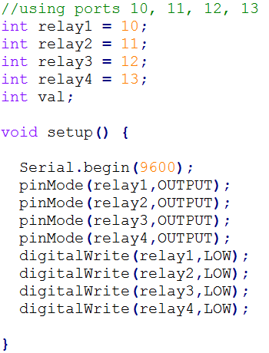

The setup() function is called when a sketch starts. Use it to initialize variables, pin modes, start using libraries, etc. The setup() function will only run once, after each powerup or reset of the Arduino board.

Serial.begin () sets the communication rate in bits per second.

The pinMode() function is used to configure a specific pin to behave either as an input or an output.

The digitalWrite() function is used to write a HIGH or a LOW value to a digital pin. If the pin has been configured as an OUTPUT with pinMode(), its voltage will be set to the corresponding value: 5V (or 3.3V on 3.3V boards) for HIGH, 0V (ground) for LOW.

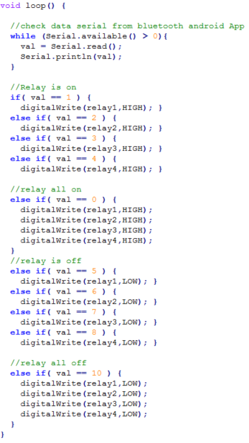

Serial.read() reads incoming serial data.

Serial.available() get the number of bytes (characters) available for reading from the serial port. This is data that’s already arrived and stored in the serial receive buffer (which holds 64 bytes).

The loop() function does precisely what its name suggests, and loops consecutively, allowing your program to change and respond.

First While loop check data serial from Bluetooth Androip App. If the application sends data, it reads it with the Serial.read() function and saves in val variable. After the data is saved, the pins are adjusted according to the value in the data.

**3.1) Android Studio Codes**

**AndroidManifest.xml**

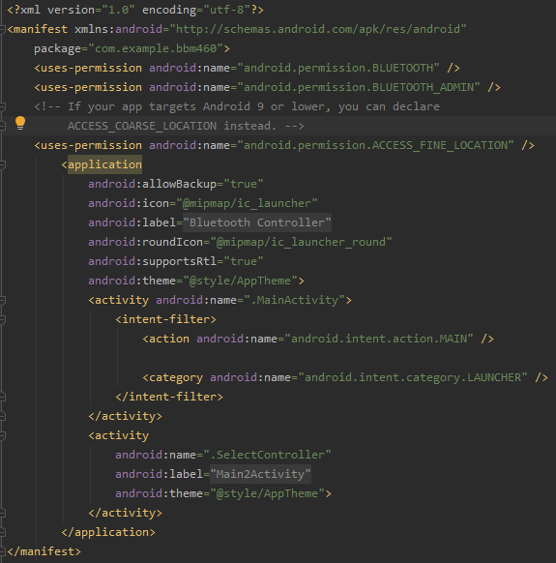

The AndroidManifest.xml file contains information of package, including components of the application such as activities, services, broadcast receivers, content providers etc.

It is responsible to protect the application to access any protected parts by providing the permissions.

It also declares the android api that the application is going to use.

It lists the instrumentation classes. The instrumentation classes provides profiling and other informations. These informations are removed just before the application is published etc.

This is the required xml file for all the android application and located inside the root directory.

AndroidManifest has 2 activity. The first is MainActivity, the second is SelectControls. MainActivity is the first class that will run when our android application is started. SelectController is for bluetooth connection

**MainActivity.java**

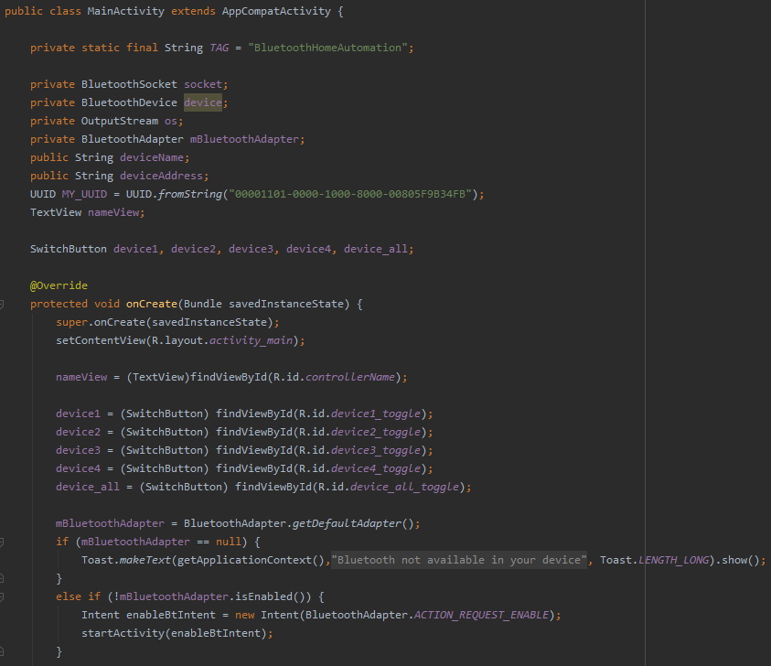

It is the part that runs when the program is opened on the phone. It will not work if the phone does not have Bluetooth. The Bluetooth connection is selected from the SelectController section. After the Bluetooth connection is established, the signal is sent with toggle buttons.

**SelectController.java**

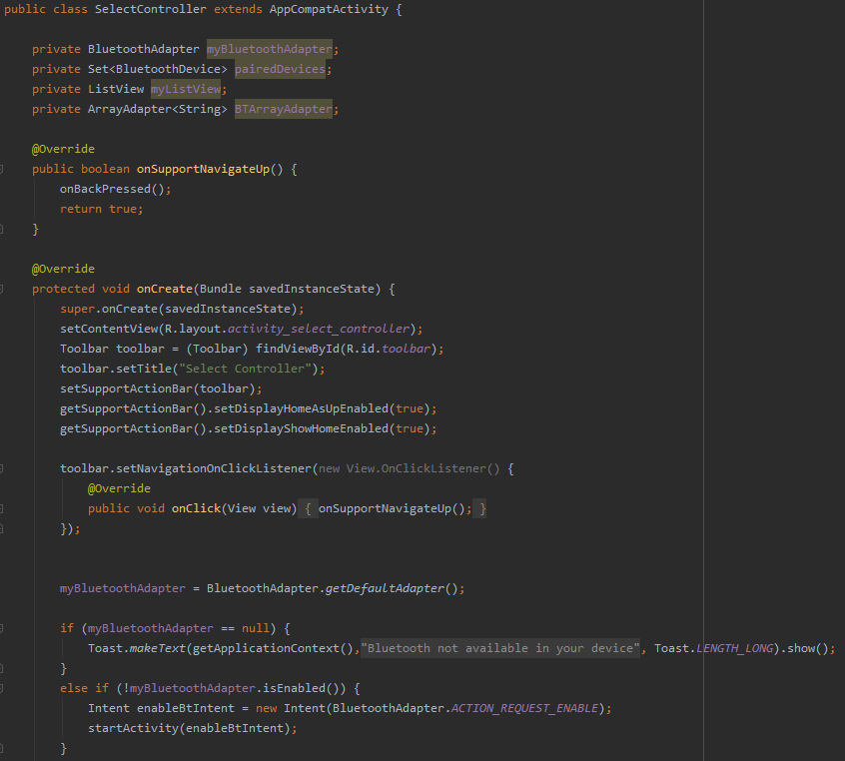

Lists paired devices on bluetooth. Establishes a connection with the device selected through the list.

**AwesomeToggle.java**

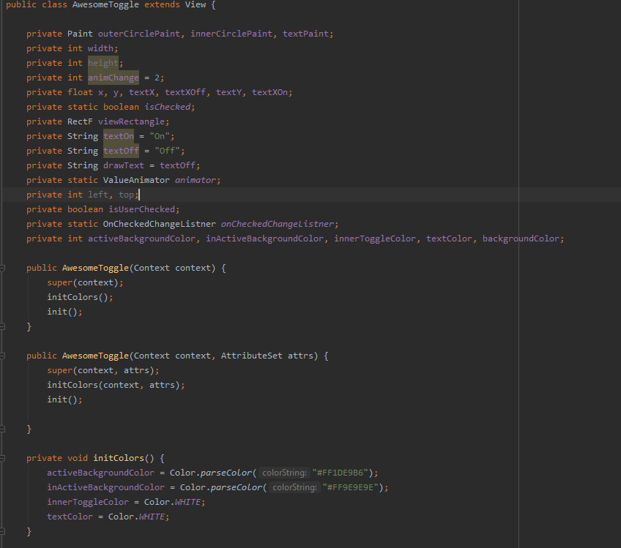

It provides graphical image change when the toggle button is pressed.

