Code Club St. Thomas School Term3 week 1 1.08.2016

Game “Memory”

Code for backdrop “Stage”

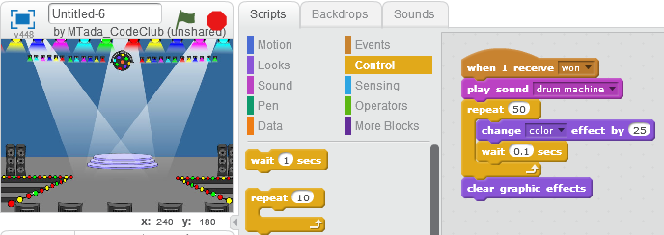

Code for sprite “yellow”

Add costume and change colors of Ballerina

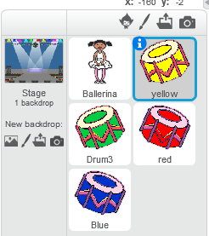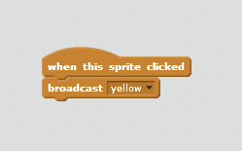

Duplicate drums and change names and colors

Preparations for coding on “ballerina”

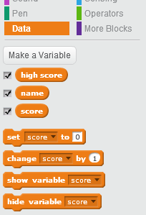 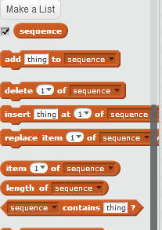

Code for sprite “ballerina”

