NED University of Engineering and Technology, Karachi
Computer Science and Information Technology
COMPLEX COMPUTING PROBLEM (CCP)
PROJECT SUBMISSION

Knowledge-Based Systems (CT-359)
Project Title | Intelligent Knowledge-Based System for Industrial Equipment Fault Diagnosis and Maintenance Decision Support
Implemented System | ARM / INSIGHT — Robotic Arm Fault Diagnosis and Maintenance Decision Support
Submission Date | 31 October 2026
Live Demo | 🌐 arm-insight-kbs.app
Source Code | GitHub Repo
Student Details
Sr. No. | Student Name | Roll No. | Signature
1 | Saad Ali | CT-24221
2 | Muhammad Taha Farrukh | CT-24224
3 | Uzair Ahmed | CT-24244
4 | UsaidUllah Qureshi | CT-24227

1. Project Instructions
ARM / INSIGHT is submitted as a browser-based KBS prototype for robotic-arm fault diagnosis. It does not command a physical robot. How each CCP instruction is met is summarized below; details appear in later sections.
Table 1: Compliance with the CCP project instructions
Instruction | How this submission complies
Source code, dataset / knowledge base files, report and presentation | Repository: dist/ (application), dataset/ (raw + cleaned UCI data, ETL notebook), knowledge_base.json, sample_cases.json, automated tests, this report and docs/*.pptx.
Implementation must be executable and demonstrable | Runs in any browser — locally via serve.py or at the live Vercel URL. A one-click Viva demo button scripts the walkthrough (Appendix A).
Assumptions | Section 4.5 lists six assumptions with justification. The prototype does not control a robot.
External datasets, sources, libraries and tools | Sections 6 and 9 cite the UCI dataset, Universal Robots documentation, Supabase and Vercel.
Report and presentation | docs/KBS_Robotic_Arm_CCP_Presentation.pptx.

Project Abstract
The system implements an explicit ETL (Extract–Transform–Load) cleaning pipeline on the authentic UCI Robot Execution Failures dataset (DOI 10.24432/C5M89N), rule-based fault prediction by forward chaining, synthetic evaluation scenarios for regression, optional cloud persistence (Supabase) and public deployment (Vercel).
The robot type, plant-specific alarm mappings, real costs and historical failure data were not supplied in the brief; non-manufacturer rules are therefore explicit educational assumptions. No operational accuracy or safety certification is claimed.

The Information Flow
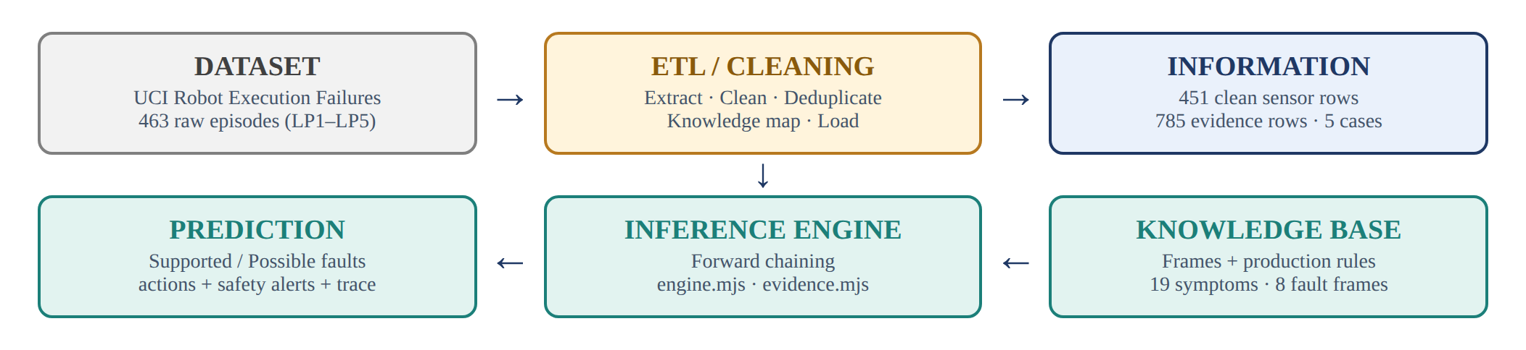
Figure 1: Information flow: Dataset → ETL → Information → Knowledge Base → Inference → Prediction.

2. Problem Statement
Table 3: Course learning outcomes (CLOs) and where they are addressed
CLO | Requirement | Addressed in
CLO 1 | Explain how a KBS can represent industrial equipment knowledge — equipment, components, symptoms, faults, causes and maintenance actions — using an appropriate knowledge-representation formalism. | Sections 5.1, 5.2, 6.3
CLO 2 | Analyze the fault-diagnosis problem by identifying incomplete requirements, stakeholder needs, relationships, constraints and suitable knowledge-based approaches. | Sections 3, 4.1 – 4.5
CLO 3 | Evaluate knowledge-representation methods and inference algorithms for diagnosing faults and recommending maintenance actions; justify the selected approach on accuracy, explainability, safety, cost and system requirements. | Sections 5.3 – 5.5, 8.1

3. Problem Description / Project Context
A manufacturing cell uses an industrial robotic arm with joints and transmission, tool (payload) configuration, controller thermal paths, position feedback, power supply, communication harness, joint brakes and an optional pneumatic gripper. Equipment knowledge is scattered across operator observations, controller and sensor alarms, maintenance records, technician inspections and manuals or expert statements. The same symptom (for example a protective stop) can arise from more than one cause, evidence is often incomplete, and different sources may disagree. Stakeholders pull in different directions: technicians need auditable hypotheses and safe next actions; supervisors want lower downtime and cost; safety officers require hazard escalation that cannot be skipped for production continuity.
The ARM / INSIGHT prototype is a rule-based KBS that records categorical observations (Yes / No / Unknown / Conflict), optionally with multi-source claims, and then applies eight explicit diagnostic production rules by forward chaining. Fully supported hypotheses receive a cause narrative and a qualified maintenance recommendation; hazards escalate independently of rule completion. A browser diagnostic studio, case archive, maintenance board, rule explorer and evaluation lab support demonstration and regression. Optional Supabase sync stores shared workspace data; the live academic demo is hosted on Vercel. The system cannot diagnose unmodelled failures and must not replace the model-specific service manual or qualified personnel.

Table 4: ARM / INSIGHT at a glance
Equipment scope | One generic educational industrial robotic arm (no live control)
Knowledge base | Version 2.1 — 19 symptoms, 8 fault frames, 3 cited manufacturer sources
Representation | Frames + production rules stored as inspectable JSON
Inference | Forward chaining; four evidence states; independent safety alerts
Dataset | UCI Robot Execution Failures — 463 episodes (LP1–LP5), cleaned to 451 sensor rows
Verification | 13/13 evaluation scenarios PASS; 24 additional automated checks PASS (37 in total)
Deployment | Vercel static site (live) and localhost via serve.py; optional Supabase sync

4. Problem Analysis

4.1 Problem Understanding
The core difficulty is dispersed, incomplete and sometimes conflicting maintenance knowledge. A useful KBS must:
- Represent equipment → component → symptom → fault → cause → action relationships explicitly.
- Distinguish unknown (not checked) from no (verified absence).
- Allow multiple simultaneous fault hypotheses.
- Show why a rule fired or failed (explanation facility).
- Respect safety, while still supporting cost and downtime preferences as secondary concerns.
The prototype narrows the broad “all industrial equipment” brief to one generic educational robotic arm, so the knowledge base stays inspectable and defensible in the viva.

4.2 Stakeholders and Their Requirements
Table 5: Stakeholders and required outcomes
Stakeholder | Required outcome
Operator | Record symptoms and source notes without having to decide the root cause.
Maintenance technician | See matched, missing and conflicting evidence, the possible cause and a safe next action.
Safety officer | Immediate hazard escalation regardless of whether a diagnostic rule is complete.
Production supervisor | Compare relative downtime and cost without overriding hazard priority.
Knowledge engineer / instructor | Inspect and edit rules, provenance and regression results.
Course examiner | Demonstrable, explainable KBS aligned to CLO 1–3 and the CCP rubrics.

4.3 Constraints and Conflicting Requirements
Table 6: Conflicting requirements and how the prototype resolves them
Conflict | How the prototype treats it
Safety vs rapid restart | Protective stops and hazard symptoms escalate independently; recommendations require qualified review.
Lower cost vs reliability | Cost and downtime are secondary sort keys after status and severity.
Need for a decision vs missing data | Unknown never counts as No; rules stay Possible / Unassessed until evidence exists.
Conflicting reports | Opposing Yes / No source claims → Conflict; that symptom cannot fully support a rule.
Local demo vs shared audi | Browser localStorage always works; Supabase optionally mirrors the workspace for a shared demo.

4.4 Root Cause / Requirement Identification
The brief leaves several requirements incomplete. Before any real plant deployment, the organisation would still need to identify:
- Exact robot model and end-effector configuration
- Alarm-code semantics and approved sensor thresholds
- Access control and technician sign-off rules
- Field maintenance history and source-reliability weights
- Real cost and downtime figures
- Shared audit and retention policy
These were not supplied. The project therefore avoids inventing numeric thresholds, marks synthetic cases clearly and documents its educational assumptions.

4.5 Assumptions
Table 7: Assumptions made to complete the problem
# | Assumption
A1 | One generic robot configuration is used; the UI arm map is illustrative, not a certified model.
A2 | Observations are categorical: Yes, No, Unknown, Conflict. Source claims are Yes or No only; opposing claims are not averaged.
A3 | Each diagnostic rule is an AND conjunction of required symptoms. A full match gives a Supported hypothesis, not a legally confirmed root cause.
A4 | Severity, relative cost and downtime labels are teaching attributes, not measured plant KPIs.
A5 | Evidence source labels (operator, sensor, etc.) are user assertions, not authenticated telemetry.
A6 | Cloud sync uses educational open Row-Level Security for the demo; it is not production hardening.

5. Knowledge Representation and KBS Design

5.1 Selected Knowledge Representation Formalism
The selected formalism is frames + production rules, stored as inspectable JSON. Frames capture the structure of each fault (component, cause, action, severity, and provenance); production rules capture the diagnostic logic (IF all required symptoms are present THEN support the fault).
Table 8: Knowledge-representation constructs
Construct | What it represents
Symptom dictionary | Observable evidence vocabulary (equipment observations).
Fault frame | Component, name, required conditions, cause, severity, cost, downtime, action and provenance.
Production rule | IF all conditions = Yes THEN support fault + recommend action.
Evidence / claims | Provenance: source type, present / absent, note and timestamp.

The conceptual chain that the knowledge base encodes is shown in Figure 2.
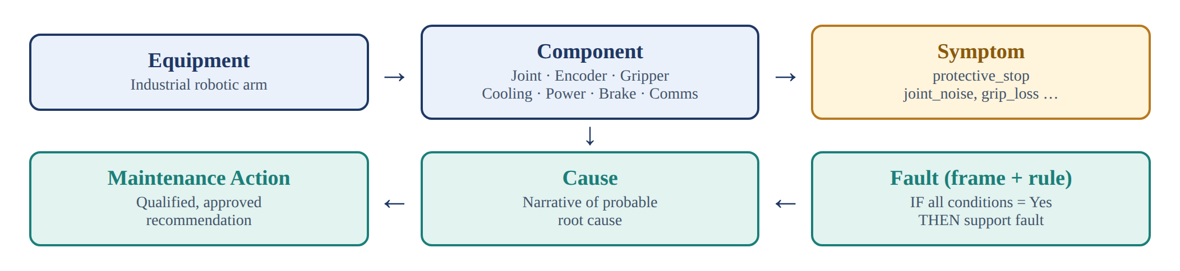
Figure 2: Conceptual knowledge chain: equipment → component → symptom → fault → cause → maintenance action.

5.2 Knowledge Base / Ontology / Rule Base
The file knowledge_base.json (version 2.1) contains 19 symptoms, 8 fault rules and 3 cited manufacturer concept sources. Table 9 lists the fault rules and Table 10 the symptom dictionary.
Table 9: Fault rules in the knowledge base (all required observations must be Yes)
Fault ID | Fault name | Component | Required observations | Severity | Cost / Down
payload | Payload configuration mismatch | Tool configuration | protective_stop ∧ payload_mismatch | High | Low / Short
mechanical | Joint mechanical degradation | Joint / transmission | joint_noise ∧ joint_friction ∧ position_drift | High | High / Long
thermal | Cooling-related overheating | Motor / controller cooling | overtemperature ∧ cooling_blocked | High | Medium / Medium
encoder | Position feedback fault | Encoder / feedback circuit | encoder_alarm ∧ feedback_unstable | High | Medium / Medium
gripper | Pneumatic grip fault | End effector | grip_loss ∧ pressure_low | High | Low / Short
communication | Communication connection fault | Communication harness | communication_alarm ∧ connection_damage | Medium | Medium / Medium
power | Power supply fault | Power system | power_alarm ∧ supply_unstable | High | Medium / Medium
brake | Joint holding / brake fault | Joint brake | brake_alarm ∧ joint_droop | Critical | High / Long

Table 10: Symptom dictionary (19 observable evidence items)
Symptom ID | Label shown in the UI | Used by fault rule
protective_stop | Protective stop reported | payload
payload_mismatch | Configured payload / centre of gravity differs from tool | payload
position_drift | Repeated positioning drift | mechanical
joint_noise | Abnormal joint noise | mechanical
joint_friction | Abnormal joint friction reported by qualified inspection | mechanical
overtemperature | Controller reports overtemperature | thermal
cooling_blocked | Cooling path obstructed | thermal
encoder_alarm | Encoder / position feedback alarm | encoder
feedback_unstable | Position feedback unstable | encoder
grip_loss | Gripper loses workpiece | gripper
pressure_low | Pneumatic pressure below equipment specification | gripper
communication_alarm | Communication fault alarm | communication
connection_damage | Visible cable / connector damage | communication
power_alarm | Supply voltage alarm | power
supply_unstable | Supply instability verified by qualified personnel | power
brake_alarm | Brake fault alarm | brake
joint_droop | Unexpected joint droop | brake
smoke | Smoke or burning smell | Safety hazard alert only
unexpected_motion | Unexpected motion observed | Safety hazard alert only

Example production rule (payload family)
IF protective_stop = Yes
AND payload_mismatch = Yes
THEN support "Payload configuration mismatch"
recommend qualified review of approved payload settings

Payload and abnormal-friction concepts follow Universal Robots guidance [1]–[3]. The exact conjunctions for the other fault families, and all cost / downtime classes, are author-created educational rules, not manufacturer-approved mappings.
Excerpt: fault frame in knowledge_base.json
{ "id": "payload",
"name": "Payload configuration mismatch",
"component": "Tool configuration",
"conditions": ["protective_stop", "payload_mismatch"],
"severity": "High", "cost": "Low", "downtime": "Short",
"cause": "Incorrect tool mass or centre-of-gravity configuration.",
"action": "Compare tool and workpiece data with approved payload settings;
have an authorized technician correct configuration.",
"provenance": "UR protective-stop guidance; illustrative diagnostic conjunction." }

5.3 Inference Mechanism
The selected algorithm is forward chaining over the rule base, implemented in dist/engine.mjs as the function diagnose(). Observations are the initial facts; each rule is evaluated against them and every satisfied rule adds a conclusion and an action to the explanation trace. Figure 3 shows the stages.
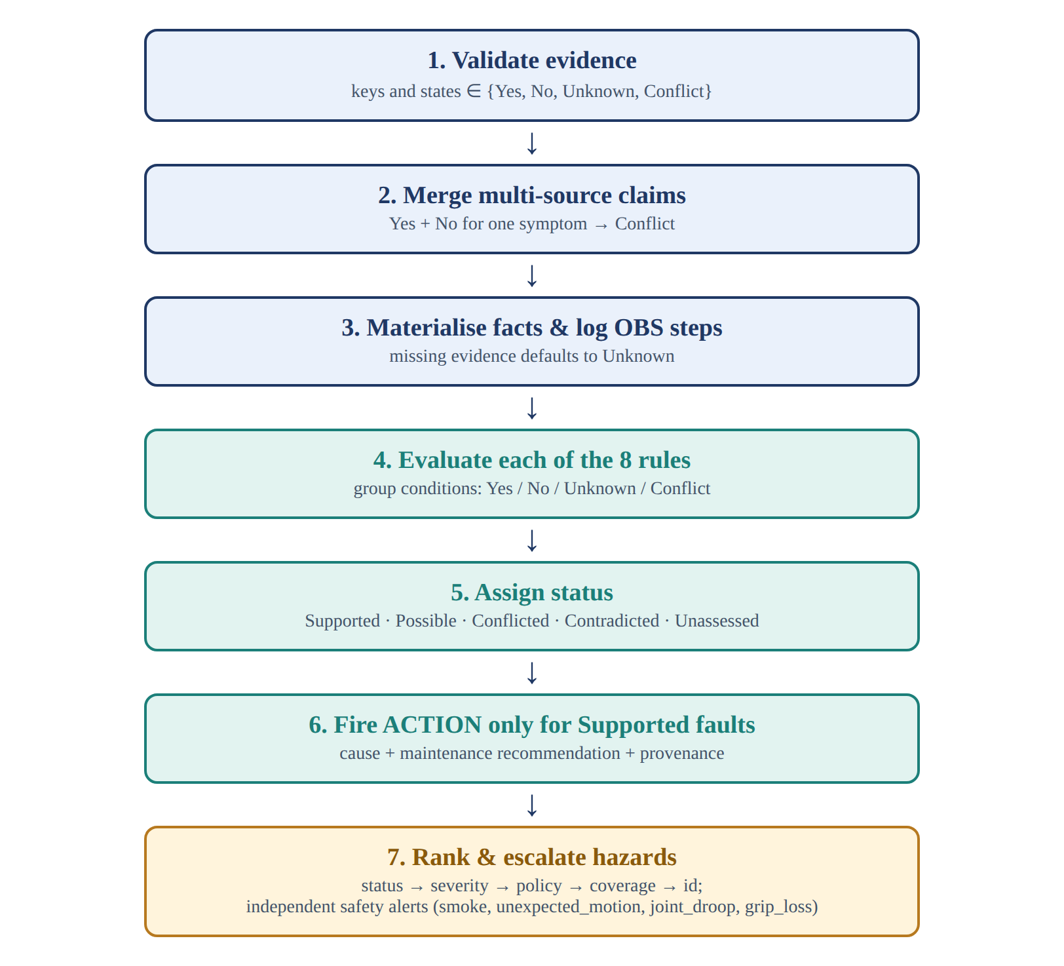
Figure 3: Inference pipeline implemented by diagnose() in engine.mjs.
For each fault rule the conditions are partitioned into Yes / No / Unknown / Conflict groups and one of five statuses is assigned (Table 11).
Table 11: Hypothesis status assigned to each fault rule
Status | Meaning
Supported | All required conditions are Yes — the maintenance action is fired.
Possible | Some conditions are Yes and none is No or Conflict — evidence is incomplete.
Conflicted | At least one condition is Conflict and none is No.
Contradicted | At least one condition is No — the rule cannot hold.
Unassessed | No condition is Yes yet.

Hypotheses are ranked by status → severity → selected policy (Safety first / Lower cost / Less downtime) → coverage → id. Independent safety alerts are emitted for the hazard symptoms smoke, unexpected_motion, joint_droop and grip_loss when they are Yes or Conflict. For F rules with at most K conditions the cost is O(FK) for evaluation plus O(F log F) for sorting; the rule graph is acyclic, so chaining always terminates.
Excerpt: status assignment in dist/engine.mjs
const status = groups.no.length ? 'Contradicted'
: groups.conflict.length ? 'Conflicted'
: groups.yes.length === f.conditions.length ? 'Supported'
: groups.yes.length ? 'Possible' : 'Unassessed';
if (status === 'Supported') trace.push(`RULE ${f.id}: ${f.conditions.join(' AND ')} → fault:${f.id}`);

5.4 Conflict Resolution Strategy
- Multi-source merge (evidence.mjs): if any claim is Yes and any claim is No for the same symptom, the state becomes Conflict.
- Conflicted symptoms cannot count as Yes for rule support, so the hypothesis becomes Conflicted (or stays incomplete).
- The UI lists conflicts; guided mode prioritises unresolved checks.
- A manual override of a symptom clears prior claims for that key (an explicit user choice).
- Hazards that are Yes or Conflict still escalate even if no rule is Supported.
- Ranking never lets cost or downtime outrank Supported / Critical safety ordering.
Table 12: Worked conflict-resolution example (payload_mismatch)
Source claims | Merged state | Effect on the payload rule
Operator: Yes | Yes | Counts as present evidence.
Operator: Yes + Sensor: No | Conflict | Rule becomes Conflicted; not Supported until the source is verified.
No claims | Unknown | Rule stays Possible (if protective_stop = Yes).
Sensor: No only | No | Rule becomes Contradicted.

5.5 Explanation Facility
For each visible hypothesis the UI shows:
- Status badge and severity
- Coverage (% of conditions that are Yes) — not a probability
- Grouped evidence lines (yes / no / unknown / conflict)
- Cause text and, when Supported, the maintenance action
- Provenance string
A reasoning timeline lists OBS / RULE / ACTION steps (shown in Figure 14). Case export includes observations, findings, notes and the trace for viva and audit discussion.

5.6 System Architecture
The system is organised in five layers (Figure 4, Table 13). The knowledge and inference layers are independent of the user interface and are exercised directly by the Node.js regression tests.
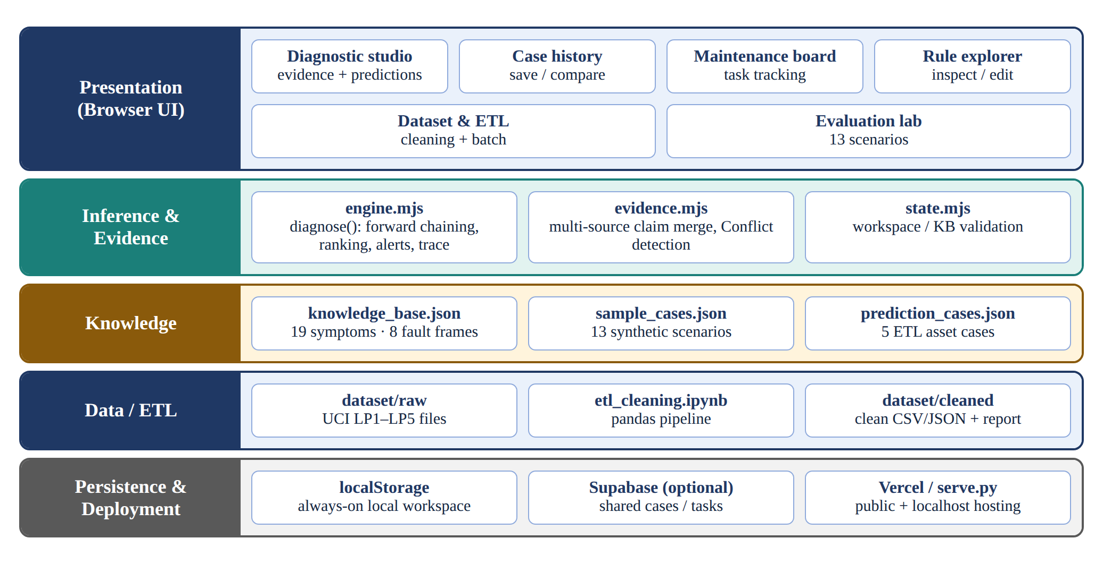
Figure 4: Layered architecture of ARM / INSIGHT.
Table 13: Architecture layers and responsibilities
Layer | Responsibilities
ETL | UCI extract → clean → knowledge map → load, plus UI report
Presentation | Studio, ETL page, cases, maintenance board, rules and evaluation
Inference / Prediction | Four-state rule evaluation, hazards, next-best questions, trace
Evidence | Source categories and conflict merge
Knowledge | JSON frames / rules plus 13 synthetic scenarios
Persistence | localStorage plus optional Supabase upsert / mirror
Deployment | Vercel static site; schema in supabase/schema.sql

5.7 Prediction Facility
In this KBS, prediction means inferring the most plausible fault hypotheses from cleaned or observed evidence using the rule base (not a trained ML classifier).
- Supported predictions fire maintenance recommendations.
- Possible predictions flag incomplete evidence.
- Batch prediction runs on the ETL-built asset cases (prediction_cases.json) from the Dataset & ETL page.
- Coverage % is rule-match completeness, not probability.

6. Dataset / Knowledge Sources
Table 14 lists every dataset and knowledge source. Items marked submit are part of the submission package.
Table 14: Datasets and knowledge sources
Source / Dataset | Type | Size / Records | Purpose | Citation / URL
External sources
UCI Robot Execution Failures | Authentic public dataset (LP1–LP5) | 463 episodes | Robot force / torque after failure detection | [8] https://doi.org/10.24432/C5M89N (CC BY 4.0)
Universal Robots — Understanding Protective Stops | Manufacturer guidance | 1 article | Payload / friction concepts | [1]
Universal Robots — C162 Error Code | Manufacturer error note | 1 page | Incorrect payload / CoG example | [2]
Universal Robots — e-Series Service Handbook | Service manual (PDF) | Protective-stop flow | Troubleshooting reference | [3]
Project artefacts
dataset/raw/uci_robot_failures/*.data | Original UCI files | 5 files | Untouched source download | UCI archive
dataset/raw/uci_robot_failures_instances.csv | Parsed authentic table | 463 instances | ETL extract output | Project file
dataset/etl_cleaning.ipynb | Jupyter ETL (pandas) | DataFrame pipeline | Cleaning + knowledge-map demo | Project file
dataset/cleaned/* | Cleaned information + report | 451 sensor rows | Load for prediction | Project file
knowledge_base.json | Authored rule / frame KB | 8 faults; 19 symptoms | Vocabulary, actions, provenance | Project file [5]
sample_cases.json | Synthetic test cases | 13 scenarios | Regression + demonstration | Project file [5]
Supabase project tables | Cloud datastore | workspaces, cases, tickets | Optional shared persistence | [6]
Automated tests test*.mjs | Software checks | 37 checks (3 suites) | Behaviour regression | Project file

6.A ETL and Cleaning (Dataset → Information)
The ETL step is a must-have for this project. The authentic source is the UCI Robot Execution Failures dataset — force and torque samples recorded after a failure is detected, with each failure described by 15 samples of six measurements (90 features) [8]. It is distributed as five learning problems, LP1–LP5 (Table 15). Local copies are kept under dataset/raw/uci_robot_failures/, with the citation in dataset/raw/SOURCE.md.
Table 15: UCI Robot Execution Failures — the five learning problems
Set | Failure type described | Instances | Share of 463
LP1 | Failures in approach to grasp position | 88 | 19.0 %
LP2 | Failures in transfer of a part | 47 | 10.2 %
LP3 | Position of part after a transfer failure | 47 | 10.2 %
LP4 | Failures in approach to ungrasp position | 117 | 25.3 %
LP5 | Failures in motion with part | 164 | 35.4 %
Total |  | 463 | 100 %

The six ETL steps are summarised in Table 16. The pipeline is demonstrated in dataset/etl_cleaning.ipynb (pandas DataFrames) and visualised on the Dataset & ETL page of the application.
Table 16: ETL pipeline steps
Step | Name | What we do
1 | Extract | Parse UCI LP1–LP5 .data files into an instance DataFrame (class + force / torque summaries).
2 | Clean incomplete | Drop episodes with incomplete 15-sample windows.
3 | Clean missing / outliers | Drop NaNs; remove extreme force / torque absolute-maximum outliers.
4 | Deduplicate | Drop duplicate sensor fingerprints.
5 | Knowledge map | Map UCI failure_class → educational KB symptoms (documented mapping table).
6 | Load | Write cleaned CSVs and prediction cases → app Dataset & ETL page.
Measured cleaning result (current run): 463 UCI instances → 451 sensor rows kept (4 extreme outliers and 8 duplicates removed) → 785 mapped evidence rows → 5 LP-grouped prediction cases loaded into the UI.
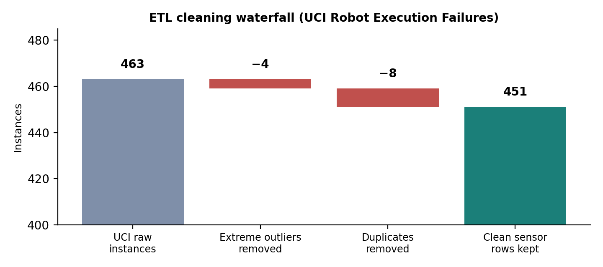
Figure 5: ETL cleaning waterfall: 463 raw instances reduced to 451 clean sensor rows.

Table 17: Noise removed by the cleaning pipeline
Drop reason | Count | Note
incomplete_ft_window | 0 | All episodes had full 15-sample windows
missing_class_or_features | 0 | UCI reports no missing values
extreme_sensor_outlier | 4 | Extreme force / torque absolute-maximum values
duplicate | 8 | Duplicate sensor fingerprints
unmapped_class | 0 | All failure classes map to a KB symptom

CLI refresh: py -V:3.13 dataset/parse_uci_robot_failures.py followed by py -V:3.13 dataset/run_etl_notebook_logic.py.

6. Implementation

6.1 Software / Tools / Libraries
Table 18: Software, tools and libraries
Tool | Role
HTML / CSS / JavaScript (ES modules) | Client-side KBS application
JSON / CSV | Knowledge base, sample cases, raw and cleaned dataset
Python 3 + pandas | etl_cleaning.ipynb, run_etl_notebook_logic.py and the serve.py local server
Node.js (optional) | CLI regression tests (test*.mjs)
Supabase JS (CDN ESM) | Optional cloud sync [6]
Vercel | Public static deployment of dist/ [7]

6.2 Modules and Components
Table 19 lists the application modules; Figures 6–12 show the main screens (captured from the running application).
Table 19: Application modules and their functions
Module / screen | Function
Diagnostic studio | Enter observations; show fault predictions and the reasoning trace.
Dataset & ETL | Show cleaning steps, the noise-drop table and batch prediction.
Case history | Save, reopen and compare investigations (with a KB snapshot).
Maintenance board | Track Open / In progress / Completed tasks.
Rule explorer | Inspect and edit educational rules with validation.
Evaluation lab | Run the 13 authored scenarios.
Viva demo button | Scripted walkthrough: payload → conflict → evaluation.
Cloud sync | Push / pull workspace when Supabase keys are configured.

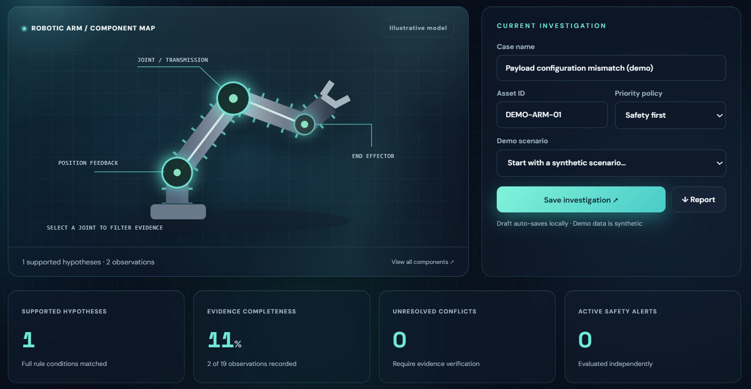
Figure 6: Diagnostic studio — component map, current investigation and live metrics (payload scenario loaded).
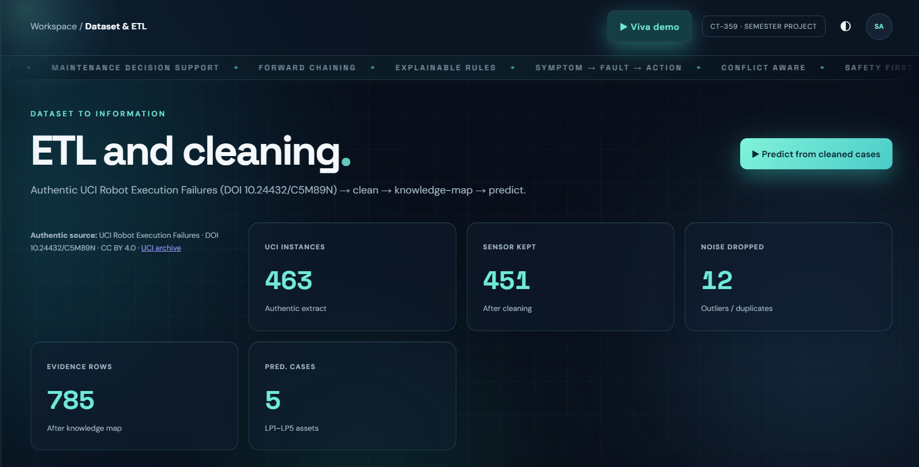
Figure 7: Dataset & ETL page — authentic source citation and cleaning metrics (463 → 451 sensor rows, 785 evidence rows, 5 cases).
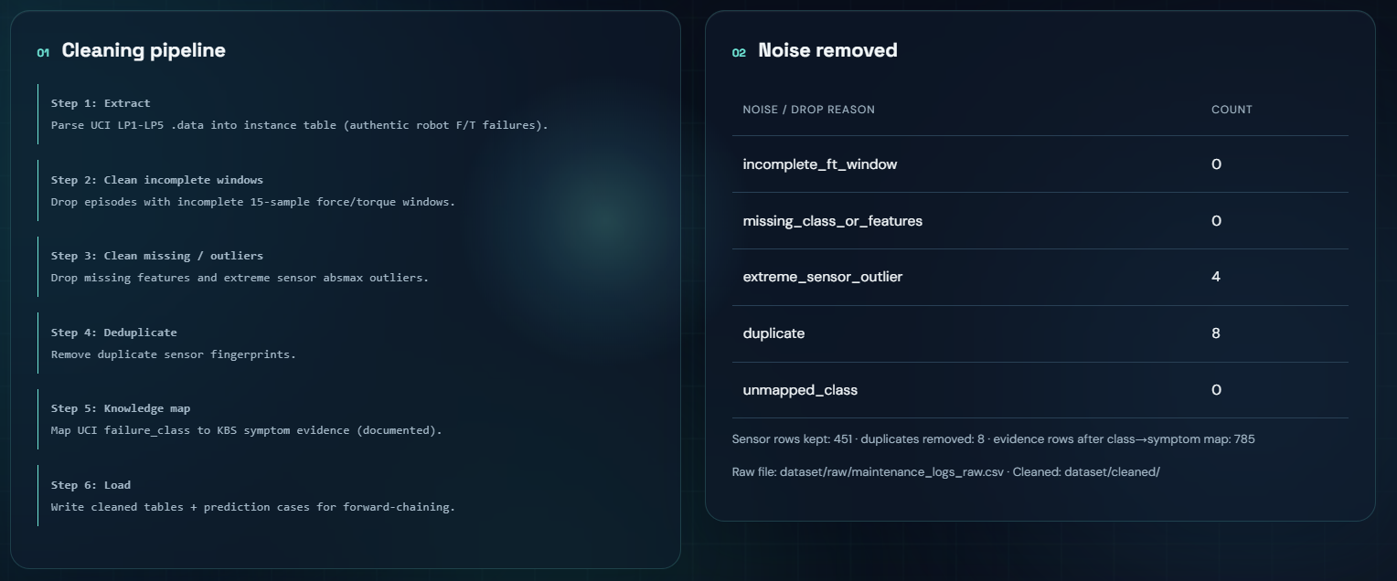
Figure 8: Dataset & ETL page — six-step cleaning pipeline and the noise-removed table.
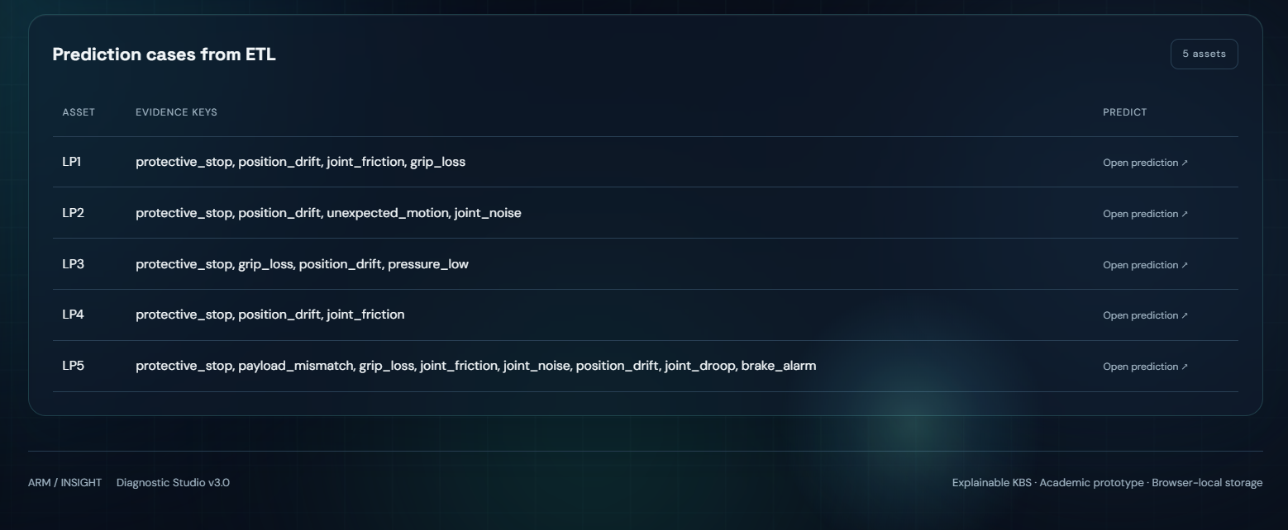
Figure 9: Dataset & ETL page — batch predictions from the cleaned UCI asset cases (LP1–LP5).
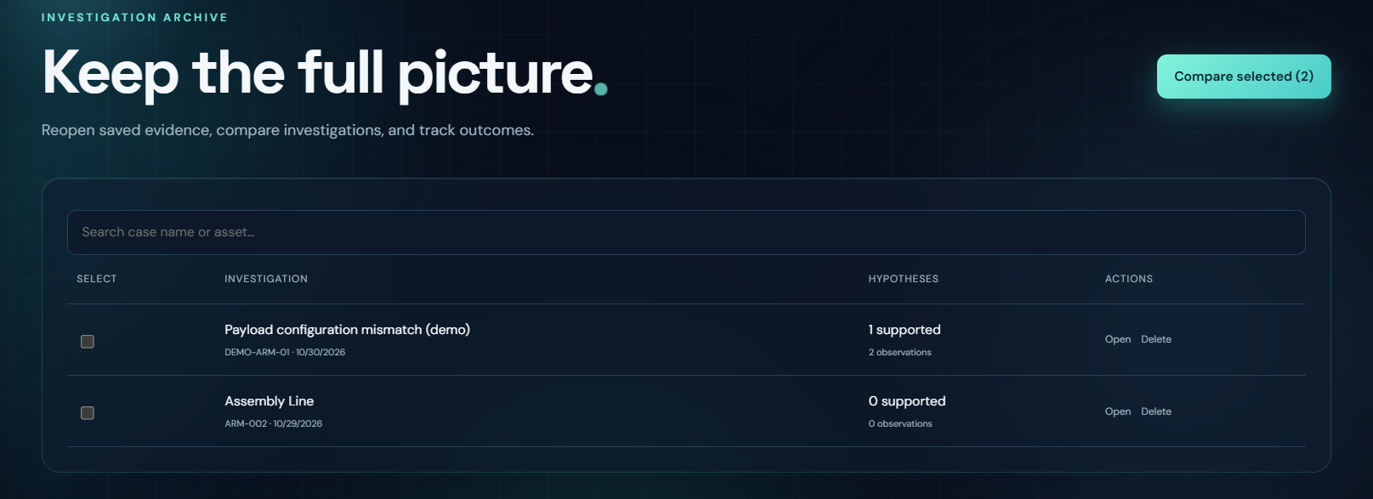
Figure 10: Case history — saved investigation with search, selection and comparison.
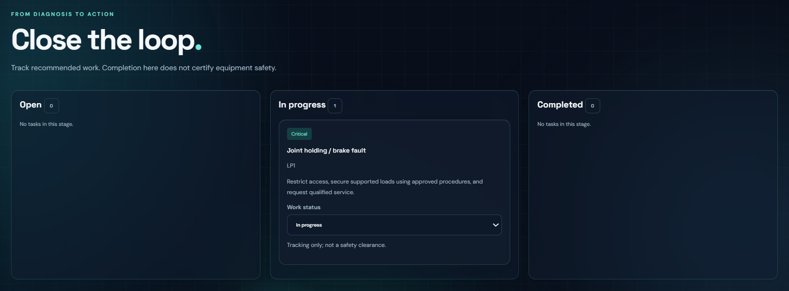
Figure 11: Maintenance board — the recommended task appears in the Open column of the Open / In progress / Completed workflow.
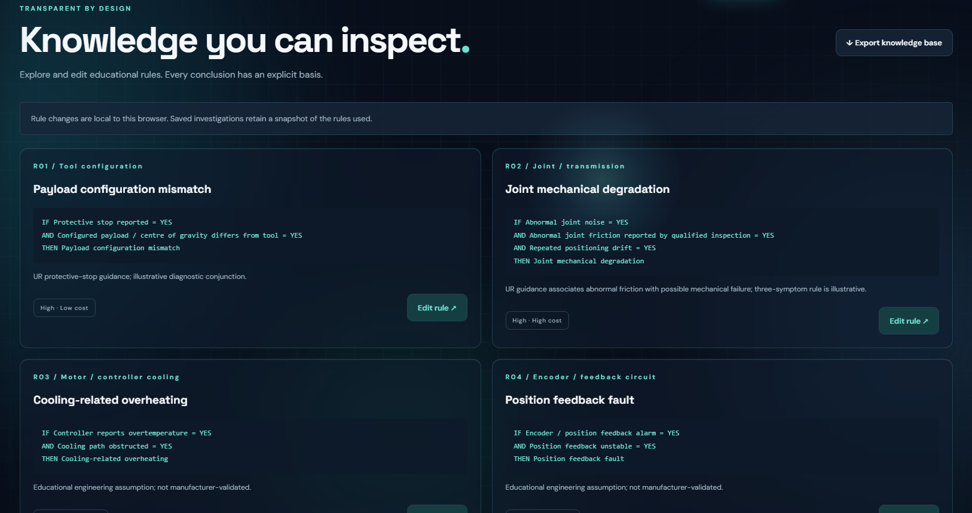
Figure 12: Rule explorer — every diagnostic rule with its conditions, severity and provenance.

6.3 Code Structure
Table 20: Repository structure and file roles
Path | Role
dataset/raw/uci_robot_failures/ | Authentic UCI LP1–LP5 source
dataset/cleaned/ | Cleaned data + ETL report
dataset/etl_cleaning.ipynb | Extract → clean → map → load
dist/index.html | Shell UI, ambient motion layer, splash
dist/app.mjs | Events, rendering, ETL UI, predictions
dist/engine.mjs | diagnose() — inference / prediction core
dist/evidence.mjs | Claim merge + validation
dist/state.mjs | Workspace / KB validation
dist/cloud.mjs | Supabase pull / push
dist/config.mjs | Supabase URL / anon key (empty = offline)
dist/knowledge_base.json | Frames + rules
dist/etl_cleaning_report.json | UI copy of the cleaning audit
dist/prediction_cases.json | UI copy of the ETL prediction cases
dist/sample_cases.json | Synthetic scenarios
dist/style.css / polish.css | Layout + glass / motion styling
serve.py | Localhost server
supabase/schema.sql | Tables + educational RLS policies
vercel.json | Publish dist/
test.mjs, test-state.mjs, test-evidence.mjs | Automated checks

6.4 User Inputs and Outputs
Table 21: Inputs accepted and outputs produced
Direction | Details
Inputs | Symptom states or multi-source claims; case name; asset ID; notes; priority policy (Safety first / Lower cost / Less downtime); optional rule edits; optional restore backup / cloud sync.
Outputs | Ranked hypotheses; next-best questions; safety alerts; reasoning trace; maintenance tasks; case comparison; text investigation report; KB export; workspace backup JSON; mirrored rows in Supabase when enabled.

7. Testing and Results

7.1 Synthetic Evaluation Lab (13 / 13)
All 13 authored scenarios matched the expected Supported fault-id sets under the default rules (Table 22, Figure 13).
Table 22: Evaluation-lab scenarios and results
# | Scenario | Expected supported | Result
1 | Payload configuration mismatch | payload | PASS
2 | Joint mechanical degradation | mechanical | PASS
3 | Cooling-related overheating | thermal | PASS
4 | Position feedback fault | encoder | PASS
5 | Pneumatic grip fault | gripper | PASS
6 | Communication connection fault | communication | PASS
7 | Power supply fault | power | PASS
8 | Joint holding / brake fault | brake | PASS
9 | Insufficient evidence | (none) | PASS
10 | Conflicting payload reports | (none) | PASS
11 | Negative evidence | (none) | PASS
12 | Two simultaneous faults | payload, gripper | PASS
13 | Immediate safety escalation | (none) + safety alert | PASS

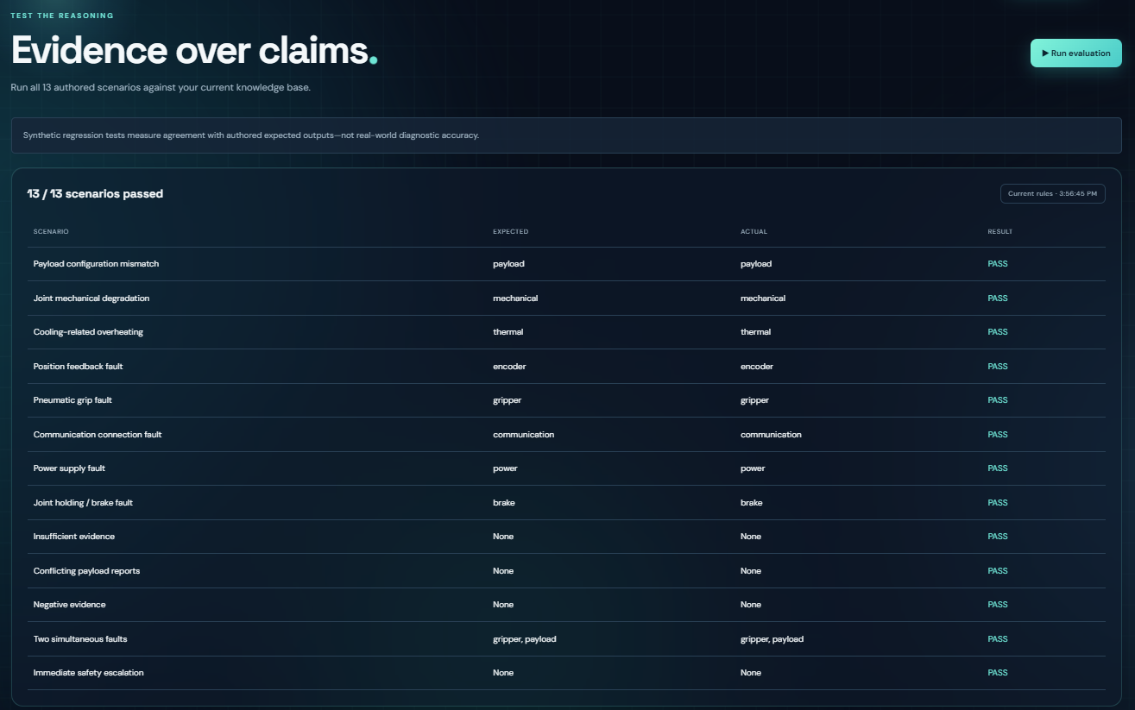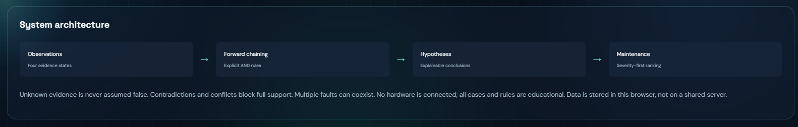
Figure 13: Evaluation lab after “Run evaluation”: all scenarios pass with expected and actual hypotheses shown.

7.2 Automated Node Checks
The three CLI suites were re-run for this report with node test.mjs, node test-state.mjs and node test-evidence.mjs:
Table 23: Automated test-suite output
Suite | Output | Checks
test.mjs | 13 sample scenarios and 8 inference checks passed. | 21
test-state.mjs | 9 workspace and rule validation checks passed. | 9
test-evidence.mjs | 7 evidence-source tests passed. | 7
Total |  | 37 — all passed
The inference checks verify Possible vs Supported, Contradicted, Conflicted, hazard alerts, multi-fault ordering under each policy and invalid-evidence rejection; the state and evidence suites verify workspace / rule validation and source-merge behaviour. These check software behaviour, not field diagnostic accuracy.

7.3 Manual and Demonstration Checks
Key behaviours were also verified in the running application (Figures 14–17).
- Demo scenario loads findings and trace.
- Operator Yes + Sensor No → Conflict blocks support.
- Case save survives refresh (localStorage); Sync mirrors to Supabase when configured.
- Guided mode advances unanswered checks.
- Case compare, maintenance-task status, and rule edit + re-run evaluation.
- Deployed URL loads the same static client.
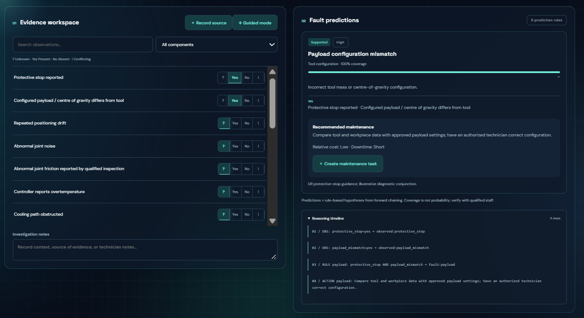
Figure 14: Supported fault: protective_stop = Yes and payload_mismatch = Yes fire the payload rule, with the cause, recommended action and the 4-step reasoning timeline.
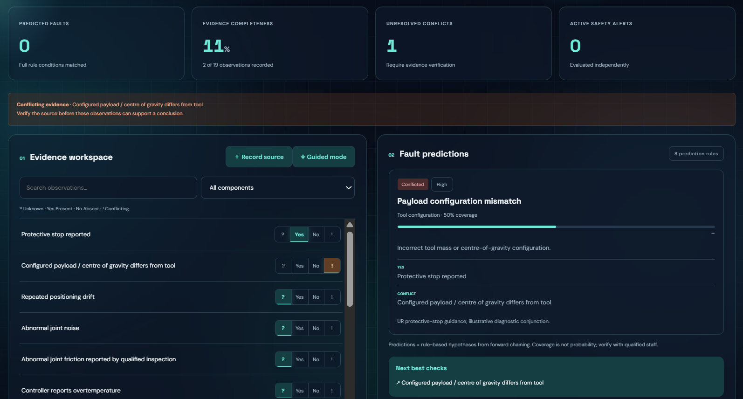
Figure 15: Conflict handling: the payload symptom is Conflicting, so the hypothesis is “Conflicted” with 50 % coverage and a next-best check is suggested.
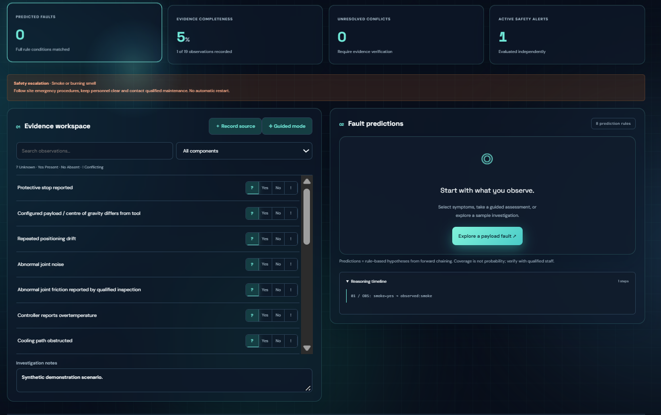
Figure 16: Immediate safety escalation: hazard symptoms raise an independent alert even when no fault rule is Supported.
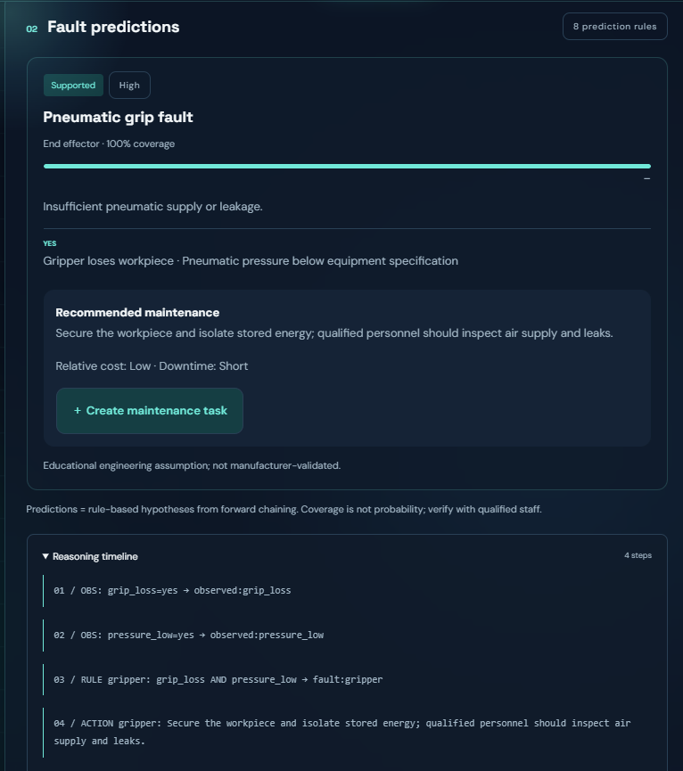
Figure 17: Two simultaneous faults: payload and gripper rules are both Supported and listed together with their actions.

8. Evaluation, Limitations and Conclusion

8.1 Evaluation of the Proposed Approach
Table 24 compares the chosen rule-based forward-chaining approach with the main alternatives against the criteria named in CLO 3.
Table 24: Evaluation of rule-based forward chaining against alternatives (CLO 3)
Criterion | Rule-based forward chaining (chosen) | Alternative / trade-off
Explainability | Every condition and derived action is inspectable. | ML needs labels and post-hoc explanation.
Incomplete evidence | Unknown ≠ No; rules stay Possible. | Bayesian methods need calibrated probabilities (not supplied).
Safety | Independent hazard alert and severity-first ranking. | Still requires human procedures.
Cost / availability | Secondary qualitative ordering. | Needs real plant numbers.
Maintainability | Editable JSON rules and a regression suite. | A large ontology / graph may scale better across many asset types.
Screening style | Natural for “given these observations, what fires?” | Backward chaining is better if a single target fault is already suspected.

8.2 Limitations
- Generic arm; only eight fault hypotheses.
- Qualitative cost / downtime; no live telemetry or model-specific thresholds.
- Source categories are not authenticated or credibility-weighted.
- Conflicts wait for human resolution.
- Supabase demo policies are intentionally open (educational) — not production security.
- Regression PASS ≠ industrial accuracy or safety clearance.

8.3 Future Improvements
- Bind knowledge to a specific robot model and approved manuals.
- Acquire expert-labelled incident cases; measure precision / recall and missed-hazard rate.
- Import timestamped alarms; weight source reliability.
- Add authentication and audit logging on the shared store.
- Optionally enrich with a lightweight ontology / graph view for cross-equipment reuse, while keeping rule explanation.

8.4 Conclusion
ARM / INSIGHT demonstrates how a KBS can represent industrial robotic-arm knowledge, analyse incomplete stakeholder requirements and apply justified forward-chaining inference with conflict handling and explanations. Synthetic tests and a deployable prototype support course demonstration. The system’s academic value is transparency; real deployment requires model-specific knowledge acquisition and independent validation.

9. References
[1] Universal Robots, “Understanding Protective Stops.” https://www.universal-robots.com/articles/ur/robot-care-maintenance/understanding-protective-stops/ (accessed 2026-10-23).
[2] Universal Robots, “C162 Error Code.” https://www.universal-robots.com/manuals/EN/HTML/SW5_19/Content/prod-err-codes/topics/CODE_162.html (accessed 2026-10-23).
[3] Universal Robots, “e-Series Service Handbook — Protective Stop.” https://www.universal-robots.com/manuals/EN/PDF/SW5_24/service-manual_e-series/e-Series_Service_Manual_en.pdf (accessed 2026-10-23).
[4] NED University of Engineering and Technology, Knowledge-Based Systems (CT-359) Complex Computing Problem brief and report template, 2026.
[5] ARM / INSIGHT project package: knowledge_base.json, sample_cases.json, inference engine and tests, version 2.1, 2026. https://github.com/MTahaFarrukh/arm-insight-kbs
[6] Supabase documentation — client libraries and Row Level Security (project educational use), 2026.
[7] Vercel documentation — static site deployment, 2026.
[8] L. Lopes and L. Camarinha-Matos, “Robot Execution Failures” [Dataset], UCI Machine Learning Repository, 1998. https://doi.org/10.24432/C5M89N (CC BY 4.0).

Appendix A. Requirement Traceability
Table 25: Requirement traceability matrix
Brief requirement | Implementation evidence
Knowledge representation (CLO 1) | JSON symptom dictionary; eight component / fault / cause / action frames.
Problem analysis (CLO 2) | Section 4 — stakeholders, incomplete requirements, constraints, assumptions.
Algorithm assessment (CLO 3) | Sections 5.3 and 8.1 — forward chaining vs alternatives.
Conflicting information | Multi-source Yes + No → Conflict; blocks Supported.
Explanation and safety | Trace, condition groups, independent hazard alerts.
Dataset and results | UCI 463 episodes + ETL; 13 / 13 evaluation PASS; 37 CLI checks PASS.
Deployable demo | https://arm-insight-kbs-dist.vercel.app/ and localhost serve.py.

