

Name : Muhammad Taha Qadri Rizivi

Father’s Name: Muhammad Taufiq

Class: BSCS 2nd year (3rd Semester )

Section : “B”

Seat No: EP-1649065

Submitted to : Sir Muhammad Fahad

*Object-Oriented Programming (OOP)*

*Project Documentation*

*Blood Bank Management System*

*Blood Bank Management System:*

The main aim of developing this Blood Bank Management System is to provide blood to the people who are in need of blood. The number of persons who are in need of blood are increasing in large number day by day. Using this app user can search blood group available in the city and he can also get contact number of the donor who has the same blood group he needs. In order to help people who are in need of blood, Blood Bank App can be used effectively for getting the details of available blood groups and user can also get contact number of the blood donors having the same blood group and within the same city. So if the blood group is not available in the blood bank user can request the donor to donate the blood to him and save someone life. Using Blood Bank App people can register himself or herself who want to donate blood. To register in the system they have to enter their contact information like address mobile number etc.

This Blood Bank App is an desktop app so it is easily available to everyone on windows app store to download and install. When a person want to donate blood he have to register to the app. Donor registration is very easy, to get register to the app he have to make an account then fill up registration form. After submitting the registration form his name is available in donors list. Donor have to give information like blood group, contact details etc.

Using this blood bank system people can search blood group available which they are needed. They check it online using our blood bank management website. If in case blood group is not available in blood bank they can also get contact numbers of the persons who has the same blood group he is need. And he can request the person to donate the blood for saving someone life. Our system also allow user to search online the person who have the same blood group he needs and if he find the If he find a donor in his city then we give him all details of the donor, if he doesn’t find any donor then he is given the contact numbers and addresses of the Life Saving Contact Persons for big cities.

*Advantages:*

The people in need of blood can search for the donors of blood type they want. It saves time as he can search donors online without going anywhere. Using this system user can get blood in time and can save his relative or friend life. Our App work 24x7 so user can get information of blood donor any time. Blood donor can also get registered and save life of other person. The main benefit of this system is the information of available blood group. When blood is need in the operation then people have very less time to get the blood available so if he get the information like who can give him blood in time in his city is life saving. And here our app work, whenever a person need blood he get information of the person who has the same blood group he needs.

### *Modules of Blood Bank Management System:*

Online Blood Bank management system is to provide services for the people who are in need of blood by getting help from the donors who are interested in donating blood for the people. There are seven main modules in this system only four modules for and seven for admin.

For User:

* Register
* Patients
* Search
* Donors
* Match Blood
* Edit

For Admin:

* Register
* Patients
* Search
* Donors
* Change
* Match Blood
* To Donate

Register:

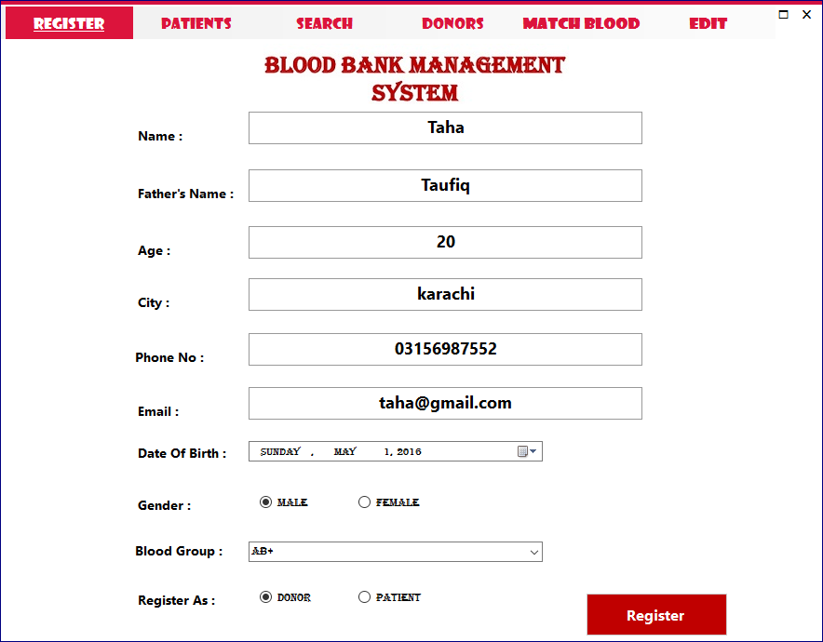

In this module user can register himself/herself as an donor to donate blood or as an patient so they want blood.

Patients:

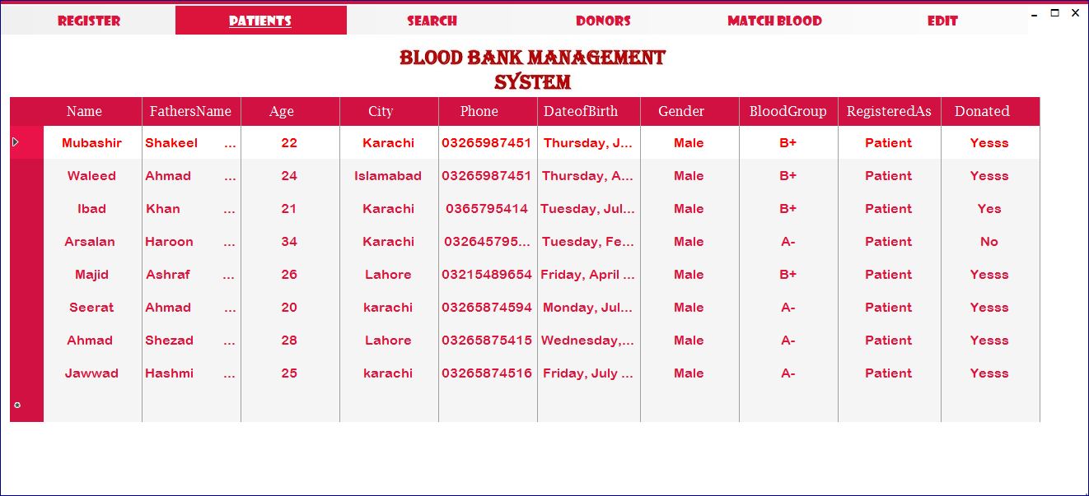

In this module user can see the list of all patients who are registered as an patient so if anyone want to donate the blood to the patient he can easily register and donate blood.

Search:

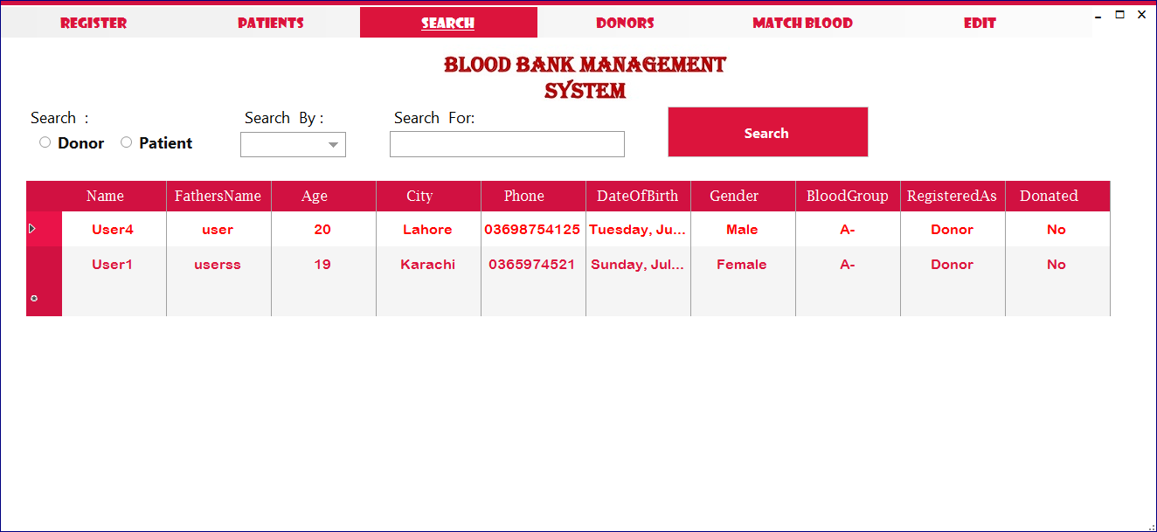

In this module user both patients or donors by their name, age, gender, city, phone no, blood type and all the information they provided

Donors:

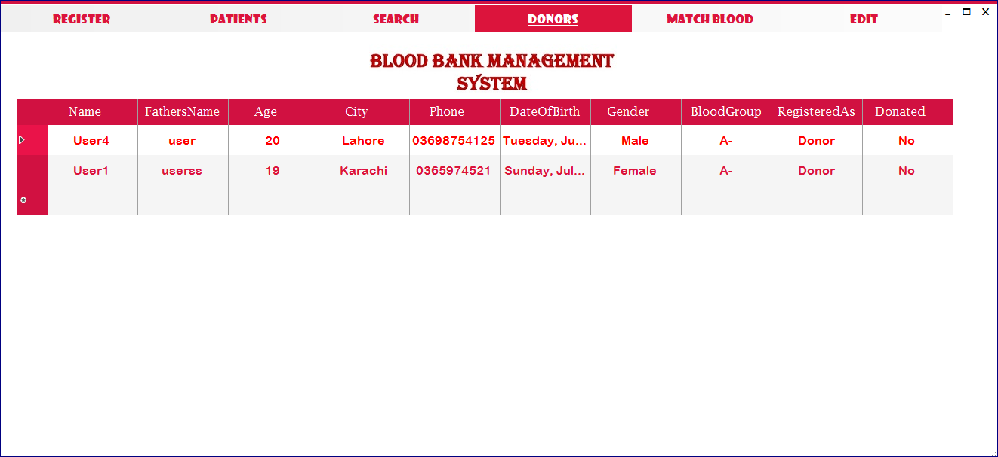

In this module user can see the list of all Donors who are registered as an donors so any user can see the list and to make sure the specific blood type donor is available.

Edit:

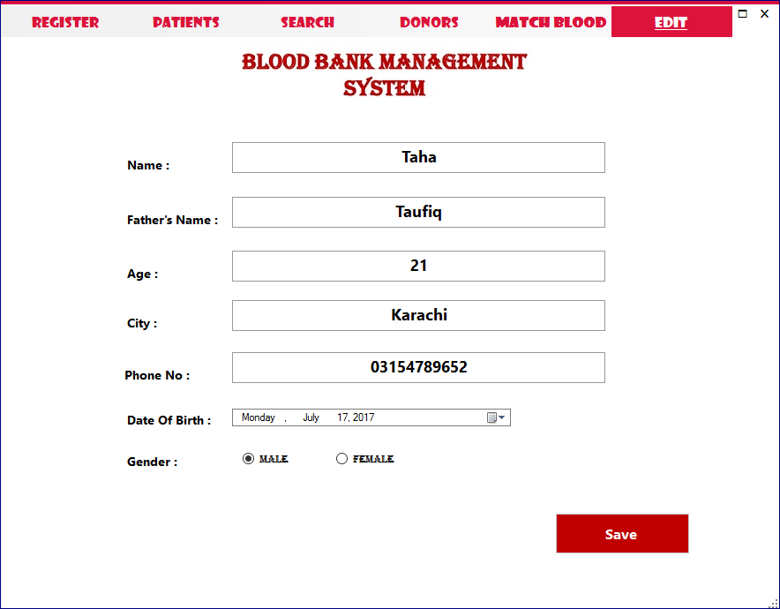

If user by mistake enter the data which is not correct so no problem he/she can easily edit their data by using edit feature and update thier data in database

Match Blood:

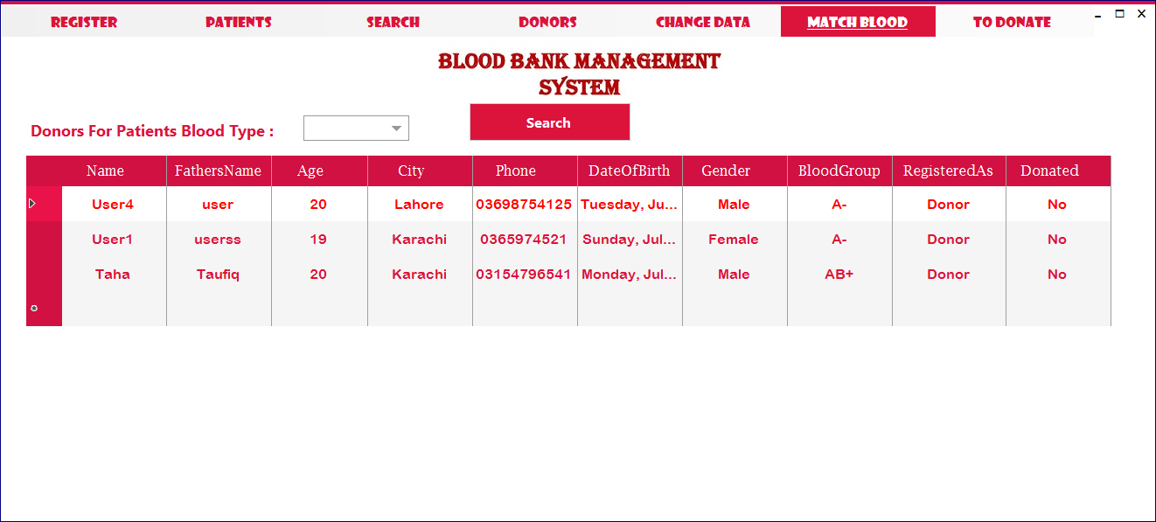

This module is only for admin and in this module admin can search the donors of specific blood type.

Change:

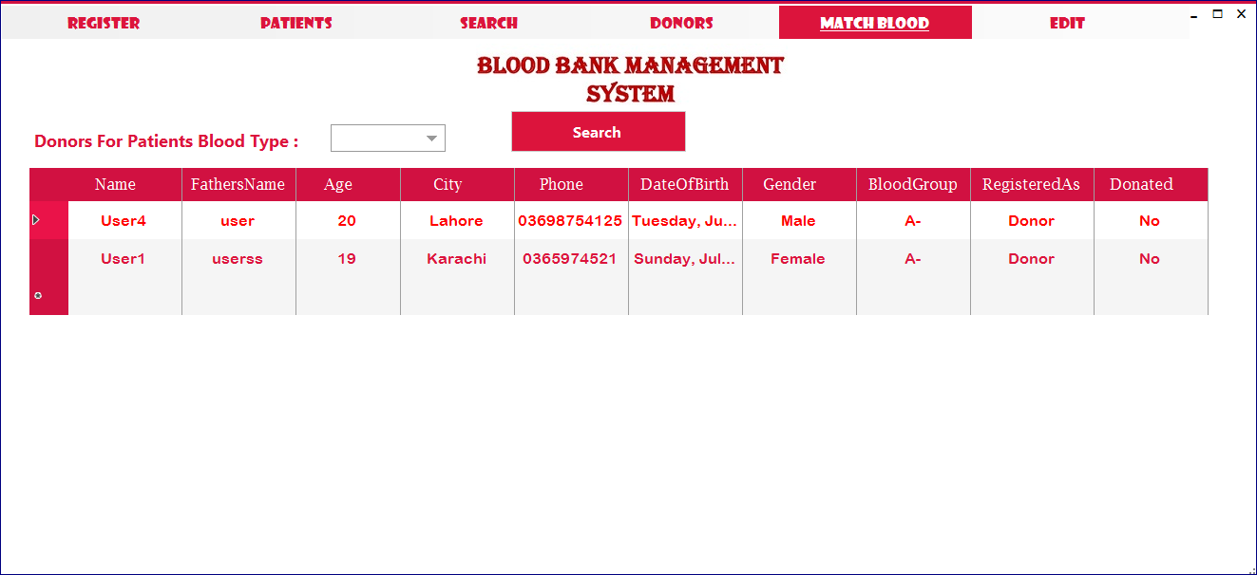

This module is only for admin and in this module admin can edit the information of both patients and donors.

To Donate:

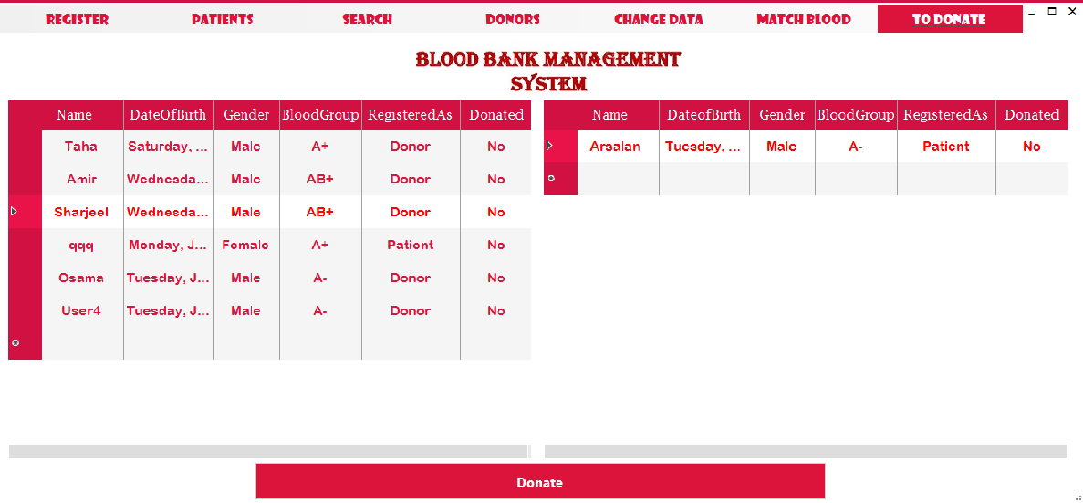

This module is only for admin and in this module admin can update the information of both patients and donors that they both donate the blood.

Object Oriented Programming(OOP) Details:

Blood Bank Management System is consist of nine classes windows form classes and four simple class name as:

Windows form classes:

* Login
* SignUp
* Register
* Patients
* Search
* Donors
* Change Data
* Match Blood
* Edit

Simple classes:

* SignUpData
* LoginData
* RegisterData
* SearchData
* ChangeData
* ToDonateData

Abstract class:

* DonorOrPatient

Simple classes are consists of instance, non-parameterized constructor and -parameterized constructor and different methods which are called in different classes

SignUpData class is consist of few variables, parametrized constructor ,method which is call is signUp class to save the data of user in database

LoginData is use for the purpose to check email and password and allow user to access Blood Bank if data is correct and it is consist of few variables, parameterized constructor and method and one static method which return true if user is an admin otherwise false to check in different classes either user is admin or user

DonorOrPatients is an abstract class which is consist of two method RefreshDonors and RefreshPatinets and three classes are inherited from it which are name as RegisterData, ChangeData, ToDonateData to implement the definition of these two method in different way.

Object of RegisterData is create in Register class to called RegisterOrUpdateDonors and RegisterOrUpdateDonorsPatients Methods and relation between them is compostion.

In Patient class we create object of RegisterData class to called a method name as RefreshPatients to show the updated list of all Patients to users

Object on one class is created in other so they are in Composition relation

Search class called method of SearhData class name as SearchforDonor using object of searchdata class to search the donors and patients details

Donors is used to show the data of all donors who are registered in blood bank management system that’s why the used the method of RegisterData class which are name as RefreshDonors to show the updated list all donors to registered users

ChangeData class is consist of instance ,non-parametrized constructor, parametrized constructor and four method name as updateDonor, updatePatients, DeleteDonors, DeletePatients and they are used in change class for edit the details of donors and patients and delete the record of both only by admin

MatchBlood class is used to show the donors of specific blood type patients which is search by admin or user to donate blood to the patient easily.

Edit class is also created if user wants to change the data in database they can easyly do that by using this class

ToDonateData class is consist of instance ,non-parametrized constructor, parametrized constructor and there methods name as ToDonateBlood, RefreshPatients and RefreshDonors. ToDonateBlood method is called in ToDonate Class by using its object which is created in the same class to update the of both patient and donors that blood is donated to them

And after that refreshDonors and refreshPatients Method are called to refersh the list so user can see updated information every time.

cONTENT:

Blood Bank Management System is created using windows in C# and metro framework is also used with SQl local database.