

Name; Muhammad Talha Ansari

roll # 024

assigned by sir rafay

Which gates are categorized as **UNIVERSAL GATES** and how they are used?

A universal gate is a gate which can implement any Boolean function without need to use any other gate type. **The NAND and NOR gates are universal gates**. In practice, this is advantageous since NAND and NOR gates are economical and easier to fabricate and are the basic gates used in all IC digital logic families.

Working of **NAND gate:**

To prove that any Boolean function can be implemented using only NAND gates, we will show that the AND, OR, and NOT operations can be performed using only these gates.

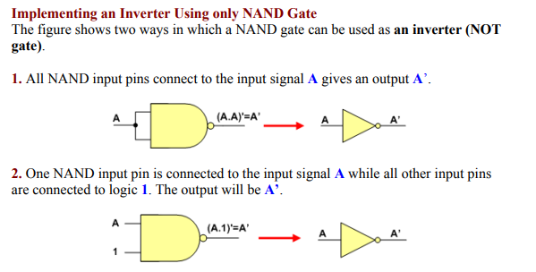

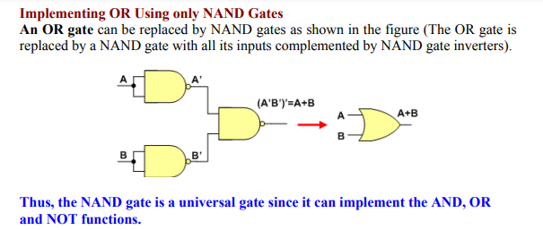

Working of **NOR gate:**

To prove that any Boolean function can be implemented using only NOR gates, we will show that the AND, OR, and NOT operations can be performed using only these gates.

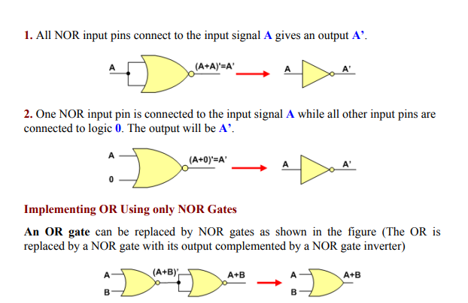

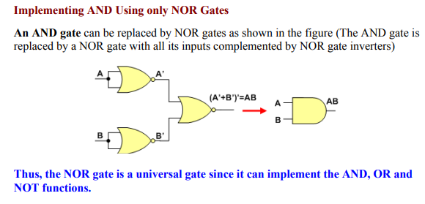

**Verify the Truth Table for AND Gate and OR Gate.**

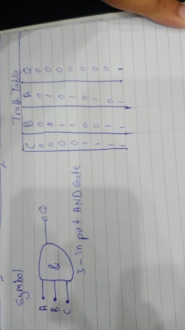

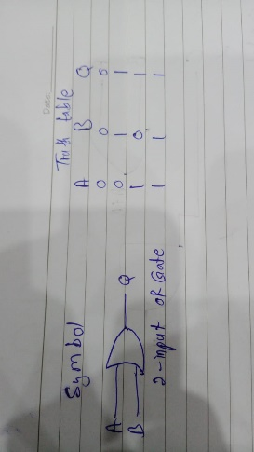

**Verify the Truth Table for NOR Gate and NAND Gate.**

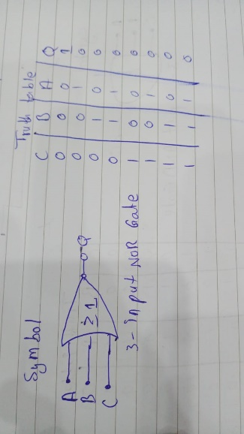

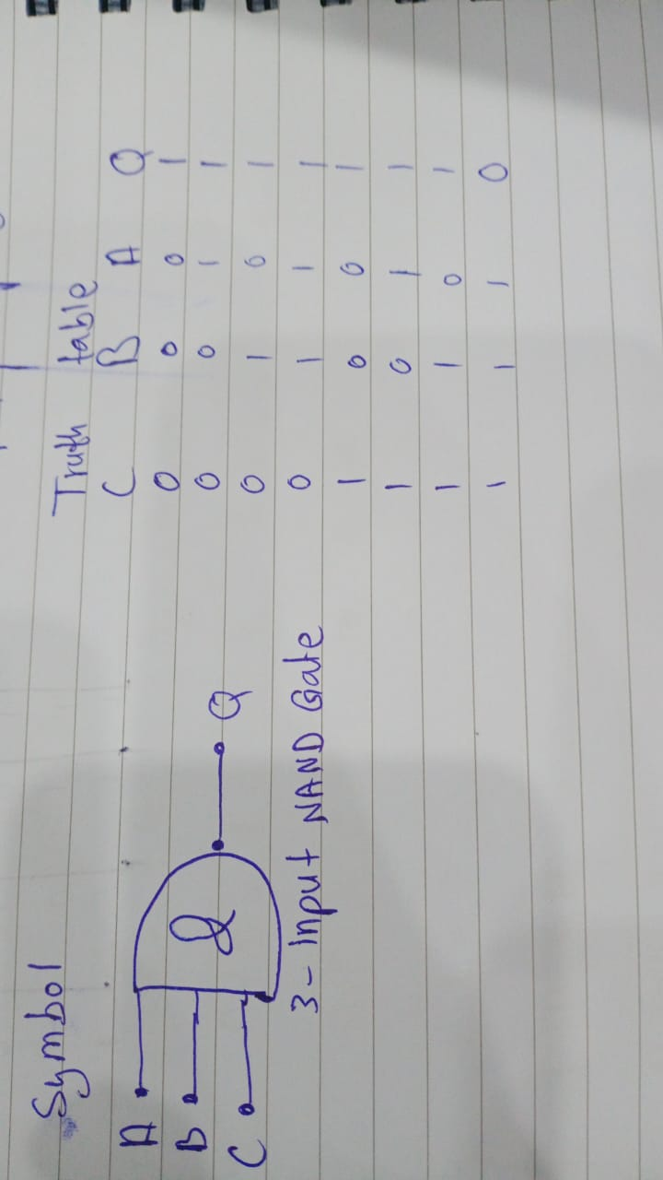

**Verify the Truth Table for XOR Gate and XNOR Gate.**

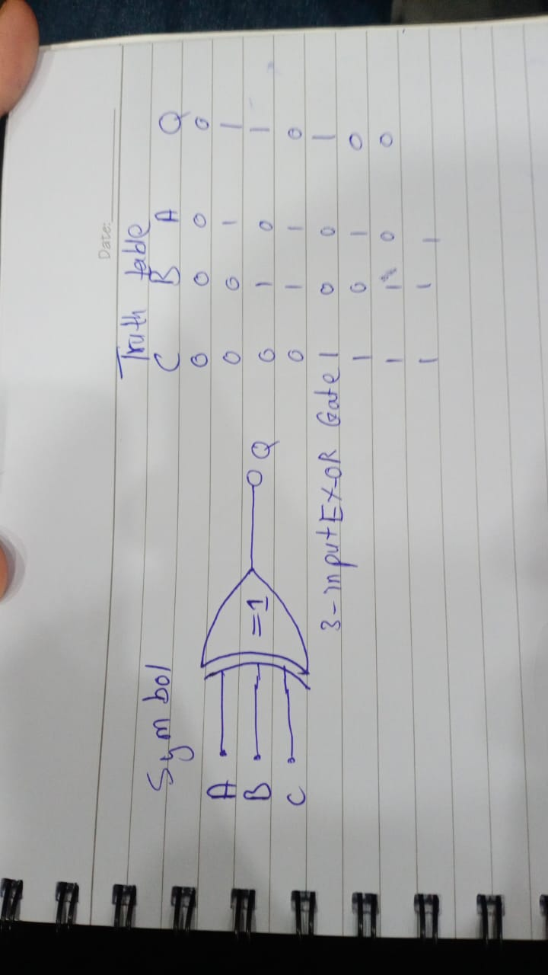

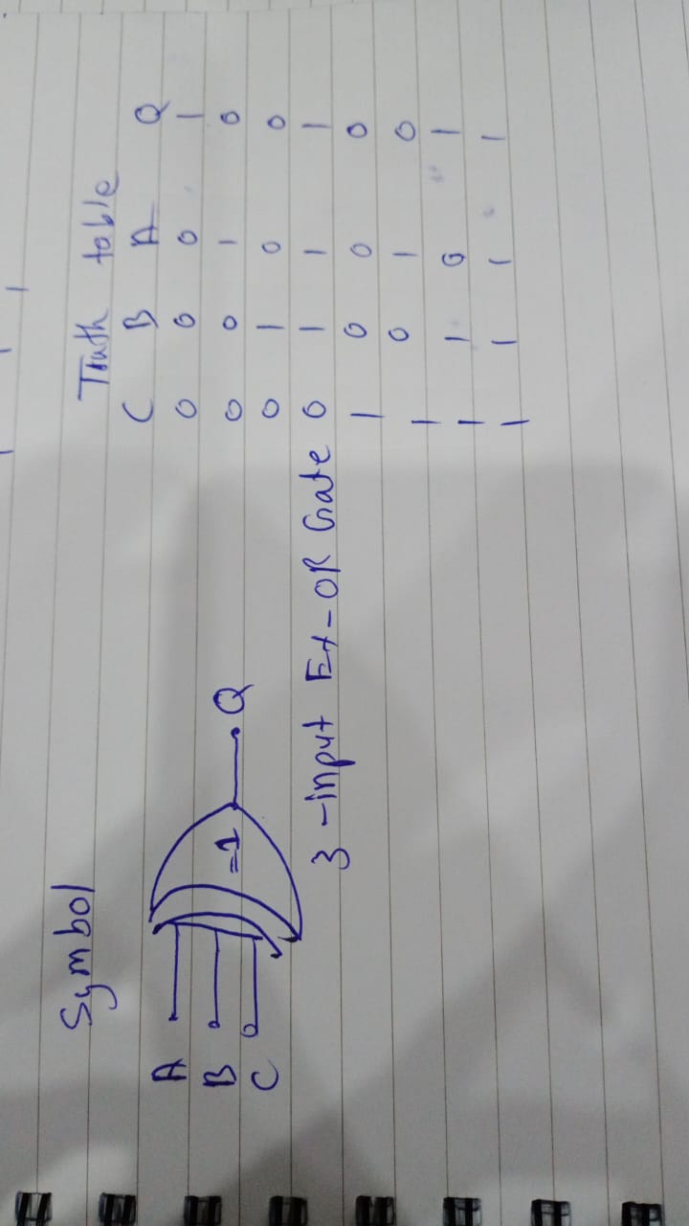

**Convert the following logic gate circuit into a Boolean expression, writing Boolean sub-expressions next to each gate output in the diagram:**

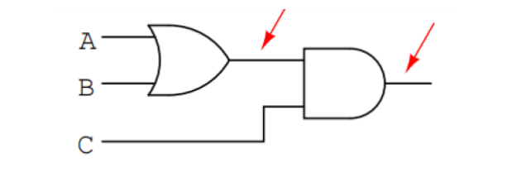

**Answer #1: A+B | Answer #2: A+B.C**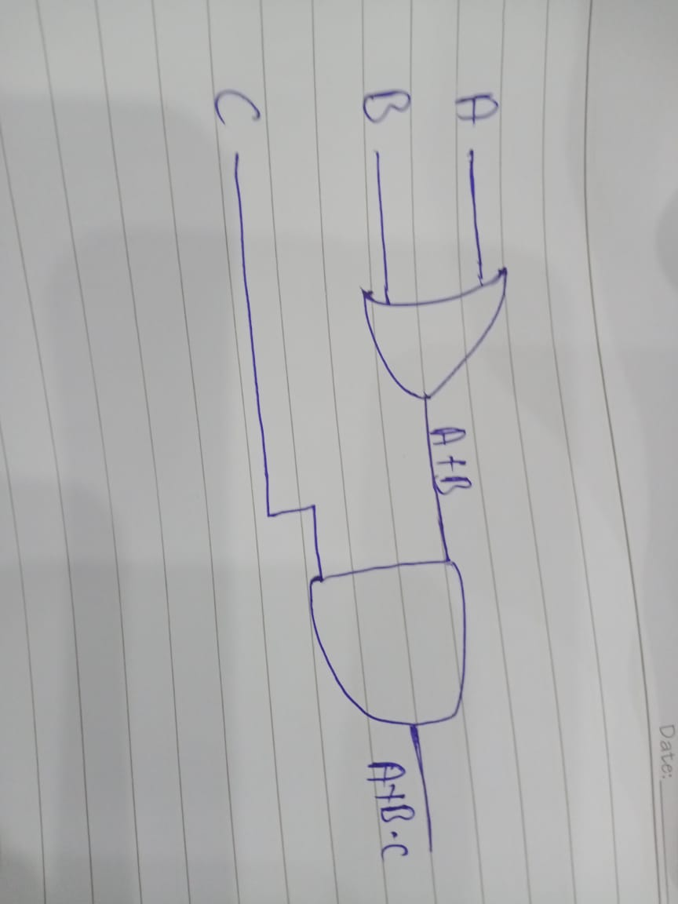

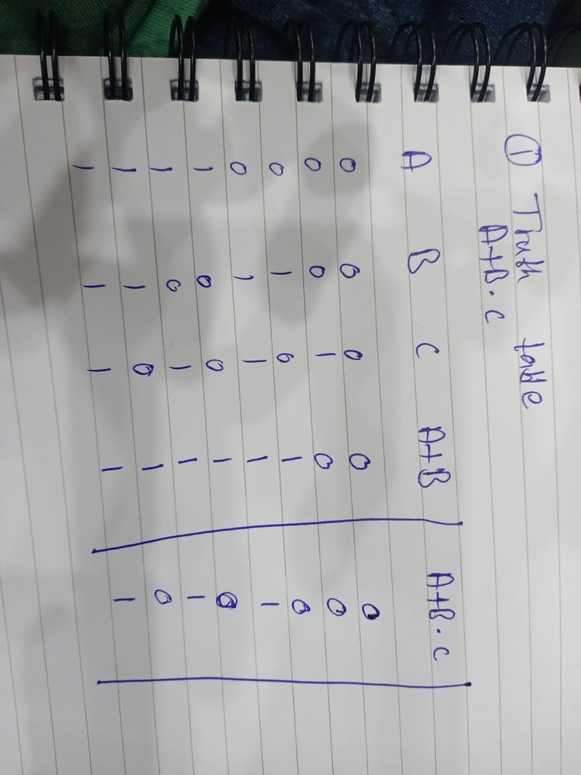

**Draw the following function in Circuit maker**

1. 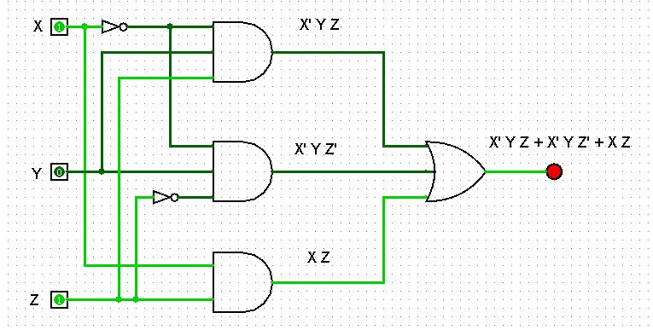**F = 𝑿’YZ + 𝑿’Y𝒁’ + XZ**

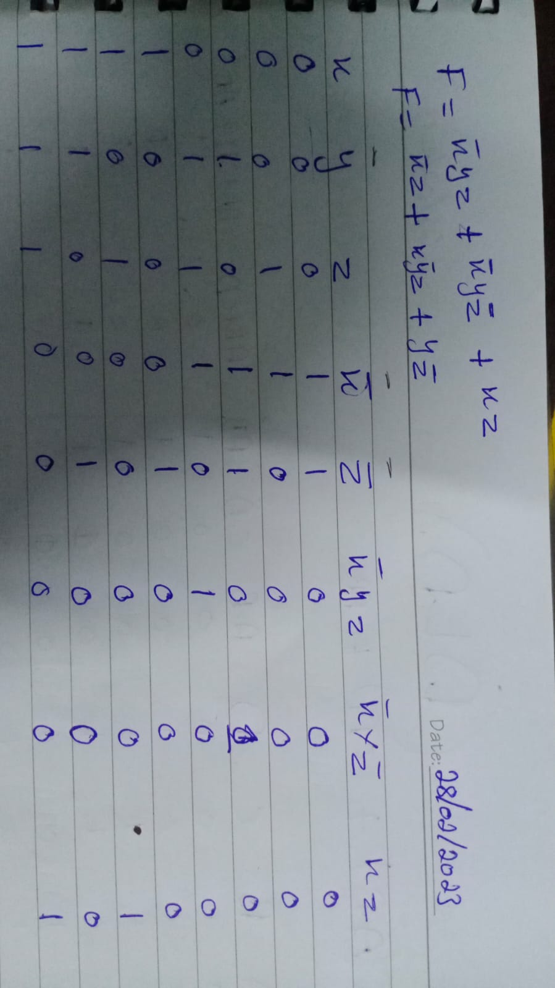

1. 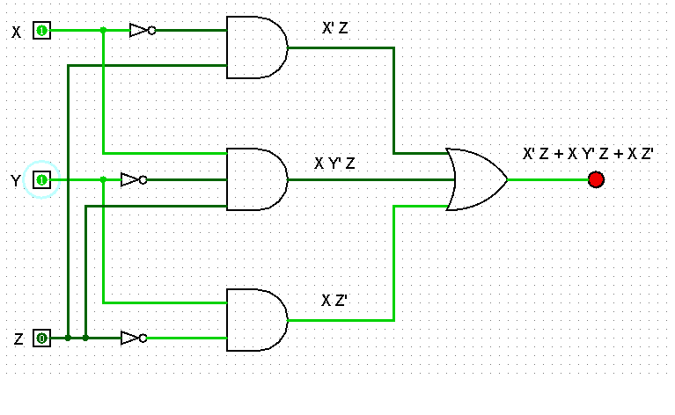**F=𝑿’Z + X𝒀’Z +YZ’**

