**Project Description:**

In this project, you are required to apply following machine learning algorithms to the dataset used in project 1.

1. Linear Regression
2. Logistic Regression
3. Decision Tree
4. Support Vector Machines
5. Principal Component Analysis
6. K-means
7. **Problem formulation:**

Making a classification model for the Iris dataset. The Iris dataset includes characteristics of the sepal length, sepal breadth, petal length, and petal width of iris flowers **(Dimensionality of 4**). Three classes—setosa, versicolor, and virginica—make up the dataset.

The goal is to create a model that can correctly divide fresh iris flower occurrences into their associated classes using the data provided with trait measurements. The model should be highly accurate at predicting the right class labels and be able to generalise effectively to unknown data.

In order to properly categorize iris flowers into their appropriate groups based on the measured qualities and achieve high generalizability and accuracy, the problem must be solved.

1. **Cross validation and Metrics to use for model evaluation [60, 10 per algorithm]**

**Linear Regression**

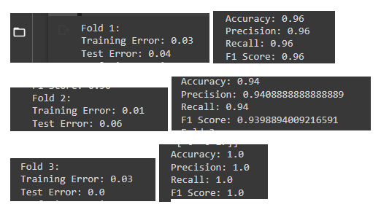

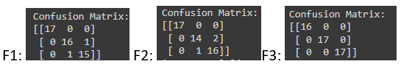

**Logistics Regression**

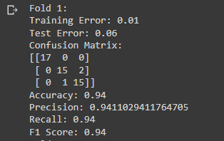 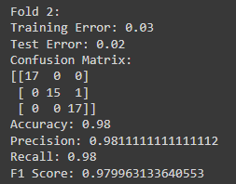 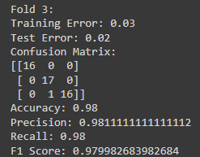

**Decision Tree**

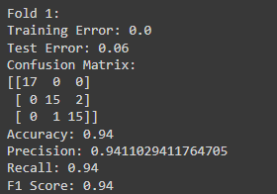 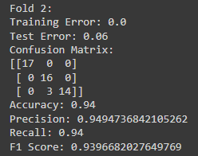 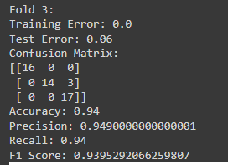

**Support Vector Machines**

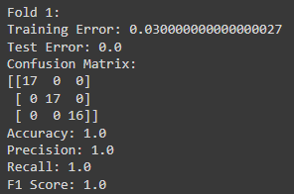 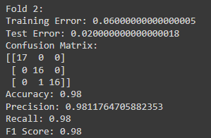 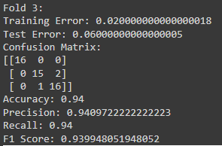

**Principal Component Analysis**

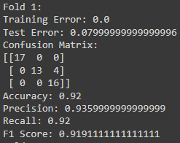 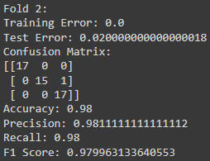 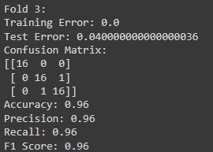

**K-means**

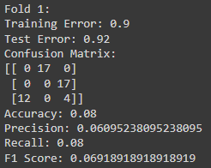 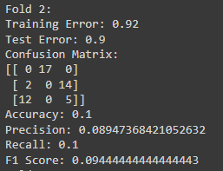 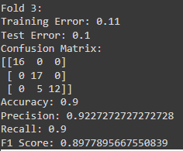

**How to submit**

You have to submit your code files and the documentation.

* Basic code on your own dataset.
* Documentation containing all results.