Final Year Project Report

Fabric Defect Detection using Computer Vision



Project Advisor: Dr Tahir Mushtaq

Submitted By:
Muhammad Talha Qadri F2020376027

Session: 2024

University of Management and Technology

C-II Johar Town Lahore Pakistan

Dedication

"With profound dedication to the fabric industry leaders across Pakistan, this defect detection system is designed to enhance efficiency and streamline operations across all types of fabrics. Our aim is to support you in focusing on what you do best: creating impeccable textiles. As you navigate the intricate threads of this industry, this technology stands not just as a tool, but as a testament to your unwavering commitment to quality and innovation. We hope its capabilities will not only contribute to the growth and success of your enterprises but also bolster the Pakistani textile industry on a global scale. This system is a tribute to your vision and dedication, aiming to position you at the forefront of technological advancement in textile production. May it serve as a catalyst for both cultural and economic growth, elevating Pakistan’s standing in the international fabric industry."

Final Approval

Panel of Examiners

- Head of Department ______________________
Department of Artificial Intelligence
UMT Lahore

- Director (Final Year Projects) ______________________
Department of Artificial Intelligence
UMT Lahore

- Supervisor ______________________
Department of Artificial Intelligence
UMT Lahore

- Co-Supervisor ______________________

Acknowledgements
We, as a dedicated group of three members, take pride in acknowledging our pivotal role in the development of our fabric defect detection system. Working collaboratively, we have been actively engaged in gathering and optimizing real-time data from the industry, ensuring that our dataset is comprehensive and reflective of actual manufacturing challenges. This collective effort has been instrumental in producing a valued product that aligns seamlessly with industry needs.

Our sincere thanks go to our investors who believed in our vision and provided crucial support throughout this journey. Their trust has been a driving force, allowing us to innovate and contribute meaningfully to the field of fabric defect detection.

We extend our gratitude to all contributors, including our team members and industry partners, for their unwavering commitment and support in shaping this advanced solution.

Abstract
This project presents an innovative approach to detecting defects in fabrics using advanced computer vision techniques, addressing a critical need in Pakistan’s textile industry. We developed a real-time defect detection system by harnessing the power of deep learning, aiming to enhance the quality control processes in textile manufacturing.

The core of this research involved the collection of a comprehensive dataset directly from the manufacturing floors of various textile industries especially from Faisalabad and across Pakistan. The dataset, encompassing a diverse range of fabrics and defect types, was meticulously per-processed and labeled to facilitate effective model training.

We employed both pretrained models such YOLO V8, InceptionV3, EfficientNet, ResNet & U-Net and custom-built deep learning model for defect detection. The pretrained models were adapted to suit the specific requirements of fabric defect detection, while the custom models were innovatively designed to capture the unique characteristics of textile defects. These models were rigorously trained and validated using our dataset, ensuring robustness and accuracy.

Initial results demonstrate a promising capacity of the system to accurately identify a wide array of fabric defects. These findings not only exhibit the potential of computer vision in quality control but also lay the groundwork for further research and development in this field. Through this project, we aspire to contribute to the elevation of Pakistan's textile industry, enhancing its efficiency and global competitiveness through technological innovation.

Contents.
Acknowledgements 4
Abstract 5
Contents 6
Definitions and Acronyms 7
1. Introduction 9
1.1 Problem Overview 9
1.2 Research Questions 9
1.3 Research Objectives 9
1.4 Scope 10
1.4 Methodology 10
1.5 Significance/ Potential Applications 10
2. Background 11
3. Literature review 12
4. Proposed Methodology 14
5. Design and Implementation 19
6. Evaluation 22
a. Experimentation 22
b. Results 22
c. Discussion/Analysis 22
7. Conclusion and Future work 24
8. References/ Bibliography 25
9. Appendix 26
a. Glossary of terms 26
b. Pre-requisites 26
c. Reference/ Source Documents 26

Definitions and Acronyms
Definitions
Fabric Defect Detection System:
A computerized system utilizing computer vision and deep learning techniques to identify and classify defects in fabrics, such as stains, holes, lines or marori and normal fabric.
Classifiction:
A computer vision task in we simply classify objects into sub-category.
Segmentation:
A computer vision task involving the identification and delineation of individual objects within an image, providing a detailed outline for each object.
Pre-trained Models:
Neural network models that have been trained on a large dataset for a specific task before being fine-tuned for a particular application.
Real-time Data:
Data collected and processed immediately as it becomes available, providing up-to-the-moment information from the fabric industry production floors.
Data Preprocessing:
The preparation and enhancement of raw data, including cleaning, resizing, normalization, and augmentation, to make it suitable for training machine learning models.
Model Fine-Tuning:
The process of adjusting a pretrained model's parameters to adapt it for a specific task or dataset.

Acronyms
- CV: Computer Vision
- DL: Deep Learning
- RGB: Red, Green, Blue (Color channels in an image)
-HSV: Hue, Saturation, Value (Color space)
- ROI: Region of Interest
- IoU: Intersection over Union
- API: Application Programming Interface
- CNN: Convolutional Neural Network
- ML: Machine Learning
- QC: Quality Control

Introduction

Problem Overview
In the textile industry of Pakistan, ensuring the highest quality of fabric is paramount to maintaining competitive advantage in the global market. The traditional approach to fabric defect detection, primarily reliant on manual inspection, is fraught with inefficiencies. These methods are time-consuming, labor-intensive, and prone to human error, leading to inconsistent quality control and increased production costs. W. Ouyang, B. Xu, J. Hou, and X. Yuan, ‘’in their research, highlight that in contrast to the 60–75% defect detection accuracy of human visual analysis, a typical state-of-the-art automatic fabric inspection system can attain an impressive detection rate of up to 90%’’ .The challenge lies in automating this process to achieve a high level of accuracy and efficiency in defect detection. The project aims to tackle this issue by harnessing computer vision and deep learning technologies, offering a sophisticated solution to a longstanding industrial problem.

Research Questions
This research is driven by several critical questions:

- How can advanced computer vision and deep learning techniques be adapted to accurately detect various types of fabric defects?
- What are the most effective ways to process and analyze the complex, varied data obtained in real-time from textile manufacturing environments?
- How can existing deep learning models be fine-tuned and optimized for the specific task of identifying and classifying defects such as Lines or Twisted Thread (marori), Stains, Holes or cuts, and Normal fabric?
- How does camera selection impact on-loom fabric image acquisition in fabric defect detection systems?

Research Objectives
The primary goal of this research is to investigate, design and develop an automated prototype for fabric defect detection that leverages the capabilities of computer vision and deep learning. The objectives include:

- Developing a reliable method for the accurate detection and classification of a range of fabric defects commonly encountered in the textile industry.
- Adapting and fine-tuning existing pre-trained deep learning models to meet the specific needs of fabric defect detection.
- Overcoming the challenges associated with processing and interpreting real-time data from industrial environments.
According to a systematic literature review (Hanbay, Talu, & Özgüven, 2016),he choice between area scan and line scan cameras is crucial for on-loom fabric image acquisition. Line scan cameras, synchronized with fabric movement through encoders, enable rapid image capture in the form of lines, ensuring accurate defect detection.

Scope
The scope of this project is specifically tailored to address the needs of the Pakistani textile industry in quality control. Key areas of focus include:
- Creating an detection or instance segmentation or classification based system capable of identifying and classifying fabric defects.
- Application and adaptation of various deep learning models to process real-world data from textile manufacturing units.
- Comprehensive evaluation of the system's effectiveness in accurately detecting a variety of fabric defects under different conditions.

1.4 Methodology
Data Collection Methods:
Systematic collection of real-time data from the production floors of textile manufacturing units.
Classification and labeling of various fabric defects to facilitate model training and accuracy.
Data Analysis Methods:
Application of sophisticated deep learning techniques for data analysis and interpretation.
Utilization of instance segmentation methodologies for precise defect identification and classification.
Software Development Methods:
Integration and customization of pretrained models such as YOLO-V9, Inception-V3, EfficientNet, ResNet, and U-Net to suit the specific requirements of fabric defect detection.
Development of specialized algorithms to address the unique challenges of real-time industrial data processing in fabric defect detection.

1.5 Significance/ Potential Applications
The significance of this research lies in its potential to revolutionize quality control in the textile industry. By automating the defect detection process, the project aims to:

- Significantly improve the quality and consistency of textile products.
- Reduce the reliance on manual labor and associated costs, thereby increasing operational efficiency.
- Enhance the global competitiveness of Pakistan's textile industry through the adoption of advanced technology.
- Provide a blueprint for the application of computer vision and deep learning in other areas of industrial quality control.
This research not only solves a critical industrial problem but also contributes to the fields of computer vision and machine learning. It offers valuable insights into the processing and analysis of complex, real-time data in an industrial setting, paving the way for further technological innovations in the industry.

Background
The fabric defect detection system proposed in this project operates within the broader context of the textile industry, where ensuring the quality of fabrics is paramount. Sialkot and Faisalabad, as major textile industries in the region, contribute significantly to this context, emphasizing the importance of innovative solutions for defect detection.

- Technical and Social Background:
In recent years, advancements in computer vision and deep learning techniques have revolutionized defect detection processes. These technological strides align with the social significance of producing high-quality fabrics, reflecting the industry's commitment to meeting diverse demands.

- Important Concepts Relevant to the Problem Domain:
The project revolves around key concepts like instance segmentation, where the aim is not only to detect defects but also to precisely outline and categorize them. The fabric defects under consideration—stain, hole, lines, Twisted Thread (marori)—significantly impact the textile manufacturing process, necessitating advanced detection methods.

- Theory Associated with the Problem Area:
The theoretical foundation of the project lies in the principles of computer vision and deep learning. These theories form the backbone of fabric defect detection methodologies, enabling the development of accurate, efficient, and adaptive systems.

- Constraints on the Approach:
Real-time data from the industry introduces challenges, due to its inherent variability. The system must be adaptable to different conditions, and constraints in handling such dynamic datasets must be considered in the approach. Additionally, human error in manual detection processes poses a risk of inaccuracies, reinforcing the need for automated and reliable defect detection systems. Moreover, the high labor cost associated with manual inspection further highlights the economic motivation for automated solutions.

- Regional Industry Significance:
Faisalabad, lahore & Sialkot, as major textile hubs, underscore the regional significance of this project. The challenges and opportunities presented by these industries shape the project's focus, recognizing the unique conditions and requirements of these textile manufacturing centers.

Literature review
3.1 Past Literature and Theories
The existing literature in the field of fabric defect detection using computer vision provides a foundation for this research. Papers like "Automatic Fabric Defect Detection" and "Automatic Fabric Defect Detection Using Deep Convolutional Neural Network " by Jun-Feng Jing have explored various methodologies, from deep convolutional neural networks to comprehensive reviews of computer vision techniques. These studies have laid the groundwork in understanding the application of computer vision in industrial settings, particularly in the textile sector.

3.2 Theoretical Framework
The theories underlying the literature, predominantly from the fields of computer vision and machine learning, are instrumental in guiding this research. The principles of image processing, pattern recognition, and neural networks form the core theoretical foundation. These theories are crucial in shaping the problem statement and refining the research ideas, particularly in the context of real-time data processing and analysis. According to a systematic literature review (Hanbay, Talu, & Özgüven, 2016), in automated inspection, defect detection is carried out during the production process. In real-time inspection, these systems detect the defect and are able to stop the production process just when the defect has occurred

3.3 Importance of the Research Topic
The chosen topic is significant due to the critical need for innovation in quality control within the textile industry. The application of computer vision and deep learning for fabric defect detection represents a technological leap in an industry traditionally reliant on manual inspection, promising enhanced efficiency, accuracy, and cost-effectiveness.

3.4 Gap Analysis
- Strengths and Weaknesses of Existing Approaches:
- Strengths: Advanced image processing techniques, utilization of deep learning for pattern recognition.
- Weaknesses: Heavy reliance on pre-compiled dataset such as TILDA public dataset, limited application in real-time industrial environments.
- Tradeoffs Between Different Approaches:
- Pretrained models offer rapid deployment but may lack specificity for unique industrial conditions.
- Custom models tailored to specific data types can offer higher accuracy but require more resources for development and training.
- Unresolved Issues:
- The need for effective processing of real-time, industrial-grade data.
- The adaptation of models to diverse and complex fabric types under varying manufacturing conditions.

This chapter underscores the project's relevance in addressing these gaps, highlighting the novelty of the approach in applying real-time data analysis and custom dataset development, areas not fully explored in existing literature.

Proposed Methodology
4.1 Suggested Approach
- What We Have Learned from Previous Research and How We Position Ourselves:
Building on insights from previous research, it is clear that fabric defect detection requires a shift from traditional manual methods to advanced automated solutions. Positioning ourselves as innovators, we recognize the strengths and weaknesses of existing approaches, aiming to leverage computer vision and deep learning for a more efficient and accurate fabric defect detection system.

- Description of Research Design and Procedures Used:
The research design involves a systematic and iterative process. We begin with a comprehensive literature review to understand the landscape of fabric defect detection technologies. Subsequently, we develop a robust methodology that integrates data collection, analysis, and model development. The research design is structured to ensure the project's scaling and adaptability to different industrial settings.

- How We Developed an Appropriate Research Strategy:
Our strategy is twofold: understanding the unique challenges posed by the textile industry in Pakistan and harnessing the power of deep learning for defect detection. We engage in an in-depth exploration of real-time data from textile manufacturing units, ensuring that our research is rooted in the industry's practical intricacies. Simultaneously, we strategically select and fine-tune pretrained models or develop custom model to align with the specific requirements of fabric defect detection.

- Sources of Data and Sampling Procedures:
Data collection involves gathering real-time data directly from the production floors of textile manufacturing units in Sialkot or Faisalabad. Sampling procedures include the classification and labeling of various fabric defects to facilitate model training and accuracy. The dataset encompasses diverse conditions to ensure the robustness and adaptability of the proposed system.

Here is the glimpse of our dataset :
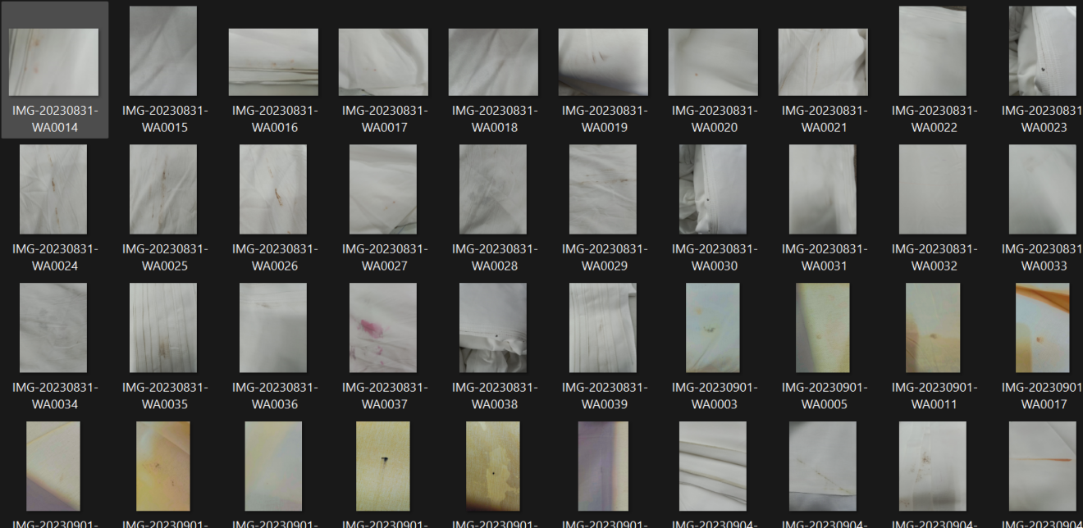

4.2 Workflow of the System
- How We Chose Our Core Setting:
The core setting for this project is the dynamic and challenging environment of textile manufacturing units in Sialkot and Faisalabad. We selected these locations due to their significance as major textile hubs, providing a representative snapshot of the industry. The choice of the core setting aligns with the project's goal of addressing the specific needs and conditions of the Pakistani textile industry.
- What We Need to Know About the Setting:
Understanding the setting involves delving into the intricacies of industrial processes, variations in production conditions, and the unique challenges faced by workers. This knowledge is crucial for tailoring our fabric defect detection system to effectively operate within the complexities of the chosen setting.
- Calculations, Technique, Procedure, and Equipment:
The workflow encompasses calculations related to data pre-processing, model training, and evaluation metrics. Techniques include Detection or Classification & Segmentation for precise defect identification. Procedures involve systematic data collection, model training, and real-time defect detection. Equipment comprises cameras for data acquisition, computing resources for model training, and specialized algorithms for defect identification.
- Limitations, Assumptions, and Range of Validity:
Limitations include potential variations in lighting conditions and fabric types, impacting the system's performance. Assumptions are made regarding the generalized proposed system across different textile manufacturing units. The range of validity extends to real-time data processing and defect detection within the chosen industrial setting.

4.3 Algorithms/Architecture
Description of Any Novel Procedures Proposed or Implemented:
A novel aspect of our approach involves adapting and fine-tuning deep learning models to suit the specific requirements of fabric defect detection. This includes customized models and some pretrained models such as Yolo-V9, InceptionV3, EfficientNet, ResNet, and U-Net. The incorporation of classification and segmentation methodologies represents a novel procedure for precise defect identification and classification.
While leveraging existing deep learning models, we bring innovation through their adaptation and customization. The pretrained models serve as a foundation, but their settings are adjusted to meet the challenges posed by real-time industrial data. The incorporation involves aligning the models with the unique conditions and requirements of fabric defect detection in the textile industry.

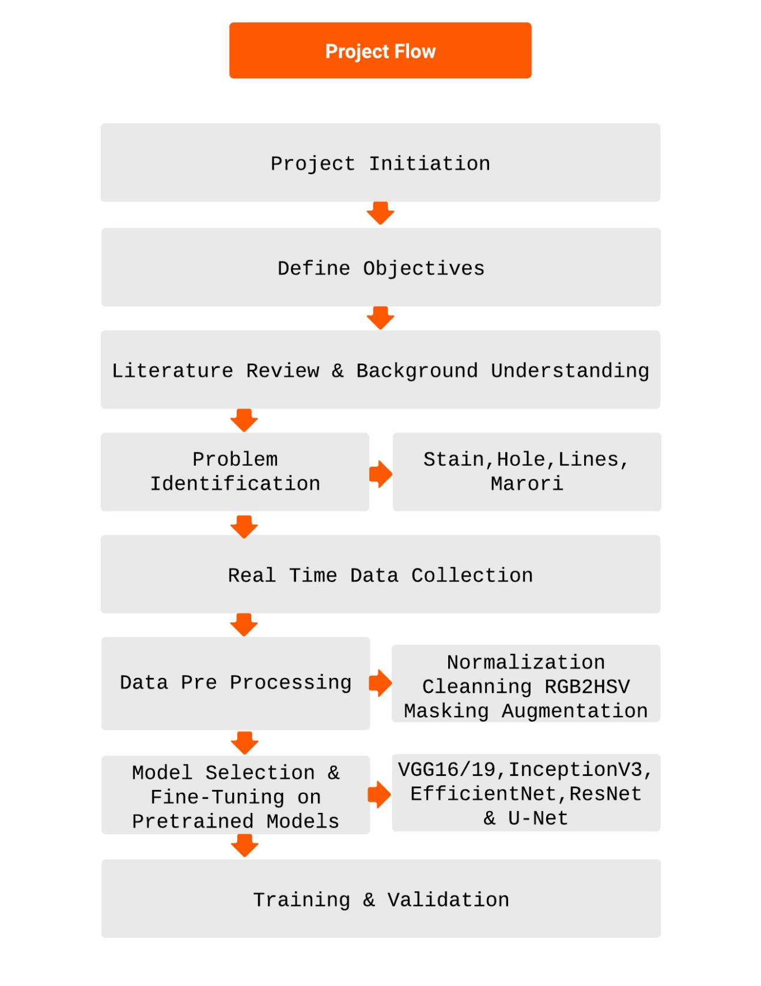
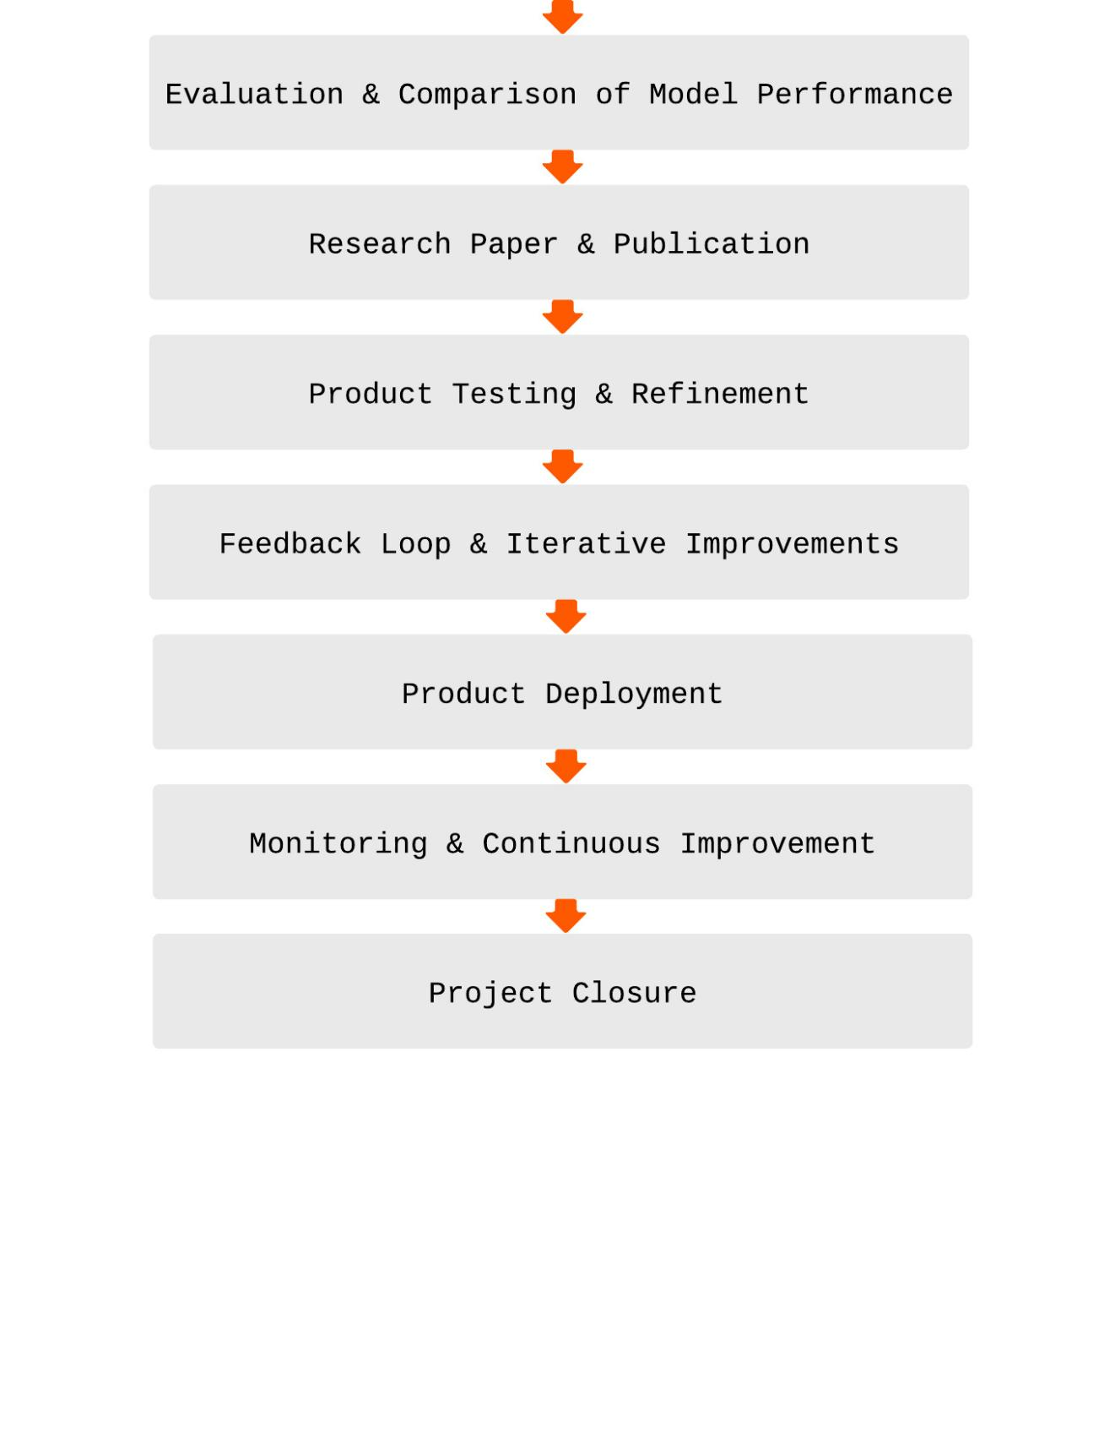

Design and Implementation

System Design
- Performance:
The system design prioritizes high performance in fabric defect detection. Pretrained deep learning models, including YOLO-V9, InceptionV3, EfficientNet, ResNet, and U-Net, are customized and optimized on a bespoke dataset specifically curated from the textile manufacturing units in Sialkot and Faisalabad. The instance segmentation methodology is employed to enhance precision, ensuring efficient defect identification and classification.

- Robustness:
Robustness is ensured by developing the system to handle variations in real-time data from textile manufacturing units. The pretrained models, fine-tuned on a custom dataset, are designed to accommodate different fabric types, lighting conditions, and defect complexities. This robust design contributes to the system's reliability across diverse industrial settings.

- Interactivity:
The system is designed to operate interactively, providing real-time fabric defect detection. The interactive nature enables quick feedback to manufacturing units, allowing for timely adjustments and quality control interventions based on insights from the custom-trained models.

- Flexibility:
Flexibility is achieved through the adaptability of deep learning models, pretrained on a custom dataset. The system can be fine-tuned to accommodate changes in fabric types, defect patterns, and manufacturing conditions specific to the textile industry in Sialkot and Faisalabad. This flexibility ensures the longevity and relevance of the system in dynamic industrial environments.

- Re-usability and Portability:
The modular design of the system, with pretrained models trained on a custom dataset, promotes re-usability and portability. Each component, including the models and defect detection algorithms, can be repurposed for similar applications in different industrial contexts, provided a similar dataset is available. The system's portability allows seamless integration into various textile manufacturing units.

- Security:
While security considerations are not the primary focus, data security protocols are implemented to safeguard the collected real-time data. Encryption and access control measures are employed to protect sensitive information related to fabric defects and manufacturing processes in the custom dataset.

5.2 System Implementation

- Develops Tools and Environment Used:
The systems for implementation were using Python as the primary programming language. TensorFlow/Pytorch and Keras libraries and some other libs are utilized for developing and customizing deep learning models. OpenCV is employed for image processing tasks, and the implementation is carried out in a Jupyter Notebook and Google Colab environment. The system is executed on high-performance computing clusters to handle the computational demands of real-time data processing.

- Implementation of Different Modules:
- Data Collection Module: Involves systematic gathering of real-time data from textile manufacturing units in Sialkot and Faisalabad.
- Data Preprocessing Module: Includes the classification and labeling of various fabric defects, preparing the custom dataset by cleaning, re-sizing, and other data wrangling techniques for model training.
- Model Training Module: Customization and fine-tuning of pretrained deep learning models on the custom dataset to meet the specific requirements of fabric defect detection.
- Defect Detection Module: Application of these trained models for precise defect identification and classification of defects.

- Difficulties Faced and How They Were Addressed:
It took long time to understand that there was more than 40 types of defects. From them, we had to pick major defects. Names of these defects were also difficult as every worker was calling same defect with different name. We had to understand each defect crucially due to its importance. This costs us time. Challenges were encountered in dataset collection as well. As It was very slow process and was probably hard to stand for long time to capture defect. Due to time constrained, we just collected 3000 images of these more than 40 images. Later, we had to stick to 5 major classes as mentioned previously. This reduced our dataset to around 1500 images. Then preprocesing of the dataset was totally manual. After that adapting pretrained models to the nuances of the custom dataset. Additional efforts were made to fine-tune the models with the specific characteristics of fabric defects observed in factory. Collaboration with industry experts played a crucial role in addressing these challenges and refining the system's performance.

5.3 Assumptions/Constraints
The system operates under the assumption that the pretrained models, when fine-tuned on the custom dataset, can effectively adapt to the specific characteristics of fabric defect detection in the chosen industrial setting. Constraints include potential limitations in data availability, requiring continuous efforts to expand and diversify the custom dataset for improved model performance. Additionally, the system assumes a reasonable level of computational resources for real-time processing in the industrial environment.
According to W. Ouyang, B. Xu, J. Hou, and X. Yuan, fabric defects, ‘’considered as fine structures in computer vision, are often represented by a small number of pixels in an image. To improve the segmentation of these fine structures, additional processing is embedded in a Convolutional Neural Network (CNN) to fine-tune the coarse outputs generated during the initial CNN processing’’.
Here is the glimpse of preprocessed dataset sample:

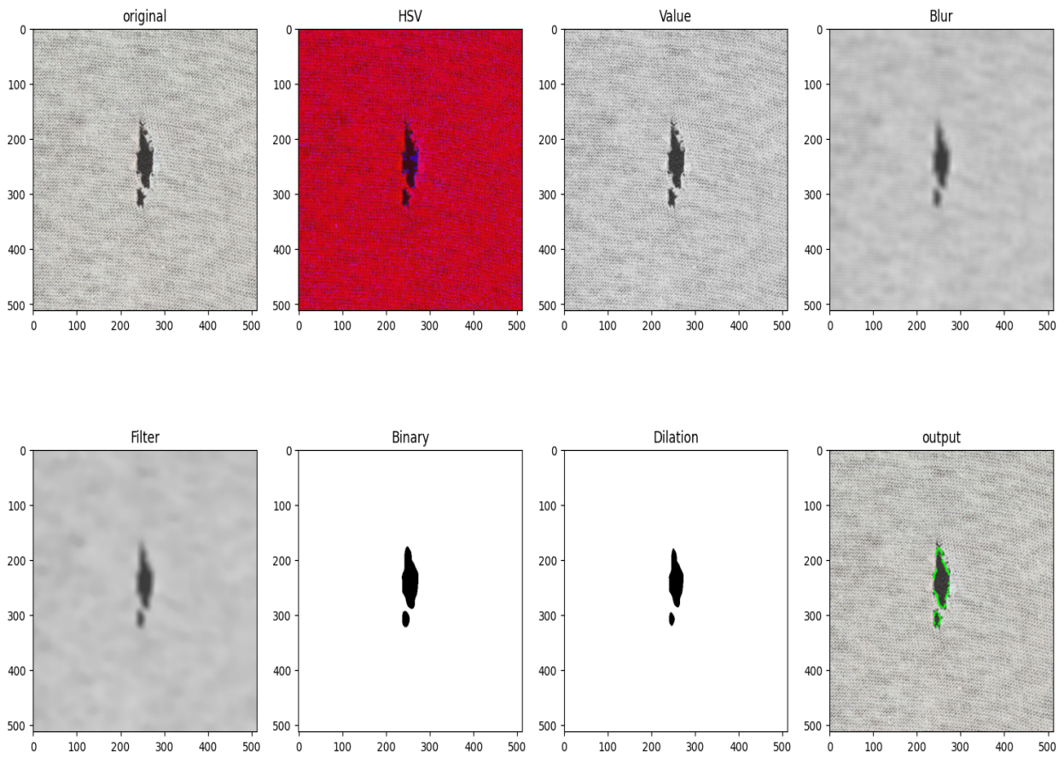
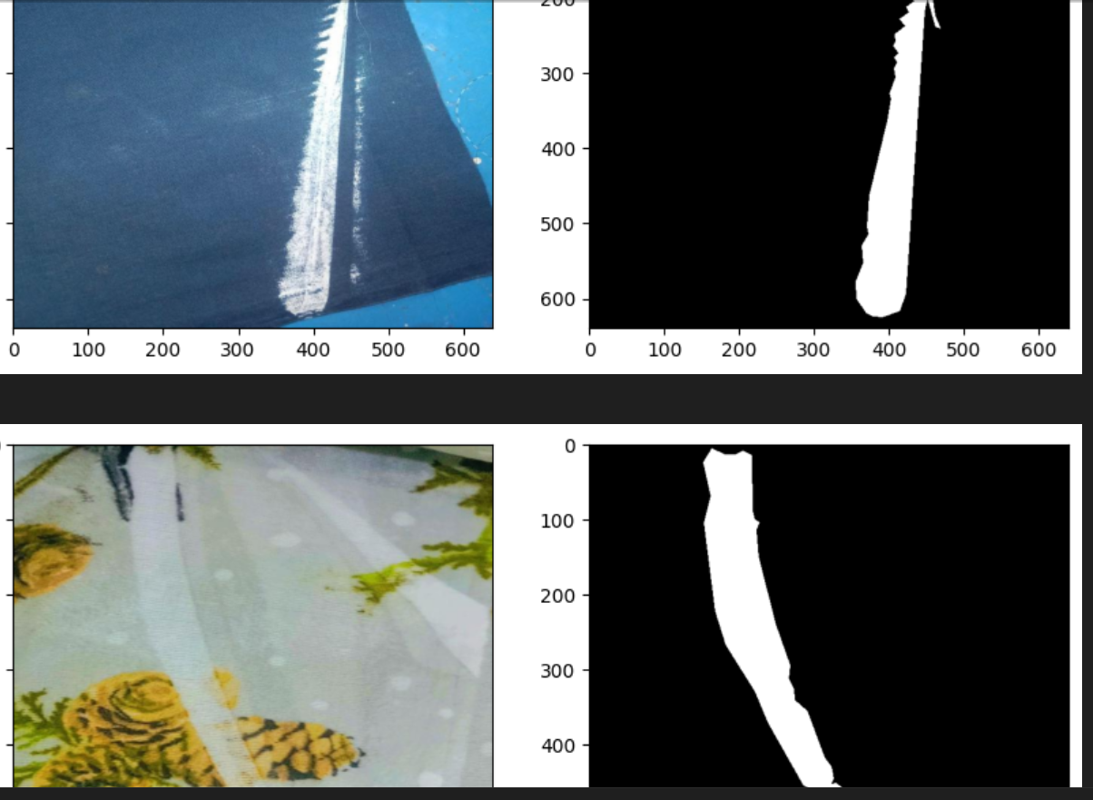

Evaluation

Experimentation
Our experimental setup is meticulously crafted to simulate real-world conditions in fabric defect detection. We have established a multi-faced data collection and analysis framework, incorporating advanced deep learning methodologies.

- Data Collection: We have collaborated with multiple textile manufacturing units across different regions to gather a rich dataset. This dataset includes various fabric types, encompassing a wide array of defects such as lines and marori, stains, holes, and normal fabric conditions.
- Preprocessing: The collected images undergo rigorous preprocessing, which includes normalization to standardize image intensities, augmentation to increase dataset diversity, and precise labeling for supervised learning.
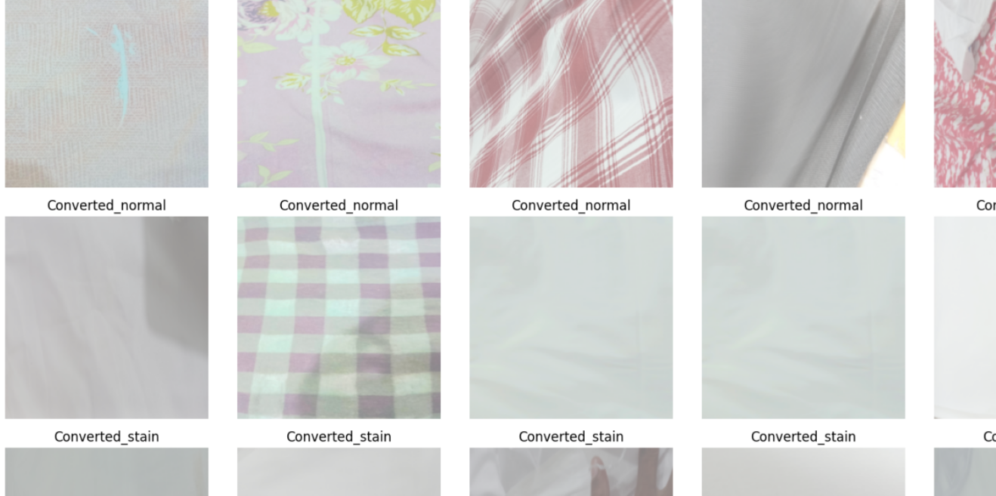
- Model Infrastructure: We have set up a robust computational infrastructure, utilizing high-performance GPUs for efficient model training and evaluation.

Experiments Design/Details
Our experiments are designed to evaluate the effectiveness of both pretrained and custom models in fabric defect detection.

- Model Implementation: Pretrained models like Yolo and InceptionV3 are fine-tuned, and custom models will be developed to address specific challenges in fabric defect detection.
- Performance Metrics: We assess models based on accuracy, precision, recall, and F1-scores. Special attention is given to the models' ability to distinguish between different defect types.
- Validation Strategy: The models are validated using a hold-out test set representative of the real-world distribution of fabric defects.

Results
The results section are comprehensive presentation of our experimental findings.

- Quantitative Analysis: Detailed pictures showcasing model performance metrics, including accuracy, precision, recall, and F1-scores for each defect type.
Best of your findings:
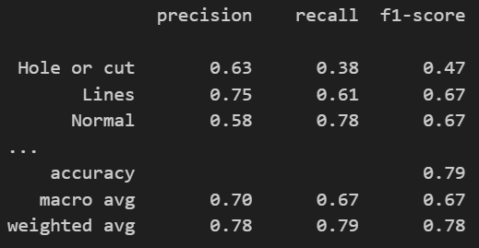
- Qualitative Evaluation: Visual aids such as confusion matrices, along with sample images of the models’ defect detections, provide qualitative insights into model performance.

- Comparison with Baselines: Our custom model is very good than any of our testing from pre-trained models. The Average Validation Accuracy across these epochs is approximately 73.58%

Discussion/Analysis
- Interpretation of Results
We will analyze how our results align with the project's objectives, particularly in improving accuracy and efficiency in fabric defect detection.
The results will be scrutinized to extract insights, especially regarding the models' performance on the diverse, real-time dataset.
- Comparative Analysis
- Model Comparisons: We draw parallels with existing research, discussing how our models perform in comparison to established methods in fabric defect detection.
- Strengths and Weaknesses: A critical evaluation of the strengths and limitations of each model, considering factors like adaptability to different fabric types and real-time processing capabilities.
- Sources of Error and Future Directions
Error Analysis: We identify and discuss potential sources of error, such as biases in the dataset or overfitting in the models.
Recommendations for Future Research: Suggestions for further enhancements and research directions are provided, based on the observed results and challenges encountered during the project.

Conclusion and Future work
As we conclude this documentation, it is evident that our project, focused on fabric defect detection using computer vision and deep learning, marks a significant advancement in the field of textile manufacturing quality control. Our comprehensive approach, from data collection to model implementation and evaluation, underscores the potential of AI-driven solutions in industrial applications.
Achievements
We successfully developed and tested some of models, pre-trained and custom-designed, to accurately detect and classify different types of fabric defects. Our unique approach of utilizing real-time data from the manufacturing floor has provided valuable insights, demonstrating the applicability of our models in real-world settings. The results achieved not only meet the initial objectives set for the project but also pave the way for further technological innovations in the textile industry.
Future Work
Looking ahead, we plan to expand the scope of our project with several enhancements:
1. Scaling with Real-Time Data Analysis: We intend to scale our project by incorporating more extensive real-time data analysis. This will involve processing larger datasets and possibly integrating more diverse fabric types, further enhancing the robustness and versatility of our models.
2. Integration with Edge Technology: A significant advancement will be the integration of our defect detection system with edge computing technology. This will enable real-time processing and decision-making at the manufacturing site. For instance, if a critical defect is detected, the system will automatically notify the operators and, if necessary, halt the machine. his automation will not only improve the efficiency of defect detection but also enhance safety and quality control measures.
3. Machine Control and Feedback Mechanisms: We plan to implement advanced control mechanisms where our system can provide actionable feedback to the manufacturing machines. This feedback could range from adjustments in the manufacturing process to prevent certain types of defects to immediate stoppage in case of critical quality issues.
4. Continuous Learning and Adaptation: To ensure the system remains effective over time, we will explore mechanisms for continuous learning, allowing the system to adapt to new types of defects or changes in manufacturing processes.
- Broader Industrial Application: Eventually, we aim to generalize our system for broader industrial applications beyond textile manufacturing. This would involve customizing the system for different types of manufacturing processes and defect detection requirements.

In conclusion, our project stands as a testament to the potential of combining computer vision and deep learning to solve real-world industrial problems. The advancements we have made not only contribute significantly to the textile industry but also open avenues for further research and development in the application of AI in industrial settings. We are confident that the continued evolution of this project will lead to more innovative solutions, contributing substantially to the fields of manufacturing, quality control, and industrial automation.

References/ Bibliography
(Fabric defect detection systems and methods—A systematic literature review, pp. 11960-11973)

(Automatic fabric defect detection using a deep convolutional neural network, 2019, pp. 213-223)

(Fabric defect detection systems and methods—A systematic literature review, pp. 11960-11973)

(Fabric defect detection using activation layer embedded convolutional neural network, 2019, pp. 70130-70140)

(Fabric defect detection using activation layer embedded convolutional neural network, 2019, pp. 70122-70140)
(Fabric defect detection systems and methods—A systematic literature review, pp. 11960-11973)

Appendix

Glossary of terms
Instance Segmentation: A computer vision task involving the identification and delineation of individual objects within an image, providing a detailed understanding of object boundaries.
Deep Learning: A subset of machine learning where artificial neural networks, particularly deep neural networks, are employed to mimic the human brain's ability to learn and make decisions.
Pretrained Models: Neural network models that are trained on large datasets for generic tasks before being fine-tuned for specific applications.
Augmentation: The process of artificially expanding a dataset by applying various transformations, such as rotation, scaling, or flipping, to enhance model robustness.

Pre-requisites
Python Programming: Proficiency in Python programming language for implementing and customizing machine learning models.
Computer Vision: Understanding of computer vision concepts and techniques for image processing and analysis.
Deep Learning Frameworks: Familiarity with deep learning frameworks such as TensorFlow or PyTorch for model development.

Reference/ Source Documents
Hanbay, K., Talu, M. F., & Özgüven, Ö. F. (2016). Fabric defect detection systems and methods—A systematic literature review. Optik, 127(24), 11960-11973.
Jing, J. F., Ma, H., & Zhang, H. H. (2019). Automatic fabric defect detection using a deep convolutional neural network. Coloration Technology, 135(3), 213-223.
Ouyang, W., Xu, B., Hou, J., & Yuan, X. (2019). Fabric defect detection using activation layer embedded convolutional neural network. IEEE Access, 7, 70130-70140.

