PRESENTATION

SUBJECT : INTRODUCTION TO SOFTWARE ENGINEERING

INSTRUCTOR : SIR SHAKIR RASHEED KHAN KHATTAK

GROUP MEMBERS

MUHAMMAD TARIQ : 4338-FBAS-BSSE-F21-B

YASIR ALI : 4343-FBAS-BSSE-F21-B

SIAM KHAN : 4333 -FBAS-BSSE-F21-B

SHAYAN UMAR : 4316-FBAS-BSSE-F21-B

USAMA KHAN : 4317 -FBAS-BSSE-F21B

**USE-CASES OF ONLINE SHOPPING STORE**

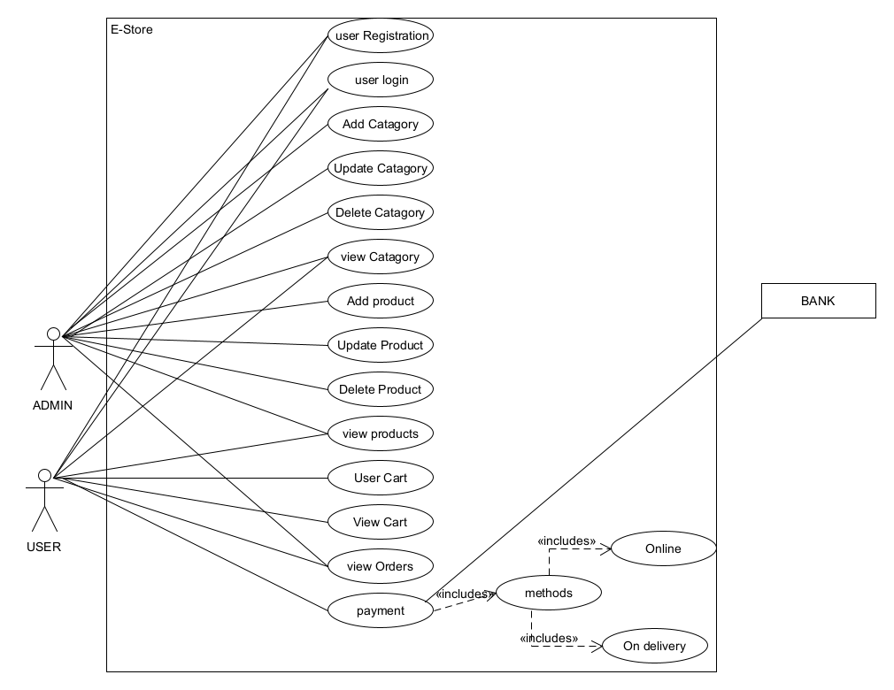

**DOMAIN-MODEL OF ONLINE SHOPPING STORE**

