**NAME : MUHAMMAD TARIQ**

**REG NUMBER : 4338-FBAS-BSSE-F21-B**

**SUBJECT : INTRODUCTION TO SOFTWARE ENGINEERING**

**INSTRUCTOR : SIR SHAKIR RASHID KHAN KHATTAK**

**QUESTION NO:01**

**Describe waterfall model and list the stages of waterfall model for software development and list three of its advantages and disadvantages?**

**ANSWER**

**WATERFALL MODEL**

I. The term was first introduced in a paper published in 1970 by Dr. Winston W. Royce and continues to be used in applications of industrial design.

II. The Waterfall Model is a classical model used in System Development Life Cycle (SDLC) to create a system with a linear and sequential approach. It is also referred to as a linear-sequential life cycle model.

III. It is termed as waterfall because the model develops systematically from one phase to another in a downward fashion.

IV. In a waterfall model, each phase must be completed fully before the next phase can begin

V. This model is divided into different phases and the output of one phase is used as the input of the next phase.

VI. At the end of each phase, a review takes place to determine if the project is on the right path and whether or not to continue or discard the project.

VII. This type of software development model is basically used for the project which is small and there are no uncertain requirements.

VIII. In this model software testing starts only after the development is complete. In waterfall model phases do not overlap.

**STAGES**

■ It has the following phases:

1. Communication - Requirements Gathering

2. Planning – Estimating/Scheduling/Tracking

3. Modeling - Analysis & Design

4. Construction - Coding/Implementation/Test

5. Deployment – Delivery/Support/Feedback

**ADVANTAGES:**

1. Upfront documentation and planning stages allow for large or shifting teams to remain informed and move towards a common goal.

2. Forces structured , disciplined organization.

3. Is simple to understand, follow and arrange tasks.

4. Facilitates departmentalization and managerial control based on schedule or deadlines.

**DISADVANTAGES:**

1. Design is not adaptive; often when a flaw is found, the entire process needs to start over.

2. Ignores the potential to receive mid-process user or client feedback and make changes based on results.

3. Delays testing until the end of the development life cycle.

4. Does not consider error correction.

**QUESTION NO: 02**

**LIST THE STAGES OF SOFTWARE DEVELOPMENT LIFE CYCLE(SDLC) DESCRIBE EACH STAGE IN PHRASE**

**ANSWER**

**Stage 1: Planning and Requirement Analysis : –**

**Requirement analysis** is the most important and fundamental stage in SDLC. – It is performed by the senior members of the team with inputs from the customer, the market surveys and domain experts in the industry.

– **Planning** for the quality assurance requirements and identification of the risks associated with the project is also done in the planning stage.

**Stage 2: Defining Requirements : –** Once the requirement analysis is done the next step is to clearly define and document the product requirements and get them approved from the customer – This is done through ‘SRS’ – Software Requirement Specification document which consists of all the product requirements to be designed and developed during the project life cycle.

**Stage 3: System Design: –**

Based on the requirements in SRS desired features and operation in detail are specified and documented in a DDS(Design Document Specification) – Including Screen layouts, Business rules, Process diagrams and other documentation

**Stage 4:** **Building or Developing the Product : –** In this stage of SDLC the actual development starts and the product is built. The programming code is generated as per DDS during this stage.

**Stage 5: Testing the Product : –** This stage refers to the testing of the product where products defects are reported, tracked, fixed and retested, until the product reaches the quality standards defined in the SRS.

**Stage 6: Deployment : –** Once the product is tested and ready to be deployed it is released formally in the appropriate market. (i.e. where the software is put into production and runs actual business)

**Maintenance: –** What happens during the rest of software’s life: changes corrections, additions and more

**Question No.03**

**USER LEVEL REQUIREMENT**

**i.**The end-user must be enrolled in university

**ii.**the system should take input the book ISBAN number from the end-user

**SYSTEM LEVEL REQUIREMENTS**

**i.**Each book will have a unique identification number

**ii.**there could be more than one copy of a book, we will call each copy of a book a bookcopy

**iii.**the system should be able to retrieve information like the availability of the book and due date

**iv.** the system should be able to keep track of the book borrower like his registration number, department name etc.

**v.**A book can be loaned only for two weeks at a time

**vi.**the system should be able to search a book

**QUESTION NO:04**

USE-CASES

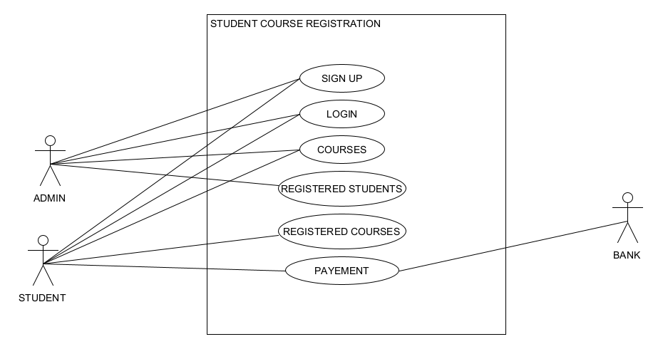

DOMIAN MODEL

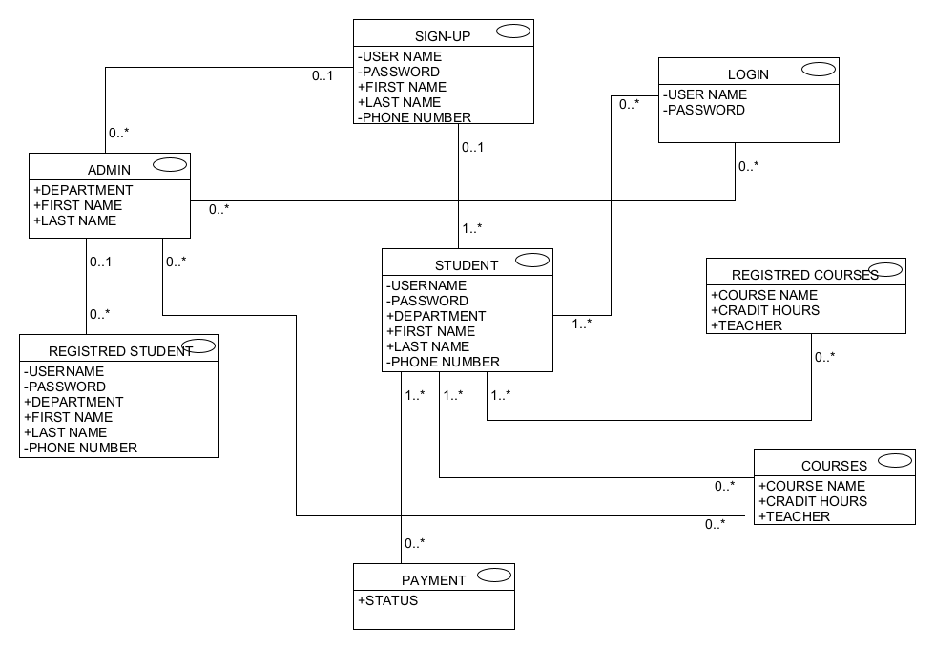

**QUESTION NO.05**

**Write the non functional requirements for the following projects?**

1. **- BIKE RACING GAME :**

**Usability** **:** is classical nonfunctional requirement that addresses a simple question: How hard is it to use the product?

**Compatibility:** as an aspect of portability, defines how a system can coexist with another system in the same environment. For instance, software installed on an operating system must be compatible with its firewall or antivirus protection.

**Reliability** **:** Reliability reflects the capacity of the software to maintain its performance over the time. It implies how well the system performs in peak hours.

1. **– ONLINE BANKING SYSTEM :**

**i.** **Security:** Security is the feature of the system which ensures that system must be protected from the unintentional or malignant harm; unauthorized access to the data is not permissible.

**ii.** **Availability :**  The online banking should be available round the clock. It means for how long the system is available for its users or clients and for how long the system will be operational.

**iii.** **Usability** **:** online banking is carried by various types of clients i.e. whether they have knowledge of computers or not so the application designed for online baking must be easy to use and enable the client to manage their ccounts or transactions with simplicity.

**iv.** **Usability** **:** online banking is carried by various types of clients i.e. whether they have knowledge of computers or not so the application designed for online baking must be easy to use and enable the client to manage their ccounts or transactions with simplicity.

**vi.** **Reliability** : Reliability reflects the capacity of the software to maintain its performance over the time. It implies how well the system performs in peak hours.

**x.** **Visibility :** It alludes to condition of having the capacity to see online banking empowers the client to see the login screen and the configuration of the online banking application as per the client desire.